**ASSIGNMENT-4**

**(Regression)**

**Linear Regression:**

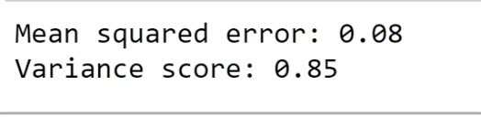

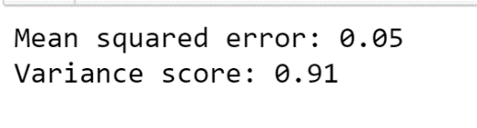

**Logistic Regression:**

Confusion Matrix:

