**ASSIGNMENT-4**

**REGRESSION**

**TEAM:**

1. **SURYANARAYAN N PES1201700094**
2. **HARIKRISHNAN V PES1201700155**
3. **UNNATI CHATURVEDI PES1201700225**
4. **KRUTHIK JT PES1201701509**

**Linear Regression:**

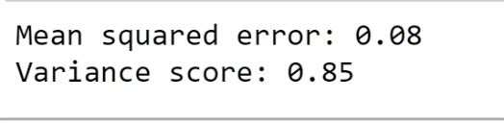

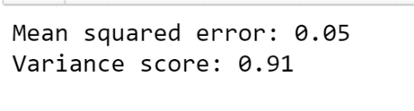

**Logistic Regression:**

Confusion Matrix:

