**COLLABORATIVE FILTERING**

**ITEM BASED:**

Movie Recommended if MATRIX is watched:

Movie Recommended if PULP FICTION is watched:

**USER-BASED:**

User Similarity Matrix:

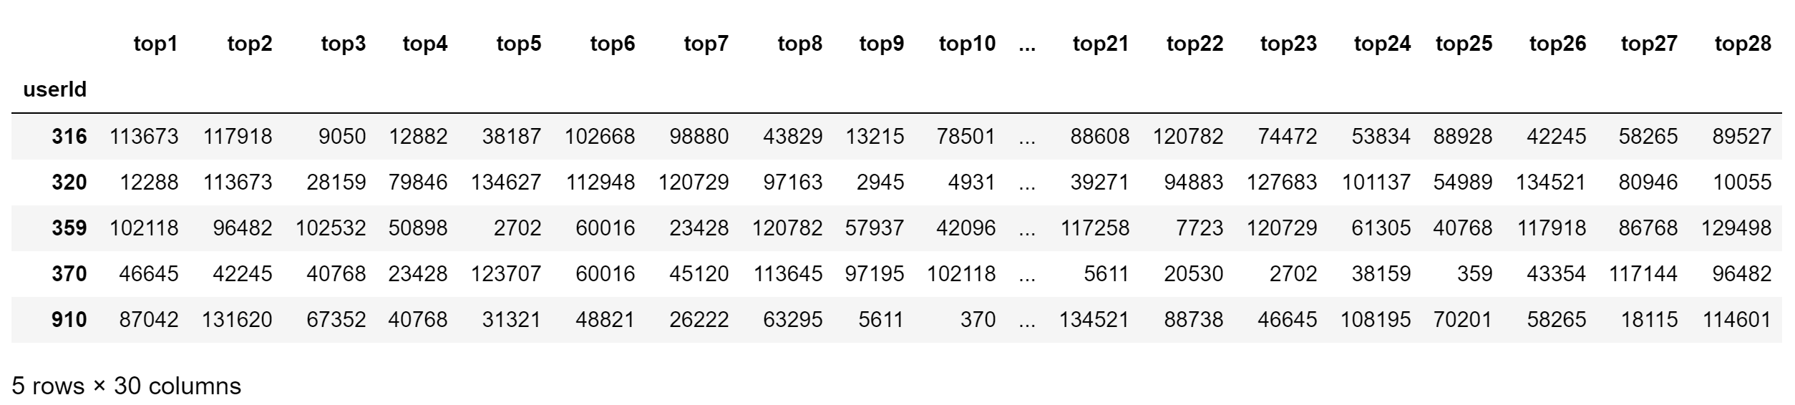

Prediction for User id: 370

