**ASSIGNMENT-7**

**COLLABORATIVE FILTERING**

**TEAM:**

1. **SURYANARAYAN N PES1201700094**
2. **HARIKRISHNAN V PES1201700155**
3. **UNNATI CHATURVEDI PES1201700225**
4. **KRUTHIK JT PES1201701509**

**ITEM BASED:**

Movie Recommended if MATRIX is watched:

Movie Recommended if PULP FICTION is watched:

**USER-BASED:**

User Similarity Matrix:

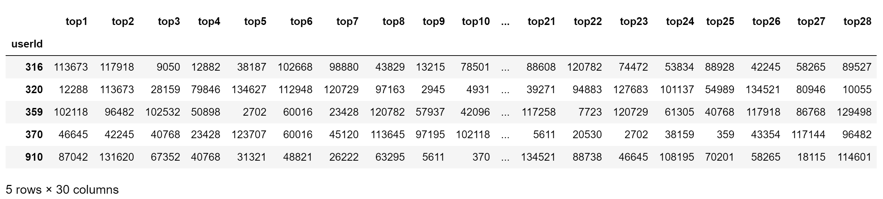

Prediction for User id: 370

