Online Ticket Support System
– By Surya Pratap Singh (24BCS10163)

1. Executive Summary
This document presents the design and implementation of an Online Ticket Support System, a full-stack web application developed to streamline issue reporting, tracking, and resolution. The system allows users to raise support tickets while administrators manage and resolve them using a structured workflow. The project focuses on clean REST APIs, role-based access control, and maintainable backend architecture.
2. Technology Stack
Frontend: React, HTML, CSS, Axios and API communication
Backend: Spring Boot, Spring Security, Spring Data JPA
Database: MySQL
Authentication: JWT
Version Control: Git & GitHub
3. High Level Design (HLD)
The system follows a client-server architecture where the frontend communicates with the backend through REST APIs. The backend handles authentication, business logic, and data persistence.
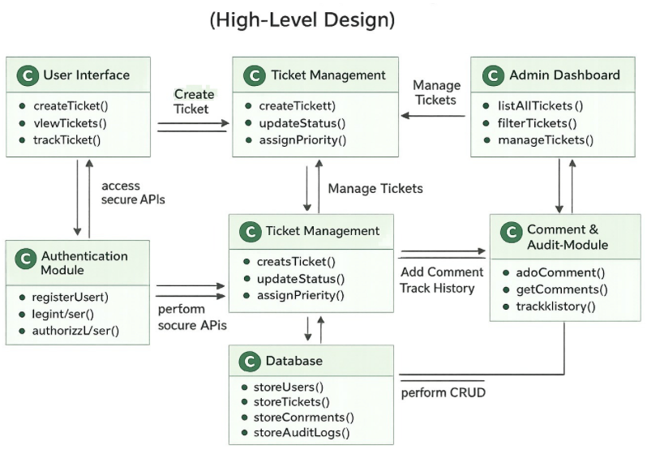
High-Level Components:-
- Frontend Client (React)
- Backend Application (Spring Boot)
- Authentication & Authorization Module
- Ticket Management Module
- Comment & Audit Module
- MySQL Database
All client requests are authenticated and authorized before accessing protected resources.
4. Backend Architecture Overview
The backend is divided into authentication, ticket management, and audit modules. Each module is responsible for a single business concern and communicates via service layers.
The backend follows a layered architecture to ensure separation of concerns and maintainability.
Key Backend Modules
Authentication & Authorization Module
- Handles user registration and login
- Issues JWT tokens
- Enforces role-based access (USER / ADMIN)
Ticket Management Module
- Creates and updates tickets
- Manages ticket lifecycle and status transitions
- Handles priority and category logic
Comment & Audit Module
- Stores user/admin comments
- Maintains history of ticket updates
- Tracks timestamps and actions
5. Frontend Modules Overview
Authentication ModuleUser Ticket ModuleAdmin Dashboard Module
F1. Authentication Module
- Login and registration pages
- JWT token handling
- Role-based routing
F2. User Ticket Module
- Create new ticket
- View own tickets
- Track status and responses
F3. Admin Dashboard Module
- View all tickets
- Filter by status, priority, category
- Update ticket status
- Respond to tickets
6. Low Level Design (LLD)
The backend uses a standard layered design pattern.
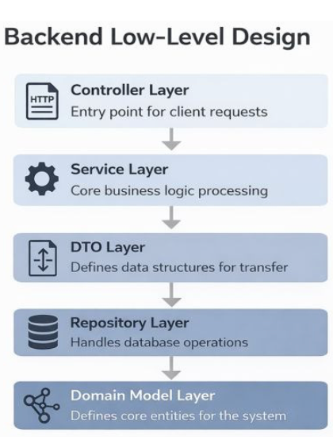
Controller Layer
- Acts as the entry point for HTTP requests
- Handles request validation
- Returns appropriate HTTP responses
- Contains no business logic
Service Layer
- Contains all business logic
- Handles ticket status transitions
- Applies role-based rules
- Implements escalation or priority logic
Repository Layer
- Interacts with MySQL using Spring Data JPA
- Performs CRUD operations
- Abstracts database access
DTO Layer
- Defines request and response structures
- Prevents direct exposure of entity models
- Enables clean data transfer
Domain Model Layer
- Core entities:
  - User
  - Ticket
  - Comment
  - AuditLog
All decision-making logic resides strictly in the service layer.
7. Ticket Lifecycle
OPEN → IN_PROGRESS → RESOLVED → CLOSED
- OPEN: Ticket created by user
- IN_PROGRESS: Admin starts working on issue
- RESOLVED: Solution provided
- CLOSED: Ticket finalized
Status transitions are validated to prevent invalid updates.
8. Functional Requirements
(User authentication, Ticket creation and tracking, Admin management, Commenting system, Audit logs)
- User registration and authentication
- Secure login using JWT
- Ticket creation with category and priority
- Ticket status tracking
- Admin ticket management
- Commenting system for communication
- Role-based access control
- Audit trail for ticket updates
9. Non-Functional Requirements
(Security, Scalability, Maintainability, Low latency)
- Secure data handling
- Low latency API responses
- Scalable architecture
- Maintainable codebase
- Clear separation of concerns
- Consistent error handling
10. Conclusion
The Online Ticket Support System demonstrates a real-world enterprise application focused on clarity, structure, and reliability. By implementing role-based workflows, clean REST APIs, and layered backend architecture, the system provides an efficient solution for issue management while remaining easy to understand, build, and extend.

