Climbing Stairs
Problem Statement: Given a number of stairs. Starting from the 0th stair we need to climb to the “Nth” stair. At a time we can climb either one or two steps. We need to return the total number of distinct ways to reach from 0th to Nth stair
- Recap: Like Fibonacci but f(0)=1 way.
- Recurrence: f(n) = f(n-1) + f(n-2)
- Start index: n (steps remaining)
- Base case: n==0 → 1, n<0 → 0
- Trick: Count ways not value.
- Short note: Ways to reach top.
- Code:
int f(int n, vector<int>&dp){
if(n==0) return 1;
if(n<0) return 0;
if(dp[n]!=-1) return dp[n];
return dp[n]=f(n-1,dp)+f(n-2,dp);
}

Frog Jump (DP 3)

Given a number of stairs and a frog, the frog wants to climb from the 0th stair to the (N-1)th stair. At a time the frog can climb either one or two steps. A height[N] array is also given. Whenever the frog jumps from a stair i to stair j, the energy consumed in the jump is abs(height[i]- height[j]), where abs() means the absolute difference. We need to return the minimum energy that can be used by the frog to jump from stair 0 to stair N-1.
N= 4, h = [ 10, 20,30, 10] , ans = 40;

- Recap: Min cost from stone 0 to stone n-1.
- Recurrence: f(i) = min(f(i-1)+|h[i]-h[i-1]|, f(i-2)+|h[i]-h[i-2]|)
- Start index: n-1 (final stone)
- Base case: i==0 → 0
- Trick: Only prev 1 or 2 jumps.
- Short note: Like stairs but with cost.
- Code:
int f(int i, vector<int>&h, vector<int>&dp){
if(i==0) return 0;
if(dp[i]!=-1) return dp[i];
int one = f(i-1,h,dp)+abs(h[i]-h[i-1]);
int two = (i>1)? f(i-2,h,dp)+abs(h[i]-h[i-2]) : INT_MAX;
return dp[i]=min(one,two);
}

Frog Jump with k Distances (DP 4):
- This is a follow-up question to “Frog Jump” discussed in the previous article. In the previous question, the frog was allowed to jump either one or two steps at a time. In this question, the frog is allowed to jump up to ‘K’ steps at a time. If K=4, the frog can jump 1,2,3, or 4 steps at every index.
Recap: Like Q3 but up to k jumps.
- Recurrence: f(i) = min over j in [1..k](f(i-j)+|h[i]-h[i-j]|)
- Start index: n-1
- Base case: i==0 → 0
- Trick: Loop inside recurrence.
- Short note: Generalized frog jump.
- Code:
int f(int i,int k,vector<int>&h,vector<int>&dp){
if(i==0) return 0;
if(dp[i]!=-1) return dp[i];
int ans=INT_MAX;
for(int j=1;j<=k && i-j>=0;j++)
ans=min(ans,f(i-j,k,h,dp)+abs(h[i]-h[i-j]));
return dp[i]=ans;
}

Maximum sum of non-adjacent elements (DP 5)
Given an array of ‘N’ positive integers, we need to return the maximum sum of the subsequence such that no two elements of the subsequence are adjacent elements in the array.
Note: A subsequence of an array is a list with elements of the array where some elements are deleted ( or not deleted at all) and the elements should be in the same order in the subsequence as in the array.
nums = [1,2,3,1]
output = 4

- Recap: Pick or skip adjacent constraint.
- Recurrence: f(i) = max(a[i]+f(i-2), f(i-1))
- Start index: n-1
- Base case: i==0 → a[0], i<0 → 0
- Trick: Robber house logic.
- Short note: Skip neighbour if take.
- Code:
int f(int i,vector<int>&a,vector<int>&dp){
if(i<0) return 0;
if(i==0) return a[0];
if(dp[i]!=-1) return dp[i];
int take = a[i]+f(i-2,a,dp);
int notTake = f(i-1,a,dp);
return dp[i]=max(take,notTake);
}

House Robber 2(DP 6)

A thief needs to rob money in a street. The houses in the street are arranged in a circular manner. Therefore the first and the last house are adjacent to each other. The security system in the street is such that if adjacent houses are robbed, the police will get notified.
Given an array of integers “Arr'' which represents money at each house, we need to return the maximum amount of money that the thief can rob without alerting the police.
• Recap: Like Q5 but circular houses.
• Recurrence: Max of robbing [0..n-2] or [1..n-1].
• Start index: Use Q5 twice.
• Base case: n==1 → arr[0]
• Trick: Break into two linear cases.
• Short note: Circular skip trick.
class Solution {
public:
int solve(vector<int> &nums, int i, int j){
if(j <= i) return 0;
if(j == i+1) return nums[i];

int pick = nums[j-1] + solve(nums,i, j-2);
int notPick = solve(nums,i,j-1);
return max(pick,notPick);
}
int rob(vector<int>& nums) {
int n = nums.size();
if(n == 1) return nums[0];
int ans1 = solve(nums,0,n-1);
int ans2 = solve(nums,1,n);
return max(ans1,ans2);
}
};

Ninja Training

Problem Statement: A Ninja has an ‘N’ Day training schedule. He has to perform one of these three activities (Running, Fighting Practice, or Learning New Moves) each day. There are merit points associated with performing an activity each day. The same activity can’t be performed on two consecutive days. We need to find the maximum merit points the ninja can attain in N Days.
We are given a 2D Array POINTS of size ‘N*3’ which tells us the merit point of specific activity on that particular day. Our task is to calculate the maximum number of merit points that the ninja can earn.

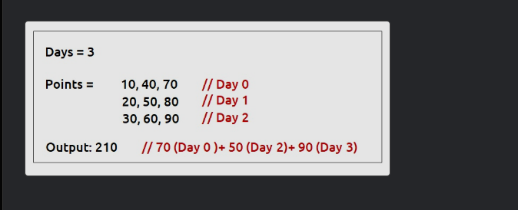

- Recap: Max points choosing different task each day.
- Recurrence:
- f(day,last) = max over task!=last (points[day][task] + f(day-1, task))
- Start index: (n-1, 3) (3 = no task restriction)
- Base case: day==0 → max over tasks != last
- Trick: Pass “last task” as parameter.
- Short note: Task choice DP.
- Code:
int f(int day,int last,vector<vector<int>>&p,vector<vector<int>>&dp){
if(day==0){
int mx=0; for(int t=0;t<3;t++) if(t!=last) mx=max(mx,p[0][t]);
return mx;
}
if(dp[day][last]!=-1) return dp[day][last];
int mx=0;
for(int t=0;t<3;t++) if(t!=last) mx=max(mx,p[day][t]+f(day-1,t,p,dp));
return dp[day][last]=mx;
}

Grid Unique Paths : DP on Grids (DP8)

Given two values M and N, which represent a matrix[M][N]. We need to find the total unique paths from the top-left cell (matrix[0][0]) to the rightmost cell (matrix[M-1][N-1]).
At any cell we are allowed to move in only two directions:- bottom and right.
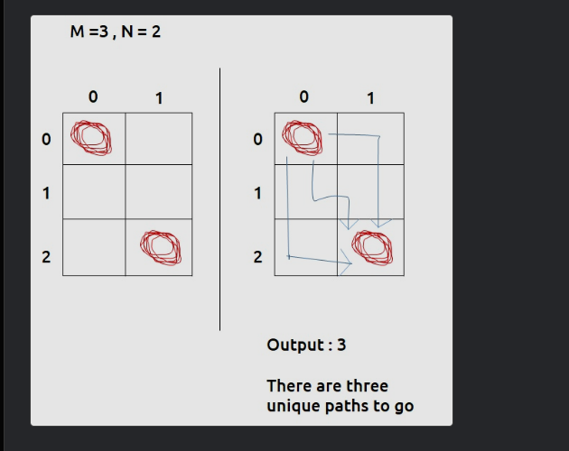

- Recap: Count ways from (0,0) to (m-1,n-1).
- Recurrence: f(i,j) = f(i-1,j) + f(i,j-1)
- Start index: (m-1, n-1)
- Base case: i==0 && j==0 → 1, invalid → 0
- Trick: Only right/down moves.
- Short note: Classic grid count.
- Code:
int f(int i,int j,vector<vector<int>>&dp){
if(i==0 && j==0) return 1;
if(i<0 || j<0) return 0;
if(dp[i][j]!=-1) return dp[i][j];
return dp[i][j]=f(i-1,j,dp)+f(i,j-1,dp);
}

Grid Unique Paths 2 (DP 9)

We are given an “N*M” Maze. The maze contains some obstacles. A cell is ‘blockage’ in the maze if its value is -1. 0 represents non-blockage. There is no path possible through a blocked cell.
We need to count the total number of unique paths from the top-left corner of the maze to the bottom-right corner. At every cell, we can move either down or towards the right.
Grid Unique Paths with Obstacles
- Recap: Same as Q8 but avoid blocked cells.
- Recurrence: Same as Q8 but if(obs[i][j]==1) return 0
- Start index: (m-1, n-1)
- Base case: Blocked start → 0
- Trick: Just add obstacle check.
- Short note: Obstacle grid variant.
- Code:
int f(int i,int j,vector<vector<int>>&dp,vector<vector<int>>&ob){
if(i>=0 && j>=0 && ob[i][j]) return 0;
if(i==0 && j==0) return 1;
if(i<0 || j<0) return 0;
if(dp[i][j]!=-1) return dp[i][j];
return dp[i][j]=f(i-1,j,dp,ob)+f(i,j-1,dp,ob);
}

Minimum Path Sum In a Grid (DP 10)

We are given an “N*M” matrix of integers. We need to find a path from the top-left corner to the bottom-right corner of the matrix, such that there is a minimum cost past that we select.
At every cell, we can move in only two directions: right and bottom. The cost of a path is given as the sum of values of cells of the given matrix.
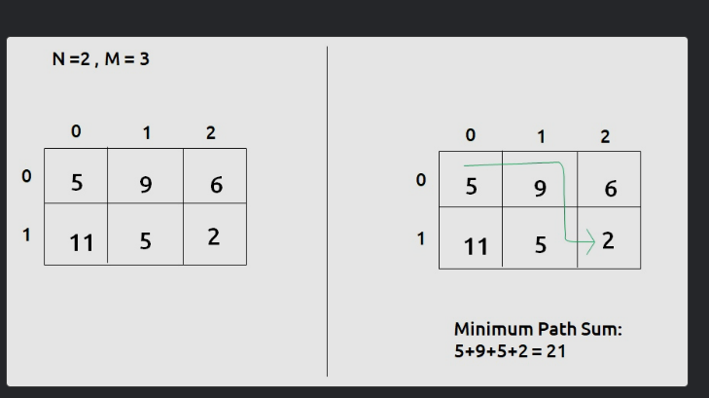

- Recap: Min sum from (0,0) to (m-1,n-1).
- Recurrence: f(i,j) = grid[i][j] + min(f(i-1,j), f(i,j-1))
- Start index: (m-1, n-1)
- Base case: (0,0) → grid[0][0]
- Trick: Same as Q8 but min cost.
- Short note: Path sum minimization.
- Code:
int f(int i,int j,vector<vector<int>>&dp,vector<vector<int>>&g){
if(i==0 && j==0) return g[0][0];
if(i<0 || j<0) return INT_MAX;
if(dp[i][j]!=-1) return dp[i][j];
return dp[i][j]=g[i][j]+min(f(i-1,j,dp,g),f(i,j-1,dp,g));
}

Minimum path sum in Triangular Grid (DP 11)

We are given a Triangular matrix. We need to find the minimum path sum from the first row to the last row.
At every cell we can move in only two directions: either to the bottom cell (↓) or to the bottom-right cell(↘)
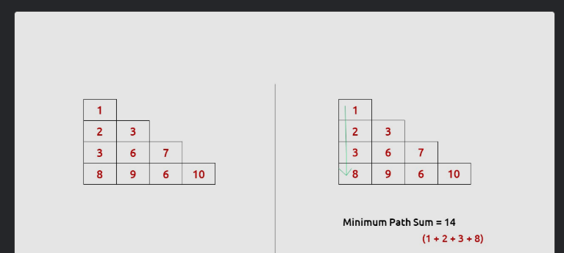

- Recap: Min path sum from top to bottom of triangle.
- Recurrence: f(i,j) = tri[i][j] + min(f(i+1,j), f(i+1,j+1))
- Start index: (0,0) → start at top.
- Base case: i==n-1 → tri[i][j]
- Trick: Down and down-right moves.
- Short note: Bottom-to-top DP.
int f(int i,int j,vector<vector<int>>&t,vector<vector<int>>&dp){
if(i==t.size()-1) return t[i][j];
if(dp[i][j]!=-1) return dp[i][j];
return dp[i][j]=t[i][j]+min(f(i+1,j,t,dp),f(i+1,j+1,t,dp));
}

Minimum/Maximum Falling Path Sum (DP-12)

We are given an ‘N*M’ matrix. We need to find the maximum path sum from any cell of the first row to any cell of the last row.
At every cell we can move in three directions: to the bottom cell (↓), to the bottom-right cell(↘), or to the bottom-left cell(↙).

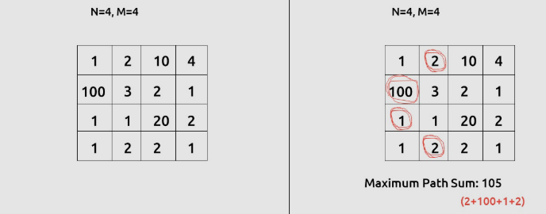

- Recap: Min/max path sum from any top cell to bottom.
- Recurrence: f(i,j) = grid[i][j] + min/max(f(i+1, j-1..j+1))
- Start index: (0, col) → try all top cells.
- Base case: i==m-1 → grid[i][j]
- Trick: Consider 3 possible moves down.
- Short note: Grid fall with diagonal.
int f(int i,int j,vector<vector<int>>&g,vector<vector<int>>&dp){
if(j<0||j>=g[0].size()) return 1e9;
if(i==g.size()-1) return g[i][j];
if(dp[i][j]!=-1) return dp[i][j];
int d=g[i][j]+f(i+1,j,g,dp);
int dl=g[i][j]+f(i+1,j-1,g,dp);
int dr=g[i][j]+f(i+1,j+1,g,dp);
return dp[i][j]=min({d,dl,dr});
}

Ninja and his friends (DP-13)

We are given an ‘N*M’ matrix. Every cell of the matrix has some chocolates on it, mat[i][j] gives us the number of chocolates. We have two friends ‘Alice’ and ‘Bob’. initially, Alice is standing on the cell(0,0) and Bob is standing on the cell(0, M-1). Both of them can move only to the cells below them in these three directions: to the bottom cell (↓), to the bottom-right cell(↘), or to the bottom-left cell(↙).
When Alica and Bob visit a cell, they take all the chocolates from that cell with them. It can happen that they visit the same cell, in that case, the chocolates need to be considered only once.
They cannot go out of the boundary of the given matrix, we need to return the maximum number of chocolates that Bob and Alice can together collect.
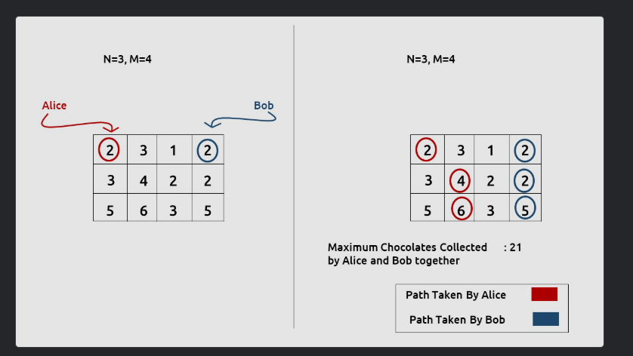

- Recap: Max cherries for 2 robots from top to bottom.
- Recurrence:
- f(i,j1,j2) = grid[i][j1]+(j1!=j2?grid[i][j2]:0)
- + max over dj1,dj2 ∈ {-1,0,1} f(i+1,j1+dj1,j2+dj2)
- Start index: (0,0,m-1) → robots start ends.
- Base case: i==n-1 → cherries in last row.
- Trick: Triple DP states.
- Short note: 3D DP problem.
int f(int i,int j1,int j2,vector<vector<int>>&g,vector<vector<vector<int>>>&dp){
if(j1<0||j2<0||j1>=g[0].size()||j2>=g[0].size()) return -1e9;
if(i==g.size()-1) return j1==j2?g[i][j1]:g[i][j1]+g[i][j2];
if(dp[i][j1][j2]!=-1) return dp[i][j1][j2];
int mx=-1e9;
for(int dj1=-1;dj1<=1;dj1++)
for(int dj2=-1;dj2<=1;dj2++)
mx=max(mx,f(i+1,j1+dj1,j2+dj2,g,dp));
int cur=g[i][j1]+(j1!=j2?g[i][j2]:0);
return dp[i][j1][j2]=cur+mx;
}
Subset sum equal to target (DP- 14)

We are given an array ‘ARR’ with N positive integers. We need to find if there is a subset in “ARR” with a sum equal to K. If there is, return true else return false

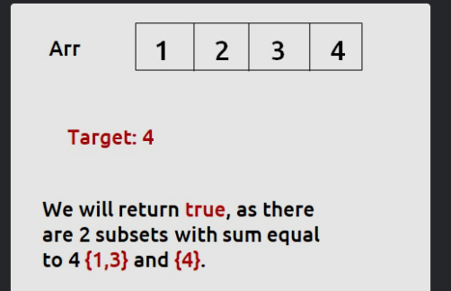

- Recap: Check if subset sum == target exists.
- Recurrence: f(i,t) = f(i-1,t) || f(i-1,t-a[i])
- Start index: (n-1, target)
- Base case: t==0 → true; i==0 → a[0]==t
- Trick: Yes/No subset DP.
- Short note: Intro to subset DP.
bool f(int i,int t,vector<int>&a,vector<vector<int>>&dp){
if(t==0) return 1;
if(i==0) return a[0]==t;
if(dp[i][t]!=-1) return dp[i][t];
bool nt=f(i-1,t,a,dp);
bool tk=false; if(a[i]<=t) tk=f(i-1,t-a[i],a,dp);
return dp[i][t]=tk||nt;
}

Partition Equal Subset Sum (DP- 15)

We are given an array ‘ARR’ with N positive integers. We need to find if we can partition the array into two subsets such that the sum of elements of each subset is equal to the other.
If we can partition, return true else return false.
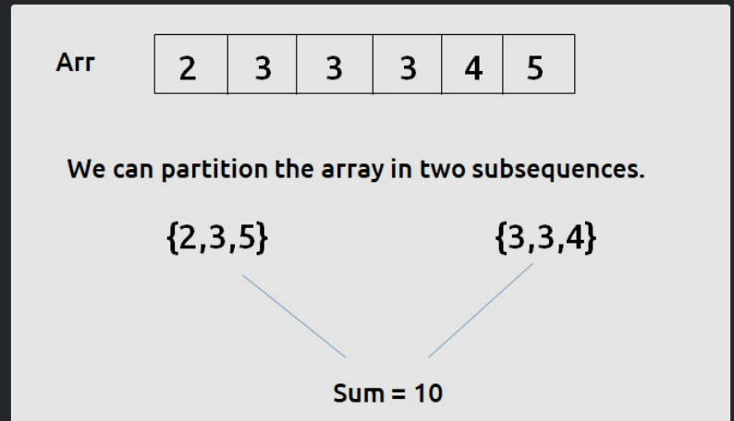

- Recap: Can array be split into 2 equal sums?
- Recurrence: Reduce to Q14 with target=total/2.
- Start index: (n-1, sum/2)
- Base case: Same as Q14.
- Trick: Transform to subset sum.
- Short note: Equal halves check.
bool canPartition(vector<int>&a){
int sum=accumulate(a.begin(),a.end(),0);
if(sum%2) return false;
vector<vector<int>>dp(a.size(),vector<int>(sum/2+1,-1));
return f(a.size()-1,sum/2,a,dp);
}

Partition Set Into 2 Subsets With Min Absolute Sum Diff (DP- 16)

We are given an array ‘ARR’ with N positive integers. We need to partition the array into two subsets such that the absolute difference of the sum of elements of the subsets is minimum.
We need to return only the minimum absolute difference of the sum of elements of the two partitions.
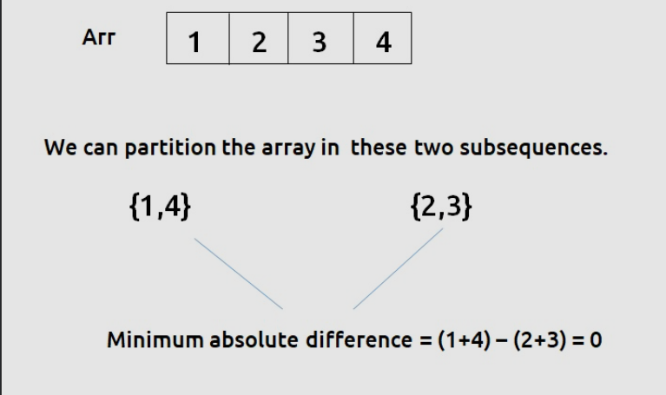

- Recap: Min |sum1-sum2| possible.
- Recurrence: Compute all subset sums ≤ total/2, find min diff.
- Start index: (n-1, target)
- Base case: Same as Q14.
- Trick: Subset sum table then diff calc.
- Short note: Balance two groups.
int minDiff(vector<int>&a){
int sum=accumulate(a.begin(),a.end(),0);
vector<vector<int>>dp(a.size(),vector<int>(sum+1,-1));
f(a.size()-1,sum,a,dp); // fill table
int mn=1e9;
for(int s=0;s<=sum/2;s++) if(dp[n-1][s]) mn=min(mn,sum-2*s);
return mn;
}
Count Subsets with Sum K (DP - 17)

We are given an array ‘ARR’ with N positive integers and an integer K. We need to find the number of subsets whose sum is equal to K.

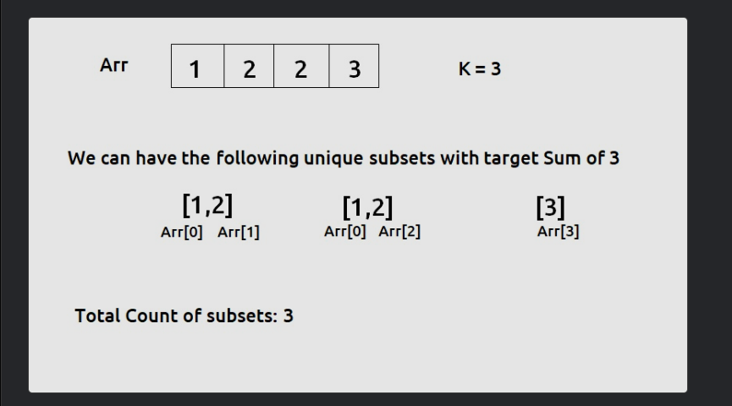
- Recap: Count subsets sum==K.
- Recurrence: f(i,t) = f(i-1,t) + f(i-1,t-a[i])
- Start index: (n-1, K)
- Base case: If t==0 → 1; if i==0 → (a[0]==t)
- Trick: Counting not just exist.
- Short note: Combinatorics DP.
int f(int i,int t,vector<int>&a,vector<vector<int>>&dp){
if(t==0) return 1;
if(i==0) return a[0]==t;
if(dp[i][t]!=-1) return dp[i][t];
int nt=f(i-1,t,a,dp);
int tk=0; if(a[i]<=t) tk=f(i-1,t-a[i],a,dp);
return dp[i][t]=tk+nt;
}

Count Partitions with Given Difference (DP - 18)

In the problem Count Subsets with Sum K, the problem constraints stated that an array element is greater than 0, so the code we have written there works perfectly for the given constraints.
If the constraints mentioned that an array element can also be equal to 0 and the target sum can also be 0, then that code will fail. To understand it we will take an example:
Let the target arr = [0,0,1] and the target = 1.
The previous code will give us the answer 1 as it first takes the element arr[2] and then finds the answer by picking it. Then from the base condition, we will return 0 ( as the target will become 0 by picking 1). But for this question, the answer will be 4 with the following subsets({0,1},{0,1},{0,0,1} and {1}).
int findWaysUtil(int ind, int target, vector<int>& arr, vector<vector<int>> &dp){

if(ind == 0){
if(target==0 && arr[0]==0)
return 2;
if(target==0 || target == arr[0])
return 1;
return 0;
}

if(dp[ind][target]!=-1)
return dp[ind][target];

int notTaken = findWaysUtil(ind-1,target,arr,dp);

int taken = 0;
if(arr[ind]<=target)
taken = findWaysUtil(ind-1,target-arr[ind],arr,dp);

return dp[ind][target]= notTaken + taken;
}
DP 19. 0-1 Knapsack
- Recap: Max value with weight ≤ capacity.
- Recurrence: f(i,W) = max(val[i]+f(i-1,W-wt[i]), f(i-1,W))
- Start index: (n-1, W)
- Base case: i==0 → if wt[0]≤W return val[0] else 0
- Trick: Classic knapsack.
- Short note: Weight constraint DP.
int f(int i,int W,vector<int>&wt,vector<int>&val,vector<vector<int>>&dp){
if(i==0) return wt[0]<=W?val[0]:0;
if(dp[i][W]!=-1) return dp[i][W];
int nt=f(i-1,W,wt,val,dp);
int tk=-1e9; if(wt[i]<=W) tk=val[i]+f(i-1,W-wt[i],wt,val,dp);
return dp[i][W]=max(tk,nt);
}

Minimum Coins (DP - 20)

We are given a target sum of ‘X’ and ‘N’ distinct numbers denoting the coin denominations. We need to tell the minimum number of coins required to reach the target sum. We can pick a coin denomination for any number of times we want.

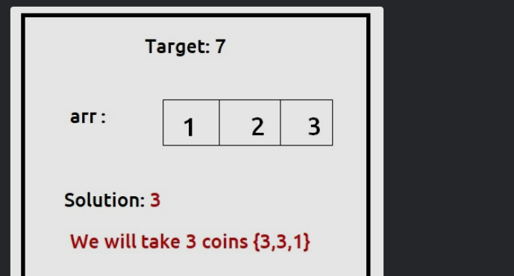

DP 20. Minimum Coins
- Recap: Min coins to form sum target (infinite coins allowed).
- Recurrence: f(i,t) = min(1+f(i,t-coin[i]), f(i-1,t))
- Start index: (n-1, target)
- Base case: i==0 → if t%coin[0]==0 return t/coin[0] else INF
- Trick: Unbounded knapsack min mode.
- Short note: Coin change min.
int f(int i,int t,vector<int>&c,vector<vector<int>>&dp){
if(i==0) return (t%c[0]==0)?t/c[0]:1e9;
if(dp[i][t]!=-1) return dp[i][t];
int nt=f(i-1,t,c,dp);
int tk=1e9; if(c[i]<=t) tk=1+f(i,t-c[i],c,dp);
return dp[i][t]=min(tk,nt);
}

Target Sum (DP - 21)

We are given an array ‘ARR’ of size ‘N’ and a number ‘Target’. Our task is to build an expression from the given array where we can place a ‘+’ or ‘-’ sign in front of an integer. We want to place a sign in front of every integer of the array and get our required target. We need to count the number of ways in which we can achieve our required target.
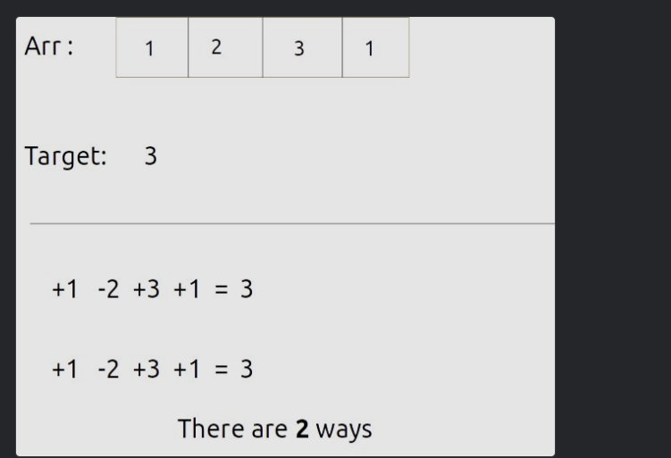

- If we think deeper, we can say that the given ‘target’ can be expressed as addition of two integers (say S1 and S2).
S1 + S2 = target – (i)
- Now, from where will this S1 and S2 come? If we are given the array as [a,b,c,d,e], we want to place ‘+’ or ‘-’ signs in front of every array element and then add it. One example is :
+a-b-c+d+e which can be written as (+a+d+e) + (-b-c).
Therefore, we can say that S1=(+a+d+e) and S2=(-b-c) for this example.
- If we calculate the total sum of elements of the array (say totSum), we can can say that,
S1 = totSum - S2 – (ii)
- Now solving for equations (i) and (iii), we can say that
S2 = (totSum - target)/2 – (iv)
Therefore this question is modified to “Count Number of subsets with sum (totSum - target)/2 ”. This is exactly what we had discussed in the article Count Subsets with Sum K.

#include <bits/stdc++.h>
using namespace std;

// Function to count partitions of the array into subsets with a given target sum
int countPartitionsUtil(int ind, int target, vector<int>& arr, vector<vector<int>>& dp) {
// Base cases
if (ind == 0) {
if (target == 0 && arr[0] == 0)
return 2; // Two ways to partition: include or exclude the element
if (target == 0 || target == arr[0])
return 1; // One way to partition: include or exclude the element
return 0; // No way to partition
}

// If the result for this index and target sum is already calculated, return it
if (dp[ind][target] != -1)
return dp[ind][target];

// Calculate the number of ways without taking the current element
int notTaken = countPartitionsUtil(ind - 1, target, arr, dp);

// Calculate the number of ways by taking the current element
int taken = 0;
if (arr[ind] <= target)
taken = countPartitionsUtil(ind - 1, target - arr[ind], arr, dp);

// Store the sum of ways in the DP array and return it
return dp[ind][target] = (notTaken + taken);
}

// Function to count the number of ways to achieve the target sum
int targetSum(int n, int target, vector<int>& arr) {
int totSum = 0;
for (int i = 0; i < arr.size(); i++) {
totSum += arr[i];
}

// Checking for edge cases
if (totSum - target < 0)
return 0; // Not possible to achieve the target sum
if ((totSum - target) % 2 == 1)
return 0; // The difference between the total sum and target sum must be even

int s2 = (totSum - target) / 2; // Calculate the required sum for each subset

vector<vector<int>> dp(n, vector<int>(s2 + 1, -1)); // Initialize DP table
return countPartitionsUtil(n - 1, s2, arr, dp); // Call the helper function
}

int main() {
vector<int> arr = {1, 2, 3, 1};
int target = 3;

int n = arr.size();
cout << "The number of ways found is " << targetSum(n, target, arr) << endl;

return 0; // Return 0 to indicate successful program execution
}

Coin Change 2 (DP - 22)

We are given an array Arr with N distinct coins and a target. We have an infinite supply of each coin denomination. We need to find the number of ways we sum up the coin values to give us the target.
Each coin can be used any number of times.
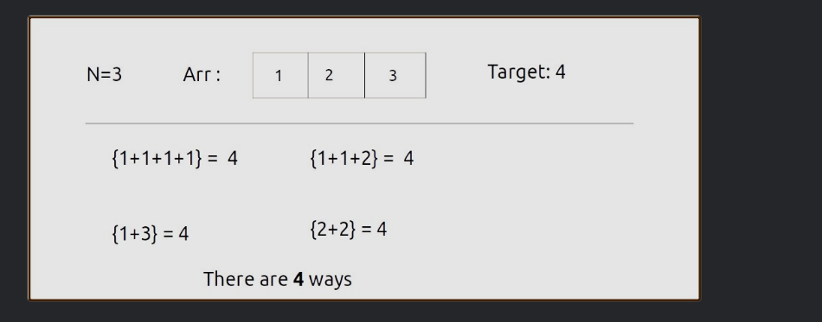

Desc: Count ways to make amount with infinite coins (order doesn’t matter).
Recurrence: ways(i,t) = ways(i-1,t) + ways(i, t - coin[i])
Start: (n-1, amount) — try last coin or move left.
Base: i==0 → (t % coin[0] == 0).
Trick: “Stay on same i when you take” = unbounded.
Mini note: Distinct combinations, not permutations.
long long f(int i,int t,vector<int>&c,vector<vector<long long>>&dp){
if(i==0) return (t % c[0] == 0);
if(dp[i][t]!=-1) return dp[i][t];
long long notTake=f(i-1,t,c,dp);
long long take=(c[i]<=t)?f(i,t-c[i],c,dp):0;
return dp[i][t]=take+notTake;
}
long long change(int amount, vector<int>&coins){
int n=coins.size(); vector<vector<long long>>dp(n,vector<long long>(amount+1,-1));
return f(n-1,amount,coins,dp);
}
Variations/Pitfalls: If order matters → different recurrence (permutation DP)
Unbounded Knapsack (DP-23)

A thief wants to rob a store. He is carrying a bag of capacity W. The store has ‘n’ items of infinite supply. Its weight is given by the ‘wt’ array and its value by the ‘val’ array. He can either include an item in its knapsack or exclude it but can’t partially have it as a fraction. We need to find the maximum value of items that the thief can steal. He can take a single item any number of times he wants and put it in his knapsack.

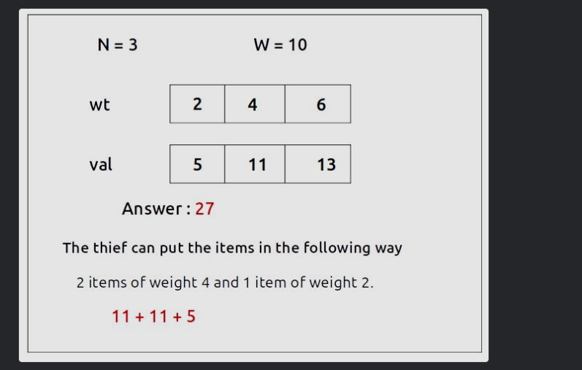

Desc: Maximize value with capacity W, infinite copies allowed.
Recurrence: val(i,W) = max( val(i-1,W), val[i] + val(i, W - wt[i]) )
Start: (n-1, W) — choose item i repeatedly.
Base: i==0 → (W / wt[0]) * val[0].
Trick: Taking keeps i same (unbounded).
Mini note: Identical to rod cutting pattern.
int f(int i,int W,vector<int>&wt,vector<int>&val,vector<vector<int>>&dp){
if(i==0) return (W/wt[0])*val[0];
if(dp[i][W]!=-1) return dp[i][W];
int notTake=f(i-1,W,wt,val,dp);
int take=(wt[i]<=W)? val[i]+f(i,W-wt[i],wt,val,dp) : INT_MIN/2;
return dp[i][W]=max(take,notTake);
}
Variations/Pitfalls: Don’t accidentally move to i-1 in take step.
Rod Cutting Problem | (DP - 24)

We are given a rod of size ‘N’. It can be cut into pieces. Each length of a piece has a particular price given by the price array. Our task is to find the maximum revenue that can be generated by selling the rod after cutting( if required) into pieces.
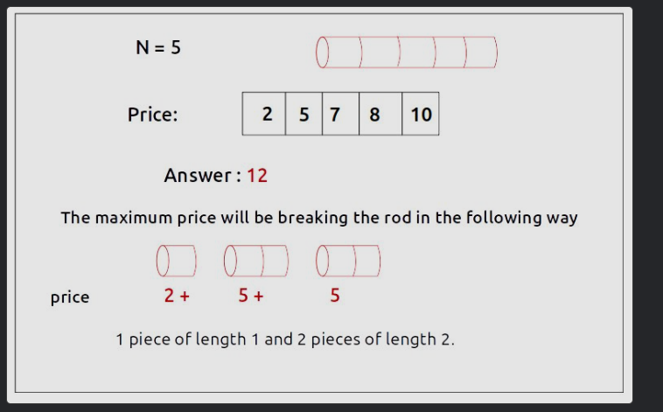

Desc: Price of piece length i+1 given; max revenue cutting rod of length L.
Recurrence: best(i,L) = max( best(i-1,L), price[i] + best(i, L-(i+1)) )
Start: (n-1, L) — last length or shorter lengths.
Base: i==0 → L * price[0] (pieces of length 1).
Trick: Pure unbounded knapsack with len=i+1.
Mini note: Length index ↔ price index aligned.
int f(int i,int L,vector<int>&price,vector<vector<int>>&dp){
if(i==0) return L*price[0];
if(dp[i][L]!=-1) return dp[i][L];
int notTake=f(i-1,L,price,dp);
int take=(i+1<=L)? price[i]+f(i, L-(i+1), price, dp) : INT_MIN/2;
return dp[i][L]=max(take,notTake);
}
Variations/Pitfalls: Ensure indices map len=i+1.
Longest Common Subsequence | (DP - 25)

Now we will look at “Longest Common Subsequence”. The longest Common Subsequence is defined for two strings. It is the common subsequence that has the greatest length.

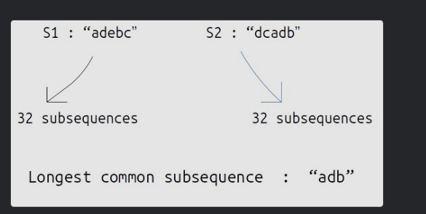

Desc: Max length subsequence common to both strings.
Recurrence:
If a[i]==b[j]: 1 + f(i-1,j-1) else max(f(i-1,j), f(i,j-1))
Start: (n-1, m-1) — comparing suffixes.
Base: i<0 || j<0 → 0.
Trick: “Match → diag; else skip one”.
Mini note: Backbone for many string DPs.
int f(int i,int j,string& a,string& b,vector<vector<int>>&dp){
if(i<0||j<0) return 0;
if(dp[i][j]!=-1) return dp[i][j];
if(a[i]==b[j]) return dp[i][j]=1+f(i-1,j-1,a,b,dp);
return dp[i][j]=max(f(i-1,j,a,b,dp), f(i,j-1,a,b,dp));
}
Variations/Pitfalls: Use 0-based or 1-based consistently; printing needs reconstruction.
Print Longest Common Subsequence | (DP - 26)

Desc: Recover one LCS string.
Idea: Use LCS length dp (above), then reconstruct by moving where dp doesn’t drop.
Start: (n-1,m-1); Base: out-of-range → "".
Trick: If chars match → take and go diag; else move to side with larger dp.
Mini note: Build string in reverse recursion.
int lcsLen(int i,int j,string& a,string& b,vector<vector<int>>&dp){
if(i<0||j<0) return 0;
if(dp[i][j]!=-1) return dp[i][j];
if(a[i]==b[j]) return dp[i][j]=1+lcsLen(i-1,j-1,a,b,dp);
return dp[i][j]=max(lcsLen(i-1,j,a,b,dp), lcsLen(i,j-1,a,b,dp));
}
string build(int i,int j,string& a,string& b,vector<vector<int>>&dp){
if(i<0||j<0) return "";
if(a[i]==b[j]) return build(i-1,j-1,a,b,dp)+a[i];
int up = (i>0)?dp[i-1][j]:0, left=(j>0)?dp[i][j-1]:0;
if(up>=left) return build(i-1,j,a,b,dp);
else return build(i,j-1,a,b,dp);
}
Variations/Pitfalls: Multiple LCS exist; this returns one.
Longest Common Substring | (DP - 27)

A substring of a string is a subsequence in which all the characters are consecutive. Given two strings, we need to find the longest common substring.
We need to print the length of the longest common substring.
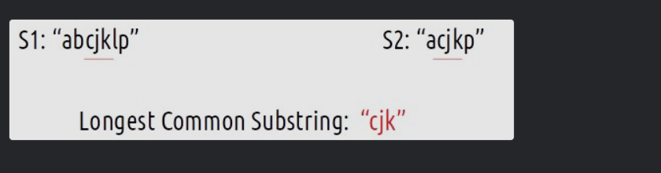

Desc: Max length of contiguous common substring.
Recurrence: If match: 1 + f(i-1,j-1) else 0. Keep global max over all (i,j).
Start: Evaluate all (i,j) ends.
Base: i<0 || j<0 → 0.
Trick: On mismatch, reset to 0 (unlike LCS).
Mini note: “Substring = reset on break”.
int g(int i,int j,string& a,string& b,vector<vector<int>>&dp){
if(i<0||j<0) return 0;
if(dp[i][j]!=-1) return dp[i][j];
if(a[i]==b[j]) return dp[i][j]=1+g(i-1,j-1,a,b,dp);
return dp[i][j]=0;
}
int longestCommonSubstring(string a,string b){
int n=a.size(),m=b.size(),ans=0;
vector<vector<int>>dp(n,vector<int>(m,-1));
for(int i=0;i<n;i++) for(int j=0;j<m;j++) ans=max(ans,g(i,j,a,b,dp));
return ans;
}
Variations/Pitfalls: Printing substring is easy with tabulation, trickier top-down
string longestCommonSubstring(string a, string b) {
int n = a.size(), m = b.size();
vector<vector<int>> dp(n+1, vector<int>(m+1, 0));

int maxLen = 0;
int endIdx = -1; // end index in 'a'

for(int i = 1; i <= n; i++) {
for(int j = 1; j <= m; j++) {
if(a[i-1] == b[j-1]) {
dp[i][j] = 1 + dp[i-1][j-1];
if(dp[i][j] > maxLen) {
maxLen = dp[i][j];
endIdx = i-1; // store last matched index
}
} else {
dp[i][j] = 0; // reset
}
}
}

if(maxLen == 0) return ""; // no common substring
return a.substr(endIdx - maxLen + 1, maxLen);
}

Longest Palindromic Subsequence | (DP-28)
A palindromic string is a string that is equal to its reverse. For example: “Nitin” is a palindromic string. Now the question states to find the length of the longest palindromic subsequence of a string. It is that palindromic subsequence of the given string with the greatest length. We need to print the length of the longest palindromic subsequence



Desc: Max length palindromic subsequence in s.
Recurrence:
If s[i]==s[j]: 2 + f(i+1,j-1) else max(f(i+1,j), f(i,j-1))
Start: (0, n-1) — span of string.
Base: i>j → 0, i==j → 1.
Trick: Two-pointer on string range.
Mini note: Also equal to LCS(s, reverse(s)).
int f(int i,int j,string& s,vector<vector<int>>&dp){
if(i>j) return 0;
if(i==j) return 1;
if(dp[i][j]!=-1) return dp[i][j];
if(s[i]==s[j]) return dp[i][j]=2+f(i+1,j-1,s,dp);
return dp[i][j]=max(f(i+1,j,s,dp), f(i,j-1,s,dp));
}
Variations/Pitfalls: For building LPS string, reconstruct like LCS on (i,j).
Minimum insertions to make string palindrome | DP-29

A palindromic string is a string that is the same as its reverse. For example: “nitin” is a palindromic string. Now the question states that we are given a string, we need to find the minimum insertions that we can make in that string to make it a palindrome

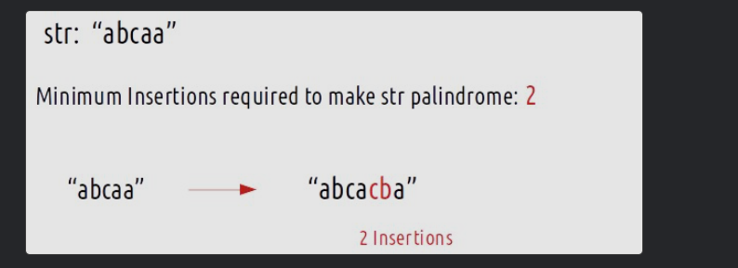

Desc: Fewest insertions to make s a palindrome.
Formula: ans = n - LPS(s).
Start/Base/Trick: Use DP28 LPS.
Mini note: Insertions compensate for chars not in LPS.
int minInsertionsPalindrome(string s){
int n=s.size(); vector<vector<int>>dp(n,vector<int>(n,-1));
auto LPS = f(0,n-1,s,dp); // from DP28
return n - LPS;
}
Variations/Pitfalls: If asked min deletions → same value.
Minimum Insertions/Deletions to Convert String | (DP- 30)

e are given two strings, str1 and str2. We are allowed the following operations:
- Delete any number of characters from string str1.
- Insert any number of characters in string str1.
We need to tell the minimum operations required to convert str1 to str2.
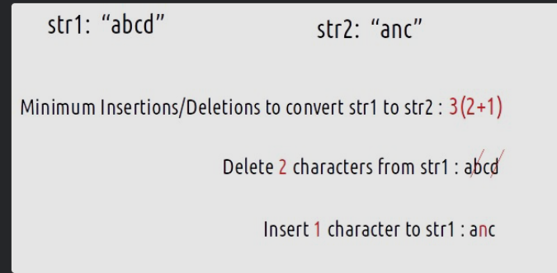

Desc: Convert A to B with min insertions+deletions.
Formula: L = LCS(A,B); deletions = |A|-L, insertions = |B|-L.
Start/Base: LCS (DP25).
Trick: Edits = align to LCS.
Mini note: Replace = delete+insert; we count separately.
int lcsLen2(int i,int j,string& a,string& b,vector<vector<int>>&dp){
if(i<0||j<0) return 0;
if(dp[i][j]!=-1) return dp[i][j];
if(a[i]==b[j]) return dp[i][j]=1+lcsLen2(i-1,j-1,a,b,dp);
return dp[i][j]=max(lcsLen2(i-1,j,a,b,dp), lcsLen2(i,j-1,a,b,dp));
}
pair<int,int> minInsDel(string A,string B){
int n=A.size(), m=B.size();
vector<vector<int>>dp(n,vector<int>(m,-1));
int L=lcsLen2(n-1,m-1,A,B,dp);
return {n-L, m-L}; // {deletions, insertions}
}
Variations/Pitfalls: If asked edit distance (DP33) → different DP (costs 1/insert/delete/replace).

Quick “pattern reflex” (step-by-step) for these 10
- Signs/Partitions/Counts? → reduce to subset sum (DP21,18,17,15,16).
- Infinite supply? → keep index on take (DP22,23,24,20).
- Two strings subsequence? → LCS skeleton (DP25/26, 30).
- Substring (contiguous)? → reset to 0 on mismatch (DP27).
- Palindrome ops? → via LPS (DP28,29).

DP 31 — Shortest Common Supersequence (SCS)
Problem (short): Given strings A and B, return the shortest string that has both A and B as subsequences (often asked for length or actual string).
Example: A="abac", B="cab" → one SCS = "cabac" (length 5).
Recurrence (length):
if A[i]==B[j]: scs(i,j) = 1 + scs(i-1,j-1)
else scs(i,j) = 1 + min( scs(i-1,j), scs(i,j-1) )
Start index & why: (n-1, m-1) — we define scs length ending at those indices.
Base case: if i<0 return j+1 (need to add remaining B chars); if j<0 return i+1.
Trick: like LCS but you count the added character (so +1 every step).
Mini note: len(SCS) = n + m - LCS.
Short memo code (length + reconstruct):
// length
int scsLen(int i,int j,string &A,string &B, vector<vector<int>>&dp){
if(i<0) return j+1; if(j<0) return i+1;
if(dp[i][j]!=-1) return dp[i][j];
if(A[i]==B[j]) return dp[i][j]=1+scsLen(i-1,j-1,A,B,dp);
return dp[i][j]=1+min(scsLen(i-1,j,A,B,dp), scsLen(i,j-1,A,B,dp));
}
// reconstruct one SCS
string buildSCS(string A,string B){
int n=A.size(), m=B.size();
vector<vector<int>> dp(n, vector<int>(m,-1));
scsLen(n-1,m-1,A,B,dp);
int i=n-1,j=m-1; string ans="";
while(i>=0 && j>=0){
if(A[i]==B[j]){ ans.push_back(A[i]); i--; j--; }
else if(dp[i-1<0?0:i-1][j] < dp[i][j-1<0?0:j-1]){ ans.push_back(A[i]); i--; }
else { ans.push_back(B[j]); j--; }
}
while(i>=0) ans.push_back(A[i--]);
while(j>=0) ans.push_back(B[j--]);
reverse(ans.begin(), ans.end());
return ans;
}
Example: A="abac", B="cab" → buildSCS(...) returns "cabac" (or any valid SCS)
Variations / pitfalls: easier compute length using n+m-LCS. Reconstruction is fiddly — prefer table (bottom-up) for robust trace.

DP 32 — Distinct Subsequences
Problem: Count distinct ways string S can form string T as a subsequence.
Example: S="rabbbit", T="rabbit" → output 3.
Recurrence:
if S[i]==T[j]: ways(i,j) = ways(i-1,j-1) + ways(i-1,j)
else ways(i,j) = ways(i-1,j)
Start index & why: (n-1, m-1). We consider prefixes/suffixes.
Base case: if j<0 => 1 (T formed); if i<0 => 0 (S exhausted).
Trick: choose match (use it) or skip.
Mini note: counts grow large → use long long or mod.
Short memo code:
using ll = long long;
ll f(int i,int j,string &S,string &T, vector<vector<ll>>&dp){
if(j<0) return 1;
if(i<0) return 0;
if(dp[i][j]!=-1) return dp[i][j];
ll ans = f(i-1,j,S,T,dp);
if(S[i]==T[j]) ans += f(i-1,j-1,S,T,dp);
return dp[i][j]=ans;
}
ll numDistinct(string S,string T){
int n=S.size(), m=T.size();
vector<vector<ll>> dp(n, vector<ll>(m, -1));
return f(n-1,m-1,S,T,dp);
}
Example: numDistinct("rabbbit","rabbit") → 3
Variations/pitfalls: zeros and empty target: T=="" → 1. For huge counts use modulo.

DP 33 — Edit Distance (Levenshtein)
Problem: Min operations (insert/delete/replace) to convert word1 → word2.
Example: word1="horse", word2="ros" → output 3.
Recurrence:
if A[i]==B[j]: dp(i,j)=dp(i-1,j-1)
else dp(i,j)=1+min( dp(i-1,j-1) /*replace*/, dp(i,j-1) /*insert*/, dp(i-1,j) /*delete*/ )
Start index & why: (n-1,m-1) comparing suffixes.
Base case: if i<0 return j+1 (need j+1 inserts); if j<0 return i+1 (deletes).
Trick: think in reverse: insert in A ~ delete in B etc.
Mini note: classic dynamic programming with three operations.
Short memo code:
int ed(int i,int j,string &A,string &B, vector<vector<int>>&dp){
if(i<0) return j+1; if(j<0) return i+1;
if(dp[i][j]!=-1) return dp[i][j];
if(A[i]==B[j]) return dp[i][j]=ed(i-1,j-1,A,B,dp);
int rep = ed(i-1,j-1,A,B,dp);
int ins = ed(i,j-1,A,B,dp);
int del = ed(i-1,j,A,B,dp);
return dp[i][j]=1+min(rep, min(ins,del));
}
int minDistance(string A,string B){
int n=A.size(), m=B.size();
vector<vector<int>>dp(n, vector<int>(m,-1));
return ed(n-1,m-1,A,B,dp);
}
Example: minDistance("horse","ros") → 3
Variations/pitfalls: replace vs insert/delete symmetry; bottom-up reduces recursion depth.

DP 34 — Wildcard Matching
Problem: Given s and pattern p with ? (one char) and * (any sequence, incl empty), decide if p matches whole s.
Examples:
- s="aa", p="a" → false
- s="aa", p="*" → true
- s="adceb", p="*a*b" → true
Recurrence:
if p[j]==s[i] or p[j]=='?': f(i,j)=f(i-1,j-1)
else if p[j]=='*': f(i,j)= f(i-1,j) /*star matches s[i]*/ OR f(i,j-1) /*star is empty*/
else false
Start index & why: (n-1,m-1) comparing ends.
Base case: both exhausted -> true. If j<0 and i>=0 -> false. If i<0 -> true only if all remaining p[0..j] are *.
Trick: * can be empty or take a character.
Mini note: careful with leading *s; use memo to avoid TLE.
Short memo code:
int f(int i,int j,string &s,string &p, vector<vector<int>>&dp){
if(i<0 && j<0) return 1;
if(j<0) return 0;
if(i<0){
for(int k=0;k<=j;k++) if(p[k]!='*') return 0;
return 1;
}
if(dp[i][j]!=-1) return dp[i][j];
if(p[j]=='?' || p[j]==s[i]) return dp[i][j]=f(i-1,j-1,s,p,dp);
if(p[j]=='*') return dp[i][j]= (f(i-1,j,s,p,dp) || f(i,j-1,s,p,dp));
return dp[i][j]=0;
}
bool isMatch(string s,string p){
int n=s.size(), m=p.size();
vector<vector<int>> dp(n, vector<int>(m,-1));
return f(n-1,m-1,s,p,dp);
}
Example: isMatch("adceb","*a*b") → true
Variations/pitfalls: naive recursion TLE; memo is necessary; iterative DP with careful initialization is common.

DP 35 — Best Time to Buy and Sell Stock I (one transaction)
Problem: Given prices array, choose one buy and one later sell to maximize profit.
Example: [7,1,5,3,6,4] → 5 (buy at 1 sell at 6).
Approach / Recurrence (greedy scan):
maxProfit = max(maxProfit, price[i] - minPriceSoFar)
Start index & why: single pass (0→n-1). Not really overlapping-subproblem DP; best as O(n) scan.
Base case: minPrice = prices[0], maxProfit=0.
Trick: minimum buy price seen so far.
Mini note: simple linear time.
Short code (canonical):
int maxProfit1(vector<int>&p){
int n=p.size();
int minP=1e9, ans=0;
for(int x:p){ minP=min(minP,x); ans=max(ans,x-minP); }
return ans;
}
Example: [7,1,5,3,6,4] → 5
Variations/pitfalls: if negative prices or no profit -> 0.

DP 36 — Best Time to Buy and Sell Stock II (unlimited transactions)
Problem: Max profit with as many transactions as you like (but cannot hold >1 share at a time).
Example: [7,1,5,3,6,4] → 7 (sum of positive diffs: (5-1)+(6-3)=7).
Recurrence (DP form):
Let f(i, holding) = best profit from day i with holding(0/1).
if holding==0: f(i,0)=max(f(i+1,0), -price[i] + f(i+1,1))
else: f(i,1)=max(f(i+1,1), price[i] + f(i+1,0))
Start index & why: i=0 to n-1.
Base case: i==n → 0.
Trick: Equivalent to summing all max(0, price[i+1]-price[i]).
Mini note: greedy simpler than DP.
Short memo code (DP/recursion):
int f(int i,int hold,vector<int>&p,vector<vector<int>>&dp){
if(i==p.size()) return 0;
if(dp[i][hold]!=-1) return dp[i][hold];
int res;
if(hold==0) res=max(f(i+1,0,p,dp), -p[i]+f(i+1,1,p,dp));
else res=max(f(i+1,1,p,dp), p[i]+f(i+1,0,p,dp));
return dp[i][hold]=res;
}
int maxProfit2(vector<int>&prices){
int n=prices.size(); vector<vector<int>>dp(n,vector<int>(2,-1));
return f(0,0,prices,dp);
}
Greedy: sum += max(0, prices[i+1]-prices[i]).
Example: [7,1,5,3,6,4] → 7
Variations/pitfalls: DP useful when adding constraints (cooldown, fee, k-transactions).

DP 37 — Best Time to Buy and Sell Stock III (at most 2 transactions)
Problem: Max profit with at most 2 transactions.
Example: [3,3,5,0,0,3,1,4] → 6 (buy0 sell5 profit2 + buy1 sell4 profit4).
Approach (common DP):
Use f(i,k,holding) or split into two passes. Recurrence (memo):
f(i, k, 0) = max( f(i+1,k,0), -price[i]+f(i+1,k,1) )
f(i, k, 1) = max( f(i+1,k,1), price[i]+f(i+1,k-1,0) )
where k is remaining transactions (each sell consumes one). Start k=2.
Start index & why: i=0, k=2, holding=0.
Base case: i==n or k==0 → 0.
Trick: model transactions count as number of sells allowed.
Mini note: can be optimized to O(n) using 4 variables.
Short memo code (recursive):
int f(int i,int k,int hold,vector<int>&p, vector<vector<vector<int>>>&dp){
if(i==p.size()||k==0) return 0;
if(dp[i][k][hold]!=-1) return dp[i][k][hold];
int res;
if(hold==0) res=max(f(i+1,k,0,p,dp), -p[i]+f(i+1,k,1,p,dp));
else res=max(f(i+1,k,1,p,dp), p[i]+f(i+1,k-1,0,p,dp));
return dp[i][k][hold]=res;
}
int maxProfit3(vector<int>&prices){
int n=prices.size(), K=2;
vector<vector<vector<int>>> dp(n, vector<vector<int>>(K+1, vector<int>(2,-1)));
return f(0,K,0,prices,dp);
}
Example: [3,3,5,0,0,3,1,4] → 6
Variations/pitfalls: k=2 special-case has linear O(n) formula using 4 variables (buy1,sell1,buy2,sell2).

DP 38 — Best Time to Buy and Sell Stock IV (at most K transactions)
Problem: Max profit with at most K transactions.
Example: prices=[3,2,6,5,0,3], K=2 → 7.
Approach (DP generalization):
If K >= n/2 reduce to unlimited transactions. Else use:
f(i,k,0) = max( f(i+1,k,0), -price[i]+f(i+1,k,1) )
f(i,k,1) = max( f(i+1,k,1), price[i]+f(i+1,k-1,0) )
Start index & why: i=0, k=K, hold=0.
Base case: i==n or k==0 → 0.
Trick: optimization to O(nK) DP table bottom-up.
Mini note: K large => greedy.
Short memo code (top-down with K):
int f(int i,int k,int hold,vector<int>&p, vector<vector<vector<int>>>&dp){
if(i==p.size()||k==0) return 0;
if(dp[i][k][hold]!=-1) return dp[i][k][hold];
int res;
if(hold==0) res=max(f(i+1,k,0,p,dp), -p[i]+f(i+1,k,1,p,dp));
else res=max(f(i+1,k,1,p,dp), p[i]+f(i+1,k-1,0,p,dp));
return dp[i][k][hold]=res;
}
int maxProfitK(vector<int>&prices,int K){
int n=prices.size();
if(K>=n/2){ int ans=0; for(int i=1;i<n;i++) if(prices[i]>prices[i-1]) ans+=prices[i]-prices[i-1]; return ans; }
vector<vector<vector<int>>> dp(n, vector<vector<int>>(K+1, vector<int>(2,-1)));
return f(0,K,0,prices,dp);
}
Example: maxProfitK([3,2,6,5,0,3],2) → 7
Variations/pitfalls: watch memory O(nK). Use iterative O(Kn) bottom-up for large constraints

DP 39 — Buy and Sell Stocks With Cooldown
Problem: After you sell you have one day cooldown (cannot buy next day). Maximize profit.
Example: [1,2,3,0,2] → 3.
Approach (recurrence with cooldown):
Use f(i, canBuy). If canBuy:
f(i,1) = max( f(i+1,1), -price[i] + f(i+1,0) )
If holding (cannot buy):
f(i,0) = max( f(i+1,0), price[i] + f(i+2,1) ) // sell and skip next day
Start index & why: i=0, canBuy=1.
Base case: i>=n -> 0. If i==n-1 handle boundaries normally (f(i+2,1) returns 0).
Trick: selling leads to i+2 because of cooldown.
Mini note: only small index shift difference vs normal.
Short memo code:
int f(int i,int canBuy, vector<int>&p, vector<vector<int>>&dp){
int n=p.size();
if(i>=n) return 0;
if(dp[i][canBuy]!=-1) return dp[i][canBuy];
int res;
if(canBuy) res = max(f(i+1,1,p,dp), -p[i] + f(i+1,0,p,dp));
else res = max(f(i+1,0,p,dp), p[i] + f(i+2,1,p,dp));
return dp[i][canBuy]=res;
}
int maxProfitCooldown(vector<int>&prices){
int n=prices.size(); vector<vector<int>>dp(n+2,vector<int>(2,-1));
return f(0,1,prices,dp);
}
Example: [1,2,3,0,2] → 3
Variations/pitfalls: converting to iterative uses arrays sell/buy/cool variables.

DP 40 — Buy and Sell with Transaction Fee
Problem: Each time you sell you pay a fee. Maximize profit.
Example: prices=[1,3,2,8,4,9], fee=2 → 8.
Approach (recurrence):
if canBuy: f(i,1)=max( f(i+1,1), -price[i] + f(i+1,0) )
else: f(i,0)=max( f(i+1,0), price[i] - fee + f(i+1,1) )
Start index & why: i=0, canBuy=1.
Base case: i==n -> 0.
Trick: subtract fee on sell.
Mini note: similar to cooldown but fee reduces sell value.
Short memo code:
int f(int i,int canBuy, vector<int>&p, int fee, vector<vector<int>>&dp){
if(i>=p.size()) return 0;
if(dp[i][canBuy]!=-1) return dp[i][canBuy];
int res;
if(canBuy) res=max(f(i+1,1,p,fee,dp), -p[i]+f(i+1,0,p,fee,dp));
else res=max(f(i+1,0,p,fee,dp), p[i]-fee + f(i+1,1,p,fee,dp));
return dp[i][canBuy]=res;
}
int maxProfitFee(vector<int>&prices,int fee){
int n=prices.size(); vector<vector<int>>dp(n,vector<int>(2,-1));
return f(0,1,prices,fee,dp);
}
Example: maxProfitFee([1,3,2,8,4,9], 2) → 8
Variations/pitfalls: Equivalent iterative solution uses two vars buy/sell; fee can be accounted on buy or sell (consistent carefulness).

Quick recap — patterns & how to spot them
- Two-string problems → LCS family: SCS, SCS length, Distinct subsequences, Edit distance, Shortest common supersequence, etc. Use (i,j) state.
- Wildcard → pattern matching: * -> two choices (consume char or skip), ? -> single char.
- Stock family → parameterize with i (day), holding (bool) and k (transactions) or additional shifts for cooldown/fee. If k >= n/2 then reduce to unlimited transactions.
- Convert greedy ↔ DP: some stock problems have simple greedy reductions (I & II); others require DP (k, fee, cooldown).

DP41 Longest Increasing Subsequence (LIS)

Problem
Given an array nums[], find the length of the longest strictly increasing subsequence.
Example: nums = [10,9,2,5,3,7,101,18] → LIS = 4 ([2,3,7,101]).

Recurrence
At index i with prev as previous index:
dp[i][prev+1] = max( take if nums[i]>nums[prev], notTake )
= max(1 + f(i+1,i), f(i+1,prev))

Starting Index & Base Case
- Start i=0, prev=-1 (no element taken yet).
- Base case: if i==n → return 0.

Trick
Think “for every index, I have 2 options: pick if increasing OR skip”.
LIS = recursive binary choice with prev tracking.

Short Note
Subsequence → index + prev DP.

Compressed Memo Code (C++)
int f(int i,int prev,vector<int>&a,vector<vector<int>>&dp){
if(i==a.size()) return 0;
if(dp[i][prev+1]!=-1) return dp[i][prev+1];
int notTake=f(i+1,prev,a,dp);
int take=0;
if(prev==-1 || a[i]>a[prev]) take=1+f(i+1,i,a,dp);
return dp[i][prev+1]=max(take,notTake);
}
int lengthOfLIS(vector<int>&a){
int n=a.size(); vector<vector<int>>dp(n,vector<int>(n+1,-1));
return f(0,-1,a,dp);
}

Variations
- LIS in O(n log n) with binary search.
- LIS in 2D (envelopes nesting).
- LIS length vs LIS count.
// Function to find the length of the longest increasing subsequence
int longestIncreasingSubsequence(int arr[], int n) {
// Create a temporary vector to store the increasing subsequence
vector<int> temp;
temp.push_back(arr[0]);
int len = 1;
for (int i = 1; i < n; i++) {
if (arr[i] > temp.back()) {
// If arr[i] is greater than the last element of temp, extend the subsequence
temp.push_back(arr[i]);
len++;
} else {
// If arr[i] is not greater, replace the element in temp with arr[i]
int ind = lower_bound(temp.begin(), temp.end(), arr[i]) - temp.begin();
temp[ind] = arr[i];
}
}
return len;
}

DP42 Printing LIS

Problem
Print the actual LIS sequence, not just length.
Example: nums=[5,8,3,7,9,1] → [5,7,9].

Recurrence
Same as LIS, but store predecessor pointer.

Trick
Store hash[i] = index of prev in LIS ending at i. Track maxLenEnd.

Short Note
LIS path reconstruction = trace parent.

Compressed Memo Code (C++)
vector<int> LISseq(vector<int>&a){
int n=a.size(),ans=0,last=0;
vector<int>dp(n,1),hash(n);
for(int i=0;i<n;i++){ hash[i]=i;
for(int j=0;j<i;j++) if(a[j]<a[i] && 1+dp[j]>dp[i]){
dp[i]=1+dp[j]; hash[i]=j;
}
if(dp[i]>ans){ans=dp[i]; last=i;}
}
vector<int>seq;
while(hash[last]!=last){ seq.push_back(a[last]); last=hash[last]; }
seq.push_back(a[last]); reverse(seq.begin(),seq.end());
return seq;
}

DP43 Largest Divisible Subset

Problem
Given nums[], return largest subset such that for every pair (a,b) → a%b==0 or b%a==0.
Example: nums=[1,2,3] → [1,2].

Recurrence
Sort nums → now find LIS style but condition = divisibility:
if(nums[i]%nums[j]==0) dp[i]=max(dp[i],1+dp[j])

Starting Index & Base Case
- Sort first.
- dp[i] = LIS length ending at i.
- Base: each element alone forms subset length = 1.

Trick
It’s LIS but replace > with %==0.

Short Note
Think LIS with divisibility condition.

Compressed Memo Code (C++)
vector<int> largestDivisibleSubset(vector<int>&a){
sort(a.begin(),a.end()); int n=a.size();
vector<int>dp(n,1),hash(n),res; int maxi=1,last=0;
for(int i=0;i<n;i++){ hash[i]=i;
for(int j=0;j<i;j++) if(a[i]%a[j]==0 && dp[j]+1>dp[i]){
dp[i]=dp[j]+1; hash[i]=j;
}
if(dp[i]>maxi){maxi=dp[i]; last=i;}
}
while(hash[last]!=last){ res.push_back(a[last]); last=hash[last]; }
res.push_back(a[last]); reverse(res.begin(),res.end());
return res;
}

DP 45 — Longest String Chain
Problem (short): Given an array of words, return the length of the longest chain where wordA → wordB is valid if wordB can be formed by adding exactly one character to wordA (and keeping relative order).
Example: ["a","b","ba","bca","bda","bdca"] → output 4 (chain: "a" → "ba" → "bda" → "bdca").
Recurrence: After sorting by length, for each i:
dp[i] = 1 + max( dp[j] ) over all j < i where isPred(words[j], words[i])
(where isPred(x,y) checks whether x is predecessor of y i.e. |y| = |x|+1 and y can be formed by inserting one char into x)
Start index & why: iterate i from 0..n-1 after sorting by length; we build chains from shorter to longer words.
Base case: dp[i] = 1 (single word chain).
Trick: Sort by length first → then only check previous words with len-1.
Mini note: it's LIS on word lengths with a custom predecessor test.
Code (memoized via iterative top-down style using dp array memo):
#include <bits/stdc++.h>
using namespace std;
bool isPred(const string &a, const string &b){ // a len = b len - 1
int i=0,j=0,miss=0;
while(i<a.size() && j<b.size()){
if(a[i]==b[j]) { i++; j++; }
else { miss++; j++; if(miss>1) return false; }
}
return true;
}
int longestStrChain(vector<string>&words){
sort(words.begin(), words.end(), [](const string &x,const string &y){
return x.size()<y.size();
});
int n=words.size();
vector<int> dp(n,1);
int ans=1;
for(int i=0;i<n;i++){
for(int j=0;j<i;j++){
if(words[j].size()+1==words[i].size() && isPred(words[j], words[i])){
dp[i]=max(dp[i], dp[j]+1);
}
}
ans=max(ans, dp[i]);
}
return ans;
}
// Example: ["a","b","ba","bca","bda","bdca"] -> 4
Variations / pitfalls: Using a hashmap of length→words reduces comparisons. Checking predecessor must be O(L) two-pointe

DP 46 — Longest Bitonic Subsequence (LBS)
Problem (short): Given nums[], find the length of the longest subsequence which first strictly increases then strictly decreases (either part may be empty).
Example: nums=[1,11,2,10,4,5,2,1] → output 6 (LBS = [1,2,10,4,2,1]).
Recurrence:
Compute two arrays via memoized recursions:
LIS_left[i] = 1 + max{ LIS_left[j] } for j < i and nums[j] < nums[i]
LIS_right[i] = 1 + max{ LIS_right[j] } for j > i and nums[j] < nums[i]
LBS = max_i ( LIS_left[i] + LIS_right[i] - 1 )
Start index & why: LIS_left computed for each i from 0..n-1 (depends on previous indices). LIS_right computed for each i checking indices after i.
Base case: if no valid j → value 1.
Trick: LBS = increasing ending at i + decreasing starting at i − 1 (counted twice).
Mini note: Two LIS runs (forward & backward).
Code (top-down memo for left & right):
#include <bits/stdc++.h>
using namespace std;
int lisLeft(int i, vector<int>&a, vector<int>&memo){
if(memo[i]!=-1) return memo[i];
int best=1;
for(int j=0;j<i;j++) if(a[j]<a[i]) best=max(best, 1+lisLeft(j,a,memo));
return memo[i]=best;
}
int lisRight(int i, vector<int>&a, vector<int>&memoR){
if(memoR[i]!=-1) return memoR[i];
int best=1;
for(int j=i+1;j<a.size();j++) if(a[j]<a[i]) best=max(best, 1+lisRight(j,a,memoR));
return memoR[i]=best;
}
int longestBitonic(vector<int>&a){
int n=a.size();
vector<int> left(n,-1), right(n,-1);
for(int i=0;i<n;i++) lisLeft(i,a,left);
for(int i=0;i<n;i++) lisRight(i,a,right);
int ans=0;
for(int i=0;i<n;i++) ans=max(ans, left[i]+right[i]-1);
return ans;
}
// Example: [1,11,2,10,4,5,2,1] -> 6
Variations / pitfalls: Iterative O(n^2) DP is same complexity; O(n log n) variants exist for single LIS but bitonic typically O(n^2).

DP 47 — Number of Longest Increasing Subsequences (count LIS)
Problem (short): Given nums[], return the count of distinct LIS (i.e., number of ways to pick an increasing subsequence with maximum length).
Example: nums=[1,3,5,4,7] → output 2 (LIS length 4; subsequences [1,3,5,7] and [1,3,4,7]).
Recurrence (per index): For each index i define (len[i], cnt[i]):
len[i] = 1 + max{ len[j] } for j < i and nums[j] < nums[i]
cnt[i] = sum{ cnt[j] } over j < i where nums[j] < nums[i] and len[j]+1 == len[i]
(if no such j: len[i]=1, cnt[i]=1)
Start index & why: compute for i from 0..n-1 (each depends on earlier indices).
Base case: default (1,1) when no predecessor.
Trick: When you find a longer len via j, replace count; if equal length, add counts.
Mini note: counts can be large → use long long.
Code (top-down memo style returning pair):
#include <bits/stdc++.h>
using namespace std;
using pll = pair<int,long long>;
vector<pll> memo;
vector<int> a;
pll solve(int i){
if(memo[i].first!=-1) return memo[i];
int bestLen=1; long long ways=1;
for(int j=0;j<i;j++) if(a[j]<a[i]){
auto pr = solve(j);
int curLen = pr.first + 1;
if(curLen>bestLen){ bestLen=curLen; ways=pr.second; }
else if(curLen==bestLen) ways += pr.second;
}
return memo[i] = {bestLen, ways};
}
long long numberOfLIS(vector<int>&nums){
a = nums; int n=a.size();
memo.assign(n, {-1,0});
int maxLen=0; long long total=0;
for(int i=0;i<n;i++){
auto pr = solve(i);
if(pr.first>maxLen){ maxLen=pr.first; total=pr.second; }
else if(pr.first==maxLen) total += pr.second;
}
return total;
}
// Example: [1,3,5,4,7] -> 2
Variations / pitfalls: watch overflow; ensure memo stores both len and count. For duplicates in array, counts combine per rules above

DP 48 / 49 — Matrix Chain Multiplication (MCM)
Problem (short): Given dims[] of length n+1 representing n matrices where matrix i is dims[i-1] x dims[i], compute minimum scalar multiplications to multiply the chain. Optionally also output parentheses order.
Example: dims = {40,20,30,10,30} (matrices: A1 40×20, A2 20×30, A3 30×10, A4 10×30) → min cost 26000.
Recurrence:
For i <= j range of matrices i..j:
mcm(i,j) = 0 if i==j
mcm(i,j) = min over k in [i..j-1] { mcm(i,k) + mcm(k+1,j) + dims[i-1]*dims[k]*dims[j] }
Start index & why: call mcm(1, n) for n matrices (1-based matrix indices) — each split partitions chain.
Base case: i==j → 0 (single matrix no multiplication).
Trick: standard partition DP (like matrix parenthesization).
Mini note: choose split k to minimize cost.
Code (memo + parent for reconstruction):
#include <bits/stdc++.h>
using namespace std;
int MCMrec(int i,int j, vector<int>&dims, vector<vector<int>>&dp, vector<vector<int>>&split){
if(i==j) return 0;
if(dp[i][j]!=-1) return dp[i][j];
int best = INT_MAX;
for(int k=i;k<j;k++){
int left = MCMrec(i,k,dims,dp,split);
int right = MCMrec(k+1,j,dims,dp,split);
int cost = left + right + dims[i-1]*dims[k]*dims[j];
if(cost < best){ best = cost; split[i][j]=k; }
}
return dp[i][j]=best;
}
string buildPar(int i,int j, vector<vector<int>>&split){
if(i==j) return string("A")+to_string(i);
int k=split[i][j];
return string("(")+buildPar(i,k,split)+" x "+buildPar(k+1,j,split)+")";
}
int matrixChainOrder(vector<int>&dims){
int n=(int)dims.size()-1;
vector<vector<int>> dp(n+1, vector<int>(n+1,-1));
vector<vector<int>> split(n+1, vector<int>(n+1, -1));
int cost = MCMrec(1,n,dims,dp,split);
string par = buildPar(1,n,split); // optional
// par is parenthesization string
return cost;
}
// Example: dims={40,20,30,10,30} -> 26000
Variations / pitfalls: indexing confusion (use 1..n for matrices). Reconstructing parentheses requires storing split index k.

DP 50 — Minimum Cost to Cut the Stick (Cutting Sticks)
Problem (short): Given stick length n and cut positions cuts[], performing a cut on a segment costs the length of that segment. Return minimum total cost to perform all cuts in any order.
Example: n=7, cuts=[1,3,4,5] → output 16.
Recurrence: Let pos = [0] + sorted(cuts) + [n]; for indices i<j (positions in pos):
cost(i,j) = 0 if j == i+1
cost(i,j) = min over k in (i+1 .. j-1) { cost(i,k) + cost(k,j) + pos[j] - pos[i] }
Start index & why: call cost(0, m-1) where m = pos.size()-1. We consider segment between pos[i]..pos[j] and try each cut inside.
Base case: if no cut inside segment (j == i+1) → 0.
Trick: exactly like matrix chain partition style but cost is segment length.
Mini note: include 0 and n in pos.
Code (top-down memo):
#include <bits/stdc++.h>
using namespace std;
int solveCut(int i,int j, vector<int>&pos, vector<vector<int>>&dp){
if(j==i+1) return 0;
if(dp[i][j]!=-1) return dp[i][j];
int best = INT_MAX;
for(int k=i+1;k<j;k++){
int left = solveCut(i,k,pos,dp);
int right = solveCut(k,j,pos,dp);
best = min(best, left + right + pos[j] - pos[i]);
}
return dp[i][j] = best==INT_MAX?0:best;
}
int minCostCut(int n, vector<int>&cuts){
sort(cuts.begin(), cuts.end());
vector<int> pos; pos.push_back(0);
for(int c:cuts) pos.push_back(c);
pos.push_back(n);
int m=pos.size();
vector<vector<int>> dp(m, vector<int>(m,-1));
return solveCut(0,m-1,pos,dp);
}
// Example: n=7, cuts=[1,3,4,5] -> 16
Variations / pitfalls: sort cuts first; pos size = cuts.size()+2; time complexity O(m^3) naive, O(m^3) workable for small m (m ≤ 100 typical).

Quick summary (patterns & how to spot them)
- String chain → LIS on word lengths + predecessor test (DP45).
- Bitonic → two LIS passes (left & right) and combine (DP46).
- Count LIS → track both length & count per index (DP47).
- Partition DP (MCM / Cut stick) → interval DP with choosing a split k inside (DP48–50). Always include endpoints and base j==i+1j==i+1j==i+1 → 0.

DP 51 — Burst Balloons
Problem: Given array nums of balloons, bursting balloon i gives nums[L]*nums[i]*nums[R] coins where L and R are nearest remaining balloons. Find max coins by bursting in optimal order.
Example: nums=[3,1,5,8] → 167.
Recurrence (interval DP): Pad nums with 1 at both ends → a = [1, ... ,1].
For interval (i,j) (exclusive ends), choose last balloon k in (i,j):
f(i,j) = max_{k in (i+1..j-1)} ( f(i,k) + a[i]*a[k]*a[j] + f(k,j) )
Start index & why: interval DP call f(0, n-1) on padded array; we pick last-burst k inside interval.
Base case: if j == i+1 -> 0 (no balloon).
Trick: treat some balloon k as last in interval — makes independent subproblems.
Mini note: classic partition/interval DP like MCM / cut stick.
C++ (memoized interval DP):
int solveBurst(int i,int j, vector<int>&a, vector<vector<int>>&dp){
if(j==i+1) return 0;
if(dp[i][j]!=-1) return dp[i][j];
int best=0;
for(int k=i+1;k<j;k++){
int cur = solveBurst(i,k,a,dp) + a[i]*a[k]*a[j] + solveBurst(k,j,a,dp);
best = max(best, cur);
}
return dp[i][j]=best;
}
int maxCoins(vector<int>&nums){
int n=nums.size();
vector<int> a; a.push_back(1);
for(int x:nums) a.push_back(x);
a.push_back(1);
int m=a.size();
vector<vector<int>> dp(m, vector<int>(m,-1));
return solveBurst(0,m-1,a,dp);
}
// Example: [3,1,5,8] -> 167
Variations / pitfalls: O(n³) time; works fine for n≤300-ish if optimized. Order-of-last trick is key.

DP 52 — Evaluate Boolean Expression to True
Problem: Given expression S containing operands T/F and operators & | ^, count ways to parenthesize to evaluate true.
Example: S = "T^F|F" → 2 (both (T^(F|F)) and ((T^F)|F) evaluate true).
Recurrence: parse operands array P[] and ops O[]. Let T(i,j) = #ways operands i..j evaluate true; F(i,j) false.
For each split k where operator = O[k] combining P[i..k] and P[k+1..j]:
if O[k]=='&' : T += T(l)*T(r), F += total_left*total_right - T_contribution
if O[k]=='|' : T += total_left*total_right - F_contrib ; F += F(l)*F(r)
if O[k]=='^' : T += T(l)*F(r) + F(l)*T(r); F += T(l)*T(r) + F(l)*F(r)
(where total = T + F for that subrange).
Start & why: indices over operands 0..m-1 — partitions at operator positions.
Base case: i==j: T=1 if operand T, else F=1 if F.
Trick: compute (T,F) pairs for each subinterval and combine using operator truth tables.
Mini note: parse into operands/operators first — simpler indexing.
C++ (memoized counts):
#include <bits/stdc++.h>
using namespace std;
using ll = long long;
pair<ll,ll> solveTF(int i,int j, vector<char>&P, vector<char>&O,
vector<vector<long long>>&dpT, vector<vector<long long>>&dpF){
if(dpT[i][j]!=-1 && dpF[i][j]!=-1) return {dpT[i][j], dpF[i][j]};
if(i==j){
if(P[i]=='T') return dpT[i][j]=1, dpF[i][j]=0, make_pair(1LL,0LL);
else return dpT[i][j]=0, dpF[i][j]=1, make_pair(0LL,1LL);
}
ll waysT=0, waysF=0;
for(int k=i;k<j;k++){
auto L=solveTF(i,k,P,O,dpT,dpF); auto R=solveTF(k+1,j,P,O,dpT,dpF);
ll LT=L.first, LF=L.second, RT=R.first, RF=R.second;
if(O[k]=='&'){ waysT += LT*RT; waysF += (LT+LF)*(RT+RF) - LT*RT; }
else if(O[k]=='|'){ waysF += LF*RF; waysT += (LT+LF)*(RT+RF) - LF*RF; }
else { // '^'
waysT += LT*RF + LF*RT;
waysF += LT*RT + LF*RF;
}
}
dpT[i][j]=waysT; dpF[i][j]=waysF;
return {waysT, waysF};
}
long long countTrue(string s){
vector<char> P, O;
for(int i=0;i<s.size();i++){
if(i%2==0) P.push_back(s[i]); else O.push_back(s[i]);
}
int m=P.size();
vector<vector<long long>> dpT(m, vector<long long>(m,-1)), dpF(m, vector<long long>(m,-1));
return solveTF(0,m-1,P,O,dpT,dpF).first;
}
// Example: "T^F|F" -> 2
Variations / pitfalls: counts can grow fast; use long long or modulo if requested. Ensure correct parsing.

DP 53 — Palindrome Partitioning (Minimum Cuts)
Problem: Partition s into palindromic substrings; return minimum cuts needed.
Example: s="aab" → minimal cuts = 1 ("aa"|"b").
Recurrence: Precompute isPal[i][j]. Let cuts(i) = min cuts for substring s[i..n-1].
cuts(i) = min_{j from i..n-1 and isPal[i][j]} ( j==n-1 ? 0 : 1 + cuts(j+1) )
Start & why: start i=0 → full string; recursion splits by picking first palindrome block.
Base case: i==n → 0 (no cuts needed). If i==n-1 and single char palindrome -> 0.
Trick: Precompute palindrome table O(n²) to make each check O(1).
Mini note: Answer is cuts(0).
C++ (pal table + memoized cuts):
int solveCuts(int i, string &s, vector<int>&dp, vector<vector<char>>&isPal){
int n=s.size();
if(i==n) return 0;
if(dp[i]!=-1) return dp[i];
int best=INT_MAX;
for(int j=i;j<n;j++){
if(isPal[i][j]){
int cost = (j==n-1)? 0 : 1 + solveCuts(j+1,s,dp,isPal);
best=min(best,cost);
}
}
return dp[i]=best;
}
int minCut(string s){
int n=s.size();
vector<vector<char>> isPal(n, vector<char>(n,0));
for(int len=1; len<=n; ++len){
for(int i=0;i+len-1<n;i++){
int j=i+len-1;
if(s[i]==s[j] && (len<=2 || isPal[i+1][j-1])) isPal[i][j]=1;
}
}
vector<int> dp(n,-1);
return solveCuts(0,s,dp,isPal);
}
// Example: "aab" -> 1
Variations / pitfalls: Some prompts ask to return all palindromic partitions (list)—that uses backtracking, not min-cuts DP

DP 54 — Partition Array for Maximum Sum (LeetCode 1043)
Problem: Given arr[] and k, partition array into contiguous subarrays of length ≤ k. For each partition, set all elements to the partition's maximum. Return max possible sum.
Example: arr=[1,15,7,9,2,5,10], k=3 → 84.
Recurrence: Let f(i) = max sum for suffix starting at i:
f(i) = max_{len=1..k and i+len<=n} ( max(arr[i..i+len-1]) * len + f(i+len) )
Start & why: start i=0 build partitions from left.
Base case: i==n → 0.
Trick: while iterating len, maintain running mx (max in window) to avoid recomputing.
Mini note: greedy inside DP window optimization.
C++ (memoized top-down):
int solvePart(int i, vector<int>&a, int k, vector<int>&dp){
int n=a.size();
if(i==n) return 0;
if(dp[i]!=-1) return dp[i];
int best=0, mx=0;
for(int len=1; len<=k && i+len<=n; ++len){
mx = max(mx, a[i+len-1]);
best = max(best, mx*len + solvePart(i+len, a, k, dp));
}
return dp[i]=best;
}
int maxSumAfterPartitioning(vector<int>&arr, int k){
int n=arr.size();
vector<int> dp(n,-1);
return solvePart(0,arr,k,dp);
}
// Example: [1,15,7,9,2,5,10], k=3 -> 84
Variations / pitfalls: iterative bottom-up is common; be careful to update mx inside the len loop.

DP 55 — Maximum Rectangle Area with all 1’s (Maximal Rectangle)
Problem: In binary matrix, find largest rectangle containing only 1s (area).
Example:
matrix = [
[1,0,1,0,0],
[1,0,1,1,1],
[1,1,1,1,1],
[1,0,0,1,0]
]
→ 6.
Idea / approach (not memoization): This is solved per row by treating each row as base of a histogram of heights of consecutive 1s above (including current row). Then compute largest rectangle in histogram (stack O(m)) for each row. This is the standard and optimal approach.
Procedure:
- heights[j] = (matrix[i][j]==1)? heights[j]+1 : 0
- For each row compute largestRectangleArea(heights) using monotonic stack.
Trick: transform 2D problem → repeated 1D histograms.
Mini note: not interval DP — histogram + stack best.
C++ (histogram method):
int largestRectHist(vector<int>&h){
int n=h.size(); stack<int> st; int best=0;
for(int i=0;i<=n;i++){
int cur = (i==n? 0 : h[i]);
while(!st.empty() && cur < h[st.top()]){
int height = h[st.top()]; st.pop();
int left = st.empty()? -1 : st.top();
best = max(best, height * (i - left - 1));
}
st.push(i);
}
return best;
}
int maximalRectangle(vector<vector<int>>&mat){
if(mat.empty()) return 0;
int n=mat.size(), m=mat[0].size(), ans=0;
vector<int> h(m,0);
for(int i=0;i<n;i++){
for(int j=0;j<m;j++) h[j] = mat[i][j]? h[j]+1 : 0;
ans = max(ans, largestRectHist(h));
}
return ans;
}
// Example above -> 6
Variations / pitfalls: Some try brute force O(n^3); histogram+stack is O(n*m). Be careful with indices in stack method.

DP 56 — Count Square Submatrices with All Ones
Problem: Given binary matrix, count all square submatrices whose elements are all 1.
Example:
matrix = [
[0,1,1,1],
[1,1,1,1],
[0,1,1,1]
]
→ 15.
Recurrence (classic DP): Let dp[i][j] = side length of largest square with bottom-right at (i,j):
if matrix[i][j]==1:
dp[i][j] = 1 + min(dp[i-1][j], dp[i][j-1], dp[i-1][j-1])
else dp[i][j] = 0
Total count = sum of all dp[i][j].
Start & why: iterate rows/cols left-to-right top-to-bottom so previous three neighbors already computed.
Base case: first row or col -> dp[i][j] = matrix[i][j].
Trick: dp value = # of squares ending at that cell.
Mini note: O(n*m) time, O(m) space possible.
C++ (memo/tabulation straightforward):
int countSquares(vector<vector<int>>& mat){
int n=mat.size(), m=mat[0].size();
vector<vector<int>> dp(n, vector<int>(m,0));
int ans=0;
for(int i=0;i<n;i++){
for(int j=0;j<m;j++){
if(mat[i][j]==1){
if(i==0||j==0) dp[i][j]=1;
else dp[i][j]=1+min(dp[i-1][j], min(dp[i][j-1], dp[i-1][j-1]));
ans += dp[i][j];
}
}
}
return ans;
}
// Example above -> 15
Variations / pitfalls: can compress to 1D row dp if memory constrained.

