**Exam Registration System**

**Interaction Diagram**

**Team Members :**

|  |  |
| --- | --- |
| **Name** | **Register Number** |
| Surya Prakash G | 185001179 |
| Surya S S | 185001180 |
| Suria Prakash J | 185001178 |

**Collaboration Diagram :**

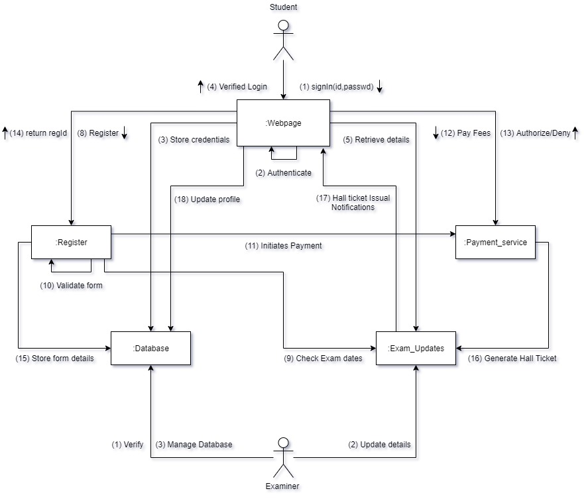

**Sequence Diagram :**

