**Exam Registration System**

**Use case model**

**Team Members :**

|  |  |
| --- | --- |
| **Name** | **Register Number** |
| Surya Prakash G | 185001179 |
| Surya S S | 185001180 |
| Suria Prakash J | 185001178 |

**Fully dressed Use case :**

**Identification of Actors :**

* **Student :** They are the main actors in ERS. Their role is to apply for exams with a registered user account by providing required details and receiving their hall tickets. They can also view exam details and updates.
* **Exam controller :** They are able to access all the student database. Their role is to update the exam details such as date, subject etc. They also provide proper notifications on completion of exam registration. They are responsible for the approval and issue of hall tickets.

**Identification of Scenarios :**

**Success Scenarios :**

* A student creates an account by providing proper details
* A student logs in to his/her account on valid authentication.
* A student registers for his/her exam on successful submission of the form and the payment of fees.
* The exam controller sends fees acknowledgment and Hall ticket via email after verifying the provided student details.
* A student can view his/her exam guidelines by logging into their account.

**Failure Scenarios :**

* A student who does not have registered account but tries to login to the system.
* A student logs in with invalid login credentials.
* Invalid registration information and payment details results in the failure of registration.
* A student somehow faces issues on receiving notifications.

**Use case diagram :**

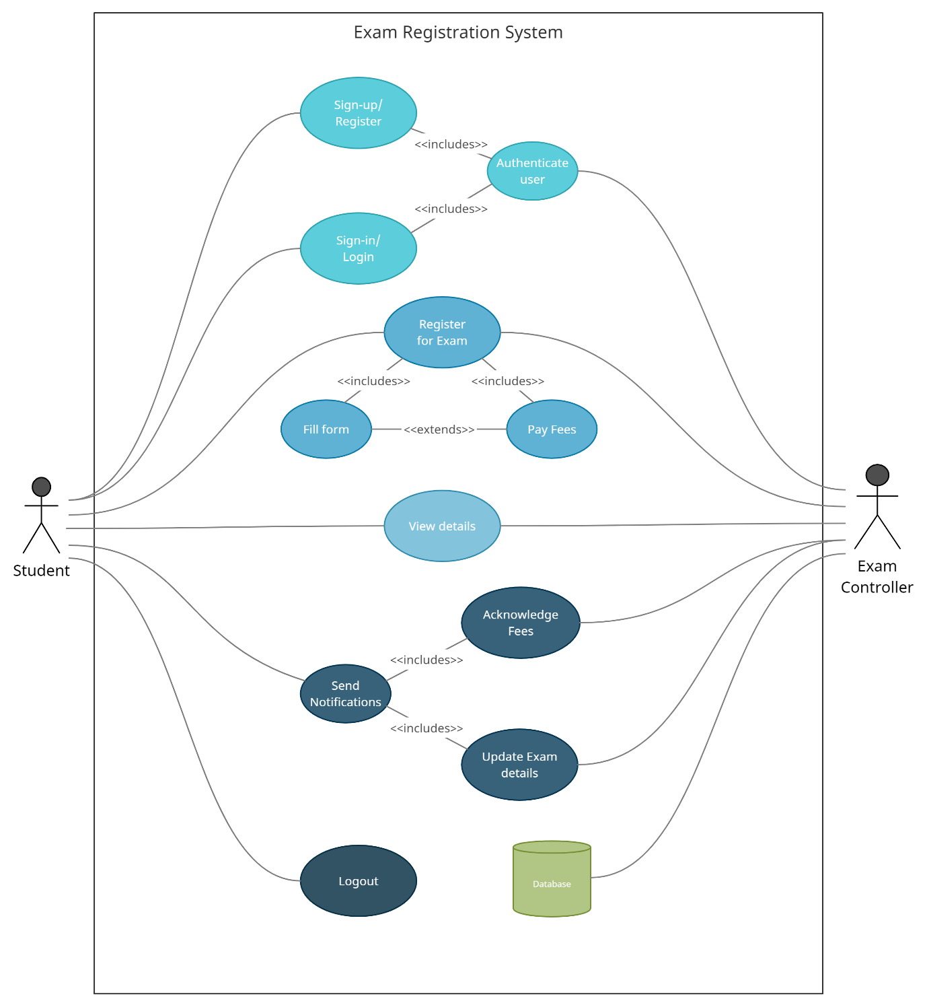

**Use cases :**

* Sign-up
* Login or Sign-in
* Register for exam
* Send notifications
* View details
* Logout

**Sub-functions :**

* Authenticate user
* Fill form
* Pay fees
* Acknowledge fee
* Update Exam details

**Use case description :**

**User goals :**

**Login or Sign-in :**

|  |  |
| --- | --- |
| **Use Case Section** | **Comment** |
| **Use Case Name** | Login or Sign-in |
| **Scope** | Logs in registered users |
| **Level** | User goal |
| **Primary Actor** | Student |
| **Stakeholders and interests** | Student who wants to be logged in |
| **Preconditions** | Student must have a registered account, stable internet connection |
| **Success Guarantee** | Student will be logged in on valid authentication |
| **Main Success Scenario** | Logged in |
| **Extensions** | **Authenticate user :** On failure the student will be given 5 more chances for login |
| **Special requirements** | Valid credentials for login |

**Register for Exam :**

|  |  |
| --- | --- |
| **Use Case Section** | **Comment** |
| **Use Case Name** | Register for exam |
| **Scope** | Approval of hall ticket |
| **Level** | User goal |
| **Primary Actor** | Student |
| **Stakeholders and interest** | Student who wants to register for a particular exam |
| **Preconditions** | Student must have a registered account, stable network, valid bank details |
| **Success Guarantee** | Student will be notified on successful registration |
| **Main Success Scenario** | Guaranteed issue of hall ticket |
| **Extensions** | **Fill form :** Prompts to fill all the required details  **Pay fees :** On failure of payment the student will be asked to provide proper banking details |
| **Special requirements** | Valid bank details, Subject code |

**Send notifications :**

|  |  |
| --- | --- |
| **Use Case Section** | **Comment** |
| **Use Case Name** | Send notifications |
| **Scope** | Get notified on registration |
| **Level** | User goal |
| **Primary Actor** | Exam controller, Student |
| **Stakeholders and interest** | Exam controller who verifies the registration |
| **Preconditions** | Exam controller must have a registered account, stable network |
| **Success Guarantee** | If student has registered for an exam he will be notified |
| **Main Success Scenario** | Sending notification on successful exam registration |
| **Extensions** | None |
| **Special requirements** | Notifications are automated  through mail |

**View details :**

|  |  |
| --- | --- |
| **Use Case Section** | **Comment** |
| **Use Case Name** | View details |
| **Scope** | Student can view the exam details |
| **Level** | User goal |
| **Primary Actor** | Student |
| **Stakeholders and interest** | Student who wants to get info about the exam |
| **Preconditions** | Student must have a registered for an exam, stable network |
| **Success Guarantee** | If registered for exam |
| **Main Success Scenario** | View exam details |
| **Extensions** | None |
| **Special requirements** | Access to the portal |

**Sub-functions :**

**Acknowledge fee :**

|  |  |
| --- | --- |
| **Use Case Section** | **Comment** |
| **Use Case Name** | Send fee acknowledgment |
| **Scope** | Acknowledgment to Student |
| **Level** | Sub-function |
| **Primary Actor** | Exam controller, Student |
| **Stakeholders and interest** | Exam controller who is responsible for notifying the fee payment |
| **Preconditions** | Exam controller must have a registered account, stable network |
| **Success Guarantee** | On payment of exam fees, students must be notified |
| **Main Success Scenario** | Student receives fee receipt |
| **Extensions** | Send notifications |
| **Special requirements** | Access to the portal, Bank log for checking payment if received |

**Update Exam details :**

|  |  |
| --- | --- |
| **Use Case Section** | **Comment** |
| **Use Case Name** | Update exam details |
| **Scope** | Exam updates |
| **Level** | Sub-function |
| **Primary Actor** | Exam controller |
| **Stakeholders and interest** | Exam controller who is responsible for informing changes in exam dates, timing etc.. |
| **Preconditions** | Exam controller must have a registered account, stable network |
| **Success Guarantee** | If any changes regarding exams, students must be notified |
| **Main Success Scenario** | Student receives the update |
| **Extensions** | Send notifications |
| **Special requirements** | Access to the portal |