Query :

SELECT * FROM sales_data;

Result:

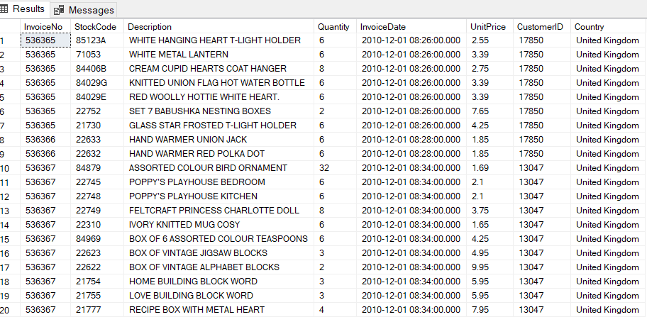

Query:

SELECT * FROM sales_data WHERE Country = 'France';

Result:

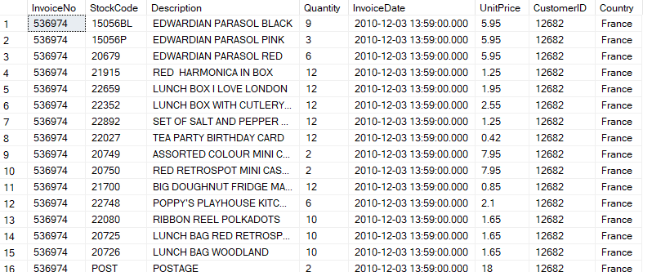

Query:

SELECT Description, UnitPrice FROM sales_data ORDER BY UnitPrice DESC;

Result:

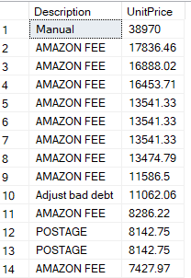

Query:

SELECT Country, SUM(Quantity) AS TotalQuantity FROM sales_data GROUP BY Country ORDER BY TotalQuantity DESC;

Result:

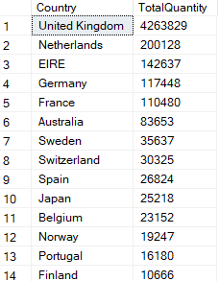

Query:

CREATE TABLE product_categories (StockCode VARCHAR(20),Category VARCHAR(50));

SELECT s.InvoiceNo, s.Description, p.Category FROM sales_data s LEFT JOIN product_categories p ON s.StockCode = p.StockCode;

Result:

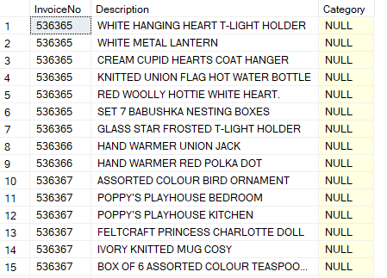

Query:

SELECT DISTINCT CustomerID FROM sales_data WHERE CustomerID IN (SELECT CustomerID FROM sales_data GROUP BY CustomerID HAVING SUM(Quantity) > 100);

Result:

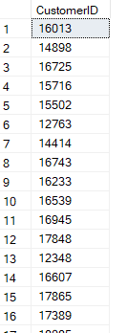

Query:

SELECT Country, AVG(UnitPrice) AS AvgPrice FROM sales_data GROUP BY Country;

Result:

