

ULO SMART

**(3D based Smart Home Automation Module)**

by

SURYA V 2040164

YAMIN NATHER S 2040181

HARINIVAS SRINIVASAN 2040173

Under the guidance of

Dr Arokia Paul Rajan R

ULO SMART **(3D based Smart Home automation Module)** project report submitted in partial fulfillment of the requirements of VI semester BSc (Computer Science, CHRIST (Deemed to be University)

March - 2023



CERTIFICATE

*This is to certify that the report titled ULO SMART (****3D based Smart Home Automation Module )***  *is a bona fide record of work done by Surya V (2040164), Yamin Nather S (2040181), Harinivas Srinivasan (2040173) of CHRIST (Deemed to be University), Bangalore, in partial fulfillment of the requirements of VI Semester BSc Computer Science during the year 2023.*

**Head of the Department Project Guide**

**Dr: Ashok Immanuel (Head of The Department),**

Valued-by:

|  |  | Name | : |
| --- | --- | --- | --- |
| 1. |  | Register Number | : |
|  |  | Examination Centre | : Christ (Deemed to be University) |
| 2. |  | Date of Exam | : |

**ACKNOWLEDGEMENTS**

First of all, we thank God almighty for his immense grace and blessings showered on us at every stage of this work. *We are grateful to our respectable former* Head, Department of Computer Science, CHRIST (Deemed to be University), ***Dr Joy Paulose***, for providing the opportunity to take up this project as part of my curriculum.

*We also pay our gratitude* *to the Head* Of Department, Computer Science, CHRIST (Deemed to be University), ***Dr Ashok Immanuel V*** and Coordinator, Department of Computer Science, CHRIST(Deemed to be University) ***Dr Manjunatha Hiremath*** *for their support throughout.*

*We are grateful to our guide, Coordinator,* Department of Computer Science, CHRIST (Deemed to be University), **Dr Arokia Paul Rajan R**, *whose insightful leadership and knowledge benefited us to complete this project successfully. Thank you so much for your continuous support and presence whenever needed.*

We express our sincere thanks to all faculty members and staff of the Department of Computer Science, CHRIST (Deemed to be University), for their valuable suggestions during the course of this project. Their critical suggestions helped us to improve the project work.

*We would also like to thank the Alumni Evaluator for his advice and suggestions to the project.*

*Last but not the least, we would like to thank everyone who is involved in the process directly or indirectly.*

**ABSTRACT**

The Smart Home automation system using 3D model with WiFi technology and IoT is a sophisticated and intelligent system that seamlessly integrates various components to provide a convenient, efficient, and secure way to control and monitor the various home appliances and systems. The system includes a 3D model home design, IoT devices, cloud Firestore database, ESP8266 WiFi module, mobile app or web-based interface, and machine learning algorithms. The 3D model serves as the visual representation of the home and its various components, while the IoT devices are equipped with sensors and actuators that allow them to communicate with the system. The cloud Firestore database stores all data related to the system, while the ESP8266 WiFi module serves as the intermediary between the database and the IoT devices. The mobile app or web-based interface allows the user to control and monitor the system, while the machine learning algorithms provide insights into the user's behavior and preferences. Overall, the Smart Home automation system using 3D model with WiFi technology and IoT is a scalable and adaptable system that provides an efficient and intelligent home automation solution.

**Table of Contents**

| **Chapters** | **Contents** | **Page Number** |
| --- | --- | --- |
| **1** | **Introduction** |  |
|  | 1.1 Overview of the system |  |
|  | 1.2 Purpose of the Study |  |
|  | 1.3 Objective of the study |  |
|  | 1.4 Importance of the study |  |
|  |  |  |
| **2** | **System Analysis** |  |
|  | 2.1 Existing System |  |
|  | 2.2 Limitations of Existing System |  |
|  | 2.3 Proposed System |  |
|  | 2.4 Benefits of the Proposed System |  |
|  | 2.5 Literature Review |  |
|  | 2.6 Functional Requirements |  |
|  | 2.7 Software and Hardware Requirements |  |
|  |  |  |
| **3** | **System Design** |  |
|  | 3.1 Block Diagram |  |
|  | 3.2 Database Design |  |
|  | 3.3 ER Diagram |  |
|  | 3.4 Data Flow Diagram |  |
|  | 3.5 Use case Diagram |  |
|  | 3.6 User Interface Design |  |
|  |  |  |
| **4** | **Implementation** |  |
|  | 4.1 Source Code |  |
|  | 4.2 Screen Shots |  |
|  |  |  |
| **5** | **Testing** |  |
|  | 5.1 Test Strategies |  |
|  | 5.1.1 Unit Testing |  |
|  | 5.1.2 Functional Testing |  |
|  | 5.1.3 Integration Testing |  |
|  | 5. 2 Test Cases and Reports |  |
|  | 5.2.1 Unit Testing |  |
|  | 5.2.2 Functional Testing |  |
|  | 5.2.3 Integration Testing |  |
| 6 | Conclusion and future Scope |  |
|  | Applications |  |
| 7 | References |  |
|  |  |  |

INTRODUCTION

*This chapter contains the overview of the present study. It gives an introduction to the technologies used. And also, it gives an overview of what is a “ULO SMART”. It gives a beginner’s view as to what is Desktop based app, Arduino Uno mother board and also the tools used.*

The idea of automating homes has gained significant traction in recent years with the rapid growth of the Internet of Things (IoT) technology. Smart homes, which are equipped with various interconnected devices and appliances, provide homeowners with the ability to control their homes remotely, increase energy efficiency, and improve overall comfort and security. With the integration of 3D modeling and WiFi technology, the possibilities for home automation are endless. This project aims to explore the potential of using a 3D model to control various home appliances and systems through WiFi technology, ultimately creating a more efficient and intelligent home. In this project, we will design and develop a prototype that demonstrates the benefits of a smart home with the use of 3D modeling and WiFi technology.

Our project, "Smart Home Automation using 3D Model with WiFi Controls," aims to design and develop a system that allows homeowners to control various appliances and devices in their homes through a 3D model interface. The system uses WiFi connectivity to provide seamless and effortless control over the devices, allowing homeowners to monitor and manage their homes from anywhere at any time.

This project focuses on creating a smart home automation system that utilizes a 3D model and WiFi technology. The system will allow homeowners to remotely control various home appliances and systems through a mobile app or web-based interface, providing greater convenience, energy efficiency, and security.

In this project, we will explore the potential of 3D modeling and WiFi controls in creating an intuitive and user-friendly interface for home automation. We will design and develop a prototype that showcases the features of the system, including the ability to control lighting, temperature, security, and other aspects of the home

2. SYSTEM ANALYSIS

*This chapter elaborates the need for the present study. It also discusses about the limitations of existing problem and discuss about the benefits of the proposed system. It gives the functional, software and hardware requirements for the proposed project.*

2.1 EXISTING SYSTEM

1. Smart homes refer to houses that use automation technology to provide convenience, comfort, security, and energy efficiency. Home automation is the use of electronic devices, such as sensors, switches, and controllers, to monitor and control various home systems, including lighting, temperature, entertainment, and security.
2. Smart home automation systems are designed to make life easier and more comfortable for homeowners. They allow users to remotely control and monitor their home's systems through a mobile app or a central control system. For example, a smart thermostat can be programmed to adjust the temperature of a room based on the time of day, the season, or the user's preferences. Similarly, a smart lighting system can be controlled using a smartphone, allowing users to turn lights on or off, change their color, or adjust their brightness.
3. Home automation technology has been evolving rapidly over the past decade, and it has become more accessible and affordable to homeowners. Smart home devices are now available in many forms, including voice assistants, smart thermostats, security cameras, and smart locks. Many of these devices can be integrated with each other to create a comprehensive smart home system.

Overall, smart homes and home automation systems are becoming increasingly popular among homeowners who value convenience, energy efficiency, and security. As technology continues to advance, it's likely that smart homes will become even more prevalent in the future.

2.1.2 LIMITATIONS IN EXISTING SYSTEM

While there are several advantages to using a 3D home design module in smart home automation, there are also some limitations that should be considered. Here are some of the key limitations:

* Complexity: Developing a 3D model of the home can be complex and time-consuming, requiring specialized software and technical skills. This can make it difficult for homeowners or DIY enthusiasts to implement such a system on their own.
* Cost: The cost of implementing a 3D home design module in smart home automation can be relatively high, as it requires specialized hardware and software components.
* Maintenance: Maintaining a 3D home design module can also be complex, requiring regular updates and maintenance to ensure that the system remains functional and up-to-date.
* Compatibility: The 3D home design module may not be compatible with all smart home automation components, which could limit the range of devices that can be integrated into the system.
* Privacy and Security Concerns: As with any smart home automation system, there may be concerns around privacy and security. A 3D model of the home could potentially be used for surveillance or other intrusive purposes, which could be a concern for some homeowners.

Overall, while there are several advantages to using a 3D home design module in smart home automation, it's important to consider the limitations and potential drawbacks before implementing such a system.

2.1.3 SOFTWARE AND HARDWARE REQUIREMENTS

1. Software Requirements
2. JavaScript
3. NodeJS
4. Metamask
5. Hardhat
6. Openzeppelin
7. Infura
8. VS Code
9. Git

**2.2 PROPOSED SYSTEM**

There have been several previous studies and research on the topic of smart home automation and 3D home design module. Here are some of the key findings:

* In a study published in the Journal of Ambient Intelligence and Humanized Computing, researchers developed a 3D smart home simulation tool that allowed users to control various home systems, including lighting, heating, and security. The study found that the 3D simulation tool provided an intuitive and effective way for users to control their smart home systems.
* Another study published in the Journal of Intelligent & Robotic Systems evaluated the effectiveness of using a 3D home design module for home automation planning and design. The study found that the 3D design module allowed for more accurate and efficient planning of home automation systems.
* In a research paper published in the International Journal of Smart Home, researchers proposed a smart home automation system that integrated a 3D home design module with a virtual assistant. The system was designed to provide personalized and context-aware home automation services to users..

**2.2.1 PRELIMINARY INVESTIGATION**

The first step in the system development life cycle is the preliminary investigation to determine the feasibility of the system. The purpose of preliminary investigation is to evaluate project requests. It is not a design study or the collection of details to describe the business system in all respect. It is the collecting of information that helps committee members to evaluate the merits of the project request and make an informed judgement about the feasibility of the project.

Preliminary investigation should answer the following points.

* Clarify and understand the project goal
* Determine the size of the project
* Determine the cost and benefits
* Examine the technical and operational feasibility of alternate approaches

**2.2.2 FEASIBILITY STUDY**

A feasibility study is an important step in evaluating the potential success of a project. Here are some key factors to consider in a feasibility study of using a 3D home design module in smart home automation:

1. **Technical Feasibility**: The first step is to determine whether the necessary hardware and software components for a 3D home design module are available and compatible with the smart home automation system. This will require an assessment of the available technology, including 3D modeling software, smart home automation devices, and other hardware components.
2. **Economic Feasibility**: The cost of implementing a 3D home design module in smart home automation can be relatively high, including the cost of hardware and software components, installation, and ongoing maintenance. A cost-benefit analysis can help determine whether the project is economically feasible and whether the expected benefits outweigh the costs.
3. **Operational Feasibility**: It is important to consider the practical aspects of using a 3D home design module in smart home automation, including whether it can be integrated seamlessly into existing systems and whether it can be operated effectively by end-users.
4. **Legal and Regulatory Feasibility**: Smart home automation systems are subject to various legal and regulatory requirements, including data privacy and security regulations. It is important to ensure that the 3D home design module is compliant with all relevant laws and regulations.
5. **Environmental Feasibility:** A 3D home design module in smart home automation can also have environmental impacts, such as energy consumption and waste. It is important to consider the environmental implications of the project and to implement measures to minimize any negative impacts.

Overall, a feasibility study of using a 3D home design module in smart home automation should consider a range of factors, including technical, economic, operational, legal and regulatory, and environmental feasibility. This can help ensure the success and sustainability of the project.

**2.3 OBJECTIVES OF THE STUDY**

The objectives of the study of using a 3D home design module in smart home automation may include:

* To assess the potential benefits and limitations of using a 3D home design module in smart home automation.
* To evaluate the technical feasibility of implementing a 3D home design module in smart home automation.
* To determine the economic feasibility of the project, including the costs and benefits of implementing a 3D home design module in smart home automation.
* To assess the operational feasibility of the project, including the usability and effectiveness of the 3D home design module in controlling smart home automation systems.
* To evaluate the legal and regulatory implications of implementing a 3D home design module in smart home automation, including compliance with data privacy and security regulations.
* To assess the environmental implications of implementing a 3D home design module in smart home automation and identify measures to minimize any negative impacts.
* To identify best practices and recommendations for implementing a 3D home design module in smart home automation.

Overall, the objectives of the study should be aligned with the potential benefits and limitations of using a 3D home design module in smart home automation, and aim to provide useful insights for practitioners and researchers in the field.  
**2.4 PROJECT PLANNING**

Project planning is a crucial step in ensuring the successful implementation of a project. Here are some key steps in planning a project of using a 3D home design module in smart home automation:

1. Define project scope: Clearly define the scope of the project, including the goals, objectives, and expected outcomes. This should include a detailed description of the 3D home design module and how it will be integrated with the smart home automation system.
2. Develop a project plan: Develop a detailed project plan that outlines the tasks, timelines, and resources required to complete the project. This should include a breakdown of the project into smaller tasks and milestones, as well as an estimation of the time and resources required for each task.
3. Identify stakeholders: Identify all stakeholders involved in the project, including end-users, developers, vendors, and project sponsors. This should include a clear description of the roles and responsibilities of each stakeholder.
4. Assess project risks: Identify potential risks and challenges that could impact the success of the project, such as technical challenges, budget constraints, and regulatory compliance. Develop a risk management plan that outlines how these risks will be mitigated and managed.
5. Develop a communication plan: Develop a communication plan that outlines how stakeholders will be kept informed about the progress of the project, including regular updates, progress reports, and other communication channels.
6. Develop a testing plan: Develop a testing plan to ensure the quality and reliability of the 3D home design module in smart home automation. This should include a description of the testing methodologies, tools, and resources required for the testing process.
7. Develop a training plan: Develop a training plan to ensure that end-users and other stakeholders are adequately trained on the use of the 3D home design module in smart home automation. This should include a detailed description of the training materials, resources, and timelines.

Overall, project planning should be a detailed and well-organized process that includes a clear definition of the project scope, a detailed project plan, stakeholder identification, risk assessment, communication planning, testing planning, and training planning. By following these steps, the project of using a 3D home design module in smart home automation can be successfully planned and executed.

**2.5 PROJECT SCHEDULING** 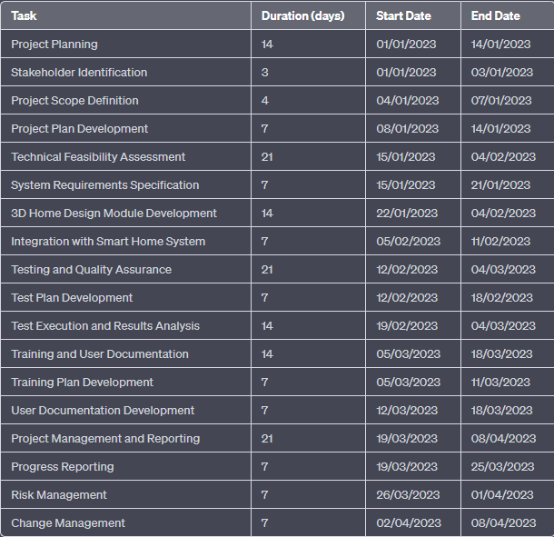

A Gantt chart is a useful tool for visualizing project timelines and dependencies. Here is an example of a Gantt chart for the project of using a 3D home design module in smart home automation:

**GANTT Chart**

IT is a project controlling technique. It is used for scheduling, budgeting and resource planning. A Gantt is a bar chart with each bar representing activity. The bars are drawn against a timeline.

|  |  | | Jan 1-15 | Jan 16-31 | Feb 1-15 | Feb 16- 28 | Mar 1- 15 | Mar 15-31 | April 1-15 |
| --- | --- | --- | --- | --- | --- | --- | --- | --- | --- |
| Synopsis submission | | |  |  |  |  |  |  |  |
| Review collection | | |  |  |  |  |  |  |  |
| Design | |  |  |  |  |  |  |  |  |
|  | idea building | |  |  |  |  |  |  |  |
|  | Database connection | |  |  |  |  |  |  |  |
|  | Design Building | |  |  |  |  |  |  |  |
|  | testing | |  |  |  |  |  |  |  |
| Implementation | | |  |  |  |  |  |  |  |
| Final checking | | |  |  |  |  |  |  |  |
| Report Preparation | | |  |  |  |  |  |  |  |

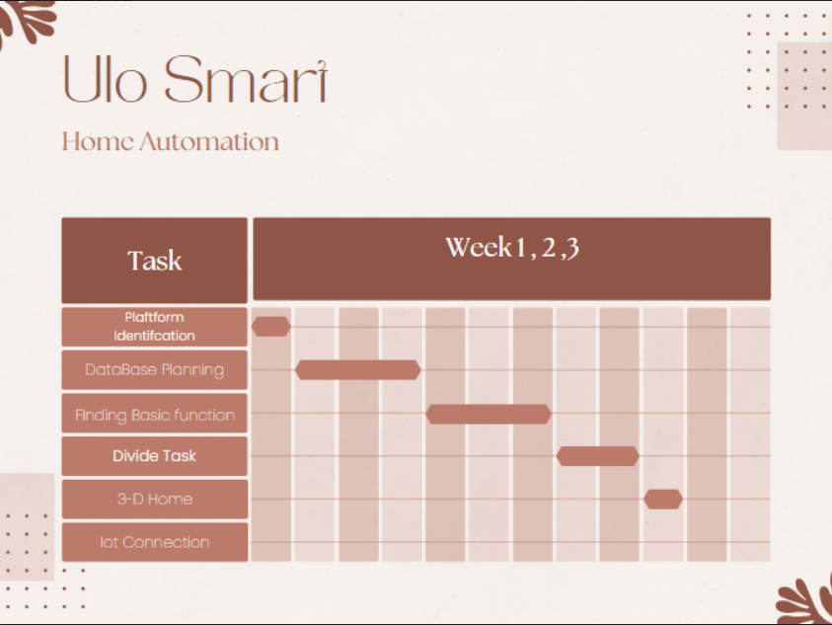

**2.6 METHODOLOGY**

The Methodology adopted is “Agile Methodology”

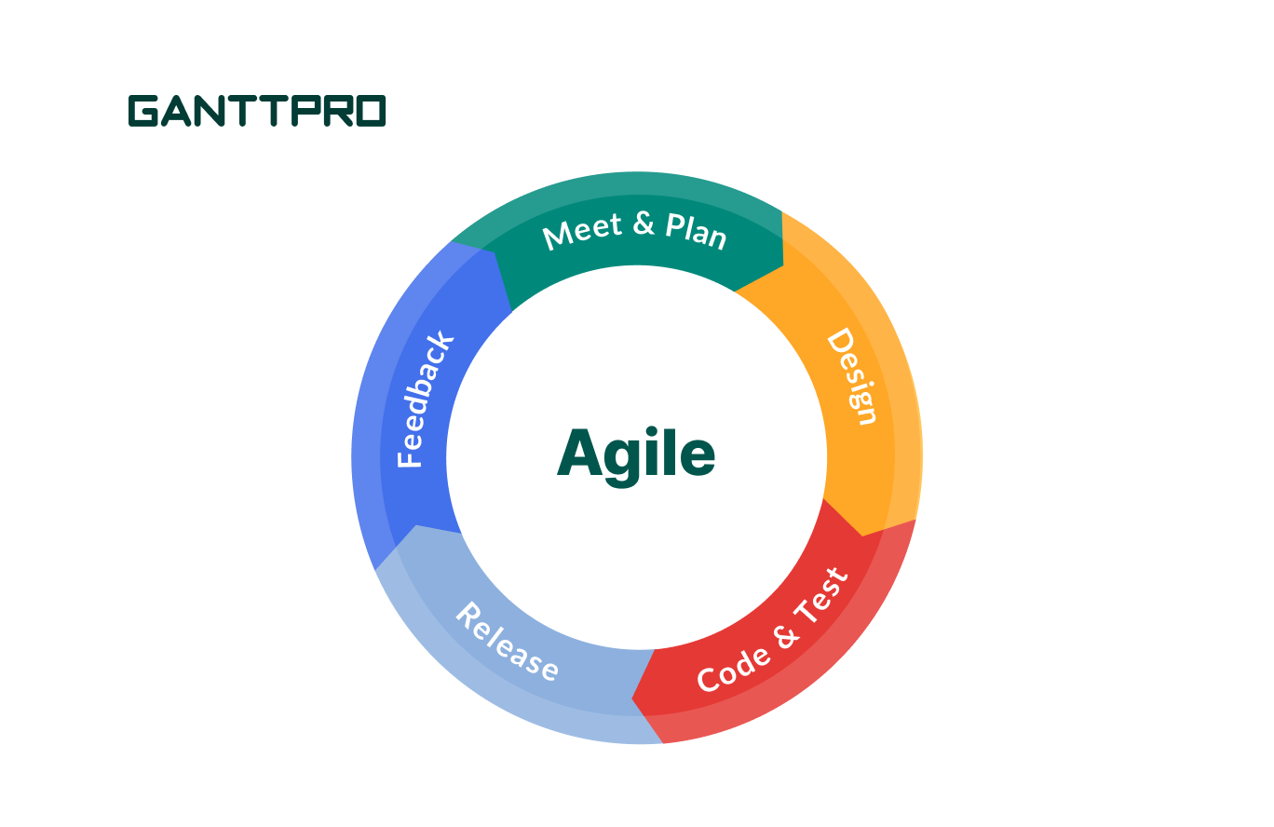

Agile methodology is a flexible and iterative approach to software development that emphasizes collaboration between cross-functional teams, customer satisfaction, and rapid delivery of working software. Here are some ways that Agile methodology can be applied to the 3D home design module in smart home automation project:

* Define user stories: The project team can define user stories based on the requirements gathered from stakeholders. These user stories can then be prioritized and included in the product backlog.
* Sprint planning: The project team can plan sprints, which are time-boxed iterations, usually two to four weeks long, during which the team works on a set of user stories from the product backlog. The team can estimate the effort required for each user story and select the stories to work on during the upcoming sprint.
* Daily stand-up meetings: The project team can hold daily stand-up meetings to discuss progress, identify and address any issues, and ensure that everyone is on the same page.
* Continuous integration and testing: The team can continuously integrate and test the code to ensure that it works as expected. This can help catch defects early in the development process.
* Sprint review: At the end of each sprint, the project team can hold a sprint review meeting to demonstrate the completed user stories to stakeholders and get feedback.
* Sprint retrospective: The team can also hold a sprint retrospective meeting to reflect on the previous sprint, identify areas for improvement, and make adjustments for the next sprint.

**2.7 SOFTWARE REQUIREMENT SPECIFICATIONS (SRS)**

The software requirements are produced at the culmination of the analysis task. The function and performance allocated to software as part of system are refined by establishing a complete information description, an indication of performance requirements and design constraints, validation criteria and other data pertinent to requirements.  
Facilities required for proposed work

**COMPONENTS REQUIRED**

* Arduino UNO
* Servo Motor
* ESP8266
* DC Fan (Motor)
* LED’s
* MQ sensor
* LCD

**3.SYSTEM DESIGN**

* Data models (like DFD), Control Flow diagrams, State Diagrams/Sequence  
  diagrams, Entity Relationship Model, Class Diagrams/CRC Models/CollaborationDiagrams/Use-case Diagrams/Activity Diagrams depending upon your project requirements
* 3D Model Home Design: The 3D model home design serves as the visual representation of the home and its various components. It includes detailed models of home appliances and systems, such as lights, thermostats, cameras, and security systems. The 3D model is used to provide an interactive and intuitive interface for the user to control the home appliances and systems.
* IoT Devices: The IoT devices are the various home appliances and systems that are controlled by the smart home automation system. Each device is equipped with sensors and actuators that allow them to communicate with the ESP8266 WiFi module and receive commands from the cloud Firestore database. Examples of IoT devices include smart lights, thermostats, door locks, and security cameras.
* Cloud Firestore Database: The cloud Firestore database serves as the central repository for all data related to the smart home automation system. It stores information about the current status of various home appliances and systems, as well as user preferences and settings. The database is also used to manage user accounts and authentication.
* ESP8266 WiFi Module: The ESP8266 WiFi module serves as the intermediary between the cloud Firestore database and the home appliances and systems. It receives data from the database and uses it to control the various appliances and systems, as well as send status updates back to the database. The module communicates with the IoT devices using various wireless protocols, such as Wi-Fi, Zigbee, or Bluetooth.

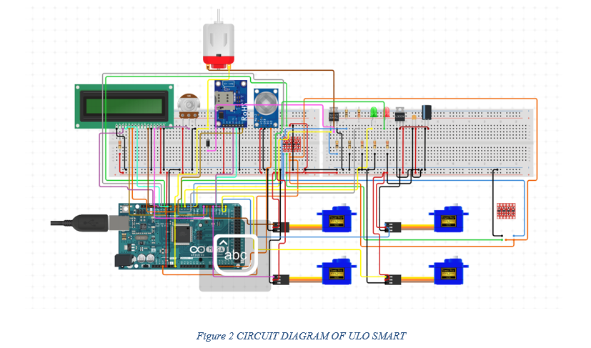

**3.1 PROJECT DESCRIPTION**

In this project, we are using a 3D module home design to send data to a cloud Firestore database, which allows for easy management and access to the data from anywhere. The cloud Firestore database is a NoSQL document database that is designed to store and sync data in real-time, making it perfect for IoT applications.

The data that is sent from the 3D module home design to the cloud Firestore database includes information on the current status of various home appliances, such as lights, fans, and air conditioning units. This data is then received by an ESP8266 WiFi module that is connected to the cloud Firestore database.

The ESP8266 WiFi module is a low-cost wireless network module that is commonly used in IoT applications. It is capable of connecting to a WiFi network and communicating with other devices over the network. In this project, the ESP8266 WiFi module is used to receive data from the cloud Firestore database and control the home appliances accordingly.

Using this setup, users can control their home appliances from anywhere using a mobile app or a web-based interface. For example, if a user wants to turn on the lights in their living

room, they can do so using the app or web-based interface, which sends a command to the cloud Firestore database. The ESP8266 WiFi module receives the command from the database and turns on the lights. Overall, this project demonstrates the power and potential of IoT technology for home automation. By combining 3D module home design, cloud Firestore database, and ESP8266 WiFi module, we can create a system that is both efficient and intelligent, making our homes more comfortable, secure, and energy-efficient.

**3.2 BLOCK DIAGRAM**

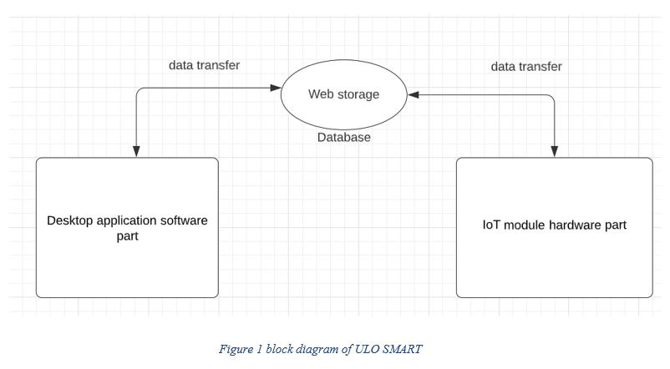

**3.3 CONTROL FLOW EXPLANATION:**

1. The user opens the mobile app or web-based interface to access the smart home automation system.
2. The 3D model home design sends data to the cloud Firestore database, which stores information about the current status of various home appliances and systems.
3. The ESP8266 WiFi module receives data from the cloud Firestore database, which is used to control the home appliances and systems

.

1. The user selects the desired action for a specific home appliance or system, such as turning on the lights or adjusting the thermostat.
2. The mobile app or web-based interface sends a command to the cloud Firestore database to execute the selected action.
3. The ESP8266 WiFi module receives the command from the database and executes the selected action by controlling the corresponding home appliance or system.
4. The updated status of the home appliance or system is sent back to the cloud Firestore database, which is then reflected in the mobile app or web-based interface for the user to see.
5. The user can continue to interact with the smart home automation system through the mobile app or web-based interface, controlling various home appliances and systems from anywhere at any time.
6. Overall, this control flow diagram demonstrates the seamless and efficient integration of 3D modeling, cloud Firestore database, and ESP8266 WiFi module to create a highly intelligent and responsive smart home automation system.

**3.4 USER FLOW DIAGRAM**

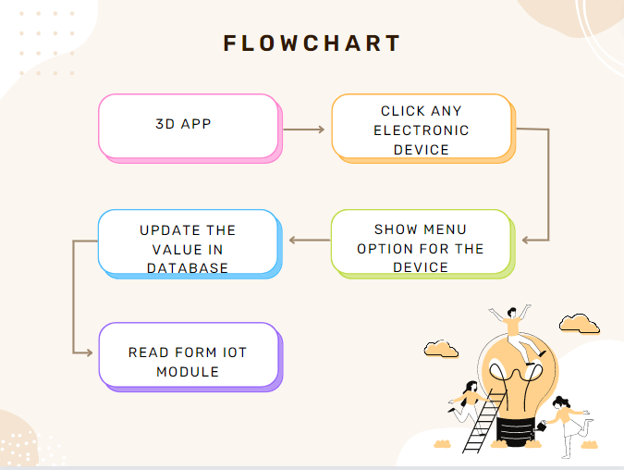

* User opens the 3D home design module software and starts designing their home. They can choose the layout, furniture, and other design elements.
* Once the design is complete, the user can add smart home automation systems to the design. They can select from a variety of options such as lighting, temperature control, security, entertainment, and more.
* The user can then customize each system to fit their specific needs. For example, they can set up custom lighting scenes for different times of day or create schedules for their thermostat.
* Once the smart home automation systems are set up, the user can test the functionality of each system within the 3D home design module. They can see how the systems interact with each other and ensure that everything is working as intended .After testing is complete, the user can deploy the smart home automation systems in their real-life home

**3.5 DATA FLOW DIAGRAM**

A data flow diagram (DFD) maps out the flow of information for any process or system. It uses defined symbols like rectangles, circles and arrows, plus short text labels, to show data inputs, outputs, storage points and the routes between each destination. Data flowcharts can range from simple, even hand-drawn process overviews, to in-depth, multi-level DFDs that dig progressively deeper into how the data is handled. They can be used to analyze an existing system or model a new one.

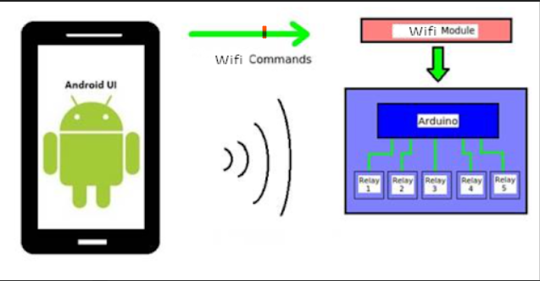

* 1. **ENTITY RELATIONSHIP DIAGRAM**

ER diagrams are related to data structure diagrams (DSDs), which focus on the relationships of elements within entities instead of relationships between entities themselves. ER diagrams also are often used in conjunction with data flow diagrams (DFDs), which map out the flow of information for processes or systems.

An Entity Relationship (ER) Diagram is a type of flowchart that illustrates how “entities” such as people, objects or concepts relate to each other within a system. ER Diagrams are most often used to design or debug relational databases in the fields of software engineering, business information systems, education and research. 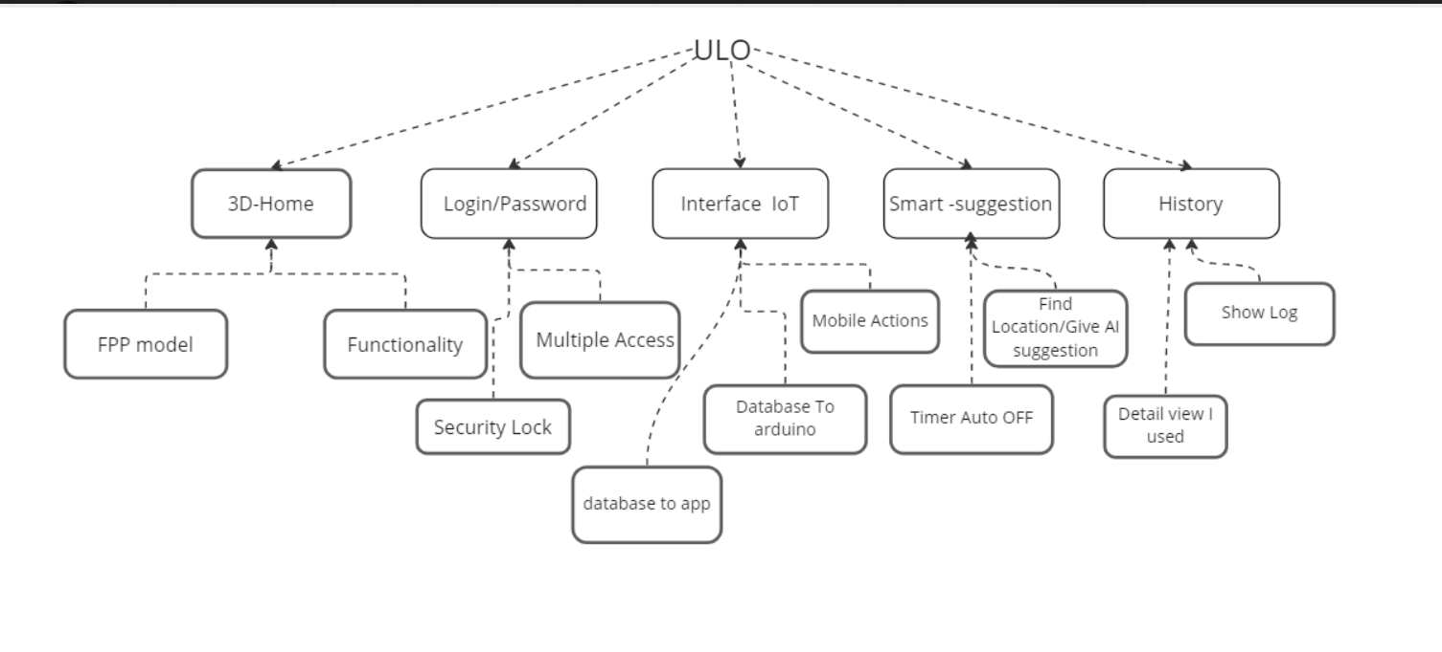

Primary Phase:

Here the system is designed at block level. The blocks are created on the basis of analysis done in the problem identification phase. Different blocks are created for different functions to minimize the information flow between blocks.

Secondary Phase

Detailed design of every block was done in this phase.

Tasks involved in the design process

* Design various blocks for overall system processes
* Design smaller, compact and workable modules in each block
* Design various database structures
* Program detailed to achieve desired functionality
* Design the form of inputs and outputs of the system
* Perform documentation of the design
* Frequent system review and testing

              ♦ Modularisation details   
              ♦ Data integrity and constraints   
              ♦ Database design, Procedural Design/Object Oriented Design   
              ♦ User Interface Design

* 1. **USER INTERFACE DESIGN**

UI design is concerned with the sharing of information between USER and Computer. The following are the guidelines for UI design

* The system user should be aware of what to do next
* The screen should be formatted so that various types of information, instructions and messages always appear in the same display area.
* Message, instructions or information should displayed long enough to allow the system user to read them
* Use display attributes
* Default values for fields and answers to be entered by the user should be specified
* A user should not be allowed to proceed without correcting an error
* The system user should never get an operating system message or fatal error.

**4. IMPLEMENTATION**

Design of IOT and Its Code

IOT NODE MCU CODE:

#include <FirebaseESP8266.h>

#include <ESP8266WiFi.h>

#include<SoftwareSerial.h>

#include <Servo.h>

// Set these to run example.

#define FIREBASE_HOST "ulosmart-3feee-default-rtdb.firebaseio.com" //https://ulosmart-3feee-default-rtdb.firebaseio.com/

#define FIREBASE_AUTH "oIoSU7H8h46gH1HyYZT8W59JyZYAnwLUR1o7849X"

#define WIFI_SSID "Hari Phone"    //provide ssid (wifi name)

#define WIFI_PASSWORD "tjij3231"  //wifi password

// Define the Firebase Data object

FirebaseData fbdo;

// Define the FirebaseAu8th data for authentication data

FirebaseAuth auth;

// Define the FirebaseConfig data for config data

FirebaseConfig config;

#if defined(ESP_8266)

WiFiMulti multi;

#endif

//Started SoftwareSerial at RX and TX pin of ESP8266/NodeMCU

SoftwareSerial s(3,1);

void setup() {

  // Debug console

  //Serial.begin(9600);

  s.begin(9600);

// connect to wifi.

#if defined(ESP_8266)

  multi.addAP(WIFI_SSID, WIFI_PASSWORD);

  multi.run();

#else

  WiFi.begin(WIFI_SSID, WIFI_PASSWORD);

#endif

  Serial.print("Connecting to Wi-Fi");

  unsigned long ms = millis();

  while (WiFi.status() != WL_CONNECTED) {

    Serial.print(".");

    delay(300);

#if defined(ESP_8266)

    if (millis() - ms > 10000)

      break;

#endif

  }

  Serial.println();

  Serial.print("Connected with IP: ");

  Serial.println(WiFi.localIP());

  Serial.println();

  config.database_url = FIREBASE_HOST;

  config.signer.test_mode = true;

  Firebase.reconnectWiFi(true);

#if defined(ESP_8266)

  config.wifi.clearAP();

  config.wifi.addAP(WIFI_SSID, WIFI_PASSWORD);

#endif

  Firebase.begin(&config, &auth);

  Serial.print("Firebase Connected");

  Serial.print("\nFolder Created in Firebase");

  Firebase.setInt(fbdo, "/hall/light/isOn", 0);

  Firebase.setInt(fbdo, "/hall/fan/isOn", 0);

  Firebase.setInt(fbdo, "/hall/door/isOpen", 0);

  Firebase.setInt(fbdo, "/kitchen/light/isOn", 0);

  Firebase.setInt(fbdo, "/kitchen/door/isOpen", 0);

  Firebase.setInt(fbdo, "/kitchen/mqSensor/isDetected", 0);

  Firebase.setInt(fbdo, "/bedroom/light/isOn", 0);

  Firebase.setInt(fbdo, "/bedroom/fan/isOn", 0);

}

void loop() {

  hall();

  kitchen();

  bedroom();

}

void hall() {

  if(Firebase.getInt(fbdo, "/hall/door/isOpen")) {

    if(fbdo.to<int>() == 0) {s.write(110);}

    else {s.write(111);}

  }

  if(Firebase.getInt(fbdo, "/hall/fan/isOn")) {

    if(fbdo.to<int>() == 0) {s.write(120);}

    else {s.write(121);}

  }

  if(Firebase.getInt(fbdo, "/hall/light/isOn")) {

    if(fbdo.to<int>() == 0) {s.write(130);}

    else {s.write(131);}

  }

   else {

    Serial.println(fbdo.errorReason());

  }

}

void kitchen() {

  if(Firebase.getInt(fbdo, "/kitchen/door/isOpen")) {

    if(fbdo.to<int>() == 0) {s.write(210);}

    else {s.write(211);}

  }

  if(Firebase.getInt(fbdo, "kitchen/mqSensor/isDetected")) {

    if(s.read() == 1) {Firebase.setInt(fbdo, "/kitchen/mqSensor/isDetected", 1);}

    else {Firebase.setInt(fbdo, "/kitchen/mqSensor/isDetected", 0);}

  }

  if(Firebase.getInt(fbdo, "/kitchen/light/isOn")) {

    if(fbdo.to<int>() == 0) {s.write(230);}

    else {s.write(231);}

  }

   else {

    Serial.println(fbdo.errorReason());

  }

}

void bedroom() {

  if(Firebase.getInt(fbdo, "bedroom/light/isOn")) {

    if(fbdo.to<int>() == 0) {s.write(320);}

    else {s.write(321);}

  }

  if(Firebase.getInt(fbdo, "/bedroom/fan/isOn")) {

    if(fbdo.to<int>() == 0) {s.write(330);}

    else {s.write(331);}

  }

   else {

    Serial.println(fbdo.errorReason());

  }

}

ARDUINO UNO FUNCTIONS CODE

#include <Servo.h>

Servo Door1; //Hall

Servo Door2; //Kitchen

int ledPin1 = 10; //Channel 4-Light-kitchen

int ledPin2 = 11; //Channel 3-Light-hall

int ledPin3 = 12; //Channel 2-Light-room

int fan = 13; //Channel 1-Fan-room&hall

int data;

int sensorValue;

#define Threshold 400

#define MQ2pin 0

void setup() {

  Serial.begin(9600);

  pinMode(ledPin1, OUTPUT);

  pinMode(ledPin2, OUTPUT);

  pinMode(ledPin3, OUTPUT);

  digitalWrite(ledPin1, HIGH);

  digitalWrite(ledPin3, HIGH);

  digitalWrite(ledPin2, HIGH);

  Door1.attach(3);

  Door2.attach(5);

  Door1.write(90);

  Door2.write(90);

  pinMode(fan, OUTPUT);

  delay(20000);

}

void loop() {

  hall();

  kitchen();

  bedroom();

  data=Serial.read();

}

void hall(){

  if (data == 130) digitalWrite(ledPin2, HIGH);

  else if (data == 131) digitalWrite(ledPin2, LOW);

  else if (data == 120) digitalWrite(fan, HIGH);

  else if (data == 121) digitalWrite(fan, LOW);

  else if (data == 110) Door1.write(90);

  else if (data == 111) Door1.write(180);

}

void kitchen(){

  sensorValue = analogRead(MQ2pin);

  Serial.println(sensorValue);

  //if(sensorValue > Threshold) Serial.println(sensorValue);

  switch(data){

    case 210:

      Door2.write(90);

      break;

    case 221:

      Door2.write(180);

      break;

    case 230:

      digitalWrite(ledPin1, HIGH);

      break;

    case 231:

      digitalWrite(ledPin1, LOW);

      break;

  }

}

void bedroom(){

  switch(data){

    case 320:

      digitalWrite(ledPin3, HIGH);

      break;

    case 321:

      digitalWrite(ledPin3, LOW);

      break;

    case 330:

      digitalWrite(8, LOW);

      break;

    case 331:

      digitalWrite(8, HIGH);

      break;

  }

}

**Design of Software 3D module**

**5.TESTING**

              ♦ Test Cases (Unit Test Cases and System Test Cases)

Steps involved during unit testing

* Preparation of test cases
* Preparation of possible test data with all the validation checks
* Complete code review of the module
* Actual testing done manually
* Modifications done for the errors found during testing
* Prepare the test result scripts

**Unit Testing**

**Unit testing** done included the testing of the following items

* Functionality of the entire module
* Validations for user in out
* Checking of the coding standards to be maintained during codeing
* Testing the module
* Testing the functionality involving calculations
* Commenting standard in the source files

After completing the unit testing of all the modules, the whole system is integrated with all its dependencies in that module. While system integration, integrates modules one by one and tested the system at each step. This helps in reduction of errors.

Steps involves in System testing

**System Testing is a black-box testing**. System Testing is performed after the integrationtesting and before the acceptance testing.   
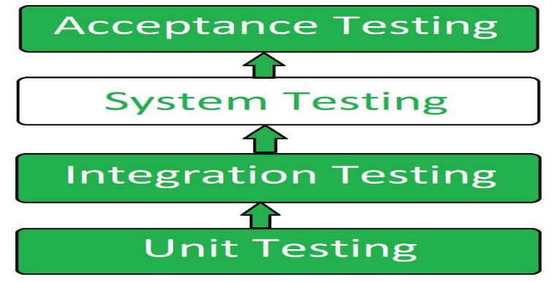

**System Testing Process:** System Testing is performed in the following steps:

* **Test Environment Setup:** Create testing environment for the better quality testing.
* **Create Test Case:** Generate test case for the testing process.
* **Create Test Data:** Generate the data that is to be tested.
* **Execute Test Case:** After the generation of the test case and the test data, test cases are executed.
* **Defect Reporting:** Defects in the system are detected.
* **Regression Testing:** It is carried out to test the side effects of the testing process.
* **Log Defects:** Defects are fixed in this step.
* **Retest:** If the test is not successful then again test is performed.

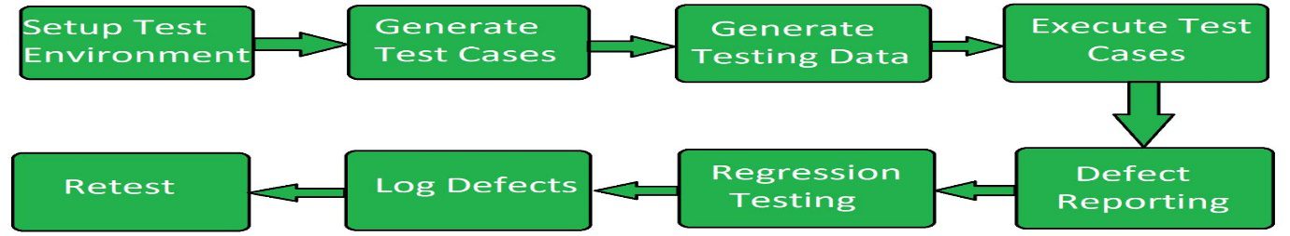

Common tools used for System Testing:

1. HP Quality Center/ALM
2. IBM Rational Quality Manager
3. Microsoft Test Manager
4. Selenium
5. Appium
6. LoadRunner
7. Gatling

**Advantages of System Testing**

* Verifies the overall functionality of the system.
* Detects and identifies system-level problems early in the development cycle.
* Helps to validate the requirements and ensure the system meets the user needs.
* Improves system reliability and quality.
* Facilitates collaboration and communication between development and testing teams.
* Enhances the overall performance of the system.
* Increases user confidence and reduces risks.
* Facilitates early detection and resolution of bugs and defects.
* Supports the identification of system-level dependencies and inter-module interactions.
* Improves the system’s maintainability and scalability Coding

**6.FUTURE SCOPE OF THE PROJECT**

Smart home automation has been gaining popularity over the years, and the addition of 3D home design modules can greatly enhance its capabilities. With 3D home design modules, homeowners and designers can create detailed virtual models of their homes and visualize how different smart home automation systems will fit into the space.

Here are some potential future and scopes of smart home automation using 3D home design module:

* **Customization:** 3D home design modules enable homeowners to customize their smart home automation systems to fit their specific needs. They can see how different systems will look and function in their home before making any final decisions.
* **Increased Efficiency:** Smart home automation systems can increase the efficiency of energy usage, security, and other aspects of home management. With 3D home design modules, homeowners can design systems that are specifically tailored to their homes and lifestyles, which can further increase efficiency.
* **Integration:** 3D home design modules can allow homeowners to integrate multiple smart home automation systems into a single platform. This will help to simplify the management of various systems, and allow for a more streamlined experience.
* **Remote Access:** 3D home design modules can also allow homeowners to remotely access and control their smart home automation systems. This can be particularly useful for people who travel frequently or have multiple homes.
* **Increased Value:** Smart home automation systems can increase the value of a home, and the addition of 3D home design modules can help homeowners to visualize the potential value of different systems before investing in them.

Overall, the future and scope of smart home automation using 3D home design modules is promising. As technology advances, we can expect to see even more sophisticated systems that can be easily integrated and controlled through 3D home design modules**.**

**7.REFERENCE**

* "3D Home Design Software: The Future of Smart Home Automation" by Mary Parker. This article discusses how 3D home design software can be used to design and visualize smart home automation systems.
* "Designing Smart Homes with 3D Home Design Software" by Michelle Kaufman. This article explores the benefits of using 3D home design software to create smart homes that are customized to the needs of the homeowners.
* "The Benefits of Using 3D Home Design Software for Smart Home Automation" by Scott Ferguson. This article discusses how 3D home design software can help homeowners to design and deploy smart home automation systems that are efficient, secure, and easy to use.
* "Smart Home Design: Using 3D Home Design Software for Home Automation" by Lisa Montgomery. This article provides an overview of how 3D home design software can be used to design and deploy smart home automation systems, as well as some tips for choosing the right software.
* "Building a Smart Home: How 3D Home Design Software is Revolutionizing the Industry" by Sarah Foster. This article discusses how 3D home design software is changing the way that smart homes are designed and built, and the benefits that it provides to homeowners, designers, and builders alike.