TICHI – Katomaran_Defect_Report
Defect 1
Defect_Id: D_001.
Test_case_Id: TC_007.
Description: Verify that the user can't use an Email address which starts with special character in the Sign In page.
Module: Sign Up Page.
Test Data: E-mail: #suryasprsnl123@gmail.com
Steps to Reproduce:
1. Open the website.
2. Click the Sign In button.
3. Enter Invalid email address.
4. Click 'continue' button.

Expected Result: An alert message should be appeared to enter a valid email address for Sign in when the user enters the invalid input.
Actual Result: No alert message appears and it navigates to the next page even the mail is invalid.
Status: New/Open for failed cases.
Severity: Medium.
Priority: High.

Screenshot:
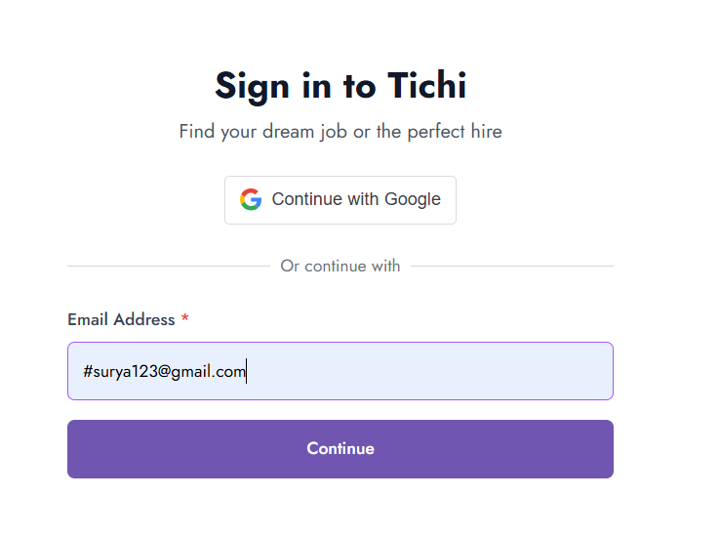
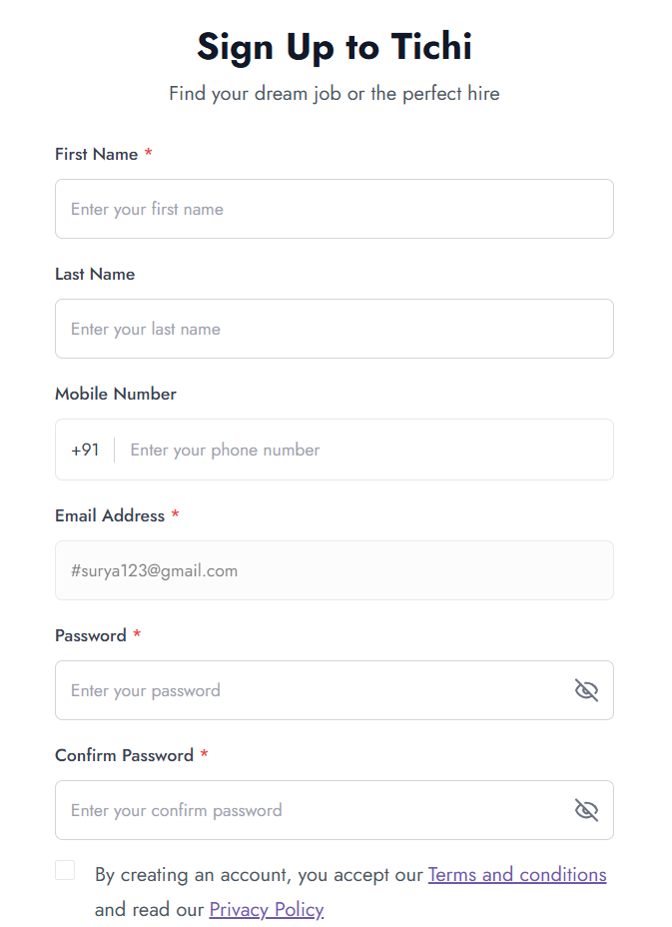

Remarks: Invalid E-Mail also supported in the E-mail address field and navigated to the next page.

Defect 2

Defect_Id: D_002.
Test_case_Id: TC_022.
Description: Verify the user can sign in by using the specific password based on the rules.
Module: Sign Up Page.
Test Data:
- E-mail: suryasprsnl1234@gmail.com or some other sample mail for execution.
- First Name: Balasurya
- Last Name: G
- Mobile Number: 8111018494
- Password: Suryacys_11
- Confirm Password: Suryacys_11
Steps to Reproduce:
1. Open the website.
2. Click the Sign In button.
3. Enter the Email address.
4. Click the 'Continue' button.
5. Enter the First Name
6. Enter the Last Name.
7. Enter the Mobile Number.
8. Create a password and confirm that password.
9. Select the check box and click the Sign Up button.

Expected Result: The user should be navigate to the next page for email verification when he enters the valid credentials.
Actual Result: An alert message is coming like 'Password must be alpha numeric' and the user does not navigate to the next page even the password rules are matching.
Status: New/Open for failed cases.
Severity: Medium.
Priority: Medium.

Screenshot:
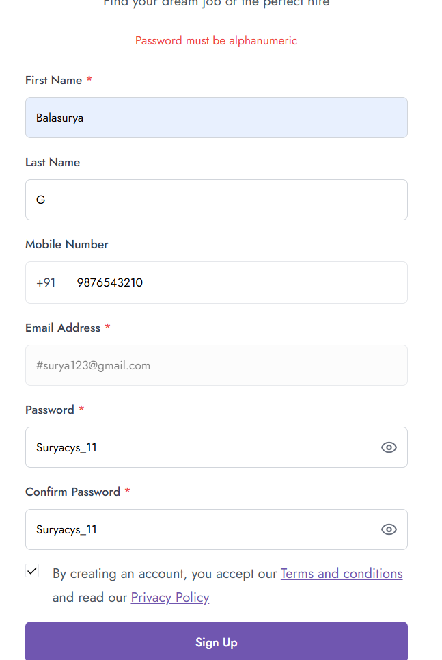

Remarks: The user can't able to redirect to the next page by using this password. It not supports the underscore special character.

DEFECT 3

Defect_Id: D_003.
Test_case_Id: TC_023.
Description: Verify the password matching section and the alert message in the Sign Up Page.
Module: Sign Up Page.
Test Data:
- E-mail: suryasprsnl1234@gmail.com or some other sample mail.
- First Name: Balasurya
- Last Name: G
- Mobile Number: 8111018494
- Password: Suryacys_11
- Confirm Password: Suryacys_11

Steps to Reproduce:
1. Open the website.
2. Click the Sign In button.
3. Enter the Email address.
4. Click the 'Continue' button.
5. Enter the First Name
6. Enter the Last Name.
7. Enter the Mobile Number.
8. Create a password and confirm that password.
9. Select the check box and again click the Confirm password field.

Expected Result: When the user enters the password and confirms the password. The information such as 'Confirm password must be match with password' should be disappear
Actual Result: The message 'Confirm password must be match with password' is again coming when the user clicks the confirm password text box even the user enters the matching password.
Status: New/Open for failed cases.
Severity: Low.
Priority: Medium.

Screenshot:

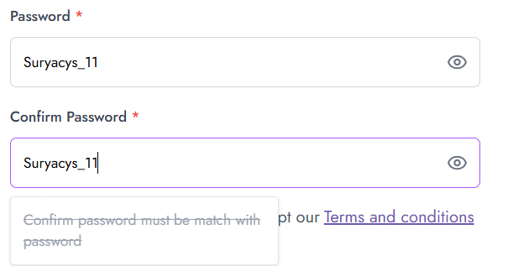

Remarks: The alert message is again coming when the user clicks the confirm password input field even the password is matching.

DEFECT 4

Defect_Id: D_004.
Test_case_Id: TC_029.
Description: Verify that user can create an account with the credentials of deleted account.
Module: Sign Up Page.
Test Data:
- E-mail: suryasprsnl1234@gmail.com or any sample mail.
- First Name: Balasurya
- Last Name: G
- Mobile Number: 8111018494
- Password: Suryacys#11
- Confirm Password: Suryacys#11

Steps to Reproduce:
1. Open the website.
2. Click the Sign In button.
3. Enter the Email address.
4. Click the 'Continue' button.
5. Enter the First Name
6. Enter the Last Name.
7. Enter the Mobile Number.
8. Create a password and confirm that password.
9. Select the check box and click the Sign Up button.
10. Verify through Gmail.
11. Click the profile Icon
11. Click the Delete account

Expected Result: The user should able to create another account with the same name, mobile number and Email that he already used for account creation and delete it.
Actual Result: The alert message appeared like 'User already exist' even the credentials and account has been deleted.
Status: New/Open for failed cases.
Severity: Medium.
Priority: Medium.

Screenshot:

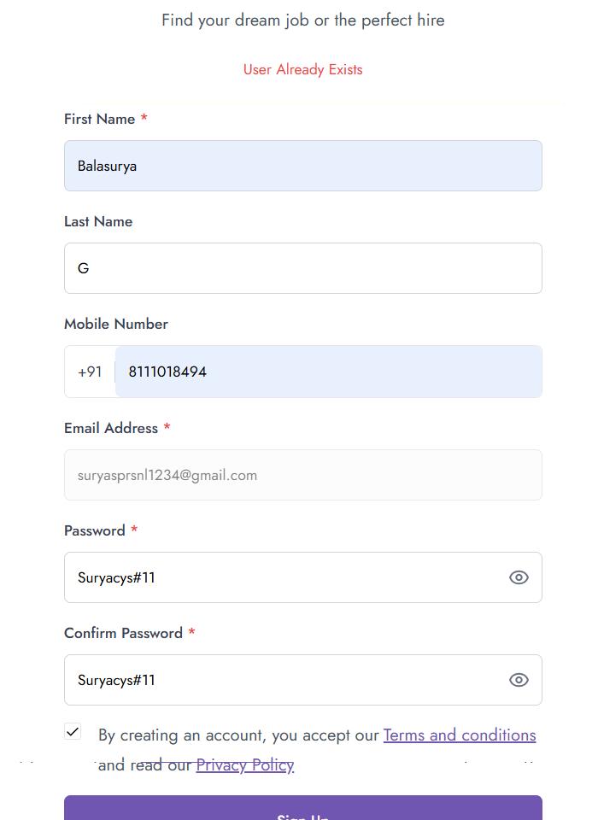

Remarks: Email/Account not properly deleted from system.

DEFECT 5

Defect_Id: D_005.

Test_case_Id: TC_031.

Description: Verify the user can Sign Up by using Invalid email after he navigates to the Sign Up page.
Module: Sign Up Page.

Test Data:
- E-mail: #suryasprsnl123@gmail.com or any invalid mail id
- First Name: Balasurya
- Last Name: G
- Mobile Number: 8111018494
- Password: Suryacys#11
- Confirm Password: Suryacys#11

Steps to Reproduce:
- Open the website.
- Click the Sign In button.
- Enter the Invalid Email address.
- Click the 'Continue' button.
- Enter the First Name
- Enter the Last Name.
- Enter the Mobile Number.
- Create a password and confirm that password.
- Select the check box and click the Sign Up button.

Expected Result: An alert message should be appeared as 'E-mail must be an E-mail' for Sign Up and it should not navigate to the next page.

Actual Result: The Sign Up is working even though the user use the Invalid E-mail address and it moves to the next page.

Status: New/Open for failed cases.

Severity: Medium.

Priority: High.

Screenshot:

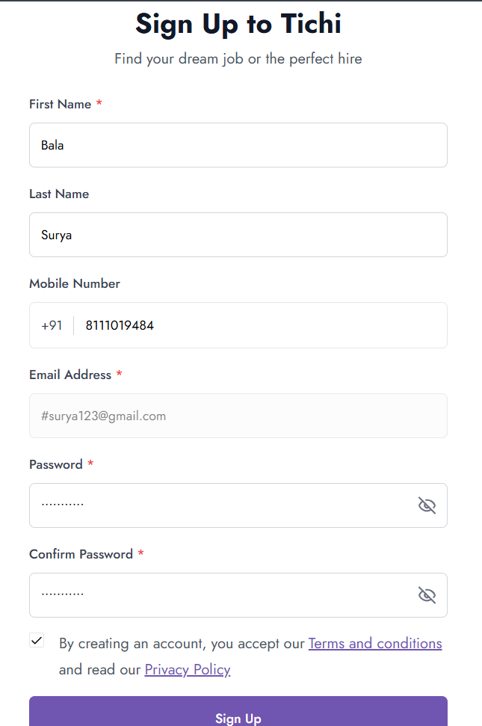

The user account sign up is navigates to the verification page with Invalid mail id.

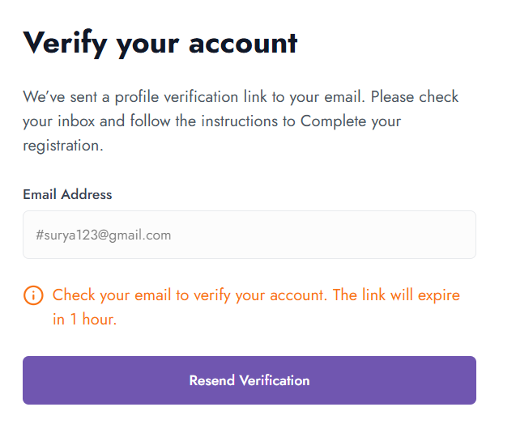
Remarks: Invalid E-Mail is supported for Sign Up process.
DEFECT 6

Defect_Id: D_006.

Test_case_Id: TC_032.

Description: Verify the user can Enter the valid mobile number for country code +91.
Module: Sign Up Page.

Test Data:
- E-mail: suryasprsnl1234@gmail.com
- First Name: Balasurya
- Last Name: G
- Mobile Number: 2345018494
- Password: Suryacys#11
- Confirm Password: Suryacys#11

Steps to Reproduce:
- Open the website.
- Click the Sign In button.
- Enter the valid Email address.
- Click the 'Continue' button.
- Enter the First Name
- Enter the Last Name.
- Enter the Invalid Mobile Number.
- Create a password and confirm that password.
- Select the check box and click the Sign Up button.

Expected Result: The Mobile Number should be valid and correct based on the country code (+91). The user should not sign up using the invalid mobile number or some alert has to be appeared as ‘incorrect mobile number’.

Actual Result: The User can enter any 10 digit number that is irrelevant to the country code. The user was able to continue the Sign Up process.

Status: New/Open for failed cases.

Severity: Medium.

Priority: Medium.

Screenshot:
Enter a invalid mobile number:
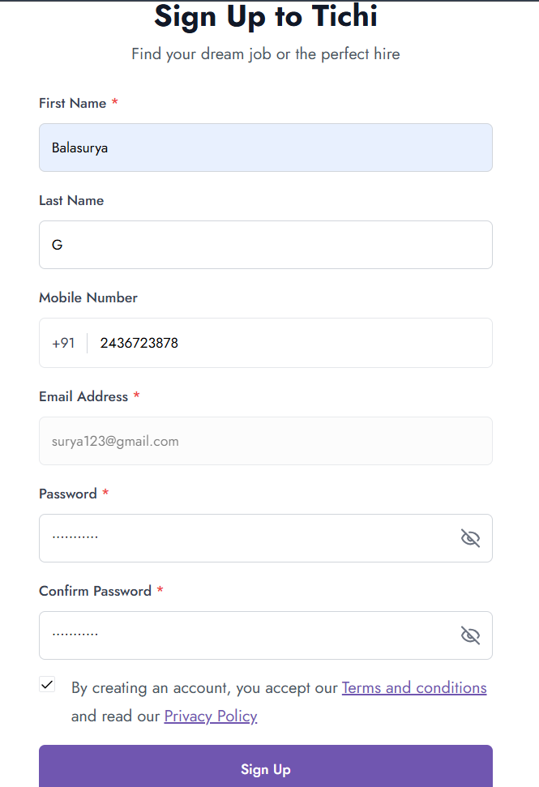

The Sign Up is working even the mobile number is invalid.

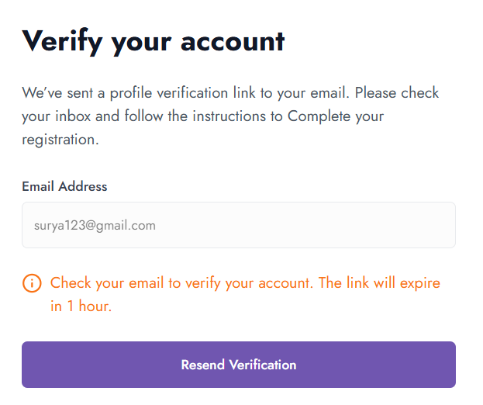

Remarks: Mobile Number validation based on the country code is not working and the user can Sign Up with invalid mobile number on basis of the country code.

