Establish a new directory, populate it with script files, initiate an empty repository on GitHub, convert the local directory into a Git repository, and link it to GitHub to push the code into the repository.

To create a new directory:

Command used is mkdir

Created a new repository in github called guvi_surya

Created a local file called “file” using touch command

To add it to staging command used: “git add .”

To commit the change: “git commit –m “commit message”

To push the changes into the main branch “git push –u origin main”

Changes has been populated in the main branch.

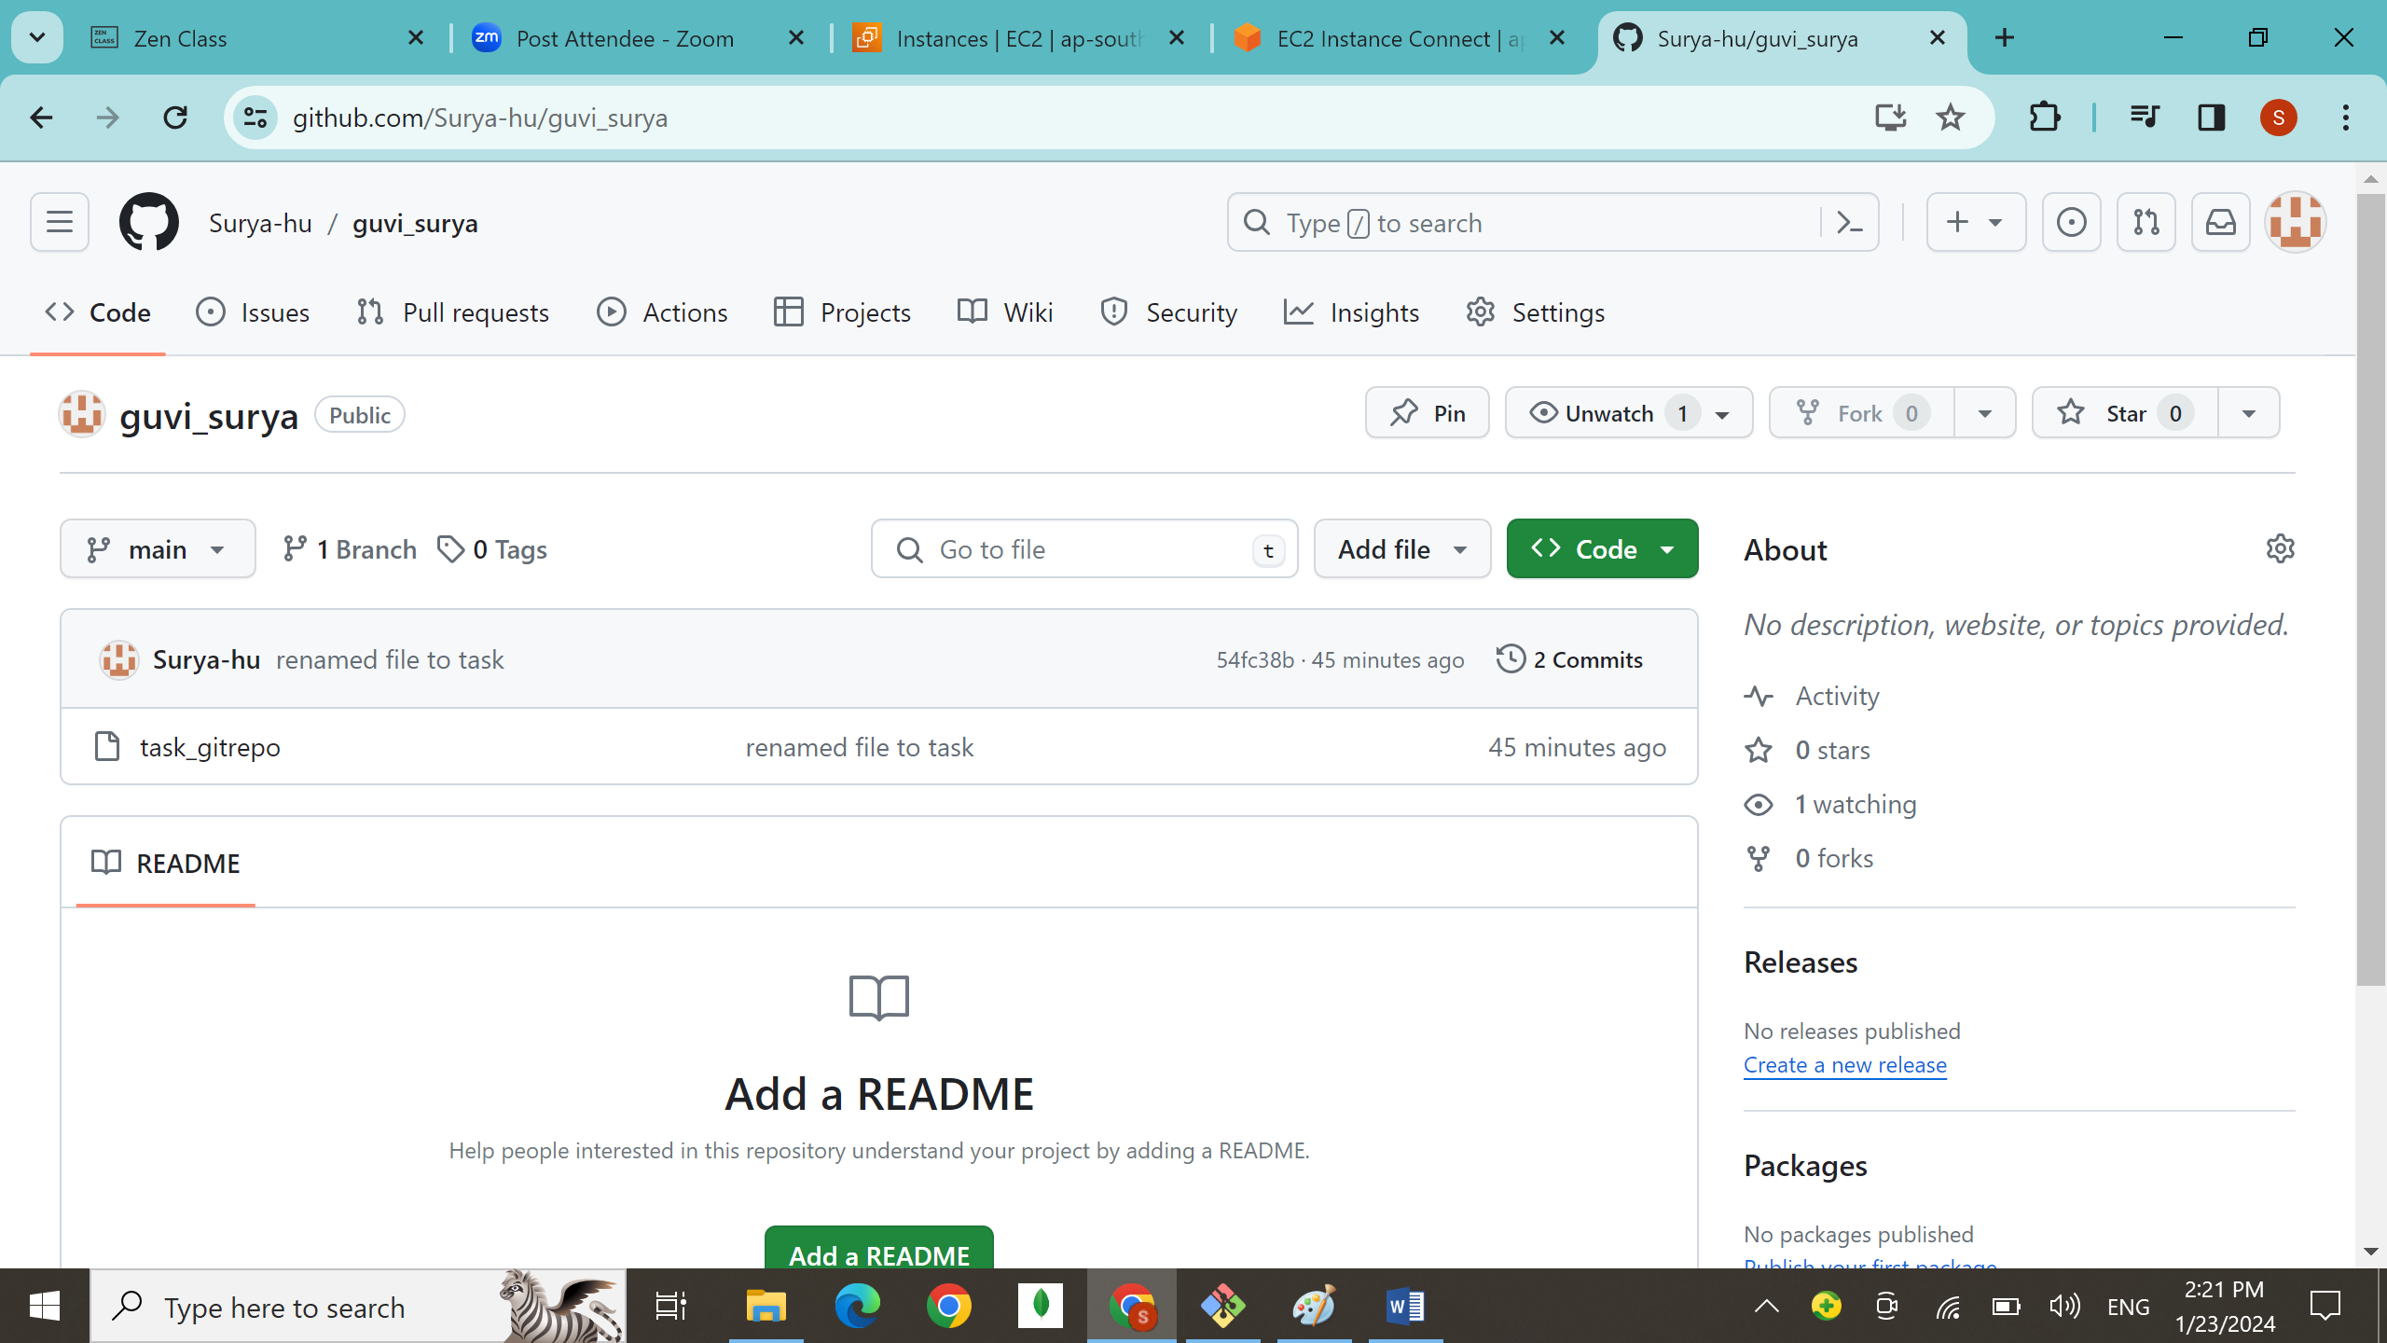

Converting local directory as git repo

Command: git init foldername

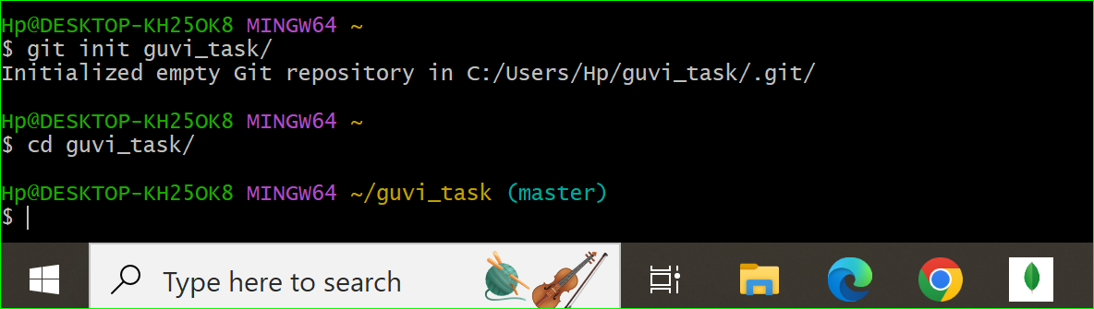

Pushing the local repo to github main branch;

