Install docker on EC2 and explore the docker commands (docker images, containers, volumes, network)

1. To install we need first to update using “apt update”
2. To install docker: “apt install docker.io”

After installed:

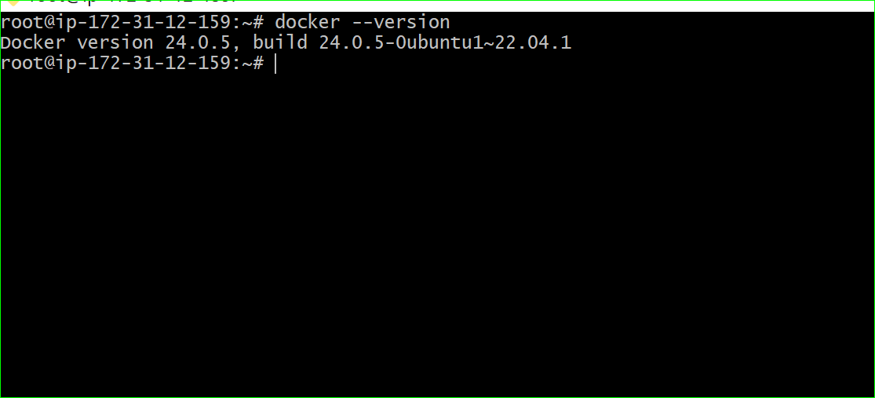

Docker commands used:

1. Docker run -itd -p “8000:80” httpd
2. Docker images
3. Docker ps
4. Docker network ls
5. docker volume create volume
6. Docker volume ls

As shown below picture:

