**INDIAN POSTAL DELIVERY AUTOMATION**

**AN MAJOR REPORT**

***Submitted by***

## Darshan Ramesh [RA1911026010011]

## Paluru Surya Kiran [RA1911026010057]

*Under the guidance of*

## A. Jackulin Mahariba

(Assistant Professor, Department of Department of Computational Intelligence)

***in partial fulfillment for the award of the degree of***

**BACHELOR OF TECHNOLOGY**

in

## COMPUTER SCIENCE & ENGINEERING

of

**FACULTY OF ENGINEERING AND TECHNOLOGY**



S.R.M.Nagar, Kattankulathur, Chengalpattu District

**MAY 2023**

SRM INSTITUTE OF SCIENCE AND TECHNOLOGY

(Under Section3 of UGC Act,1956)

## BONAFIDE CERTIFICATE

Certified that this project report titled ”INDIAN POSTAL DELIVERY AUTOMATION” is the bonafide work of “PALURU SURYA KIRAN [ RA1911026010057 ], DARSHAN RAMESH [ RA1911026010011]”, who carried out the project work under my supervision. Certified further, that to the best of my knowledge the work reported herein does not form any other project report or dissertation on the basis of which a degree or award was conferred on an earlier occasionon this or any other candidate.

**SIGNATURE**

Jackul Mahariba **GUIDE**

Assistant Professor Dept.of Department Computational Inelligence

### SIGNATURE

Dr. Annie Uthra R

**HEAD OF THE DEPARTMENT**

Professor

Department of Computational Intelligence

# ACKNOWLEDGEMENT

It is a great pleasure to have the opportunity to extend our heartfelt gratitude to everyone who helped us throughout the course of this project. We are profoundly grateful to our supervisor A. Jackulin Mahariba, Department of Computational Intelligence, College of Engineering & Technology, SRM Institute of Science and Technology, for his expert guidance, continuous encouragement and ever willingness to spare time from his otherwise busy schedule for the project’s progress reviews. His continuous inspiration has made us complete this project and achieve its target. We would also like to express our deepest appreciation. We would also like to convey our gratitude to the panel members who gave us timely feedback and suggestions for the project scope to be ex- tended further as well

# ABSTRACT

The Indian Postal Automation project aims to address the inefficiency and challenge in India's existing manual postal system. This project aims to design and implement an automated postal system that can improve the speed and accuracy of postal operations while reducing the cost of operations. This paper addresses the most common and essential problem in the postal department of parcel segregation tasks by proposing a fully-automated solution. The proposed methodology uses bidirectional LSTM for handwritten address recognition, followed by address parsing techniques and the construction of knowledge graphs to pinpoint the accurate location of the delivery. This proposed solution can bring the parcel segregation process from hours to

|  |
| --- |
|  |

## CHAPTER 1

**INTRODUCTION**

## Problem Statement

India is one of the world's most significant postal systems, with roughly 1.5 lakh post offices and around 6 lakh post boxes for collecting packages. The suggested solution employs BiLSTM for handwritten address recognition, then employs address parsing methods and knowledge graph creation to determine the precise location of the delivery.

Bidirectional LSTM (BiLSTM) is a recurrent neural network used primarily for natural language processing. Unlike standard LSTM, the input flows in both directions and can utilize information from both sides. It is also a powerful tool for modeling the sequential dependencies between words and phrases in both directions of the sequence. Address parsing is breaking down an address into its parts. Many applications, such as geocoding and record linking, depend on this activity. Determining the various components of a lesson can be helpful when locating a specific location using textual information.

## Objective

## Design and build an OCR model to recognize the handwritten text written on the postal card.

## Design and build an address parser for parsing the address information form the text extracted from the OCR model.

## Construction of Knowledge graph from the data returned by the address parser.

## Generation of exact location from the data in knowledge graph.

## Motivation

Every day, millions of letters and couriers are delivered worldwide. Indian postal services earn around 1700 crores per annum and is said to be world's most widely distributed postal system, with a collection of around 1.5 lakh post offices. More than 100 million parcels are delivered every year on average There are almost 6Lac post boxes from which letters are collected. 6 Usually when a courier or mail is sent to PO, a person manually reads and segregates the letters based on which city and state the letter is supposed to go. Automatic sorting of mailing items plays a crucial role in the postal service system. In such a situation, an OCR module is required to recognise the postal address on mailing items and a parser module to parse the address.

## Innovation Idea Of Project

## We There is no previous model exists that is fully automated with minimal human intervention. We are aiming to design an efficient solution that is fully automated as well as easy to use. There is no address parser designed for Indian postal address. Current Indian postal automation projects are limited to pin-code detection and segregation based on the pin-code. We are aiming to design the project that can take address into consideration to minimize the error to a greater extent.

### Gathering the Data :

The data for address parser was manually created

The data includes

* + - * Address - The whole address manually created
      * Building name – Name of building extracted from address
      * Building number – No. of building extracted from address
      * City – City extracted from address
      * Recipient – Recipient extracted from address
      * Street – Name of street extracted from address
      * Zip Code – zip code extracted from address
      * State – Name of state extracted from address
      * Area – name of area or region extracted from address

## Chapter 2

## Literature Survey

**Marouane Yassine, David Beauchemin, Franc¸ois Laviolette, Luc Lamontag (2021)**  in their paper titled Multinational **Address Parsing: A Zero-Shot Evaluation** have used Multinational address parsing using a Recurrent Neural Network (RNN)

**Hao Li , Wei Lu, Pengjun Xie, Linlin Li** a recent endeavour in **2019** have used a Neural Network approach and have recorded the implementation in their paper titled **Neural Chinese Address Parsing**

**Mustain Billah, Md. Kamruzzaman Ruman, Nazmus Sadat, Md. Mahfuzul Islam**, in the article named **Bangladeshi Post Office Automation System Using Neural Network 2019,** authors have checked positional and statistical features like GLCM, LBP, Histogram of oriented gradients

**Hongjian Zhan, Shujing Lyu, Umapada Pal, Yue Lu,** have concluded in their paper **CNN-based Hindi Numeral String Recognition for Indian Postal Automation** in **2019** Convolutional Neural Network and Connectionist temporal classification

**Xiang Li, Hakan Kardes, Xin Wang, Ang Sun,** have used an HMM based approach and documented it in **HMM-based Address Parsing: Efficiently Parsing Billions of Addresses on MapReduce** in year **2014.**

**S. Thadchanamoorthy, N. D. Kodikara; H.L.Premaratne, Umapada Pal, Fumitaka Kimura** in their paper titled **Tamil Handwritten City Name Database Development and Recognition for Postal Automation 2013,** have used MQFD for likelihood estimation of a letter

**Bharath V, N. Shobha Rani,** in the article named **A Font style classification system for English OCR 2017,** authors have used a technique for classification of the font style based on character image is proposed by employing the distance profile features with respect to left, right and diagonal directions of a character image.

**Rohit Saluja, Devaraj Adiga, Parag Chaudhuri, Ganesh Ramakrishnan, Mark Carman** have concluded in their paper **Error Detection and Corrections in Indic OCR using LSTMs** in **2017** a Long Short-Term Memory (LSTM) based character level language model with a fixed delay for discriminative language modeling in the context of OCR errors for jointly addressing the problems of error detection and correction in Indic OCR

**Thi-Tuyet-Hai Nguyen L3i, Adam Jatowt Graduate Mickael Coustaty L3i, Nhu-Van Nguyen L3i, Antoine Doucet L3i** have used Five aspects related to general OCR errors are studied and compared with human-generated misspellings, including edit operations, length effects, erroneous character positions, real-word vs. non-word errors, and word boundaries and documented it in **Deep Statistical Analysis of OCR Errors for Effective Post-OCR Processing** in year **2019.**

**Abhash Sinha, Martin Jenckel, Syed Saqib Bukhari, Andreas Dengel** in their paper titled **Unsupervised OCR Model Evaluation Using GAN 2019,** have used OCR model evaluation with Generative Adaptive Neural networks

**Isuri Anuradha, Chamila Liyanage, Harsha Wijayawardhana, Ruvan Weerasinghe** in the article named **Deep Learning Based Sinhala Optical Character Recognition (OCR) 2020,** authors have used a Tesseract OCR based model.

**Paula Cruz, Leonardo Vanneschi, Marco Painho and Paulo Rita** have concluded in their paper **Automatic Identification of Addresses: A Systematic Literature Review** in **2021** HMM with CRF augmentation based approach.

**Darren Yates, Zahidul Islam, Yanchang Zhao, Richi Nayak, Vladimir Estivill-Castro, Salil Kanhere** have used HMM and neural network based approach and documented it in **PostMatch: A framework for efficient address matching** in year **2021.**

**Jason Rigby** in his paper titled **AddressNet: A robust street address parser 2019,** used GRU type of RNN with LSTM

**Aimee Vachon, Leslie Ordonez, Jorge Fonseca** in the article named **Global Postal Automation 2021,** authors have used New Field theory with OCR.

**Purna Vithlani, Dr. C. K. Kumbharana,** have compared in their paper **A study of Optical Character Patterns identified by different OCR Algorithms** in **2018** the different OCR algorithms.Neural Network Algorithm and Support Vector Machine Algorithm are presented in this paper.

## 2.1 Research Gap

- There is no address parser exists for Indian addresses exists (to the best of my knowledge), and mostly previous models are pin-code based that fails to work in case of wrongly detected pin-code.

- Existing models are unable to identify Indian regional address terms like nagar, marg that are very common into consideration and fails to respond for those.

- Rule-based techniques are computationally efficient and provide promising results on standardized addresses but are limited in terms of classification and require intense domain knowledge

## CHAPTER 3

**SYSTEM ARCHITECTURE AND DESIGN**

## Architecture Diagram

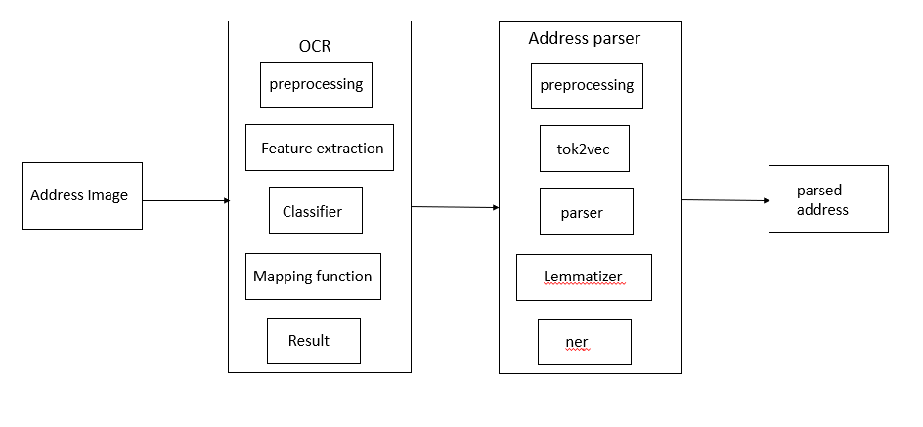

.

## Work Flow Diagram

## 

**3.3 Use Case Diagram**

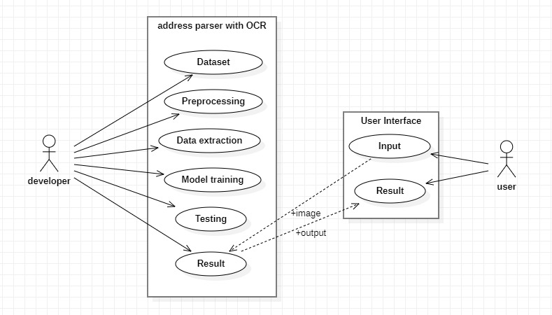

## CHAPTER 4

## METHODOLOGY

* 1. **Design Of Modules**

The project is essentially divided into two modules- OCR and Address Parser.

The work flow of the project is as described, when a courier or parcel is sent to the Post Office, a person has to manually read the address and segregate the parcels based on destination address. Everyday the Post Office receives thousands of packages. So if the work is done manually, the cost and time both increases.

To automate the reading process an OCR is required which can read the address written on packages. The OCR is used to extract the text from images using BiLSTM. This module first extracts features from the images then it tries to classify the letters or numbers based on the training data.

Then the text which is the address extracted from image is passed on to Address Parser module to extract various information regarding the address like the city name, state name, building number etc.

### 4.1.1 Module 1

### OCR

The acronym ‘OCR’ stands for Optical Character Recognition. Commonly known as ‘Text Recognition,’ it is a popular technique for extracting text from images. An OCR program is a tool that extracts and re-purposes data from scanned documents, camera images, and image-only pdf. An OCR system uses a combination of hardware, such as optical scanners and software capable of image processing.

**Keras-OCR –**This is a powerful open-source library. The Keras-OCR library provides a high-level API and end-to-end training pipeline to build new OCR models.

We can reconstruct the text which was extracted in a machine-readable format. By using the same we can select the extracted text and edit the same in regular text. By using a simpler sense OCR is converting digital data into the image format into editable words by using processing documents. This tool is advanced by using implementation techniques like intelligent character recognition which was identifying languages.

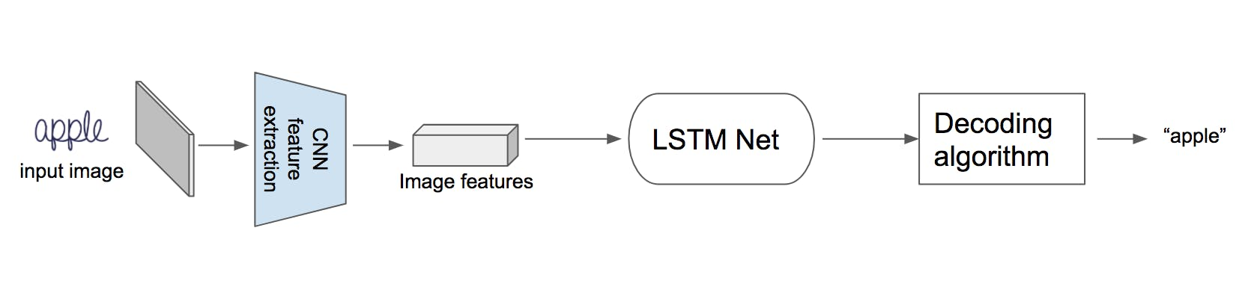

### 4.1.2 Module 2

### Address Parser

### Address parsing is one of these several pre-processing steps which helps to identify & segment an address string into different components such as Recipient, Building, Street, State, County, Postal code, and other such applicable components for that particular country

### SpaCy - spaCy is an open-source software library for advanced natural language processing, written in the programming languages Python and Cython.

 spaCy uses **Thinc**, a deep learning library, which is optimized for CPU usage (often an adoption constraint) and tackles specialized NLP tasks such as tokenization, lemmatization, part-of-speech (POS) tagging, text classification, named-entity recognition, and many others.

**NER and SpaCy -** a subtask of information extraction that seeks to locate and classify [named entities](https://en.wikipedia.org/wiki/Named_entity) mentioned in unstructured text into pre-defined categories such as person names, organizations, locations, medical codes, time expressions, quantities, monetary values, percentages, etc. spaCy provides an out-of-box [NER feature](https://spacy.io/usage/linguistic-features#named-entities) as part of its pre-trained pipelines so that you don’t necessarily have to go through the steps of building a model.

## CHAPTER 5 CODING AND TESTING

**OCR Module**

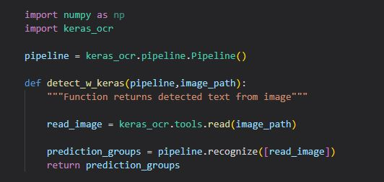

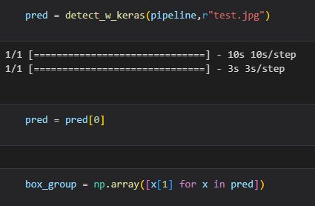

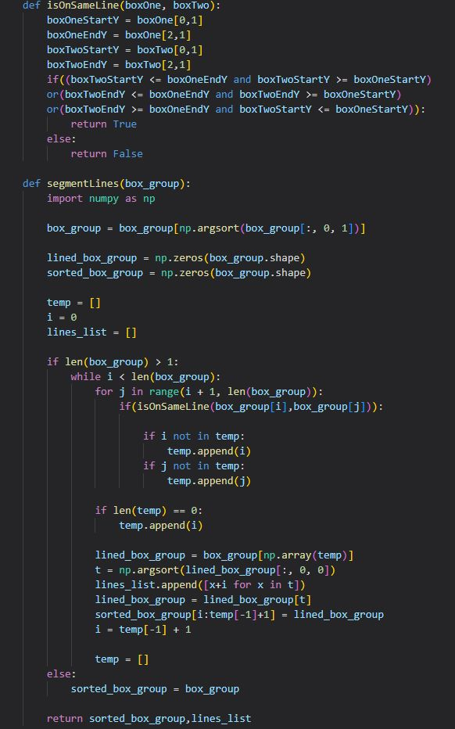

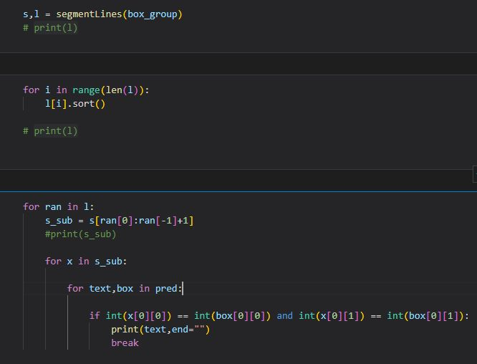

**Address Parser Module**

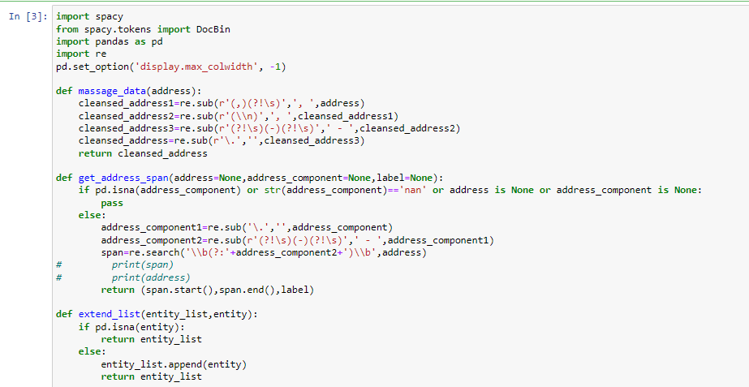

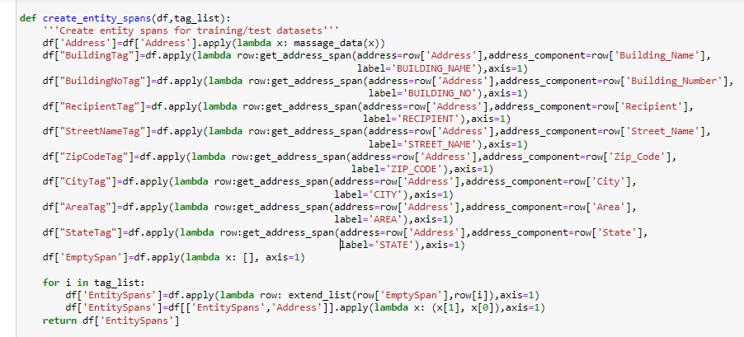

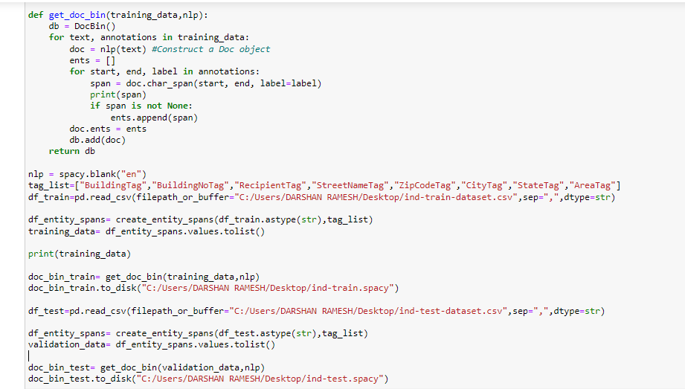

**CHAPTER 6**

**RESULTS AND DISCUSSION**

## Code output

**OCR Module**

Input:

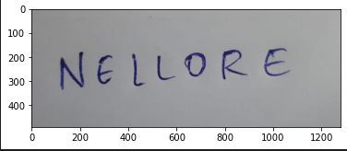

Output:



**Address Parser Module**

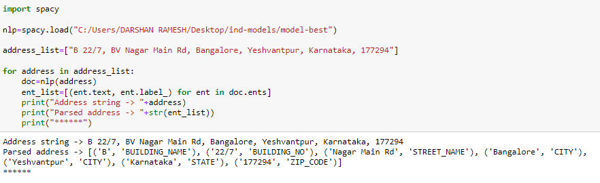

**6.2 Results and Discussions**

* The OCR module is almost able to identify all the letters of the word successfully.
* The accuracy can be improved further if the training size is increased.
* The Address Parser is able to successfully parse any address given to it.

## CHAPTER 7

## CONCLUSION AND FUTURE ENHANCEMENT

Since Its an AI tool the accuracy grows on and on as it gets feeded with new training data regularly so the scope of error in future is even more reduced so inorder enhance the accuracy we have to feed even more address and handwritten words with perfect annotation and measure the accuracies and take necessary steps for particular address and words accordingly.

# CHAPTER 8

# REFERENCES

1] Marouane Yassine, David Beauchemin, Franc¸ois Laviolette, Luc Lamontagn, Multinational Address Parsing: A Zero-Shot Evaluation 2021

2] Hao Li , Wei Lu, Pengjun Xie, Linlin Li, Neural Chinese Address Parsing 2019

3] Mustain Billah, Md. Kamruzzaman Ruman, Nazmus Sadat, Md. Mahfuzul Islam, Bangladeshi Post Office Automation System Using Neural Network 2019

4] Hongjian Zhan, Shujing Lyu, Umapada Pal, Yue Lu, CNN-based Hindi Numeral String Recognition for Indian Postal Automation 2019

5] Xinghui Dong , Junyu Dong , Huiyu Zhou , Jianyuan Sun , and Dacheng Tao Automatic Chinese Postal Address Block

Location Using Proximity Descriptors and Cooperative Profit Random Forests 2018

6] medium.com building address parser with spaCy

7] Deepak John Reji youtube channel Train Custom NER Model

8] Python Tutorial YouTube channel Word Vectors (NER)

9] towardsdatascience website AddressNet: How to build a robust street address parser using a Recurrent Neural Network

10] towardsdatascience website Build a Handwritten Text Recognition System using TensorFlow