Vehicle Detection Algorithm

**By**

**Paluru Surya Kiran RA1911026010057**

**Prasanna Sai Kuriti RA1911026010068**

**Soma Karthikeya RA1911026010066**

Contents

Project title: 2

Objective: 2

Scope: 2

Architecture diagram: 2

Implementation: 2

Results: 4

References: 5

# Project title:

**Vehicle detection algorithm using Classification**.

# Objective:

Vehicle automation being the present trend in the technology, we aim to build a basic block of the main objective of vehicle automation that is **object detection**. Object detection is a process of identifying and analyzing a object. Our objective is to build a model that could detect vehicle in an image.

# Scope:

We aim to build a model that could detect vehicle in an image. We took dataset that is readily available via online. There are too complex models in the market we aim to make it a simple. The project is completed with in duration of 2 weeks where we worked on dataset loading and pre-processing in the first week and worked on training model in the second week.

# Architecture diagram:

Import modules

Load data

Import modules

Preprocess data

# 

Predict output

# Implementation:

# Importing necessary modules

import numpy as np

import pandas as pd

import matplotlib.pyplot as plt

import seaborn as sns

import cv2

#loading the datasaet

path = r"D:\Surya\College\SEM_6\Applied Machine Learning\Assignments\Mini Project\dataset\data\vehicles/1.png"

image = cv2.imread(path)

image = cv2.cvtColor(image, cv2.COLOR_BGR2RGB)

plt.figure(figsize=(15,8))

plt.imshow(image)

plt.axis("off")

print("Shape:", image.shape)

print("Pixel(0,0):", image[0][0])

from sklearn.datasets import load_files

data = load_files("D:\Surya\College\SEM_6\Applied Machine Learning\Assignments\Mini Project\dataset\data")

data.keys()

for i in range(len(data["data"])):

data["data"][i] = cv2.imdecode(np.asarray(bytearray(data["data"][i]), dtype=np.uint8), cv2.IMREAD_COLOR)

plt.imshow(data["data"][5])

print(data["target"][5])

plt.imshow(data["data"][15000])

print(data["target"][15000])

plt.imshow(data["data"][0])

print(data["target"][0])

# building and Training a model

from sklearn.naive_bayes import MultinomialNB

from sklearn.model_selection import train_test_split

from sklearn.metrics import classification_report

X = data["data"]

y = data["target"]

n_channels = 3 #RGB

width = 64 #px

height = 64 #px

X = np.array(X).reshape(len(X),n_channels*width*height)

X_train, X_test, y_train, y_test = train_test_split(

X, y, test_size=0.1, random_state=42, shuffle=True)

clf = MultinomialNB()

clf.fit(X_train, y_train) y_pred = clf.predict(X_test)

print(classification_report(y_test, y_pred))

sns.histplot(y_pred)

n_predictions = 5

images_test = X_test[20:20+n_predictions].reshape(n_predictions, width, height, n_channels)

for i, img in enumerate(images_test):

plt.imshow(img)

plt.title(y_pred[20+i])

plt.show()

from sklearn.metrics import accuracy_score

accuracy_score(y_test,y_pred)

# Results:

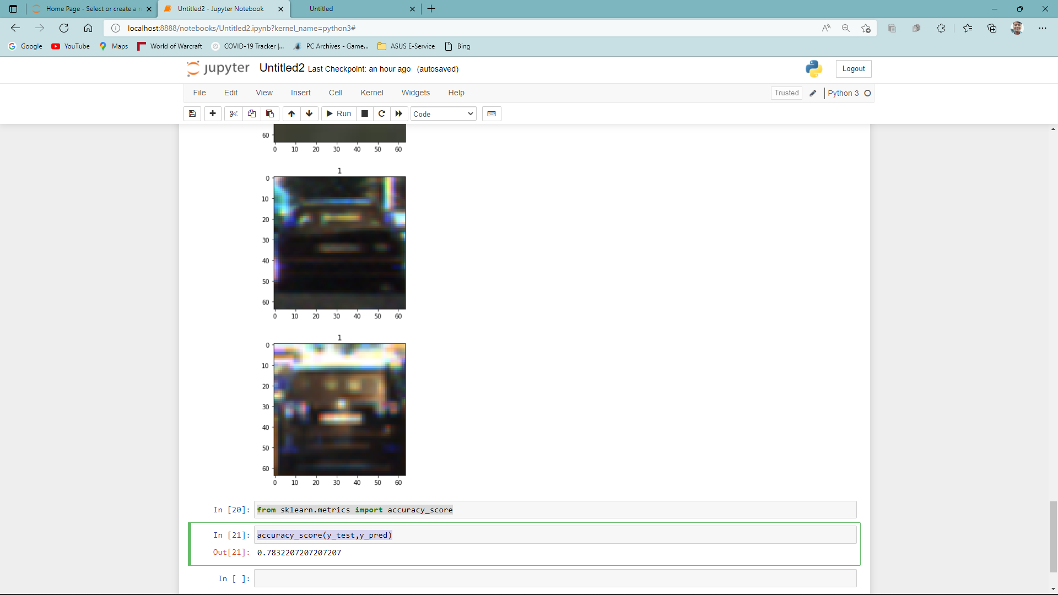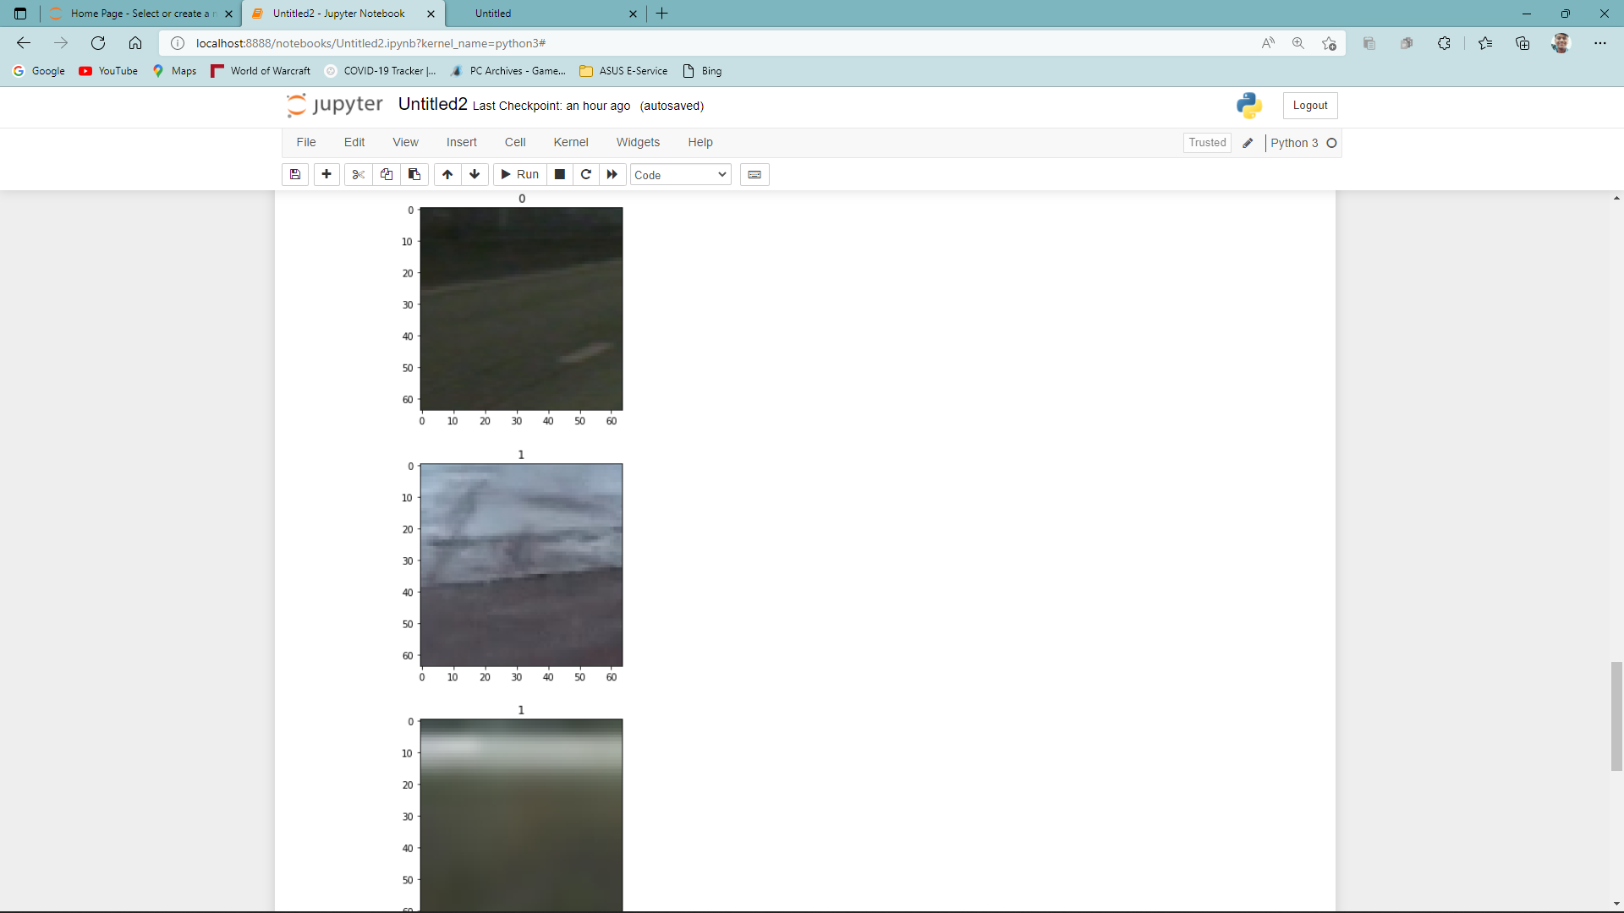

**Note: prediction 1 – true and prediction 0 is false**

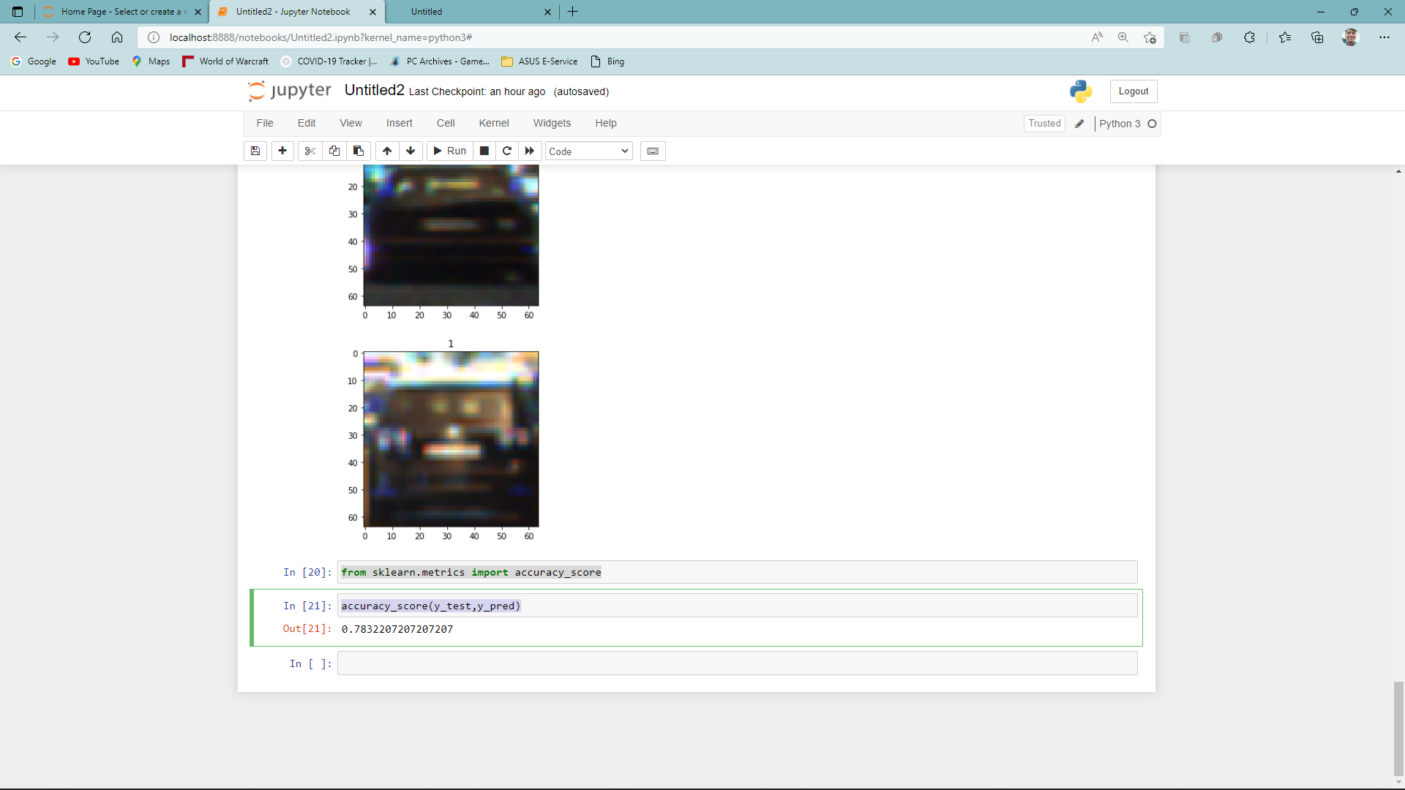

**Accuracy of our model is 78.32%**

# References:

<https://www.kaggle.com/datasets/brsdincer/vehicle-detection-image-set> (Dataset)

https://scikit-learn.org/stable/supervised_learning.html#supervised-learning