1. **package** CC_1;

**import** org.openqa.selenium.By;

**import** org.openqa.selenium.WebDriver;

**import** org.openqa.selenium.chrome.ChromeDriver;

**import** org.openqa.selenium.chrome.ChromeOptions;

**import** io.github.bonigarcia.wdm.WebDriverManager;

**public** **class** Check_1 {

**public** **static** **void** main(String[] args) **throws** Exception {

ChromeOptions co=**new** ChromeOptions();

co.addArguments("--remote-allow-origins=*");

WebDriverManager.*chromedriver*().setup();

WebDriver driver;

driver=**new** ChromeDriver();

driver.get("https://www.saucedemo.com/");

driver.manage().window().maximize();

Thread.*sleep*(4000);

driver.findElement(By.*xpath*("//*[@id=\"user-name\"]")).click();

driver.findElement(By.*xpath*("//*[@id=\"user-name\"]")).sendKeys("standard_user");

driver.findElement(By.*xpath*("//*[@id=\"password\"]")).click();

driver.findElement(By.*xpath*("//*[@id=\"password\"]")).sendKeys("secret_sauce");

driver.findElement(By.*xpath*("//*[@id=\"login-button\"]")).click();

Thread.*sleep*(4000);

driver.findElement(By.*xpath*("//*[@id=\"add-to-cart-sauce-labs-backpack\"]")).click();

String c = driver.findElement(By.*xpath*("//*[@id=\"remove-sauce-labs-backpack\"]")).getText();

**if**(c.equals("Remove")) {

System.***out***.println("Added to cart");

}

driver.findElement(By.*xpath*("//*[@id=\"shopping_cart_container\"]")).click();

String cart = driver.findElement(By.*xpath*("//*[@id=\"header_container\"]/div[2]/span")).getText();

**if**(cart.equals("Your Cart")) {

System.***out***.println("Contents of the cart is viewed");

}

driver.findElement(By.*xpath*("//*[@id=\"checkout\"]")).click();

String info = driver.findElement(By.*xpath*("//*[@id=\"header_container\"]/div[2]/span")).getText();

**if**(info.equals("Checkout: Your Information")) {

System.***out***.println("Your information form is displayed");

}

driver.findElement(By.*xpath*("//*[@id=\"first-name\"]")).sendKeys("Gokul");

driver.findElement(By.*xpath*("//*[@id=\"last-name\"]")).sendKeys("D");

driver.findElement(By.*xpath*("//*[@id=\"postal-code\"]")).sendKeys("641035");

driver.findElement(By.*xpath*("//*[@id=\"continue\"]")).click();

String name = driver.findElement(By.*xpath*("//*[@id=\"item_4_title_link\"]/div")).getText();

String price = driver.findElement(By.*xpath*("//*[@id=\"checkout_summary_container\"]/div/div[1]/div[3]/div[2]/div[2]/div")).getText();

System.***out***.println("Name of the product: " + name);

System.***out***.println("Price of the product: " + price);

String title = driver.getTitle();

String url = driver.getCurrentUrl();

**if**(title.equals("Swag Labs")) {

System.***out***.println("Title matched");

}

**if**(url.equals("https://www.saucedemo.com/checkout-step-two.html")) {

System.***out***.println("url matched");

}

driver.close();

}

}

OUTPUT:

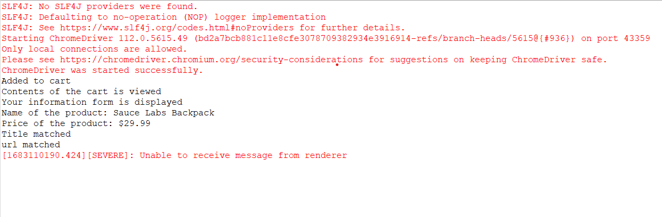

2) **package** CC_1;

**import** org.openqa.selenium.By;

**import** org.openqa.selenium.WebDriver;

**import** org.openqa.selenium.chrome.ChromeDriver;

**import** org.openqa.selenium.chrome.ChromeOptions;

**import** io.github.bonigarcia.wdm.WebDriverManager;

**public** **class** Check_2{

**public** **static** **void** main(String[] args) **throws** InterruptedException {

ChromeOptions co=**new** ChromeOptions();

co.addArguments("--remote-allow-origins=*");

WebDriverManager.*chromedriver*().setup();

WebDriver driver;

driver=**new** ChromeDriver();

driver.get("https://www.saucedemo.com/");

driver.manage().window().maximize();

Thread.*sleep*(4000);

driver.findElement(By.*xpath*("//*[@id=\"user-name\"]")).click();

driver.findElement(By.*xpath*("//*[@id=\"user-name\"]")).sendKeys("standard_user");

driver.findElement(By.*xpath*("//*[@id=\"password\"]")).click();

driver.findElement(By.*xpath*("//*[@id=\"password\"]")).sendKeys("secret_sauce");

driver.findElement(By.*xpath*("//*[@id=\"login-button\"]")).click();

Thread.*sleep*(4000);

driver.findElement(By.*xpath*("//*[@id=\"header_container\"]/div[2]/div/span/select")).click();

driver.findElement(By.*xpath*("//*[@id=\"header_container\"]/div[2]/div/span/select/option[1]")).click();

String f1 = driver.findElement(By.*xpath*("//*[@id=\"header_container\"]/div[2]/div/span/select")).getText();

Thread.*sleep*(3000);

System.***out***.println("Filtering from: " + f1);

Thread.*sleep*(3000);

String p1 = driver.findElement(By.*xpath*("//*[@id=\"item_4_title_link\"]/div")).getText();

System.***out***.println("First product name: " + p1);

driver.findElement(By.*xpath*("//*[@id=\"header_container\"]/div[2]/div/span/select")).click();

driver.findElement(By.*xpath*("//*[@id=\"header_container\"]/div[2]/div/span/select/option[2]")).click();

String f2 = driver.findElement(By.*xpath*("//*[@id=\"header_container\"]/div[2]/div/span/select")).getText();

Thread.*sleep*(3000);

System.***out***.println("Filtering from: " + f2);

String p2 = driver.findElement(By.*xpath*("//*[@id=\"item_3_title_link\"]/div")).getText();

Thread.*sleep*(3000);

System.***out***.println("First product name: " + p2);

driver.findElement(By.*xpath*("//*[@id=\"header_container\"]/div[2]/div/span/select")).click();

driver.findElement(By.*xpath*("//*[@id=\"header_container\"]/div[2]/div/span/select/option[3]")).click();

Thread.*sleep*(3000);

String f3 = driver.findElement(By.*xpath*("//*[@id=\"header_container\"]/div[2]/div/span/select")).getText();

Thread.*sleep*(3000);

System.***out***.println("Filtering from: " + f3);

String p3 = driver.findElement(By.*xpath*("//*[@id=\"item_3_title_link\"]/div")).getText();

Thread.*sleep*(3000);

System.***out***.println("First product name: " + p3);

driver.findElement(By.*xpath*("//*[@id=\"header_container\"]/div[2]/div/span/select")).click();

driver.findElement(By.*xpath*("//*[@id=\"header_container\"]/div[2]/div/span/select/option[4]")).click();

String f4 = driver.findElement(By.*xpath*("//*[@id=\"header_container\"]/div[2]/div/span/select")).getText();

System.***out***.println("Filtering from: " + f4);

String p4 = driver.findElement(By.*xpath*("//*[@id=\"item_5_title_link\"]/div")).getText();

System.***out***.println("First product name: " + p4);

driver.close();

}

}

OUTPUT:

