**DAY_4 NAME: SURYA PRAKASH M**

**REG NO:727721EUCS161**

**CE_1**

**package Day_5;**

**import org.openqa.selenium.By;**

**import org.openqa.selenium.WebDriver;**

**import org.openqa.selenium.WebElement;**

**import org.openqa.selenium.chrome.ChromeDriver;**

**import org.openqa.selenium.chrome.ChromeOptions;**

**import org.openqa.selenium.interactions.Actions;**

**import io.github.bonigarcia.wdm.WebDriverManager;**

**public class CE_1 {**

**public static void main(String[] args) throws InterruptedException**

**{**

**ChromeOptions co = new ChromeOptions();**

**co.addArguments("--remote-allow-origins=.");**

**WebDriverManager.chromedriver();**

**WebDriver driver = new ChromeDriver();**

**driver.get("https://demoqa.com/droppable/");**

**driver.manage().window().maximize();**

**Actions a = new Actions(driver);**

**WebElement source = driver.findElement(By.id("draggable"));**

**WebElement destination = driver.findElement(By.id("droppable"));**

**a.dragAndDrop(source, destination).build().perform();**

**}**

**}**

**OUTPUT:**

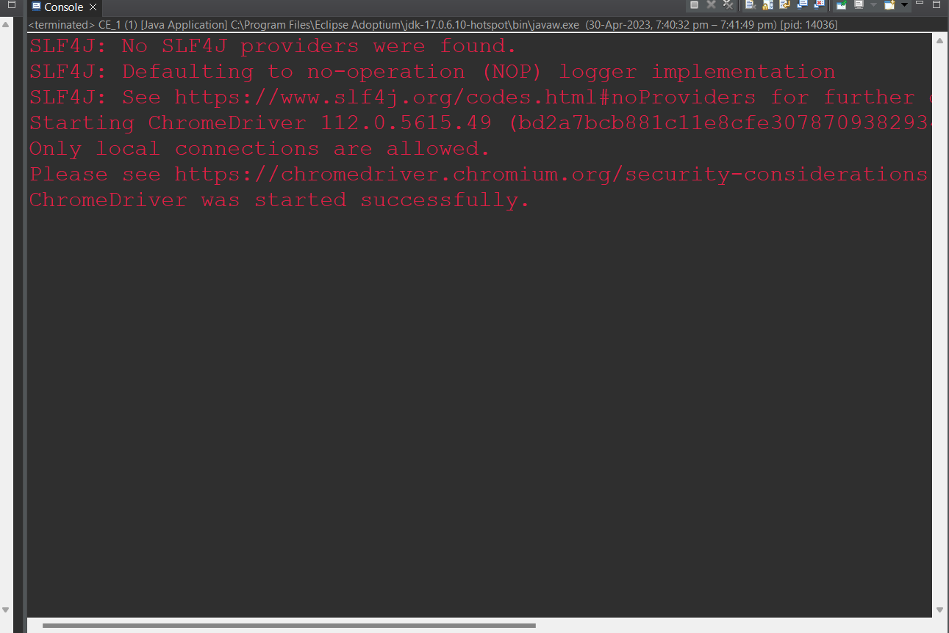

**CE_2**

**package Day_5;**

**import org.openqa.selenium.By;**

**import org.openqa.selenium.WebDriver;**

**import org.openqa.selenium.WebElement;**

**import org.openqa.selenium.chrome.ChromeDriver;**

**import org.openqa.selenium.chrome.ChromeOptions;**

**import org.openqa.selenium.interactions.Actions;**

**import io.github.bonigarcia.wdm.WebDriverManager;**

**public class CE_2 {**

**public static void main(String[] args) {**

**ChromeOptions co = new ChromeOptions();**

**co.addArguments("--remote-allow-origins=.");**

**WebDriverManager.chromedriver();**

**WebDriver driver = new ChromeDriver();**

**driver.get("https://jqueryui.com/droppable/");**

**driver.manage().window().maximize();**

**driver.switchTo().frame(0);**

**Actions a = new Actions(driver);**

**WebElement source = driver.findElement(By.id("draggable"));**

**WebElement destination = driver.findElement(By.id("droppable"));**

**a.dragAndDrop(source, destination).build().perform();**

**}**

**}**

**OUTPUT:**

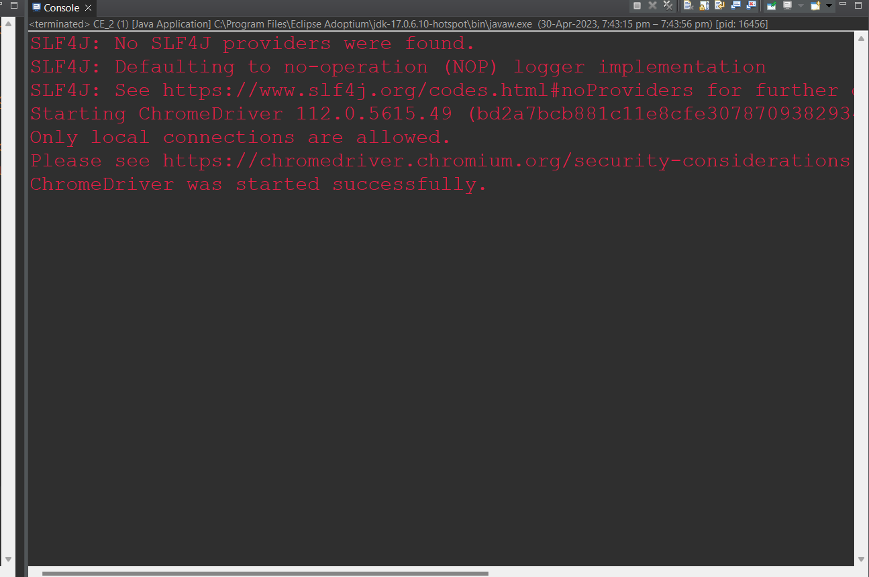

**CE_3**

**package Day_5;**

**import org.openqa.selenium.Alert;**

**import org.openqa.selenium.By;**

**import org.openqa.selenium.WebDriver;**

**import org.openqa.selenium.WebElement;**

**import org.openqa.selenium.chrome.ChromeDriver;**

**import org.openqa.selenium.chrome.ChromeOptions;**

**import io.github.bonigarcia.wdm.WebDriverManager;**

**public class CE_3 {**

**public static void main(String[] args) throws InterruptedException {**

**ChromeOptions co = new ChromeOptions();**

**co.addArguments("--remote-allow-origins=.");**

**WebDriverManager.chromedriver();**

**WebDriver driver = new ChromeDriver();**

**driver.get("https://demo.guru99.com/test/delete_customer.php");**

**driver.manage().window().maximize();**

**WebElement text = driver.findElement(By.xpath("/html/body/form/table/tbody/tr[2]/td[2]/input"));**

**text.sendKeys("401");**

**Thread.sleep(3000);**

**WebElement submit = driver.findElement(By.xpath("/html/body/form/table/tbody/tr[3]/td[2]/input[1]"));**

**submit.click();**

**Thread.sleep(2000);**

**Alert alert1 = driver.switchTo().alert();**

**alert1.dismiss();**

**text.clear();**

**text.sendKeys("402");**

**submit.click();**

**Thread.sleep(2000);**

**Alert alert2 = driver.switchTo().alert();**

**alert2.accept();**

**Alert alert3 = driver.switchTo().alert();**

**String txt = alert3.getText();**

**alert3.accept();**

**System.out.println(txt);**

**}**

**}**

**OUTPUT:**

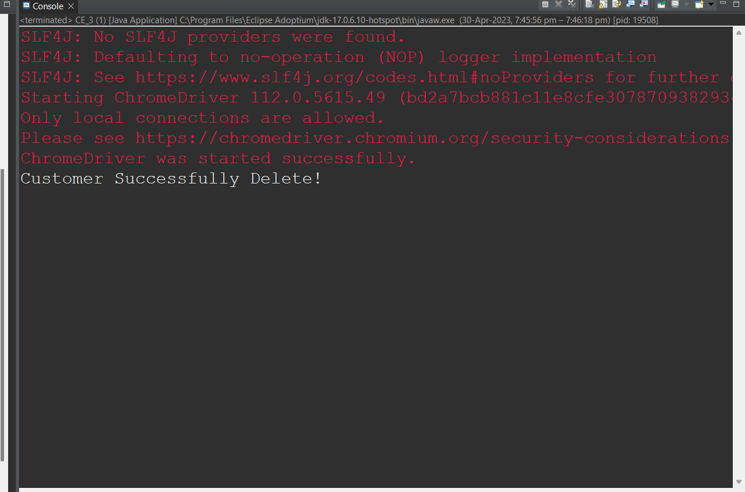

**CE_4**

**package Day_5;**

**import org.openqa.selenium.By;**

**import org.openqa.selenium.WebDriver;**

**import org.openqa.selenium.WebElement;**

**import org.openqa.selenium.chrome.ChromeDriver;**

**import org.openqa.selenium.chrome.ChromeOptions;**

**import io.github.bonigarcia.wdm.WebDriverManager;**

**public class CE_4 {**

**public static void main(String[] args) throws InterruptedException {**

**ChromeOptions co = new ChromeOptions();**

**co.addArguments("--remote-allow-origins=.");**

**WebDriverManager.chromedriver();**

**WebDriver driver = new ChromeDriver();**

**driver.get("https://www.abhibus.com/bus-ticket-booking");**

**driver.manage().window().maximize();**

**WebElement leave = driver.findElement(By.xpath("//*[@id=\"source\"]"));**

**leave.sendKeys("Coimbatore");**

**// Thread.sleep(2000);**

**WebElement going = driver.findElement(By.xpath("//*[@id=\"destination\"]"));**

**going.sendKeys("chennai");**

**Thread.sleep(2000);**

**WebElement date = driver.findElement(By.xpath("//*[@id=\"datepicker1\"]"));**

**date.click();**

**Thread.sleep(2000);**

**WebElement select = driver.findElement(By.xpath("//*[@id=\"ui-datepicker-div\"]/div[2]/table/tbody/tr[3]/td[3]/a"));**

**select.click();**

**Thread.sleep(2000);**

**WebElement button = driver.findElement(By.xpath("//*[@id=\"seo_search_btn\"]"));**

**button.click();**

**}**

**}**

**OUTPUT:**

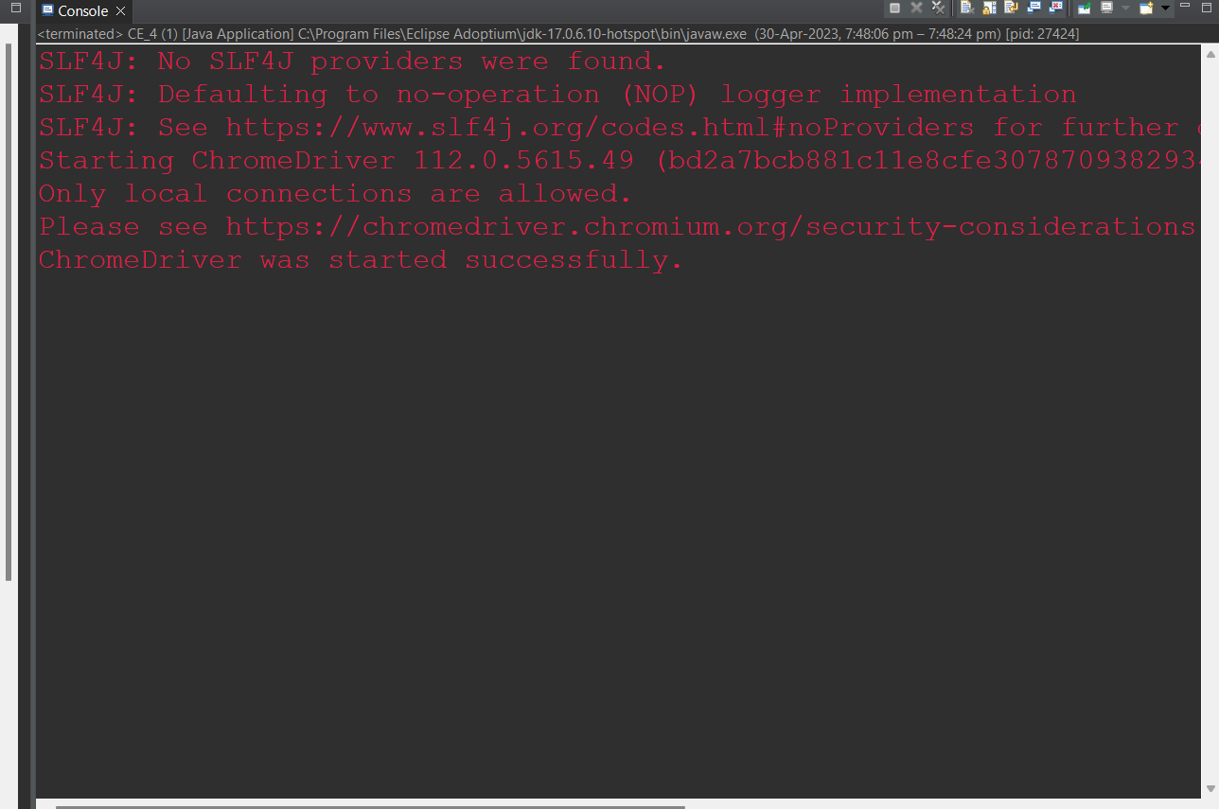

**CE_5**

**package Day_5;**

**import org.openqa.selenium.By;**

**import org.openqa.selenium.WebDriver;**

**import org.openqa.selenium.WebElement;**

**import org.openqa.selenium.chrome.ChromeDriver;**

**import org.openqa.selenium.chrome.ChromeOptions;**

**import io.github.bonigarcia.wdm.WebDriverManager;**

**public class CE_5 {**

**public static void main(String[] args) {**

**ChromeOptions co = new ChromeOptions();**

**co.addArguments("--remote-allow-origins=.");**

**WebDriverManager.chromedriver();**

**WebDriver driver = new ChromeDriver();**

**WebDriver driver2 = new ChromeDriver();**

**WebDriver driver3 = new ChromeDriver();**

**driver.get("https://www.google.com");**

**driver2.get("https://www.google.com");**

**driver3.get("https://www.google.com");**

**driver.manage().window().maximize();**

**WebElement text = driver.findElement(By.name("q"));**

**text.sendKeys("Apple");**

**WebElement btn1 = driver.findElement(By.xpath("/html/body/div[1]/div[3]/form/div[1]/div[1]/div[4]/center/input[1]"));**

**btn1.click();**

**WebElement text1 = driver2.findElement(By.name("q"));**

**text1.sendKeys("Selenium");**

**WebElement button1 = driver2.findElement(By.xpath("/html/body/div[1]/div[3]/form/div[1]/div[1]/div[4]/center/input[1]"));**

**button1.click();**

**WebElement text3 = driver3.findElement(By.name("q"));**

**text3.sendKeys("Cucumber");**

**WebElement button3 = driver3.findElement(By.xpath("/html/body/div[1]/div[3]/form/div[1]/div[1]/div[4]/center/input[1]"));**

**button3.click();**

**System.out.println(driver.getWindowHandle());**

**System.out.println(driver2.getWindowHandle());**

**System.out.println(driver3.getWindowHandle());**

**System.out.println(driver.getTitle());**

**System.out.println(driver2.getTitle());**

**System.out.println(driver3.getTitle());**

**}**

**}**

**OUTPUT:**

