LAB – 2

Aim : To perform exploratory data analysis (EDA) on a student performance dataset using Pandas and Matplotlib.
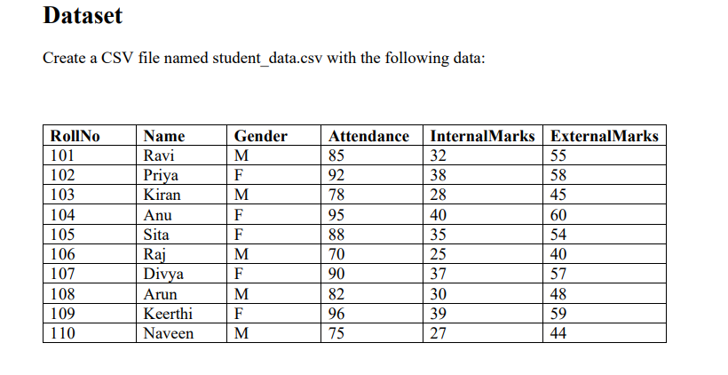
Tasks

Task A: Dataset Loading and Inspection

• Import the necessary Python libraries.
• Load the dataset into a Pandas DataFrame.
• Display the first five records.
• Display the last five records.
• Find the total number of rows and columns.
• Display the names of all columns.
• Display the data type of each column.
• Generate dataset information using info().

Code:
import pandas as pd
df = pd.read_csv(r"C:\Users\surya\Documents\students_details.csv")
df
df.head(5)
df.tail(5)
## for finding total no of rows and columns
df.shape
## for displaying column names
df.columns
#for displaying data types
df.dtypes
df.info()
Output
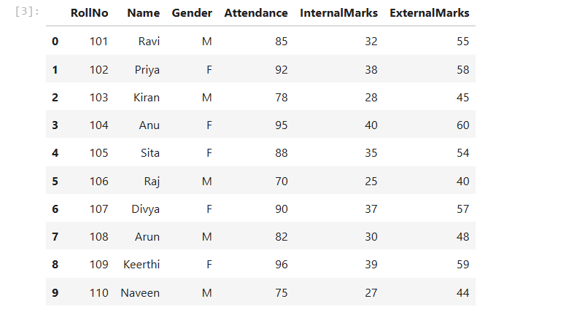
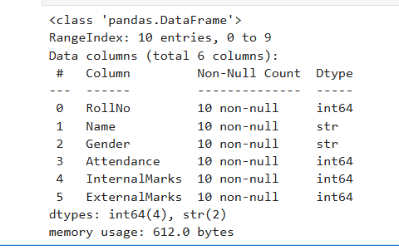
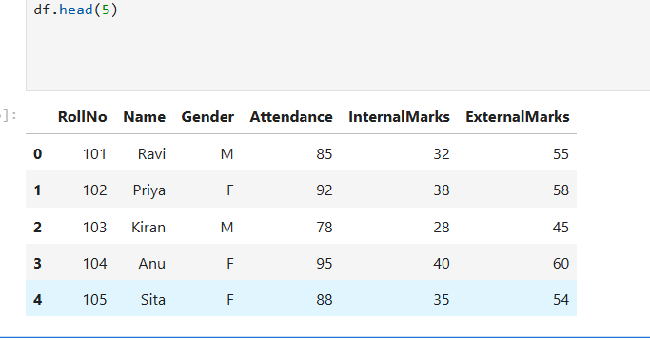
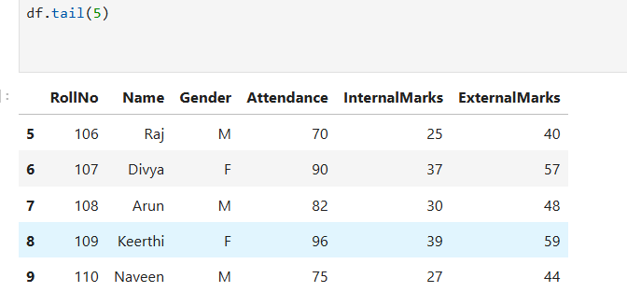
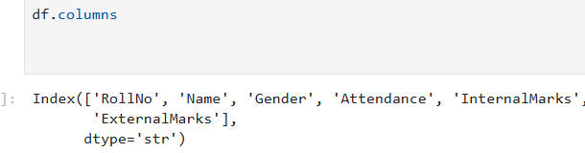
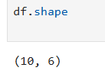

Task B: Statistical Analysis

• Calculate the mean attendance of all students.
• Calculate the average Internal Marks.
• Calculate the average External Marks.
• Find the maximum Internal Marks.
• Find the minimum Internal Marks.
• Find the maximum External Marks.
• Find the minimum External Marks.
• Calculate the standard deviation of Internal Marks.
• Generate summary statistics using describe().
Code:
#Calculate the mean attendance of all students.

print(df["Attendance"].mean())

#Calculate the average Internal Marks

print(df["InternalMarks"].mean())

#Calculate the average External Marks

print(df["ExternalMarks"].mean())

#Find the maximum Internal Marks.

print(df["InternalMarks"].max())
#Find the minimum Internal Marks.

print(df["InternalMarks"].min())
Output: #Find the maximum External Marks.

print(df["ExternalMarks"].max())

#Find the minimum External Marks.

print(df["ExternalMarks"].min())

# Calculate the standard deviation of Internal Marks.
print(df["InternalMarks"].std())
print(df.describe())

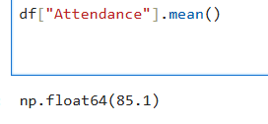
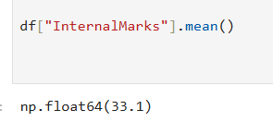
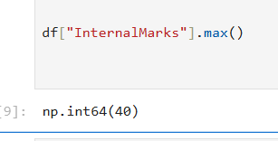
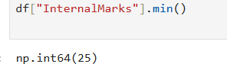
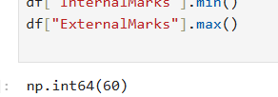
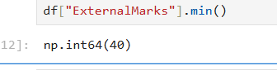
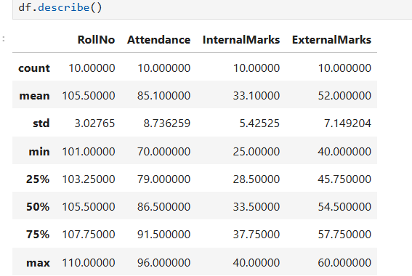

Task C: Data Manipulation
• Create a new column named TotalMarks.
• TotalMarks=InternalMarks+ExternalMarks
• Create a new column named Percentage. 1. Percentage=TotalMarks/100×100
• Display the updated DataFrame
Code:
#Create a new column named TotalMarks.

df["TotalMarks"] = df["InternalMarks"] + df["ExternalMarks"]

print(df["TotalMarks"])

#Create a new column named Percentage.
# Percentage=TotalMarks/100×100

df["Percentage"] = df["TotalMarks"]/100*100

print(df["Percentage"])

#Display the updated DataFrame

print(df)
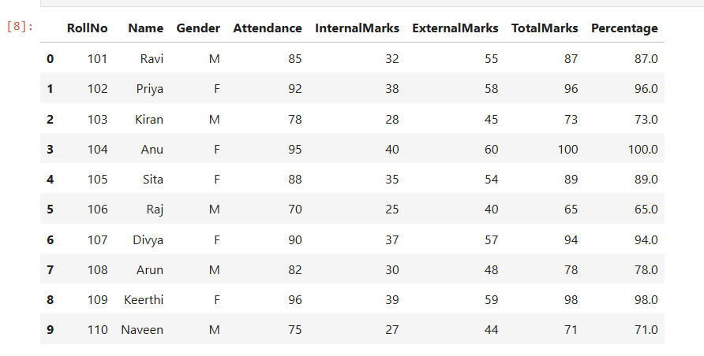
Task D: Filtering and Searching
• Display the details of students whose attendance is greater than 90%.
• Display the details of students whose TotalMarks exceed 90.
• Display the details of female students.
• Display the details of male students.
• Display students whose ExternalMarks are less than 50.
Code:
#Display the details of students whose attendance is greater than 90%.

df[df["Attendance"] > 90 ]

#Display the details of students whose TotalMarks exceed 90.
df[df["TotalMarks"] > 90]

#Display the details of female students.
df[df["Gender"] == "F"]

#Display the details of male students.
df[df["Gender"] == "M"]
# Display students whose ExternalMarks are less than 50.

df[df["ExternalMarks"] < 50]
Output
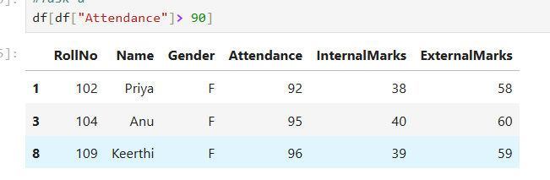
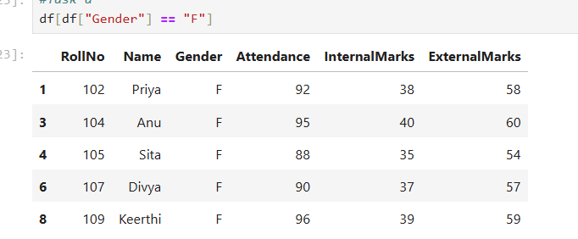
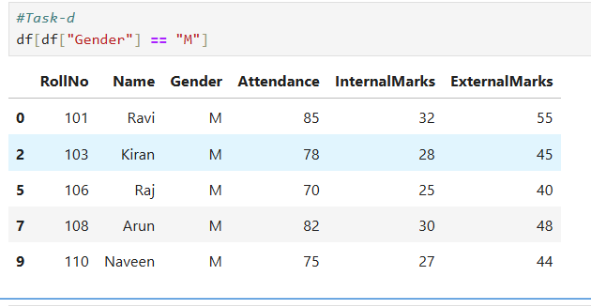
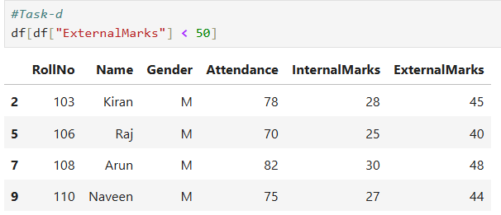
Task E: Ranking and Comparison
• Identify the student with the highest TotalMarks.
• Identify the student with the lowest TotalMarks.
• Display the top three performers based on TotalMarks.
• Display the bottom three performers based on TotalMarks.
• Determine how many students scored above the class average
Code
# Average TotalMarks by Gender
avg_male = df[df['Gender'] == 'M']['TotalMarks'].mean()
avg_female = df[df['Gender'] == 'F']['TotalMarks'].mean()
print(f"Average TotalMarks - Male : {avg_male}")
print(f"Average TotalMarks - Female: {avg_female}")

# Average Attendance by Gender
att_male = df[df['Gender'] == 'M']['Attendance'].mean()
att_female = df[df['Gender'] == 'F']['Attendance'].mean()
print(f"\nAverage Attendance - Male : {att_male}")
print(f"Average Attendance - Female: {att_female}")

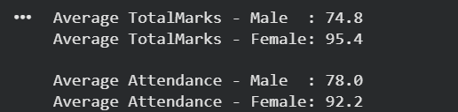
Task G: Data Visualization
• Plot a bar chart showing TotalMarks of all students.
• Plot a histogram of Attendance.
• Plot a pie chart showing the distribution of male and female students.
• Plot a scatter plot between Attendance and TotalMarks.
• Interpret the relationship between Attendance and TotalMarks.

Code:

#Task G

# 1. Bar Chart - TotalMarks of all students
plt.figure(figsize=(10, 5))
plt.bar(df['Name'], df['TotalMarks'], color='steelblue')
plt.title('TotalMarks of All Students')
plt.xlabel('Student Name')
plt.ylabel('TotalMarks')
plt.xticks(rotation=45)
plt.tight_layout()
plt.show()

# 2. Histogram - Attendance
plt.figure(figsize=(7, 4))
plt.hist(df['Attendance'], bins=5, color='orange', edgecolor='black')
plt.title('Histogram of Attendance')
plt.xlabel('Attendance (%)')
plt.ylabel('Number of Students')
plt.tight_layout()
plt.show()

# 3. Pie Chart - Gender Distribution
gender_counts = df['Gender'].value_counts()
plt.figure(figsize=(5, 5))
plt.pie(gender_counts, labels=['Female', 'Male'], autopct='%1.1f%%',
colors=['pink', 'skyblue'], startangle=90)
plt.title('Gender Distribution')
plt.show()

# 4. Scatter Plot - Attendance vs TotalMarks
plt.figure(figsize=(7, 4))
plt.scatter(df['Attendance'], df['TotalMarks'], color='green', s=100)
for i, row in df.iterrows():
plt.annotate(row['Name'], (row['Attendance'], row['TotalMarks']),
textcoords="offset points", xytext=(5, 5), fontsize=8)
plt.title('Attendance vs TotalMarks')
plt.xlabel('Attendance (%)')
plt.ylabel('TotalMarks')
plt.tight_layout()
plt.show()
Output:
