**SUMMER INTERNSHIP PROJECT REPORT**

On

AIOT AND ITS APPLICATIONS



Weed Detection And

Recommendation System Using AI

**Submitted By**

**M. Surya Rohith**

**B. Yamuna**

**U. Sruthi**

**V. Vinay Kumar**

# FROM Lakireddy Bali Reddy College of Engineering, AP.

**ORGANIZED BY NATIONAL INSISTUTE OF TECHENOOGY**

**COLLABRATED WITH BOEING PVT.LTD**

Under the guidance of

**Prof. T. KISHORE KUMAR**

**Department of ECE,**

**NIT WARANGAL**

**INDEX**

1. **Aim:** To develop an AI-based system for accurately detecting weeds and recommending appropriate pesticides to optimize crop yield.

# Objectives:

* Develop a reliable weed detection model using deep learning techniques.
* Create a comprehensive image dataset for training and validating the model.
* Implement robust preprocessing techniques to enhance data quality.
* Integrate a pesticide recommendation system based on weed detection results.
* Develop a user-friendly interface for farmers to use the system.

## Introduction:

Crop farming plays a pivotal role in the global economy, significantly contributing to countries' GDPs and providing essential food, revenue, and employment. In 2018, agriculture contributed 4% to the global GDP and accounted for over 25% of the GDP in many developing countries. As of 2020, with nearly 9% of the world's population experiencing hunger, agriculture remains a crucial sector expected to alleviate poverty and support a projected global population of 9.7 billion by 2050. However, the growth of agriculture is frequently threatened by issues such as climate change, greenhouse gas emissions, pollution, waste generation, and malnutrition. A particularly persistent problem in crop farming is weed growth, which leads to significant crop losses annually.

Weeds are unwanted plants that compete with crops for resources like space, light, water, and soil nutrients. They are often poisonous, produce thorns and burrs, and can contaminate crop harvests. Smaller weed seedlings, due to their slow growth rate, are more challenging to detect and manage compared to larger, vigorously growing weeds. The complexity of weed management is further compounded by the varying competitive nature of weeds under different conditions and seasons. For instance, the fat hen weed is dangerous to adjacent crops when it grows tall and fast but poses less threat when its seedlings appear in late summer. Similarly, chickweed, less threatening in summer, can overwhelm crops like onions and spring greens in winter. Weeds can also host pests and diseases that may spread to cultivated crops, making their management even more critical.

Traditional weed management methods, which rely heavily on manual detection and control, are expensive, labour-intensive, and often ineffective. Crop scouts are hired to manually survey fields, which is not only costly but also impractical in adverse weather conditions. These limitations make it difficult to manage weeds effectively, leading to continued crop losses each year.

This project aims to address these challenges by leveraging smart farming techniques and artificial intelligence (AI) to detect weeds in crop images using deep learning (DL). By automating weed detection, the need for crop scouts can be eliminated, and entire fields can be scanned efficiently without the management overhead. The introduction of Graphical Processing Units (GPUs) has significantly accelerated research and performance in DL applications, enabling superior image, text, video, and speech processing. Since its nascent stages before 2010 due to hardware limitations, DL has demonstrated its potential in various complex applications. Early research in weed detection highlighted the limitations of manual methods and proposed the use of digital image processing (IP) techniques. However, research using pure IP and computer vision (CV)

techniques remained limited until the integration of machine learning (ML) and DL, which has shown promising results in automatic weed detection.

This project focuses on applying DL, particularly convolutional neural networks (CNNs), to detect weeds in crop images accurately and efficiently. By summarizing recent research and providing directions for future work, this project aims to enhance weed management practices and contribute to sustainable agriculture through AI-driven solutions

# Literature review:

Wang A., Zhang W., Wei X.A, the authors summarize different problems and provided solutions to weed classification using IP and DL techniques. Four basic steps of classification, such as pre-processing, image segmentation, feature extraction (biological morphology, spectral feature, visual texture, spatial context), and classification (convolutional machine learning), have been discussed in detail. Some challenges like leaf overlapping, light variation, and stages of plant growth and their solutions were discussed. Semi-supervised learning techniques have been proposed by the authors to improve the current performance of the aforementioned techniques.

Li N., Zhang X., Zhang C., Ge L., He Y., Wu X, the challenges faced by vision-based plant and weed detection and their solutions have been discussed. Two main challenges of weed detection are the light problems, i.e., the algorithm may work differently due to the presence of light, and discrimination between crop and weed, i.e., sometimes both may look similar. Shading or artificial lighting can be used to control the variation of natural light, or image processing techniques like segmentation of background (and then converting the image into Grayscale) can be used to

tackle this problem. For the second problem, different types of IP-based classification techniques were discussed, which were based on shape, texture, height, and DL. The authors discussed the comparison of traditional classification and DL methods. They also highlight the application of online cloud databases as an important future direction to further improve the recognition or detection of weeds and crops.

Perhaps the paper most related to our work is, the authors review DL approaches to weed detection based on four steps: data acquisition, dataset preparation, weed detection, and localization and classification of weeds in crops. They develop a taxonomy for DL applications specifying the weed and crop type, the DL architecture applied, and the IP technique. In data acquisition, they detail how data or images have been collected, for example, using digital cameras, public datasets, camera moving vehicles, etc. They discuss and classify 19 public datasets according to several standard parameters, such as modality, dataset size, etc. In the data preparation phase, after acquiring images using different sources, images are prepared for training and testing, which includes different techniques, for instance, image processing, image labelling, image augmentation, etc. Weed detection is classified as a plant-based classification or a weed mapping approach. In the former, every plant needs to be localized in an image before detection, and in the latter, the density of the presence of weed in an image is used to detect that weed. In the last step, the authors discuss different algorithms, such as CNN, YOLO, FCN, GCN, and hybrid models, along with learning methods, such as supervised, unsupervised, and semi-supervised.

# Gaps Identified:

### Data Gaps:

**Insufficient Data:** Limited datasets for training models, especially for rare weed species.

**Data Quality:** Issues with data accuracy, consistency, and completeness.

**Data Variety:** Lack of diverse data representing different weed species, growth stages, and environmental conditions.

### Technological Gaps:

**Algorithm Limitations**: Current algorithms may struggle with high variability in weed appearance and environmental conditions.

**Sensor Limitations:** Inadequate resolution and sensitivity of sensors used for data collection.

### Operational Gaps:

**Scalability**: Difficulty in scaling the detection system for large agricultural areas.

**Integration:** Challenges in integrating weed detection systems with existing farm management tools.

### Knowledge Gaps:

**Lack of Expertise:** Shortage of skilled personnel in areas like machine learning, agronomy, and sensor technology.

**Research Gaps:** Need for more research on effective weed detection methods and technologies.

### User Adoption Gaps:

**Usability:** Systems may be complex and not user-friendly for farmers.

**Training and Support**: Insufficient training programs and support for end-users.

### Environmental Gaps:

**Adaptability:** Difficulty in adapting the system to different environmental conditions and crop types.

**Sustainability:** Ensuring that weed control methods are environmentally sustainable.

1. **Design Methodology:**

### Problem definition:

**Objective**: Develop an AI-based system capable of accurately detecting weeds in crop fields and recommending appropriate pesticides.

**Scope**: The system should handle various types of weeds, operate in different environmental conditions, and provide real-time

recommendations to farmers.

### Data Collection:

* **Image Acquisition**: Collect high-resolution images of crops and weeds using drones, smartphones, or specialized agricultural equipment.
* **Data Sources**: Use publicly available datasets, agricultural research institutions, and field-specific data from partner farms.
* **Data Diversity**: Ensure data includes different types of crops and weeds, varying growth stages, and environmental conditions (e.g., lighting,

weather).

### Data Preprocessing:

* **Data Augmentation**: Apply techniques such as rotation, scaling, flipping, and cropping to increase the diversity of the training dataset.
* **Normalization**: Scale pixel values to a range of [0, 1] to standardize the inputs.
* **Labelling**: Manually annotate the images to label weeds and crops accurately, ensuring a high-quality training set.

### Model Selection & Training:

* **Algorithm Selection**:
  + **Convolutional Neural Networks (CNNs)** for initial weed detection.
  + **YOLOv5** for real-time object detection due to its speed and accuracy.
  + **Faster R-CNN** for detailed and precise weed classification.

### Training:

* + Split the dataset into training, validation, and test sets.
  + Train the models using the training set, validate using the validation set, and evaluate performance on the test set.
  + Use techniques such as transfer learning to leverage pre-trained models for better accuracy.
* **Hyperparameter Tuning**: Optimize parameters such as learning rate, batch size, and epochs to improve model performance.

### Weed Detection & Classification

* **Inference**: Use the trained models to process new images and detect weeds.
* **Accuracy Improvement**: Continuously refine the models by incorporating feedback and retraining with new data.
* **Visualization**: Display detected weeds on the images to provide clear insights to farmers.

### Pesticide Recommendation System

* **Rule-Based System**: Develop a set of rules based on agricultural best practices and expert knowledge to recommend pesticides.
* **Machine Learning Models**: Train models using historical data on pesticide effectiveness and crop responses to make data-driven recommendations.
* **Integration**: Combine rule-based and machine learning models to provide robust and context-specific recommendations.

### System Integration

* **Modular Design**: Ensure each component (weed detection, classification, and pesticide recommendation) functions independently and integrates

seamlessly.

* **APIs**: Develop APIs for communication between modules and external systems (e.g., farm management software).
* **Scalability**: Design the system to handle large-scale operations and real- time processing requirements.

### User Interface Development

* **Platform Selection**: Develop user interfaces for web and mobile platforms to provide accessibility to farmers.
* **Usability**: Focus on creating intuitive and user-friendly interfaces with easy navigation and clear visualizations.
* **Features**: Include features such as image upload, weed detection results, pesticide recommendations, and feedback options.

### Deployment & Testing

* **Field Trials**: Deploy the system in real agricultural fields to test its performance in practical conditions.
* **Performance Metrics**: Evaluate the system based on metrics such as detection accuracy, recommendation precision, and user satisfaction.
* **Bug Fixes**: Identify and fix any issues that arise during field trials to ensure robust performance.

# Algorithms:

### Convolutional Neural Networks (CNNs)

* CNNs can be trained to differentiate between crops and weeds by learning from labelled images. Layers of convolution and pooling help the model extract and identify relevant features such as shapes, edges, and textures that distinguish weeds from crops.

### YOLOv5

* YOLOv5 can be used to detect multiple weeds in a single image quickly. It processes the image in one go and predicts bounding boxes and class probabilities for each detected object, making it suitable for real-time weed detection in fields.

### Faster R-CNN

* Faster R-CNN can provide high accuracy in identifying and localizing weeds in images. It is particularly useful when precise detection is

required, though it may not be as fast as YOLOv5 for real-time applications.

### Image Processing Techniques

* Techniques such as filtering, edge detection, and segmentation can be used to preprocess images, improving the accuracy of detection algorithms. For example, removing noise and enhancing contrast can make it easier for CNNs to identify weeds.

### Machine Learning and Deep Learning Algorithms

* Deep learning models (like CNNs) are used for image-based weed detection. Machine learning algorithms can be applied to recommend pesticides based on detected weed species, environmental conditions, and historical data.

### Rule-Based Systems or Machine Learning Models

* A rule-based system might use expert knowledge to recommend pesticides based on weed type and severity. Machine learning models can analyze historical data to predict the best pesticide to use, considering factors such as weed resistance, crop type, and environmental conditions.

### Large Labelled Image Dataset

* Collecting and labelling images of different weed species and crops under various conditions is essential to train robust models. The quality and quantity of the dataset directly impact the model's accuracy and generalizability.

### User Interface Development

* The interface could provide functionalities like uploading images for weed detection, viewing detection results, and receiving pesticide recommendations. It should be designed for ease of use, with clear instructions and intuitive controls.

# Flow Chart:

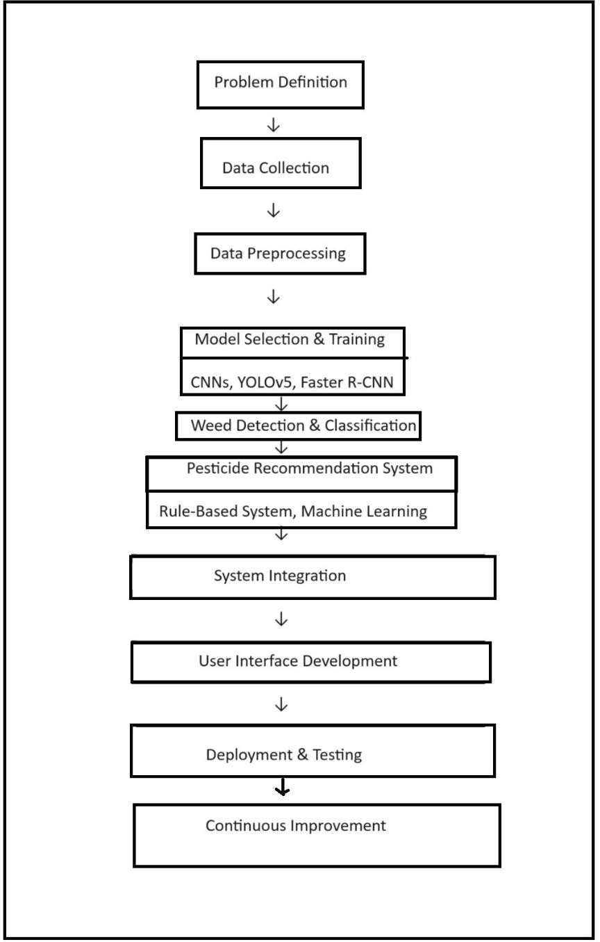

**Work-flow**

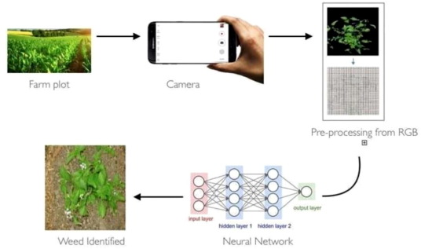

**Steps to Implemeantation:**

1. **Data collection:**

gather crops and weeds datasets and creating labels

**2.Data Pre – Processing:**

Remove noisy data and remove unwanted data

**3.MODEL Training:**

By using CNN and Machine learning Models train and testing the dataset

**4.** **Feature extraction :**

Convolutional Neural Networks are a very powerful method of extracting features from images. They have proven to outperform traditional feature extraction methods such as HOG, Wavelet Transform, FFT and SIFT to name a few. However, CNNs can be very computationally expensive to train from scratch. Thus we shall use a technique Imown as Transfer Learning for our purposes.

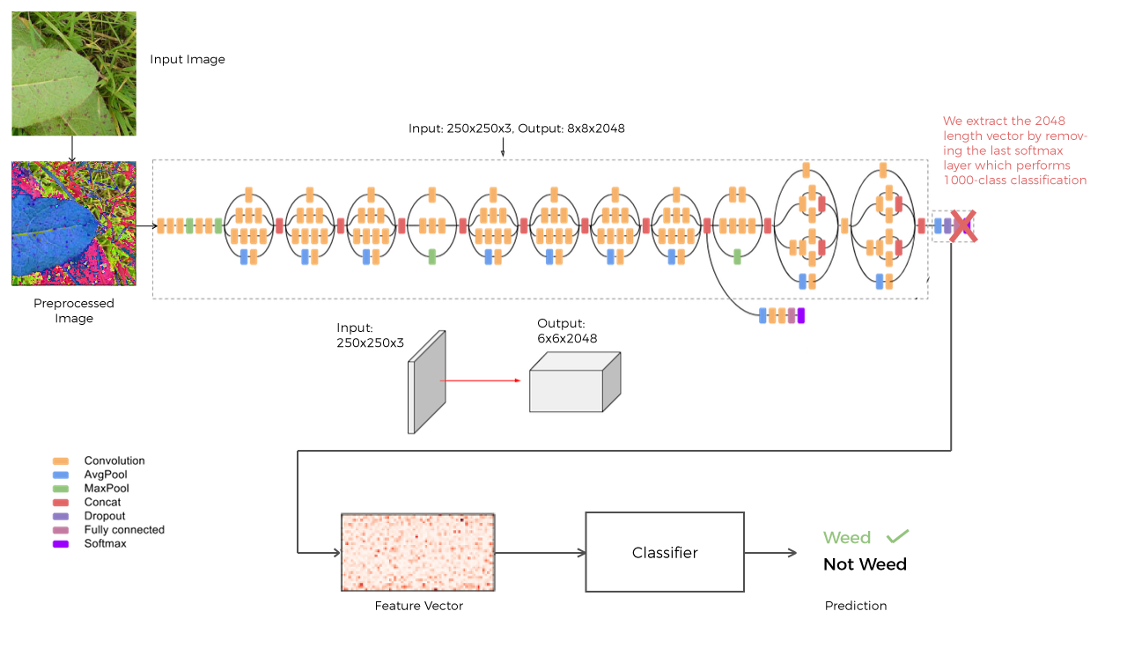

Transfer Learning makes use of pre-trained CNNs to perform feature extraction and plug into our classifier of choice to train on any dataset. These pre-trained CNNs are usually trained on the huge ImageNet image database, and are thus more powerful in terms of extracting meaningful features than a CNN trained from scratch. Out of the many available pre-trained CNNs.

we use the 1st Runner Up for Image Classification in ILSVRC (ImageNet Large Scale Visual Recognition Competition) 2015 - InceptionV3

**Model acccury Graph:**

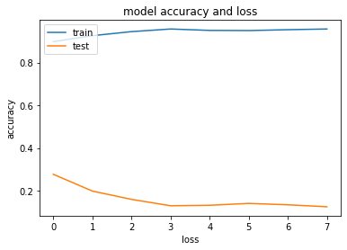

**9.Conclusion:**

Deep learning for weed detection, combined with organic pesticide recommendations, revolutionizes precision agriculture by offering efficient, real- time weed management while promoting environmental sustainability. This integration boosts crop productivity and reduces reliance on harmful chemicals. Future advancements and wider implementation will further enhance sustainable agricultural practices.

# References:

1. Wang A., Zhang W., Wei X. A review on weed detection using ground-based machine vision and image processing techniques. *Comput. Electron.*

*Agric.* 2019; **158**:226–240.

doi: 10.1016/j.compag.2019.02.005. [[CrossRef](https://doi.org/10.1016%2Fj.compag.2019.02.005)] [Google Scholar]

1. Castrignanò A., Buttafuoco G., Khosla R., Mouazen A., Moshou D., Naud

O. *Agricultural Internet of Things and Decision Support for Precision Smart Farming.* Academic Press; Cambridge, MA, USA: 2020. [[Google Scholar](https://scholar.google.com/scholar_lookup?title=Agricultural%2BInternet%2Bof%2BThings%2Band%2BDecision%2BSupport%2Bfor%2BPrecision%2BSmart%2BFarming&author=A.%2BCastrignan%C3%B2&author=G.%2BButtafuoco&author=R.%2BKhosla&author=A.%2BMouazen&author=D.%2BMoshou&publication_year=2020)]

1. Cho S., Lee D., Jeong J. AE—Automation and Emerging Technologies: Weed–plant Discrimination by Machine Vision and Artificial Neural

Network. *Biosyst. Eng.* 2002;**83**:275–280.

doi: 10.1006/bioe.2002.0117. [[CrossRef](https://doi.org/10.1006%2Fbioe.2002.0117)] [Google Scholar]

1. Aitkenhead M., Dalgetty I., Mullins C., McDonald A., Strachan N. Weed and crop discrimination using image analysis and artificial intelligence

methods. *Comput. Electron. Agric.* 2003;**39**:157–171. doi: 10.1016/S0168- 1699(03)00076-0. [[CrossRef](https://doi.org/10.1016%2FS0168-1699(03)00076-0)] [Google Scholar]