**IOT- PHASE 2- PROJECT SUBMISSION**

**SMART RESTROOMS**

**INTRODUCTION:**

In our country, people do not have enough knowledge of using toilets. The

project is based on IOT concepts using different sensors like smell sensor,

dirt sensor, sonic sensor, RFID reader, Database. Using these materials

we are trying to provide the clean toilets and create the awareness among the people.

Here the sensors like PT1000 sensor, Pressure sensor, and RFID reader are used here. PT1000 sensor used to measure the thigh temperature. Pressure sensor is used measure the pressure of the base portion of the toilet. Using RFID reader is used to sense the particular person result. It needs designing of the base portion of the toilet. It can sense all test results of patients through the toilet usage.

WORKING PRINCIPLE:

* + In the first phase, IR sensor is used to discover the dirt present in the toilet.
  + Here the set of sample images are given as input.
  + After using the toilet, the sensor senses the basin of the toilet.
  + Then it relates the sensed image with the input image.
  + If the dirt present, it increases the alarm.
  + Then the user wants to be clean the waste. Through this activity, people can get the awareness about the toilet management.
  + In the second phase, Figaro sensor is used to perceive the unwanted gases present in the toilet.
  + In the Figaro sensor, a particular range is to be stable earlier manner. If the range gets extended, it can send the alert message to the sweeper. Then they cleaned it by using proper fragrant.
  + In the third phase, RFID reader (Radio Frequency Identification) is used to observe the sweeper’s activities (absence and presence in the toilet cleaning).
  + Initially, the sweeper wants to show his/her individuality tag in front of RFID reader. It can be shown before and after cleaning the toilet.
  + Then the first phase gets initiated and senses for the dirt presence in the toilet.
  + If the dirt gets noticed, it raises the alarm.
  + Through this monitoring activity, the sweeper can realize their roles and responsibilities. Then they protect the people by disposing all the unwanted materials (dirt, unwanted gases) present in the toilet.
  + In the final phase, the sonic sensor is used to detect the depth of the septic tank.
  + Here, the range of septic tank is fixed prior manner.
  + If the sewage reached with the range, then it directs message to an organization.
  + All message transfer can be done by GSM.

BLOCK DIAGRAM: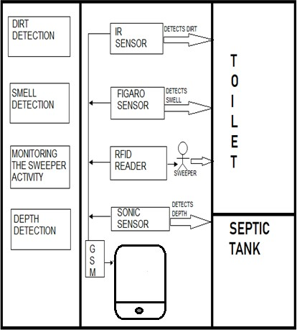

**HARDWARE REQUIREMENTS:**

* + - Microcontroller
    - Power supply
    - LCD display
    - Buzzer
    - Infrared sensor
    - Sonic sensor
    - Gas sensor
    - RFID
    - GSM Modem

SOFTWARE REQUIREMENTS:

Embedded system

BLOCK DIAGRAM:

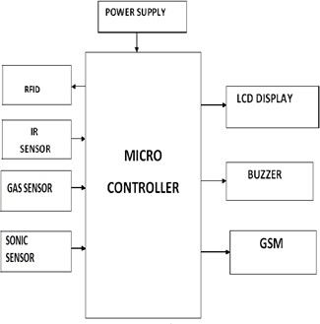

IGSM: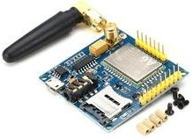

GSM stands for Global System for Mobile communication. It establishes the mobile communication from one place to another place.

It transfers the information from main circuit to operator. It uses Time Division Multiple Access (TDMA).

GSM is mainly used for communicating and transferring message from one person to concerned organisation. GSM module is used to establish communication between a computer and a GSM and GPRS system.

Here we are using GSM LT-2 communication module makes it possible to use GSM paths to provide monitoring and messaging functions in alarm systems. It facilitates cooperation with SATEL and third party control panel diallers or correctly configured outputs.

He GSM LT-2 module makes it possible to implement monitoring as well as text and voice messaging functions. The caller ID retransmission function creates it likely to present the incoming callers number on telecommunication stationsarmed with this functionality.

GSM alarm system built-in GSM communication module inside, work as a mobile handset. After purchased the GSM alarm system, people need to acquisition the SIM card, and select the mobile service package. GSM alarm system can program several phone numbers for alarm receiving. When any abnormal event happens, the system will response, then inform the owner via voice call and short message (SMS).

GSM will check the messaging activities for sweepers and also need to check with their cleanliness duty for their work. The sweepers need to check with particular activity of its work by their sensors.

**ADVANTAGES**

* + - * It can creates an awareness among the people about the proper toilet management
      * It can prevents the many contagious diseases like malaria, typhoid, cholera, streptococcus, asthma, etc..

**CONCLUSION**

Our proposed project will create awareness among the people about the proper sanitation. It makes use of Internet of things, which is a rapidly growing technology. Our proposed system will make everyone to strictly follow the cleanliness and proper sanitation in the toilets. It prevents the many new contagious diseases that spread due to improper sanitation of the toilets. Thus by using technologies in the smarter way, we can maintain the cleanliness which is next to the godliness. Keep Clean, Be Safe.