LIBRIS – Smart Digital Library with Voice-Enabled Reading for Visually Impaired Users
N. Jeevitha¹, Dr. C. Premavathi²
¹MCA Student, ²Associate Professor
Department of Computer Applications, Vellalar College for Women (Autonomous)
Erode – 638012, Tamil Nadu, India
Abstract—Visually impaired people depend on braille books, audio books and screen readers to read, yet most digital libraries are built for sighted users: they expect the user to read menus, type into login forms and click small buttons, and they narrate text in a flat, mechanical voice. This paper presents LIBRIS, a voice-first desktop digital library developed in Python with a Tkinter interface and an SQLite database, in which a reader can complete every task without seeing the screen. LIBRIS speaks first and guides the user through each step; readers create an account and sign in entirely by voice, browse the library, and listen to books narrated sentence by sentence with human-like pacing. An always-on microphone pipeline with time-aligned echo filtering lets the reader interrupt at any moment with commands such as “stop reading”, “next page”, “faster” or “louder”, even while the application is speaking. Spoken usernames are recovered using all recognition alternatives, letter-by-letter spelling and fuzzy matching against registered accounts. Reading progress is saved after every sentence, so a reader resumes from the exact point where they stopped with a short spoken recap. A separate Creator Studio allows authors to upload books from text, PDF and Word files and to monitor reader progress. Functional evaluation with scripted and eyes-closed walkthroughs showed that all reader tasks, including all fourteen reading commands, could be completed by voice alone. LIBRIS demonstrates that an accessible, low-cost reading platform can be built with standard Python tools.
Keywords—Accessibility, visually impaired users, voice user interface, speech recognition, text-to-speech, digital library, Python, Tkinter, SQLite, assistive technology.

I. Introduction
Reading is central to education, employment and leisure, but it remains difficult for people with visual impairment. The World Health Organization estimates that at least 2.2 billion people worldwide have a near or distance vision impairment [1], and the Global Burden of Disease analysis reported 43.3 million people who were blind and 295 million with moderate or severe vision impairment in 2020 [2]. For these readers, braille books are expensive and few titles are available, while audio books cover only a small part of what is published.
Digital libraries could close this gap, but most of them are designed for sighted users. Logging in requires reading and filling a form, choosing a book requires scanning a visual list, and controlling playback requires finding small buttons. General-purpose screen readers make such applications technically usable, but studies of blind users report frequent frustration with confusing page layouts, unlabelled controls and forms [3]. Screen readers also narrate long texts in a uniform voice, and they do not remember where a reader stopped in a book.
This paper presents LIBRIS, a smart digital library in which voice is the primary interface rather than an add-on. The main contributions are:
- A voice-first conversation engine that asks every question aloud, signals the user’s turn with an audio cue and re-asks automatically when no answer is heard, so that a blind user is never left in silence.
- An always-on, interruptible listening pipeline with time-aligned echo filtering, which allows reading commands to take effect while the application is still speaking.
- A spoken-credential recognition method that combines recognition alternatives, letter-by-letter spelling and fuzzy matching, making voice-only sign-up and login practical.
- A human-like narration and progress model that reads sentence by sentence with punctuation-aware pacing and resumes from the exact sentence with a spoken recap.
The remainder of the paper is organised as follows. Section II reviews related work, Section III describes the proposed system, Section IV explains the methodology and implementation, Section V discusses the results, and Section VI concludes the paper with directions for future work.
II. Related Work
Screen readers. Screen readers convert on-screen content into speech or braille and are the most common tool for blind computer users. Lazar et al. surveyed 100 blind users and found that poorly labelled links, confusing layouts and inaccessible forms were among the main causes of lost time [3]. Accessibility guidelines such as WCAG 2.1 describe how content should be structured for assistive technology [7], but compliance depends on each application.
Digital talking books. The DAISY standard defines a structured digital talking book format that allows navigation by chapter and page [6]. DAISY players offer rich navigation, but they rely on buttons or keyboard shortcuts rather than conversation, and the content must be specially produced.
Non-visual interaction. Research on accessible interaction has explored gesture-based access to touch screens, as in Slide Rule [4], and remote human assistance for visual questions, as in VizWiz [5]. These systems show that interfaces designed around non-visual interaction from the start can be far more efficient than adapted visual ones.
Speech technology. Text-to-speech synthesis has matured into widely available engines [8], and speech recognition services are accessible through simple programming interfaces [10]. Spoken dialogue systems commonly support barge-in, in which the user may interrupt the system while it is speaking [9].
Research gap. Existing tools either make visual applications readable (screen readers) or provide navigation through physical controls (talking-book players). There is a need for a simple library in which registration, login, browsing, narration control and progress tracking are all conducted through natural spoken dialogue. LIBRIS addresses this gap.
III. Proposed System
A. Design Goals
LIBRIS was designed around five goals:
- G1 – Zero-sight operation: every reader task can be completed with voice alone.
- G2 – Interruptibility: the reader can speak at any moment, including while Libris is speaking.
- G3 – Natural narration: books should sound read by a person, not recited by a machine.
- G4 – Persistent progress: reading continues from the exact sentence where it stopped.
- G5 – Low cost: the system runs on an ordinary computer with a microphone and speakers.
B. System Architecture
LIBRIS follows a layered architecture (Fig. 1). The presentation layer, built with Tkinter, contains five screens and a voice bar that shows live captions. An App controller switches screens inside one window and runs the conversation engine. The service layer contains the reading engine, the command parser, the voice engine for speech output and the voice listener for speech input. All persistent data is stored in an SQLite database through a single database module.
Speech output and recognition run in background threads so that the interface never freezes. Because Tkinter widgets may only be updated from the main thread, background threads place their results in a queue that a dispatcher reads every 30 ms using Tkinter’s after() scheduler.

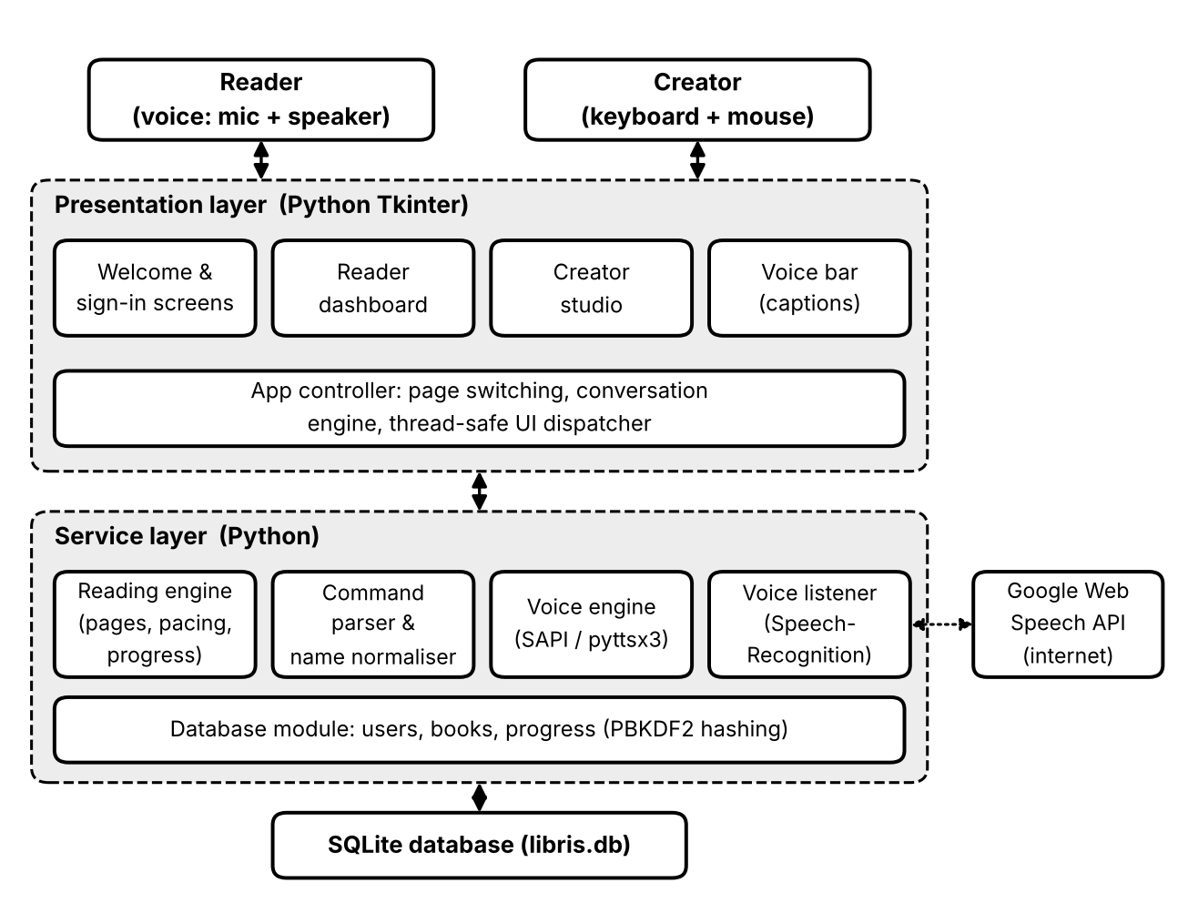
Fig. 1. Layered architecture of LIBRIS.

C. Modules
Reader module. Used by visually impaired readers and controlled entirely by voice. It provides voice registration and login, a spoken list of available books with their progress, narration with on-screen sentence highlighting, reading controls, spoken progress reports and a help command.
Creator module. Used by authors and librarians through the Creator Studio with keyboard and mouse. Creators upload books by typing, pasting or importing .txt, .pdf and .docx files, edit book details, publish or hide books, listen to a voice preview, and view reader insights such as the number of readers and average completion.
Voice engine module. Connects the user’s voice to the application. It contains speech output, always-on listening, echo filtering, command understanding and spoken-credential recognition, which are described in Section IV.
IV. Methodology and Implementation
A. Voice-First Conversation Engine
Every question is asked through a single function, converse(prompt, handler, reprompt, expect). Libris speaks the prompt, plays a short rising two-tone beep and waits for an answer. If nothing is heard within 9 s, it repeats a short version of the question. On the library screen a patient mode is used instead, which waits quietly and gives only an occasional reminder. Questions with fixed answers declare their expected answers (for example yes or no), which are matched in English as well as in common Hindi and Tamil forms such as “haan” and “aama”.
B. Always-On Listening and Barge-In
A conventional design opens the microphone only after the application finishes speaking, so anything said earlier is lost. LIBRIS instead opens one microphone stream at start-up and keeps it open (Fig. 2). A phrase ends after 0.55 s of silence, and each phrase is recognised in its own background thread, so a new command is never delayed by an earlier one. While Libris itself is speaking, the energy threshold of the recogniser is raised by a factor of 1.8, so that the user’s voice is still detected but quieter sound from the speakers is less likely to trigger it.
On Windows, speech output uses the Microsoft Speech API (SAPI 5) directly [12]. Each sentence is spoken asynchronously while the engine polls every 25 ms for a cancellation flag; when a command arrives, the queued speech is purged and narration stops within a fraction of a word. On other platforms the pyttsx3 library is used [11].

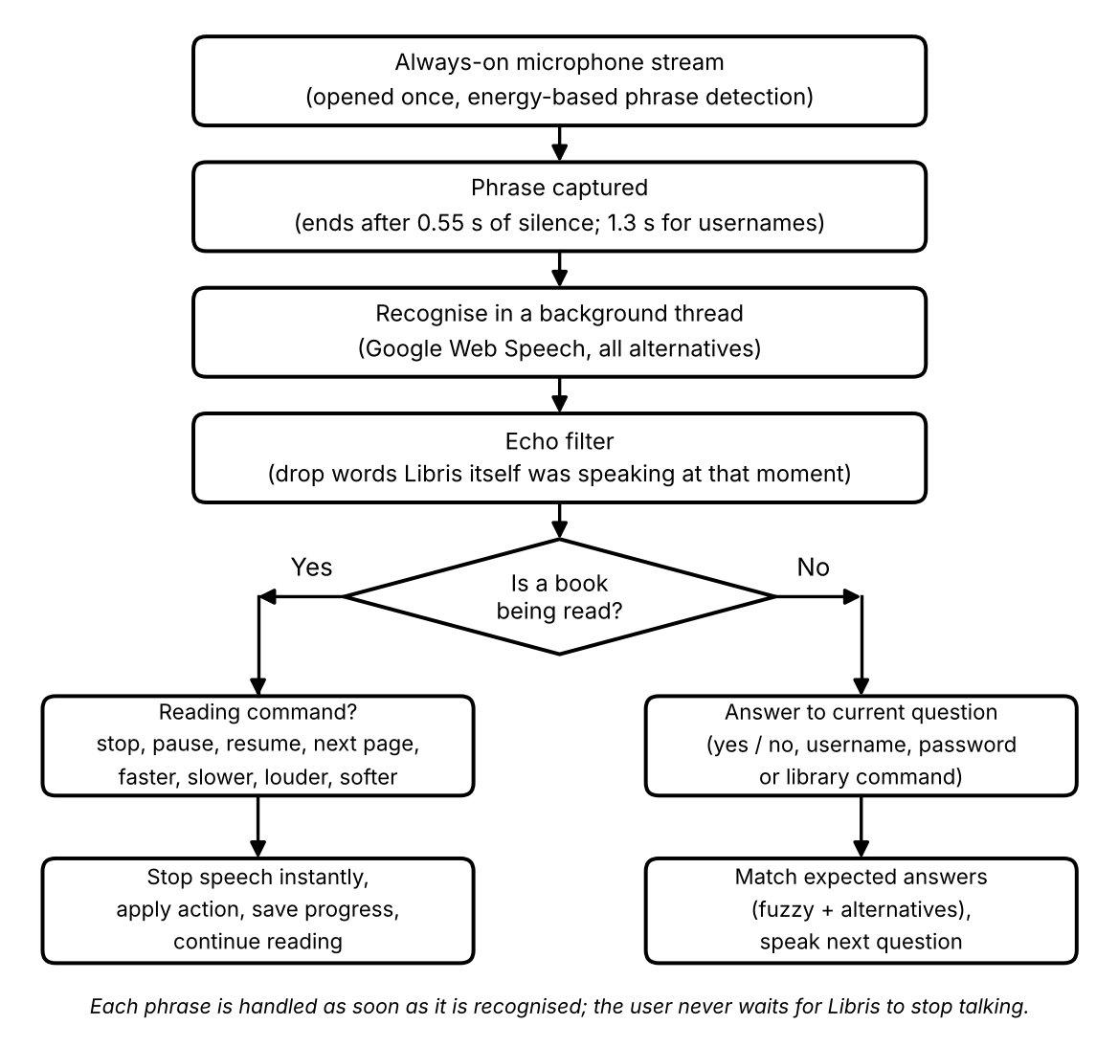
Fig. 2. Processing of a spoken phrase, from the always-on microphone to an action.

C. Time-Aligned Echo Filtering
When speakers are used, the microphone also hears Libris. Every utterance is therefore logged with its start and end time. For a recognised phrase captured between times t_{s} and t_{e}, only the text Libris was speaking in the window [t_{s} − 0.6, t_{e} + 0.2] is considered. The phrase is rejected as echo if it appears verbatim in that text, or if it has at least five words and its word overlap ratio
R = |W_{h} ∩ W_{s}| / |W_{h}| (1)
is 0.7 or more, where W_{h} is the list of heard words and W_{s} the set of spoken words. Because the window is aligned in time, a command such as “stop” is not rejected just because the word appeared earlier in the book. Questions are also phrased so that they never contain their own answers (“Is that correct?” rather than “Say yes or no”), so a spoken “yes” can never be mistaken for echo.
D. Command Understanding
Recognised text is converted into an intent by an ordered list of phrase patterns. Earlier intents take priority, so “stop reading” is matched as a pause before “reading” can match a read request. A regular expression extracts page numbers, a lookup table corrects frequent mis-recognitions (for example “paws” or “pass” for “pause”), and for utterances of up to four words a fuzzy match with a similarity cut-off of 0.75 handles the remaining errors. While a book is being read, only short commands, or commands preceded by the wake word “Libris”, are acted on, so background conversation does not interrupt the story. Table I lists the main reading commands.
TABLE I
READING COMMANDS AVAILABLE AT ANY TIME
Spoken command | Action
stop reading, pause | Stop at once and save the position
resume, continue | Continue from the same sentence
next page, previous page | Change page and keep reading
increase speed, faster | Rate +25 words per minute
decrease speed, slower | Rate −25 words per minute
increase volume, louder | Volume +20%
decrease volume, softer | Volume −20%
go to page <n> | Jump to page n
repeat that, start over | Re-read sentence / restart book
my progress, where am I | Speak progress and position

E. Spoken Credential Recognition
Usernames are the hardest part of voice-only login: users pause between parts (“Maya … seven”) or spell them, and short words are often misheard. Three techniques are combined. First, during username and password questions the end-of-phrase pause is extended to 1.3 s, and pieces that arrive within 1.4 s of each other are joined. Second, a normaliser converts the spoken form into a username: filler words are removed, number words become digits, letter names (“jay oh aitch en”) become letters when most words are single letters, and “double” and “triple” repeat the next character. Third, the recogniser is asked for all alternative transcripts; each is normalised and compared with the registered usernames, first exactly and then by similarity ratio, accepting the best match at 0.75 or above. Libris always spells the result back for confirmation before asking for the password.
F. Human-Like Narration
Uploaded text is split into paragraphs and sentences, protecting common abbreviations such as “Mr.” and “Dr.”, and grouped into pages of about 170 words that end at paragraph boundaries. Lines such as “Chapter One” are detected as headings. Each sentence is spoken separately with a rate and a following pause chosen from its punctuation and position (Table II). Occasional page-turn phrases and varied opening sentences add a conversational feel. When a book is resumed, Libris first repeats the last sentence the reader heard.
TABLE II
PUNCTUATION-AWARE PACING RULES
Sentence type | Rate (wpm) | Pause (s)
Chapter heading | Base − 25 | 1.00
Dialogue (quoted speech) | Base + 6 | 0.15
Ends with ? or ! | Base | 0.30
Ends with ellipsis (...) | Base − 10 | 0.55
Last sentence of paragraph | Base | 0.55
Other sentences | Base (165 wpm) | 0.15

G. Progress Tracking
If page p begins at sentence offset O_{p} and the reader is at sentence s of that page in a book of N sentences, the progress percentage is
P = (O_{p} + s) / N × 100 (2)
The page, sentence and percentage are saved after every sentence, so even an unexpected shutdown loses at most one sentence. Each book on the reader’s shelf shows this value as a progress bar.
H. Data Storage and Security
SQLite stores three tables (Table III): users for readers and creators, books for uploaded content and progress with a composite key of user and book. Foreign keys with cascading deletes keep the tables consistent. Passwords are never stored in plain text; they are hashed with PBKDF2-HMAC-SHA256 using a random 16-byte salt and 120,000 iterations, following the PKCS #5 recommendation [13].
TABLE III
DATABASE SCHEMA
Table | Main fields
users | id (PK), username, password hash, salt, role (reader / creator), full_name, speech_rate, created_at
books | id (PK), creator_id (FK), title, author, genre, description, content, word_count, is_published
progress | user_id + book_id (PK, FK), page, sentence, total_pages, percent, completed, last_read

I. User Interface
Although readers do not need the screen, the interface supports users with partial sight and sighted helpers. It is built with Tkinter [14]: every screen is a Frame, the book page is a Text widget in which the sentence being spoken is highlighted, and rounded buttons, progress bars, an animated voice wave and bookshelf artwork are drawn on Canvas widgets. The colour scheme has contrast ratios of 13.6:1 for body text, 12.9:1 for the book page and 10.6:1 for the highlighted sentence, all above the WCAG AAA level of 7:1 [7].
V. Results and Discussion
A. Functional Evaluation
LIBRIS was evaluated through unit tests of the text-processing, command-parsing and database functions, scripted end-to-end tests that fed recognised phrases into the application, and manual walkthroughs performed with the eyes closed. Table IV summarises representative test cases; all passed. In the scripted run, each of the fourteen command phrases — stop reading, pause, resume, continue, next page, previous page, increase speed, decrease speed, faster, slower, increase volume, decrease volume, louder and softer — changed the reading state or settings as expected while narration was in progress.
TABLE IV
REPRESENTATIVE TEST CASES
Test case | Expected result | Result
Voice registration | Account created after username confirmation and password repeated | Pass
Login, spelled username (“em a why a 7”) | Recognised as maya7 | Pass
Recogniser hears “s” for “yes” | Accepted using alternatives | Pass
No answer to a question | Question repeated automatically | Pass
“Stop reading” during narration | Stops at once, position saved | Pass
“Resume” | Continues from same sentence | Pass
“Next page” / “previous page” | Page changes, reading continues | Pass
Speed and volume commands | Setting changes, reading continues | Pass
Mic hears the sentence being read | Ignored as echo | Pass
Restart application mid-book | Resumes with spoken recap | Pass
Creator uploads a PDF book | Book appears on reader shelf | Pass

B. Comparison with Existing Approaches
Table V compares LIBRIS qualitatively with a typical screen reader used with an e-book application and with a typical audio-book player. The main differences are voice-only account access, the ability to interrupt by voice and exact-sentence resumption.
TABLE V
FEATURE COMPARISON
Feature | Screen reader + e-book | Audio-book player | LIBRIS
Voice-only login | No | No | Yes
Spoken guidance at every step | Partial | No | Yes
Interrupt by voice while reading | No | No | Yes
Natural sentence pacing | No | Yes | Yes
Resume at exact sentence | No | Partial | Yes
Per-book progress | No | Partial | Yes
Any uploaded book | Yes | No | Yes

C. Discussion and Limitations
The always-on design removed the main usability problem observed in early versions, in which commands spoken while Libris was talking were lost. Spoken-username handling was the second major issue; requesting all recognition alternatives and allowing spelling made short answers and usernames reliably recognisable in testing.
Several limitations remain. Speech recognition uses the Google Web Speech service and therefore needs an internet connection. The current version supports English only. Recognition accuracy depends on the microphone and background noise, and with loudspeakers a single-word command spoken at exactly the moment Libris says the same word may be filtered as echo; headphones avoid this. Finally, the evaluation is functional; a formal study with visually impaired participants is needed to measure task times and satisfaction.

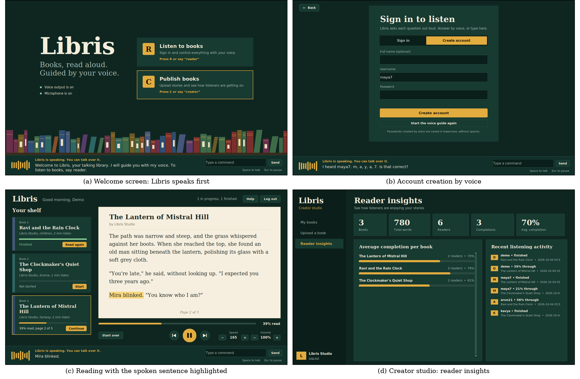
Fig. 3. Screens of LIBRIS. Readers use voice only; the screen supports partially sighted users and helpers.

VI. Conclusion and Future Work
This paper presented LIBRIS, a voice-first smart digital library for visually impaired users built with Python, Tkinter and SQLite. By treating speech as the primary interface, LIBRIS lets a reader register, sign in, choose a book, listen to natural narration and control it at any moment without seeing the screen. Always-on listening with time-aligned echo filtering makes the system immediately responsive, and robust spoken-credential recognition makes voice-only login practical. Progress saved after every sentence lets readers resume exactly where they stopped.
Future work includes offline speech recognition, narration and commands in Tamil, Hindi and other Indian languages, more expressive neural voices with different voices for characters, a mobile version, voice bookmarks and notes, support for EPUB, DAISY and scanned books through OCR, refreshable braille display output, and a user study with visually impaired readers.
Acknowledgment
The authors thank the management, the Principal and the Department of Computer Applications of Vellalar College for Women (Autonomous), Erode, for providing the facilities and support needed to complete this work.
References
[1] World Health Organization, World Report on Vision. Geneva, Switzerland: WHO, 2019.
[2] R. R. A. Bourne et al., “Trends in prevalence of blindness and distance and near vision impairment over 30 years: an analysis for the Global Burden of Disease Study,” Lancet Global Health, vol. 9, no. 2, pp. e130–e143, 2021.
[3] J. Lazar, A. Allen, J. Kleinman, and C. Malarkey, “What frustrates screen reader users on the web: A study of 100 blind users,” Int. J. Human–Computer Interaction, vol. 22, no. 3, pp. 247–269, 2007.
[4] S. K. Kane, J. P. Bigham, and J. O. Wobbrock, “Slide Rule: Making mobile touch screens accessible to blind people using multi-touch interaction techniques,” in Proc. 10th Int. ACM SIGACCESS Conf. Computers and Accessibility (ASSETS), 2008, pp. 73–80.
[5] J. P. Bigham et al., “VizWiz: Nearly real-time answers to visual questions,” in Proc. 23rd ACM Symp. User Interface Software and Technology (UIST), 2010, pp. 333–342.
[6] ANSI/NISO Z39.86-2005, Specifications for the Digital Talking Book. Bethesda, MD, USA: NISO, 2005.
[7] World Wide Web Consortium, Web Content Accessibility Guidelines (WCAG) 2.1, W3C Recommendation, Jun. 2018.
[8] P. Taylor, Text-to-Speech Synthesis. Cambridge, U.K.: Cambridge Univ. Press, 2009.
[9] D. Jurafsky and J. H. Martin, Speech and Language Processing, 3rd ed. draft. Stanford Univ., 2024. [Online]. Available: https://web.stanford.edu/~jurafsky/slp3/
[10] A. Zhang, “SpeechRecognition: Library for performing speech recognition,” Python Package Index. [Online]. Available: https://pypi.org/project/SpeechRecognition/
[11] N. M. Bhat, “pyttsx3: Text-to-speech conversion library in Python,” Python Package Index. [Online]. Available: https://pypi.org/project/pyttsx3/
[12] Microsoft, “Microsoft Speech API (SAPI) 5.4,” Microsoft Learn. [Online]. Available: https://learn.microsoft.com/
[13] K. Moriarty, B. Kaliski, and A. Rusch, “PKCS #5: Password-Based Cryptography Specification Version 2.1,” RFC 8018, IETF, Jan. 2017.
[14] Python Software Foundation, “tkinter — Python interface to Tcl/Tk,” Python 3 Documentation. [Online]. Available: https://docs.python.org/3/library/tkinter.html
[15] D. R. Hipp et al., “SQLite,” [Online]. Available: https://www.sqlite.org/

