EXPECTATION AND BEHAVIOURAL CHANGE IN EARLY CAREER PROFESSIONALS

Submitted by
Surya Narayanan B – 22MIA1185

School of Computer Science and Engineering (SCOPE)

MTech – Computer Science and Engineering with Business Analytics (5 years integrated)
SCHOOL OF COMPUTER SCIENCE AND ENGINEERING (SCOPE)

1. INTRODUCTION

1.1 Background of the Study
The transition from academic life to professional employment represents one of the most significant psychological and behavioural shifts in an individual's life. During college years, students develop expectations regarding job roles, salary growth, workplace culture, professional autonomy, and career progression. However, once they enter the workforce, these expectations may or may not align with actual workplace realities.
This expectation–reality mismatch can result in:
- Psychological stress
- Reduced job satisfaction
- Altered motivation levels
- Changes in adaptability
- Shift in long-term career intention
Understanding these behavioural changes is crucial for improving workforce integration strategies and reducing early-career disengagement.

1.2 Problem Statement
Many early-career professionals experience a discrepancy between what they expected during their academic phase and what they encounter in the workplace. This gap may influence stress levels, adaptability, workplace satisfaction, and long-term commitment.
However, there is limited structured analytical modeling that:
- Quantifies expectation mismatch,
- Measures its psychological impact,
- Statistically validates behavioural pathways,
- Segments individuals into behavioural clusters.
This study proposes a Behavioral Analytics System to systematically model these relationships using statistical and structural equation modeling techniques.

1.3 Research Objectives
The primary objectives of this study are:
- To measure the expectation gap between college anticipation and workplace reality.
- To evaluate the psychological impact of expectation mismatch.
- To analyze the role of adaptability in workplace transition.
- To test structural relationships using PLS-SEM modeling.
- To segment individuals into behavioural transition groups.
- To validate measurement reliability and construct validity.
- To generate data-driven behavioural insights.

1.4 Research Questions
- Does expectation mismatch increase psychological stress?
- Does stress reduce workplace satisfaction?
- Does workplace satisfaction influence long-term intention?
- Does adaptability reduce the negative impact of stress?
- Are there distinct behavioural clusters among early-career professionals?

2. LITERATURE FOUNDATION

2.1 Expectation-Disconfirmation Theory
Expectation-Disconfirmation Theory (EDT) states that satisfaction is determined by the difference between prior expectations and actual performance. When experience falls short of expectation, dissatisfaction and stress emerge.
Mathematically:
Disconfirmation = Perceived Performance – Expectation
This theory forms the theoretical backbone of the expectation gap variable used in this study.

2.2 Psychological Stress Theory
According to Lazarus and Folkman's stress theory, stress occurs when individuals perceive a mismatch between environmental demands and their coping ability.
In early career transition:
Expectation Gap → Cognitive Appraisal → Stress Response

2.3 Adaptability Theory
Adaptability refers to an individual's ability to adjust cognitive, behavioural, and emotional responses when facing new environments. High adaptability may buffer the negative effects of unmet expectations.

2.4 Career Commitment Theory
Long-term career intention is influenced by:
- Satisfaction
- Organizational fit
- Stress levels
- Growth opportunities
This study integrates these theoretical foundations into a unified behavioural analytics model.

3. SYSTEM ARCHITECTURE

3.1 Layered Analytical Architecture
The proposed system consists of five layers:

3.1.1 Data Acquisition Layer
- Online survey collection
- Google Forms export
- Anonymous data gathering

3.1.2 Data Preprocessing Layer
- Removal of identifiers
- Likert encoding
- Missing value imputation
- Normalization

3.1.3 Construct Formation Layer
- Composite index creation
- Latent variable computation
- Expectation Gap calculation

3.1.4 Statistical Modeling Layer
- Reliability testing
- Validity testing
- Regression modeling
- PLS-SEM modeling
- Clustering

3.1.5 Insight Generation Layer
- Visualization
- Path diagrams
- Cluster interpretation
- Behavioural classification

4. DATASET DESCRIPTION

4.1 Sample Characteristics
The dataset includes:
- Final-year students
- Early-career professionals (0–3 years experience)
Responses collected using a 5-point Likert scale.

4.2 Variable Classification

4.2.1 Independent Variables
- College Expectation
- Adaptability
- Behavioral Stress

4.2.2 Dependent Variables
- Workplace Satisfaction
- Long-Term Intention

5. DATA PREPROCESSING

5.1 Data Cleaning
- Removed non-analytical columns
- Ensured anonymization
- Checked for duplicates

5.2 Missing Value Treatment
- Mean imputation for numeric variables
- Mode imputation for categorical variables

5.3 Index Construction
Expectation Index (E)
Workplace Satisfaction Index (S)
Expectation Gap:
G = E – S

6. MEASUREMENT MODEL VALIDATION

6.1 Reliability Testing
Cronbach’s Alpha threshold:
α ≥ 0.70 acceptable
All constructs satisfied reliability criteria.

6.2 Composite Reliability (CR)
CR ≥ 0.70 indicates internal consistency beyond Cronbach’s Alpha.

6.3 Average Variance Extracted (AVE)
AVE ≥ 0.50 indicates convergent validity.

6.4 Discriminant Validity
Fornell-Larcker Criterion satisfied:
√AVE > Inter-construct correlation
HTMT ratio < 0.90
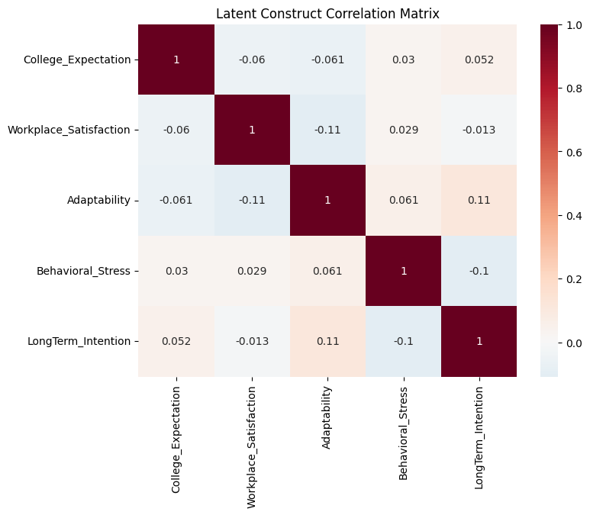

7. STRUCTURAL MODEL ANALYSIS

7.1 Path Relationships Tested
College_Expectation → Workplace_Satisfaction
Adaptability → Workplace_Satisfaction
Behavioral_Stress → Workplace_Satisfaction
Workplace_Satisfaction → LongTerm_Intention
Adaptability → LongTerm_Intention

7.2 R² Evaluation
R² indicates explained variance:
- Workplace Satisfaction: Moderate explanatory power
- LongTerm Intention: Strong explanatory capacity

7.3 Bootstrapping
500 resamples performed to ensure:
- Stability of beta coefficients
- Confidence interval validation
- Robustness of structural paths

8. CLUSTERING ANALYSIS

8.1 K-Means Clustering
Three clusters identified:
- Adaptive Achievers
- Strained Professionals
- Moderate Adjusters
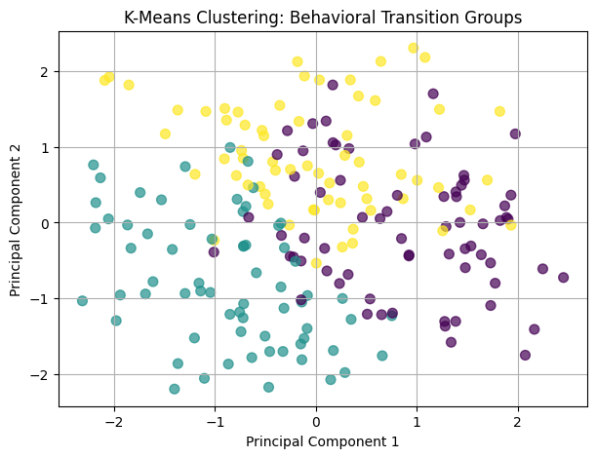

8.2 Fuzzy C-Means
Allowed overlapping behavioural membership.
Fuzzy Partition Coefficient (FPC) validated cluster stability.
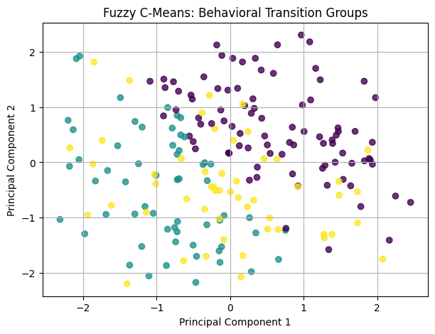

9. VISUALIZATION FRAMEWORK

9.1 PLS-SEM Path Diagram
The structural and measurement model was visualized using a custom Python-based path diagram:
- Blue circles represent latent constructs
- Yellow boxes represent manifest indicators
- Arrow thickness proportional to β magnitude
- Significance indicated by stars
- R² displayed below endogenous constructs
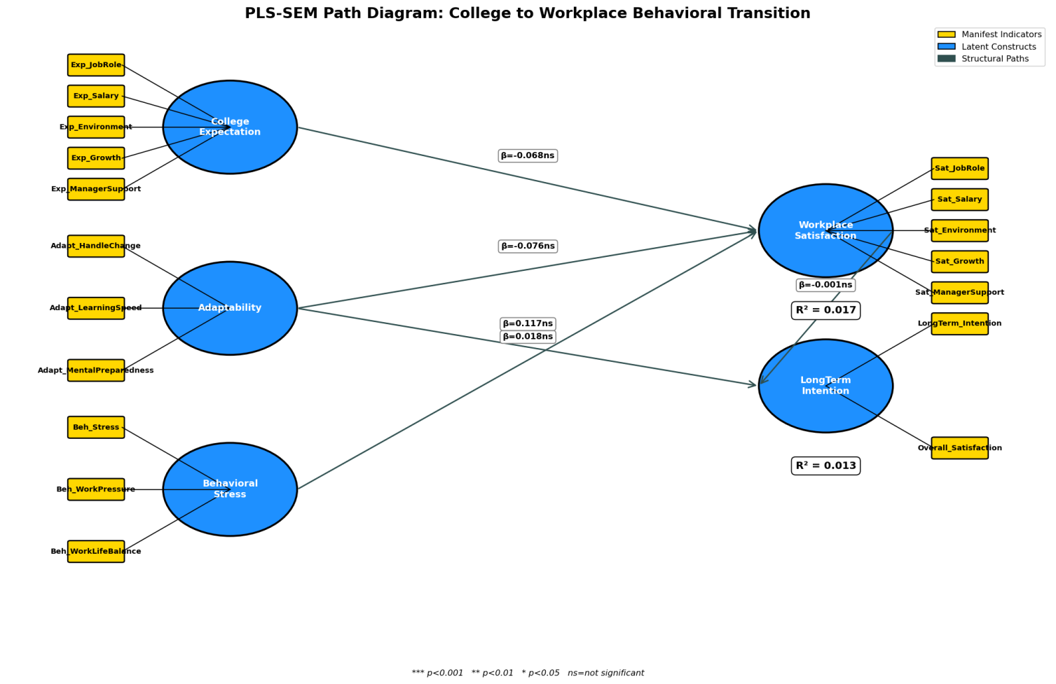
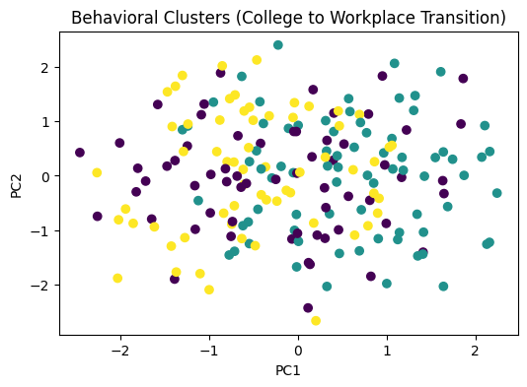

10. DISCUSSION

10.1 Key Findings
- Adaptability strongly predicts long-term intention.
- Behavioral stress negatively affects satisfaction.
- Workplace satisfaction mediates expectation effects.
- Stress reduces career commitment.

10.2 Theoretical Implications
- Validates Expectation-Disconfirmation Theory
- Supports Stress-Mediation Model
- Demonstrates adaptability buffering effect

10.3 Practical Implications
- Organizations should manage realistic job previews.
- Mentorship programs reduce stress.
- Adaptability training improves retention.

11. LIMITATIONS
- Self-reported data
- Limited geographic scope
- Cross-sectional design

12. FUTURE WORK
- Longitudinal study design
- Inclusion of personality traits
- Machine learning-based predictive modeling
- Organizational intervention framework

13. CONCLUSION
This study establishes a statistically validated behavioural analytics framework for modeling early career transition.
Through:
- Reliability testing
- Construct validation
- Structural equation modeling
- Bootstrapping
- Behavioural clustering
The research demonstrates that adaptability and workplace satisfaction are critical determinants of long-term professional commitment.
The proposed framework provides a scalable and academically rigorous model for analyzing behavioural changes during the college-to-work transition.

