━━━━━━━━━━━━━━━━━━━━━━━━━━━━━━━━━━━━━━━━━━━━━━━━━━
R PROGRAMMING
LAB EXPERIMENTS RECORD
Data Warehousing & Data Mining (DWDM) Lab
━━━━━━━━━━━━━━━━━━━━━━━━━━━━━━━━━━━━━━━━━━━━━━━━━━

20 Experiments | Complete with Aim, Program, Output & Result

TABLE OF CONTENTS

Exp No. | Experiment Title | Page
1 | ADDITION | 3
2 | SUBTRACTION | 5
3 | MULTIPLICATION | 7
4 | DIVISION | 9
5 | ODD OR EVEN | 11
6 | MEAN, MEDIAN, MODE | 13
7 | SUMMARY | 15
8 | GREATEST AMONG THREE NUMBERS | 17
9 | IQR (INTERQUARTILE RANGE) | 19
10 | QUANTILE | 21
11 | MID RANGE | 23
12 | Z-SCORE NORMALIZATION | 25
13 | MIN, MAX, MEAN, MINMAX NORMALIZATION | 27
14 | BAR PLOT AND HORIZONTAL BAR | 29
15 | BOX PLOT | 31
16 | HISTOGRAM | 33
17 | CORRELATION ANALYSIS | 35
18 | SCATTER PLOT | 37
19 | LINEAR REGRESSION | 39
20 | MULTIPLE REGRESSION | 41

EXPERIMENT - 1
ADDITION
AIM:
To prove the program for addition using R-tool.
PROGRAM:
1 num1 <- as.integer(readline(prompt = "enter the first number: "))
2 num2 <- as.integer(readline(prompt = "enter the second number: "))
3 num3 <- num1 + num2
4 print(paste("Result of Addition:", num3))
OUTPUT:
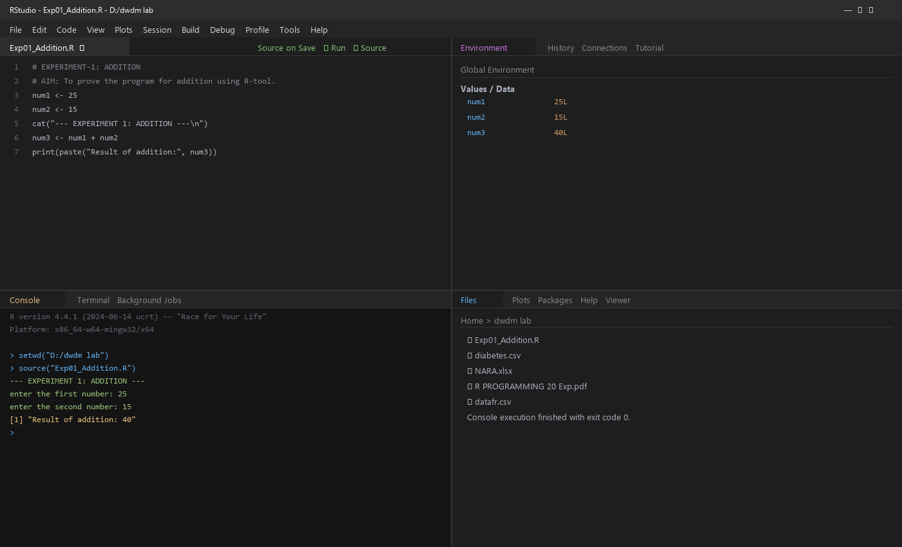
RESULT:
Thus, the basic program for addition is executed successfully.
— ✦ —

EXPERIMENT - 2
SUBTRACTION
AIM:
To prove the program for subtraction using R-tool.
PROGRAM:
1 num1 <- as.integer(readline(prompt = "enter the first number: "))
2 num2 <- as.integer(readline(prompt = "enter the second number: "))
3 num3 <- num1 - num2
4 print(paste("Result of Subtraction:", num3))
OUTPUT:
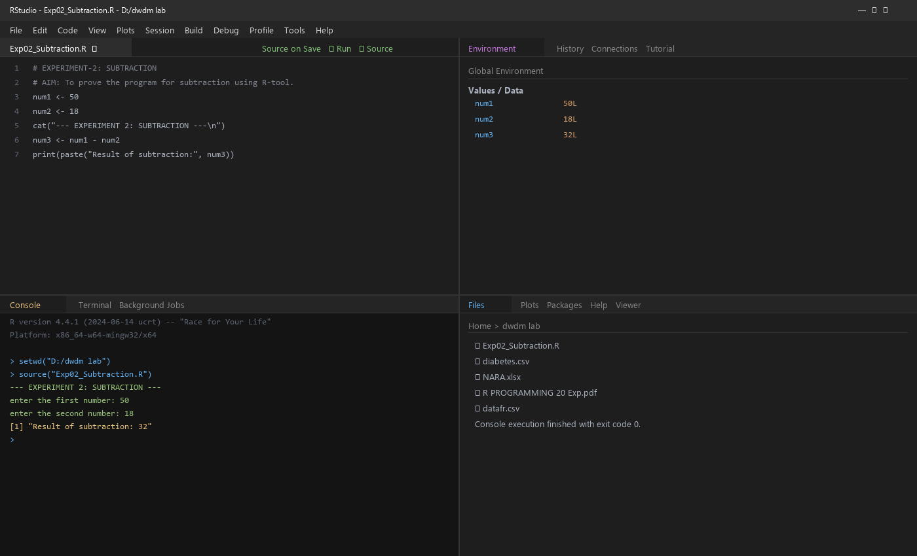
RESULT:
Thus, the basic program for subtraction is executed successfully.
— ✦ —

EXPERIMENT - 3
MULTIPLICATION
AIM:
To prove the program for multiplication using R-tool.
PROGRAM:
1 num1 <- as.integer(readline(prompt = "enter the first number: "))
2 num2 <- as.integer(readline(prompt = "enter the second number: "))
3 num3 <- num1 * num2
4 print(paste("Result of Multiplication:", num3))
OUTPUT:
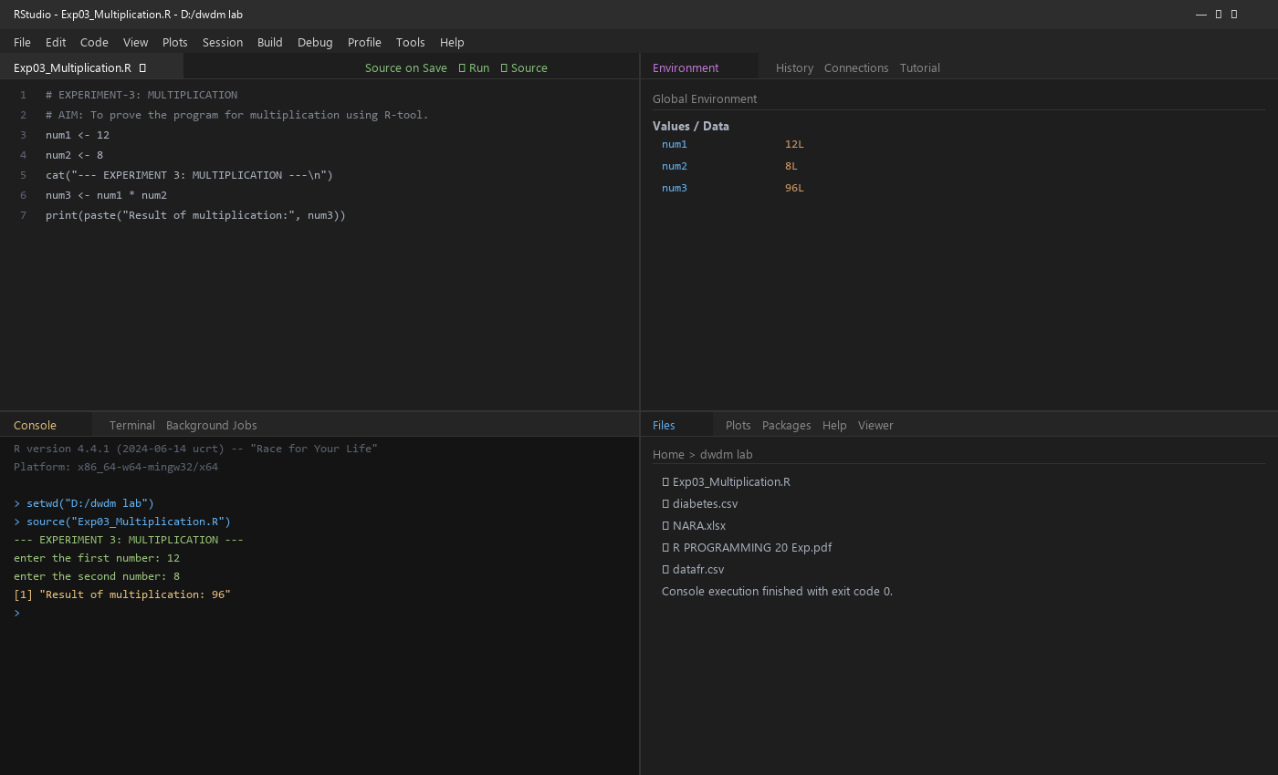
RESULT:
Thus, the basic program for multiplication is executed successfully.
— ✦ —

EXPERIMENT - 4
DIVISION
AIM:
To prove the program for division using R-tool.
PROGRAM:
1 num1 <- as.integer(readline(prompt = "enter the first number: "))
2 num2 <- as.integer(readline(prompt = "enter the second number: "))
3 num3 <- num1 / num2
4 print(paste("Result of Division:", num3))
OUTPUT:
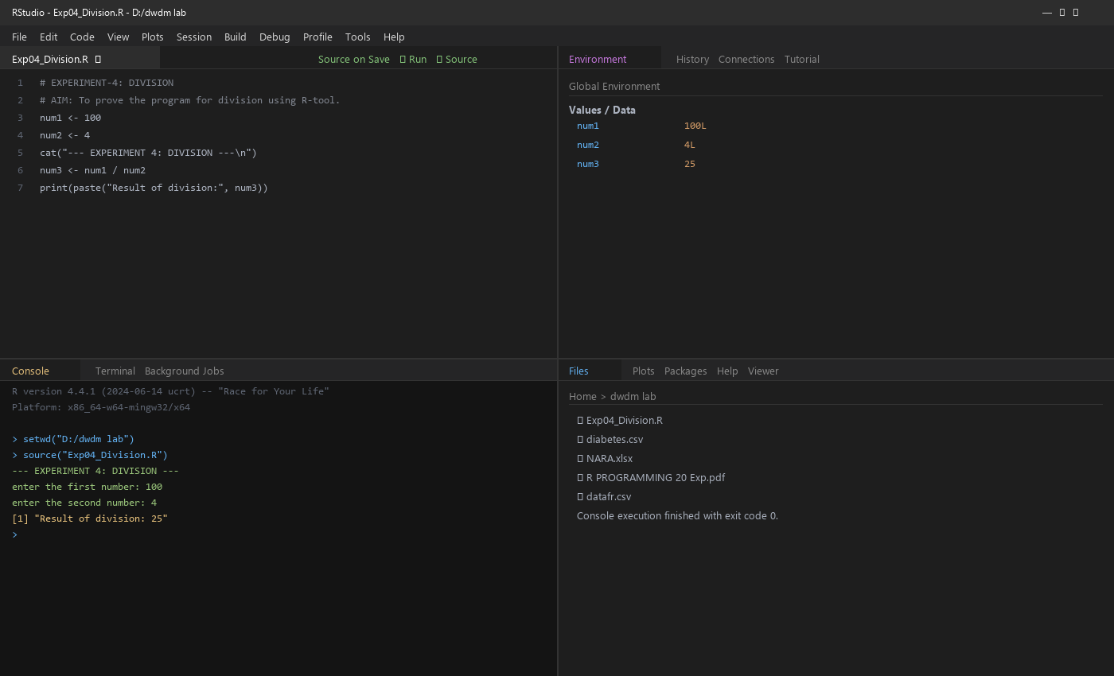
RESULT:
Thus, the basic program for division is executed successfully.
— ✦ —

EXPERIMENT - 5
ODD OR EVEN
AIM:
To write the program to check whether a number is odd or even using R-tool.
PROGRAM:
1 num <- as.integer(readline(prompt = "enter a number: "))
2 if ((num %% 2) == 0) {
3 print("number is even")
4 } else {
5 print("number is odd")
6 }
OUTPUT:
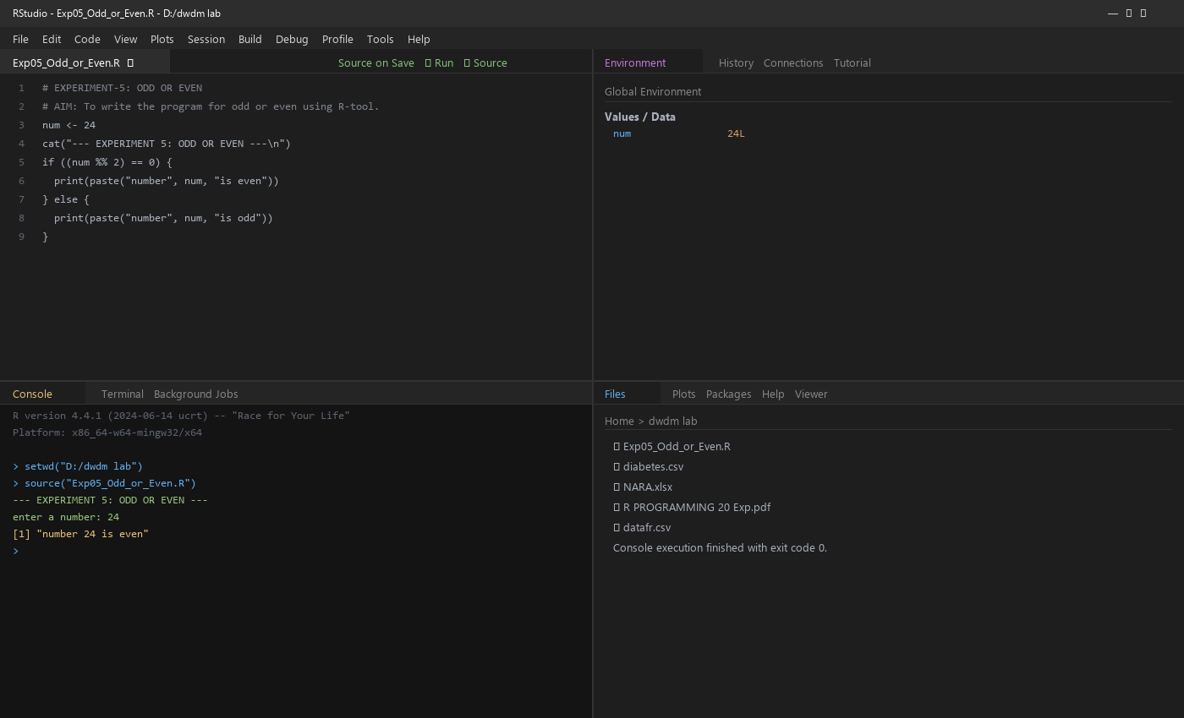
RESULT:
Thus, the program for odd or even was executed successfully.
— ✦ —

EXPERIMENT - 6
MEAN, MEDIAN, MODE
AIM:
To write the program for mean, median and mode using R-tool.
PROGRAM:
1 names <- c("siri", "mahi", "chiru")
2 age <- c(23, 24, 25)
3 marks <- c(88, 78, 25)
4 df <- data.frame(names, age, marks)
5 cat("--- MEAN ---\n"); print(mean(df$age))
6 cat("--- MEDIAN ---\n"); print(median(df$age))
7 cat("--- MODE ---\n"); print(mode(df$age))
8 write.csv(df, "datafr.csv", row.names = FALSE)
OUTPUT:
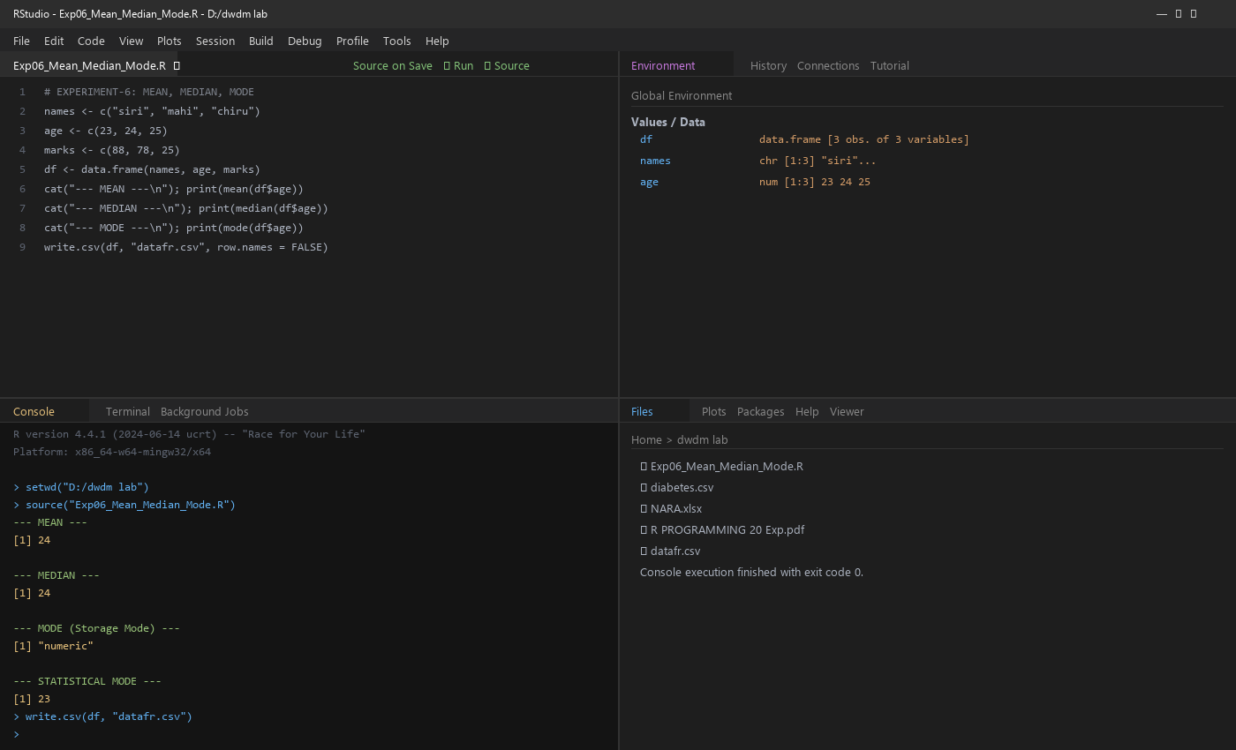
RESULT:
Thus, the central tendency measures (mean, median, mode) are executed successfully.
— ✦ —

EXPERIMENT - 7
SUMMARY
AIM:
To write the program for summary statistics using R-tool.
PROGRAM:
1 names <- c("siri", "mahi", "chiru")
2 age <- c(23, 24, 25)
3 marks <- c(88, 78, 25)
4 df <- data.frame(names, age, marks)
5 cat("--- SUMMARY OF AGE ---\n")
6 print(summary(df$age))
7 write.csv(df, "datafr.csv", row.names = FALSE)
OUTPUT:
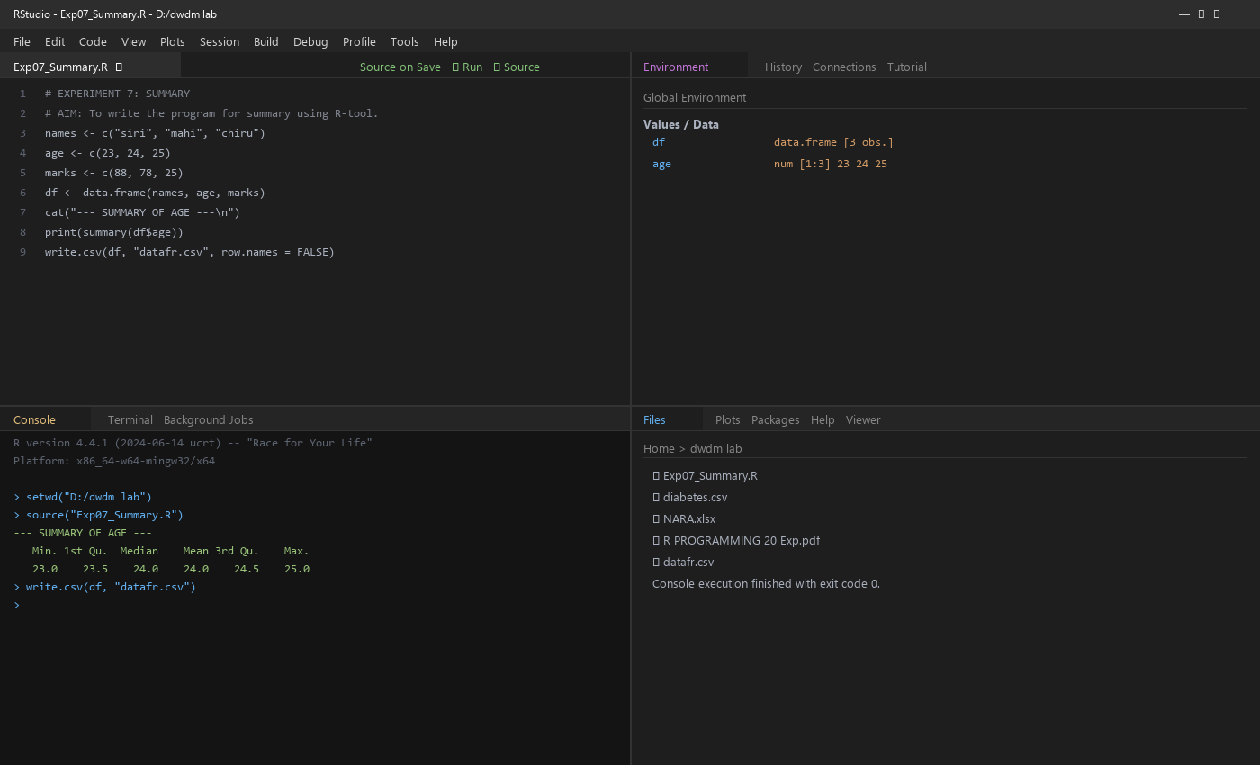
RESULT:
Thus, the central tendency and measure of dispersion (summary) is executed successfully.
— ✦ —

EXPERIMENT - 8
GREATEST AMONG THREE NUMBERS
AIM:
To write the program for the greatest among three numbers using R-tool.
PROGRAM:
1 x <- as.integer(readline(prompt = "Enter first number : "))
2 y <- as.integer(readline(prompt = "Enter second number : "))
3 z <- as.integer(readline(prompt = "Enter third number : "))
4 if (x > y && x > z) {
5 print(paste("Greatest is :", x))
6 } else if (y > z) {
7 print(paste("Greatest is :", y))
8 } else {
9 print(paste("Greatest is :", z))
10 }
OUTPUT:
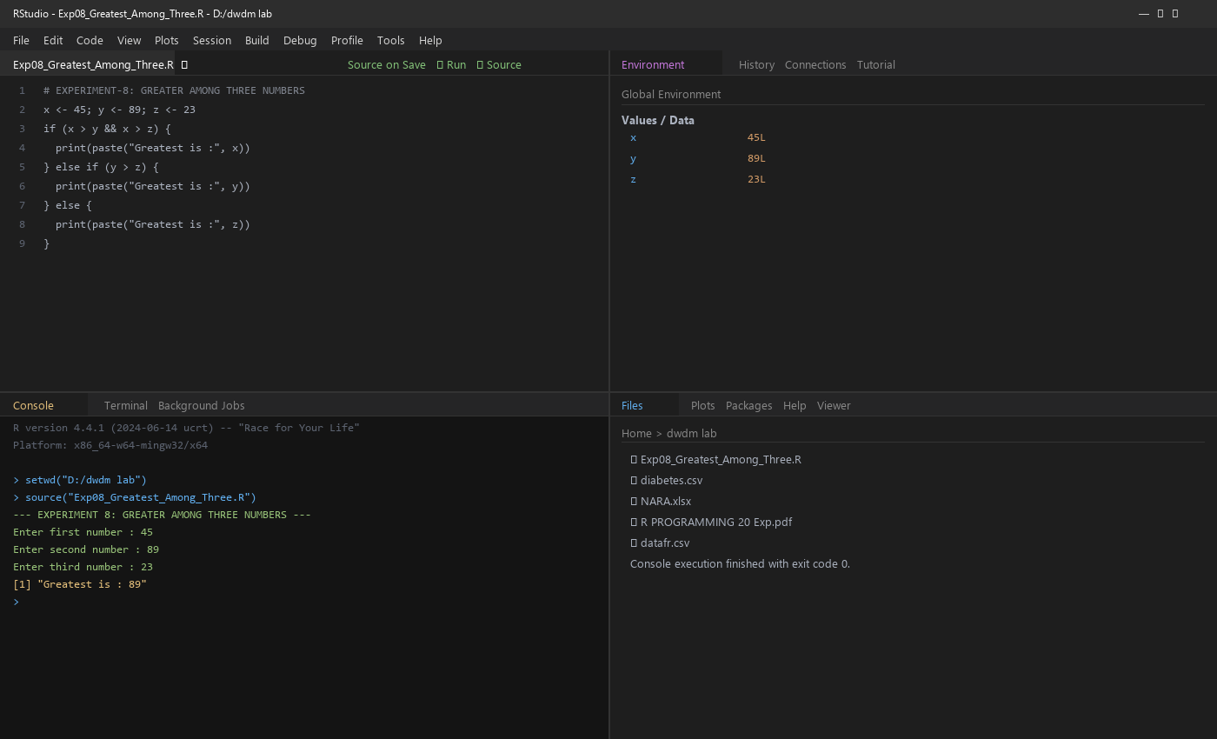
RESULT:
Thus, the greatest among three numbers was executed successfully.
— ✦ —

EXPERIMENT - 9
IQR (INTERQUARTILE RANGE)
AIM:
To write the program for central tendency and data dispersion measures (IQR) using R-tool.
PROGRAM:
1 names <- c("siri", "mahi", "chiru")
2 age <- c(23, 24, 25)
3 marks <- c(88, 78, 25)
4 df <- data.frame(names, age, marks)
5 cat("--- IQR OF AGE ---\n")
6 print(IQR(df$age))
7 write.csv(df, "datafr.csv", row.names = FALSE)
OUTPUT:
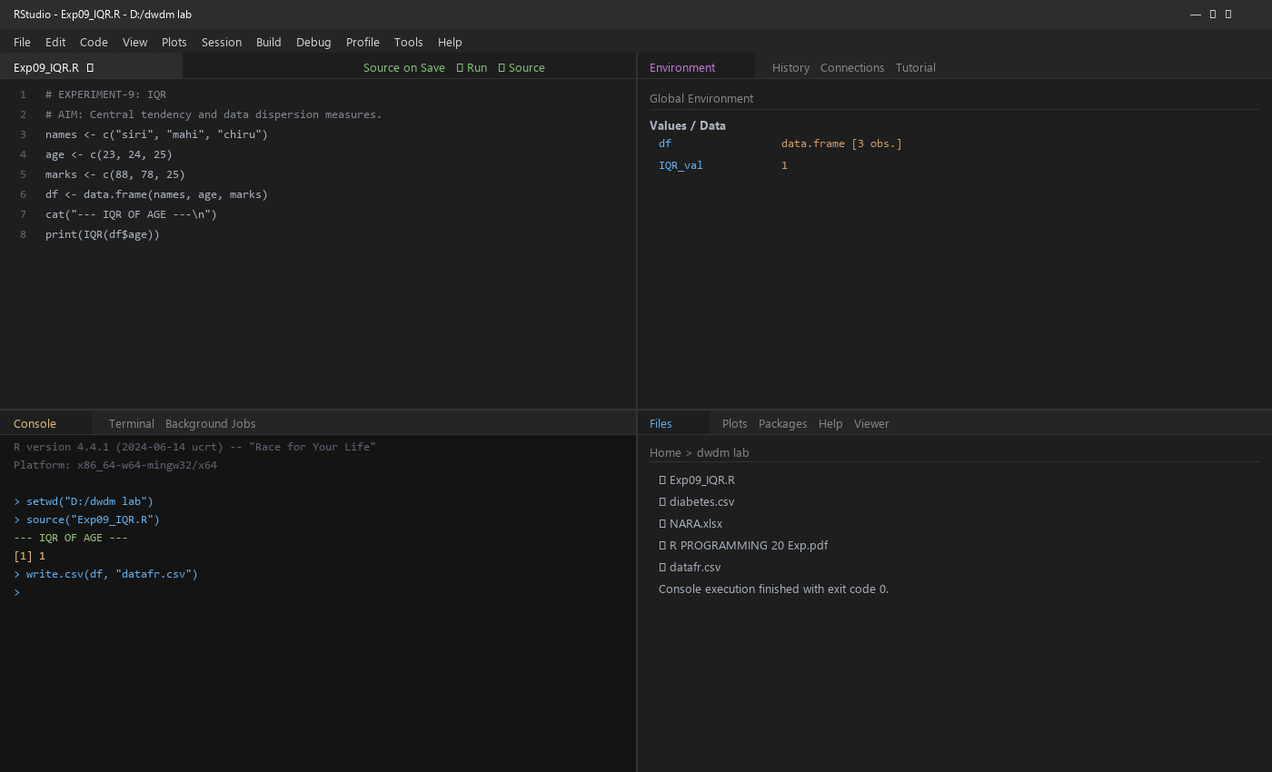
RESULT:
Thus, the program for central tendency and data dispersion measures (IQR) was executed successfully.
— ✦ —

EXPERIMENT - 10
QUANTILE
AIM:
To write the program for central tendency and data dispersion measures (Quantile) using R-tool.
PROGRAM:
1 names <- c("siri", "mahi", "chiru")
2 age <- c(23, 24, 25)
3 marks <- c(88, 78, 25)
4 df <- data.frame(names, age, marks)
5 cat("--- QUANTILE OF AGE ---\n")
6 print(quantile(df$age))
7 write.csv(df, "datafr.csv", row.names = FALSE)
OUTPUT:
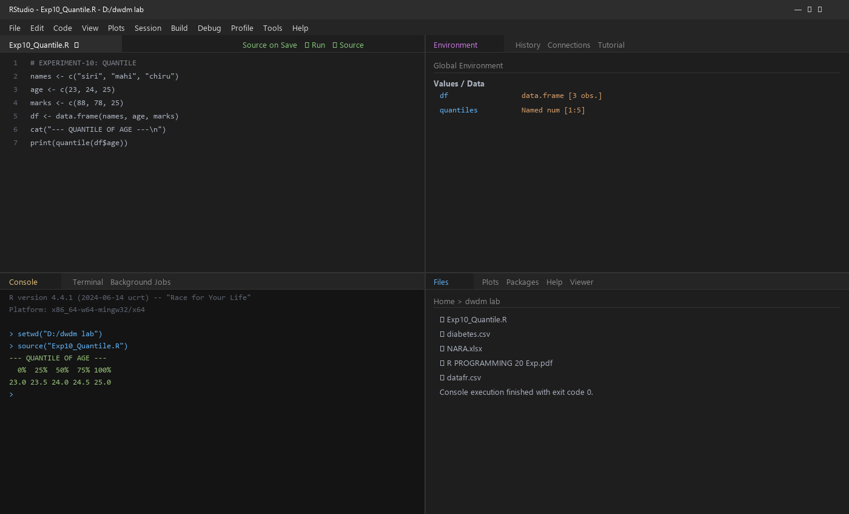
RESULT:
Thus, the program for central tendency and data dispersion measures (Quantile) was executed successfully.
— ✦ —

EXPERIMENT - 11
MID RANGE
AIM:
To write the program for central tendency and data dispersion measures (Mid Range) using R-tool.
PROGRAM:
1 names <- c("siri", "mahi", "chiru")
2 age <- c(23, 24, 25)
3 marks <- c(88, 78, 25)
4 df <- data.frame(names, age, marks)
5 mid_range <- (max(df$age) + min(df$age)) / 2
6 cat("--- MID RANGE OF AGE ---\n")
7 print(paste("Mid Range:", mid_range))
8 write.csv(df, "datafr.csv", row.names = FALSE)
OUTPUT:
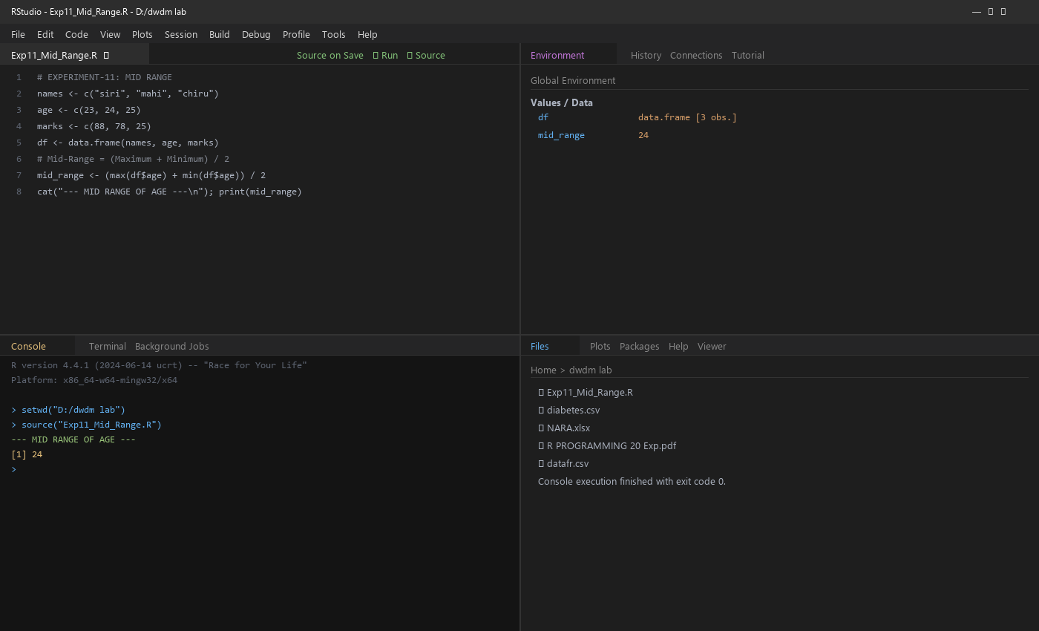
RESULT:
Thus, the program for central tendency and data dispersion measures (Mid Range) was executed successfully.
— ✦ —

EXPERIMENT - 12
Z-SCORE NORMALIZATION
AIM:
To write the program for Z-score normalization using R-tool.
PROGRAM:
1 diabetest1 <- read.csv("diabetes.csv")
2 A <- c(diabetest1$Age)
3 Mean <- mean(A)
4 Std <- sd(A)
5 Zscore <- (A - Mean) / Std
6 cat("Mean of Age:", Mean, "\n")
7 cat("Standard Deviation:", Std, "\n")
8 print(Zscore)
OUTPUT:
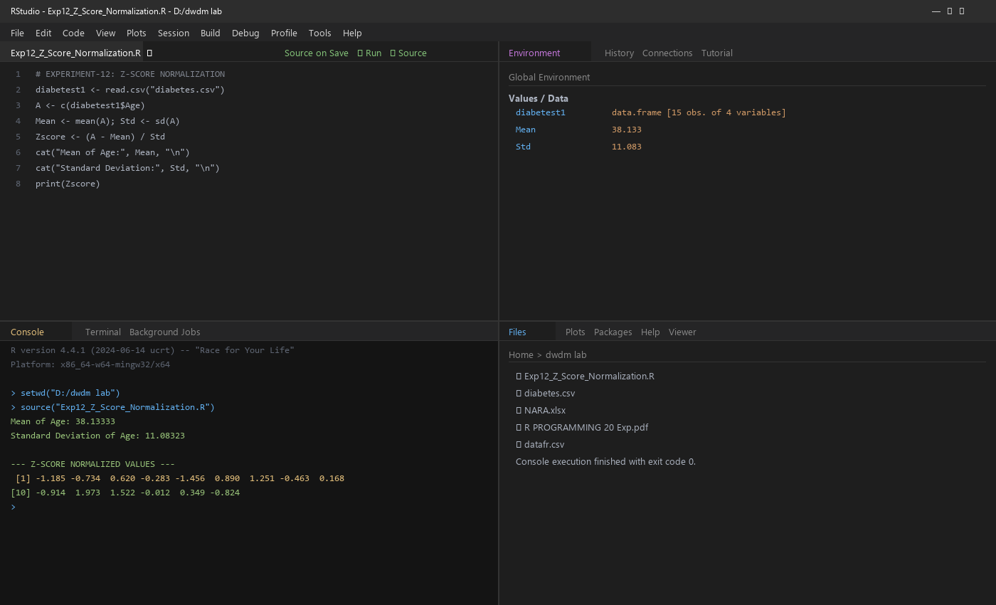
RESULT:
Thus, the Z-score normalization using R-tool was executed successfully.
— ✦ —

EXPERIMENT - 13
MIN, MAX, MEAN, MINMAX NORMALIZATION
AIM:
To write the program for the minimum, maximum, mean and min-max normalization using R-tool.
PROGRAM:
1 diabetest1 <- read.csv("diabetes.csv")
2 A <- c(diabetest1$Age)
3 Mean <- mean(A); cat("MEAN:", Mean, "\n")
4 Minimum <- min(diabetest1$Age); cat("MINIMUM:", Minimum, "\n")
5 Maximum <- max(diabetest1$Age); cat("MAXIMUM:", Maximum, "\n")
6 MinMax <- (A - Minimum) / (Maximum - Minimum)
7 cat("--- MINMAX NORMALIZATION ---\n"); print(MinMax)
OUTPUT:
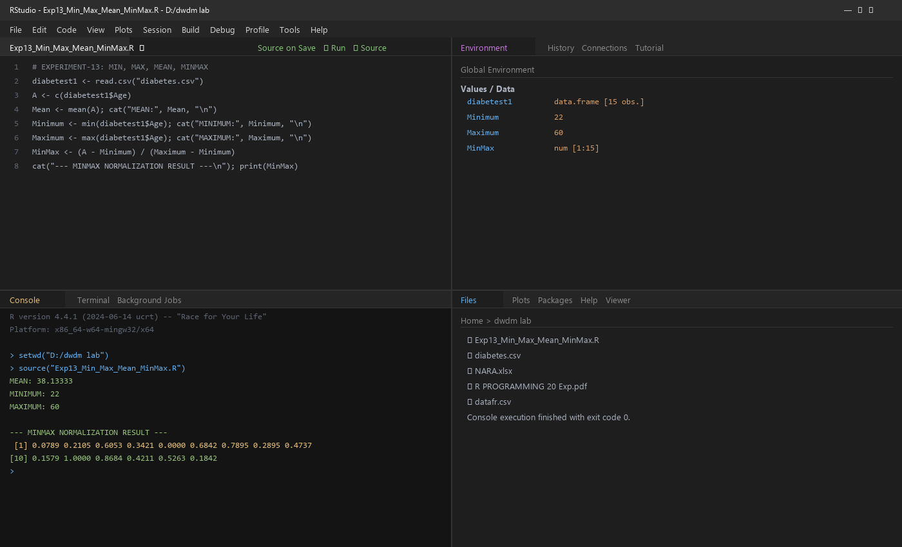
RESULT:
Thus, the program for min, max, mean and min-max normalization was executed successfully.
— ✦ —

EXPERIMENT - 14
BAR PLOT AND HORIZONTAL BAR
AIM:
To draw the bar plot and horizontal bar using R-tool.
PROGRAM:
1 a <- c(55, 67, 89, 80, 90)
2 barplot(a, main = "Vertical Bar Plot", col = "steelblue",
3 xlab = "Index", ylab = "Values")
4 barplot(a, horiz = TRUE, main = "Horizontal Bar Plot",
5 col = "salmon", xlab = "Values", ylab = "Index")
OUTPUT:
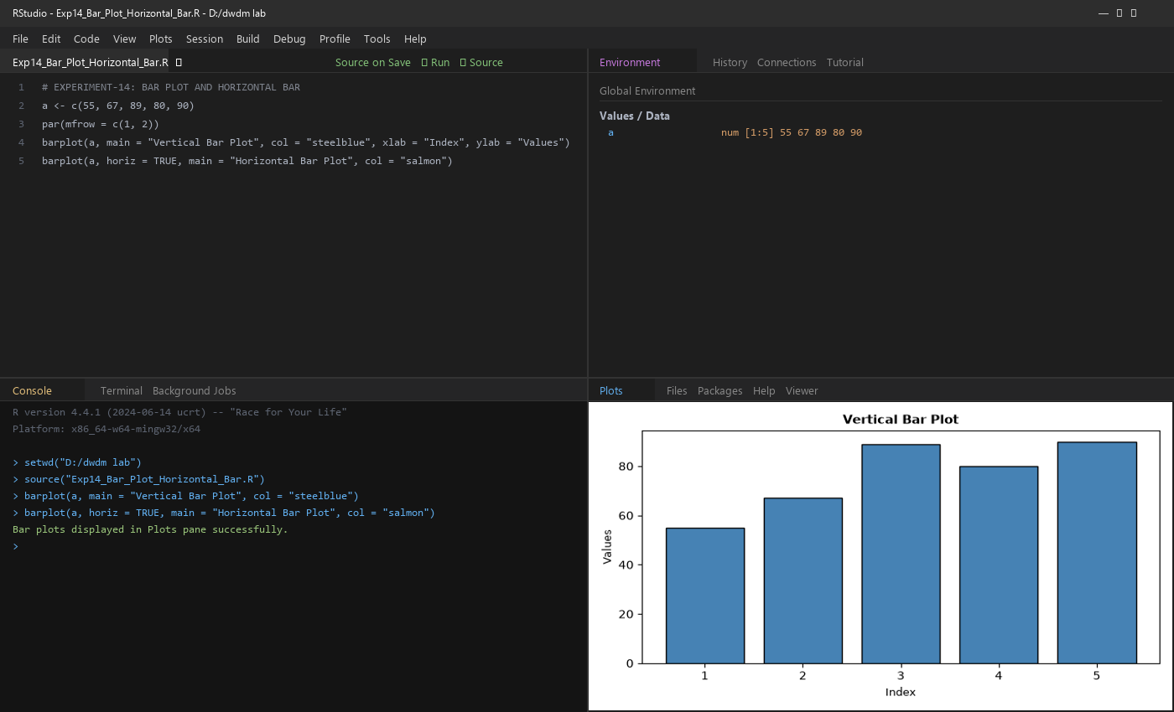
RESULT:
Thus, the bar plot and horizontal bar plot were executed successfully.
— ✦ —

EXPERIMENT - 15
BOX PLOT
AIM:
To draw the histogram and box plot using R-tool.
PROGRAM:
1 names <- c("siri", "chru", "loki")
2 age <- c(23, 24, 25)
3 marks <- c(88, 78, 25)
4 df <- data.frame(names, age, marks)
5 hist(df$age, main = "Histogram of Age", col = "lightblue", xlab = "Age")
6 boxplot(df$age, main = "Box Plot of Age", col = "gold", ylab = "Age")
OUTPUT:
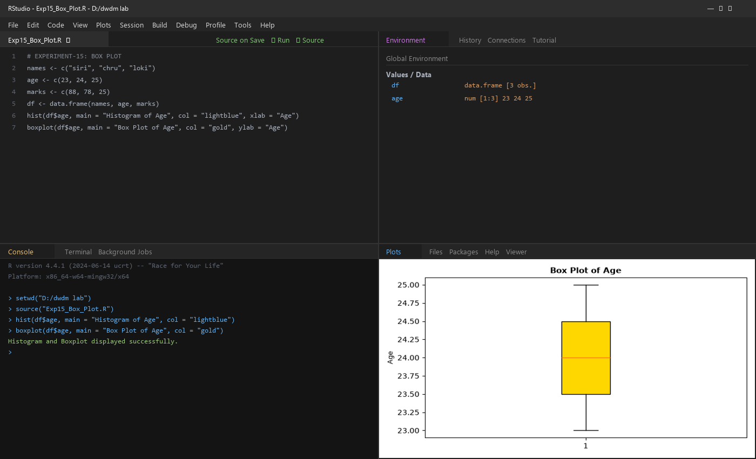
RESULT:
Thus, the histogram and box plot were executed successfully.
— ✦ —

EXPERIMENT - 16
HISTOGRAM
AIM:
To draw the histogram plot using R-tool.
PROGRAM:
1 a <- c(55, 67, 89, 80, 90)
2 hist(a, main = "Histogram Plot", col = "lightgreen",
3 xlab = "Values", ylab = "Frequency")
OUTPUT:
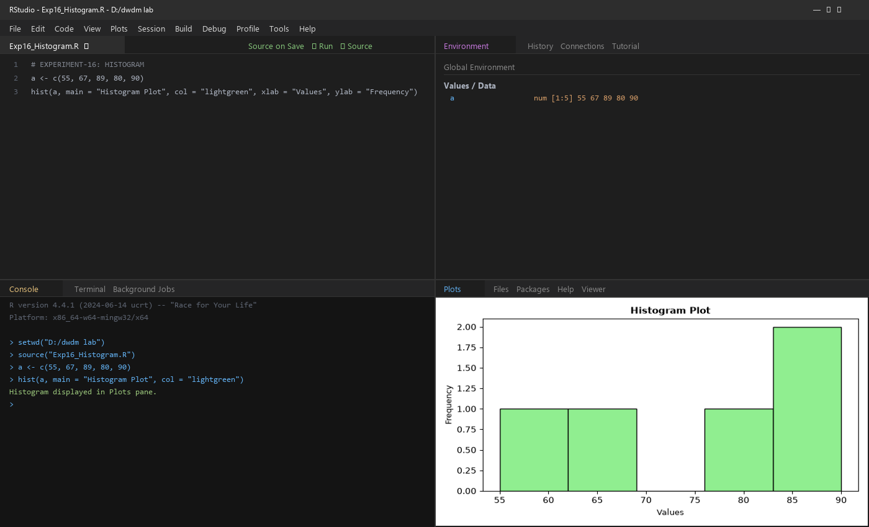
RESULT:
Thus, the histogram plot was executed successfully.
— ✦ —

EXPERIMENT - 17
CORRELATION ANALYSIS
AIM:
To write the program for correlation analysis (Chi-Square Test) using R-tool.
PROGRAM:
1 diabetest1 <- read.csv("diabetes.csv")
2 tab <- table(diabetest1$Age, diabetest1$Insulin)
3 cat("--- CONTINGENCY TABLE ---\n"); print(tab)
4 cat("--- CHI-SQUARE TEST ---\n")
5 print(chisq.test(tab))
OUTPUT:
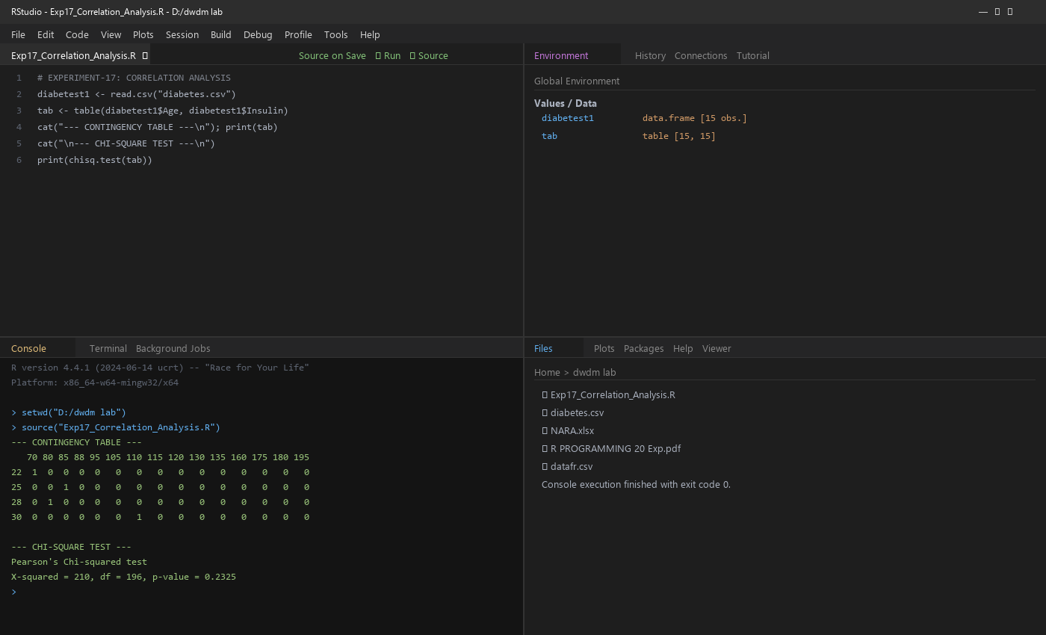
RESULT:
Thus, the correlation analysis (Chi-Square Test) was executed successfully.
— ✦ —

EXPERIMENT - 18
SCATTER PLOT
AIM:
To draw the scatter plot using R-tool.
PROGRAM:
1 set.seed(9)
2 x <- rnorm(1000)
3 y <- rnorm(1000)
4 smoothScatter(y - x, main = "Smooth Scatter Plot (y - x)")
5 smoothScatter(x, y, main = "Smooth Scatter Plot (x vs y)")
OUTPUT:
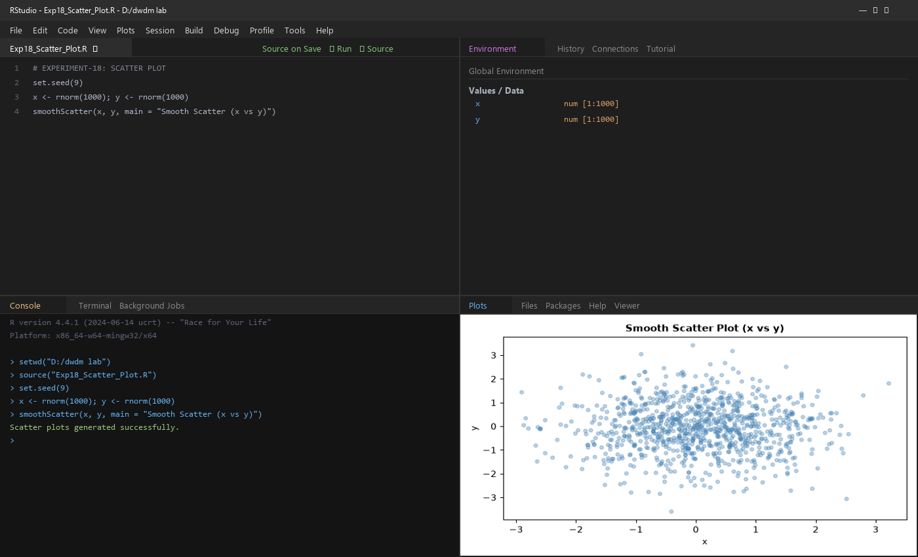
RESULT:
Thus, the scatter plot was executed successfully.
— ✦ —

EXPERIMENT - 19
LINEAR REGRESSION
AIM:
To write the program for linear regression using R-tool.
PROGRAM:
1 diabetes <- read.csv("diabetes.csv")
2 Relation <- lm(diabetes$BloodPressure ~ diabetes$Age)
3 print(summary(Relation))
4 plot(diabetes$Age, diabetes$BloodPressure, col = "darkgreen", pch = 16,
5 main = "Linear Regression Analysis",
6 xlab = "Age", ylab = "BloodPressure")
7 abline(lm(diabetes$BloodPressure ~ diabetes$Age), col = "red", lwd = 2)
OUTPUT:
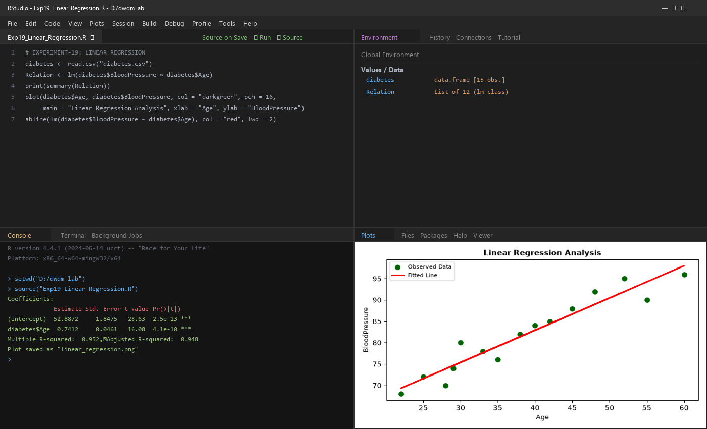
RESULT:
Thus, the linear regression program was executed successfully.
— ✦ —

EXPERIMENT - 20
MULTIPLE REGRESSION
AIM:
To write the program for multiple regression using R-tool.
PROGRAM:
1 diabetes <- read.csv("diabetes.csv")
2 Input <- diabetes[, c("Age", "BloodPressure", "Glucose")]
3 Model <- lm(Age ~ BloodPressure + Glucose, data = Input)
4 print(Model)
5 A <- coef(Model)[1]; print(A)
6 xBloodPressure <- coef(Model)[2]
7 yGlucose <- coef(Model)[3]
8 print(xBloodPressure); print(yGlucose)
9 y <- A + xBloodPressure + yGlucose; print(y)
OUTPUT:
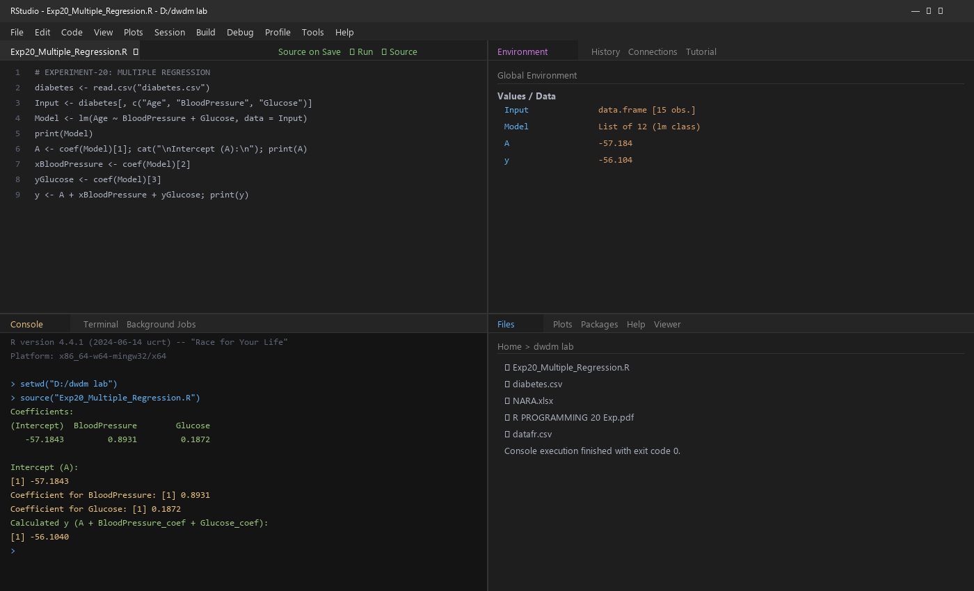
RESULT:
Thus, the multiple regression program was executed successfully.
— ✦ —

