SPRING DATA JPA (HANDSON)

Exercise 1: Spring Data JPA - Quick Example
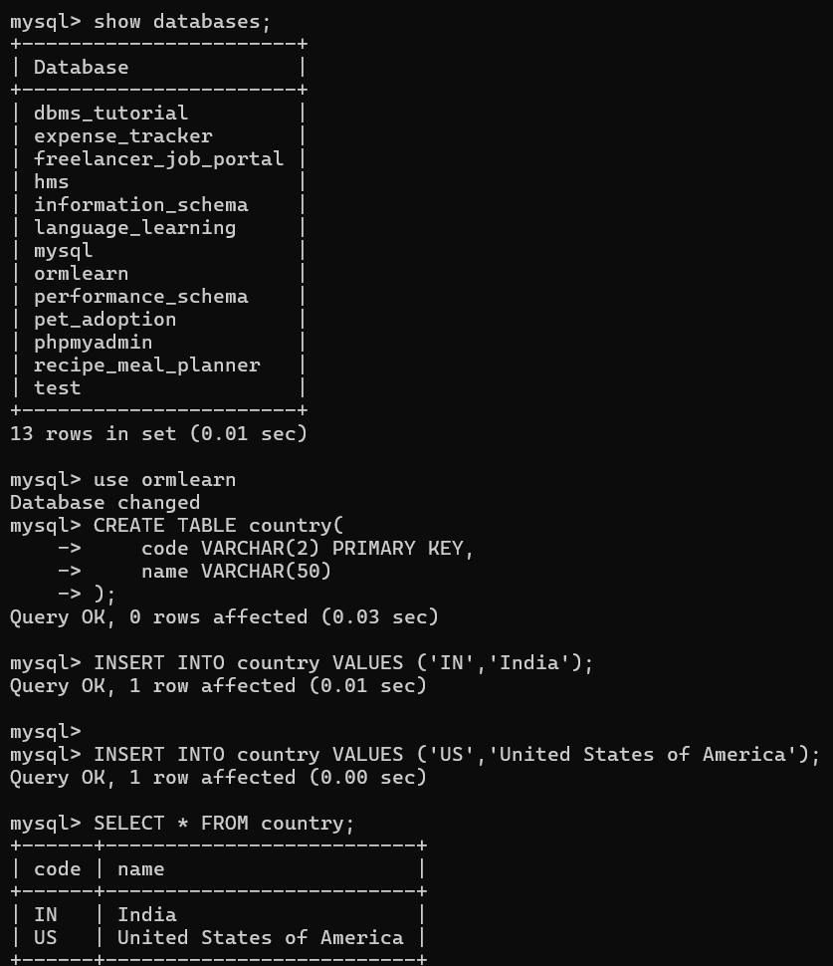

Country.java:
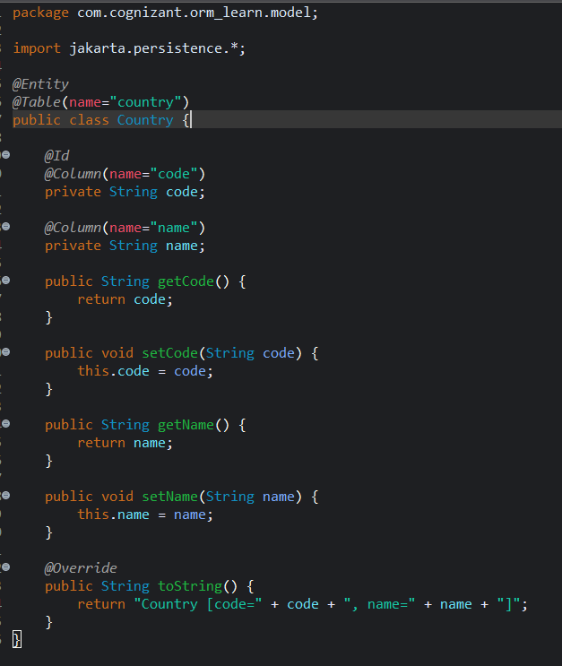

CountryRepository.java:
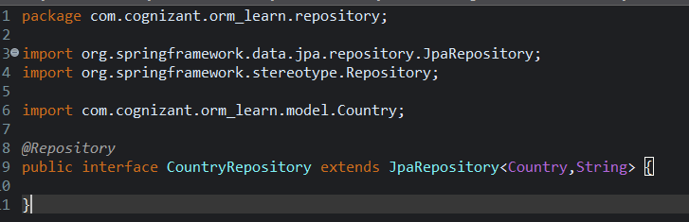
CountryService.java:
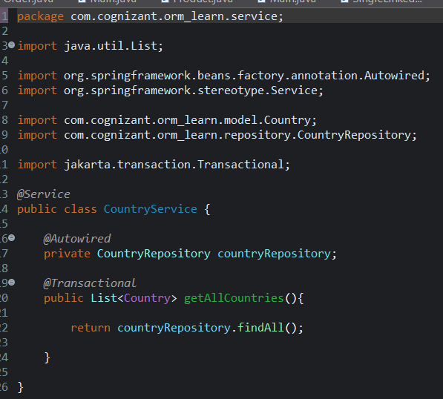

ormLearnApplicationsTests.java:
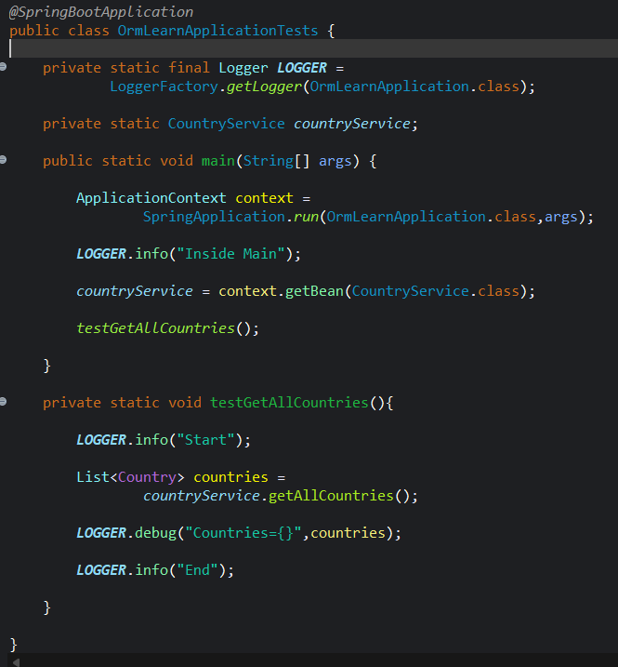

Output:
