React-JS_Mandatory_Hands_On_Task_3

Exercise: 3
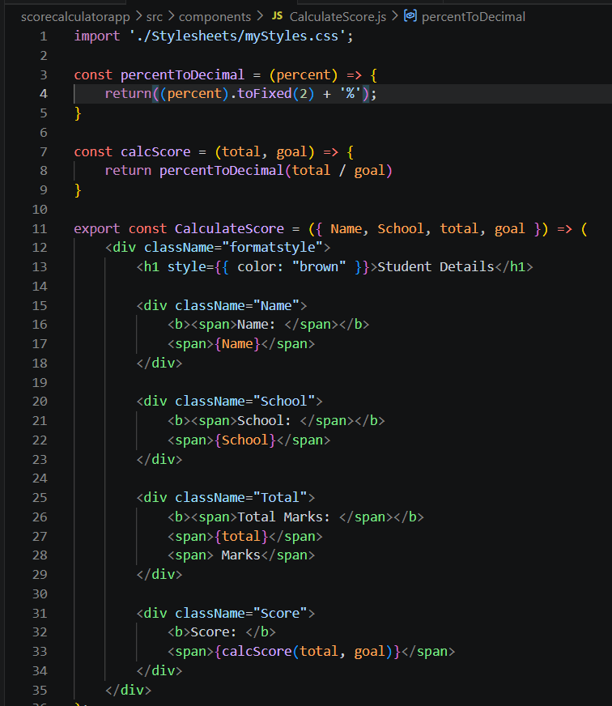
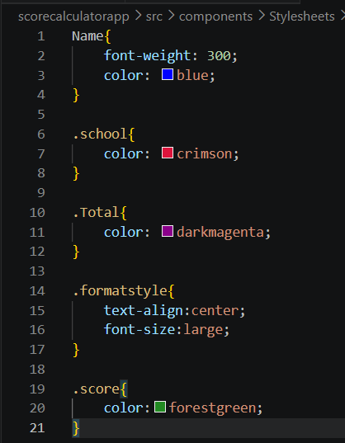

Output:

