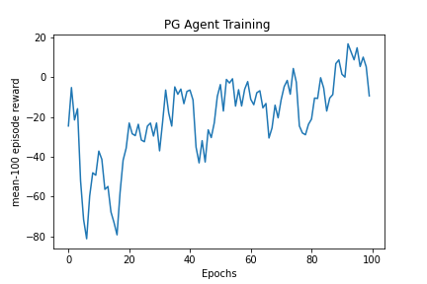

PG Agent Training

**mean-100 episode reward**

20

40

60

80

100

Epochs