
RAJALAKSHMI ENGINEERING COLLEGE
(An Autonomous Institution, Affiliated to Anna University, Chennai)
Department of Computer Science and Design
FILM MAKING AND RADIO PODCASTING
Short Film Analysis & Production Report
“THE LIGHT”
“There's no perfect parent, so just be a real one.”
Submitted by | SURYA. K
Register Number | 231701058
Department | B.E. COMPUTER SCIENCE AND DESIGN
Semester / Year | VII Semester (4th Year)
Camera Used | Nikon D3500 (DSLR)

Academic Year 2026 – 2027

BONAFIDE CERTIFICATE
This is to certify that this report titled “THE LIGHT” — A Short Film Analysis and Production Report, is a bonafide record of the work carried out by SURYA. K (Register Number: 231701058), of B.E. COMPUTER SCIENCE AND DESIGN, RAJALAKSHMI ENGINEERING COLLEGE, in partial fulfilment of the requirements for the course FILM MAKING AND RADIO PODCASTING, during the academic year 2026 – 2027.

________________________ | ________________________
Faculty In-Charge | Head of the Department

Submitted for the practical / continuous-assessment evaluation held on ____________________.

________________________
Internal Examiner

DECLARATION
I, SURYA. K (Register Number: 231701058), hereby declare that the short film “THE LIGHT” and this accompanying report were conceived, written, directed, shot and edited by me as an original piece of work for the course FILM MAKING AND RADIO PODCASTING, RAJALAKSHMI ENGINEERING COLLEGE. The analysis, observations and reflections presented in this report are my own, arrived at through the process of making the film. Any reference material consulted has been acknowledged in the References section.

Place: Chennai
Date: ____________
(SURYA. K)

ACKNOWLEDGEMENT
I would like to express my sincere gratitude to the Department of Computer Science and Design, RAJALAKSHMI ENGINEERING COLLEGE, for offering FILM MAKING AND RADIO PODCASTING as a course that pushed me to think beyond code and into narrative, image and sound.
I thank my faculty in-charge for the guidance given during the scripting, shooting and editing stages of this project, and for the continuous feedback that shaped the final cut of the film.
I am grateful to my mother and my younger cousin, who stepped in front of the camera as the Mother and the Boy respectively, for their patience through repeated takes in a dimly lit room, and to my family for allowing their living room to become a film set for an evening.
Finally, I thank my classmates and friends who previewed early cuts of the film and whose reactions — silence at the right moments — told me the edit was working.

TABLE OF CONTENTS
Abstract 6
Chapter 1 — Introduction 7
1.1 About the Course · 1.2 Project Overview · 1.3 One-Line Premise · 1.4 Objectives 7
Chapter 2 — Pre-Production 8
2.1 Concept and Theme · 2.2 Synopsis · 2.3 Characters · 2.4 Locations · 2.5 Equipment 8
Chapter 3 — Scene-by-Scene Analysis 10
3.0 Cold Open — Title Card 10
3.1 Scene 1 — A Normal Evening 10
3.2 Scene 2 — The Power Cut 12
3.3 Scene 3 — The Change 13
3.4 Scene 4 — The Message 15
3.5 Final Shot 15
Chapter 4 — Cinematography & Visual Language 16
Chapter 5 — Sound Design 17
Chapter 6 — Editing & Post-Production 18
Chapter 7 — Thematic Analysis 19
Chapter 8 — Learning Outcomes 20
Chapter 9 — Conclusion 21
Annexure A — Full Shooting Script 22
Annexure B — Technical Specification Sheet 24
References 25

ABSTRACT
“THE LIGHT” is a 3–5 minute short film made for the course FILM MAKING AND RADIO PODCASTING, built around a single evening in an ordinary household. A mother, half-listening to a television news report on rising academic stress and student suicides, watches her son quietly building with blocks on the floor. When a power cut plunges the house into darkness, the boy's fear becomes an occasion for the mother to show him — not tell him — that she is present: she lights a candle, plays with its flame until his fear turns to curiosity, and the two end up building and playing together in the candlelight. The film closes on a direct address: “Sometimes, all a child needs is someone who stays.”
This report documents the making of the film and analyses it as a piece of craft: the concept and one-line premise, the script (reproduced in full in Annexure A), a scene-by-scene breakdown supported by screenshots taken directly from the edited footage, the cinematography and lighting choices made with a Nikon D3500, the sound design, the editing rhythm, and the central theme of presence over perfection in parenting. It closes with the learning outcomes drawn from the exercise and a set of reflections on what the course — spanning both film making and radio podcasting — contributed to the way the film was written, shot and voiced.

CHAPTER 1 — INTRODUCTION

1.1 About the Course
FILM MAKING AND RADIO PODCASTING is a practical, production-oriented course that asks students to work across two closely related disciplines: the visual grammar of film making and the audio-first discipline of radio podcasting. Both share a common root — using a limited set of tools (camera and lens on one side, microphone and voice on the other) to hold an audience's attention and land an emotional or informational point within a short running time. This project applies the film-making half of the course: writing, shooting, and editing an original short film of 3–5 minutes.

1.2 Project Overview
The brief for the exercise was open: conceive, script, shoot and edit a short narrative film with a clear message, using whatever equipment and location was realistically available. I chose to shoot at home, with a Nikon D3500 DSLR, using my own family as the cast, because the story I wanted to tell — a parent showing up for a child in a moment of fear — needed a setting that felt lived-in rather than staged.

1.3 One-Line Premise (Logline)
“There's no perfect parent, so just be a real one.”
The film opens on this line and returns to its idea at the very end, framing everything in between — the news report, the power cut, the candle — as a single, concrete illustration of what that sentence means in practice.

1.4 Objectives
- To write a short, dialogue-light script that communicates an emotional idea primarily through action and image rather than exposition.
- To direct non-professional, first-time performers (family members) in a way that produces natural, unforced reactions on camera.
- To use practical, in-camera lighting (a single candle) as both a story device and the film's main light source.
- To edit the footage into a coherent 3–5 minute arc with a clear beginning, turning point and resolution.
- To connect the film's message to a real social concern — rising academic stress and mental-health strain among students — without turning the film into a public-service announcement.

CHAPTER 2 — PRE-PRODUCTION

2.1 Concept and Theme
The starting point for “THE LIGHT” was a news line that keeps recurring in the real world: reports of students struggling under academic pressure and, in the worst cases, of that pressure ending in suicide. Rather than dramatising that crisis directly, the film asks what could stand between a child and that outcome, and lands on something small and ordinary — a parent who is simply, reliably present. The theme is stated in the course's own vocabulary: good parenting and emotional support, not as abstractions but as a mother lighting a candle instead of turning on her phone's torch, and choosing to sit on the floor and play instead of issuing reassurance from a distance.

2.2 Synopsis
On a quiet evening, a Boy plays contentedly with building blocks while his Mother watches a television news report on student stress and suicide. The news troubles her, but the Boy — absorbed in his own small act of creation — notices nothing. A sudden power cut throws the house into darkness; the Boy, startled, calls out for his mother. Instead of simply comforting him with words, she lights a candle and begins playing with its flame, casting shadows on the wall, until her own ease with the light draws the Boy out of his fear and into play beside her. The camera pulls back to show them playing together in the candlelight as a voiceover delivers the film's message: presence, not perfection, is what a child needs from a parent. A final shot of the two of them building blocks together by candlelight, and an on-screen line — “Sometimes, all a child needs is someone who stays” — closes the film.

2.3 Characters
Character | Played by | Description
Mother | Family member (uncredited, courtesy appearance) | Half-attentive to the news at first; the emotional centre of the film. Her arc moves from quiet worry to deliberate, playful presence.
Boy | Family member (uncredited, courtesy appearance) | Absorbed in his blocks, then frightened by the dark; his fear-to-curiosity arc is the film's turning point.
Voice-over (English) | Narrator (non-diegetic) | Delivers the film's closing message directly to the audience over the final images.

2.4 Locations and Setup
- Interior — a family living room, used for all four scenes (single-location shoot).
- Practical props: a working television tuned to a pre-recorded news clip, wooden/plastic building blocks and toys, a candle, and a matchbox.
- Shot in the evening to use naturally low ambient light, which made the staged power cut visually credible.

2.5 Equipment
- Camera: Nikon D3500 (DSLR), used for every shot in the film.
- Kit lens, handheld and static tripod shots depending on the beat — steadier framing for dialogue, slightly looser handheld framing during the power-cut panic for a subjective feel.
- A single candle as the sole practical light source for Scenes 2–4, supplemented only by whatever ambient light the room retained.
- On-camera audio for dialogue and room tone; the English voice-over was recorded separately and laid over the final cut.

CHAPTER 3 — SCENE-BY-SCENE ANALYSIS
This chapter breaks the film down scene by scene, following the structure of the shooting script (reproduced in full in Annexure A). Each section includes the on-screen action, the shots used to capture it, and frame grabs taken directly from the first-half edit of the film supplied for this report; scenes beyond the first-half cut are analysed from the script and shot plan alone, and are marked accordingly.

3.0 Cold Open — Title Card
The film opens, before any picture of a location appears, on the film's own tagline set in white serif type against black: “There's no perfect parent, so just be a real one.” — attributed on screen, followed by the title card “THE LIGHT”. Opening on the thesis statement rather than burying it in a mid-film voiceover is a deliberate structural choice: the audience is told exactly what argument the next four minutes are going to make, which turns the film into a demonstration rather than a mystery.
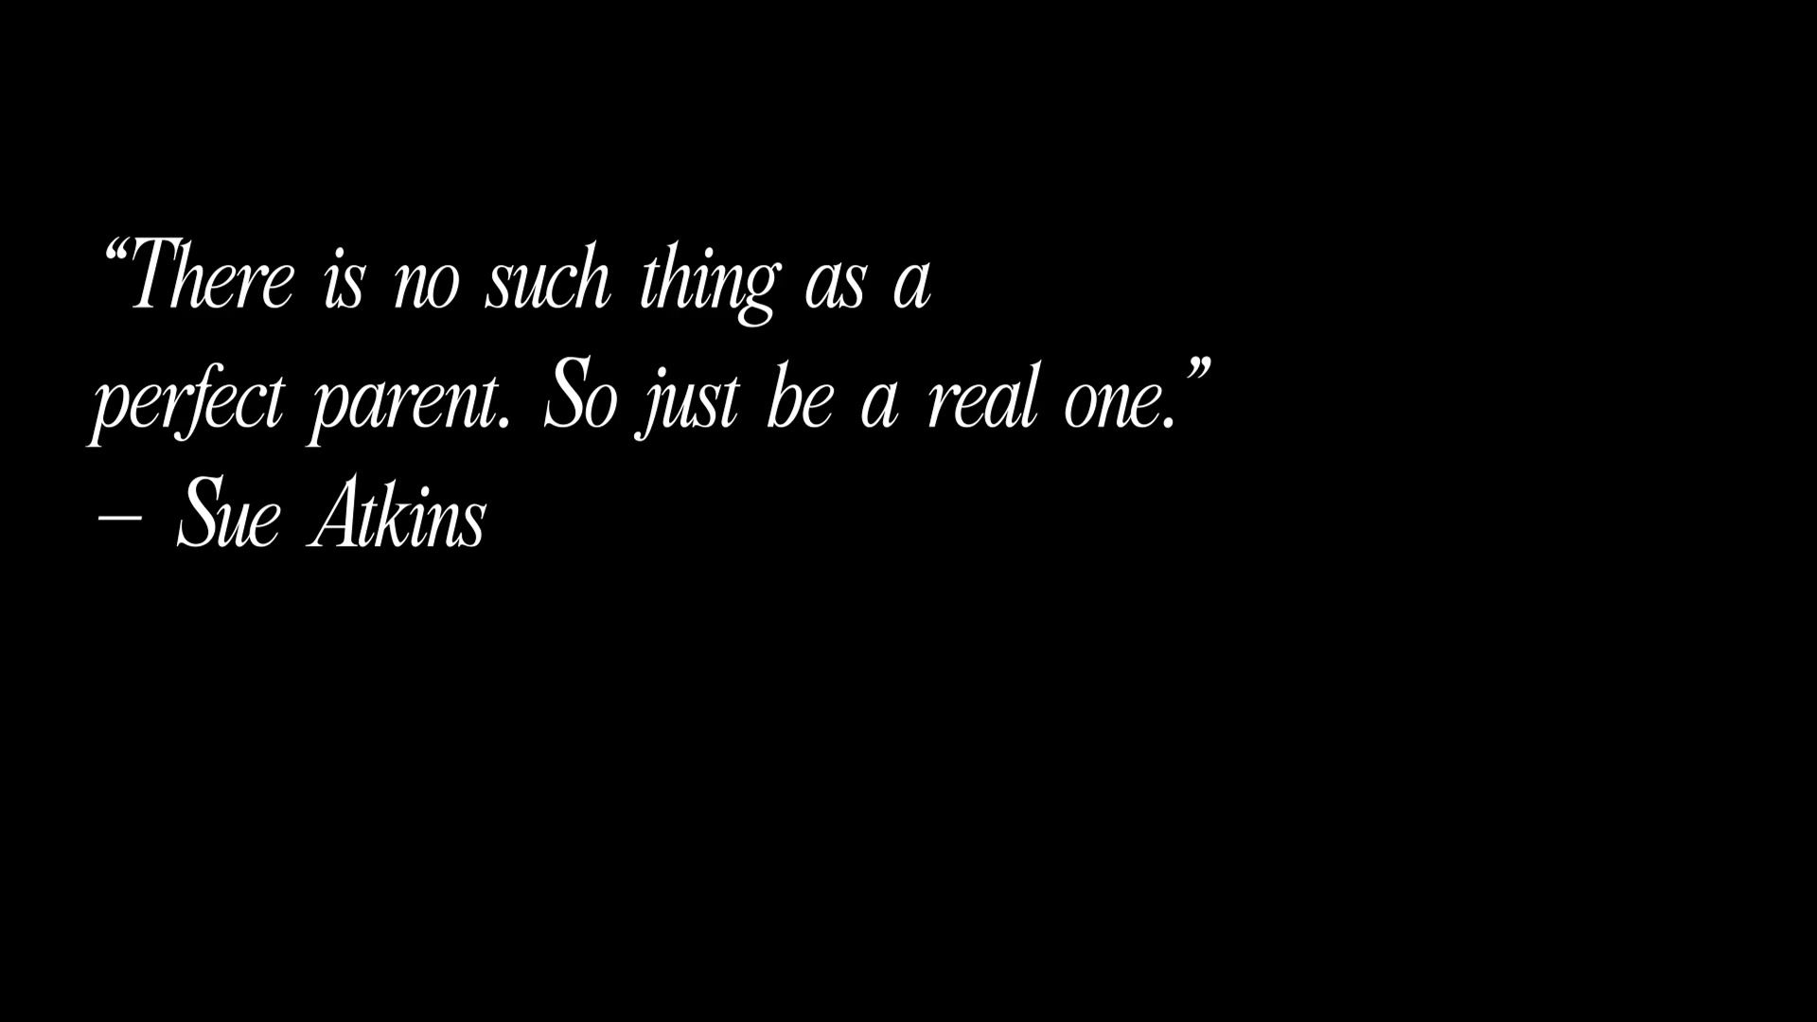
Opening title card — the film states its thesis before a single scene begins.
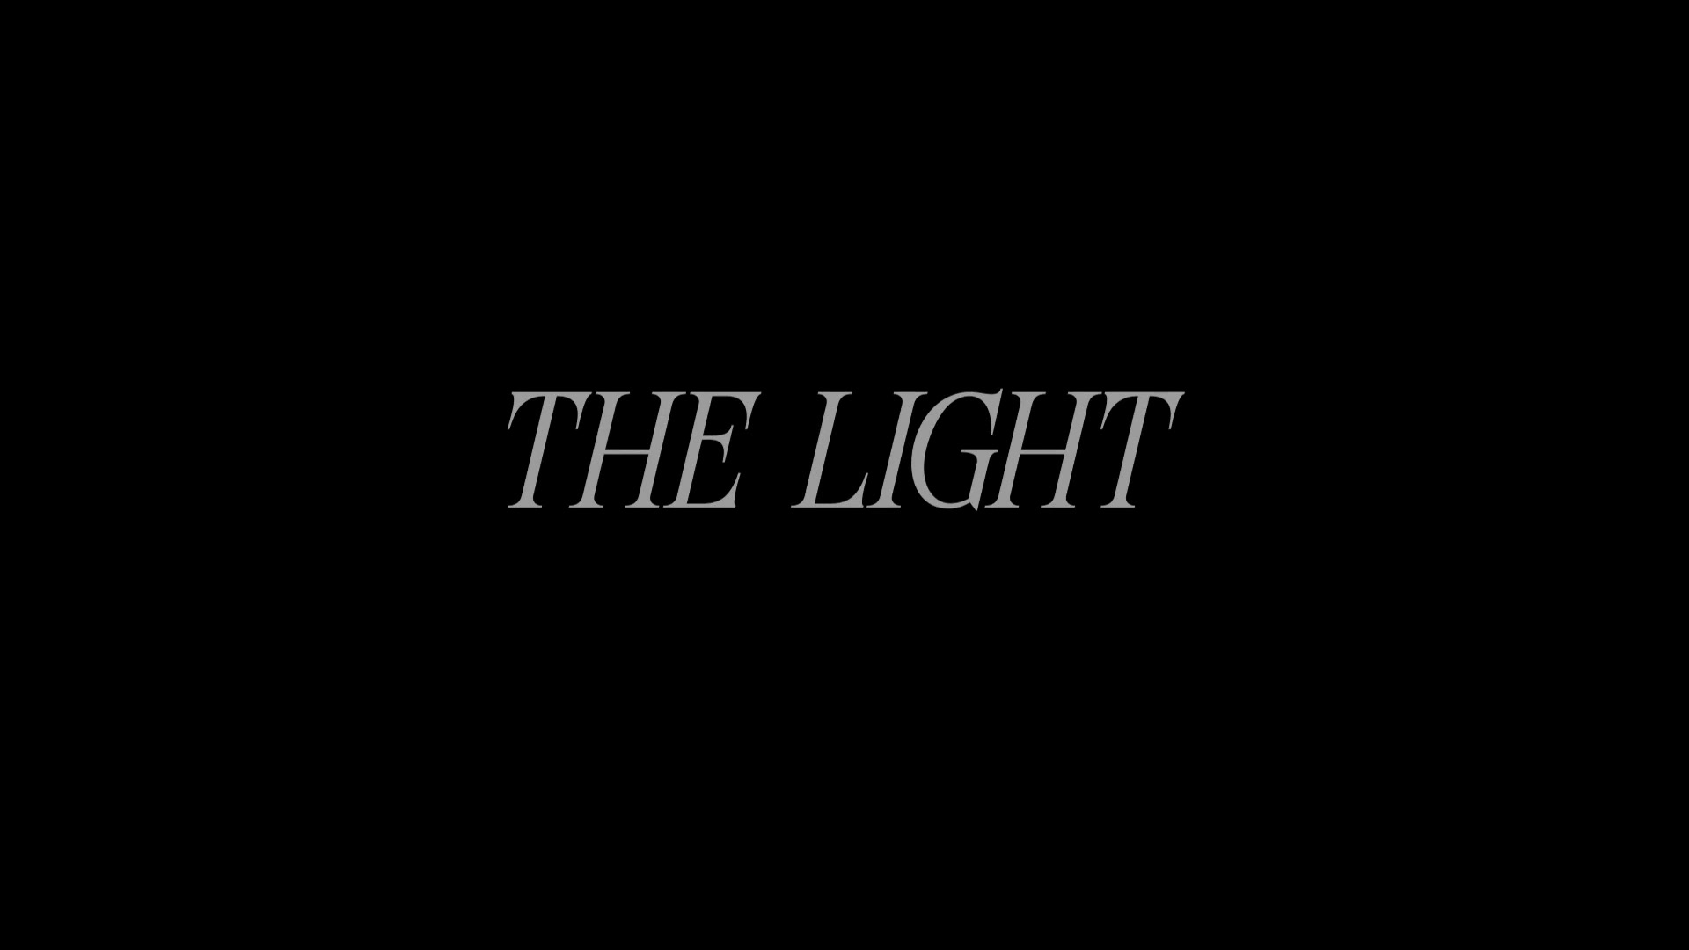
Film title card, in the same restrained white-on-black typography.

3.1 Scene 1 — A Normal Evening
INT. HOUSE — EVENING
The house is quiet. The Boy sits on the floor, completely absorbed in building with his blocks. The Mother sits nearby watching television; a news broadcast reports on student academic pressure and, in some cases, suicide. She grows visibly troubled, glances at her son — who notices nothing, still focused on placing the final block — and the scene holds on that gap between her private worry and his untroubled play.
Shot | Shot Type | Description
1A | Wide / Establishing | Living room in warm ambient light: TV in frame, Mother seated on the floor, Boy cross-legged with his blocks in the foreground — establishes the domestic ordinariness the film will shortly interrupt.
1B | Medium, TV + Mother | Mother watching the television; the news audio is allowed to play in full over the shot rather than being cut short, so the audience reads the headline with her.
1C | Close-up, Mother | Her expression shifts from passive viewing to concern as the report continues.
1D | Close-up, Boy | The Boy finishes his block tower, unaware of the broadcast — the shot that sets up the dramatic irony the power cut will resolve.
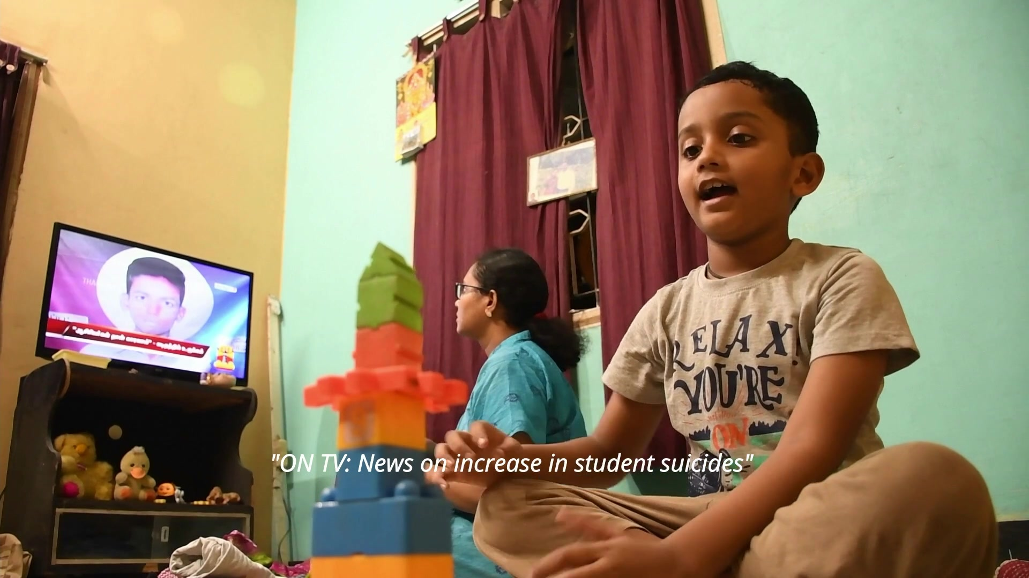
Scene 1 — the television news report plays in the background as the Boy calls out to his mother, absorbed in his own moment.
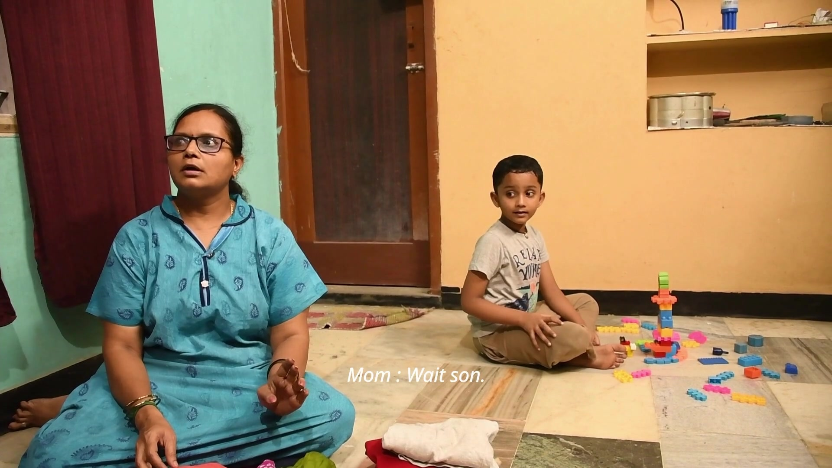
Scene 1 — the Mother seated beside the Boy as he builds with his blocks; the calm before the power cut.
Craft note: the scene never cuts to a close shot of the television screen itself — the news stays audio-only. This keeps the film's register personal rather than journalistic; the crisis is something the audience hears about, the way the Mother hears about it, rather than something the camera reports on directly.

3.2 Scene 2 — The Power Cut
INT. HOUSE — CONTINUOUS
The power cuts without warning. The room goes fully dark. The Boy freezes, then calls out, “Amma!” The Mother answers instantly — “Bayapadadha da… Amma inga irukken” (“Don't be afraid, dear... Amma is right here”) — gets up, lights a candle, and walks toward him. He looks at the candle with fear and edges away.
Shot | Shot Type | Description
2A | Wide, blackout | Hard cut from the warmly lit Scene 1 to near-total darkness — the single biggest lighting contrast in the film, used to physically startle the audience along with the Boy.
2B | Close-up, Boy (silhouette) | Barely lit by whatever residual light remains; his voice carries the beat rather than his visible expression.
2C | Medium, Mother lighting candle | The strike of the match and the small bloom of flame is the scene's only true light source, shot in tight close-up so the flame itself becomes a character.
2D | Medium, Mother approaching | Candle-lit walk toward the Boy; his flinch away from the light is held long enough to register before Scene 3 begins the turn.
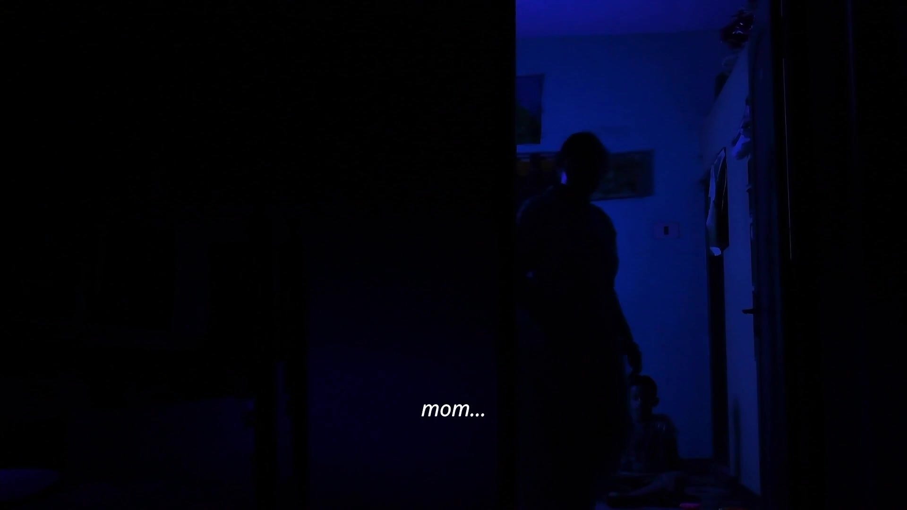
Scene 2 — the blackout: only a sliver of blue ambient light remains as the Boy calls out for his mother.
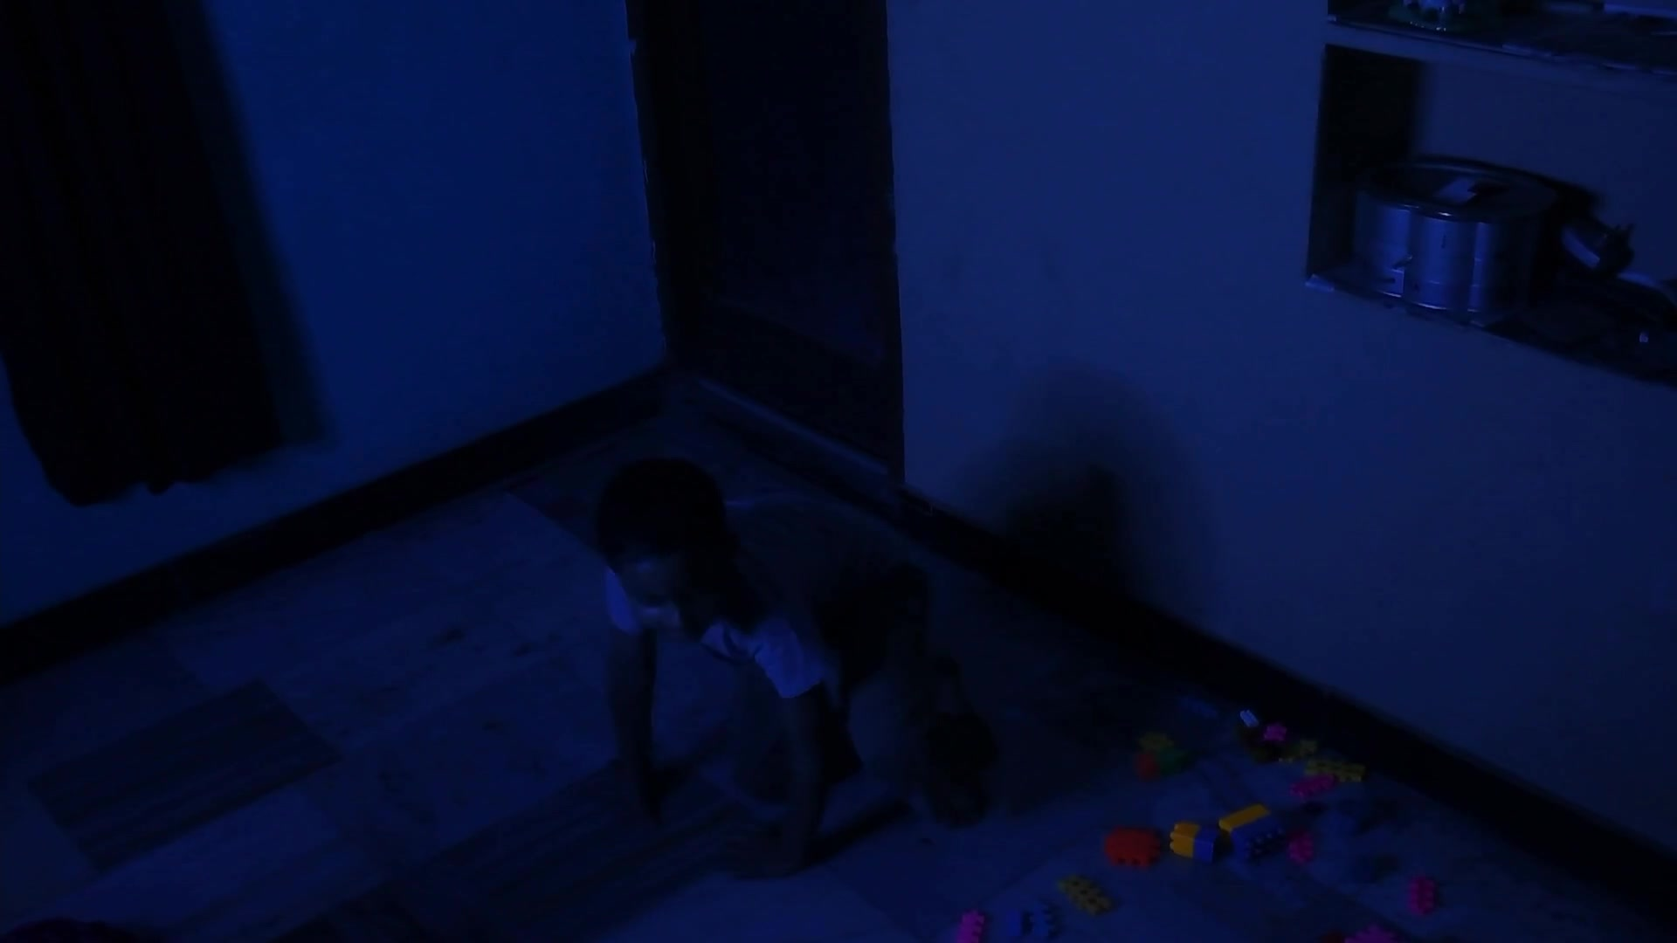
Scene 2 — a lone silhouette in the dark room in the seconds before the candle is lit.
Craft note: rather than resolving the darkness with a torch or phone light — the realistic modern choice — the script insists on a candle. That choice is not incidental: a candle has to be tended, sat with and watched, which is what turns the next scene into shared activity instead of a simple fix.

3.3 Scene 3 — The Change
INT. HOUSE — CONTINUOUS
The Mother sits beside the Boy with the candle and begins playing with the flame herself — moving her hand near the light, throwing playful shadows on the wall. Watching her treat the thing he feared as a source of play, the Boy's fear loosens. He edges closer, then joins in, and the Mother gently takes his hand. They play together in the candlelight.
Shot | Shot Type | Description
3A | Two-shot, low angle | Mother and Boy on the floor at the candle's eye level, letting the flame's warm light fall across both faces evenly.
3B | Insert, hands + flame | Close, shallow-focus shot of the shadow play on the wall — the visual proof of the mother modelling calm rather than instructing it.
3C | Close-up, Boy's face | Fear giving way to curiosity, lit only by the candle — the emotional hinge of the entire film.
3D | Wide, both playing | Pulls back to show the two of them fully at ease, building and playing together by candlelight.
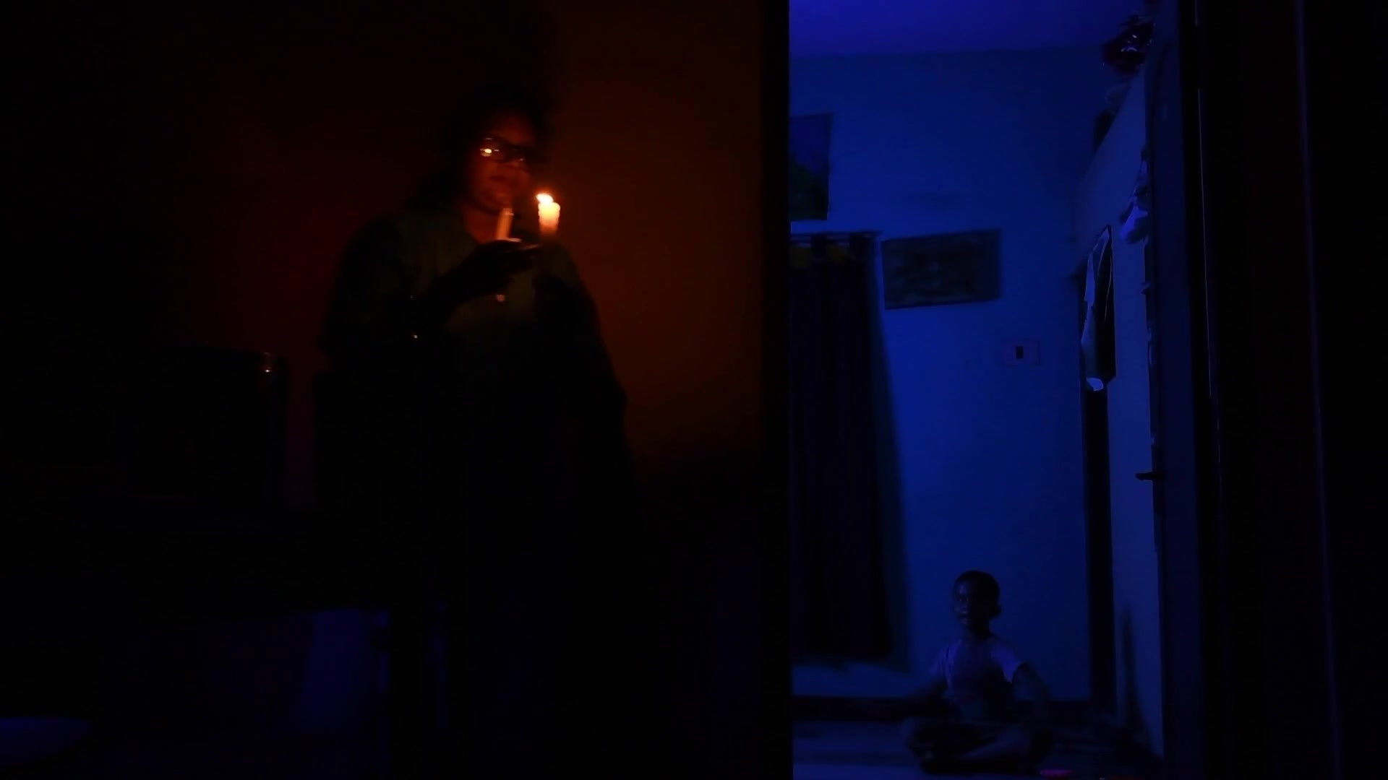
Scene 3 — candlelight held close, its reflection catching on the floor as the Mother draws the Boy back into play.
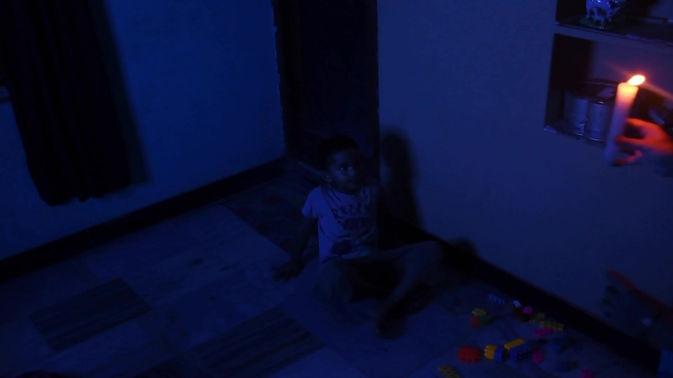
Scene 3 — Mother and Boy together on the floor, the room still dark but the fear already gone.
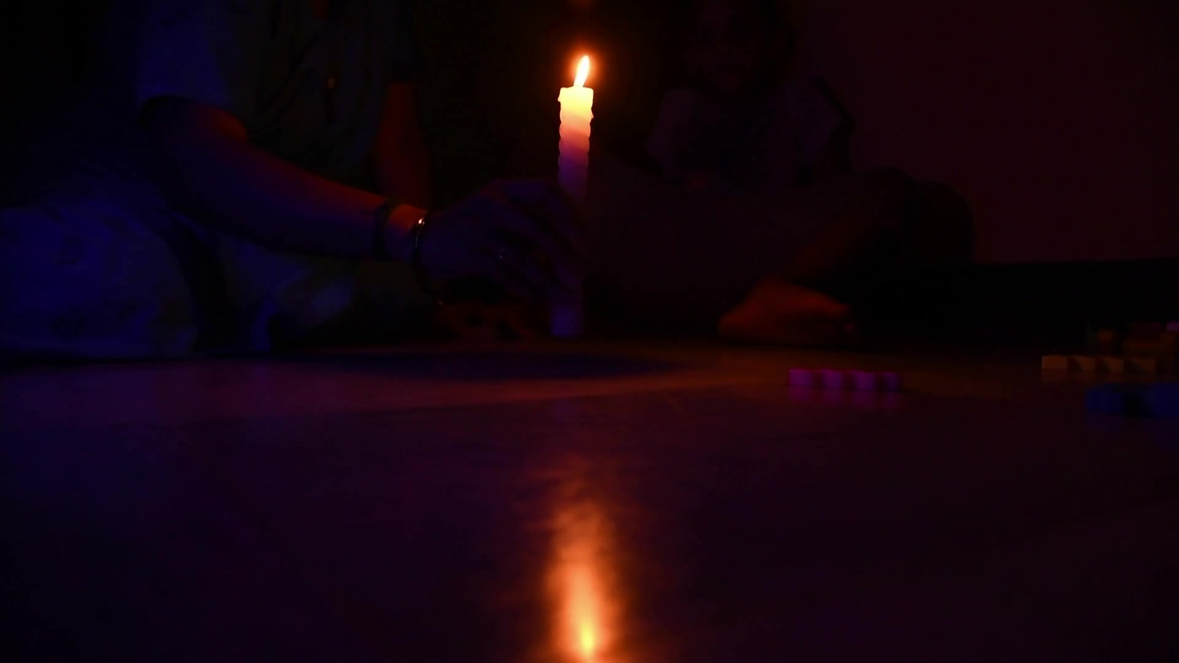
Scene 3 — the Boy's face lit only by the candle, the moment his fear turns to ease.
Note on footage supplied: the frame grabs above are drawn from the first-half edit provided for this report, which covers Scenes 1 through 3. Scene 4 and the Final Shot, described below, are documented from the shooting script and shot plan, as that portion of the edit was not included in the file supplied.

3.4 Scene 4 — The Message (from script; not in supplied footage)
The camera slowly pulls away from the Mother and son, still playing in the candlelight, as an English-language voice-over begins over the image: “Sometimes, a child doesn't need the perfect words. They just need someone to be there.” The voice-over continues in short, declarative lines — “Good parenting is not about teaching a child to face every problem alone. It is about making them feel that they never have to face it alone.” — building to direct instructions to the audience: “Listen to your children. Talk to them. Understand what they are going through. And when they feel like giving up, don't walk away. Stay. Support them. Give them hope.” It closes on the film's central image: “Because sometimes, your presence can be the light that helps them find their way out of the darkness.”

3.5 Final Shot (from script; not in supplied footage)
As the Mother and Boy continue playing with the building blocks, the camera slowly zooms out, holding them together in the candlelit room, before the scene fades to black. On-screen text restates the title and author credit, followed by the film's closing line: “Sometimes, all a child needs is someone who stays. LISTEN. SUPPORT. STAY.” — a direct, three-word call to action that turns the film's private story into a public one.

CHAPTER 4 — CINEMATOGRAPHY & VISUAL LANGUAGE

4.1 Camera and Lens Choices
The entire film was shot on a Nikon D3500, an entry-level APS-C DSLR, with its standard kit lens. The camera's small sensor and modest low-light performance were treated as a creative constraint rather than a limitation to fight: because the D3500 struggles at very high ISO, the candle-lit scenes were shot at wider apertures and deliberately underexposed rather than pushed to a noisy ISO, which kept the grain low and let the shadows stay genuinely dark instead of a washed-out grey.

4.2 Lighting Design
The film's lighting is built on a single contrast: the flat, ambient light of ordinary evening in Scene 1 against the near-total darkness of Scene 2, resolved only by a practical candle for Scenes 3 and 4. No additional film lights, reflectors or diffusion were used — the candle is both a prop and the key light for every shot after the power cut, which meant blocking the actors' hands and faces to stay close enough to the flame to be lit by it, a constraint that pushed the two-shots in Scene 3 physically closer together and, in turn, made the scene read as more intimate.

4.3 Colour and Symbolism
- Warm, neutral tones in Scene 1 — the ordinary, safe evening before the disruption.
- Cold blue-black in the blackout of Scene 2 — visually coding fear and disorientation.
- Warm orange candlelight from Scene 3 onward — coding comfort, closeness and safety, and visually answering the cold blue of Scene 2 with its opposite.
This warm/cool alternation does the thematic work that dialogue is deliberately kept light on: the audience feels the shift from fear to safety through colour temperature before the voice-over ever states it outright.

4.4 Composition
Scene 1 favours slightly wider, more separated framing — Mother and Boy occupy different parts of the frame, mirroring her private worry and his private play. From the candle-lighting shot onward, framing tightens into two-shots and close-ups that place both faces inside the same small pool of light, so the composition itself enacts the film's message: presence means being in the same frame, not just the same room.

CHAPTER 5 — SOUND DESIGN
Because this course pairs film making with radio podcasting, sound was treated as a full second layer of storytelling rather than an afterthought bolted on in the edit — closer to how a podcast episode is built around voice and room tone than how a student film often treats its audio track.

5.1 Diegetic Sound
- The television news broadcast — the inciting sound of the entire film — is a scripted, purpose-recorded clip rather than a real news bulletin, allowing the exact wording ("students academic pressure and emotional stress", "suicide pannirukaanga") to be controlled for the story.
- The power-cut sound effect — a sudden electrical cut — is used as a hard audio button that lands in the same frame as the picture cut to black, so the audience's ears and eyes lose the room at the same instant.
- Dialogue is sparse by design: only two lines are spoken in the entire film ("Amma!" and "Bayapadadha da… Amma inga irukken"), both in Tamil, both short enough to land as pure emotional reflex rather than expository speech.

5.2 Non-Diegetic Sound and Voice-Over
The English voice-over that carries Scene 4 was recorded as a separate, controlled audio pass rather than captured on location — a direct application of the radio-podcasting half of the course, where voice takes are recorded dry, close to the microphone, and shaped afterward with pacing and pauses rather than performance energy. The lines are written short and are read slowly, with a pause placed after nearly every sentence, so that each instruction ("Listen to your children." / "Talk to them." / "Stay.") has room to land individually rather than blurring into a single paragraph of narration.

5.3 Use of Silence
Silence is used almost as deliberately as sound. The seconds immediately after the power cut are held with only ambient room tone and the Boy's breathing before the dialogue lands, and the candle-lighting shot plays out with no music at all — only the small, real sounds of a match striking and a wick catching. Withholding score at the film's most tender beat keeps the moment from being told to the audience through music cues; the picture is left to carry the emotion on its own.

CHAPTER 6 — EDITING & POST-PRODUCTION

6.1 Pacing and Rhythm
Scene 1 is cut at a relaxed, observational pace — longer takes, few cuts — to establish normalcy. The power cut is the film's sharpest edit: a hard, unfiltered cut from a fully lit wide shot to near-black, with no cross-dissolve, so the disruption is felt as abruptly on the cut as it is in the story. From the candle-lighting shot onward, the pace slows again, this time deliberately, holding on faces slightly longer than strictly necessary to let the fear-to-ease transition read as earned rather than rushed.

6.2 Transitions
- Fade-in from black at the very start, under the opening tagline card — a slow reveal that sets the film's unhurried tone before a single scene of action begins.
- Hard cut (no transition) at the power cut — the one moment in the film where an abrupt edit is the correct choice, because the story event itself is abrupt.
- Slow zoom-out at the Final Shot, paired with a fade to black — the visual language of an ending, used only once, so it isn't diluted by earlier overuse.

6.3 On-Screen Text
On-screen text is used twice and only twice: the opening tagline card and the closing title-and-credit card with the line “Sometimes, all a child needs is someone who stays. LISTEN. SUPPORT. STAY.” Both use the same restrained white serif typeface on black, so the film opens and closes on visually matching bookends — the audience is meant to recognise, without being told, that the closing card is answering the opening one.

CHAPTER 7 — THEMATIC ANALYSIS

7.1 Central Theme — Presence Over Perfection
The film's argument, stated outright in its opening tagline, is that “there's no perfect parent, so just be a real one.” Every story beat is built to demonstrate rather than explain that idea: the Mother does not deliver a speech when the lights go out; she lights a candle and sits down to play. The film's thesis is enacted in behaviour before it is ever spoken aloud in the Scene 4 voice-over, which is why the voice-over can afford to be direct and even slightly didactic — the audience has already seen the idea proven once, so the narration reads as a summary rather than a lecture.

7.2 Social Relevance
The television news report that opens the film is not incidental colour — it names the real, ongoing concern of academic pressure and student suicide that the course brief and the wider cultural conversation around student mental health made an obvious, urgent subject for a short film. By keeping the on-screen crisis at one remove (heard on a broadcast, not depicted directly) and instead dramatising the small, preventive act of a parent staying present, the film positions itself as a piece of quiet advocacy rather than a dramatisation of tragedy — a choice suited to a short, shareable format meant for a general audience rather than a clinical or classroom one.

7.3 Symbolism of Light and Darkness
The film's title is also its central metaphor. Darkness stands for fear, isolation and the unspoken crisis named in the news report; light — specifically a small, tended, human-scaled light rather than an instant electric fix — stands for attention that has to be chosen and maintained. The choice of a candle over a torch or phone light is the film's clearest piece of visual argument: real support, the film suggests, is not a switch you flip but a flame you sit with.

7.4 Target Audience and Intended Impact
The film is aimed at a general audience but speaks most directly to parents and caregivers of school- and college-age children, and secondarily to students who may want to send it to a parent as an indirect way of asking to be listened to. At 3–5 minutes with almost no dialogue, it is built for the format it will most likely circulate in — a shared video clip — where a clear, single idea delivered quickly outperforms a longer, more explanatory treatment.

CHAPTER 8 — LEARNING OUTCOMES
As a Computer Science and Design student, the most valuable part of this exercise was seeing how much of the discipline transfers from software work to filmmaking: both are exercises in cutting away everything that doesn't serve the core idea. The specific, transferable outcomes from this project were:
- Scripting for the screen: learning to cut dialogue down to the two lines the film actually needed, and to trust blocking and performance to carry meaning that a script draft had originally tried to explain in words.
- Directing non-actors: getting natural reactions from family members required simple, concrete instructions ("look at the candle, then look at your hand") rather than discussion of motivation or backstory.
- Practical, in-camera lighting: working with a single candle as a key light on a consumer DSLR taught real lessons in exposure, ISO trade-offs and the value of underexposing rather than pushing noise.
- Sound-as-craft, carried over from the radio-podcasting half of the course: recording a clean, separately-paced voice-over and treating silence as a deliberate choice rather than a gap to be filled.
- Editing for rhythm: understanding that a hard cut and a slow zoom are both tools that should be spent once, at the moment they mean the most, rather than used as a default stylistic habit.
- Producing to a constraint: completing an entire narrative short — script to final cut — using one location, two non-professional performers, and one piece of consumer camera equipment.

CHAPTER 9 — CONCLUSION
“THE LIGHT” set out to make a small, specific argument — that a parent's steady presence matters more than any perfect response — and to make that argument through image and behaviour rather than dialogue. Working within the real limits of a single evening, one location, two family members as cast, and a Nikon D3500, the film's clearest achievement is structural discipline: every scene, shot and sound choice points back at the same idea stated in its opening tagline. The candle motif in particular did more storytelling work than any line of dialogue could have, turning a simple lighting solution into the film's central symbol.
For this course, the project served its purpose twofold: as a complete film-making exercise from concept to final cut, and as a practical rehearsal of the voice and sound discipline emphasised on the radio-podcasting side of the syllabus, most visible in the separately recorded, deliberately paced voice-over. The finished film is short enough to be shared as-is, and its central metaphor — light chosen and tended, rather than switched on — is deliberately simple enough that it should read the same way to any audience, technical or not.

ANNEXURE A — FULL SHOOTING SCRIPT
THE LIGHT
Written and Directed by Surya K
Theme: Good Parenting, Emotional Support | Duration: 3–5 minutes

SCENE 1 — A NORMAL EVENING
INT. HOUSE — EVENING
The house is quiet and peaceful.
A BOY is sitting on the floor, happily playing with his building blocks and toys. He is completely focused on what he is building.
His MOTHER is sitting nearby, watching television.
TV NEWS:
“Recent reports-la neraya students academic pressure and emotional stress nala romba struggle panraanga. Unfortunately, sila students suicide pannirukaanga.”
The mother becomes worried after hearing the news.
She looks at her son, who continues playing without noticing.
The boy carefully places the final block on his creation.
SCENE 2 — THE POWER CUT
INT. HOUSE — CONTINUOUS
Suddenly, the power goes out.
SFX: Electricity cuts off.
The entire room becomes dark.
The boy freezes and looks around nervously.
BOY:
“Amma!”
The mother immediately turns toward him.
MOTHER:
“Bayapadadha da… Amma inga irukken.”
She gets up and lights a candle.
She slowly walks toward her son, holding the candle.
The boy looks at the candle with fear and moves slightly away.
SCENE 3 — THE CHANGE
The mother sits beside him with the candle.
She starts playing with the candle flame, carefully moving her hand near the light and creating playful shadows on the wall.
The boy watches her closely.
Seeing his mother comfortably playing with the candle, the boy slowly begins to lose his fear.
He looks at his mother, then at the candle.
After a moment, he moves closer and starts playing with the light along with his mother.
The mother smiles and gently holds his hand.
They continue playing together in the candlelight.
SCENE 4 — THE MESSAGE
The camera slowly moves away from the mother and son.
The room is still dark, but the candle continues to glow.
The mother and son continue playing together.
VOICE-OVER — ENGLISH
“Sometimes, a child doesn't need the perfect words. They just need someone to be there.”
“Good parenting is not about teaching a child to face every problem alone.”
“It is about making them feel that they never have to face it alone.”
“Listen to your children.”
“Talk to them.”
“Understand what they are going through.”
“And when they feel like giving up, don't walk away.”
“Stay.”
“Support them.”
“Give them hope.”
“Because sometimes, your presence can be the light that helps them find their way out of the darkness.”
FINAL SHOT
As the mother and son continue playing together with the building blocks, the camera slowly zooms out, capturing them together in the candlelit room.
The scene gradually fades to black.
TEXT ON SCREEN
THE LIGHT — By Surya K
“Sometimes, all a child needs is someone who stays.” LISTEN. SUPPORT. STAY.

ANNEXURE B — TECHNICAL SPECIFICATION SHEET
Parameter | Detail
Film title | THE LIGHT
Writer / Director | Surya K
Genre | Drama / Social short film
Duration | 3–5 minutes
Theme | Good parenting, emotional support
Camera | Nikon D3500 (DSLR, APS-C sensor)
Lens | Standard kit lens
Resolution / Frame rate | 1920 × 1080, 30 fps
Primary light source | Practical candle (Scenes 2–4); ambient room light (Scene 1)
Location | Single interior location — family living room
Cast | Mother and Boy — played by family members (courtesy appearance)
Languages | Tamil (dialogue), English (voice-over)
Number of scenes | 4 scenes + Final Shot

REFERENCES
- Field, S., Screenplay: The Foundations of Screenwriting, Delta, 1979 — for principles of short-form dramatic structure applied to the four-scene outline.
- Atkins, S. — on-screen attributed quotation used as the film's opening tagline: “There's no perfect parent, so just be a real one.”
- Course lecture notes and studio sessions, Film Making and Radio Podcasting, Department of Computer Science and Design, Rajalakshmi Engineering College.
- Original shooting script, “THE LIGHT” by Surya K (reproduced in full in Annexure A).
- Nikon D3500 camera and kit-lens technical documentation, consulted for exposure and low-light shooting parameters.

