|  |  |  |
| --- | --- | --- |
|  | **PORTFOLIO PROJECT** |  |

# Submitted by

# SURYA G

# 1P24MC052

In partial fulfillment of the requirements for the award of the Degree of

#### MASTER OF COMPUTER APPLICATIONS

From Bharathiar University, Coimbatore.

Under the Internal Supervision of

## Dr. S. RANJITHA KUMARI, M.Sc., M.Phil., Ph.D.,

Associate Professor, Dept. of MCA, RVSCAS



## SCHOOL OF COMPUTER STUDIES MASTER OF COMPUTER APPLICATIONS

**RVS COLLEGE OF ARTS AND SCIENCE (AUTONOMOUS)**

## Sulur, Coimbatore – 641 402.

**Nov 2024**

# RVS COLLEGE OF ARTS AND SCIENCE (AUTONOMOUS)

## Sulur, Coimbatore – 641 402. School of Computer Studies

**Department of Computer Applications (MCA)**



#### Nov 2024.

**Register Number: 1P24MC052**

Certified *bonafide* original record of work done by **SURYA G**

## Internal Supervisor Director

Submitted for the project Evaluation and *Viva-Voce* held on**………………….**

**Internal Examiner External Examiner**

# CONTENT INDEX

|  |  |
| --- | --- |
| **Chapter** | **Page No.** |
| **Chapter 1**: Video Introduction  1.1. YouTube Video | 1 |
| **Chapter 2:** Website Bio Score   * 1. About me   2. Contact Information | 2 |
| **Chapter 3**: Pages & Navigation   * 1. Landing Page      1. Responsive Query   2. Project Page   3. Navigation bar   4. Skill Page   5. Qualification Page | 17 |
| **Chapter 4**: Style Score  4.1 Style links | 46 |

|  |  |
| --- | --- |
| **Chapter 5**: Website include the following Information   * 1. Project link to the GitHub   2. Project Description | 49 |
| **Chapter 6**: Bootstrap  6.1 Uses of Bootstrap | 51 |
| **Chapter 7**: Project README  Title description  How to run the project  Future improvement in the Project | 54 |
| **Chapter 8**: File structure  8.1 GitHub file Structure | 57 |

**Chapter-1**

## 1.1Video Information

# 

# Description:

In this page, you can see the self-introduction of mine. By clicking the play button it will redirect to the YouTube page, so that you can know me more.

**Source Code:**

### HTML:

<iframewidth="320"height="180" src="https://www.youtube.com/embed/xJ8kwkPaEzU?si=zH7WOD44G3tnzpuU"

title="YouTube video player" frameborder="0"

allow="accelerometer; autoplay; clipboard-write; encrypted-media; gyroscope; picture-in-picture; web-share"referrerpolicy="strict-origin-when-cross-origin" allowfullscreen></iframe>

# 

# Chapter-2:

## Website Bio Score

## 2.1 About Me:

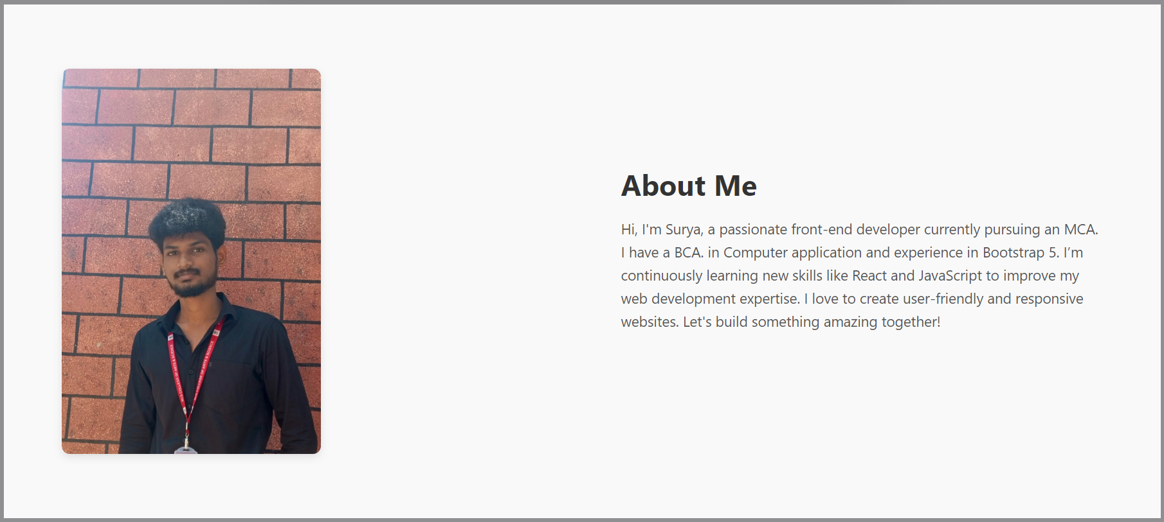

## Description:

In this page, there is an image of mine, paragraph about me and my self introduction video.

## Source Code:

### HTML:

<!--==================== ABOUT ====================-->

<section id="About" class="about-me-section">

<div class="container">

<div class="about-me-content">

<!-- Left side with image -->

<div class="about-me-left">

<img src="./asset/img/surya image.jpg" alt="surya Picture" />

</div>

<!-- Right side with text content -->

<div class="about-me-right">

<h2>About Me</h2>

<p>Hi, I'm Surya, a passionate front-end developer currently pursuing an MCA. I have a BCA. in Computer application and experience in Bootstrap 5. I’m continuously learning new skills like React and JavaScript to improve my web development expertise. I love to create user-friendly and responsive websites. Let's build something amazing together!</p>

</section>

### **CSS:**

/*=============== ABOUT ===============*/

.about-me-section {

background-color: #f9f9f9;

padding: 80px 0;

}

.about-me-content {

display: flex;

align-items: center;

justify-content: space-between;

gap: 50px;

}

.about-me-left img {

max-width: 50%;

border-radius: 10px;

box-shadow: 0 4px 10px rgba(0, 0, 0, 0.1);

}

.about-me-right {

max-width: 600px;

}

.about-me-right h2 {

font-size: 36px;

color: #333;

margin-bottom: 20px;

font-weight: bold;

}

.about-me-right p {

font-size: 18px;

line-height: 1.6;

color: #555;

margin-bottom: 30px;

}

/* Responsive Design */

@media (max-width: 768px) {

.about-me-content {

flex-direction: column;

text-align: center;

}

.about-me-right {

max-width: 100%;

}

.social-icons {

justify-content: center;

}

}

## 2.2 Contact Page :

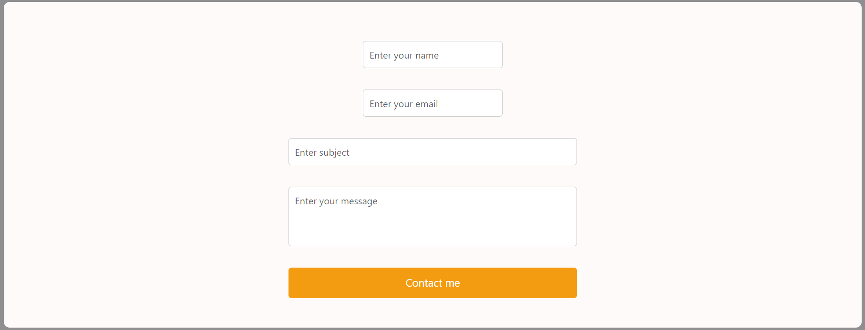

**Description:**

The above displayed figure is a contact page in the website. If the user wants to contact me, they can fill the form with their valid details. Here I imported library called Email-js to send messages.

## Source Code:

### HTML:

<!--==================== CONTACT ====================-->

<section id="contact">

<form action="#" class="row g-lg-3 gy-3">

<div class="form-group col-md-6">

<input type="text" class="form-control" id="name" placeholder="Enter your name">

</div>

<div class="form-group col-md-6">

<input type="email" class="form-control" id="email" placeholder="Enter your email">

</div>

<div class="form-group col-12">

<input type="text" class="form-control" id="subject" placeholder="Enter subject">

</div>

<div class="form-group col-12">

<textarea name="" rows="4" class="form-control" id="message" placeholder="Enter your message"></textarea>

</div>

<div class="form-group col-12 d-grid">

<button type="submit" class="btn btn-brand" onclick=" sendMail()">Contact me</button>

</div>

</form>

</section>

### CSS :

/*=============== CONTACT ===============*/

.

#contact {

    padding: 50px;

    background-color: #fefafa;

    margin-top: 30px;

    text-align: center;

    border-radius: 10px;

}

#contact h2 {

    font-size: 28px;

    margin-bottom: 20px;

    color: #333;

    text-transform: uppercase;

}

#contact form {

    display: flex;

    flex-direction: column;

    align-items: center;

    max-width: 500px;

    margin: 0 auto;

}

#contact label {

    font-size: 18px;

    color: #333;

    margin-bottom: 10px;

    width: 100%;

    text-align: left;

}

#contact input, #contact textarea {

    width: 100%;

    padding: 10px;

    margin-bottom: 20px;

    border: 1px solid #ccc;

    border-radius: 5px;

    font-size: 16px;

}

#contact textarea {

    height: 100px;

    resize: none;

}

#contact button {

    background-color: #f39c12;

    color: #fff;

    padding: 12px 20px;

    font-size: 18px;

    border: none;

    border-radius: 5px;

    cursor: pointer;

    transition: background-color 0.3s ease;

}

#contact button:hover {

    background-color: #e67e22;

}

/* Add responsive design */

@media (max-width: 768px) {

    #skills ul {

        flex-direction: column;

        align-items: center;

    }

    header .profile img {

        width: 120px;

        height: 120px;

    }

    #introduction video {

        width: 100%;

    }

# Chapter-3:

## Pages & Navigation

* 1. **Landing Page:**

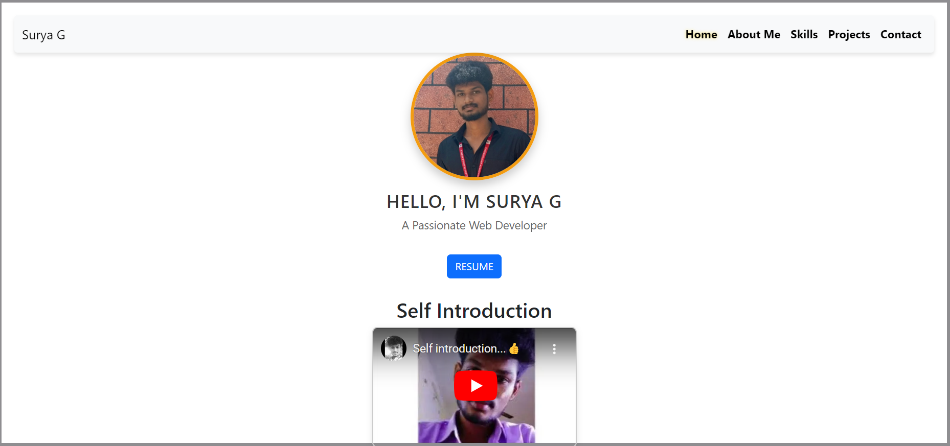

Figure 3.1.1

## Description:

The above Figure 3.1.1 are the screenshot of Homepage in a desktop view. And this is a home screen of the portfolio which shows the landing page and navigation bar. Here I also attached my resume and users allow to view and download the resume. which shown as Figure 3.1.1.

## Source Code

### HTML

<!--==================== HOME ====================-->

<div class="profile text-center">

<img src="./asset/img/MEEE.jpg" alt="Profile Photo" class="profile-photo img-fluid">

<h1 class="profile-title">Hello, I'm Surya G</h1>

<p class="profile-description">A Passionate Web Developer</p>

<a href="./Resume.html" class="btn btn-primary mt-3">RESUME </a> <!-- New Button -->

</div>

</header>

<section id="about">

<h2 style="display: flex; justify-content: center; align-items: center;">Self Introduction</h2>

<div style="display: flex; justify-content: center; align-items: center;">

<div style="max-width: 320px; margin: 0 auto; border: 2px solid #ccc; border-radius: 8px; overflow: hidden; box-shadow: 0px 4px 10px rgba(0,0,0,0.1);">

<iframewidth="320"height="180" src="https://www.youtube.com/embed/xJ8kwkPaEzU?si=zH7WOD44G3tnzpuU"

title="YouTube video player" frameborder="0"

allow="accelerometer; autoplay; clipboard-write; encrypted-media; gyroscope; picture-in-picture; web-share"

referrerpolicy="strict-origin-when-cross-origin" allowfullscreen></iframe>

</div>

</div>

### **CSS:**

/*=============== HOME ===============*/

header .profile {

display: flex;

flex-direction: column;

align-items: center;

margin-bottom: 30px;

}

/* Profile Image Styling */

header .profile img {

width: 200px; /* Increased size for bigger profile photo */

height: 200px;

border-radius: 50%; /* Circular image */

border: 5px solid #f39c12; /* Add border around the image */

box-shadow: 0px 8px 15px rgba(0, 0, 0, 0.2); /* Attractive shadow effect */

object-fit: cover; /* Ensure the image fits nicely */

transition: transform 0.3s ease-in-out, box-shadow 0.3s ease-in-out; /* Smooth transition for hover effect */

}

header .profile img:hover {

transform: scale(1.1); /* Slight zoom on hover */

box-shadow: 0px 12px 20px rgba(0, 0, 0, 0.3); /* Bigger shadow on hover */

}

/* Name and Role Styling */

header .profile h1 {

font-size: 28px;

margin-top: 15px;

color: #333;

text-transform: uppercase;

letter-spacing: 1px;

}

header .profile p {

font-size: 18px;

color: #666;

}

/* Introduction Section */

#introduction {

padding: 50px;

background-color: rgb(93, 89, 89);

margin-top: 30px;

border-radius: 10px;

}

#introduction h2 {

font-size: 28px;

margin-bottom: 20px;

color: #333;

text-transform: uppercase;

}

#introduction video {

width: 80%;

max-width: 50px;

border-radius: 10px;

margin-top: 20px;

box-shadow: 0px 6px 15px rgba(0, 0, 0, 0.2);

text-align: center;

}

**(Mobile view sample for one background image)**

### 

### 

Figure 3.1.2

## Description:

The above Figure 3.1.2 are the screenshot of Homepage in a Mobile view. And this is a home screen of the portfolio which shows the landing page and navigation bar ,which shownas Figure 3.1.2.

## 3.2 Project Page

## 

## 

**Source Code**

### HTML:

<!-- ==================== PROJECTS ==================== -->

<section class="project-section" id="project">

<h1>MY PROJECT</h1>

<div class="project-cards-container">

<!-- Project 1 -->

<div class="project-card">

<img src="github images2.jpg" alt="Project Image 1" class="project-image">

<div class="project-content">

<h2 class="project-title">Ball Project </h2>

<p class="project-description">A short description of Ball Project goes here.</p>

<div class="buttons">

<a href="https://github.com/Surya3338/Ball-move" class="button button-code" target="_blank">Source Code</a>

<a href="https://surya3338.github.io/Ball-move/" class="button button-output" target="_blank">Live Demo</a>

</div>

</div>

</div>

<!-- Project 2 -->

<div class="project-card">

<img src="github images2.jpg" alt="Project Image 2" class="project-image">

<div class="project-content">

<h2 class="project-title">Cursor Project </h2>

<p class="project-description">A brief description of Cursor Project goes here.</p>

<div class="buttons">

<a href="https://github.com/Surya3338/Cursor-move" class="button button-code" target="_blank">Source

Code</a>

<a href="https://surya3338.github.io/Cursor-move/" class="button button-output" target="_blank">Live

Demo</a>

</div>

</div>

</div>

<div class="project-card">

<img src="github images2.jpg" alt="Project Image 2" class="project-image">

<div class="project-content">

<h2 class="project-title">Simulation Ball </h2>

<p class="project-description">A brief description of Simulation Ball Project goes here.</p>

<div class="buttons">

<a href="https://github.com/Surya3338/Simulation-_Ball-Move" class="button button-code"

target="_blank">Source Code</a>

<a href="https://surya3338.github.io/Simulation-_Ball-Move/" class="button button-output"

target="_blank">Live Demo</a>

</div>

</div>

</div>

<div class="project-card">

<img src="github images2.jpg" alt="Project Image 2" class="project-image">

<div class="project-content">

<h2 class="project-title">Boston Project </h2>

<p class="project-description">A brief description of Boston Project goes here.</p>

<div class="buttons">

<a href="https://github.com/Surya3338/Boston" class="button button-code" target="_blank">Source Code</a>

<a href="https://surya3338.github.io/Boston/" class="button button-output" target="_blank">Live Demo</a>

</div>

</div>

</div>

<div class="project-card">

<img src="github images2.jpg" alt="Project Image 2" class="project-image">

<div class="project-content">

<h2 class="project-title">Word Count Project </h2>

<p class="project-description">A brief description of Word Count Project goes here.</p>

<div class="buttons">

<a href="Thttps://github.com/Surya3338/Word_count" class="button button-code" target="_blank">Source

Code</a>

<a href="https://surya3338.github.io/Word_count/" class="button button-output" target="_blank">Live Demo</a>

</div>

</div>

</div>

<!-- Project 3 -->

<div class="project-card">

<img src="github images2.jpg" alt="Project Image 3" class="project-image">

<div class="project-content">

<h2 class="project-title">ROUTE MAP Project </h2>

<p class="project-description">A brief description of Map Marker Project goes here.</p>

<div class="buttons">

<a href="https://github.com/Surya3338/Route_Map" class="button button-code" target="_blank">Source Code</a>

<a href="https://surya3338.github.io/Route_Map/" class="button button-output" target="_blank">Live Demo</a>

</div>

</div>

</div>

<div class="project-card">

<img src="github images2.jpg" alt="Project Image 3" class="project-image">

<div class="project-content">

<h2 class="project-title">TOWER OF HANOI Project </h2>

<p class="project-description">A brief description of PlaceHolder Project goes here.</p>

<div class="buttons">

<a href="https://github.com/Surya3338/Tower_Hanoi" class="button button-code" target="_blank">Source

Code</a>

<a href="https://surya3338.github.io/Tower_Hanoi/" class="button button-output" target="_blank">Live

Demo</a>

</div>

</div>

</div>

<div class="project-card">

<img src="github images2.jpg" alt="Project Image 3" class="project-image">

<div class="project-content">

<h2 class="project-title">Pacman Project 1</h2>

<p class="project-description">A brief description of PacMan Project 1 goes here.</p>

<div class="buttons">

<a href="https://github.com/Surya3338/PacMan1" class="button button-code" target="_blank">Source Code</a>

<a href="https://surya3338.github.io/PacMan1/" class="button button-output" target="_blank">Live Demo</a>

</div>

</div>

</div>

<div class="project-card">

<img src="github images2.jpg" alt="Project Image 3" class="project-image">

<div class="project-content">

<h2 class="project-title">PacMan Project 2 </h2>

<p class="project-description">A brief description of PacMan Project 2 goes here.</p>

<div class="buttons">

<a href="https://github.com/Surya3338/PacMan2" class="button button-code" target="_blank">Source Code</a>

<a href="https://surya3338.github.io/PacMan2/" class="button button-output" target="_blank">Live Demo</a>

</div>

</div>

</div>

</div>

</div>

</section>

### **CSS:**

/*=============== PROJECTS ===============*/

.project-section {

padding: 2rem;

background-color: #f4f4f4;

text-align: center;

}

.project-section h1 {

font-size: 2.5rem;

margin-bottom: 2rem;

}

/* Flexbox layout for project cards */

.project-cards-container {

display: flex;

flex-wrap: wrap;

justify-content: space-around;

gap: 2rem;

}

/* Individual project card styling */

.project-card {

background-color: #fff;

border-radius: 8px;

box-shadow: 0 4px 8px rgba(0, 0, 0, 0.1);

overflow: hidden;

max-width: 300px;

text-align: left;

transition: transform 0.3s;

}

.project-card:hover {

transform: scale(1.05);

}

.project-image {

width: 100%;

height: 200px;

object-fit: cover;

}

.project-content {

padding: 1rem;

}

.project-title {

font-size: 1.5rem;

margin-bottom: 1rem;

color: #333;

}

.project-description {

margin-bottom: 1.5rem;

color: #666;

}

.buttons {

display: flex;

justify-content: space-between;

}

.button {

background-color: #4CAF50;

color: white;

padding: 0.5rem 1rem;

text-decoration: none;

border-radius: 5px;

transition: background-color 0.3s;

}

.button:hover {

background-color: #45a049;

}

/* Media queries for responsiveness */

/* Tablet view */

@media (max-width: 768px) {

.project-cards-container {

flex-direction: column;

align-items: center;

}

.project-card {

max-width: 90%; /* Make cards wider on smaller screens */

}

.project-section h1 {

font-size: 2rem;

}

}

/* Mobile view */

@media (max-width: 576px) {

.project-section h1 {

font-size: 1.75rem;

}

.project-card {

max-width: 100%;

margin-bottom: 1rem;

}

.buttons {

flex-direction: column;

gap: 1rem;

}

.button {

text-align: center;

width: 100%;

}

}

## Navigation Bar

### Desktop View:



Figure-3.3.1

## Description:

The Figure-3.3.1 are the samples of navigation bar in both desktop View.This was a user-friendlymethod only, so the user can easily use the features.

## Source Code

### HTML:

<!--==================== HEADER ====================-->

< <header>

<!-- Navigation Bar -->

<nav class="navbar navbar-expand-lg navbar-light bg-body-tertiary sticky-top">

<div class="container-fluid">

<a class="navbar-brand" href="#">Surya G</a>

<button class="navbar-toggler" type="button" data-bs-toggle="collapse" data-bs-target="#navbarSupportedContent"

aria-controls="navbarSupportedContent" aria-expanded="false" aria-label="Toggle navigation">

<span class="navbar-toggler-icon"></span>

</button>

<div class="collapse navbar-collapse" id="navbarSupportedContent">

<ul class="navbar-nav ms-auto mb-2 mb-lg-0">

<li class="nav-item">

<a class="nav-link active" aria-current="page" href="#">Home</a>

</li>

<li class="nav-item">

<a class="nav-link" href="#About">About Me</a>

</li>

<li class="nav-item">

<a class="nav-link" href="#skills">Skills</a>

</li>

<li class="nav-item">

<a class="nav-link" href="#project">Projects</a>

</li>

<li class="nav-item">

<a class="nav-link" href="#contact">Contact</a>

</li>

</ul>

</div>

</div>

</nav>

### CSS:

/*=============== HEADER & NAV ===============*/

.navbar {

  background-color: #4CAF50; /* Green background */

  padding: 1rem; /* Add padding */

  box-shadow: 0 4px 6px rgba(0, 0, 0, 0.1); /* Subtle shadow */

  border-radius: 5px; /* Rounded corners */

}

/* Style for navbar links */

.navbar-nav .nav-link {

  color: black; /* White text for links */

  font-size: 1.1rem; /* Slightly larger font */

  font-weight: bold; /* Bold text */

  transition: color 0.3s ease-in-out; /* Smooth hover effect */

}

/* Hover effect for navbar links */

.navbar-nav .nav-link:hover {

  color: #FFD700; /* Gold color on hover */

  text-decoration: underline; /* Underline text on hover */

}

/* Style for the active link */

.navbar-nav .nav-link.active {

  color: #FFD700; /* Highlight the active link */

  text-shadow: 0 0 5px rgba(255, 215, 0, 0.5); /* Glowing effect */

}

/* Style for the search button */

.btn-outline-success {

  color: white;

  border-color: #FFD700;

  background-color: #4CAF50;

}

.btn-outline-success:hover {

  background-color: #FFD700;

  border-color: #4CAF50;

  color: white;

}

# Mobile View

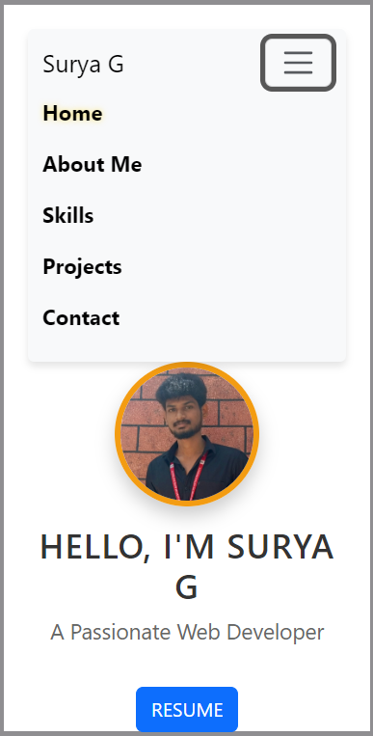

Figure -3.3.1 (mobile view)

## Description:

The figure-3.3.1 are the samples of navigation bar in both mobile view. This was a user-friendly method only, so the user can easily use the features.

**Features:**

There are many styles are added. Whenever the user move lists to the navigation bar it will hover with some effect. And also the navigation bar will be stable in the same position, even we switch to any other pages.

**3.4. Skills:**

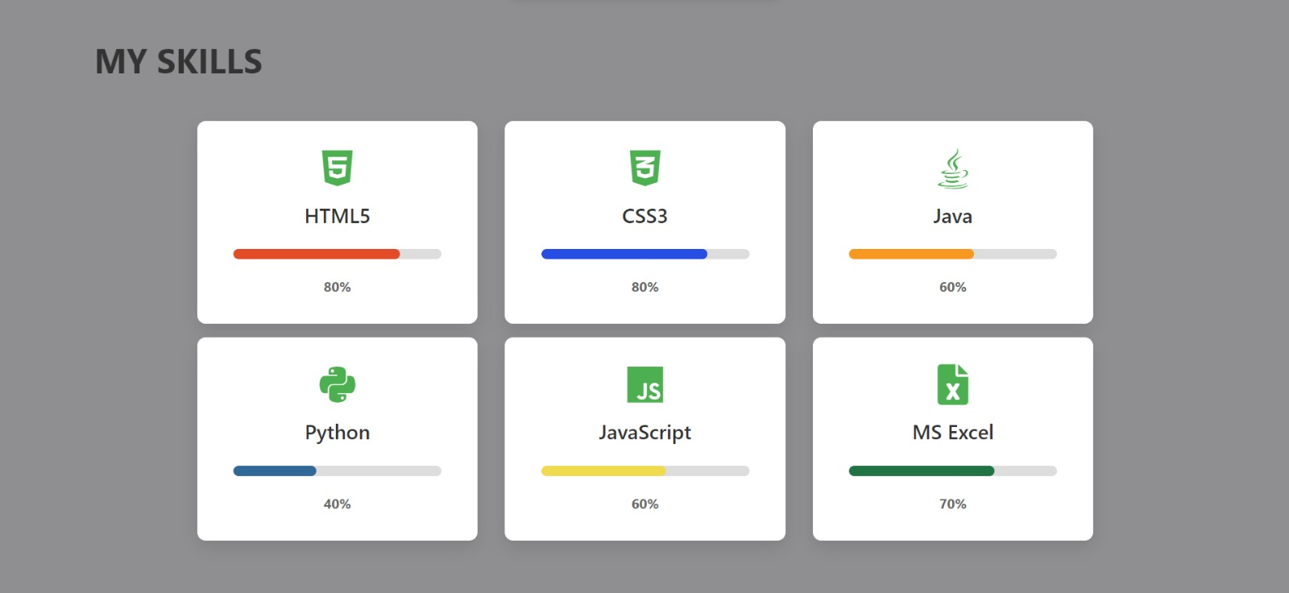

## Description:

The above figures are skill page, which contain a subdivision named skills and expertise,education and training, soft skills and self-introduction video. Basically, it is an animation, when the user load the page and click the specified box it will toggle with border with orange color.

**Source Code:**

HTML:

<!--==================== Skills ====================-->

<section class="skills section" id="skills">

<div class="container">

<h2 class="section-title" data-aos="fade-down">My Skills</h2>

<div class="row justify-content-center mt-5">

<!-- HTML5 Skill -->

<div class="col-lg-3 col-md-6 skill-card" data-aos="zoom-in">

<div class="skill-inner">

<i class="fab fa-html5 skill-icon"></i>

<h3>HTML5</h3>

<div class="skill-progress html">

<div class="progress-fill"></div>

</div>

<span class="skill-percent">80%</span>

</div>

</div>

<!-- CSS3 Skill -->

<div class="col-lg-3 col-md-6 skill-card" data-aos="zoom-in" data-aos-delay="200">

<div class="skill-inner">

<i class="fab fa-css3-alt skill-icon"></i>

<h3>CSS3</h3>

<div class="skill-progress css">

<div class="progress-fill"></div>

</div>

<span class="skill-percent">80%</span>

</div>

</div>

<!-- Java Skill -->

<div class="col-lg-3 col-md-6 skill-card" data-aos="zoom-in" data-aos-delay="400">

<div class="skill-inner">

<i class="fab fa-java skill-icon"></i>

<h3>Java</h3>

<div class="skill-progress java">

<div class="progress-fill"></div>

</div>

<span class="skill-percent">60%</span>

</div>

</div>

<!-- Python Skill -->

<div class="col-lg-3 col-md-6 skill-card" data-aos="zoom-in" data-aos-delay="600">

<div class="skill-inner">

<i class="fab fa-python skill-icon"></i>

<h3>Python</h3>

<div class="skill-progress python">

<div class="progress-fill"></div>

</div>

<span class="skill-percent">40%</span>

</div>

</div>

<!-- JavaScript Skill -->

<div class="col-lg-3 col-md-6 skill-card" data-aos="zoom-in" data-aos-delay="800">

<div class="skill-inner">

<i class="fab fa-js skill-icon"></i>

<h3>JavaScript</h3>

<div class="skill-progress js">

<div class="progress-fill"></div>

</div>

<span class="skill-percent">60%</span>

</div>

</div>

<!-- MS Excel Skill -->

<div class="col-lg-3 col-md-6 skill-card" data-aos="zoom-in" data-aos-delay="1000">

<div class="skill-inner">

<i class="fas fa-file-excel skill-icon"></i>

<h3>MS Excel</h3>

<div class="skill-progress excel">

<div class="progress-fill"></div>

</div>

<span class="skill-percent">70%</span>

</div>

</div>

</div>

</div>

</section>

**CSS:**

/*=============== Skills ===============*/

.skills {

background-color: #ebebeb;

color: #ffffff;

background: url(skill.jpg);

background-repeat: no-repeat;

background-size: cover; /* Adjusts the background image to cover the entire area */

padding: 50px 0;

}

.skill-circle {

text-align: center;

}

.circle {

width: 150px;

height: 150px;

border-radius: 50%;

display: flex;

justify-content: center;

align-items: center;

font-size: 24px;

font-weight: bold;

color: rgb(255, 255, 255);

margin: 0 auto;

box-shadow: 0px 10px 15px rgba(122, 36, 36, 0.1);

position: relative;

transition: transform 0.1s ease-in-out;

}

.circle span {

position: absolute;

}

.skill-circle:hover .circle {

transform: scale(1.3);

}

.html-circle {

background: linear-gradient(135deg, #b202c2, #6cc9ee);

color: rgb(0, 0, 0);

}

.css-circle {

background: linear-gradient(135deg, #05ce31, #d86d09);

color: rgb(0, 0, 0);

}

.java-circle {

background: linear-gradient(135deg, #f57c00, #77faf3);

color: rgb(0, 0, 0);

}

.python-circle {

background: linear-gradient(135deg, #07bb34, #bd16d3);

color: rgb(0, 0, 0);

}

.js-circle {

background: linear-gradient(135deg, #b62bf7, #a70404);

color: rgb(0, 0, 0);

}

.excel-circle {

background: linear-gradient(135deg, #dd2b2b, #66bb6a);

color: rgb(0, 0, 0);

}

.education-section {

max-width: 800px;

margin: 0 auto;

padding: 20px;

}

.education-section h1 {

font-size: 2.5em;

text-align: center;

margin-bottom: 30px;

color: #ffffff;

}

.education-entry {

margin-bottom: 20px;

padding: 10px;

border-left: 5px solid #007bff;

background-color: #f9f9f9;

border-radius: 5px;

box-shadow: 0 4px 8px rgba(0, 0, 0, 0.1);

}

.education-entry h2 {

font-size: 1.5em;

color: #007bff;

margin-bottom: 5px;

}

.education-entry p {

font-size: 1.1em;

color: #555;

}

**3.4. Qualification Page:**

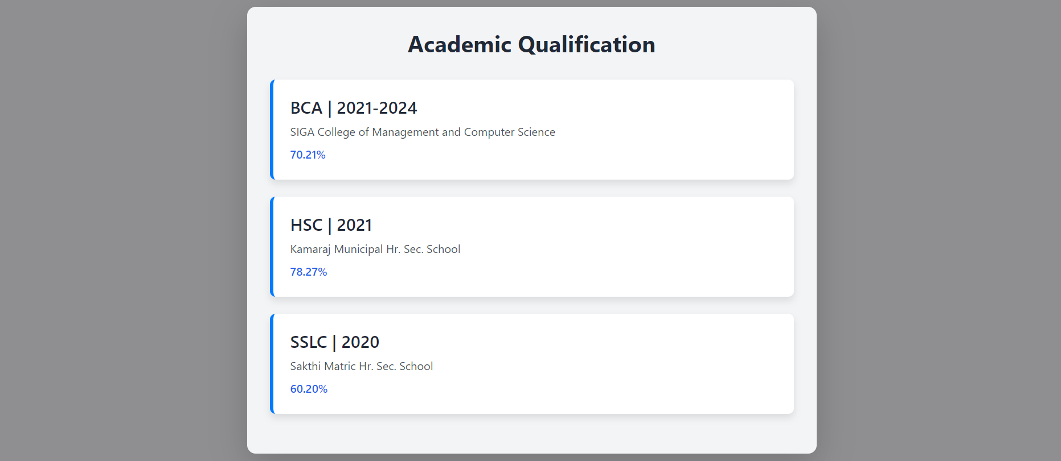

## Description:

The above figures are skill page, which contain a subdivision named skills and expertise,education and training, soft skills and self-introduction video. Basically, it is an animation, when the user load the page and click the specified box it will toggle with border with orange color.

## Source Code:

### HTML:

<!--==================== Qualification ====================-->

<section class="education-section bg-gray-100 p-6 rounded-lg shadow-lg mb-8" id="education">

<h1 class="text-2xl font-bold text-center mb-6">Academic Qualification</h1>

<!-- Education Entry 1 -->

<div class="education-entry bg-white p-4 rounded-lg shadow-md mb-4">

<h2 class="text-xl font-semibold mb-2">BCA | 2021-2024</h2>

<p class="text-gray-700">SIGA College of Management and Computer Science</p>

<p class="text-blue-600 font-semibold">70.21%</p>

</div>

<!-- Education Entry 2 -->

<div class="education-entry bg-white p-4 rounded-lg shadow-md mb-4">

<h2 class="text-xl font-semibold mb-2">HSC | 2021</h2>

<p class="text-gray-700">Kamaraj Municipal Hr. Sec. School</p>

<p class="text-blue-600 font-semibold">78.27%</p>

</div>

<!-- Education Entry 3 -->

<div class="education-entry bg-white p-4 rounded-lg shadow-md">

<h2 class="text-xl font-semibold mb-2">SSLC | 2020</h2>

<p class="text-gray-700">Sakthi Matric Hr. Sec. School</p>

<p class="text-blue-600 font-semibold">60.20%</p>

</div>

</section>

**CSS:**

/*=============== Qualification ===============*/

.education-section {

background-color: #f3f4f6; /* Light gray background */

padding: 2rem; /* Section padding */

border-radius: 12px; /* Rounded corners */

box-shadow: 0 10px 15px rgba(0, 0, 0, 0.1); /* Shadow for the section */

margin-bottom: 2rem; /* Margin below section */

}

.education-section h1 {

font-size: 2rem; /* Section title size */

font-weight: bold; /* Section title font weight */

text-align: center; /* Center align title */

margin-bottom: 2rem; /* Space below title */

color: #1f2937; /* Dark gray for title */

}

/* Individual Education Entry Styles */

.education-entry {

background-color: #ffffff; /* White background for entries */

padding: 1.5rem; /* Padding inside entries */

border-radius: 8px; /* Rounded corners */

box-shadow: 0 6px 10px rgba(0, 0, 0, 0.1); /* Soft shadow */

margin-bottom: 1.5rem; /* Space between entries */

transition: transform 0.3s ease-in-out; /* Smooth hover effect */

}

/* Hover effect for larger screens */

.education-entry:hover {

transform: scale(1.02); /* Slight zoom on hover */

}

/* Education Entry Title */

.education-entry h2 {

font-size: 1.5rem; /* Entry title size */

font-weight: 600; /* Bold font */

color: #1f2937; /* Dark gray for text */

margin-bottom: 0.5rem; /* Space below title */

}

/* Institution and Percentage Styles */

.education-entry p {

font-size: 1rem; /* Paragraph font size */

color: #4b5563; /* Medium gray for text */

margin: 0; /* Remove margin */

}

.education-entry p:last-child {

color: #2563eb; /* Blue for percentages */

font-weight: 600; /* Bold font for percentage */

margin-top: 0.5rem; /* Space above percentage */

}

/* Media Queries for Responsiveness */

@media (max-width: 992px) { /* Tablets and small desktops */

.education-section {

padding: 1.5rem;

}

.education-section h1 {

font-size: 1.75rem;

}

.education-entry {

padding: 1.25rem;

}

.education-entry h2 {

font-size: 1.25rem;

}

}

@media (max-width: 768px) { /* Mobile and small tablets */

.education-section {

padding: 1rem;

}

.education-section h1 {

font-size: 1.5rem;

}

.education-entry {

padding: 1rem;

}

.education-entry h2 {

font-size: 1.125rem;

}

}

@media (max-width: 576px) { /* Small mobile screens */

.education-section {

padding: 0.75rem;

}

.education-section h1 {

font-size: 1.25rem;

}

.education-entry {

padding: 0.75rem;

}

.education-entry h2 {

font-size: 1rem;

}

.education-entry p {

font-size: 0.875rem;

}

}

# Chapter-4 Style Score

## Styles

**Source Code:**

### CSS:

/*=============== REUSABLE CSS CLASSES ===============*/

html, body {

height: 100%; /* Ensures the background color fills the entire screen */

background-color: #8f8e91; /* Your chosen background color */

color: #f10202;

line-height: 1.6;

padding: 20px;

}

.social-links {

display: flex;

justify-content: center;

gap: 20px;

}

.social-links a {

color: #fff; /* White text color */

font-size: 20px;

text-decoration: none;

padding: 10px 20px;

border-radius: 5px;

transition: background-color 0.3s ease;

}

.social-links a:hover {

background-color: #f39c12; /* Hover background color */

}

.social-icon i {

margin-right: 8px; /* Space between icon and text */

}

## Style Links

<!--=============== FONT AWESOME ===============-->

<link rel="stylesheet" href="https://cdnjs.cloudflare.com/ajax/libs/font-awesome/6.0.0-beta3/css/all.min.css">

<!--=============== CSS ===============-->

<link rel="stylesheet" href="style.css">

# Chapter 5:

## Website include the following Information

**5.1 Project links to GitHub:**

## Project-1

Title: **BALL MOVEMENT**

Link: https://github.com/Surya3338/Simulation-_Ball-Move.git

## Project Description:

This HTML page displays a continuous bouncing red ball animation within a rectangular area controlled by JavaScript using the setInterval function with a 500- millisecond interval.

## Project-2

Title: **RANDOM BALL BOUNCING**

Link: https://github.com/Surya3338/Ball-move.git

## Project Description:

Elevate the animation by enabling user input for modifying the ball's movement, incorporating elementslike keyboard and mouse controls, as well as introducing obstacles or targets to enhance interactivity.

#### PROJECT-3

Title: **PAC-MAN**

Link: https://github.com/Surya3338/PacMan1.git

## Project Description:

This HTML page features a Pac-Man animation moving horizontally within a container, controlled by JavaScript for direction, mouth animation, and boundary reversal, with a continuous animation loop triggered by setInterval every 100 milliseconds.

## PROJECT-4

Title: **BOSTON CITY DATA**

Link: https://github.com/Surya3338/Boston.git

## Project Description:

This JavaScript program retrieves and displays information about the top five earning employeesin Boston, providing key details for each employee.

## PROJECT-5

Title: **WORD COUNT**

Link: https://github.com/Surya3338/Word_count.git

## Project Description:

This HTML document displays the top 5 most frequently occurring words from a providedparagraph after removing punctuation and converting all text to lowercase.

**PROJECT-6**

Title: **PACKMAN GAME**

Link: https://github.com/Surya3338/PacMan2.git

* + - **Project Description:**

The HTML document creates a basic Pac-Man game with randomly generated Pac-Man characters that bounce off the container's boundaries and change mouth states while moving.

**PROJECT-7**

Title: **MOVING EYES**

Link: https://github.com/Surya3338/Cursor-move.git

* + - **Project Description:**

This HTML document creates a simple interactive face with moving eyes that follow the user's mouse cursor. The face consists of a yellow circle with two eyes, and the eyes' black pupils follow the mouse movement.

**PROJECT-8**

Title: **MAP**

Link: https://github.com/Surya3338/Route_Map.git

* + - **Project Description:**

This HTML document displays a map using Mapbox and a button to animate a marker's movement along predefined bus stops between Gandhipuram and Sulur

**PROJECT-9**

Title: **Towers of hanoi**

Link: <https://github.com/Surya3338/Tower_Hanoi.git>

❖**Project Description:**

This HTML code creates a basic interface for the Tower of Hanoi game. It includes an input field for the number of disks and a button to make moves. The external JavaScript and CSS files, hanoi.js and tower.js, handle the game's logic and styling, respectively.

# Chapter-6:

## Bootstrap

**6.1 Uses of Bootstrap:**

## Source Code

<!-- Bootstrap CSS (required for Bootstrap) -->

## <link href="https://cdn.jsdelivr.net/npm/bootstrap@5.3.3/dist/css/bootstrap.min.css" rel="stylesheet"

## integrity="sha384-QWTKZyjpPEjISv5WaRU9OFeRpok6YctnYmDr5pNlyT2bRjXh0JMhjY6hW+ALEwIH" crossorigin="anonymous">

## Description:

I have used bootstrap in this website as a embeded in html. Which was a built in CSS file, so we can use it to reduce our time and also it carries a (N) number of designs. So, I had linked them to the code in HTML.

**CSS:**

# 

# .btn {

# padding: 12px 28 px;

# font-weight: 700;

# }

# .btn-brand {

# background-color: var(--color-brand);

# border-color: var(--color-brand);

# color: var(--color-base);

# }

# .btn-brand:hover,

# .btn-brand:focus {

# background-color: var(--color-brand2);

# color: var(--color-base);

# border-color: var(--color-brand2);

# }

# .link-custom {

# font-weight: 700;

# position: relative;

# }

# .link-custom::after {

# content: "";

# width: 0%;

# height: 2px;

# background-color: var(--color-brand);

# position: absolute;

# left: 0;

# top: 110%;

# transition: all 0.4s;

# }

# .link-custom:hover::after {

# width: 100%;

# }

# Chapter 7:

## Project README

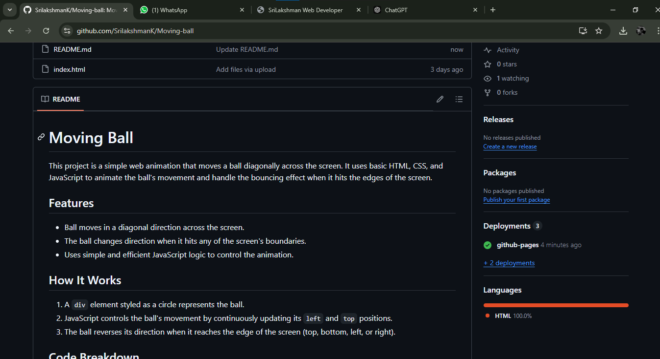

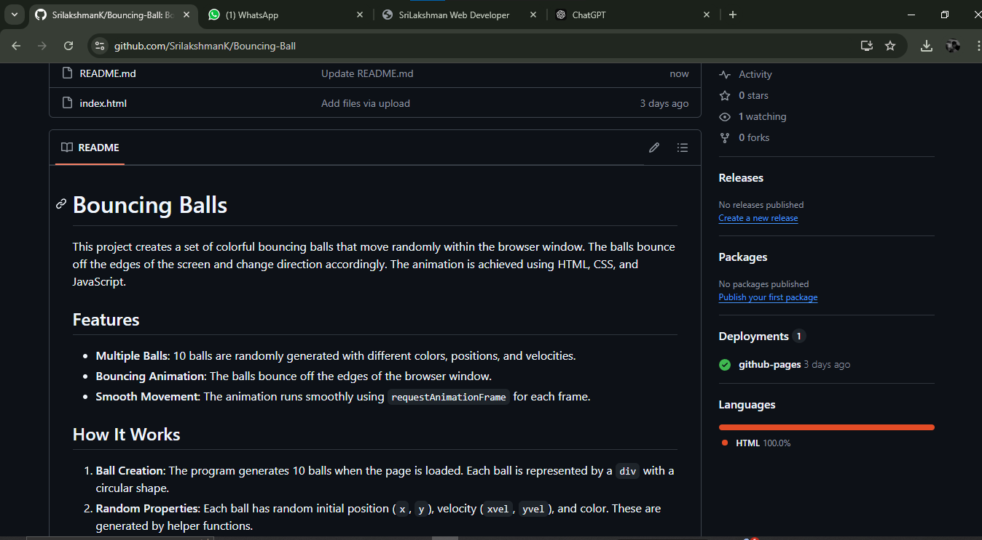

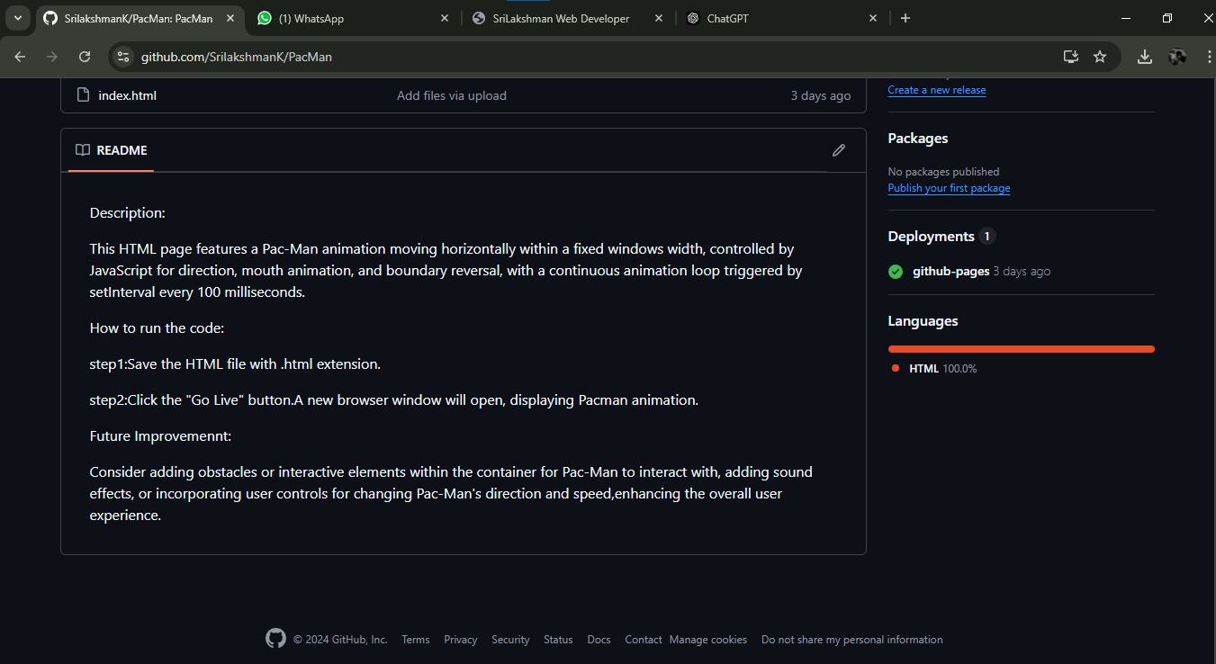

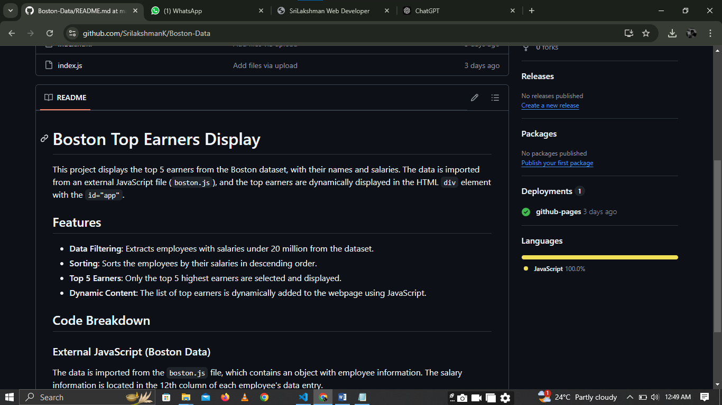

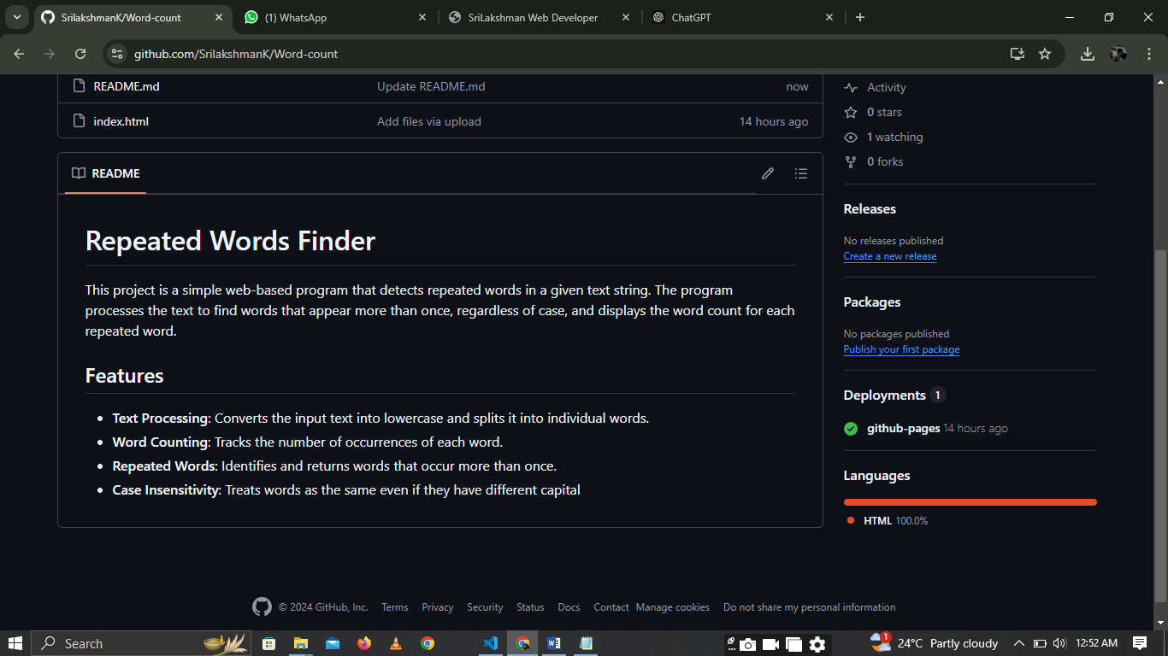

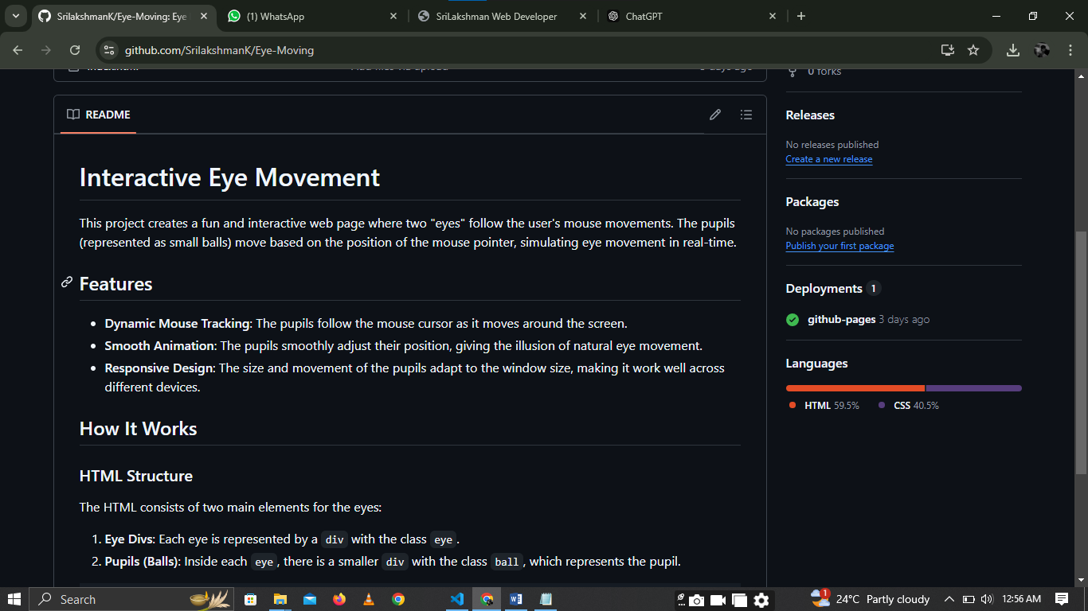

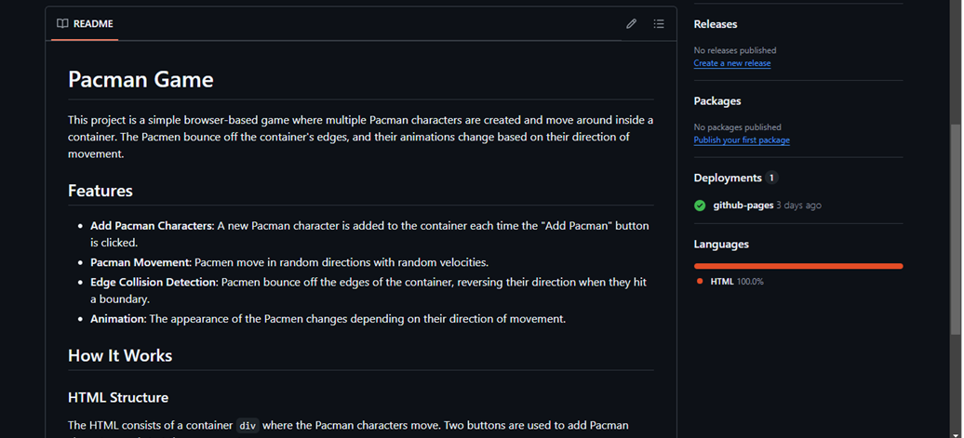

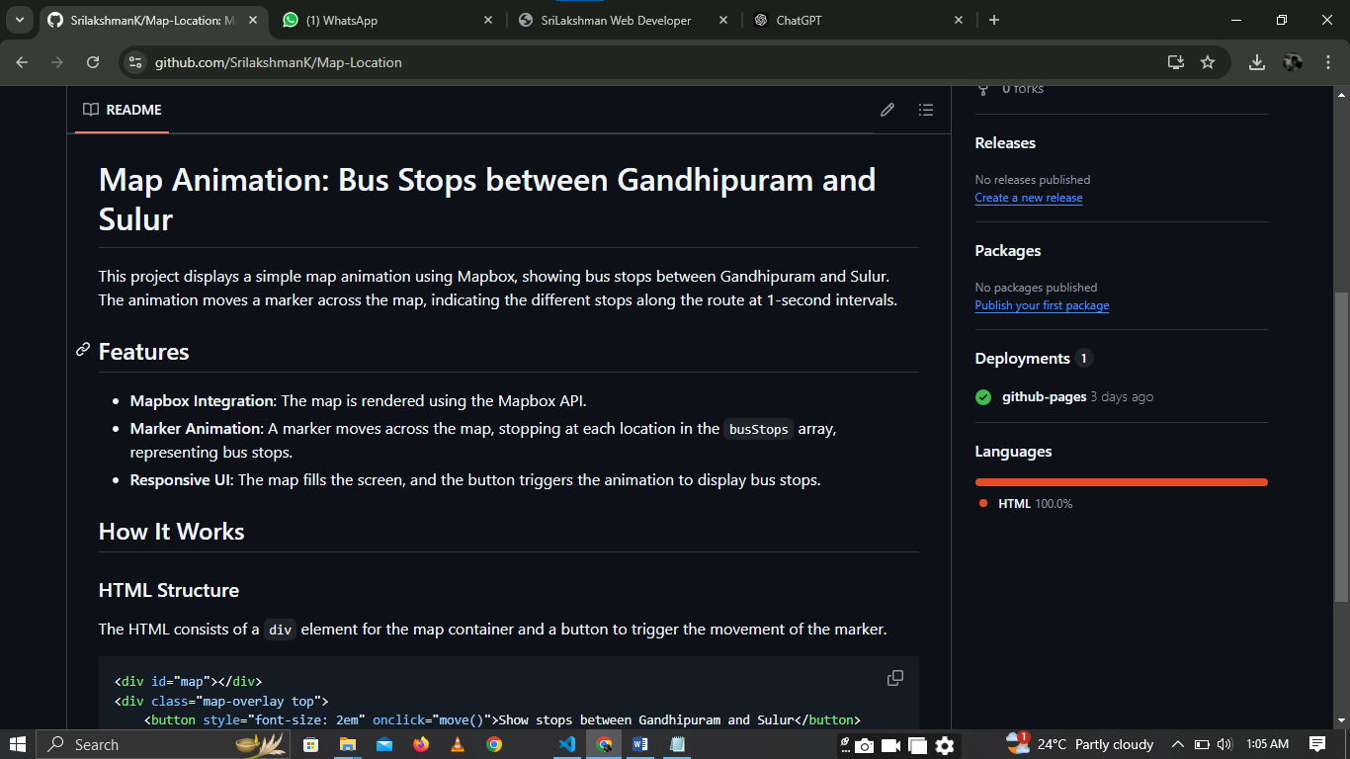

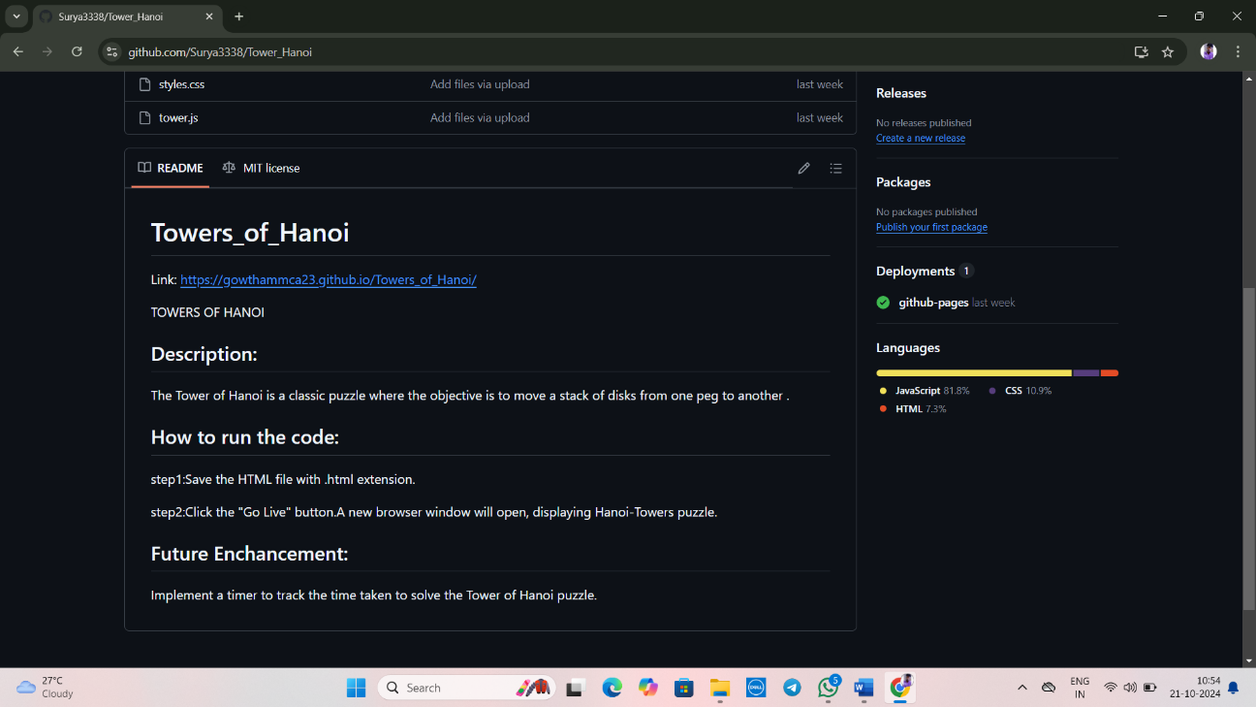

**Description:**

The above figures are the screenshot of project README files (Description, steps to run, futureimprovement) in a desktop view.

# Chapter 8

## File Structure

**8.1 GitHub File Structure**

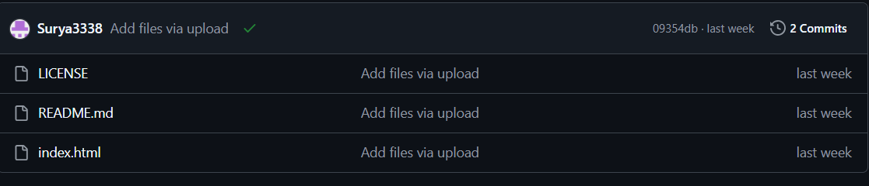

Figure 8.1.1

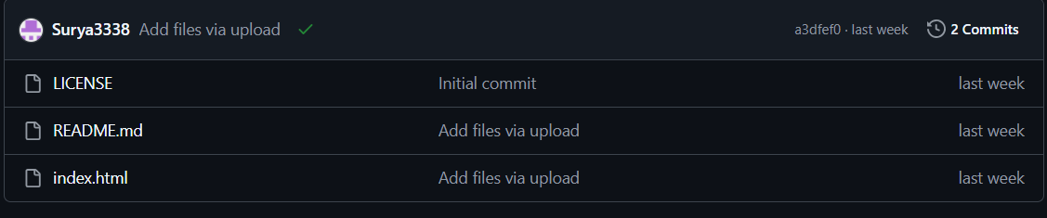

Figure 8.1.2

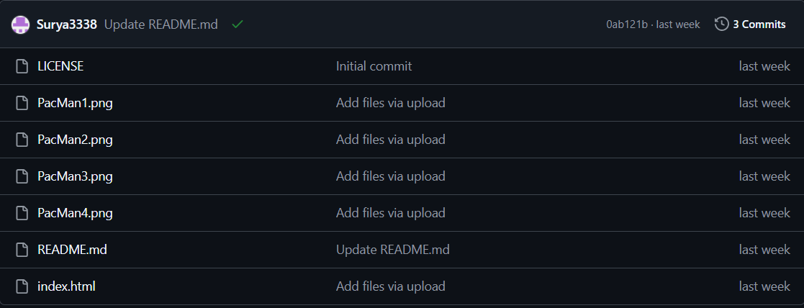

Figure 8.1.3

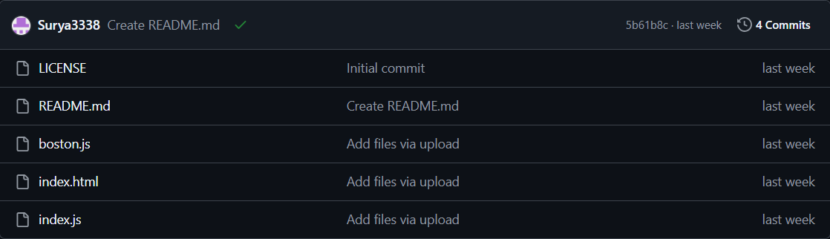

Figure 8.1.4

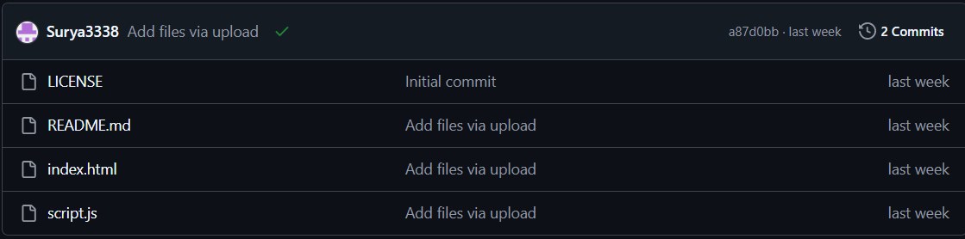

Figure 8.1.5

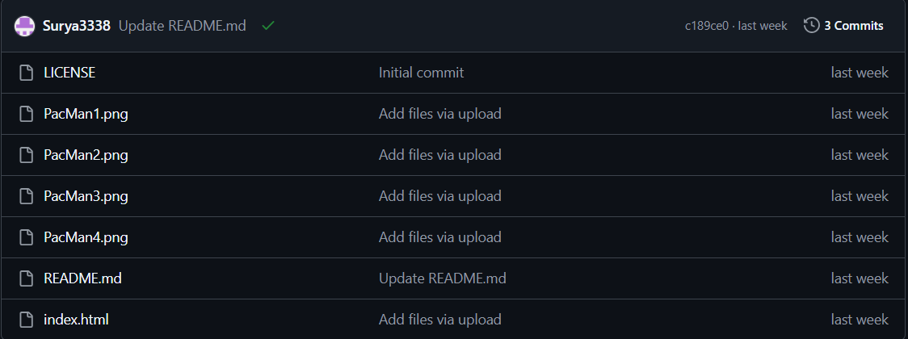

Figure 8.1.6

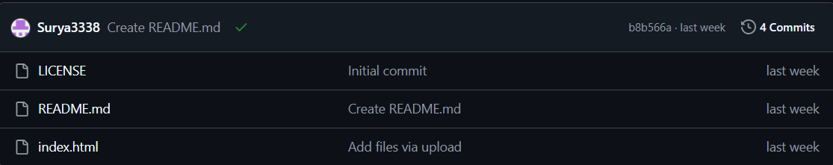

Figure 8.1.7

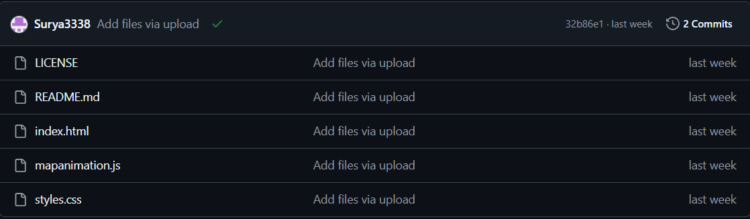

Figure 8.1.8

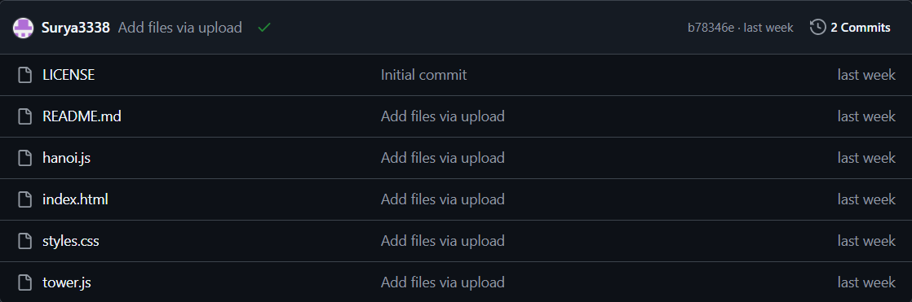

Figure 8.1.9

## Description:

This above Figures 8.1.1, 8.1.2, 8.1.3, 8.1.4, 8.1.5, 8.1.6, 8.1.7, 8.1.8,8.1.9 shows GitHub File Structure in desktop.