CRYPTOCURRENCY PREDICTION AND MARKET ANALYSIS SYSTEM
SHAIRAAJ V S - 25MX221
SURYA L - 25MX229
Dissertation submitted in partial fulfilment of the
requirements for the degree of
MASTER OF COMPUTER APPLICATIONS
ANNA UNIVERSITY

OCTOBER 2026
DEPARTMENT OF COMPUTER APPLICATIONS
PSG COLLEGE OF TECHNOLOGY
(Autonomous Institution)
COIMBATORE – 641 004

PSG COLLEGE OF TECHNOLOGY
(Autonomous Institution)
COIMBATORE – 641 004
CRYPTOCURRENCY PREDICTION AND MARKET ANALYSIS SYSTEM
Bonafide record of work done by
SHAIRAAJ V S – 25MX221
SURYA L – 25MX229
23MX37 – MINI PROJECT
Report submitted in partial fulfillment of the
requirements for the degree of
MASTER OF COMPUTER APPLICATIONS
ANNA UNIVERSITY
OCTOBER 2026

Faculty Guide

Dr. M. SUBATHRA
Assistant Professor (Sl. Gr.)
Department of Computer Applications
PSG College of Technology

ACKNOWLEDGEMENT
We take this opportunity to express our sincere gratitude to our beloved Principal, Dr. G. Thilagavathi, PSG College of Technology, for providing us the opportunity and necessary facilities in carrying out this project.
We are deeply indebted to Dr. N. Ilayaraja, Professor and Head, Department of Computer Applications, PSG College of Technology, for her continual support and ardent motivation.
We extend our thanks to our Programme Coordinator, Mrs. A. Kalyani, Assistant Professor (Sl. Gr.), Department of Computer Applications, PSG College of Technology, whose motivation and support encouraged us in taking up and completing our project.
We owe our heartfelt gratitude to our Guide, Dr. M. Subathra, Assistant Professor (Sl. Gr.), Department of Computer Applications, PSG College of Technology, for her continual support and enduring guidance throughout our project tenure.
We also extend our thanks to our tutor Dr. N. Geetha, Assistant Professor (Sl. Gr.), Department of Computer Applications, PSG College of Technology, for her/his guidance throughout our project tenure.
We also express our sincere thanks to all faculty members and non-teaching staff of the Department of Computer Applications for their kind cooperation, encouragement, and support. We also thank our parents and all the hands that helped us.

SYNOPSIS
The primary aim of this project is to develop an Explainable Cryptocurrency Prediction and Market Analysis Platform that integrates technical analysis, financial sentiment analysis, and machine learning techniques to provide transparent and interpretable forecasts for major cryptocurrencies. The proposed project develops an Explainable Cryptocurrency Prediction and Market Analysis Platform for five major digital assets: Bitcoin, Ethereum, Solana, Cardano, and Ripple. The platform integrates market data, financial sentiment, technical indicators, predictive modelling, and explainability within a unified analytical framework.
The system implements an automated end-to-end data pipeline for market and news data processing. Daily and real-time data are collected through the CoinGecko API, while current financial news headlines are obtained through NewsAPI. The collected data are stored in a local SQLite database for subsequent processing and analysis. Financial sentiment is derived using FinBERT, a transformer-based language model pre-trained on financial text, which classifies news content into positive, neutral, and negative categories. The resulting daily sentiment scores are integrated with eleven technical indicators calculated from historical price data, including Moving Averages, Relative Strength Index (RSI), Moving Average Convergence Divergence (MACD), Bollinger Bands, and Average True Range (ATR).
The integrated feature set is used to train an XGBoost regression model for next-day return and price forecasting. TimeSeriesSplit validation is applied to preserve the chronological structure of the dataset and reduce the risk of look-ahead bias during model evaluation. The model generates forecast values along with an empirical confidence score. TreeSHAP is incorporated to improve model interpretability by decomposing individual predictions into the contributions of the corresponding technical and sentiment features. The resulting feature attributions identify the variables with the greatest influence on each forecast.
The user interface is implemented as a responsive single-page application using React 19, Tailwind CSS, and TradingView Lightweight Charts. A modular Python Flask REST API provides the backend services and incorporates response caching for efficient data access. The platform integrates technical analysis, financial sentiment processing, machine learning-based forecasting, and explainable artificial intelligence within a unified environment for cryptocurrency market analysis and decision support

CONTENTS
CHAPTER PAGE
ACKNOWLEDGEMENT i
SYNOPSIS ii
1. INTRODUCTION 1
1.1 PROJECT OVERVIEW 1
1.2 PROBLEM STATEMENT 2
1.3 PROJECT OBJECTIVES 4
1.4 SCOPE OF THE PROJECT 4
1.5 TOOLS AND TECHNOLOGIES USED 5
2. SYSTEM ANALYSIS 7
2.1 EXISTING SYSTEM 7
2.2 PROPOSED SYSTEM 8
2.3 FUNCTIONAL REQUIREMENTS 9
2.3.1 MARKET DATA INGESTION 9
2.3.2 NEWS INGESTION 9
2.3.3 SENTIMENT CLASSIFICATION 9
2.3.4 DAILY SENTIMENT AGGREGATION 9
2.3.5 TECHNICAL INDICATOR COMPUTATION 9
2.3.6 FEATURE CONSTRUCTION 9
2.3.7 PRICE PREDICTION 10
2.3.8 PREDICTION EXPLANATION 10
2.3.9 API ACCESS 10
2.3.10 DASHBOARD PRESENTATION 10
2.4 NON-FUNCTIONAL REQUIREMENTS 10
2.4.1 PERFORMANCE 10
2.4.2 RELIABILITY 10
2.4.3 MAINTAINABILITY 10
2.4.4 USABILITY 11
2.4.5 SECURITY 11
2.4.6 PORTABILITY 11
2.5 FEASIBILITY STUDY 11
2.5.1 TECHNICAL FEASIBILITY 11
2.5.2 ECONOMIC FEASIBILITY 11
2.5.3 OPERATIONAL FEASIBILITY 12
2.5.4 SCHEDULE FEASIBILITY 12
3. SYSTEM DESIGN 13
3.1 SYSTEM ARCHITECTURE 13
3.1.1 OVERALL SYSTEM ARCHITECTURE 13
3.1.2 CLIENT–SERVER INTERACTION ARCHITECTURE 16
3.1.3 MACHINE LEARNING AND EXPLAINABILITY ARCHITECTURE 18
3.2 SYSTEM WORKFLOW 21
3.3 DATABASE DESIGN 23
3.5 MODULE DESIGN 24
3.5.1 DATA INGESTION MODULE 24
3.5.2 DATA STORAGE MODULE 25
3.5.3 TECHNICAL INDICATOR PROCESSING MODULE 25
3.5.4 SENTIMENT ANALYSIS MODULE 25
3.5.5 PREDICTION MODULE 25
3.5.6 EXPLAINABILITY MODULE 25
3.5.7 REST API MODULE 26
3.5.8 DASHBOARD MODULE 26
4. SYSTEM IMPLEMENTATION 27
4.1 HOME PAGE 27
4.2 PRICE CHART AND TECHNICAL INDICATORS PAGE 28
4.3 NEWS SENTIMENT ANALYSIS PAGE 29
4.4 PRICE FORECAST PAGE 30
4.5 SHAP EXPLANATION PAGE 31
5. SYSTEM TESTING 32
5.1 TESTING TECHNIQUES 32
6. CONCLUSION 35
BIBLIOGRAPHY 36

CHAPTER 1
INTRODUCTION
1.1 PROJECT OVERVIEW
Cryptocurrency markets operate continuously on a global scale through decentralized and fragmented trading platforms. This market structure differs significantly from conventional equity markets, which operate within defined trading hours and centralized clearing mechanisms. Continuous trading, distributed liquidity, and substantial participation from speculative investors contribute to elevated market volatility and complex price dynamics. As a result, effective cryptocurrency market analysis requires the examination of both historical market behaviour and external factors that influence investor sentiment.
Technical analysis provides a quantitative representation of market behaviour through historical price and volume data. Common indicators, including Moving Averages and the Relative Strength Index, assist in identifying trends, momentum, and potential changes in market conditions. However, these indicators are derived primarily from historical market data and do not directly represent the influence of external information such as financial news, regulatory developments, or changes in public sentiment.
Sentiment analysis provides an additional dimension for evaluating market conditions by assessing the potential effect of financial news and related textual information. Conventional keyword-based and lexicon-based sentiment analysis approaches may provide limited accuracy in financial contexts because the interpretation of individual terms can vary according to the surrounding financial context. Consequently, the integration of financial sentiment with technical market indicators provides a more comprehensive representation of the factors associated with cryptocurrency price movements.
Machine learning techniques have also been applied to cryptocurrency price prediction; however, the interpretability of predictive models remains an important consideration. A forecast generated by a machine learning model provides limited analytical value when the factors responsible for the prediction cannot be identified. In financial applications, interpretability is particularly relevant because model outputs may be influenced by multiple technical and sentiment-related variables.
The proposed project addresses these aspects through an integrated cryptocurrency analysis and prediction platform. Market data and financial news associated with five major cryptocurrencies are collected and processed through a unified data pipeline. Technical indicators are derived from historical market data, while financial news is analysed using a domain-specific language model to generate daily sentiment scores for each cryptocurrency. The resulting technical and sentiment features are integrated into a supervised machine learning framework for next-day price forecasting.
To improve model transparency, each generated forecast is accompanied by a feature attribution analysis. The attribution identifies the contribution of individual technical indicators and sentiment-related features to the corresponding prediction. This enables the forecast to be examined in relation to the underlying model inputs and provides an interpretable representation of the prediction process.
The resulting platform integrates market data processing, financial sentiment analysis, technical indicator computation, machine learning-based forecasting, and explainable artificial intelligence within a unified analytical environment. The system is designed to support structured and transparent cryptocurrency market analysis through the combined evaluation of quantitative and textual information.
1.2 PROBLEM STATEMENT
Cryptocurrency price behaviour is influenced by both technical market conditions and external information conveyed through financial news and other textual sources. However, the analytical tools commonly available to individual analysts and investors generally treat these sources independently. Technical analysis platforms provide market indicators derived from price and volume data, while news aggregation platforms provide relevant textual information. The relationship between market movements and external information is consequently assessed separately by the user. This separation limits the ability to obtain a unified view of the factors associated with cryptocurrency price movements.
The characteristics of cryptocurrency markets further increase the complexity of this problem. Cryptocurrency prices generally exhibit high levels of volatility, resulting in substantial short-term fluctuations. Under such conditions, relatively small changes in market or sentiment-related signals may coincide with significant price movements. This increases the importance of incorporating multiple sources of information during short-term market analysis.
Machine learning models introduce another challenge related to interpretability. Existing prediction systems may generate outputs in the form of predicted prices or trading signals without providing sufficient information about the factors responsible for those outputs. In the absence of feature-level explanations, users have limited visibility into the relationship between the model inputs and the resulting prediction. This makes it difficult to evaluate the basis of an individual forecast and to assess the consistency of model behaviour across different market conditions.
The problem addressed by this project is the absence of an integrated analytical framework that combines technical market indicators, financial news sentiment, short-term price forecasting, and prediction interpretability for cryptocurrency markets. The proposed system is designed to integrate market-derived technical indicators and news-derived sentiment into a unified feature representation for selected cryptocurrencies. This integrated representation is used to generate short-term price forecasts through a supervised machine learning model. Each forecast is further supported by feature-level attribution that identifies the factors contributing to the predicted outcome. The resulting approach provides a structured basis for analysing cryptocurrency price movements and interpreting machine learning predictions.

1.3 PROJECT OBJECTIVES
The primary objective of this project is to build an explainable cryptocurrency forecasting platform that combines market data with news sentiment. This is decomposed into the specific objectives listed in Table 1.1.
Table 1.1. Project Objectives
S.No. | Objective
01 | Build an automated data-ingestion pipeline that retrieves daily and real-time OHLCV market data for the five selected cryptocurrencies from the CoinGecko API, and current financial news headlines from NewsAPI, and stores both in a local SQLite database.
02 | Apply the FinBERT financial language model to classify ingested news headlines into positive, neutral, and negative sentiment, and aggregate these classifications into a daily sentiment score per asset.
03 | Compute a consistent set of technical indicators from price history for each asset, covering trend (SMA, EMA), momentum (RSI, MACD), and volatility (Bollinger Bands, ATR), and combine them with the daily sentiment score into a unified feature table.
04 | Train an XGBoost regression model on the combined feature set using TimeSeriesSplit cross-validation to forecast next-day returns and price targets while preventing lookahead bias.
05 | Integrate TreeSHAP feature attribution so that every prediction is accompanied by a ranked breakdown of the technical and sentiment factors that contributed to it, together with an empirical confidence score.
06 | Expose the platform's functionality through a Flask REST API with response caching, and present it through a responsive React 19 dashboard using TradingView Lightweight Charts for price visualisation.

1.4 SCOPE OF THE PROJECT
The project focuses on five benchmark cryptocurrencies: Bitcoin, Ethereum, Solana, Cardano, and Ripple. These assets are selected based on their market presence, market capitalisation, and liquidity. For each cryptocurrency, the system collects Open, High, Low, Close, and Volume market data through the CoinGecko API and retrieves relevant financial news headlines through NewsAPI. The collected market and news data are stored in a local SQLite database for subsequent processing and analysis.
The analytical scope of the project includes the computation of eleven technical indicators described in Section 1.5 and the generation of financial sentiment scores using FinBERT. The processed features are used to train an XGBoost regression model for next-day price and return forecasting. Model validation is performed using TimeSeriesSplit to preserve the chronological structure of the dataset during evaluation. TreeSHAP is incorporated to provide feature-level explanations for individual predictions and to identify the relative contribution of the input features to the model output.
The application layer consists of a Flask-based REST API and a React-based dashboard. The REST API provides access to cached market data, sentiment results, and prediction outputs. The React dashboard presents interactive price charts, sentiment information, and prediction explanations to support the analysis of cryptocurrency market conditions.
The proposed platform is intended for analytical and decision-support purposes. The system does not execute trades, place orders, or establish connections with brokerage accounts. Forecasting is performed at a daily frequency and does not include intraday prediction. Sentiment analysis is restricted to financial news headlines obtained through NewsAPI. Sentiment derived from social media platforms is not included within the scope of the current implementation.
1.5 TOOLS AND TECHNOLOGIES USED
Table 1.2. lists the tools and technologies used to implement the platform and their role in the project.
Table 1.2. Tools and Technologies Used
Technology / Tool | Purpose in the Project
Python 3.14 | Core language for the backend, data pipeline, and machine learning components.
Flask 3.1.3 | Serves the REST API endpoints consumed by the React dashboard.
SQLite | Local relational storage for market data, news, sentiment, features, and predictions.
CoinGecko API | Source of daily and real-time OHLCV market data for the five tracked assets.
NewsAPI | Source of current cryptocurrency-related financial news headlines.
FinBERT | Pre-trained financial transformer model used to classify news sentiment.
Pandas / NumPy | Time-series alignment and computation of technical indicators from price history.
XGBoost | Gradient-boosted regression model used for next-day price and return forecasting.
Scikit-learn (TimeSeriesSplit) | Chronological cross-validation of the forecasting model.
SHAP (TreeSHAP) | Feature attribution used to explain individual predictions.
React 19 | Frontend framework used to build the dashboard single-page application.
Tailwind CSS | Utility-first styling used for the dashboard layout.
TradingView Lightweight Charts | Renders interactive candlestick and price charts in the dashboard.
CHAPTER 2
SYSTEM ANALYSIS
2.1 EXISTING SYSTEM
Cryptocurrency market analysis commonly involves the use of conventional charting platforms, exchange-provided dashboards, and independent financial news or social media sources. Technical analysis is generally performed through established indicators such as Moving Average crossovers and Relative Strength Index (RSI) thresholds applied to historical price data. These analyses are typically conducted independently of concurrent financial news and other external information. News and sentiment information, when considered, are usually obtained manually from news aggregation platforms or social media sources and compared with observed price movements without a standardized analytical procedure.
Machine learning based prediction systems are also available for cryptocurrency market analysis. These systems commonly generate outputs in the form of target prices or directional signals without providing sufficient information regarding the factors influencing the prediction. The absence of such information limits the user's ability to examine the basis of an individual forecast and determine the contribution of specific input variables. Consequently, the relationship between the observed market conditions and the generated prediction remains difficult to interpret.
Sentiment analysis is incorporated into some existing cryptocurrency platforms, but the classification process may rely on keyword matching or general-purpose lexicon-based approaches. Such methods do not specifically account for the characteristics of financial language and may therefore have limitations when processing domain-specific terminology, contextual expressions, and market-related statements.
The existing approach presents several limitations in cryptocurrency market analysis. Technical indicators and sentiment information are generally processed through separate analytical channels, requiring manual correlation of the resulting information. Machine learning based forecasts often provide limited interpretability because the contributing features are not explicitly identified. In addition, sentiment analysis methods used by some systems are not specifically optimized for financial text. These limitations establish the requirement for an integrated system that combines technical analysis, financial sentiment analysis, predictive modelling, and model interpretability within a unified framework.
2.2 PROPOSED SYSTEM
The proposed system integrates four functional components that are commonly implemented as separate capabilities in existing tools. These components include automated market and news data acquisition, financial-domain sentiment analysis, technical indicator computation, and explainable cryptocurrency price forecasting. All four components are integrated within a single analytical dashboard to provide a unified view of market conditions and prediction results.
Market data and financial news headlines are collected automatically through the CoinGecko and NewsAPI services, respectively, and stored in a common SQLite database. The shared data repository enables the market and news records to be synchronized according to the same date and tracked cryptocurrency. Financial sentiment is determined using FinBERT instead of a general-purpose sentiment lexicon because the model is pre-trained on financial text and is designed to capture domain-specific language more effectively. The resulting sentiment scores are integrated with eleven technical indicators calculated from historical price data to construct a unified daily feature dataset for each cryptocurrency.
The combined feature dataset is used to train an XGBoost regression model, with TimeSeriesSplit applied during validation to preserve the chronological ordering of observations. The system also incorporates TreeSHAP to provide an explanation for each generated prediction. The explanation identifies and ranks the technical and sentiment features that have the greatest influence on the corresponding model output. The complete workflow, including data acquisition, feature computation, prediction, and explanation, is provided through a Flask REST API and presented through a React dashboard. This integration enables the forecast, supporting market information, and feature-level explanation to be accessed within the same analytical interface.

2.3 FUNCTIONAL REQUIREMENTS
The functional requirements describe what the platform must do, from acquiring raw market and news data to presenting an explained forecast to the user.
2.3.1 Market Data Ingestion
The system shall retrieve daily and real-time OHLCV data for the five tracked cryptocurrencies from the CoinGecko API. The retrieved records shall be stored in the SQLite database so that they are available for indicator computation and forecasting.
2.3.2 News Ingestion
The system shall retrieve current cryptocurrency-related news headlines from NewsAPI. Each headline shall be stored together with its publication metadata, allowing news records to be matched with market data by date and asset.
2.3.3 Sentiment Classification
The system shall classify each ingested news headline as positive, neutral, or negative using FinBERT. This provides a sentiment label for every article before the results are combined at the daily level.
2.3.4 Daily Sentiment Aggregation
The system shall aggregate the individual article sentiment results into a single daily sentiment score for each cryptocurrency. This score represents the news sentiment of an asset for a given day and is used as an input feature.
2.3.5 Technical Indicator Computation
The system shall compute the defined set of technical indicators from the stored price history. These include SMA, EMA, RSI, MACD, Bollinger Bands, ATR, and the related measures defined by the system.
2.3.6 Feature Construction
The system shall combine the technical indicators and the daily sentiment score into a unified feature record for each asset and date. This record forms the input supplied to the forecasting model.
2.3.7 Price Prediction
The system shall apply the trained XGBoost model to the constructed features to generate a next-day price and return forecast for the selected cryptocurrency.
2.3.8 Prediction Explanation
The system shall apply TreeSHAP to each prediction and return a ranked list of the contributing features together with their attribution values. This allows the technical and sentiment factors behind a forecast to be identified.
2.3.9 API Access
The system shall expose market, sentiment, and prediction data through a cached Flask REST API, which serves as the interface between the backend components and the dashboard.
2.3.10 Dashboard Presentation
The system shall present price charts, sentiment indicators, and prediction explanations through a React-based dashboard, so that the analytical results are available to the user in a single interface.
2.4 NON-FUNCTIONAL REQUIREMENTS
The non-functional requirements define the quality attributes the system is designed to satisfy.
2.4.1 Performance
Cached API responses for market and prediction data should be returned with low latency under normal conditions. This keeps the dashboard responsive without repeatedly recomputing or re-fetching unchanged data.
2.4.2 Reliability
The system shall handle external API failures and rate limiting gracefully. When such a failure occurs, it shall fall back to the most recent stored data rather than failing outright.
2.4.3 Maintainability
Backend functionality shall be organised into separable modules, namely ingestion, sentiment, features, prediction, explanation, and API. This keeps each component independently testable and allows one to be modified without affecting the others.
2.4.4 Usability
The dashboard shall remain legible and usable across common desktop and mobile screen sizes.
2.4.5 Security
API credentials for external services shall be stored outside source control. Database queries shall be parameterised to prevent injection.
2.4.6 Portability
The backend and data pipeline shall run on standard Python environments without platform-specific dependencies.
2.5 FEASIBILITY STUDY
2.5.1 Technical Feasibility
The components of the proposed platform are implemented using established and actively maintained open-source technologies. CoinGecko and NewsAPI provide documented REST APIs with free-tier access. FinBERT is available through the Hugging Face Transformers library and supports inference on standard CPU-based systems. XGBoost, scikit-learn, and SHAP are mature Python libraries supported by extensive technical documentation and community resources. SQLite operates without the requirement for a separate database server. React 19 and Tailwind CSS are compatible with modern web browsers without requiring additional plugins. The proposed architecture does not depend on specialised or proprietary infrastructure. The complete system can therefore be developed, tested, and executed using standard development hardware.
2.5.2 Economic Feasibility
The software libraries and frameworks used in the proposed platform, including Python, Flask, SQLite, React, Tailwind CSS, XGBoost, SHAP, and Hugging Face Transformers, are available as open-source technologies without licensing costs. CoinGecko and NewsAPI are accessed through their respective free developer tiers, eliminating data subscription expenses during development and academic evaluation. System development, testing, and demonstration can be performed using a standard personal computer without dedicated server infrastructure or GPU hardware. The overall implementation consequently requires minimal financial expenditure.
2.5.3 Operational Feasibility
The platform is designed for cryptocurrency investors, students, and researchers who require an integrated view of technical market indicators and financial sentiment. The application can be accessed through a standard web browser without requiring software installation on the user's system. Market information, sentiment results, forecasts, and prediction explanations are presented through a unified interface. The inclusion of feature-level explanations provides additional context for each forecast and supports the use of the platform as an analytical reference within the user's existing decision-making process. The proposed operational workflow can therefore be adopted without significant changes to the user's existing analysis practices.
2.5.4 Schedule Feasibility
The project was completed within a single MCA academic semester and organised into a sequence of development phases. The major phases included requirement analysis and API evaluation, database design and data ingestion, sentiment analysis and feature engineering, model development and SHAP integration, REST API implementation, and dashboard development and testing. The use of pre-trained models such as FinBERT reduced the computational and development requirements associated with language model training. This approach enabled the major system components to be implemented and integrated within the available academic schedule.

CHAPTER 3
SYSTEM DESIGN
3.1 SYSTEM ARCHITECTURE
3.1.1 Overall System Architecture
The system architecture illustrated in Figure 3.1 is structured into six logical layers that represent the movement of data from external sources to the user interface. The external data source layer consists of the CoinGecko API and NewsAPI, which provide cryptocurrency market records and financial news headlines respectively.
The overall system architecture of the proposed Cryptocurrency Prediction and Market Analysis System is organised into a sequence of interconnected layers that manage data acquisition, storage, processing, prediction, and presentation. The external data source layer consists of the CoinGecko API and NewsAPI, which provide cryptocurrency market data and financial news headlines, respectively. The collected data is passed through the data ingestion layer and stored in a local SQLite database. The processing and feature engineering layer performs preprocessing, computes technical indicators, analyses financial news using FinBERT, and combines the resulting technical and sentiment features into a unified dataset for prediction.
The analytical and modelling layer uses the constructed feature set to train and evaluate an XGBoost regression model using TimeSeriesSplit validation. The model generates next-day price and return forecasts along with an empirical confidence score, while TreeSHAP is applied to determine the contribution of individual technical and sentiment features to each prediction. The application layer provides these analytical results through a Flask REST API with response caching, and the presentation layer uses React 19, Tailwind CSS, and TradingView Lightweight Charts to display market information, forecasts, sentiment results, and prediction explanations through an interactive dashboard. This layered architecture separates the responsibilities of data acquisition, analysis, modelling, and presentation, thereby providing a structured and maintainable framework for the proposed system.
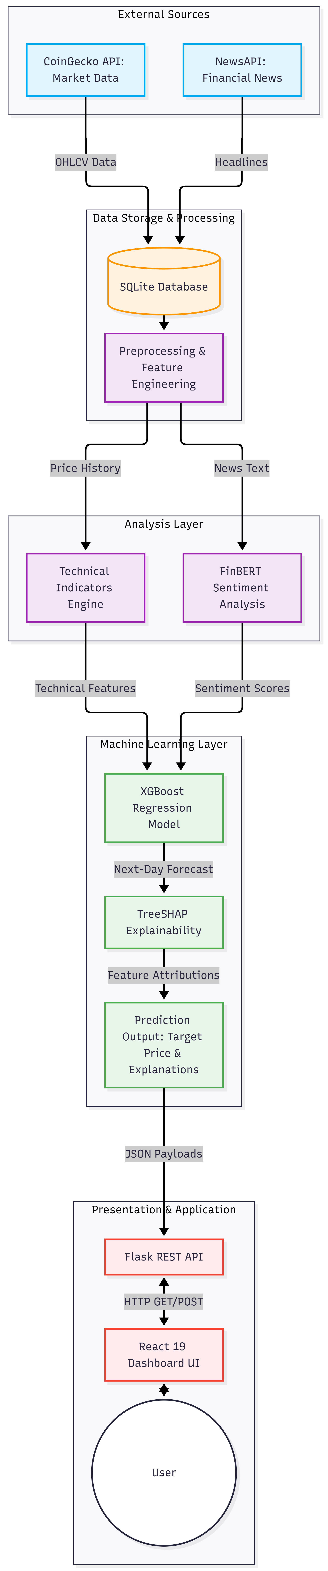
Figure 3.1. System Architecture
The preprocessing and feature engineering layer prepares the stored data for analysis by performing the required data processing operations and generating the input features. Within the analysis layer, technical indicators are calculated from the cryptocurrency price history, while FinBERT performs sentiment analysis on the financial news data. The resulting technical and sentiment features are integrated and supplied to the XGBoost regression model.
The modelling layer includes XGBoost regression and TimeSeriesSplit validation for generating and evaluating the forecasting model. The trained model produces the next-day price prediction and associated confidence value. TreeSHAP is subsequently applied to the model output to determine the contribution of individual features to the prediction and to generate interpretable prediction insights.
The presentation layer consists of the Flask REST API and the React 19 frontend. The Flask API manages communication between the analytical components and the user interface, while the React application presents the processed market data, forecasts, and feature contributions to the user. This layered architecture separates data acquisition, storage, analysis, modelling, and presentation responsibilities, providing a structured framework for system development and maintenance.

3.1.2 Client–Server Interaction Architecture
The client–server architecture defines the communication between the React-based frontend and the Flask backend of the Cryptocurrency Prediction and Market Analysis System. The React dashboard acts as the client and provides the user interface for selecting cryptocurrencies and viewing market data, sentiment information, forecasts, and prediction explanations. User requests are sent to the Flask REST API through HTTP requests, and the backend processes these requests and retrieves the required information from the underlying data and analytical components. The API provides a structured interface between the presentation layer and the backend services, ensuring that the frontend remains independent of the internal processing operations.
The Flask backend communicates with the SQLite database to retrieve stored market data, news, sentiment results, engineered features, and prediction outputs. Response caching is used to reduce repeated data retrieval and improve response efficiency when unchanged information is requested multiple times. The processed results are returned from the Flask API to the React frontend in a structured format, where they are presented using dashboard components and interactive charts. This client–server separation provides a clear division between user interaction and backend processing while allowing the analytical results of the system to be accessed through a single web-based interface.
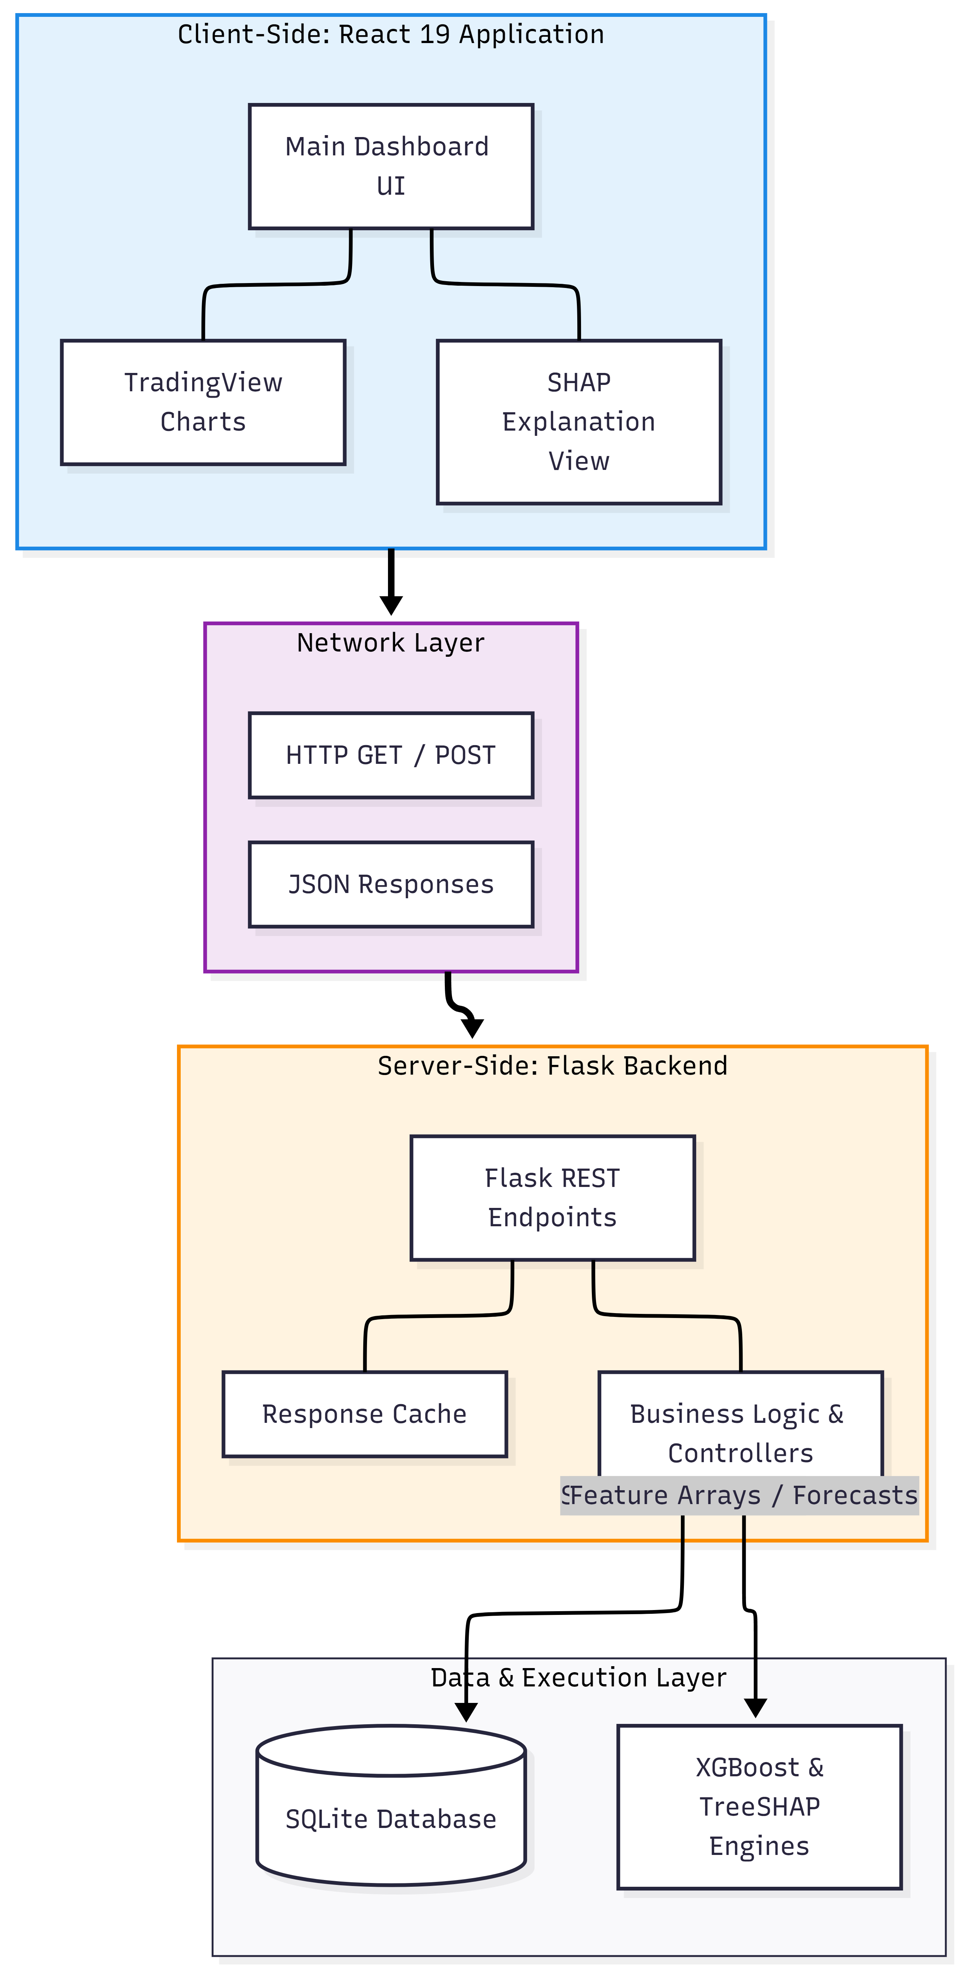
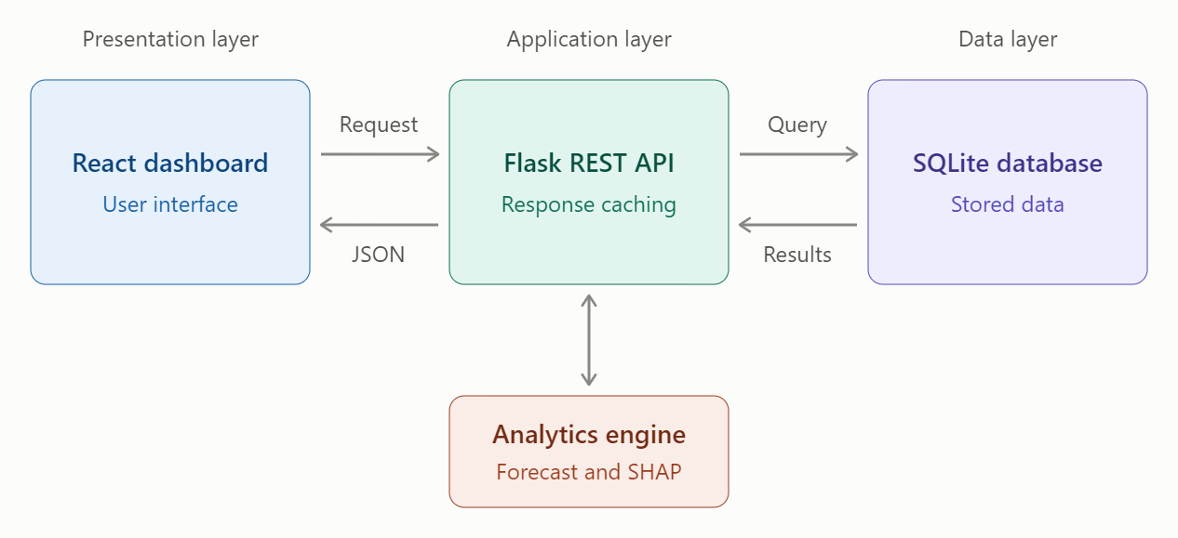
Figure 3.2. Client–Server Interaction Architecture

3.1.3 Machine Learning and Explainability Architecture
The machine learning and explainability architecture integrates technical market analysis and financial sentiment analysis to generate short-term cryptocurrency forecasts. Historical market data is first processed to calculate the defined technical indicators, while financial news headlines are analysed using the FinBERT model to obtain sentiment classifications. The individual sentiment results are aggregated into a daily sentiment score for each cryptocurrency. These technical and sentiment features are then combined to form the unified feature set used by the predictive model. The XGBoost regression model processes the feature set to generate the next-day price and return forecasts.
TimeSeriesSplit is applied during model validation to preserve the chronological ordering of the time-series observations and reduce the possibility of look-ahead bias. Along with the forecast, the system produces an empirical confidence score for the prediction. TreeSHAP is subsequently applied to the trained XGBoost model to calculate feature attribution values for individual predictions. These attribution values indicate the relative contribution of the technical and sentiment features to the model output and are ranked to provide an interpretable explanation of the forecast. The resulting prediction, confidence score, and feature-level explanation are then made available to the application layer for presentation through the dashboard.
The feature construction stage plays an important role in maintaining a consistent representation of market conditions for the forecasting model. For each cryptocurrency and date, the computed technical indicators are combined with the corresponding daily sentiment score to form an engineered feature record. This integrated representation allows the model to consider both quantitative market behaviour and information derived from financial news rather than relying exclusively on historical price variables. The engineered features are maintained on an asset-wise and date-wise basis, enabling the forecasting process to operate on a structured time-series dataset.
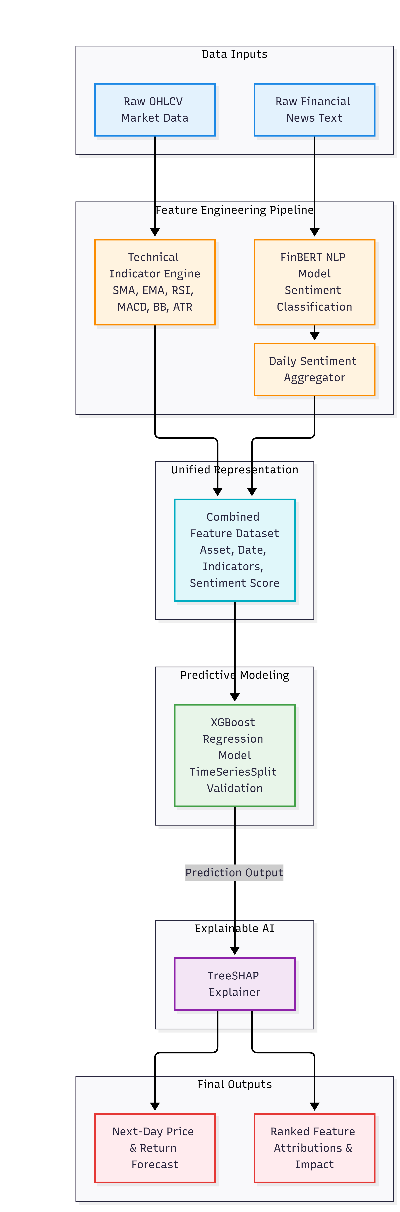
Figure 3.3. ML Prediction and Explainability Architecture
3.2 SYSTEM WORKFLOW
The system workflow begins by collecting cryptocurrency market data and financial news from CoinGecko and NewsAPI, followed by storing and preprocessing the data in SQLite.
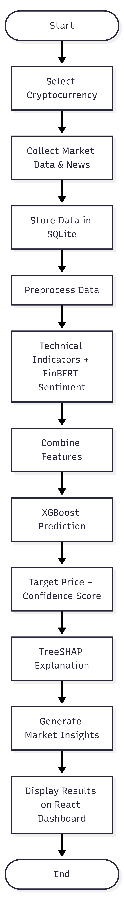
Figure 3.2. System Workflow
Figure 3.2 illustrates the overall processing flow of the proposed cryptocurrency analysis and prediction platform. The process begins with the selection of the cryptocurrency to be analysed. The system then collects the corresponding market data and financial news through the CoinGecko and NewsAPI services. The collected data are stored in the SQLite database and subjected to preprocessing to prepare them for subsequent analysis.
Following preprocessing, technical indicators are computed from the historical market data, while FinBERT is applied to the collected financial news to determine the corresponding sentiment. The technical and sentiment features are then combined to form the input feature set for the predictive model. The XGBoost model processes these features to generate the next-day price forecast and the associated confidence score.
The generated prediction is subsequently analysed using TreeSHAP to identify the contribution of individual technical and sentiment features to the model output. Based on the prediction and its feature contributions, the system generates relevant market insights. The processed results, including market information, sentiment analysis, prediction outputs, and explanations, are then presented through the React-based dashboard. The workflow concludes after the analysed results are made available to the user through the dashboard.

3.3 DATABASE DESIGN
The system utilizes a relational database implemented in SQLite to ensure data integrity and efficient querying for time-series market data and text-based sentiment records. The schema is highly normalized and centers on the core cryptocurrency assets, ensuring that all market, news, feature, and prediction records are strictly bound to a valid digital asset.
The physical database relationships are defined by primary key (PK) and foreign key (FK) constraints. The structure of the primary tables used to manage data flow from ingestion to prediction is presented in Tables 3.1 through 3.6.
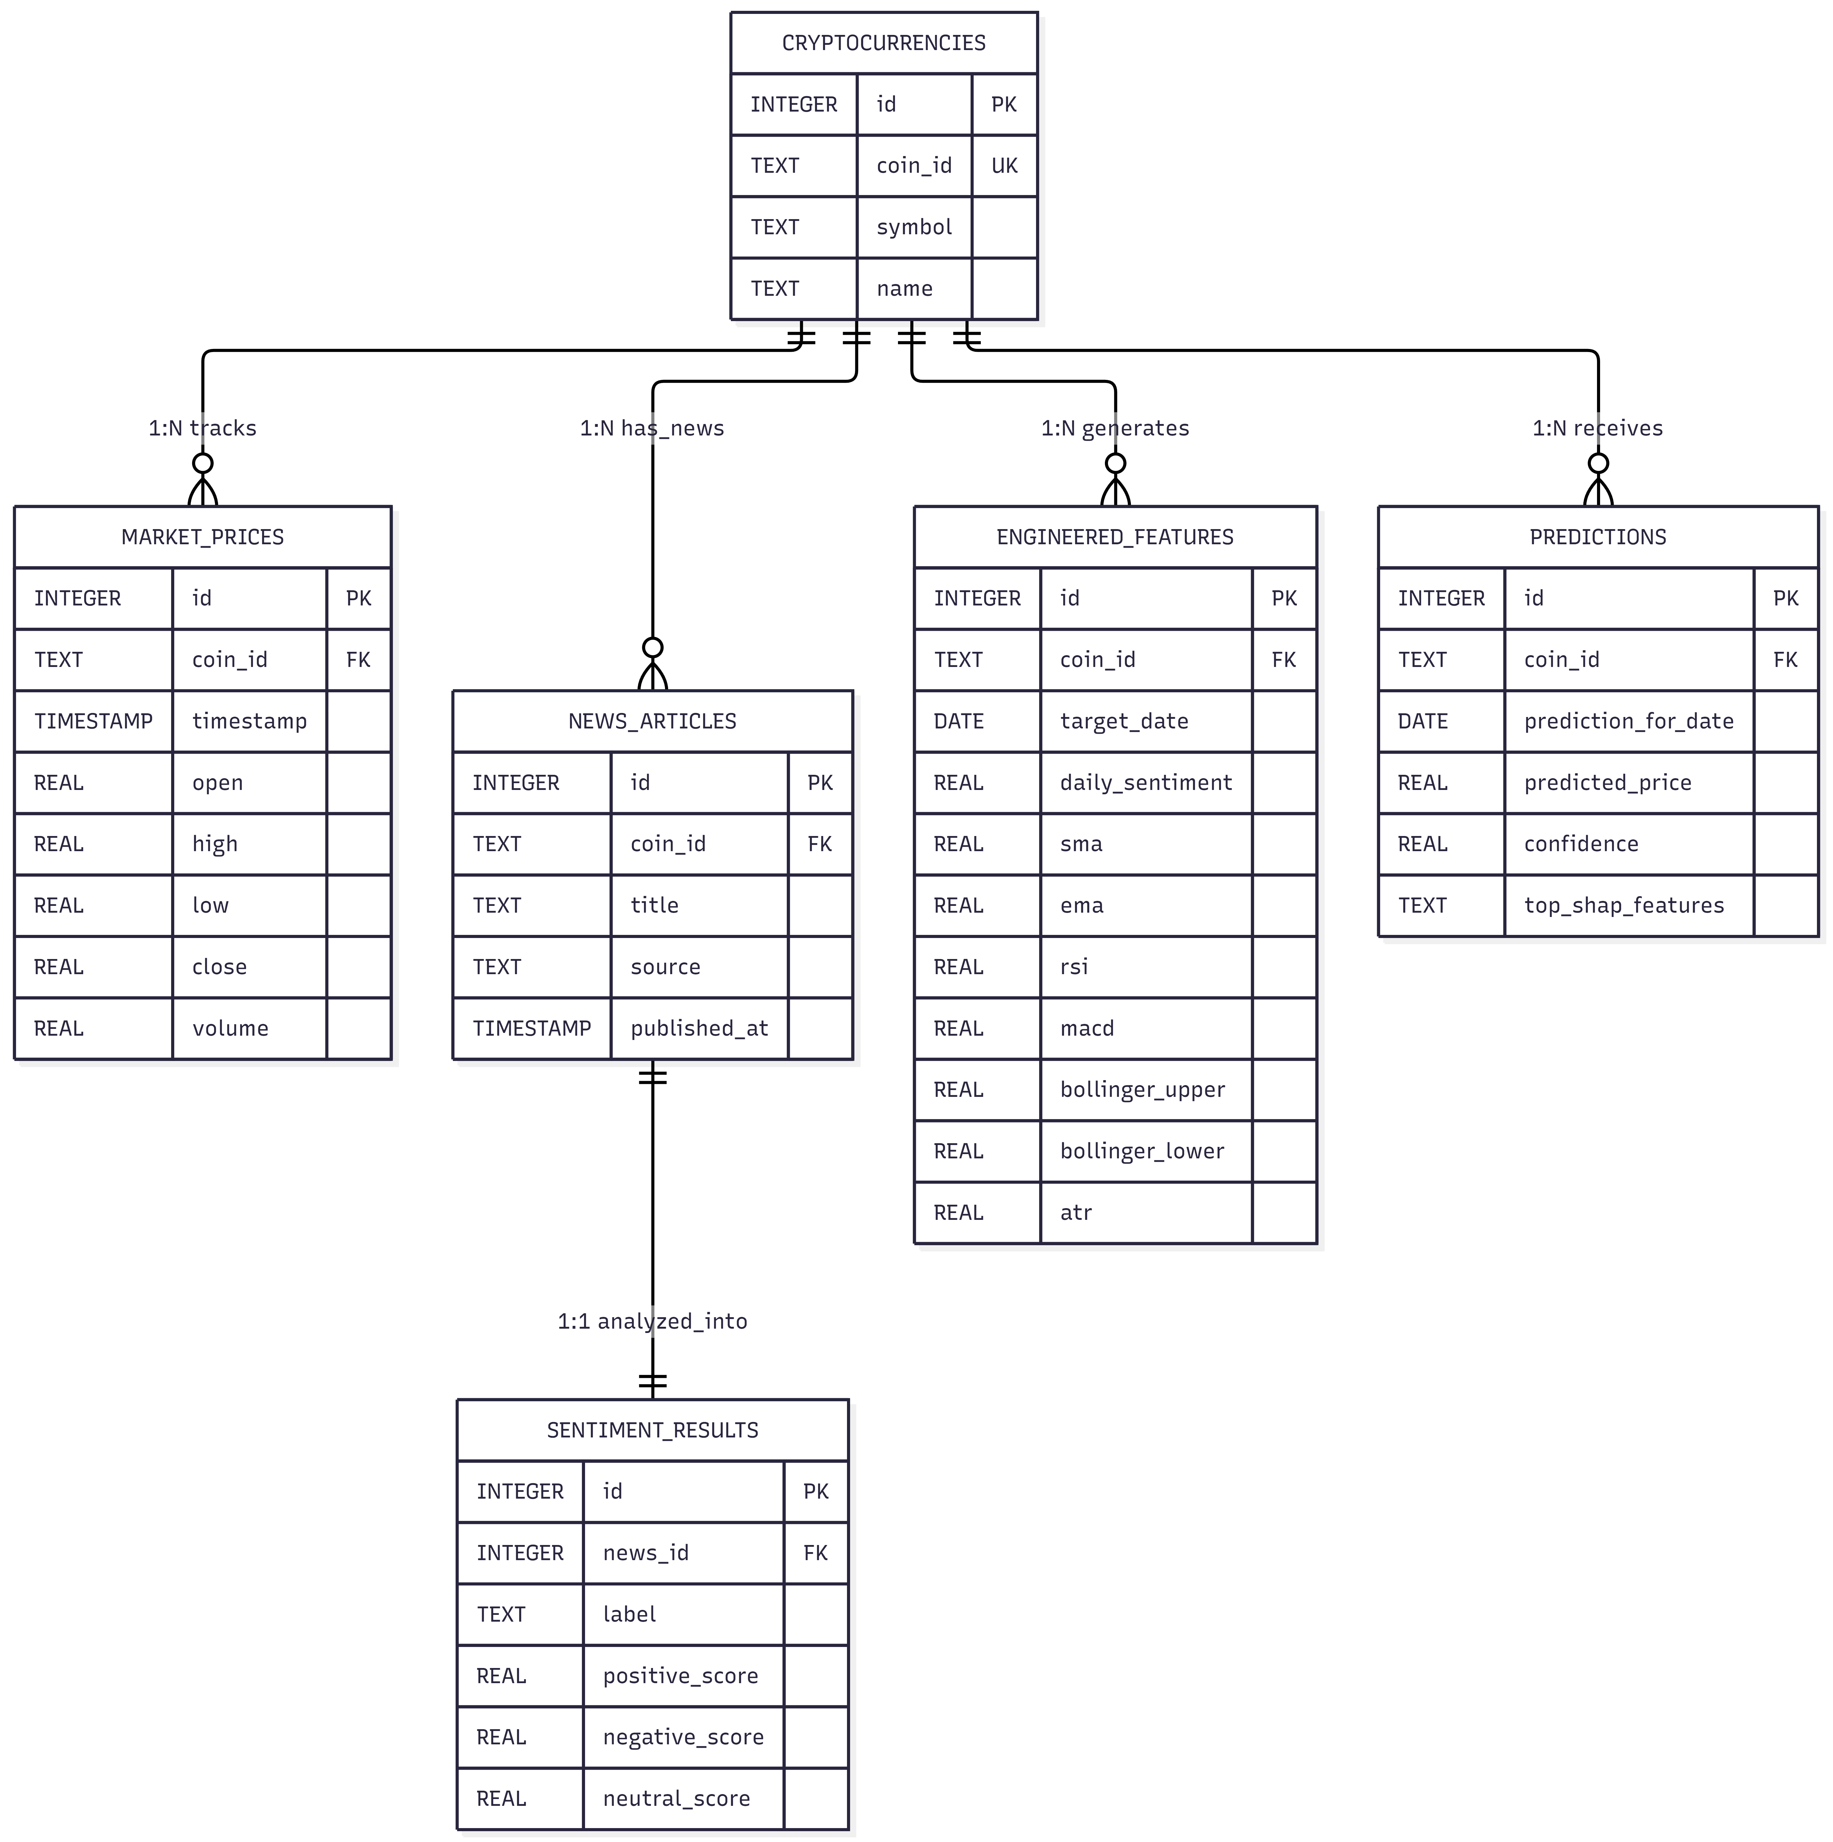
Figure 3.3. Database Design Diagram
The physical database schema is built around the central Cryptocurrencies entity, which serves as the master registry for the five tracked benchmark assets by maintaining their unique API identifiers, ticker symbols, and display names. Linked to this central entity in a one-to-many relationship is the MarketPrices structure, designed to systematically store chronological time-series data. This includes the exact timestamp of each observation along with the corresponding open, high, low, close, and volume (OHLCV) metrics retrieved from the CoinGecko API. Parallel to the market data, the NewsArticles structure archives textual data ingested from NewsAPI, recording the headline text, the publishing source, and the publication timestamp to ensure that all financial news is relationally bound to its respective cryptocurrency for subsequent analysis.
The analytical progression of the system is captured through dedicated storage structures for sentiment, model features, and forecasts. The SentimentResults schema maintains a strict one-to-one relationship with the news articles, storing the predicted sentiment label alongside the exact positive, negative, and neutral probability scores generated by the FinBERT model. To supply the machine learning pipeline, the EngineeredFeatures structure consolidates the daily aggregated sentiment scores with computed technical indicators—including Moving Averages, RSI, MACD, Bollinger Bands, and ATR—aligned to a specific target date. Finally, the Predictions entity logs the ultimate outputs of the XGBoost model, recording the forecast date, the predicted target price, and the empirical confidence score. This final structure also incorporates the TreeSHAP explanations, maintaining a serialized record of the ranked technical and sentiment features responsible for driving each individual forecast.
3.5 MODULE DESIGN
The proposed platform is divided into eight logical modules. Each module handles a specific part of the overall workflow, beginning with data collection and continuing through data processing, prediction, explanation, and presentation. The modules and their respective functions are described below.
3.5.1 Data Ingestion Module
The Data Ingestion Module is responsible for obtaining the required market and financial news data from external sources. Based on a scheduled trigger or API credentials, the module requests OHLCV market data from the CoinGecko API and relevant financial news headlines from NewsAPI. The retrieved records are prepared for storage and passed to the data storage module for further processing.
3.5.2 Data Storage Module
The Data Storage Module manages the persistence of data collected by the ingestion process. Raw market and news records are normalised and stored in the SQLite database along with processed sentiment, feature, and prediction information. The module maintains structured and query database tables that support data retrieval by the downstream analytical and application components.
3.5.3 Technical Indicator Processing Module
The Technical Indicator Processing Module derives technical features from the stored cryptocurrency price history. It calculates indicators such as SMA, EMA, RSI, MACD, Bollinger Bands, and ATR, along with the remaining indicators defined by the system. The resulting values are maintained on a per-asset and per-date basis for use in predictive modelling.
3.5.4 Sentiment Analysis Module
The Sentiment Analysis Module processes the financial news headlines associated with each tracked cryptocurrency. FinBERT is used to perform sentiment inference on the stored news content and classify the headlines according to their financial sentiment. The article-level sentiment results are aggregated into a daily sentiment score for each cryptocurrency, which is subsequently integrated with the technical features.
3.5.5 Prediction Module
The Prediction Module generates cryptocurrency forecasts using the combined technical and sentiment feature set. The processed feature record is supplied to the trained XGBoost regression model, which evaluates the input variables and generates the next-day price and return forecasts. An empirical confidence score is also produced as part of the prediction output.
3.5.6 Explainability Module
The Explainability Module provides an interpretable representation of the model prediction. It receives the prediction output together with the corresponding input features and applies TreeSHAP to calculate feature attribution values. These values are used to determine and rank the technical and sentiment features that contribute to the generated prediction, providing a feature-level explanation of the model output.
3.5.7 REST API Module
The REST API Module provides the communication interface between the backend processing components and the dashboard. It retrieves the required market, sentiment, prediction, and explanation data from the underlying storage and processing components. Response caching is applied to reduce repeated computation and data retrieval, while the resulting information is returned to the frontend in a structured JSON format.
3.5.8 Dashboard Module
The Dashboard Module provides the user-facing interface of the platform. It consumes the responses received from the REST API and presents cryptocurrency price charts, technical information, sentiment indicators, prediction results, and feature-level explanations through an interactive web interface. The module enables users to access the processed analytical results within a single integrated dashboard.

