Cryptocurrency Prediction and Market Analysis System

Software Requirement Specification done by
SHAIRAAJ V S - 25MX221
SURYA L - 25MX229

23MX41 – PROJECT WORK
Report submitted in partial fulfillment of the requirements for the degree of

MASTER OF COMPUTER APPLICATIONS
ANNA UNIVERSITY


AUGUST 2026

PSG COLLEGE OF TECHNOLOGY
(Autonomous Institution)

COIMBATORE – 641 004

Faculty Guide

…………………………….
Dr. Subathra M
Assistant Professor (Sl. Grade)
Department of Computer Applications
PSG College of Technology

Student Detail

Roll No. | Name of the Student | Name of the Faculty Guide | Name of the Industry Guide, if any
25MX221 | Shairaaj V S | Dr. M. Subathra, Assistant Professor (Sl. Gr.) | N.A.
25MX229 | Surya L | Dr. M. Subathra, Assistant Professor (Sl. Gr.) | N.A.

Project Goal
The goal of Cryptocurrency Prediction and Market Analysis System is to design and develop a web-based system that provides accurate cryptocurrency price predictions along with real-time market analysis. The system aims to assist users in making informed investment decisions by integrating machine learning techniques, sentiment analysis, and explainable AI. It focuses on improving transparency, usability, and predictive capability compared to existing platforms.

Project Abstract

The Cryptocurrency Prediction and Market Analysis System is designed to address the challenges faced by investors in understanding the highly volatile cryptocurrency market. Existing platforms mainly provide historical data and current prices but lack predictive analytics and insights into market sentiment.
This project introduces a web-based application that integrates machine learning and natural language processing to enhance decision-making. The system uses an XGBoost regression model to predict next-day cryptocurrency prices based on technical indicators such as moving averages, RSI, MACD, and volatility. In addition, it performs sentiment analysis on financial news using the FinBERT model to classify news as positive, negative, or neutral.
To improve user trust, the system incorporates SHAP (SHapley Additive Explanations), which explains how each feature contributes to the predicted price. The application is developed using React for the frontend, Flask for the backend, and SQLite for data storage.
The system provides a unified dashboard where users can view real-time prices, predictions, sentiment analysis, and explanatory insights. It is designed to be user-friendly and does not involve any blockchain transactions or trading features, making it safe and accessible for all users including beginners and researchers.

Existing System / Literature Review

Several existing platforms provide cryptocurrency-related information, but they have limitations.
Platforms like CoinGecko and CoinMarketCap provide real-time price tracking and historical data visualization. However, they lack predictive analytics and sentiment-based insights.
Trading platforms such as Binance and TradingView offer technical analysis tools, but they require manual interpretation and do not provide automated predictions.
Decentralized prediction platforms like Polymarket and Augur allow users to bet on outcomes, but they focus on prediction markets rather than data-driven forecasting.
From literature, machine learning models such as LSTM and ARIMA have been used for price prediction, but many lack integration with sentiment analysis.
Similarly, NLP-based sentiment analysis using Twitter or news data helps understand market trends but is rarely combined with price prediction models. Therefore, there is a need for a system that integrates: Price prediction, Sentiment analysis, Explainable AI.

S.No. | Existing System / Reference | Limitation Addressed
1 | CoinGecko / CoinMarketCap | Only provides price tracking, no prediction or sentiment analysis
2 | Trading/Charting Platforms | Requires manual analysis, no automated prediction
3 | Polymarket / Augur | Focus on betting, not forecasting
4 | NLP Sentiment Analysis models | Only analyzes sentiment, not linked with price prediction
5 | Existing Crypto Tools | Lack of integrated system  combining prediction + sentiment + visualization

Table 5.1 — Literature Review Summary

Project Flow Analysis

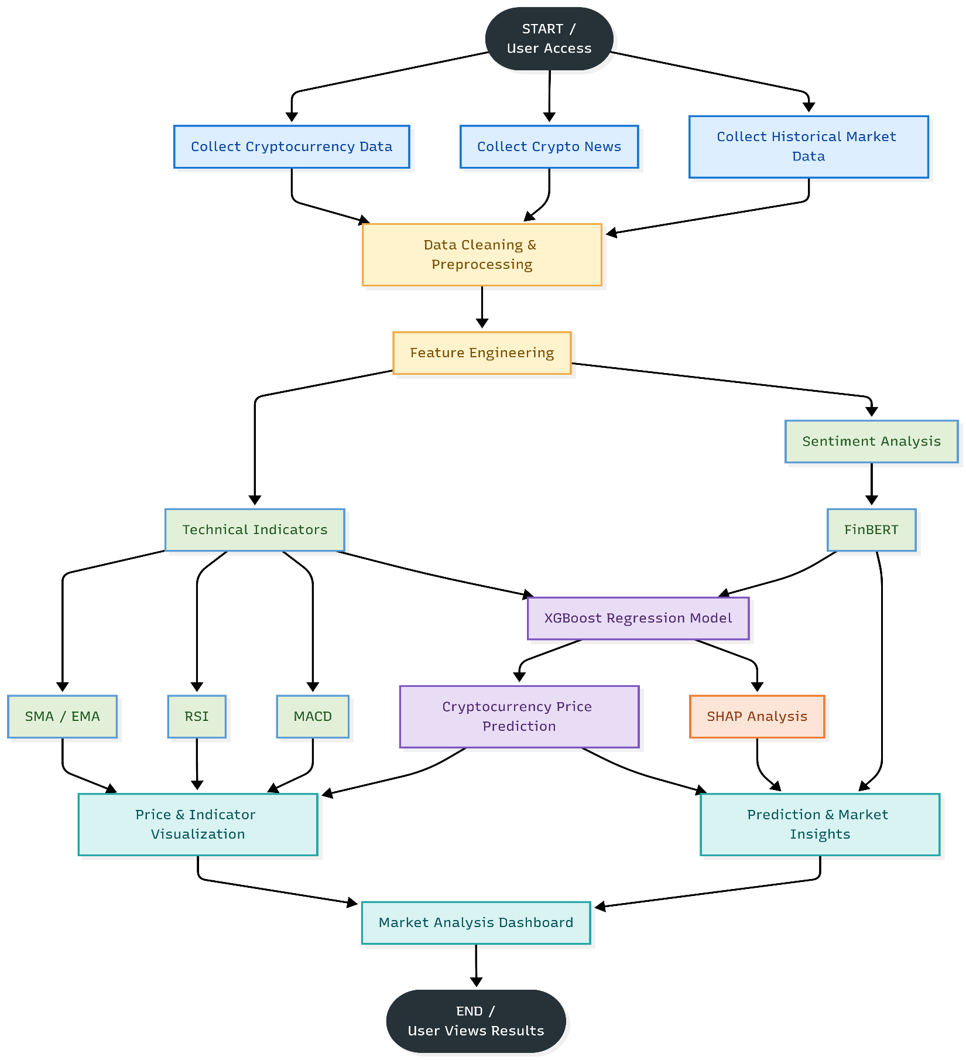

Figure 6.1 — Project Flow Analysis

Outcome of the Proposed Project

- To develop a system for predicting cryptocurrency prices
- To analyze sentiment related to cryptocurrency data
- To integrate prediction and sentiment analysis into a single platform
- To provide clear and simple visualization of results
- To reduce the need for manual analysis by users
- To improve decision-making using combined insights

Modules of the Proposed Project — Functional Requirements

The Cryptocurrency Prediction and Market Analysis System is organized into the following modules. Detailed, testable requirements for each are listed below with unique identifiers.
- 8.1 Data Ingestion & Storage
- 8.2 Feature Engineering & Sentiment Analysis
- 8.3 Machine Learning & Price Prediction
- 8.4 Backend API & Watchlist Management
- 8.5 Frontend Visualization & Dashboard

Req. ID | Module | Description
FR-01 | Data Ingestion | The system shall automatically fetch historical cryptocurrency prices (via CoinGecko) and news articles (via NewsAPI) and store them in the local database.
FR-02 | Feature Engineering | The system shall calculate technical financial indicators including 7-day and 30-day moving averages (SMA/EMA), RSI, and volatility from the raw market data.
FR-03 | Sentiment Analysis | The system shall process fetched cryptocurrency news articles using an NLP Transformer model to generate positive, negative, and neutral sentiment scores.

Req. ID | Module | Description
FR-04 | Price Prediction | The system shall use a trained XGBoost machine learning model to predict the next-day closing price and expected percentage return.
FR-05 | Watchlist | The system shall allow users to add or remove specific cryptocurrencies from a personalized watchlist.
FR-06 | Dashboard UI | The system shall display historical price charts, predicted future prices, and recent news sentiment on a centralized web dashboard.
FR-07 | Model Explainability | The system shall generate SHAP (SHapley Additive exPlanations) values to explain which features most influenced the day's prediction.
FR-08 | REST API | The backend shall provide API endpoints for the frontend to request market data, predictions, and news securely.
Table 8.1 — Functional Requirements

Non-Functional Requirements of the Project

Req. ID | Module | Description
NFR-01 | Performance | The frontend dashboard shall load and render interactive cryptocurrency price charts in under 3 seconds.
NFR- 02 | Scalability | The database and machine learning pipeline shall be modular enough to easily add support for new cryptocurrencies without requiring a schema change.

Req. ID | Module | Description
NFR-03 | Reliability | If the external NewsAPI is temporarily unavailable, the prediction model shall safely fallback to using only technical indicators without failing completely.
NFR-04 | Accuracy | The XGBoost prediction model shall aim to minimize the Mean Absolute Error (MAE) and correctly predict the directional movement of the asset.
NFR-05 | Maintainability | The backend shall follow a decoupled architecture separating data fetching scripts, model inference, and REST APIs.
NFR-06 | Usability | The web application shall be fully responsive, ensuring charts and predictions are clearly readable on both desktop and mobile devices.
Table 9.1 — Non-Functional Requirements

Project Deliverables

S.No. | Deliverable
1 | Software Requirement Specification (SRS) Document
2 | System Design Documentation (ER Diagram, Architecture Diagram, Database Schema)
3 | Working Prototype — ProjectVault web application (React frontend, Spring Boot backend, FastAPI AI microservice)
4 | PostgreSQL database with pgvector-based semantic search, populated with ~30 sample projects
5 | User Manual / README with setup instructions and demo credentials
6 | Final Project Report and Presentation
Table 10.1 — Project Deliverables

Technology to be Used

The technologies below were learnt during the MCA programme (Python, database management, web development) and are applied to Cryptocurrency Prediction and Market Analysis System based on the rationale in the table.

Layer | Technology & Rationale
Frontend | React.js (with Vite) and Tailwind CSS — a modern, component-based UI chosen for lightning-fast development, utility-first styling, and building interactive cryptocurrency charts.
Backend | Python with Flask — a lightweight, micro-framework REST API architecture chosen for its seamless integration with the Python data science and machine learning pipelines.
Database | SQLite — a serverless, file-based relational database (app.db) that handles both structured market prices and ML feature sets, avoiding the operational overhead of a separate database server.
AI / ML | XGBoost and Hugging Face Transformers — XGBoost provides highly accurate gradient boosting for time-series price prediction, while PyTorch-based transformers run NLP sentiment analysis on crypto news.
Data Ingestion | CoinGecko and NewsAPI — robust external data APIs accessed via Python requests, chosen for automated daily ingestion of historical cryptocurrency market charts and relevant financial news.
Version Control | Git and GitHub — used for source control and collaborative development between the two team members.
Table 11.1 — Technology Stack and Rationale

Timeline of Activities Planned / Completed

The project is organized into six sprints spanning July to October, shown below in table format.

Sprint | Duration | Planned Activities | Status
Sprint 1 | Jul – 1st & 2nd week | Requirement Analysis & Design — finalize modules, roles, ER model, and technology stack | Completed
Sprint 2 | Jul 3rd week – Aug 2nd week | Database & Backend Development — PostgreSQL schema, Spring Boot REST APIs, authentication | Completed
Sprint 3 | Aug 2nd week – Sept 1st week | AI Analyzer & Semantic Search — FastAPI microservice, embedding generation, pgvector integration | In Progress
Sprint 4 | Sept 2nd – 4th week | Frontend Development — React/Vite UI for upload, search, and project detail views | Planned
Sprint 5 | Oct 1st week | RBAC & Admin Panel — role-based access control and administrative dashboard | Planned
Sprint 6 | Oct 2nd week | Testing, Documentation & Final Review | Planned
Table 12.1 — Sprint Plan

Signature of the Student Signature of the Guide

