Combinational logic-consists of logic gates whose output at any time are determinde by the combination of inputs.

Sequential logic-

n inputs, m outputs

2^n = m outputs

Analysis of a combinational circuit

1. Examine the circuit to verifty it is combinational

2. Label the inputs, must be given

3. Label the outputs,must be given

4. Proceed backwards through the circuit and label each intermediate output

5. Determie the boolean function for each output gate

6. Reoear the process to obtain the boolean function for output

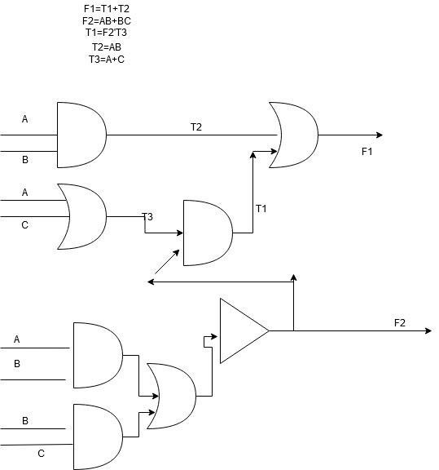

T1=(AB+BC)’+T3

=(A’+B)(B’+C’)T3

=(A’+B’)(B’+C’)(A+C)

T2=AB

F1=AB+(A’+B’)(B’+C’)(A+C)

F2=AB+BC

Designing combinational circuits

1. From the specifications of the circuit, determine the required number of inputs and outputs. Assign symbols to each input and outputs
2. Derive the truth table that describes the relationships between the inputs and outputs
3. Simplify the Boolean function for each output
4. Draw the logic circuit

*X Y C S

0 0 0 0

0 1 0 1

1 0 0 1

1 1 1 0

S(X,Y)=∑(1,2)

0 1

|  |  |
| --- | --- |
|  | 1 |
| 1 |  |

S(X,Y)=x’y+xy’

C(x,y)=∑(3)

0 1

|  |  |
| --- | --- |
|  |  |
|  | 1 |

C(x,y)=xy

**Half Adder**

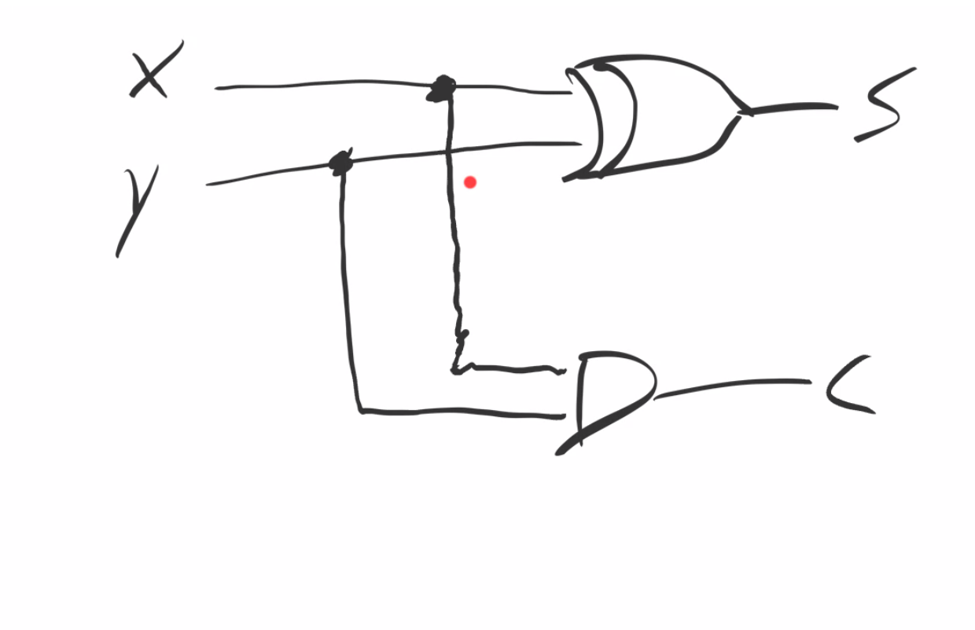

**Full Adder**

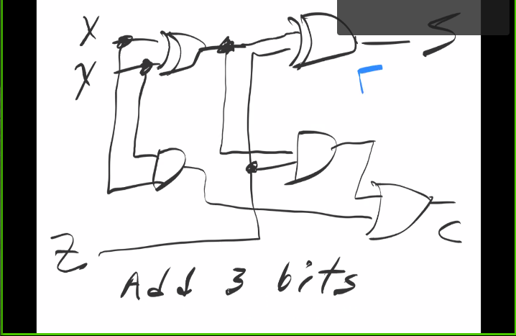

Add 3 bits

Ripple carry adder

* **2 to 4 decoder**

**X y Di**

**0 0 D0=x’y’**

1. **1 D1=x’y**
2. **0 D2=xy’**

**1 1 D3=xy**

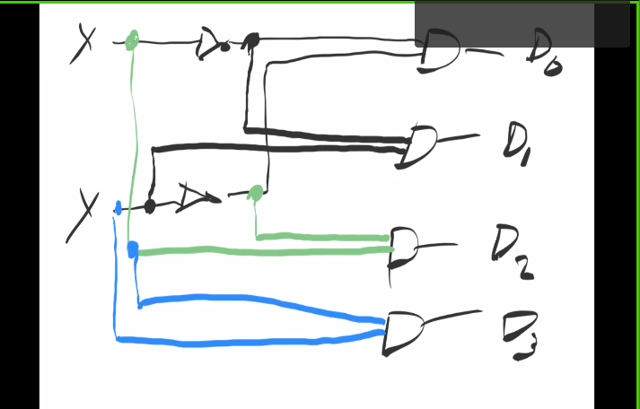

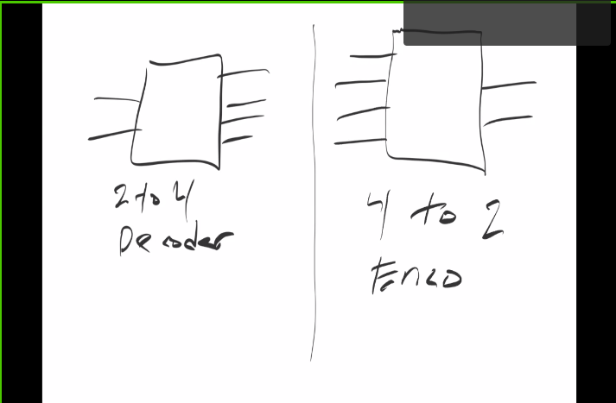

* **4 to 2 encoder**

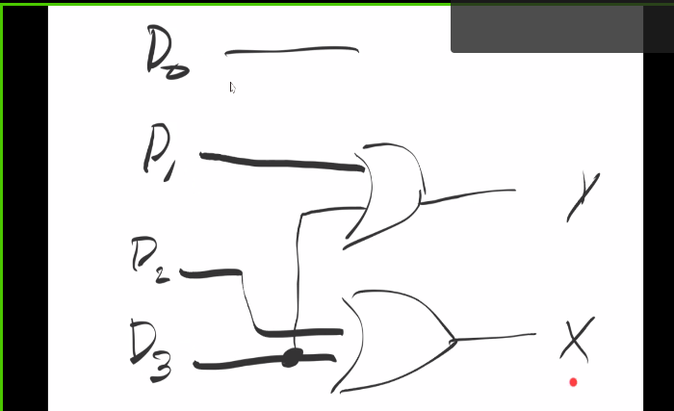

* **Priority Encoder**

D0 D1 D2 D3 x y v

0 0 0 0 x x 0

1 0 0 0 0 0 1

x 1 0 0 0 1 1

x x 1 0 1 0 1

x x x 1 1 1 1

x=D2+D3

y=D3+D1(D2)’

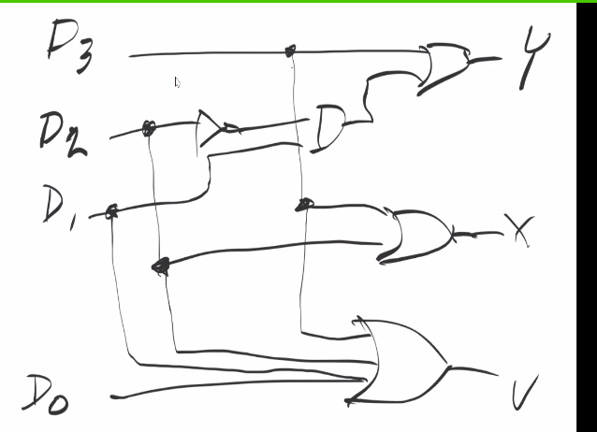

* **Multiplexer(MUX)**

**2 to 1 MUX**

