**Summary**

For my term project I plan to use reinforcement learning to develop a movie recommendation system. This recommendation system will store results from user searched movies and will display recommended movies which the user might like on the search page. I am using database from Themoviedb website, currently using only 5000 movies. I am using Flask to deploy my machine learning algorithm to a web base platform. Also, using JavaScript to make call to the API and HTML/CSS to design the website. Python libraries currently used are pandas and sklearn.

**Accomplished part in the project: -**

* Basic machine learning recommendation system is working.
* Implemented it on the web platform using Flask.
* Website design is almost completed.
* API calls are properly working.
* Searching movies and getting recommendations is working perfectly.

**Homepage showing popular movies and a search bar: -**

Popular movies are shown by making a call to themoviedb API.

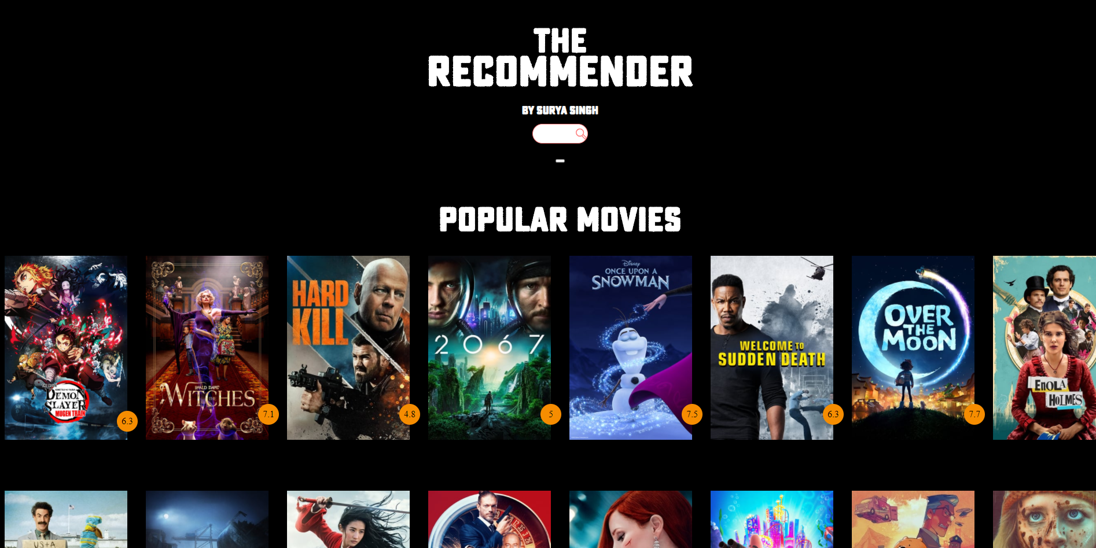

**Search Bar gives suggestion to search movies by using JSON and the API:-**

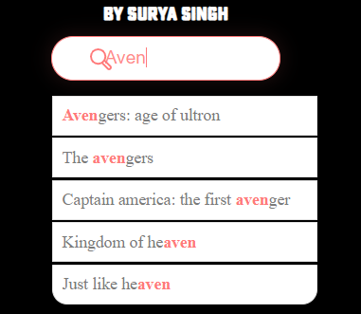

**After Searching movies three results are given: -**

