Name: Surya Partap Singh

CS-245 Discrete Structures

Assignment 5

Fall Semester, 2019

1)

a)



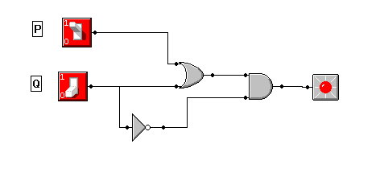

b)

|  |  |  |  |  |
| --- | --- | --- | --- | --- |
| P | Q | ~Q | PvQ | (PvQ)^~Q |
| T | T | F | T | F |
| T | F | T | T | T |
| F | T | F | T | F |
| F | F | T | F | F |

2)

a)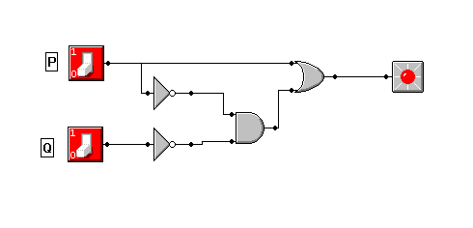

b)

|  |  |  |  |  |  |
| --- | --- | --- | --- | --- | --- |
| P | Q | ~P | ~Q | ~P^~Q | PV(~P^~Q) |
| 1 | 1 | 0 | 0 | 0 | 1 |
| 0 | 1 | 1 | 0 | 0 | 0 |
| 1 | 0 | 0 | 1 | 0 | 1 |
| 0 | 0 | 1 | 1 | 1 | 1 |

3)

a)



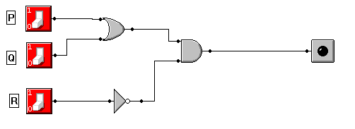

b)(PVQ)^~R

4)

a)

|  |  |  |  |  |  |
| --- | --- | --- | --- | --- | --- |
| P | Q | R | ~(PVQVR) | P^Q^R | ~(PVQVR)V(P^Q^R) |
| 1 | 1 | 1 | 0 | 1 | 1 |
| 1 | 1 | 0 | 0 | 0 | 0 |
| 1 | 0 | 1 | 0 | 0 | 0 |
| 1 | 0 | 0 | 0 | 0 | 0 |
| 0 | 1 | 1 | 0 | 0 | 0 |
| 0 | 1 | 0 | 0 | 0 | 0 |
| 0 | 0 | 1 | 0 | 0 | 0 |
| 0 | 0 | 0 | 1 | 0 | 1 |

b) ~(PVQVR)V(P^Q^R)

c)



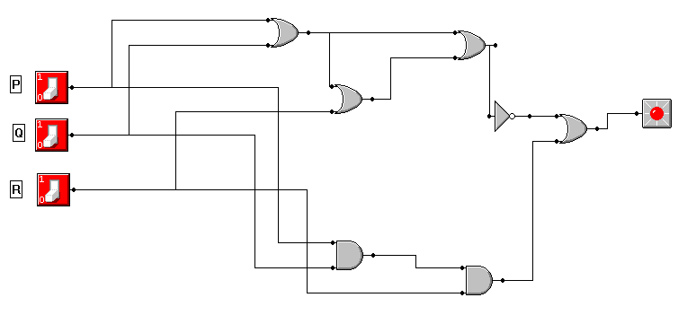

5)

a)

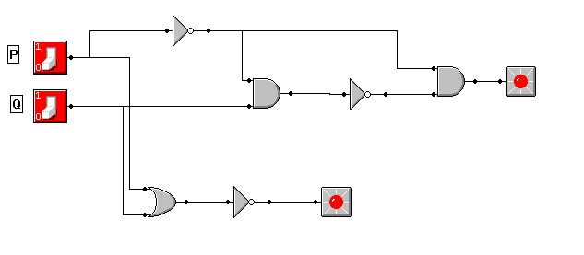

b)

|  |  |  |  |  |  |  |  |
| --- | --- | --- | --- | --- | --- | --- | --- |
| P | Q | ~P | ~P^Q | ~(~P^Q) | ~P^~(~P^Q) | PVQ | ~(PVQ) |
| 1 | 1 | 0 | 0 | 1 | 0 | 1 | 0 |
| 0 | 1 | 1 | 1 | 0 | 0 | 1 | 0 |
| 1 | 0 | 0 | 0 | 1 | 0 | 1 | 0 |
| 0 | 0 | 1 | 0 | 1 | 1 | 0 | 1 |

C)

* ~P^~(~P^Q)
* ~(PVQ)

6)