

DEPARTMENT OF COMPUTER SCIENCE AND SOFTWARE

ENGINEERING

SOEN 6441, Fall 2019

RISK Game (Build-2)

Coding Standards

Submitted To: JABABO KHALED

Submitted By: **Team E**

Git URL: https://github.com/Surya64/APP_SOEN-6441_TeamE

|  |  |  |
| --- | --- | --- |
| Sr. No. | Name | Student ID |
| 1 | Surya Prakash Govindaraju | 40085527 |
| 2 | Shruthi Kondapura Venkataiah | 40091427 |
| 3 | Sahana Anantha | 40085533 |
| 4 | Sai Charan Teja Doddi | 40076338 |
| 5 | Dolly Modha | 40084358 |

Introduction:

Coding conventions are a set of prescriptive rules that pertain to how code is to be written. It defines the Programming style. The main advantage of coding conventions are maintainability, compatibility and readability. Coding convention makes it easier for the distinct teams to interface and read the code of other teams.

Coding Conventions and Standards adopted in project:

* Naming Conventions:

We have used CamelCase naming convention. All package names are in lowercase. UpperCamelCase is used for naming the classes and lowerCamelCase for naming the methods. All the local variables, method parameters follow lowerCamelCase convention. All the constants are in Uppercase.

* Layout:

To make the code more understandable and shorter we have placed the open braces on the same line where the method starts.

* Indentation:

To convey the proper program structure, we have used the formatter present in Eclipse tool. Depending on the code’s environment the while loops, for loops and if conditions are indented by providing single tab space. Horizontal whitespace and Line wrapping are done using the available formatter.

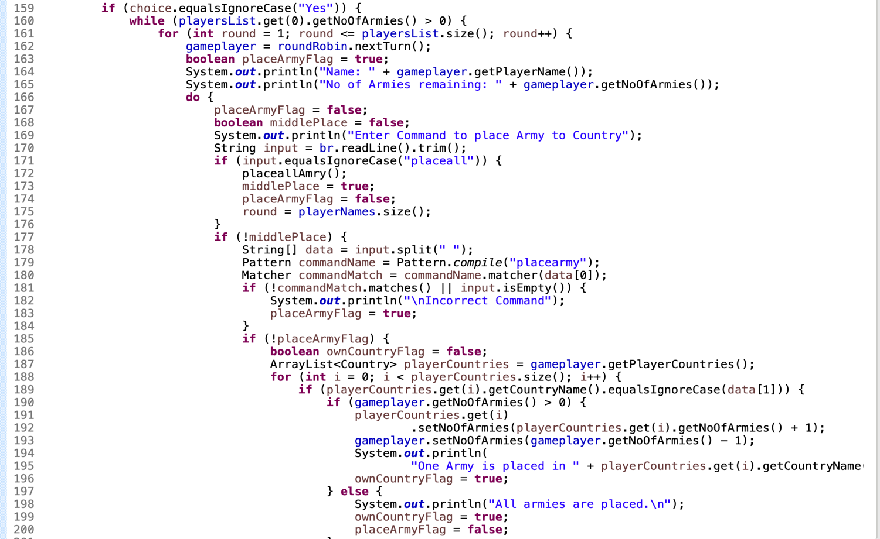

* Commenting:

We have provided comments for the methods, variables, classes to maximize readability and understandability. Comments are placed at the beginning of the classes and methods. Comments give a brief description about what that method does, the parameters used in it and return types. In few cases, we have included the comments inside the methods for more detailed explanation.

Javadoc comments are highly used in our projects which consists of special tags on classes, methods and member variables such as @param, @return.

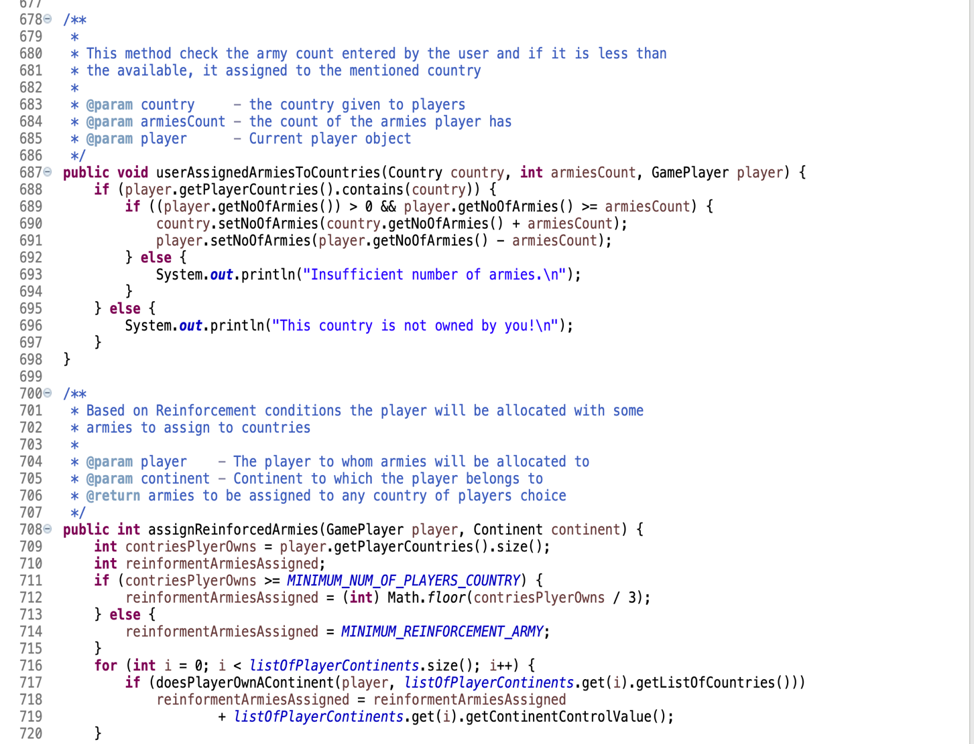

* File Naming and Organization:

We have given the relatable names for files based on their functionality and placed all the related files in the corresponding package.

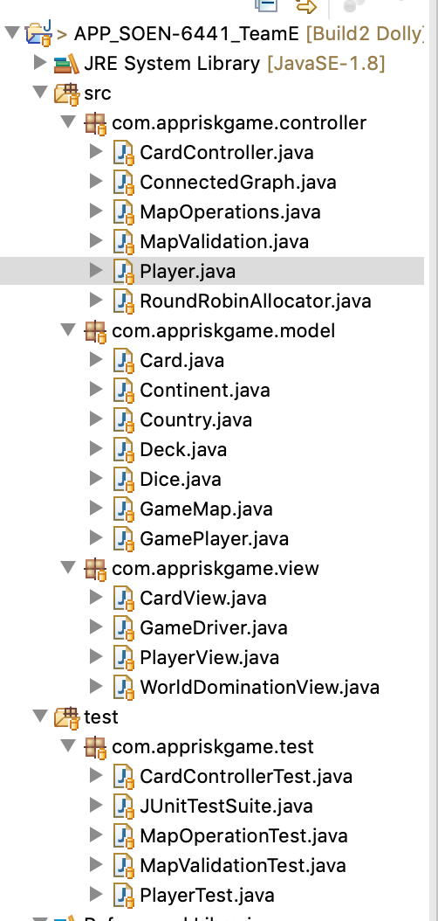

* Exception Handling:

We have used try & catch block in our project. If there is any exception, we have used meaningful print statements which helps programmer to identify and fix the bug.

