

DEPARTMENT OF COMPUTER SCIENCE AND SOFTWARE

ENGINEERING

SOEN 6441, Fall 2019

RISK Game (Build-3)

Refactoring

Submitted To: JABABO KHALED

Submitted By: **Team E**

Git URL:https://github.com/Surya64/APP_SOEN-6441_TeamE

|  |  |  |
| --- | --- | --- |
| Sr. No. | Name | Student ID |
| 1 | Surya Prakash Govindaraju | 40085527 |
| 2 | Shruthi Kondapura Venkataiah | 40091427 |
| 3 | Sahana Anantha | 40085533 |
| 4 | Sai Charan Teja Doddi | 40076338 |
| 5 | Dolly Modha | 40084358 |

1. FortificationPhase.java

Created new method isArmyCountSufficient as there was checking multiple conditions for army count and returning false.

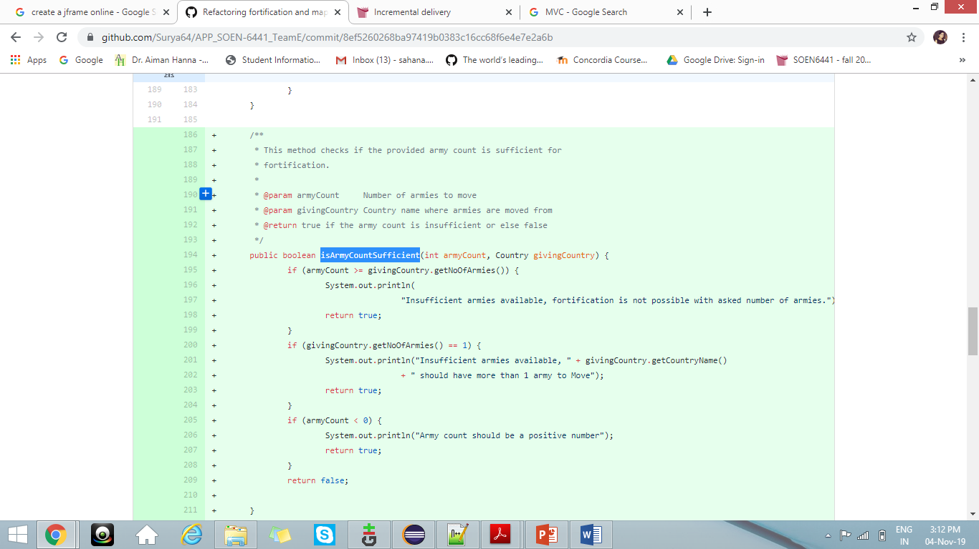

1. StartupPhase.java

Placeall method is created which is called twice in the game play phase and hence duplicate code is removed.

New playerCreation method is created.

1. MapOperation.java

MultiCommand method is optimized to two cases instead of three, as editcountry and editcontinent take the same number of arguments.