**PROBLEM SCENARIO:-**

The Indian Government wants to develop a **Library Management System (LMS)** to store information of the members, books, status of books issue, book availability and supplier’s details.

**List of Tables:-**

Table 1: - LMS_MEMBERS

Table 2: - LMS_SUPPLIERS_DETAILS

Table 3: - LMS_FINE_DETAILS

Table 4: - LMS_BOOK_DETAILS

Table 5: - LMS_BOOK_ISSUE

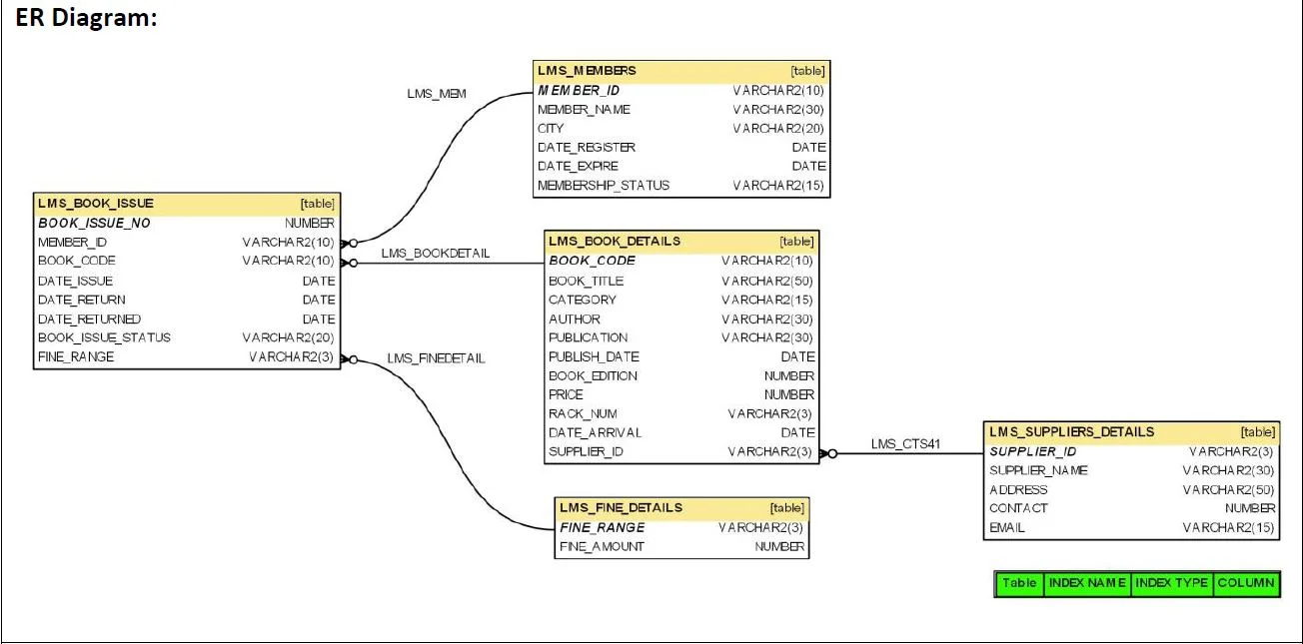

**Questions: -**

* **Problem # 1:**

Write a query to display the member id, member name, city and membership status who are all having life time membership. Hint: Life time membership status is “Permanent”.

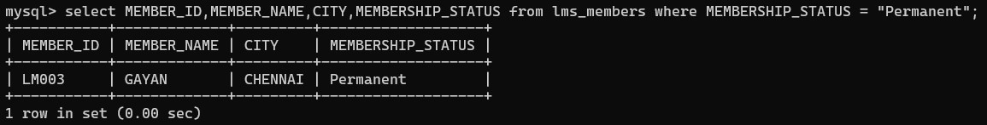

* **Problem # 2:**

Write a query to display the member id, member name who have taken the book with book code 'BL000002'.

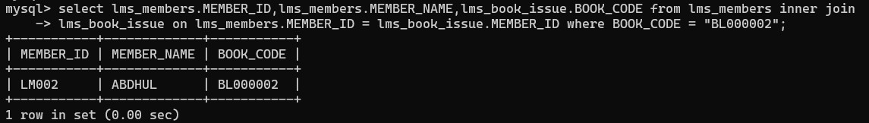

* **Problem # 3:**

Write a query to display the book code, book title and author of the books whose author name begins with 'P'.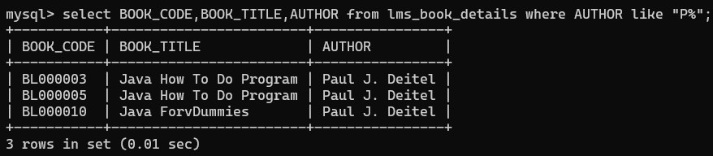

* **Problem # 4:**

Write a query to display the total number of Java books available in library with alias name ‘NO_OF_BOOKS’.

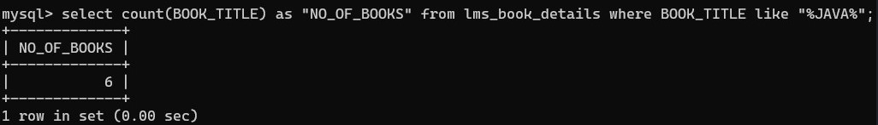

* **Problem # 5:**

Write a query to list the category and number of books in each category with alias name ‘NO_OF_BOOKS’.

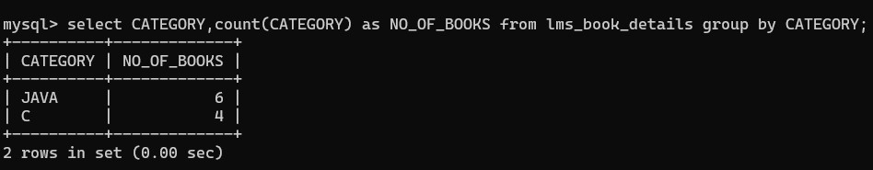

* **Problem # 6:**

Write a query to display the number of books published by "Prentice Hall” with the alias name “NO_OF_BOOKS”.

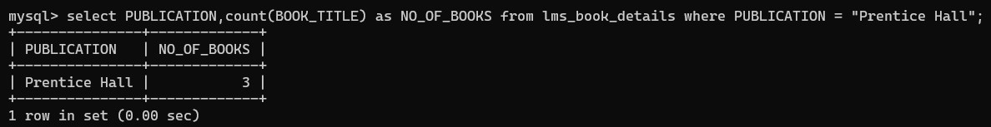

* **Problem # 7:**

Write a query to display the book code, book title of the books which are issued on the date "1st April 2012".

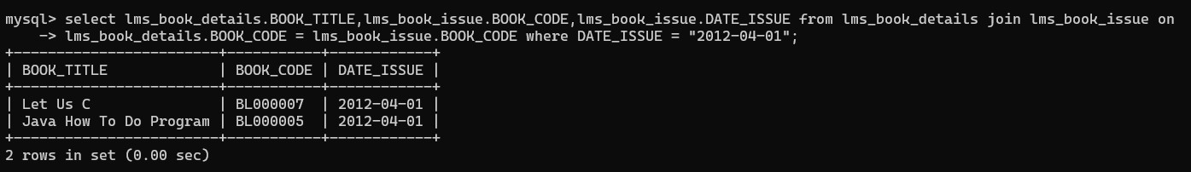

* **Problem # 8:**

Write a query to display the member id, member name, date of registration and expiry date of the members whose membership expiry date is before APR 2013.

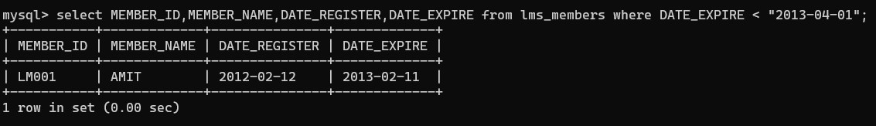

* **Problem # 9:**

Write a query to display the member id, member name, date of registration, membership status of the members who registered before "March 2012" and membership status is "Temporary"

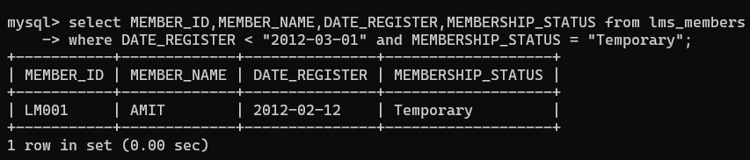

* **Problem # 10:**

Write a query to display the average price of books which is belonging to ‘JAVA’ category with alias name “AVERAGEPRICE”.

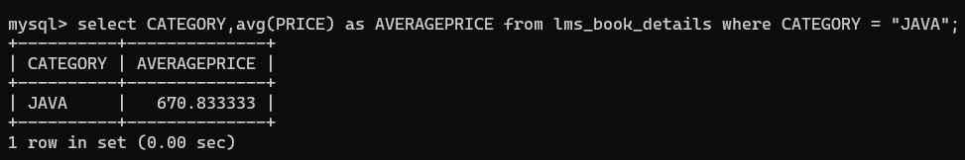

* **Problem # 11:**

Write a query to display the supplier id, supplier name and email of the suppliers who are all having gmail account.

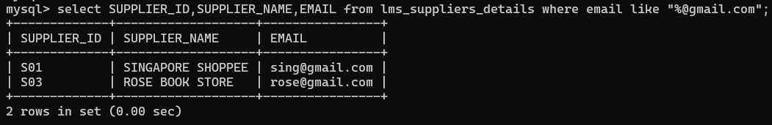

* **Problem # 12:**

Write a query to display the member id, member name of the members, book code and book title of the books taken by them.

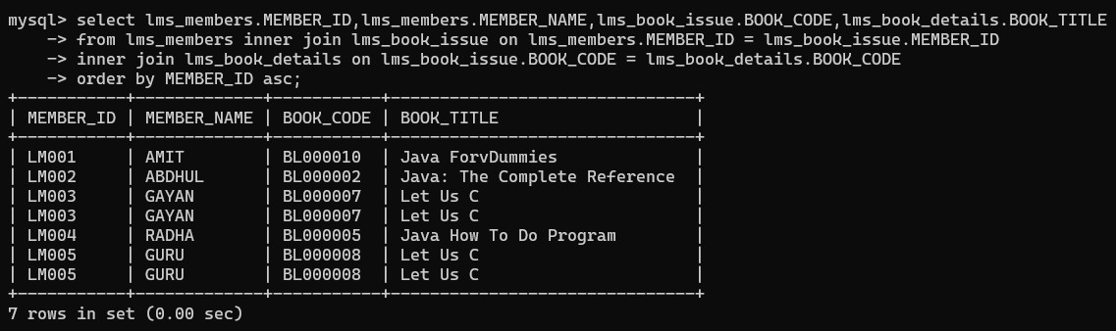

* **Problem # 13:**

Write a query to display the total number of books available in the library with alias name “NO_OF_BOOKS_AVAILABLE” (Which is not issued). Hint: The issued books details are available in the LMS_BOOK_ISSUE table.

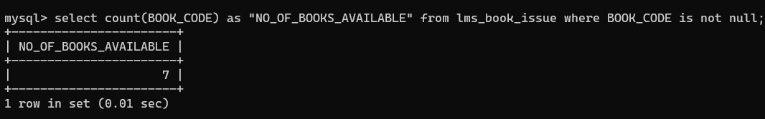

* **Problem # 14:**

Write a query to display the member id, member name, fine range and fine amount of the members whose fine amount is less than 100.

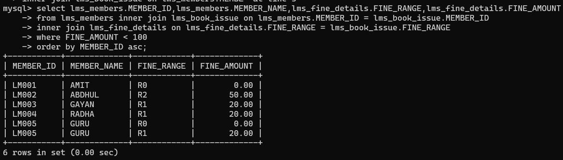

* **Problem # 15:**

Write a query to display the book code, book title and rack number of the books which are placed in rack 'A1' and sort by book title in ascending order.

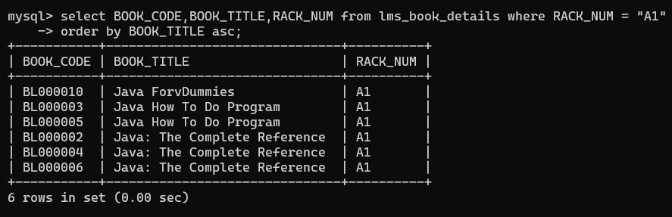

* **Problem # 16:**

Write a query to display the member id, member name, due date and date returned of the members who has returned the books after the due date. Hint: Date_return is due date and Date_returned is actual book return date.

