SIGN LANGUAGE TO TEXT AND AUDIO
CONVERSION SYSTEM
A PROJECT REPORT
Submitted by
SURYA A
(Reg. No. 511924622038)
in partial fulfillment for the award of the degree of
MASTER OF COMPUTER APPLICATIONS
DEPARTMENT OF MASTER OF COMPUTER APPLICATIONS
PRIYADARSHINI ENGINEERING COLLEGE
VANIYAMBADI
ANNA UNIVERSITY :: CHENNAI 600 025
JUNE 2026
ANNA UNIVERSITY :: CHENNAI 600 025
BONAFIDE CERTIFICATE
Certified that this project report titled “SIGN LANGUAGE TO TEXT AND AUDIO CONVERSION SYSTEM” is the bonafide work of SURYA A (Reg. No. 511924622038) who carried out the project work under my supervision. Certified further that to the best of my knowledge the work reported herein does not form part of any other thesis or dissertation on the basis of which a degree or award was conferred on an earlier occasion on this or any other candidate.

Dr. MANIKANDAN G,  Head of the Department,  Professor and Head,  Department of MCA,  Priyadarshini Engineering College,  Vaniyambadi. | «Name of the Supervisor»,  Supervisor,  «Academic Designation»,  Department of MCA,  Priyadarshini Engineering College,  Vaniyambadi.

Submitted for the Project Viva-Voce examination held on ____________________

INTERNAL EXAMINER | EXTERNAL EXAMINER

ABSTRACT
The project “SIGN LANGUAGE TO TEXT AND AUDIO CONVERSION SYSTEM” has been developed to bridge the communication gap between persons with hearing and speech impairments and the people around them. The system captures the hand gestures of American Sign Language (ASL) through an ordinary webcam directly inside the web browser. Using Google MediaPipe, twenty-one hand landmarks are extracted from every video frame in real time and forwarded to a Python Flask service, where a trained Support Vector Machine model classifies the gesture into one of thirty-six classes covering the alphabets A to Z and the digits 0 to 9.
The recognised characters are assembled into words and sentences, displayed on the screen as live subtitles, and at the same time converted into clear spoken audio using a text-to-speech engine. The complete transcript of a session can be exported as a PDF or Word document for later use. The main goal of this project is to provide an affordable, real-time and easy-to-use assistive tool that does not require any special hardware, thereby promoting independent communication and accessibility for the deaf and mute community.
Keywords: Sign language recognition, hand landmark detection, MediaPipe, Support Vector Machine, text-to-speech, assistive technology.
திட்ட சுருக்கம்
கேட்டல் மற்றும் பேச்சுத் திறன் குறைபாடு உடையவர்களுக்கும் அவர்களைச் சுற்றியள்ள மக்களுக்கும் இடையேயான தொடர்பு இடைவெளியைக் குறைக்கும் நோக்கில் “சைகை மொழியிலிருந்து உரை மற்றும் ஒலி மாற்றும் அமைப்பு” என்ற இந்தத் திட்டம் உருவாக்கப்பட்டுள்ளது. இந்த அமைப்பு, சாதாரண இணைய உலாவியிலேயே ஒரு வழக்கமான வெப்கேமராவின் மூலம் அமெரிக்க சைகை மொழியின் (ASL) கைச் சைகைகளைப் படம்பிடிக்கிறது.
கூகிள் மீடியாபைப் (MediaPipe) தொழில்நுட்பம் பயன்படுத்தி, ஒவ்வொரு காணொளி சட்டக்திலிருந்தும் இருபத்தொரு கை அடையாளப் புள்ளிகள் நிகழ்நேரத்தில் பிரித்தெடுக்கப்பட்டு, பைத்தான் ஃபிளாஸ்க் (Flask) சேவைக்கு அனுப்பப்படுகின்றன. அங்கு பயிற்சியளிக்கப்பட்ட சப்போர்ட் வெக்டர் மெஷின் (SVM) மாதிரியானது அந்தச் சைகையை A முதல் Z வரையிலான எழுத்துக்கள் மற்றும் 0 முதல் 9 வரையிலான இலக்கங்கள் உட்பட முப்பத்தாறு வகுப்புகளில் ஒன்றாக வகைப்படுத்துகிறது.
அடையாளம் காணப்பட்ட எழுத்துக்கள் சொற்களாகவும் வாக்கியங்களாகவும் இணைக்கப்பட்டு, திரையில் நேரடி வசனங்களாகக் காட்டப்படுகின்றன; அதே நேரத்தில் உரையிலிருந்து ஒலி மாற்றும் தொழில்நுட்பத்தைப் பயன்படுத்தித் தெளிவான பேச்சொலியாகவும் மாற்றப்படுகின்றன. ஒரு அமர்வின் முழு உரையையும் PDF அல்லது Word ஆவணமாக ஏற்றுமதி செய்யலாம். எந்தொரு சிறப்பு வன்பொருளும் தேவைப்படாத, மலிவான, நிகழ்நேர மற்றும் எளிதாகப் பயன்படுத்தக்கூடிய ஒரு உதவித் தொழில்நுட்பக் கருவியை வழங்குவதன் மூலம், செவித்திறன் மற்றும் பேச்சுத்திறன் குறைபாடு உடையவர்களின் சுயாதீனமான தொடர்பையும் அணுகலையும் மேம்படுத்துவதே இத்திட்டத்தின் முக்கிய நோக்கமாகும்.
முக்கிய சொற்கள்: சைகை மொழி அங்கீகாரம், கை அடையாளம் கண்டறிதல், மீடியாபைப், சப்போர்ட் வெக்டர் மெஷின், உரையிலிருந்து பேச்சு, உதவித் தொழில்நுட்பம்.
ACKNOWLEDGEMENT
First and foremost, I express my deep, heart-felt gratitude and reverence to my project supervisor and mentor for valuable guidance, advice, support, and encouragement throughout this project work.
I sincerely thank the Management of PRIYADARSHINI ENGINEERING COLLEGE and ANNA UNIVERSITY for giving me an opportunity to pursue and excel in Computer Applications.
I extend my sense of gratitude and sincere thanks to Thiru. S. NITHIYANANDAM, Chairman, Mr. K.T. ANBAZHAGAN, Managing Trustee, and Thirumathi. SAROJA RATHINAM, Correspondent of Priyadarshini Engineering College, for giving me an opportunity to be a student of this reputed college.
I warmly thank Dr. K. VIJAYARAJ, Principal of Priyadarshini Engineering College, for providing the appropriate permission and facilities to carry out this project.
I express my heartfelt thanks to the Head of the Department, Dr. MANIKANDAN G, for his support and encouragement. I also thank all the faculty members of the Department of Master of Computer Applications, Priyadarshini Engineering College, for their valuable input, discussions, and accessibility.
Finally, I bow to the ALMIGHTY for blessing me with good health and strength throughout the period of this project work.

(SURYA A)
TABLE OF CONTENTS
CHAPTER NO. | TITLE | PAGE NO.
 | ABSTRACT | i
 | திட்ட சுருக்கம் | ii
 | ACKNOWLEDGEMENT | iii
 | LIST OF FIGURES | vi
 | LIST OF TABLES | vii
1 | INTRODUCTION | 1
 | 1.1 Project Outline | 1
 | 1.2 Project Objective | 1
2 | COMPANY PROFILE | 3
 | 2.1 About the Company | 3
3 | SYSTEM ANALYSIS | 4
 | 3.1 Existing System | 4
 | 3.2 Proposed System | 4
 | 3.3 Methodology | 5
4 | SYSTEM CONFIGURATION | 7
 | 4.1 Hardware Configuration | 7
 | 4.2 Software Configuration | 7
 | 4.3 Software Description | 7
5 | SYSTEM DESIGN | 9
 | 5.1 Architecture Diagram | 9
 | 5.2 ER Diagram | 9
 | 5.3 Data Flow Diagram | 10
 | 5.4 UML Diagram | 10
 | 5.4.1 Use Case Diagram | 11
 | 5.4.2 Class Diagram | 11
 | 5.4.3 Activity Diagram | 12
 | 5.4.4 Sequence Diagram | 13
 | 5.5 Database Design | 13
6 | PROJECT DESCRIPTION | 18
 | 6.1 Problem Definition | 18
 | 6.2 Module Description | 19
7 | SOFTWARE TESTING | 21
 | 7.1 System Testing | 21
 | 7.2 Types of Testing | 21
 | 7.3 Functional Testing | 22
 | 7.4 Sample Test Case | 23
8 | CONCLUSION | 26
9 | FUTURE ENHANCEMENT | 27
10 | APPENDICES | 28
 | 10.1 Sample Coding | 28
 | 10.2 Screen Shots | 32
11 | REFERENCES | 34
 | 11.1 Web Reference | 34
 | 11.2 Book Reference | 34
LIST OF FIGURES
FIGURE NO. | TITLE | PAGE NO.
3.1 | Agile methodology | 5
5.1 | Architecture diagram | 9
5.2 | ER diagram | 10
5.3 | Data flow diagram | 10
5.4 | Use case diagram | 11
5.5 | Class diagram | 12
5.6 | Activity diagram | 12
5.7 | Sequence diagram | 13
LIST OF TABLES
TABLE NO. | TITLE | PAGE NO.
5.1 | Users table | 14
5.2 | Gesture labels table | 14
5.3 | Sessions table | 15
5.4 | Translations table | 15
5.5 | Transcripts table | 16
5.6 | Documents table | 16
5.7 | System logs table | 17

CHAPTER 1
INTRODUCTION
1.1 Project Outline
The Sign Language to Text and Audio Conversion System is a real-time, web-based application designed to translate the hand gestures of American Sign Language (ASL) into readable text and natural spoken audio. The system uses an ordinary webcam to observe a signer, detects the hand inside the browser, and recognises the gesture being shown. Each recognised letter or digit is added to a running transcript that appears on screen as a live subtitle and is simultaneously read aloud, allowing a person who communicates through signs to be understood instantly by people who do not know sign language.
The application is built as a lightweight client-server system. The browser front-end captures the camera feed and extracts hand landmarks; a Python service classifies the gesture using a trained machine-learning model, stores the result, generates speech, and exports the session transcript as a document. This outline forms the foundation for the detailed analysis, design, and implementation discussed in the chapters that follow.
1.2 Project Objective
The objective of this project is to develop an affordable and easy-to-use assistive application that recognises ASL alphabets (A–Z) and digits (0–9) from a live webcam and converts them into text and audio in real time. People with hearing and speech impairments often depend on human interpreters or on writing to communicate, which is not always available, is time-consuming, and reduces independence. Because of these limitations of the existing manual approach, an automated computerised system becomes essential.
The system aims to remove the dependence on a trained interpreter, to provide instant two-way communication, to keep the cost low by working on a normal computer with a webcam, and to run directly in a web browser without any special hardware. It further aims to record each session, allow the recognised text to be played as speech, and export the transcript as a PDF or Word file so that the conversation can be saved and shared.
CHAPTER 2
COMPANY PROFILE
2.1 About the Company
This project has been developed in the domain of assistive technology and accessibility, an area of computer applications that focuses on building tools to support persons with disabilities in their everyday communication. Sign language is the natural and primary mode of communication for a large number of people with hearing and speech impairments; however, only a small fraction of the general public understands it. This creates a constant communication barrier in schools, hospitals, offices, and public services, where an interpreter may not be readily available.
Automated sign-language recognition is therefore an active and socially valuable field that combines computer vision, machine learning, and human-computer interaction. The aim within this domain is to provide low-cost, real-time translation tools that work on widely available devices so that they can reach the people who need them most.
The project work was carried out in the Department of Master of Computer Applications, Priyadarshini Engineering College, Vaniyambadi, which provided the academic environment, technical guidance, and infrastructure for designing, developing, and testing the system. The department's focus on practical, application-oriented software development made it well suited to building and evaluating an assistive solution of this kind.
CHAPTER 3
SYSTEM ANALYSIS
3.1 Existing System
In the existing situation, communication between a sign-language user and a person who does not understand signs is handled manually. It depends mainly on a human interpreter being physically present, on exchanging written notes, or on attempts at lip-reading. A human interpreter is not always available, involves cost, and removes privacy from personal conversations. Writing notes is slow and impractical for everyday interaction, and lip-reading is unreliable.
A few hardware-based solutions, such as sensor gloves, exist but are expensive, intrusive, and not portable. Several software solutions require heavy server-side image processing, large bandwidth, and powerful machines, which make them slow and difficult to deploy. As a result, the existing approaches are inadequate, increase delay, raise cost, offer no permanent record of the conversation, and limit the independence of the user.
3.2 Proposed System
The proposed system is a new, computerised solution that recognises sign-language gestures automatically and instantly. Hand detection and landmark extraction are performed inside the web browser using Google MediaPipe, so the camera images never leave the user's machine; only a small set of numeric landmark coordinates is sent to the server, which protects privacy and keeps the system fast and lightweight.
A trained Support Vector Machine model classifies each gesture quickly and accurately, the recognised characters are shown immediately as on-screen subtitles, and the text is converted into clear speech. The system requires nothing more than a normal computer and a webcam, runs in a standard browser, and stores every session so that the transcript can be reviewed, played as audio, and exported as a PDF or Word document. The new system therefore avoids human error, reduces delay and cost, provides a permanent record, and offers a user-friendly interface.
3.3 Methodology
The Agile methodology was adopted for the development of this system. Agile promotes flexibility and continuous improvement through short, iterative cycles, allowing the system to evolve steadily in response to testing and feedback. The structured phases followed during the project are described below.
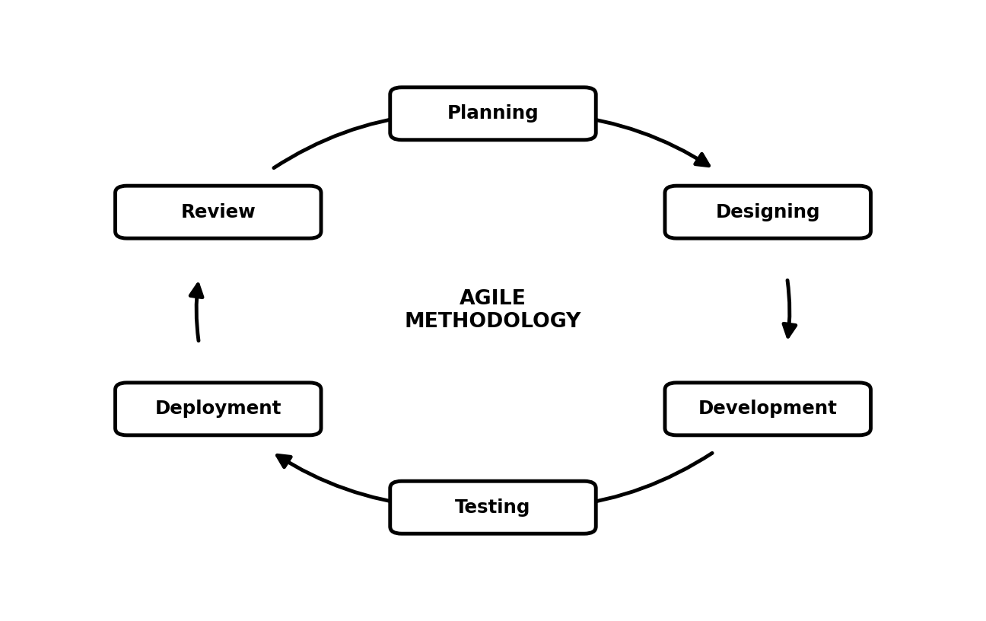
Figure No. 3.1 Agile methodology
Planning: the objectives of the system, such as real-time gesture recognition and text-and-audio output, were defined; the required tools and dataset were identified; and a prioritised list of features was prepared.
Designing: a lightweight client-server architecture was designed in which hand-landmark detection runs in the browser and classification runs on the server. The user interface, database schema, and module interactions were planned at this stage.
Development: the work was divided into short iterations, each delivering specific features such as landmark capture, model classification, transcript building, text-to-speech, and document export, while following good coding practices.
Testing: unit, integration, and acceptance testing were carried out continuously throughout development, and feedback from each test cycle was used to refine the features and correct issues promptly.
Deployment: the modules were released incrementally, beginning with the core recognition functionality and gradually adding speech output, export, and session history.
Review: each iteration ended with a review to evaluate what worked well, identify improvements, and adjust the plan, ensuring that the final system met its objectives and remained reliable and easy to use.
CHAPTER 4
SYSTEM CONFIGURATION
4.1 Hardware Configuration
Processor | : Intel Core i5
RAM | : 8 GB (16 GB recommended)
Hard Disk | : 512 GB SSD
Camera | : Integrated or USB Webcam (720p)
Display | : Standard colour monitor
4.2 Software Configuration
Operating System | : Windows 10 / 11
Front-End | : React with Vite (JavaScript)
Back-End | : Python (Flask REST API)
Hand Tracking | : Google MediaPipe (browser, CDN)
Machine Learning | : scikit-learn (Support Vector Machine)
Text-to-Speech | : gTTS / pyttsx3
Database | : SQLite (SQLAlchemy ORM)
Web Browser | : Google Chrome / Microsoft Edge
4.3 Software Description
React with Vite: React is a JavaScript library for building fast, component-based user interfaces, and Vite is the modern build tool used to run and bundle the front-end. Together they provide the responsive web interface that captures the webcam feed, displays the live subtitles, and plays the generated audio.
JavaScript: JavaScript adds the interactive behaviour to the web page. It controls the camera, runs the in-browser hand-tracking, communicates with the server, and updates the transcript and controls dynamically.
Google MediaPipe: MediaPipe is Google's framework for real-time perception. Its Hands solution detects a hand in each video frame and returns twenty-one landmark coordinates. Because it runs in the browser through a CDN, the raw camera images stay on the user's device.
Python: Python is the server-side programming language used for the application logic, machine-learning inference, speech generation, and document export, owing to its rich set of scientific and web libraries.
Flask: Flask is a lightweight Python web framework used to build the REST API. It receives the hand landmarks, runs the classification model, manages sessions, generates audio, and handles PDF and Word export.
scikit-learn: scikit-learn is a Python machine-learning library. A Support Vector Machine classifier from this library, combined with feature scaling, is trained on the hand-landmark data to recognise the thirty-six gesture classes accurately.
gTTS and pyttsx3: gTTS (Google Text-to-Speech) converts the recognised text into natural spoken audio online, while pyttsx3 provides an offline fallback so that speech output continues to work without an internet connection.
SQLite with SQLAlchemy: SQLite is a lightweight relational database that stores users, sessions, recognised translations, transcripts, exported documents, and system logs. SQLAlchemy is the ORM layer used to define the schema and interact with the database from Python.
ReportLab and python-docx: ReportLab is used to generate PDF transcripts and python-docx to generate Word transcripts, allowing each session's text to be saved and shared as a formatted document.
CHAPTER 5
SYSTEM DESIGN
5.1 Architecture Diagram
The architecture of the system follows a client-server model. The signer interacts with the React front-end, which captures the webcam feed and uses MediaPipe to obtain hand landmarks. These landmarks are sent to the Flask REST API, where the Support Vector Machine model classifies the gesture. The result is stored in the SQLite database and returned to the browser, which displays the text and plays the audio.
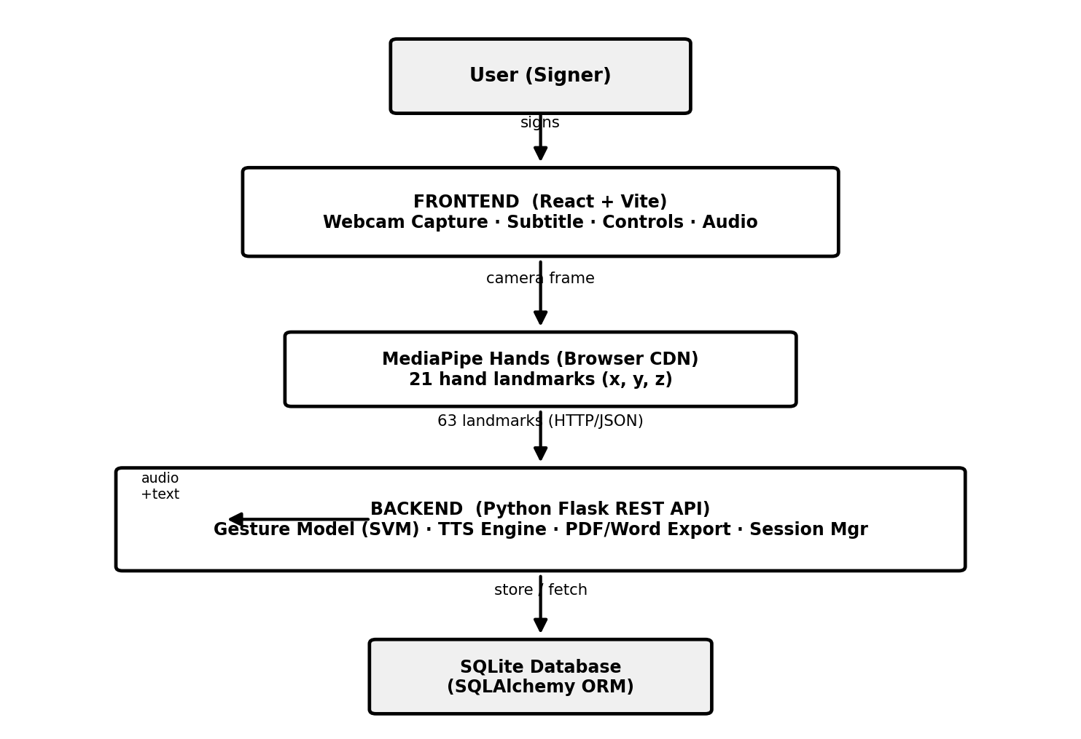
Figure No. 5.1 Architecture diagram
5.2 ER Diagram
The Entity-Relationship diagram shows the main entities of the system and the relationships among them. A user may start many sessions, each session produces many translations and a single transcript, and a session may also generate exported documents and system log entries.
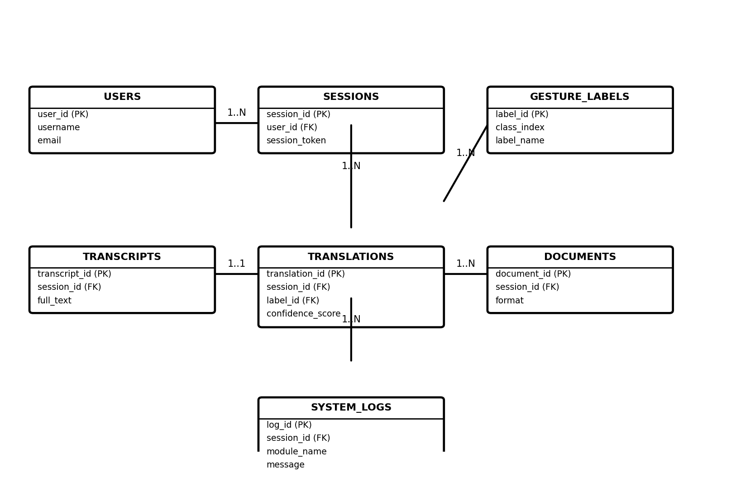
Figure No. 5.2 ER diagram
5.3 Data Flow Diagram
The Data Flow Diagram illustrates how data moves through the system, from the camera frame captured in the browser, through landmark extraction and classification, to the storage of translations and the generation of text and audio output.
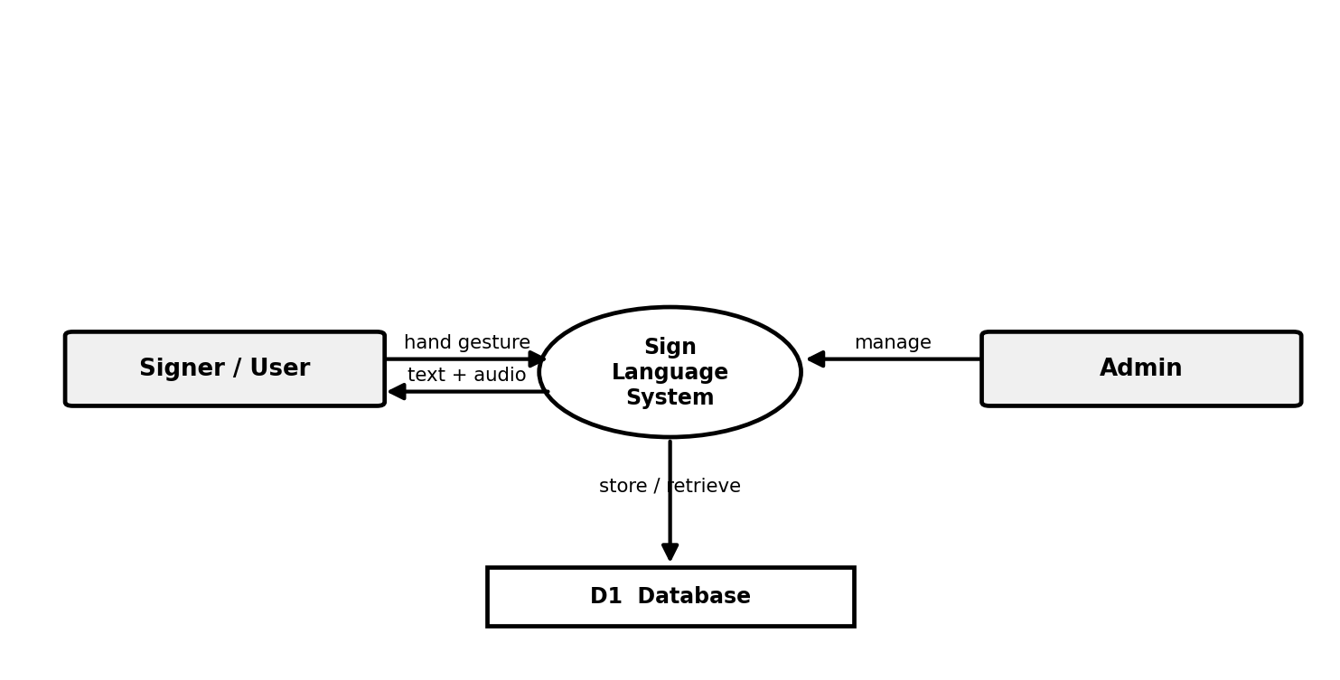
Figure No. 5.3 Data flow diagram
5.4 UML Diagram
The Unified Modeling Language (UML) diagrams describe the system from different viewpoints — the actors and their interactions, the structure of the classes, the flow of activities, and the sequence of messages exchanged among the components.
5.4.1 Use Case Diagram
The use case diagram shows the actions available to the user, such as starting a session, showing a gesture, viewing the recognised text, playing the audio, and exporting the transcript.
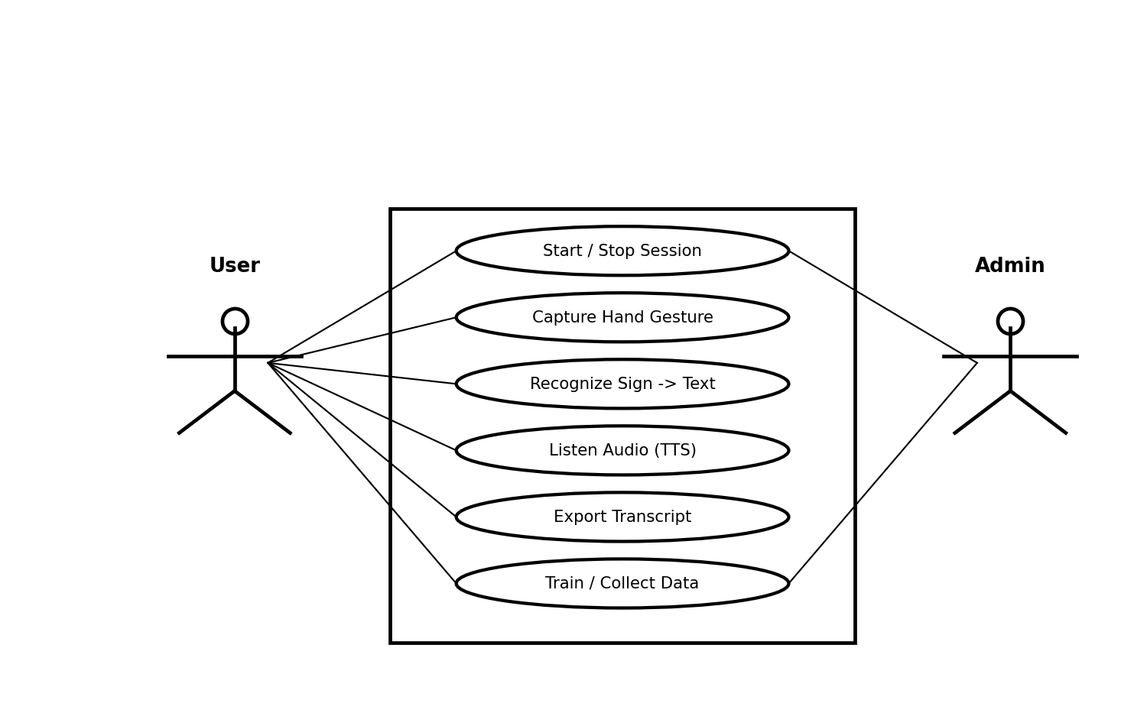
Figure No. 5.4 Use case diagram
5.4.2 Class Diagram
The class diagram presents the principal classes of the system — such as Session, Translation, Transcript, Gesture Model, and Document — together with their attributes and operations.
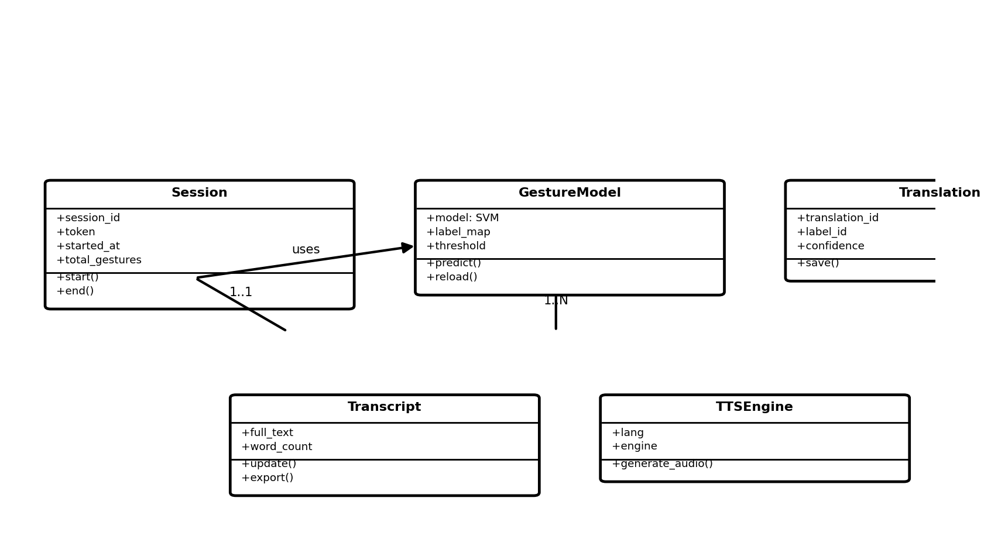
Figure No. 5.5 Class diagram
5.4.3 Activity Diagram
The activity diagram describes the step-by-step flow of the recognition process, from opening the camera and detecting a hand to predicting the gesture, checking the confidence, and displaying the text and audio.
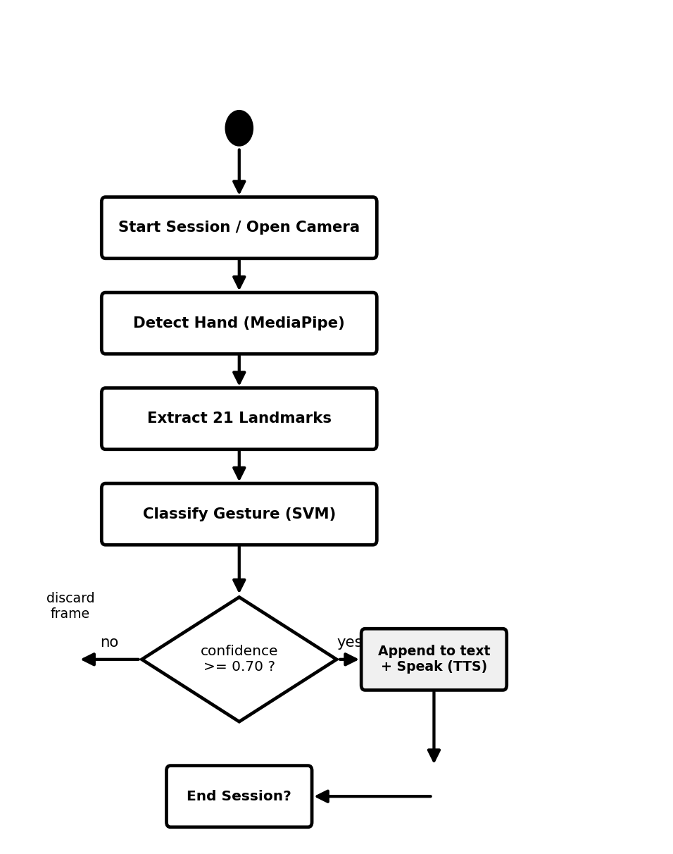
Figure No. 5.6 Activity diagram
5.4.4 Sequence Diagram
The sequence diagram shows the order of interactions between the user, the front-end, MediaPipe, the Flask API, the model, and the database during a single recognition cycle.
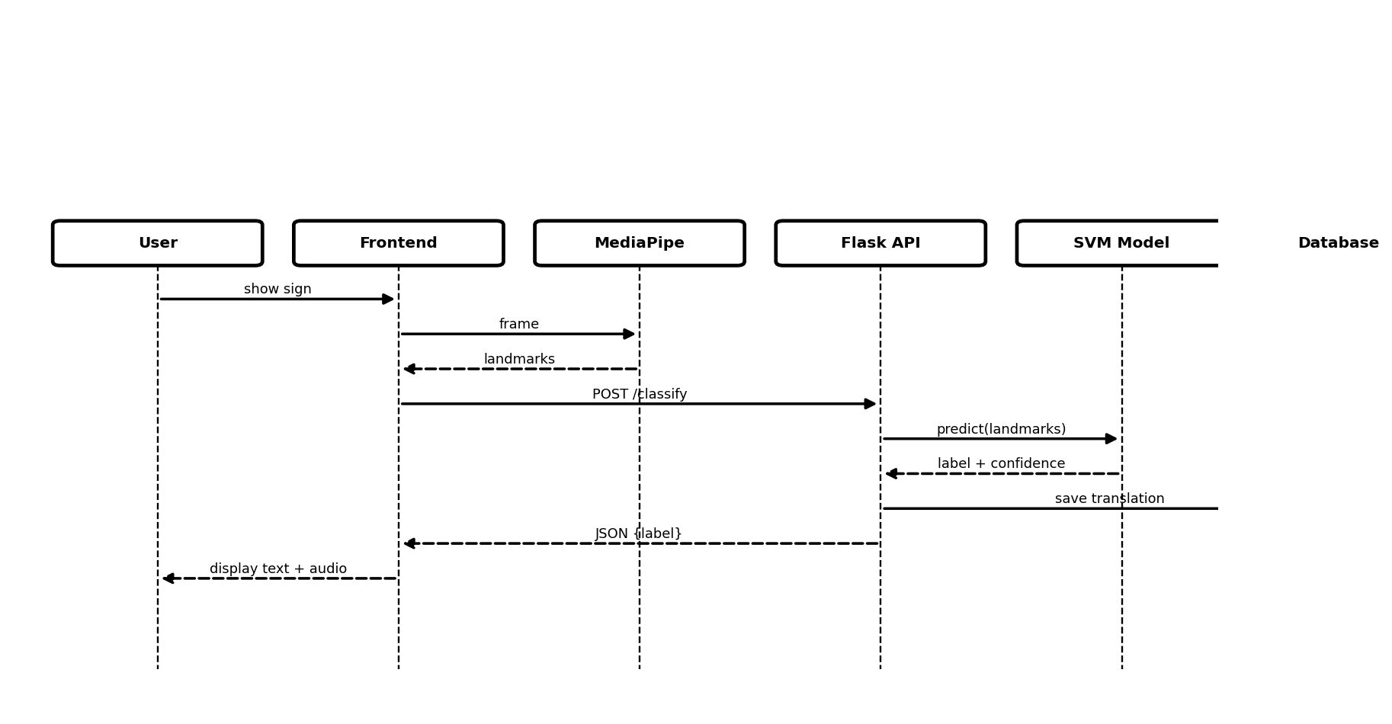
Figure No. 5.7 Sequence diagram
5.5 Database Design
The system uses an SQLite relational database, defined through the SQLAlchemy ORM, consisting of seven tables. The structure of each table is given below.
TABLE NAME: Users
S.NO | FIELD NAME | DATA TYPE | KEY | DESCRIPTION
1 | user_id | Integer | Primary Key | Unique user identifier
2 | username | Varchar (50) | Not Null | Login name of the user
3 | email | Varchar (100) | Not Null | Email address of the user
4 | created_at | DateTime | Not Null | Date and time the user was created
5 | is_active | Boolean | Not Null | Whether the account is active
Table No 5.1 Users
TABLE NAME: Gesture Labels
S.NO | FIELD NAME | DATA TYPE | KEY | DESCRIPTION
1 | label_id | Integer | Primary Key | Unique label identifier
2 | class_index | Integer | Not Null | Model output class index (0–35)
3 | label_name | Varchar (50) | Not Null | Gesture name (A–Z, 0–9)
4 | label_type | Varchar (20) | Not Null | Type: alphabet, number, or control
Table No 5.2 Gesture Labels
TABLE NAME: Sessions
S.NO | FIELD NAME | DATA TYPE | KEY | DESCRIPTION
1 | session_id | Integer | Primary Key | Unique session identifier
2 | user_id | Integer | Foreign Key | Reference to the users table
3 | session_token | Varchar (100) | Not Null | Unique token for the session
4 | started_at | DateTime | Not Null | Session start time
5 | ended_at | DateTime | Null | Session end time
6 | total_gestures | Integer | Not Null | Number of gestures recognised
Table No 5.3 Sessions
TABLE NAME: Translations
S.NO | FIELD NAME | DATA TYPE | KEY | DESCRIPTION
1 | translation_id | Integer | Primary Key | Unique translation identifier
2 | session_id | Integer | Foreign Key | Reference to the sessions table
3 | label_id | Integer | Foreign Key | Reference to the gesture_labels table
4 | confidence_score | Float | Not Null | Model confidence for the gesture
5 | recognized_at | DateTime | Not Null | Time the gesture was recognised
Table No 5.4 Translations
TABLE NAME: Transcripts
S.NO | FIELD NAME | DATA TYPE | KEY | DESCRIPTION
1 | transcript_id | Integer | Primary Key | Unique transcript identifier
2 | session_id | Integer | Foreign Key | Reference to the sessions table
3 | full_text | Text | Not Null | Complete recognised text
4 | word_count | Integer | Not Null | Number of words in the transcript
5 | updated_at | DateTime | Not Null | Last update time
Table No 5.5 Transcripts
TABLE NAME: Documents
S.NO | FIELD NAME | DATA TYPE | KEY | DESCRIPTION
1 | document_id | Integer | Primary Key | Unique document identifier
2 | session_id | Integer | Foreign Key | Reference to the sessions table
3 | format | Varchar (10) | Not Null | Export format (PDF / DOCX)
4 | filename | Varchar (200) | Not Null | Name of the exported file
5 | downloaded_at | DateTime | Not Null | Time the file was generated
Table No 5.6 Documents
TABLE NAME: System Logs
S.NO | FIELD NAME | DATA TYPE | KEY | DESCRIPTION
1 | log_id | Integer | Primary Key | Unique log identifier
2 | session_id | Integer | Foreign Key | Reference to the sessions table
3 | module_name | Varchar (50) | Not Null | Module that generated the log
4 | log_level | Varchar (10) | Not Null | Severity (INFO, WARN, ERROR)
5 | message | Text | Not Null | Log message content
6 | logged_at | DateTime | Not Null | Time the log was recorded
Table No 5.7 System Logs
CHAPTER 6
PROJECT DESCRIPTION
6.1 Problem Definition
Problem Statement: communication between persons with hearing or speech impairments and the general public is difficult because sign language is understood by very few people. The available options — a human interpreter, written notes, or lip-reading — are not always accessible, are slow, costly, and offer no permanent record of the conversation. There is a clear need for an automated system that can translate sign-language gestures into text and audio in real time.
Impact of these problems:
- Communication barrier: everyday interactions in schools, hospitals, banks, and offices become difficult and stressful without a common medium of communication.
- Dependence and loss of privacy: relying on a human interpreter reduces independence and removes privacy from personal conversations.
- Delay and cost: arranging an interpreter or writing notes is slow and may involve cost, which discourages spontaneous communication.
- No record: manual communication leaves no transcript that can be reviewed, saved, or shared afterwards.
- Limited reach of existing tools: glove-based or heavy server-side solutions are expensive, intrusive, or slow, and are not suitable for everyday use.
Proposed Solution: to overcome these problems, a real-time Sign Language to Text and Audio Conversion System has been developed that:
- Captures hand gestures through an ordinary webcam directly in the browser, keeping the camera images on the user's device.
- Extracts hand landmarks with MediaPipe and classifies the gesture with a trained Support Vector Machine model with high accuracy.
- Assembles the recognised characters into words and sentences and displays them instantly as on-screen subtitles.
- Converts the recognised text into clear spoken audio so that the message is heard immediately.
- Stores every session and allows the transcript to be exported as a PDF or Word document for later use.
- Runs on a normal computer with a webcam and a standard browser, making it low-cost and easy to use.
6.2 Module Description
Webcam Capture and Hand Detection: this module accesses the webcam in the browser and uses MediaPipe to detect the hand and extract twenty-one landmark coordinates from each frame. It sends only these numeric landmarks to the server, which keeps the system fast and privacy-preserving.
Gesture Recognition: this module receives the landmarks at the Flask API and uses the trained Support Vector Machine model to classify the gesture into one of the thirty-six classes. A confidence check ensures that only reliable predictions are accepted.
Transcript Builder: the recognised characters are combined into words and sentences. Control gestures such as SPACE and DELETE allow the user to form complete sentences, which are maintained as the live transcript of the session.
Text-to-Speech: this module converts the recognised text into spoken audio using gTTS, with pyttsx3 as an offline fallback, so that the message can be heard by people around the signer.
Document Export: this module generates a formatted transcript of the session as a PDF file using ReportLab or as a Word file using python-docx, and records the exported document in the database.
Session Management and History: this module starts and ends sessions, stores each recognised translation with its confidence and time, and provides the history of a session so that the conversation can be reviewed.
Model Training: this module collects labelled hand-landmark samples, trains the Support Vector Machine model from the dataset, and hot-reloads the updated model, allowing the recognition accuracy to be improved over time.
CHAPTER 7
SOFTWARE TESTING
7.1 System Testing
System testing is the process of evaluating the complete and integrated application to verify that it meets the specified requirements. The Sign Language to Text and Audio Conversion System was tested end to end — from capturing landmarks and classifying gestures to building the transcript, generating audio, exporting documents, and storing data — to confirm that all modules work together correctly and produce the expected results.
7.2 Types of Testing
7.2.1 Unit Testing
Unit testing verifies each individual module or function in isolation. Each API endpoint and helper function — such as session creation, gesture classification, transcript update, and document export — was tested independently to confirm that it behaves correctly for valid input and rejects invalid input gracefully.
7.2.2 Integration Testing
Integration testing checks that the separate modules work correctly when combined. The flow from the browser landmarks to the classification model, the database, the text-to-speech engine, and the export modules was tested together to ensure that data passes correctly between them.
7.2.3 Validation Testing
Validation testing confirms that the requirements established during analysis are met by the constructed software. This testing provided the final assurance that the system meets all functional, behavioural, and performance requirements, and that errors uncovered during integration testing were corrected.
7.2.4 Output Testing
Output testing verifies that the system produces the required output in the correct format. The recognised text on the screen, the generated speech audio, and the exported PDF and Word transcripts were each checked and found to be produced in the expected form, both on screen and as downloaded files.
7.2.5 Acceptance Testing
Acceptance testing determines whether the system is acceptable to its users. The application was tried by users who confirmed that the recognition, subtitles, audio output, and export features were easy to use and met their expectations, which is the key factor for the success of the system.
7.3 Functional Testing
The backend was tested using an automated pytest suite of twenty-one test cases, all of which passed. A summary of the functional test cases is given below.
Test Case ID | Module | Test Case Description | Input Data | Expected Result | Status
TC01 | Health | Verify API health check | GET /api/health | Status 'ok' returned | Pass
TC02 | Session | Start a new session | POST /api/session/start | session_id and token returned | Pass
TC03 | Session | End an active session | session_id | Message 'ended' returned | Pass
TC04 | Recognition | Classify valid landmarks | 63 valid floats | label, confidence returned | Pass
TC05 | Recognition | Reject wrong landmark count | 10 floats | accepted = false | Pass
TC06 | Recognition | Handle empty request body | Empty body | accepted = false, no crash | Pass
TC07 | Transcript | Update transcript text | Hello World | Message 'updated' returned | Pass
TC08 | Transcript | Retrieve transcript + word count | session_id | Correct word_count (3) | Pass
TC09 | Transcript | Non-existent session handled | session 99999 | Empty text returned | Pass
TC10 | TTS | Reject empty text | Empty text | Status 400 error | Pass
TC11 | History | Return session history list | session_id | history list returned | Pass
TC12 | Training | Collect valid sample | label A + 63 floats | ok = true | Pass
TC13 | Training | Reject invalid sample | empty label | Status 400 error | Pass
TC14 | Export | Export transcript as Word | text | DOCX file generated | Pass
TC15 | Export | Export transcript as PDF | text | PDF file generated | Pass
TC16 | Dataset | List dataset images | GET /api/dataset/images | image list + count | Pass
TC17 | CORS | Verify CORS headers | Cross-origin request | Correct headers present | Pass
TC18 | Session | Independent multiple sessions | 2 sessions | Sessions stay independent | Pass
TC19 | Recognition | Boundary input (all zeros) | 63 zeros | Handled without error | Pass
TC20 | API | Response is valid JSON | Any request | JSON response returned | Pass
7.4 Sample Test Case
Test Case No: #01
Test Case Name: Start a New Session With Valid Request
Project Name: Sign Language to Text and Audio
Test Case: Start Session
Test Case ID: Function_01 | Test Designed by: Surya A
Test Priority (Low/Medium/High): High | Test Designed date: 02/04/2026
Module Name: Session Management | Test Executed by: Surya A
Test Title: Verify that a new session starts correctly | Test Execution date: 04/04/2026
Description: Test the session start module
Pre-condition: The backend server must be running.
Step | Test Steps | Test Data | Expected Result | Actual Result | Status
1 | Open the application | — | Home page is displayed | Home page displayed | Pass
2 | Click Start Session | — | A new session is created | Session created | Pass
3 | Receive response | — | session_id and token returned | ID and token returned | Pass
Post-condition: A new session is created and stored in the database.
Test Case No: #02
Test Case Name: Recognise a Gesture From Valid Landmarks
Project Name: Sign Language to Text and Audio
Test Case: Gesture Recognition
Test Case ID: Function_02 | Test Designed by: Surya A
Test Priority (Low/Medium/High): High | Test Designed date: 02/04/2026
Module Name: Recognition | Test Executed by: Surya A
Test Title: Verify gesture classification with valid landmarks | Test Execution date: 04/04/2026
Description: Test the gesture classification module
Pre-condition: A session is active and the camera is on.
Step | Test Steps | Test Data | Expected Result | Actual Result | Status
1 | Show a hand sign | Hand gesture | Hand landmarks are detected | Landmarks detected | Pass
2 | Send 63 landmarks | 63 floats | Gesture is classified | Gesture classified | Pass
3 | Check result | — | Label and confidence returned | Label + confidence shown | Pass
Post-condition: The recognised letter is added to the transcript and stored.
Test Case No: #03
Test Case Name: Export the Session Transcript
Project Name: Sign Language to Text and Audio
Test Case: Document Export
Test Case ID: Function_03 | Test Designed by: Surya A
Test Priority (Low/Medium/High): Medium | Test Designed date: 02/04/2026
Module Name: Export | Test Executed by: Surya A
Test Title: Verify transcript export to PDF and Word | Test Execution date: 04/04/2026
Description: Test the document export module
Pre-condition: A session with recognised text exists.
Step | Test Steps | Test Data | Expected Result | Actual Result | Status
1 | Click Export PDF | Transcript text | A PDF file is generated | PDF generated | Pass
2 | Click Export Word | Transcript text | A DOCX file is generated | DOCX generated | Pass
3 | Open the file | — | Transcript is correctly formatted | File opens correctly | Pass
Post-condition: The transcript is downloaded and recorded in the documents table.
CHAPTER 8
CONCLUSION
The Sign Language to Text and Audio Conversion System successfully demonstrates a practical, real-time solution for translating American Sign Language gestures into text and speech. By performing hand-landmark detection in the browser with MediaPipe and classifying gestures on the server with a trained Support Vector Machine model, the system recognises the alphabets A–Z and the digits 0–9 accurately and instantly, while keeping the design lightweight and privacy-preserving.
The application builds a live transcript, speaks the recognised text aloud, stores each session, and exports the conversation as a PDF or Word document, all on a normal computer with a webcam and a standard browser. The backend was validated through an automated test suite of twenty-one cases, all of which passed, confirming that the system is reliable and behaves correctly. The project thus meets its objective of providing an affordable and easy-to-use assistive tool that helps reduce the communication barrier faced by the deaf and mute community and promotes their independent communication.
CHAPTER 9
FUTURE ENHANCEMENT
In the future, the Sign Language to Text and Audio Conversion System can be enhanced in several directions. The most significant enhancement is to extend recognition from static letters and digits to dynamic, word-level signs by training on large word-level datasets such as MS-ASL, so that complete words and common phrases can be recognised from the motion of the hands rather than spelled out letter by letter. Support for additional sign languages, such as Indian Sign Language (ISL), can also be added to widen the system's reach.
Further improvements include adding natural-language processing to convert the recognised characters into grammatically correct sentences, developing a mobile application for on-the-go access, and migrating the service to the cloud for wider availability. Two-handed and facial-expression recognition can improve accuracy and capture the full meaning of a sign, while user accounts, multi-language audio output, and offline support can make the system more personal and dependable. These enhancements would make the system more powerful, more natural, and useful to an even larger community.
CHAPTER 10
APPENDICES
10.1 Sample Coding
database.py (Database Models — SQLAlchemy ORM)
from flask_sqlalchemy import SQLAlchemy
from datetime import datetime

db = SQLAlchemy()

class User(db.Model):
__tablename__ = "users"
user_id = db.Column(db.Integer, primary_key=True, autoincrement=True)
username = db.Column(db.String(50), unique=True, nullable=False)
email = db.Column(db.String(100), unique=True, nullable=False)
created_at = db.Column(db.DateTime, default=datetime.utcnow)
is_active = db.Column(db.Boolean, default=True)
sessions = db.relationship("Session", backref="user", lazy=True)

class GestureLabel(db.Model):
__tablename__ = "gesture_labels"
label_id = db.Column(db.Integer, primary_key=True, autoincrement=True)
class_index = db.Column(db.Integer, unique=True, nullable=False)
label_name = db.Column(db.String(50), unique=True, nullable=False)
label_type = db.Column(db.String(20), default="alphabet")

class Session(db.Model):
__tablename__ = "sessions"
session_id = db.Column(db.Integer, primary_key=True, autoincrement=True)
user_id = db.Column(db.Integer, db.ForeignKey("users.user_id"), nullable=True)
session_token = db.Column(db.String(100), unique=True, nullable=False)
started_at = db.Column(db.DateTime, default=datetime.utcnow)
ended_at = db.Column(db.DateTime, nullable=True)
total_gestures = db.Column(db.Integer, default=0)
translations = db.relationship("Translation", backref="session", lazy=True)
transcript = db.relationship("Transcript", backref="session", uselist=False, lazy=True)

class Translation(db.Model):
__tablename__ = "translations"
translation_id = db.Column(db.Integer, primary_key=True, autoincrement=True)
session_id = db.Column(db.Integer, db.ForeignKey("sessions.session_id"), nullable=False)
label_id = db.Column(db.Integer, db.ForeignKey("gesture_labels.label_id"), nullable=False)
confidence_score = db.Column(db.Float, nullable=False)
recognized_at = db.Column(db.DateTime, default=datetime.utcnow)

class Transcript(db.Model):
__tablename__ = "transcripts"
transcript_id = db.Column(db.Integer, primary_key=True, autoincrement=True)
session_id = db.Column(db.Integer, db.ForeignKey("sessions.session_id"), unique=True, nullable=False)
full_text = db.Column(db.Text, default="")
word_count = db.Column(db.Integer, default=0)
updated_at = db.Column(db.DateTime, default=datetime.utcnow, onupdate=datetime.utcnow)

class Document(db.Model):
__tablename__ = "documents"
document_id = db.Column(db.Integer, primary_key=True, autoincrement=True)
session_id = db.Column(db.Integer, db.ForeignKey("sessions.session_id"), nullable=False)
format = db.Column(db.String(10), nullable=False)
filename = db.Column(db.String(200), nullable=False)
downloaded_at = db.Column(db.DateTime, default=datetime.utcnow)

class SystemLog(db.Model):
__tablename__ = "system_logs"
log_id = db.Column(db.Integer, primary_key=True, autoincrement=True)
session_id = db.Column(db.Integer, db.ForeignKey("sessions.session_id"), nullable=True)
module_name = db.Column(db.String(50), nullable=False)
log_level = db.Column(db.String(10), nullable=False)
message = db.Column(db.Text, nullable=False)
logged_at = db.Column(db.DateTime, default=datetime.utcnow)

def seed_gesture_labels(app):
"""Seed the gesture_labels table with ASL A-Z, 0-9, and SPACE/DEL if they don't exist."""
with app.app_context():
# 1. Letters A-Z
for i in range(26):
name = chr(65 + i)
if not GestureLabel.query.filter_by(label_name=name).first():
db.session.add(GestureLabel(class_index=i, label_name=name, label_type="alphabet"))
# 2. Control actions
if not GestureLabel.query.filter_by(label_name="SPACE").first():
gesture_model.py (Gesture Classification Model)
import os
import json
import numpy as np

CONFIDENCE_THRESHOLD = 0.70 # tuned for SVM Platt probabilities (was 0.85 for MLP softmax)

# Default label map A-Z + SPACE + DELETE
DEFAULT_LABEL_MAP = {i: chr(65+i) for i in range(26)}
DEFAULT_LABEL_MAP[26] = "SPACE"
DEFAULT_LABEL_MAP[27] = "DELETE"

SKLEARN_MODEL_PATH = "model/gesture_model.pkl"
TF_MODEL_PATH = "model/gesture_model.h5"
LABELMAP_PATH = "model/label_map.json"

class GestureModel:
def __init__(self):
self.model = None
self.model_type = None
self.demo_mode = False
self.label_map = self._load_label_map()
self._load()

def reload_model(self):
"""Force reload the label map and model files."""
print("[GestureModel] Reloading model...", flush=True)
self.model = None
self.model_type = None
self.demo_mode = False
self.label_map = self._load_label_map()
self._load()

def _load_label_map(self):
if os.path.exists(LABELMAP_PATH):
try:
with open(LABELMAP_PATH) as f:
raw = json.load(f)
lm = {int(k): v for k, v in raw.items()}
print(f"[GestureModel] Label map loaded: {lm}", flush=True)
return lm
except Exception as e:
print(f"[GestureModel] Label map load error: {e}", flush=True)
print("[GestureModel] No label_map.json — using default A-Z.", flush=True)
return DEFAULT_LABEL_MAP

def _load(self):
# Try sklearn model first — no TensorFlow dependency
if os.path.exists(SKLEARN_MODEL_PATH):
try:
import joblib
self.model = joblib.load(SKLEARN_MODEL_PATH)
self.model_type = "sklearn"
print(f"[GestureModel] Sklearn model loaded from '{SKLEARN_MODEL_PATH}'.", flush=True)
return
except Exception as e:
print(f"[GestureModel] Sklearn load error: {e}", flush=True)

# Try TF/Keras model
if os.path.exists(TF_MODEL_PATH):
try:
import tensorflow as tf
self.model = tf.keras.models.load_model(TF_MODEL_PATH)
self.model_type = "tensorflow"
print(f"[GestureModel] TF model loaded from '{TF_MODEL_PATH}'.", flush=True)
return
except Exception as e:
print(f"[GestureModel] TF load error: {e} — DEMO mode.", flush=True)

print("[GestureModel] No model found — DEMO mode.", flush=True)
self.demo_mode = True

def predict(self, landmarks):
if not landmarks or len(landmarks) != 63:
return {"label": None, "confidence": 0.0, "accepted": False}

if self.demo_mode:
arr = np.array(landmarks)
if arr.std() < 0.005:
return {"label": None, "confidence": 0.0, "accepted": False}
# Hold same label for 8 frames so the browser stable-frame check fires
if not hasattr(self, '_demo_remaining') or self._demo_remaining <= 0:
keys = list(self.label_map.keys())
chosen_key = int(np.random.choice(keys)) if keys else 0
self._demo_label = self.label_map.get(chosen_key, "?")
self._demo_remaining = 8
else:
self._demo_remaining -= 1
confidence = round(float(np.random.uniform(0.82, 0.97)), 4)
return {"label": self._demo_label, "confidence": confidence, "accepted": True}

features = np.array(landmarks, dtype=np.float32).reshape(1, -1)

if self.model_type == "sklearn":
probs = self.model.predict_proba(features)[0]
else:
probs = self.model.predict(features, verbose=0)[0]

class_idx = int(np.argmax(probs))
confidence = float(probs[class_idx])
label = self.label_map.get(class_idx, "?")
accepted = confidence >= CONFIDENCE_THRESHOLD

return {"label": label, "confidence": round(confidence, 4), "accepted": accepted}

app.py (Gesture Classification API Route)
db.session.add(s)
db.session.add(Transcript(session=s, full_text="", word_count=0))
db.session.commit()
return jsonify({"session_id": s.session_id, "session_token": token})
except Exception as e:
traceback.print_exc()
return jsonify({"error": str(e)}), 500

@app.route("/api/session/end", methods=["POST"])
def end_session():
try:
data = request.get_json()
s = db.session.get(Session, data.get("session_id"))
if s:
s.ended_at = datetime.utcnow()
db.session.commit()
return jsonify({"message": "ended"})
except Exception as e:
return jsonify({"error": str(e)}), 500

@app.route("/api/gesture/classify", methods=["POST"])
def classify_gesture():
"""
Receive pre-computed landmarks from browser MediaPipe.
Only run the ML model here — no frame decoding needed.

Body: { landmarks: [63 floats], session_id: int }
"""
try:
data = request.get_json(force=True)
landmarks = data.get("landmarks", [])
session_id = data.get("session_id")

if not landmarks or len(landmarks) != 63:
return jsonify({"accepted": False, "label": None, "confidence": 0.0})

result = model.predict(landmarks)

# Save to DB if accepted
if result["accepted"] and result["label"] and session_id:
s = db.session.get(Session, session_id)
lbl = GestureLabel.query.filter_by(label_name=result["label"]).first()
if s and lbl:
db.session.add(Translation(
session_id=session_id,
label_id=lbl.label_id,
confidence_score=result["confidence"]
))
s.total_gestures = (s.total_gestures or 0) + 1
db.session.commit()

return jsonify(result)

except Exception as e:
traceback.print_exc()
return jsonify({"accepted": False, "error": str(e)}), 200

@app.route("/api/transcript/update", methods=["POST"])
def update_transcript():
try:
data = request.get_json()
t = Transcript.query.filter_by(session_id=data.get("session_id")).first()
if t:
t.full_text = data.get("text", "")
t.word_count = len(t.full_text.split()) if t.full_text.strip() else 0
t.updated_at = datetime.utcnow()
tts_engine.py (Text-to-Speech Engine)
def generate_audio(text: str, use_google: bool = True) -> str:
"""
Convert text to speech and save as MP3.

Args:
text : The text to speak.
use_google : True = gTTS (online), False = pyttsx3 (offline).

Returns:
Relative path to the generated MP3 file.
"""
if not text or not text.strip():
return None

filename = f"{uuid.uuid4().hex}.mp3"
filepath = os.path.join(AUDIO_DIR, filename)

if use_google:
try:
from gtts import gTTS
tts = gTTS(text=text.strip(), lang="en", slow=False)
tts.save(filepath)
print(f"[TTS] gTTS audio saved: {filepath}")
return filepath
except Exception as e:
print(f"[TTS] gTTS failed ({e}), falling back to pyttsx3.")

# Offline fallback — pyttsx3
try:
import pyttsx3
engine = pyttsx3.init()
engine.setProperty("rate", 160)
engine.setProperty("volume", 1.0)
engine.save_to_file(text.strip(), filepath)
engine.runAndWait()
engine.stop()
print(f"[TTS] pyttsx3 audio saved: {filepath}")
return filepath
except Exception as e:
print(f"[TTS] pyttsx3 also failed: {e}")
return None

10.2 Screen Shots
The screenshots of the main pages of the application are given below.
Home Page
Live Recognition Page
Recognised Text and Subtitle View
Audio Playback Controls
Session History Page
Exported Transcript (PDF / Word)
CHAPTER 11
REFERENCES
11.1 Web Reference
[1] https://ai.google.dev/edge/mediapipe
[2] https://scikit-learn.org/stable/
[3] https://flask.palletsprojects.com/
[4] https://react.dev/
[5] https://vitejs.dev/
[6] https://gtts.readthedocs.io/
[7] https://www.w3schools.com/
[8] https://stackoverflow.com
[9] https://github.com
11.2 Book Reference
[1] Géron, Aurélien. Hands-On Machine Learning with Scikit-Learn, Keras and TensorFlow (2nd Edition). O’Reilly Media, 2019.
[2] Raschka, Sebastian, and Mirjalili, Vahid. Python Machine Learning (3rd Edition). Packt Publishing, 2019.
[3] Sommerville, Ian. Software Engineering (10th Edition). Pearson Education, 2015.
[4] Pressman, Roger S., and Maxim, Bruce R. Software Engineering: A Practitioner’s Approach (8th Edition). McGraw-Hill Education, 2014.
[5] Grinberg, Miguel. Flask Web Development (2nd Edition). O’Reilly Media, 2018.
[6] Banks, Alex, and Porcello, Eve. Learning React (2nd Edition). O’Reilly Media, 2020.

