SIGN LANGUAGE TO TEXT AND AUDIO CONVERSION SYSTEM

A PROJECT REPORT

Submitted by

SURYA A
(Reg. No: 511924622038)

in partial fulfillment for the award of the degree of

MASTER OF COMPUTER APPLICATIONS

DEPARTMENT OF MASTER OF COMPUTER APPLICATIONS
PRIYADARSHINI ENGINEERING COLLEGE, VANIYAMBADI

ANNA UNIVERSITY :: CHENNAI 600 025

JUNE 2026
ANNA UNIVERSITY : CHENNAI 600 025

BONAFIDE CERTIFICATE

Certified that this project report titled “SIGN LANGUAGE TO TEXT AND AUDIO CONVERSION SYSTEM” is the bonafide work of SURYA A (Reg. No: 511924622038) who carried out the project work under my supervision. Certified further that to the best of my knowledge the work reported herein does not form part of any other project report or dissertation on the basis of which a degree or award was conferred on an earlier occasion on this or any other candidate.

SIGNATURE SIGNATURE

Dr. MANIKANDAN G, M.Sc., B.Ed., M.Phil., Ph.D. « Name of the Supervisor »
HEAD OF THE DEPARTMENT SUPERVISOR « Designation »
Department of Computer Applications Department of Computer Applications
PRIYADARSHINI ENGINEERING COLLEGE, PRIYADARSHINI ENGINEERING COLLEGE,
Vaniyambadi. Vaniyambadi.

Submitted for the Project Viva-Voce Examination held on ____________________

INTERNAL EXAMINER EXTERNAL EXAMINER

ABSTRACT

The project “Sign Language to Text and Audio Conversion System” has been developed to bridge the communication gap between the speech and hearing-impaired community and the general public. Sign language is the primary mode of communication for the deaf and mute, yet most people are unable to understand it, which creates a barrier in day-to-day interaction. This project provides a real-time, computer-based solution that recognizes hand gestures of the American Sign Language (ASL) alphabet and numerals through a webcam and instantly converts them into readable text and audible speech.
The system uses Google MediaPipe to detect the hand and extract twenty-one three-dimensional landmark points from each video frame. These landmark features are classified by a trained Support Vector Machine (SVM) machine-learning model into one of thirty-six classes (A–Z and 0–9). The recognized characters are assembled into words and sentences, displayed as live subtitles, and spoken aloud using a Text-to-Speech engine. Each session can be saved and exported as a PDF or Word transcript.
The application is built on a modern client-server architecture with a React front-end and a Python Flask REST back-end backed by an SQLite database. The recognition model achieves an accuracy of about 97% on the validation data. The main goal of this project is to reduce dependency on human interpreters, enable independent communication for the differently-abled, and demonstrate a practical, low-cost assistive technology.

Keywords: Sign language recognition, American Sign Language, MediaPipe, hand landmarks, Support Vector Machine, gesture classification, text-to-speech, assistive technology.

திட்ட சுருக்கம்

“சைகை மொழியை உரை மற்றும் ஒலியாக மாற்றும் அமைப்பு” என்ற இந்த திட்டம், பேச்சு மற்றும் கேட்கும் திறன் குறைபாடுடைய மக்களுக்கும் பொதுமக்களுக்கும் இடையே உள்ள தகவல் பரிமாற்ற இடைவெளியை குறைக்கும் நோக்கில் உருவாக்கப்பட்டுள்ளது.
இந்த அமைப்பு, கைமுறை விசிற்றைப் பயன்படுத்தி, கையின் 21 அட்சார புள்ளிகளை எடுத்து, Support Vector Machine என்ற இயந்திர கற்றல் மாதிரி மூலம் A–Z மற்றும் 0–9 என அடையாளம் காண்கிறது. அடையாளம் காணப்பட்ட எழுத்துகள் உடனடியாக உரையாக மாற்றப்பட்டு திரையில் காட்டப்பட்டு, ஒலியாகவும் வெளிப்படுத்தப்படுகிறது.

முக்கிய சொற்கள்: சைகை மொழி, அமெரிக்க சைகை மொழி, MediaPipe, கை அட்சாரம், Support Vector Machine, உரை-குரல் மாற்றி.

ACKNOWLEDGEMENT

First and foremost, I express my deep, heartfelt gratitude and reverence to my project supervisor and mentor for their valuable guidance, advice, support, and encouragement throughout this project work.
I sincerely thank the Management of PRIYADARSHINI ENGINEERING COLLEGE and ANNA UNIVERSITY for giving me the opportunity to enhance my knowledge in the field of Computer Applications.
I extend my sense of gratitude and sincere thanks to Thiru. S. NITHIYANANDAM, Chairman, Mr. K.T. ANBAZHAGAN, Managing Trustee, and Thirumathi. SAROJA RATHINAM, Correspondent of Priyadarshini Engineering College, for giving me the opportunity to be a student of this reputed college.
I warmly thank Dr. K. VIJAYARAJ, Principal of Priyadarshini Engineering College, for providing the appropriate permission and facilities for this project.
I express my heartfelt thanks to Dr. MANIKANDAN G, Head of the Department of Computer Applications, for his constant support and encouragement. I also thank all the faculty members of the Department of Computer Applications for their valuable inputs, discussions, and accessibility throughout the period of this work.
Finally, I bow to the ALMIGHTY for blessing me with good health and strength throughout the period of my project work.

(SURYA A)

TABLE OF CONTENTS

CHAPTER NO. TITLE PAGE NO.

ABSTRACT i
திட்ட சுருக்கம் (ABSTRACT - TAMIL) ii
ACKNOWLEDGEMENT iii
LIST OF FIGURES v
LIST OF TABLES vi

1 INTRODUCTION 1
1.1 Project Outline 1
1.2 Project Objective 1
1.3 About the Project 2
2 COMPANY PROFILE 3
2.1 About the Organization 3
2.2 About the Department 3
3 SYSTEM ANALYSIS 4
3.1 Existing System 4
3.2 Proposed System 5
3.3 Methodology 5
4 SYSTEM CONFIGURATION 7
4.1 Hardware Configuration 7
4.2 Software Configuration 7
4.3 Software Description 8
5 SYSTEM DESIGN 9
5.1 Architecture Diagram 9
5.2 Data Flow Diagram 10
5.3 ER Diagram 11
5.4 UML Diagrams 12
5.5 Database Design 17
6 PROJECT DESCRIPTION 26
6.1 Problem Definition 26
6.2 Module Description 27
7 SOFTWARE TESTING AND MAINTENANCE 30
7.1 System Testing 30
7.2 Types of Testing 30
7.3 Functional Testing 32
7.4 Sample Test Case 34
7.5 System Maintenance 35
8 CONCLUSION 36
9 FUTURE ENHANCEMENT 37
10 APPENDICES 38
11 REFERENCES 42

LIST OF FIGURES

Figure No. | Title | Page No.
3.1 | Agile-based data flow overview | 6
5.1 | Architecture diagram | 9
5.2 | Data flow diagram | 10
5.3 | ER diagram | 11
5.4 | Use case diagram | 12
5.5 | Class diagram | 13
5.6 | Activity diagram | 14
5.7 | Sequence diagram | 15

LIST OF TABLES

Table No. | Title | Page No.
5.1 | Users | 17
5.2 | Gesture labels | 17
5.3 | Sessions | 18
5.4 | Translations | 18
5.5 | Transcripts | 19
5.6 | Documents | 19
5.7 | System logs | 20
7.1 | Functional test cases | 32
7.2 | Sample test case 01 | 34
7.3 | Sample test case 02 | 34

CHAPTER 1

INTRODUCTION

1.1 PROJECT OUTLINE
The Sign Language to Text and Audio Conversion System is a real-time assistive application designed to recognize hand gestures of the American Sign Language (ASL) alphabet and numerals and convert them into readable text and spoken audio. The system captures the user's hand through a standard webcam, detects the hand and its key points using computer vision, classifies the gesture using a trained machine-learning model, and presents the result as live subtitles and speech.

1.2 PROJECT OBJECTIVE
The primary objective of this project is to develop a low-cost, accessible communication aid that allows speech and hearing impaired individuals to convey their message to people who do not understand sign language. Traditionally, communication between a signer and a non-signer requires a human interpreter, which is not always available and increases dependency. Manual interpretation is also prone to delay and misinterpretation. To overcome these drawbacks, an automated, computer-based recognition system is essential.
The specific objectives of the system are listed below:
- To detect the hand and extract reliable gesture features from a live webcam feed in real time.
- To accurately classify the ASL alphabets (A–Z) and numerals (0–9) using a machine-learning model.
- To convert the recognized gestures into continuous text and form meaningful words and sentences.
- To generate audible speech from the recognized text using a Text-to-Speech engine.
- To store each communication session and allow the transcript to be exported as a PDF or Word document.

1.3 ABOUT THE PROJECT
The project is implemented as a client–server web application. The front-end, built with React and Vite, handles webcam capture, displays the recognized subtitles, plays the generated audio, and provides session controls. Hand-landmark detection is performed in the browser using Google MediaPipe. The extracted landmark data is sent to a Python Flask REST back-end, which performs gesture classification, speech synthesis, transcript management, and document export, while persisting all data in an SQLite database. This separation of responsibilities makes the system modular, lightweight, and easy to deploy on an ordinary computer.
CHAPTER 2

COMPANY PROFILE

2.1 ABOUT THE ORGANIZATION
This project was designed and developed at PRIYADARSHINI ENGINEERING COLLEGE, Vaniyambadi, an institution affiliated to Anna University, Chennai, and approved by the All India Council for Technical Education (AICTE). The college is a well-established centre of technical education offering undergraduate and postgraduate programmes in engineering, technology, and computer applications. It provides a modern academic environment with well-equipped computer laboratories, high-speed internet connectivity, and qualified faculty, which together created an ideal setting for carrying out a research-oriented software project of this nature.
The college encourages students to take up real-world, socially relevant projects that apply emerging technologies such as artificial intelligence, machine learning, and computer vision. The Sign Language to Text and Audio Conversion System was developed as a final-year project under this academic environment, with the objective of building a practical assistive technology for the speech and hearing impaired community.

2.2 ABOUT THE DEPARTMENT
The Department of Master of Computer Applications (MCA) at Priyadarshini Engineering College offers a postgraduate programme that prepares students for the software industry through a strong foundation in programming, databases, web technologies, and software engineering. The department is headed by Dr. Manikandan G, and its faculty actively guide students in the design and development of application-oriented projects.
The department provided the technical guidance, laboratory facilities, and project supervision required for this work. The combination of academic mentoring and hands-on laboratory access enabled the successful completion of the system described in this report.
CHAPTER 3

SYSTEM ANALYSIS

3.1 EXISTING SYSTEM
In the present scenario, communication between a sign-language user and a non-signer is carried out either through a human interpreter or by writing on paper. Both approaches have serious limitations. A human interpreter may not be available at all times and places, increases cost, and reduces the privacy and independence of the signer. Writing is slow, breaks the natural flow of conversation, and is impractical for lengthy interaction.
A few existing software solutions attempt to recognize signs but often depend on expensive depth sensors or wearable data gloves, require controlled lighting and backgrounds, or are too heavy to run on an ordinary personal computer. These constraints make them inaccessible to the average user.
Drawbacks of the existing system:
- Continuous dependency on a human interpreter or written notes.
- High cost of specialized hardware such as data gloves and depth cameras.
- Slow, error-prone, and inconvenient for real-time conversation.
- Limited availability and lack of an audio output for the listener.

3.2 PROPOSED SYSTEM
The proposed system is a real-time, vision-based sign-language recognition application that works with an ordinary webcam and free software. It detects the user's hand, classifies the gesture using a trained machine-learning model, and immediately produces both on-screen text and spoken audio. The system removes the need for an interpreter, works on a normal computer, and stores every session so that it can be reviewed or exported later.
Advantages of the proposed system:
- Real-time recognition of ASL alphabets and numerals from a live camera feed.
- No special hardware required — a standard webcam is sufficient.
- Dual output: live text subtitles and natural speech for the listener.
- Automatic saving of sessions with PDF and Word transcript export.
- High recognition accuracy of approximately 97% on validation data.

3.3 METHODOLOGY
The project follows the Agile software-development methodology, which promotes flexibility and continuous improvement through short, iterative cycles. The key phases are summarized below.
Planning: Define clear objectives such as real-time recognition and audio output, and prepare a prioritized list of features.
Designing: Design a scalable client–server architecture, the user interface, and the database schema.
Development: Implement features in short cycles — hand detection, model training, recognition API, text-to-speech, and export.
Testing: Perform continuous unit, integration, and acceptance testing, and refine the model and code based on the results.
Deployment & Review: Run the application, gather feedback, and iterate to improve accuracy and usability.
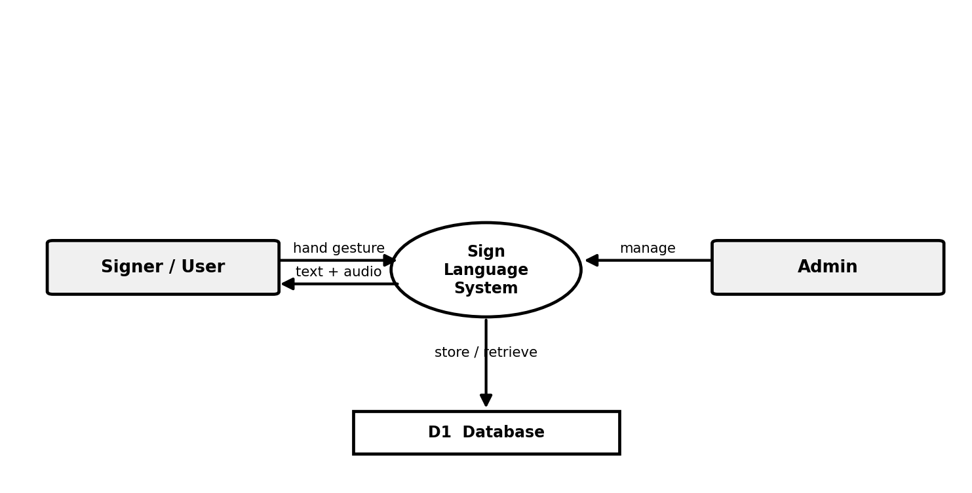
Fig No 3.1 Agile-based data flow overview
CHAPTER 4

SYSTEM CONFIGURATION

4.1 HARDWARE CONFIGURATION
Component | Specification
Processor | Intel Core i5 (or equivalent) and above
RAM | 8 GB (16 GB recommended)
Hard Disk | 512 GB
Camera | Integrated / USB Webcam (720p or higher)
Speaker | Standard audio output device

4.2 SOFTWARE CONFIGURATION
Component | Specification
Operating System | Windows 10 / 11 (64-bit)
Front-End | React.js 18, Vite, HTML5, CSS3, JavaScript
Back-End | Python 3.10, Flask, Flask-SQLAlchemy
Hand Detection | Google MediaPipe Hands
Machine Learning | scikit-learn (Support Vector Machine)
Text-to-Speech | gTTS (online), pyttsx3 (offline)
Database | SQLite
Reporting | ReportLab (PDF), python-docx (Word)

4.3 SOFTWARE DESCRIPTION
React.js & Vite: React is a JavaScript library for building fast, component-based user interfaces. Vite is a modern build tool that provides an instant development server and optimized production builds. Together they power the responsive front-end that handles webcam capture, subtitles, and controls.
Google MediaPipe: MediaPipe is an open-source framework from Google for building perception pipelines. Its Hands solution detects a hand in an image and returns twenty-one three-dimensional landmark points, which form the feature input for gesture recognition.
Python & Flask: Python is a high-level programming language widely used in machine learning. Flask is a lightweight web framework used here to build the REST API that performs classification, speech synthesis, and export, and to connect to the database through SQLAlchemy.
scikit-learn (SVM): scikit-learn is a popular machine-learning library. A Support Vector Machine classifier with a radial-basis-function kernel is trained on the hand-landmark features to recognize the thirty-six gesture classes with high accuracy.
gTTS & pyttsx3: gTTS (Google Text-to-Speech) generates natural speech audio over the internet, while pyttsx3 provides offline speech synthesis. The system uses them to read the recognized text aloud.
SQLite: SQLite is a lightweight, file-based relational database that stores users, sessions, recognized translations, transcripts, and logs without requiring a separate database server.
ReportLab & python-docx: These libraries are used to export the session transcript as a professionally formatted PDF document and Microsoft Word document respectively.
CHAPTER 5

SYSTEM DESIGN

5.1 ARCHITECTURE DIAGRAM
The architecture follows a layered client–server model. The user signs in front of the webcam; the front-end captures frames and uses MediaPipe to extract hand landmarks; the landmarks are sent to the Flask back-end where the SVM model classifies the gesture; the result is stored in the database and returned to the front-end as text and audio.
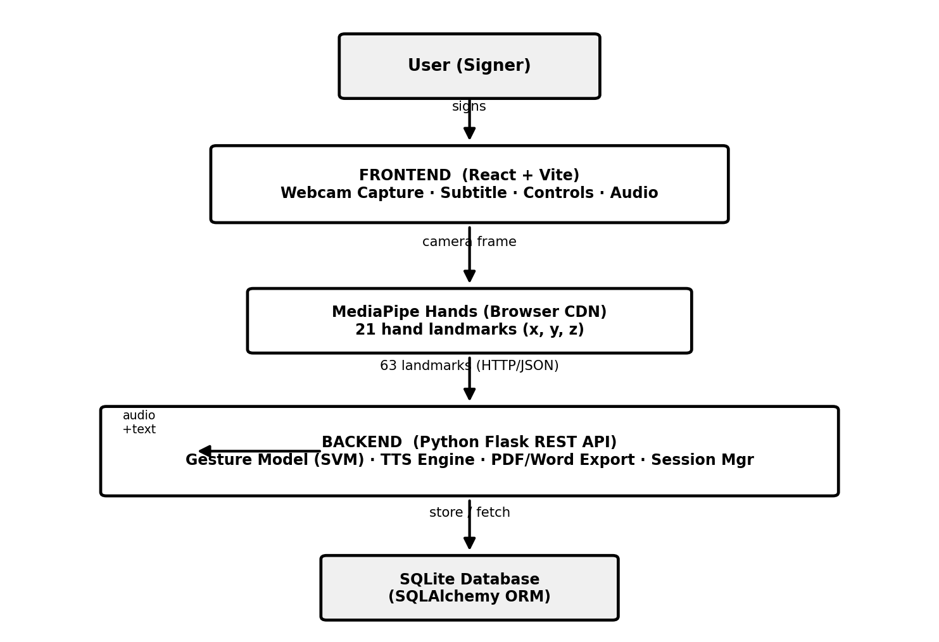
Figure No. 5.1 Architecture Diagram

5.2 DATA FLOW DIAGRAM
The data flow diagram represents the movement of information between the user, the system process, and the database.

Figure No. 5.2 Data Flow Diagram

5.3 ER DIAGRAM
The entity-relationship diagram shows the main entities of the system and the relationships among them.
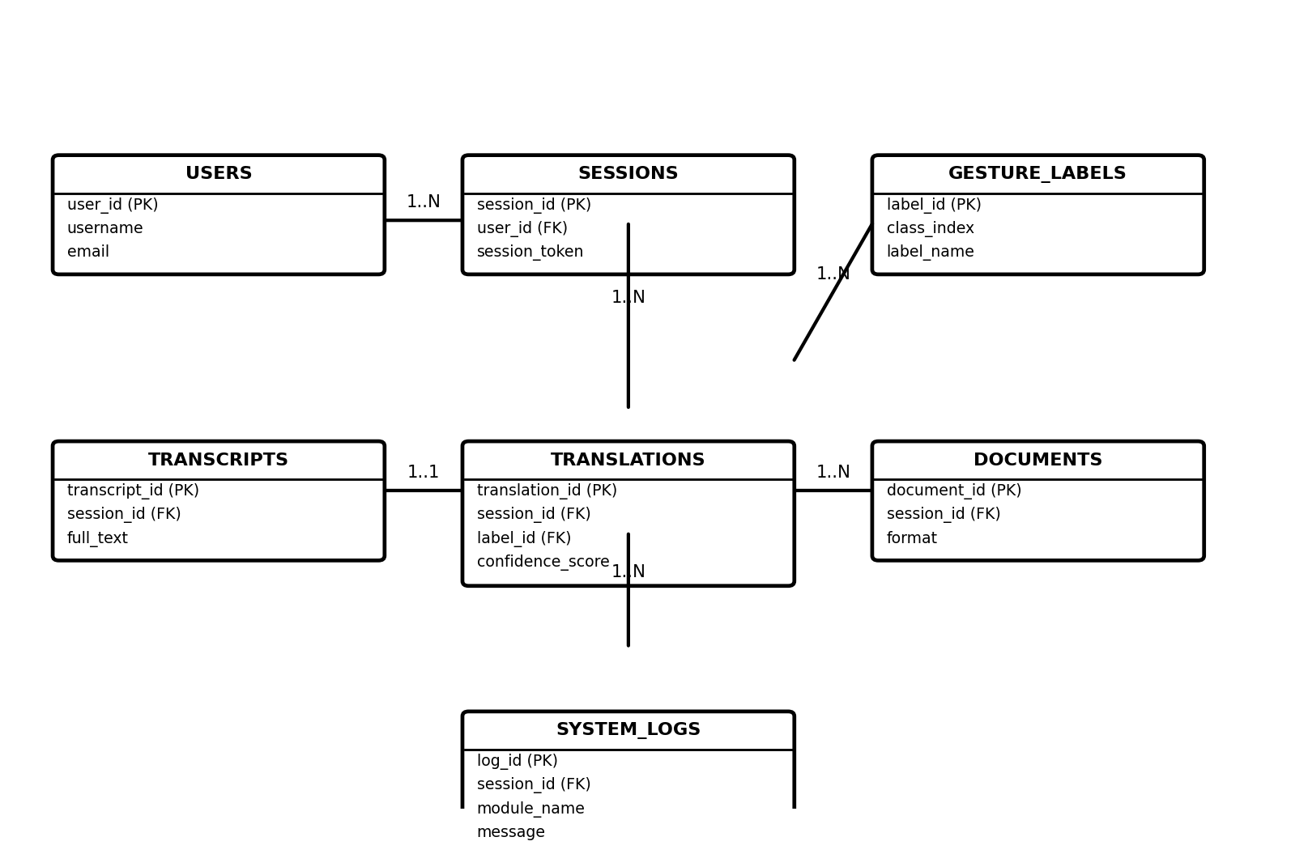
Figure No. 5.3 ER Diagram

5.4 UML DIAGRAMS
5.4.1 Use Case Diagram
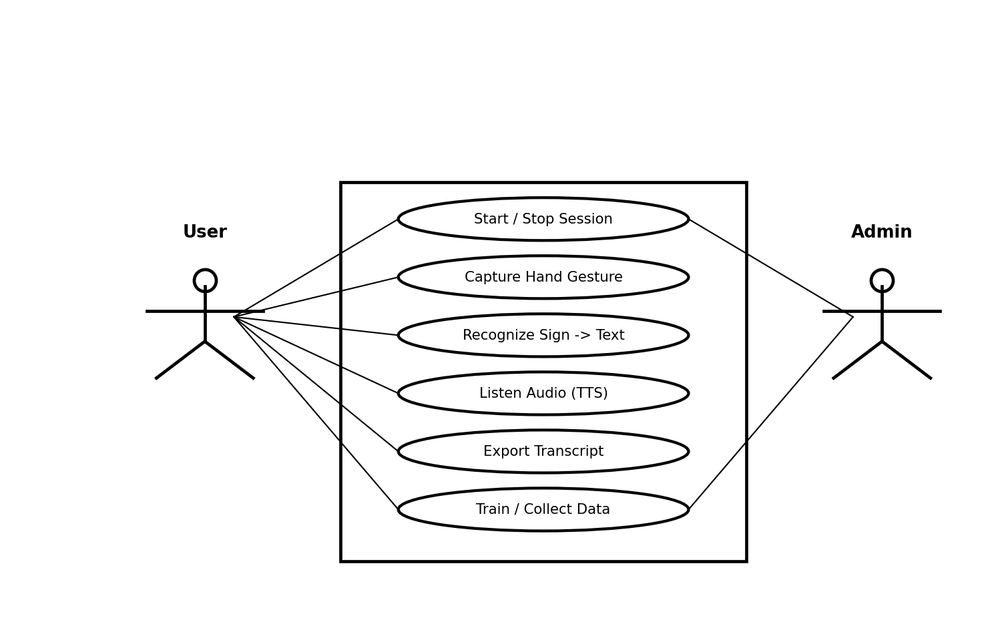
Figure No. 5.4 Use Case Diagram
5.4.2 Class Diagram
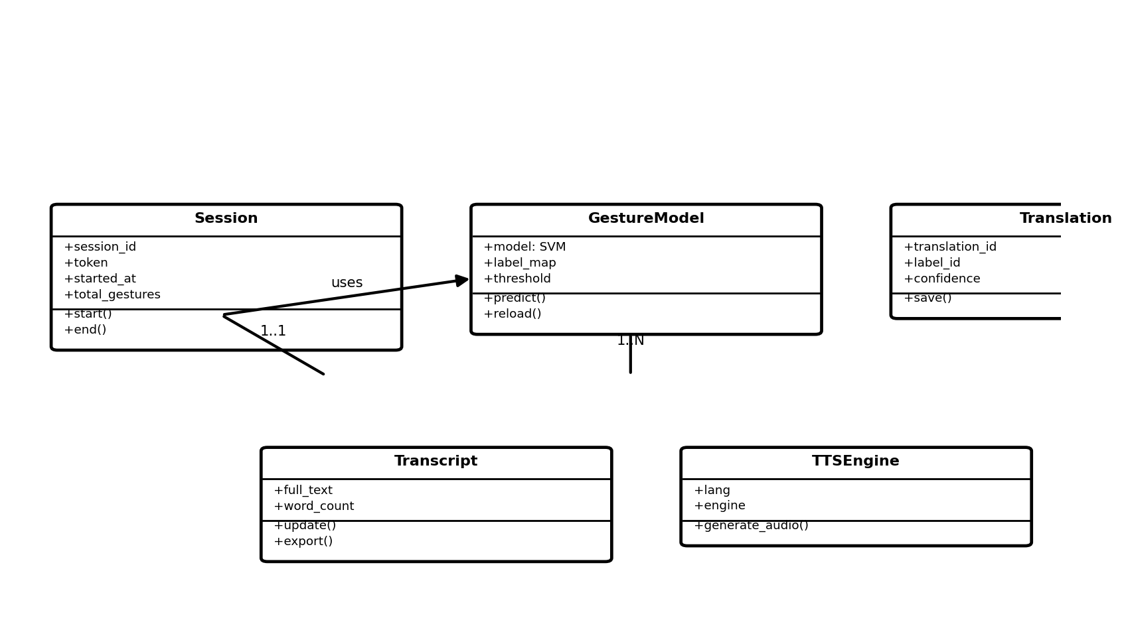
Figure No. 5.5 Class Diagram
5.4.3 Activity Diagram
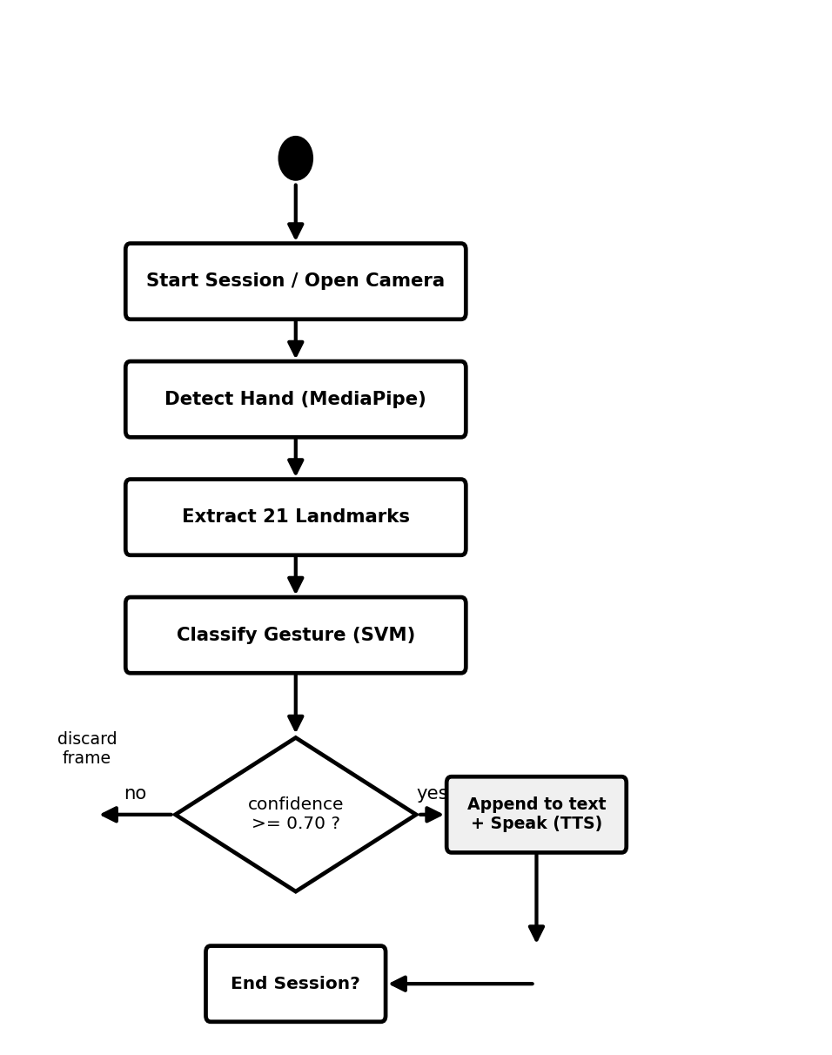
Figure No. 5.6 Activity Diagram
5.4.4 Sequence Diagram
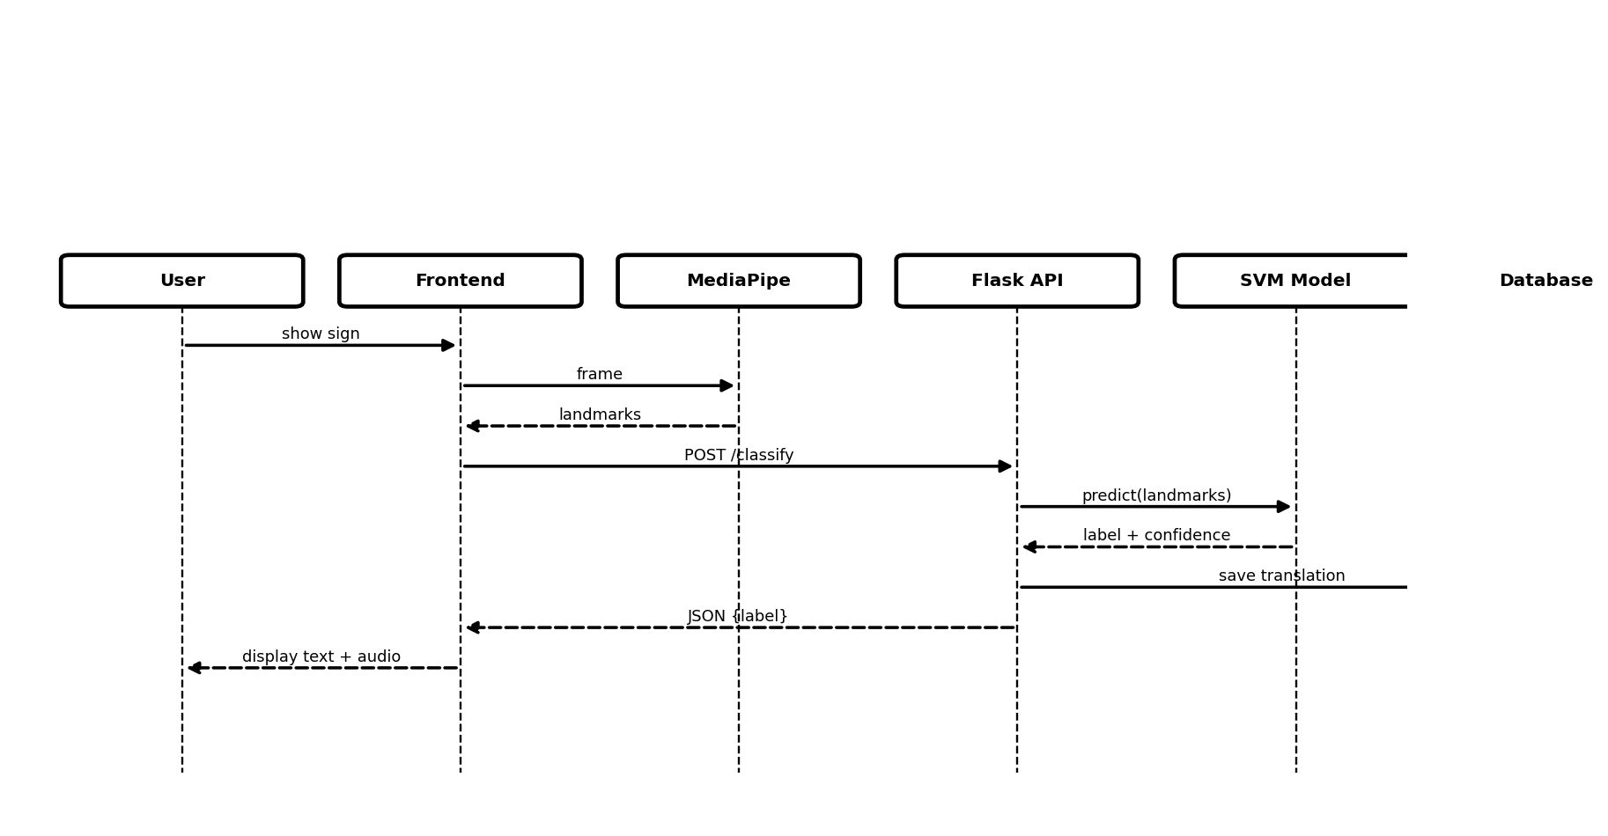
Figure No. 5.7 Sequence Diagram

5.5 DATABASE DESIGN
The database consists of seven related tables that store user, session, recognition, transcript, document, and log information.
TABLE NAME: Users
S.No | Field Name | Data Type | Key | Description
1 | user_id | Integer | Primary Key | Unique user identifier
2 | username | Varchar(50) | Not Null | Login name
3 | email | Varchar(100) | Not Null | User e-mail
4 | created_at | DateTime | Not Null | Account creation time
5 | is_active | Boolean | Not Null | Active status
Table No 5.1 Users
TABLE NAME: Gesture_Labels
S.No | Field Name | Data Type | Key | Description
1 | label_id | Integer | Primary Key | Unique label identifier
2 | class_index | Integer | Not Null | Model class index
3 | label_name | Varchar(50) | Not Null | Gesture (A–Z, 0–9, SPACE, DELETE)
4 | label_type | Varchar(20) | Not Null | alphabet / number / control
Table No 5.2 Gesture Labels
TABLE NAME: Sessions
S.No | Field Name | Data Type | Key | Description
1 | session_id | Integer | Primary Key | Unique session identifier
2 | user_id | Integer | Foreign Key | Reference to Users
3 | session_token | Varchar(100) | Not Null | Unique session token
4 | started_at | DateTime | Not Null | Session start time
5 | ended_at | DateTime | Null | Session end time
6 | total_gestures | Integer | Not Null | Count of recognized gestures
Table No 5.3 Sessions
TABLE NAME: Translations
S.No | Field Name | Data Type | Key | Description
1 | translation_id | Integer | Primary Key | Unique translation identifier
2 | session_id | Integer | Foreign Key | Reference to Sessions
3 | label_id | Integer | Foreign Key | Reference to Gesture_Labels
4 | confidence_score | Float | Not Null | Model confidence value
5 | recognized_at | DateTime | Not Null | Recognition time
Table No 5.4 Translations
TABLE NAME: Transcripts
S.No | Field Name | Data Type | Key | Description
1 | transcript_id | Integer | Primary Key | Unique transcript identifier
2 | session_id | Integer | Foreign Key | Reference to Sessions
3 | full_text | Text | Not Null | Recognized sentence text
4 | word_count | Integer | Not Null | Number of words
5 | updated_at | DateTime | Not Null | Last update time
Table No 5.5 Transcripts
TABLE NAME: Documents
S.No | Field Name | Data Type | Key | Description
1 | document_id | Integer | Primary Key | Unique document identifier
2 | session_id | Integer | Foreign Key | Reference to Sessions
3 | format | Varchar(10) | Not Null | pdf / word
4 | filename | Varchar(200) | Not Null | Exported file name
5 | downloaded_at | DateTime | Not Null | Export time
Table No 5.6 Documents
TABLE NAME: System_Logs
S.No | Field Name | Data Type | Key | Description
1 | log_id | Integer | Primary Key | Unique log identifier
2 | session_id | Integer | Foreign Key | Reference to Sessions
3 | module_name | Varchar(50) | Not Null | Module that generated the log
4 | log_level | Varchar(10) | Not Null | INFO / WARN / ERROR
5 | message | Text | Not Null | Log message
Table No 5.7 System Logs
CHAPTER 6

PROJECT DESCRIPTION

6.1 PROBLEM DEFINITION
The core problem addressed by this project is the communication barrier faced by the speech and hearing impaired community. People who use sign language find it difficult to interact with the majority who cannot understand it, leading to dependence on interpreters, loss of privacy, and exclusion from many everyday activities. Existing automated solutions are either too expensive, require special hardware, or are not designed for real-time use on a common computer.
The proposed solution overcomes these problems by providing a software-only system that recognizes ASL alphabets and numerals from a webcam in real time, converts them into text and speech, and stores the conversation for later use — all on an ordinary computer using free and open-source tools.

6.2 MODULE DESCRIPTION
Webcam Capture Module: Accesses the device camera, streams live video frames, and passes each frame to the hand-detection stage. It also displays the camera feed with overlaid hand landmarks to the user.
Hand Detection Module: Uses MediaPipe to detect the hand in each frame and extract twenty-one three-dimensional landmark points. The points are normalized relative to the wrist to make them position-independent.
Gesture Recognition Module: Feeds the landmark features to the trained Support Vector Machine model, which predicts the gesture class and a confidence score. Only predictions above a confidence threshold are accepted.
Text Builder Module: Collects the recognized characters, applies SPACE and DELETE control gestures, and assembles them into words and sentences shown as live subtitles.
Text-to-Speech Module: Converts the recognized text into natural speech using gTTS or pyttsx3 and plays it through the speaker so the listener can hear the message.
Session & Transcript Module: Starts and ends communication sessions, records every recognized gesture with its confidence, and maintains the full transcript in the database.
Export Module: Generates a downloadable PDF or Word document of the session transcript using ReportLab and python-docx.
Training Module: Allows new landmark samples to be collected and the recognition model to be retrained, so the system can be improved or extended with additional gestures.
CHAPTER 7

SOFTWARE TESTING AND MAINTENANCE

7.1 SYSTEM TESTING
System testing is the stage of implementation that ensures the system works accurately and efficiently before live operation. The complete application was tested using an automated test suite of twenty test cases covering every backend endpoint, and all of them passed successfully. Both hardware and software functions were verified to confirm reliable operation.

7.2 TYPES OF TESTING
- Unit Testing
- Integration Testing
- Validation Testing
- Output Testing
- User Acceptance Testing
7.2.1 Unit Testing
Each module — hand detection, gesture recognition, text-to-speech, and export — was tested separately during development to confirm that it produces the expected output in isolation.
7.2.2 Integration Testing
The individual modules were combined and tested together as a whole to uncover errors in the interfaces between the front-end, the Flask API, the model, and the database.
7.2.3 Validation Testing
The recognition model was validated using five-fold cross-validation on the landmark dataset. The improved Support Vector Machine model achieved an accuracy of 97.10%, a clear improvement over the earlier model (93.85%).
7.2.4 Output Testing
The recognized text, the generated speech audio, and the exported PDF and Word transcripts were checked to confirm that they match the format and content expected by the user.
7.2.5 User Acceptance Testing
The system was tested with sample users signing different letters and numbers to confirm that the recognition, subtitles, and audio behave as expected in real time.

7.3 FUNCTIONAL TESTING
The following table summarizes the automated functional test cases and their results.
TC ID | Module | Description | Expected Result | Status
TC01 | Health | Check backend health endpoint | Status returns OK | Pass
TC02 | Session | Start a new session | Session created with token | Pass
TC03 | Session | End an active session | Session marked ended | Pass
TC04 | Recognition | Classify valid 63-value landmarks | Valid label + confidence | Pass
TC05 | Recognition | Reject wrong landmark count | Graceful error response | Pass
TC06 | Recognition | Classify empty request body | Handled, no crash | Pass
TC07 | Transcript | Update transcript text | Transcript saved | Pass
TC08 | Transcript | Retrieve transcript by session | Correct text returned | Pass
TC09 | Transcript | Request non-existent session | Not-found handled | Pass
TC10 | TTS | Convert empty text | Validation error returned | Pass
TC11 | Session | Get session gesture history | History list returned | Pass
TC12 | Training | Collect valid training sample | Sample stored | Pass
TC13 | Training | Reject invalid training data | Rejected safely | Pass
TC14 | Export | Export transcript as Word | Word file generated | Pass
TC15 | Export | Export transcript as PDF | PDF file generated | Pass
TC16 | Dataset | List dataset images | Image list returned | Pass
TC17 | Security | Verify CORS headers | Headers present | Pass
TC18 | Session | Multiple independent sessions | No data overlap | Pass
TC19 | Recognition | Boundary all-zero landmarks | No false detection | Pass
TC20 | API | Response is valid JSON | JSON returned | Pass
Table No 7.1 Functional Test Cases (all passed)

7.4 SAMPLE TEST CASE
Test Case No: #01 Recognize a valid hand gesture
Field | Value | Status
Test Case ID | Function_01 | —
Module | Gesture Recognition | —
Input | 63 normalized hand landmarks | —
Expected Result | Correct ASL label with confidence ≥ 0.70 | Pass
Actual Result | Correct label returned and accepted | Pass
Table No 7.2 Sample Test Case 01
Test Case No: #02 Export session transcript as PDF
Field | Value | Status
Test Case ID | Function_02 | —
Module | Export | —
Input | Active session with transcript text | —
Expected Result | A valid PDF file is generated and downloaded | Pass
Actual Result | PDF generated successfully | Pass
Table No 7.3 Sample Test Case 02

7.5 SYSTEM MAINTENANCE
Maintenance ensures that the system continues to operate correctly and remains useful after deployment. The following types of maintenance are applicable to this project.
Corrective Maintenance: Fixing any errors or bugs discovered during real use, such as misclassified gestures or interface issues.
Adaptive Maintenance: Updating the application to remain compatible with newer browser, camera, and library versions.
Perfective Maintenance: Improving recognition accuracy by collecting more training samples and retraining the model, and enhancing the user interface based on feedback.
Preventive Maintenance: Regularly backing up the database, monitoring the system logs, and reviewing performance to prevent future failures.
CHAPTER 8

CONCLUSION
The Sign Language to Text and Audio Conversion System has been successfully designed, implemented, and tested. The system recognizes the American Sign Language alphabets and numerals from a live webcam, converts them into readable text, and produces spoken audio in real time, thereby providing an effective communication aid for the speech and hearing impaired. By using only a standard webcam and free, open-source software, the solution is affordable and easy to deploy on an ordinary computer.
The recognition model, based on a Support Vector Machine trained on MediaPipe hand-landmark features, achieved an accuracy of about 97% on validation data, and the complete application passed all twenty automated functional test cases. The project demonstrates how computer vision and machine learning can be combined to build a practical assistive technology that promotes independence and inclusion for the differently-abled community.
CHAPTER 9

FUTURE ENHANCEMENT
Although the current system performs well for the static ASL alphabet and numerals, it can be scaled into a full word-level translation system. The planned roadmap is to extend the recognition vocabulary to around one thousand conversational English words using the Microsoft ASL (MS-ASL) dataset, while keeping the solution lightweight enough to run on an ordinary computer.

9.1 WORD-LEVEL TRANSLATION USING MS-ASL
Instead of downloading and decoding thousands of raw video clips (which would require 100-150 GB of storage), the system will use the pre-extracted hand-landmark coordinates of the MS-ASL glosses. This preprocessed-coordinate approach needs only 2-5 GB of space, under 1 GB of bandwidth, and trains in minutes on a CPU, making large-vocabulary recognition practical on the existing hardware.
The landmark data will be normalized using the same scale-invariant formula already built into the application — each landmark is taken relative to the wrist and divided by the maximum hand dimension — so the model works at any camera distance or hand size. A sequential deep-learning model (a lightweight LSTM or GRU network) will then analyse the hand-movement trajectory over a sliding window of 10 to 30 frames to capture the motion signature of each word sign.

9.2 EXPECTED PERFORMANCE
Metric | Expected Result
Isolated word accuracy | 85% - 95% (e.g. Hello, Thank you, Yes, Help)
Continuous sentence translation | 70% - 85% using a temporal network
Prediction response time | Under 200 ms latency on CPU
Storage required | 2 GB - 5 GB (preprocessed coordinates)
Table No 9.1 Projected MS-ASL Word-Level Metrics

9.3 PLANNED FEATURES
- A media-file upload mode in addition to the live webcam stream, so recorded videos and images can also be translated.
- An interactive visual learning guide with a looping GIF dictionary that demonstrates how to form each word sign.
- A practice mode with target prompts that turn green when the user's hand coordinates match the target sign.
- Support for additional sign languages such as Indian Sign Language (ISL) and British Sign Language (BSL).
- A mobile application version so the system can be used on smartphones and tablets.
- Two-hand and facial-expression recognition to capture the complete grammar of sign language.
CHAPTER 10

APPENDICES

10.1 SAMPLE CODE
Gesture classification endpoint (Flask back-end):
@app.route("/api/gesture/classify", methods=["POST"])
def classify():
data = request.get_json()
landmarks = data.get("landmarks")
result = gesture_model.predict(landmarks)
return jsonify(result)
Model training using a Support Vector Machine (scikit-learn):
clf = make_pipeline(
StandardScaler(),
SVC(kernel="rbf", C=50, gamma=0.05,
probability=True, random_state=42))
clf.fit(X_train, y_train)
accuracy = clf.score(X_test, y_test) # ~0.97

10.2 SCREENSHOTS
This section contains the screenshots of the working application — the home screen, the live recognition view with subtitles, the audio playback, the session history, and the exported transcript. (Insert the application screenshots here.)
CHAPTER 11

REFERENCES

11.1 WEB REFERENCES
[1] https://developers.google.com/mediapipe
[2] https://scikit-learn.org/stable/documentation.html
[3] https://flask.palletsprojects.com
[4] https://react.dev
[5] https://www.w3schools.com/python/
[6] https://gtts.readthedocs.io
[7] https://www.sqlite.org/docs.html
[8] https://stackoverflow.com

11.2 BOOK REFERENCES
[1] Aurélien Géron, Hands-On Machine Learning with Scikit-Learn, Keras and TensorFlow (2nd Edition), O'Reilly Media, 2019.
[2] Richard Szeliski, Computer Vision: Algorithms and Applications (2nd Edition), Springer, 2022.
[3] Sommerville, Ian. Software Engineering (10th Edition), Pearson Education, 2015.
[4] Pressman, Roger S. and Maxim, Bruce R. Software Engineering: A Practitioner's Approach (8th Edition), McGraw-Hill, 2014.
[5] Mark Lutz, Learning Python (5th Edition), O'Reilly Media, 2013.

