SIGN LANGUAGE TO TEXT AND AUDIO
CONVERSION SYSTEM
A Project Report submitted to Anna University in
Partial fulfillment of the requirements for the award of degree of
Master of Computer Applications
Submitted by
SURYA A
511924622038
Under the supervision of
Dr. G. MANIKANDAN, M.C.A., M.Phil., Ph.D.,
Head of the Department
Department of Master of Computer Applications

DEPARTMENT OF MASTER OF COMPUTER APPLICATIONS
PRIYADARSHINI ENGINEERING COLLEGE
(Approved by AICTE, New Delhi and Permanently Affiliated to Anna University, Chennai)
CHETTIYAPPANUR Vill & Post, VANIYAMBADI,
TIRUPATTUR – 635 751,
TAMILNADU, INDIA.
JUNE 2026
CERTIFICATE OF EVALUATION
COLLEGE CODE & NAME : 5119 – PRIYADARSHINI ENGINEERING COLLEGE, VANIYAMBADI
BRANCH & SEMESTER : MCA, IV SEMESTER
SUBJECT CODE & NAME : MC4411 – PROJECT WORK
MONTH & YEAR : JUNE 2026
Name of the Student who has done the Project | Register Number | Title of the Project | Name of the Supervisor with Designation
SURYA A | 511924622038 | SIGN LANGUAGE TO TEXT AND AUDIO CONVERSION SYSTEM | Dr. G. Manikandan, M.C.A., M.Phil., Ph.D., Head of the Department, Department of MCA
The report of the project work submitted for the fulfillment of the Master of Computer Applications of Anna University. Evaluated and confirmed to be the report of the work done by the above student.

INTERNAL GUIDE  «Name of the Internal Guide»  «Designation»,  Master of Computer Applications,  Priyadarshini Engineering College,  Vaniyambadi – 635 751. | HEAD OF THE DEPARTMENT  Dr. G. Manikandan, M.C.A., M.Phil., Ph.D.,  Head of the Department,  Master of Computer Applications,  Priyadarshini Engineering College,  Vaniyambadi – 635 751.
ANNA UNIVERSITY :: CHENNAI 600 025
PRIYADARSHINI ENGINEERING COLLEGE
VANIYAMBADI

BONAFIDE CERTIFICATE
Certified that this Project Report titled “SIGN LANGUAGE TO TEXT AND AUDIO CONVERSION SYSTEM” is the bonafide work of Mr. SURYA A (Reg. No: 511924622038) who carried out the work under my supervision. Certified further, that to the best of my knowledge the work reported herein does not form part of any other thesis or dissertation on the basis of which a degree or award was conferred on an earlier occasion on this or any other candidate.

SUPERVISOR  «Name of the Supervisor»  «Designation»,  Master of Computer Applications,  Priyadarshini Engineering College,  Vaniyambadi – 635 751. | HEAD OF THE DEPARTMENT  Dr. G. Manikandan, M.C.A., M.Phil., Ph.D.,  Head of the Department,  Master of Computer Applications,  Priyadarshini Engineering College,  Vaniyambadi – 635 751.

Submitted to the Project Viva-Voce Examination held on ____________________ at Priyadarshini Engineering College, Vaniyambadi – 635 751.

INTERNAL EXAMINER | EXTERNAL EXAMINER

ABSTRACT
SIGN LANGUAGE TO TEXT AND AUDIO CONVERSION SYSTEM
The Sign Language to Text and Audio Conversion System is a web-based application designed to bridge the communication gap between persons with hearing and speech impairments and the people around them. The system captures the hand gestures of American Sign Language (ASL) through an ordinary webcam directly inside the web browser. Using Google MediaPipe, twenty-one hand landmarks are extracted from every video frame in real time and forwarded to a Python Flask service, where a trained Support Vector Machine model classifies the gesture into one of thirty-six classes covering the alphabets A to Z and the digits 0 to 9.
The recognised characters are assembled into words and sentences, displayed on the screen as live subtitles, and at the same time converted into clear spoken audio using a text-to-speech engine. The complete transcript of a session can be exported as a PDF or Word document for later use. The main goal of this project is to provide an affordable, real-time and easy-to-use assistive tool that does not require any special hardware, thereby promoting independent communication and accessibility for the deaf and mute community.
Keywords: Sign language recognition, hand landmark detection, MediaPipe, Support Vector Machine, text-to-speech, assistive technology.
திட்ட சுருக்கம்
சைகை மொழியிலிருந்து உரை மற்றும் ஒலி மாற்றும் அமைப்பு
கேட்டல் மற்றும் பேச்சுத் திறன் குறைபாடு உடையவர்களுக்கும் அவர்களைச் சுற்றியுள்ள மக்களுக்கும் இடையேயான தொடர்பு இடைவெளியைக் குறைக்கும் நோக்கில் இந்த அமைப்பு உருவாக்கப்பட்டுள்ளது. இது சாதாரண இணைய உலாவியிலேயே ஒரு வழக்கமான வெப்கேமராவின் மூலம் அமெரிக்க சைகை மொழியின் (ASL) கைச் சைகைகளைப் படம்பிடிக்கிறது. கூகிள் மீடியாபைப் தொழில்நுட்பத்தைப் பயன்படுத்தி, ஒவ்வொரு காணொளி சட்டத்திலிருந்தும் இருபத்தொரு கை அடையாளப் புள்ளிகள் நிகழ்நேரத்தில் பிரித்தெடுக்கப்பட்டு, பைத்தான் ஃபிளாஸ்க் சேவைக்கு அனுப்பப்படுகின்றன. அங்கு பயிற்சியளிக்கப்பட்ட சப்போர்ட் வெக்டர் மெஷின் மாதிரியானது அந்தச் சைகையை A முதல் Z வரையிலான எழுத்துக்கள் மற்றும் 0 முதல் 9 வரையிலான இலக்கங்கள் உட்பட முப்பத்தாறு வகுப்புகளில் ஒன்றாக வகைப்படுத்துகிறது.
அடையாளம் காணப்பட்ட எழுத்துக்கள் சொற்களாகவும் வாக்கியங்களாகவும் இணைக்கப்பட்டு, திரையில் நேரடி வசனங்களாகக் காட்டப்படுகின்றன; அதே நேரத்தில் தெளிவான பேச்சொலியாகவும் மாற்றப்படுகின்றன. ஒரு அமர்வின் முழு உரையையும் PDF அல்லது Word ஆவணமாக ஏற்றுமதி செய்யலாம். எந்தவொரு சிறப்பு வன்பொருளும் தேவைப்படாத, மலிவான, நிகழ்நேர உதவித் தொழில்நுட்பக் கருவியை வழங்குவதன் மூலம், செவித்திறன் மற்றும் பேச்சுத்திறன் குறைபாடு உடையவர்களின் சுயாதீனமான தொடர்பை மேம்படுத்துவதே இத்திட்டத்தின் முக்கிய நோக்கமாகும்.
முக்கிய சொற்கள்: சைகை மொழி அங்கீகாரம், கை அடையாளம் கண்டறிதல், மீடியாபைப், சப்போர்ட் வெக்டர் மெஷின், உரையிலிருந்து பேச்சு, உதவித் தொழில்நுட்பம்.
ACKNOWLEDGEMENT
First and foremost, I express my deep, heart-felt gratitude and reverence to my project supervisor and mentor for the valuable guidance, advice, support, and encouragement during this project work.
I sincerely thank the Management of PRIYADARSHINI ENGINEERING COLLEGE and ANNA UNIVERSITY for giving me an opportunity to excel in Computer Applications.
I extend my deep sense of gratitude and sincere thanks to Thiru. S. NITHIYANANDAM, Chairman, Mr. K. T. ANBAZHAGAN, Managing Trustee, and Thirumathi. SAROJA RATHINAM, Correspondent of Priyadarshini Engineering College, for giving me an opportunity to be a student of this reputed college.
I warmly thank Dr. K. VIJAYARAJ, Principal of Priyadarshini Engineering College, for providing the appropriate permission and facilities for this project.
I express my heartfelt thanks to the Head of the Department, Dr. G. MANIKANDAN, for his support and encouragement. I also thank all the faculty members of the Department of Master of Computer Applications, Priyadarshini Engineering College, for their valuable input, discussions, and accessibility.
Finally, I bow to the ALMIGHTY for blessing me with good health and strength throughout the period of this project work.

(SURYA A)
TABLE OF CONTENTS
CHAPTER NO. | TITLE | PAGE NO.
I | ABSTRACT | iv
II | திட்ட சுருக்கம் | v
III | ACKNOWLEDGEMENT | vi
IV | LIST OF FIGURES | x
V | LIST OF TABLES | xi
1 | INTRODUCTION | 1
 | 1.1 Objectives of the Project | 1
 | 1.2 About the Project | 1
2 | ORGANIZATION PROFILE | 3
 | 2.1 About the Organization | 3
3 | SYSTEM ANALYSIS | 4
 | 3.1 Existing System | 4
 | 3.2 Proposed System | 4
 | 3.3 Methodology | 5
4 | SYSTEM CONFIGURATION | 7
 | 4.1 Hardware Specification | 7
 | 4.2 Software Specification | 7
 | 4.3 Software Description | 7
5 | SYSTEM DESIGN | 9
 | 5.1 System Architecture | 9
 | 5.2 Data Flow Diagram | 9
 | 5.3 ER Diagram | 10
 | 5.4 UML Diagram | 10
 | 5.4.1 Use Case Diagram | 11
 | 5.4.2 Class Diagram | 11
 | 5.4.3 Activity Diagram | 12
 | 5.4.4 Sequence Diagram | 13
 | 5.5 Database Design | 13
6 | PROJECT DESCRIPTION | 17
 | 6.1 Problem Definition | 17
 | 6.2 Module Description | 17
7 | SOFTWARE TESTING | 19
 | 7.1 Introduction | 19
 | 7.2 Black Box Testing | 19
 | 7.3 White Box Testing | 19
 | 7.4 System Testing | 19
 | 7.5 Unit Testing | 19
 | 7.6 – 7.16 Other Testing & Maintenance | 20
8 | CONCLUSION | 23
9 | FURTHER ENHANCEMENT | 24
10 | APPENDICES | 25
 | 10.1 Sample Code | 25
 | 10.2 Screen Shots | 28
11 | REFERENCES | 29
 | 11.1 Web Reference | 29
 | 11.2 Book Reference | 29
LIST OF FIGURES
FIGURE NO. | NAME | PAGE NO.
3.1 | Waterfall model | 5
5.1 | Architecture diagram | 9
5.2 | Data flow diagram | 10
5.3 | ER diagram | 10
5.4 | Use case diagram | 11
5.5 | Class diagram | 12
5.6 | Activity diagram | 13
5.7 | Sequence diagram | 13
LIST OF TABLES
TABLE NO. | TITLE | PAGE NO.
5.1 | Users table | 14
5.2 | Gesture labels table | 14
5.3 | Sessions table | 14
5.4 | Translations table | 15
5.5 | Transcripts table | 15
5.6 | Documents table | 15
5.7 | System logs table | 16

CHAPTER 1
INTRODUCTION
1.1 Objectives of the Project
The objective of this project is to develop an affordable, real-time and easy-to-use assistive application that recognises American Sign Language (ASL) alphabets (A–Z) and digits (0–9) from a live webcam and converts them into text and audio. People with hearing and speech impairments often depend on human interpreters or on writing to communicate, which is not always available, is time-consuming, and reduces independence. Because of these limitations of the existing manual approach, an automated computerised system becomes essential.
The main objectives of the project are listed below.
- Accessibility: provide a tool that lets sign-language users communicate with anyone, using only a normal computer and a webcam.
- Real-time recognition: detect the hand and classify the gesture instantly so that conversation flows naturally.
- Accuracy: recognise the thirty-six ASL classes reliably using a trained machine-learning model with high accuracy.
- Audio output: convert the recognised text into clear speech so that the message is heard immediately.
- Record keeping: store every session and allow the transcript to be exported as a PDF or Word document for later use.
1.2 About the Project
The Sign Language to Text and Audio Conversion System is a web-based application that translates the hand gestures of American Sign Language into readable text and natural spoken audio in real time. The browser front-end, built with React and Vite, captures the webcam feed and uses Google MediaPipe to extract twenty-one hand landmarks from each frame. These landmarks are sent to a Python Flask service, where a trained Support Vector Machine model classifies the gesture into one of thirty-six classes.
The recognised characters are assembled into words and sentences, displayed on the screen as live subtitles, and converted into speech using a text-to-speech engine. Each session is stored in an SQLite database, and the transcript can be played as audio or exported as a PDF or Word document. Because the hand detection runs inside the browser, the camera images never leave the user's device, which keeps the system fast, lightweight, and privacy-preserving.
CHAPTER 2
ORGANIZATION PROFILE
2.1 About the Organization
This project has been developed in the domain of assistive technology and accessibility, a field of computer applications that focuses on building tools to support persons with disabilities in their everyday communication. Sign language is the natural and primary mode of communication for a large number of people with hearing and speech impairments; however, only a small fraction of the general public understands it. This creates a constant communication barrier in schools, hospitals, offices, and public services, where an interpreter may not be readily available.
Automated sign-language recognition is therefore an active and socially valuable area that combines computer vision, machine learning, and human-computer interaction. The aim within this domain is to provide low-cost, real-time translation tools that work on widely available devices so that they can reach the people who need them most.
The project work was carried out in the Department of Master of Computer Applications, Priyadarshini Engineering College, Vaniyambadi, which provided the academic environment, technical guidance, and infrastructure for designing, developing, and testing the system. The department's focus on practical, application-oriented software development made it well suited to building and evaluating an assistive solution of this kind.
CHAPTER 3
SYSTEM ANALYSIS
3.1 Existing System
In the existing situation, communication between a sign-language user and a person who does not understand signs is handled manually. It depends mainly on a human interpreter being physically present, on exchanging written notes, or on attempts at lip-reading. A human interpreter is not always available, involves cost, and removes privacy from personal conversations. Writing notes is slow and impractical for everyday interaction, and lip-reading is unreliable.
A few hardware-based solutions, such as sensor gloves, exist but are expensive, intrusive, and not portable. Several software solutions require heavy server-side image processing, large bandwidth, and powerful machines, which make them slow and difficult to deploy. As a result, the existing approaches are inadequate, increase delay, raise cost, offer no permanent record of the conversation, and limit the independence of the user.
3.2 Proposed System
The proposed system is a new, computerised solution that recognises sign-language gestures automatically and instantly. Hand detection and landmark extraction are performed inside the web browser using Google MediaPipe, so the camera images never leave the user's machine; only a small set of numeric landmark coordinates is sent to the server, which protects privacy and keeps the system fast and lightweight.
A trained Support Vector Machine model classifies each gesture quickly and accurately, the recognised characters are shown immediately as on-screen subtitles, and the text is converted into clear speech. The system requires nothing more than a normal computer and a webcam, runs in a standard browser, and stores every session so that the transcript can be reviewed, played as audio, and exported as a PDF or Word document.
3.3 Methodology
The Waterfall model was adopted for the development of this system. The Waterfall model is a sequential software-development approach in which each phase is completed before the next begins, making it well suited to a project with clear and well-understood requirements. The phases followed during the project are shown below.
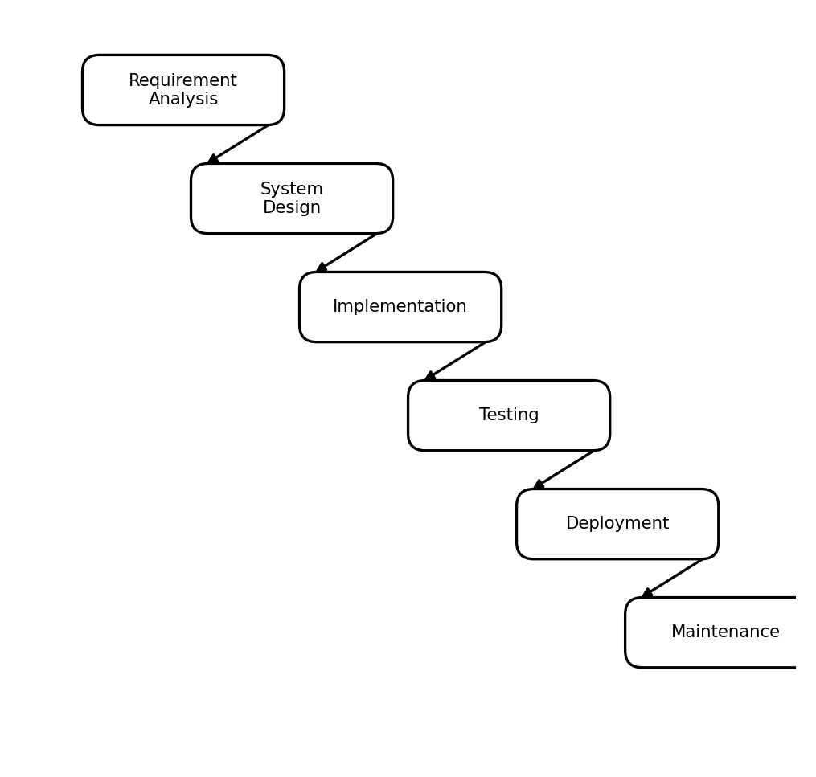
Figure No. 3.1 Waterfall model
Requirement Analysis: the objectives of the system were defined, the ASL dataset and tools were identified, and the functional requirements such as real-time recognition, text output, and audio output were established.
System Design: the client-server architecture, the modules, the database schema, and the user interface were designed at this stage.
Implementation: the front-end, the Flask REST API, the Support Vector Machine model, the text-to-speech engine, and the export modules were developed according to the design.
Testing: the system was tested through unit, integration, and acceptance testing to confirm that all modules work correctly and together.
Deployment: the verified system was released and made ready for use on a normal computer with a webcam and a browser.
Maintenance: the system is maintained by correcting issues and adding improvements such as new gestures and better accuracy over time.
CHAPTER 4
SYSTEM CONFIGURATION
4.1 Hardware Specification
COMPONENT | SPECIFICATION
Processor | Intel Core i5
RAM | 8 GB (16 GB recommended)
Hard Disk | 512 GB SSD
Camera | Integrated or USB Webcam (720p)
Display | Standard colour monitor
4.2 Software Specification
COMPONENT | SPECIFICATION
Operating System | Windows 10 / 11
Front-End | React with Vite (JavaScript)
Back-End | Python (Flask REST API)
Hand Tracking | Google MediaPipe (browser, CDN)
Machine Learning | scikit-learn (Support Vector Machine)
Text-to-Speech | gTTS / pyttsx3
Database | SQLite (SQLAlchemy ORM)
Web Browser | Google Chrome / Microsoft Edge
4.3 Software Description
React with Vite: React is a JavaScript library for building fast, component-based user interfaces, and Vite is the modern build tool used to run and bundle the front-end. Together they provide the responsive web interface that captures the webcam feed, displays the live subtitles, and plays the generated audio.
Google MediaPipe: MediaPipe is Google's framework for real-time perception. Its Hands solution detects a hand in each video frame and returns twenty-one landmark coordinates. Because it runs in the browser through a CDN, the raw camera images stay on the user's device.
Python and Flask: Python is the server-side language used for the application logic, and Flask is a lightweight web framework used to build the REST API that receives the hand landmarks, runs the classification model, manages sessions, generates audio, and handles document export.
scikit-learn: scikit-learn is a Python machine-learning library. A Support Vector Machine classifier from this library, combined with feature scaling, is trained on the hand-landmark data to recognise the thirty-six gesture classes accurately.
gTTS and pyttsx3: gTTS converts the recognised text into natural spoken audio online, while pyttsx3 provides an offline fallback so that speech output continues to work without an internet connection.
SQLite with SQLAlchemy: SQLite is a lightweight relational database that stores users, sessions, translations, transcripts, exported documents, and system logs, while SQLAlchemy is the ORM layer used to define the schema and interact with the database from Python.
CHAPTER 5
SYSTEM DESIGN
5.1 System Architecture
The architecture of the system follows a client-server model. The signer interacts with the React front-end, which captures the webcam feed and uses MediaPipe to obtain hand landmarks. These landmarks are sent to the Flask REST API, where the Support Vector Machine model classifies the gesture. The result is stored in the SQLite database and returned to the browser, which displays the text and plays the audio.
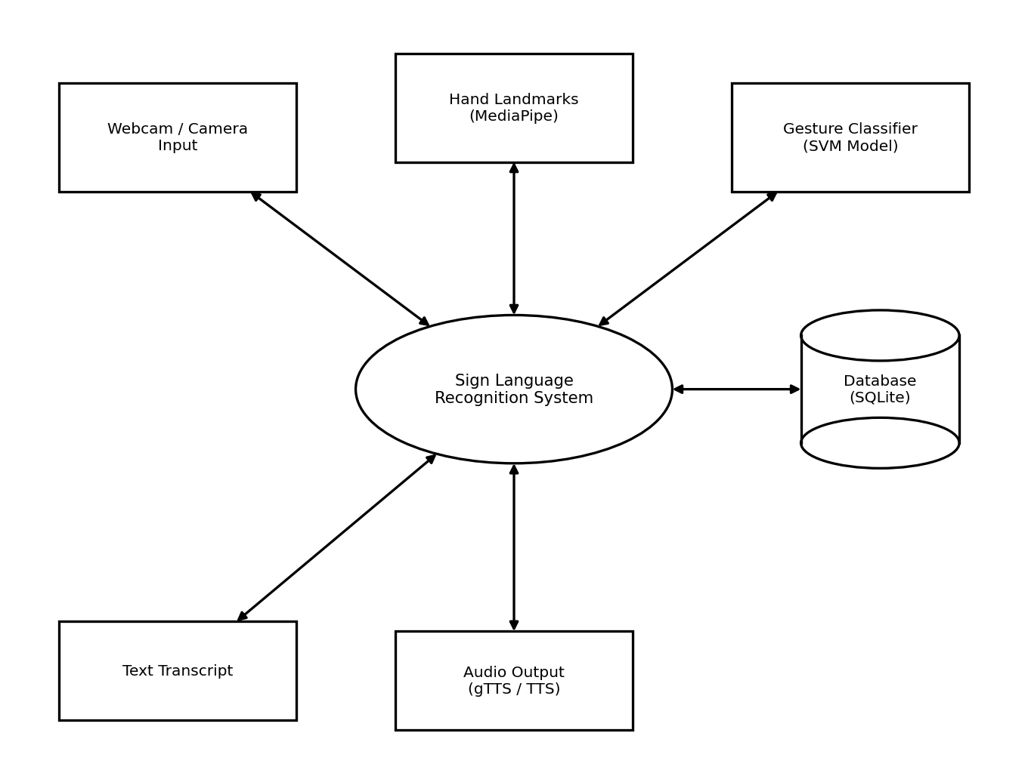
Figure No. 5.1 Architecture diagram
5.2 Data Flow Diagram
The Data Flow Diagram illustrates how data moves through the system, from the hand gesture captured in the browser, through landmark extraction and classification, to the storage of translations and the generation of text and audio output.
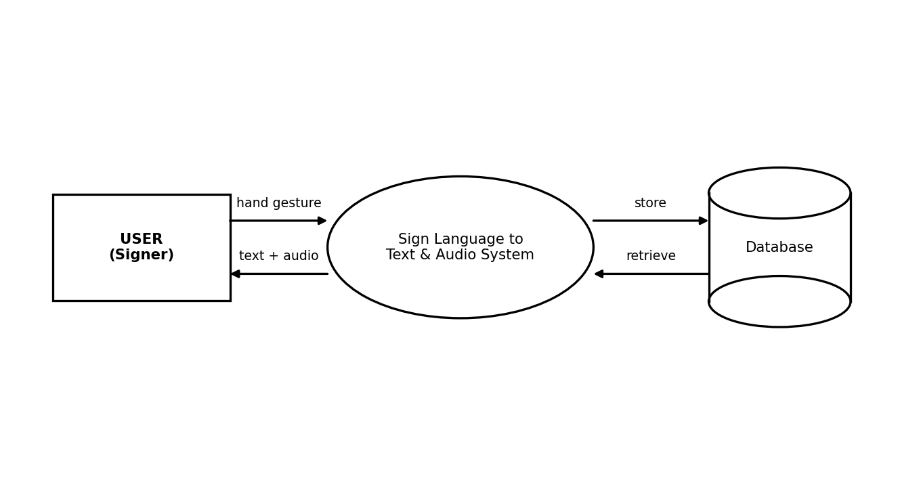
Figure No. 5.2 Data flow diagram
5.3 ER Diagram
The Entity-Relationship diagram shows the main entities of the system and the relationships among them. A user starts many sessions; each session has many translations and produces one transcript, and may also export documents; each gesture label may label many translations.
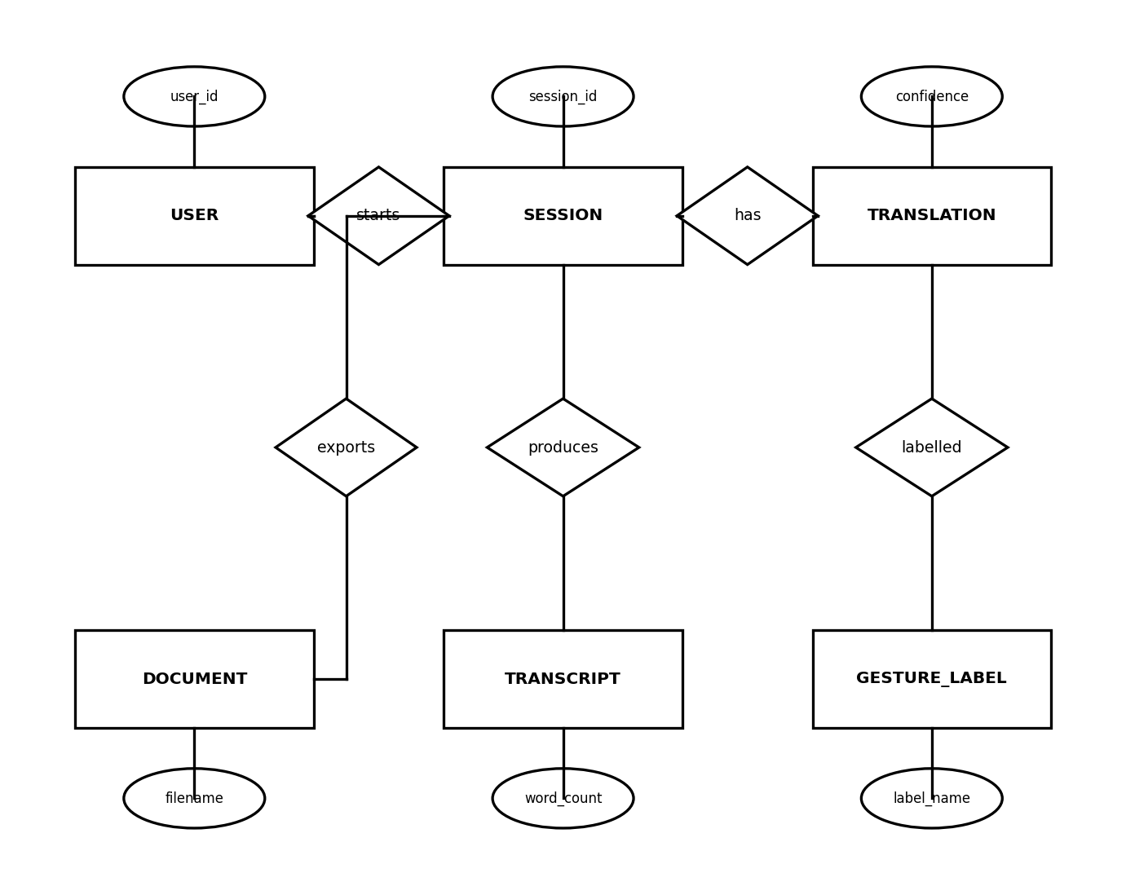
Figure No. 5.3 ER diagram
5.4 UML Diagram
The Unified Modeling Language (UML) diagrams describe the system from different viewpoints: the actors and their interactions, the structure of the classes, the flow of activities, and the sequence of messages exchanged among the components.
5.4.1 Use Case Diagram
The use case diagram shows the actions available to the user of the system.
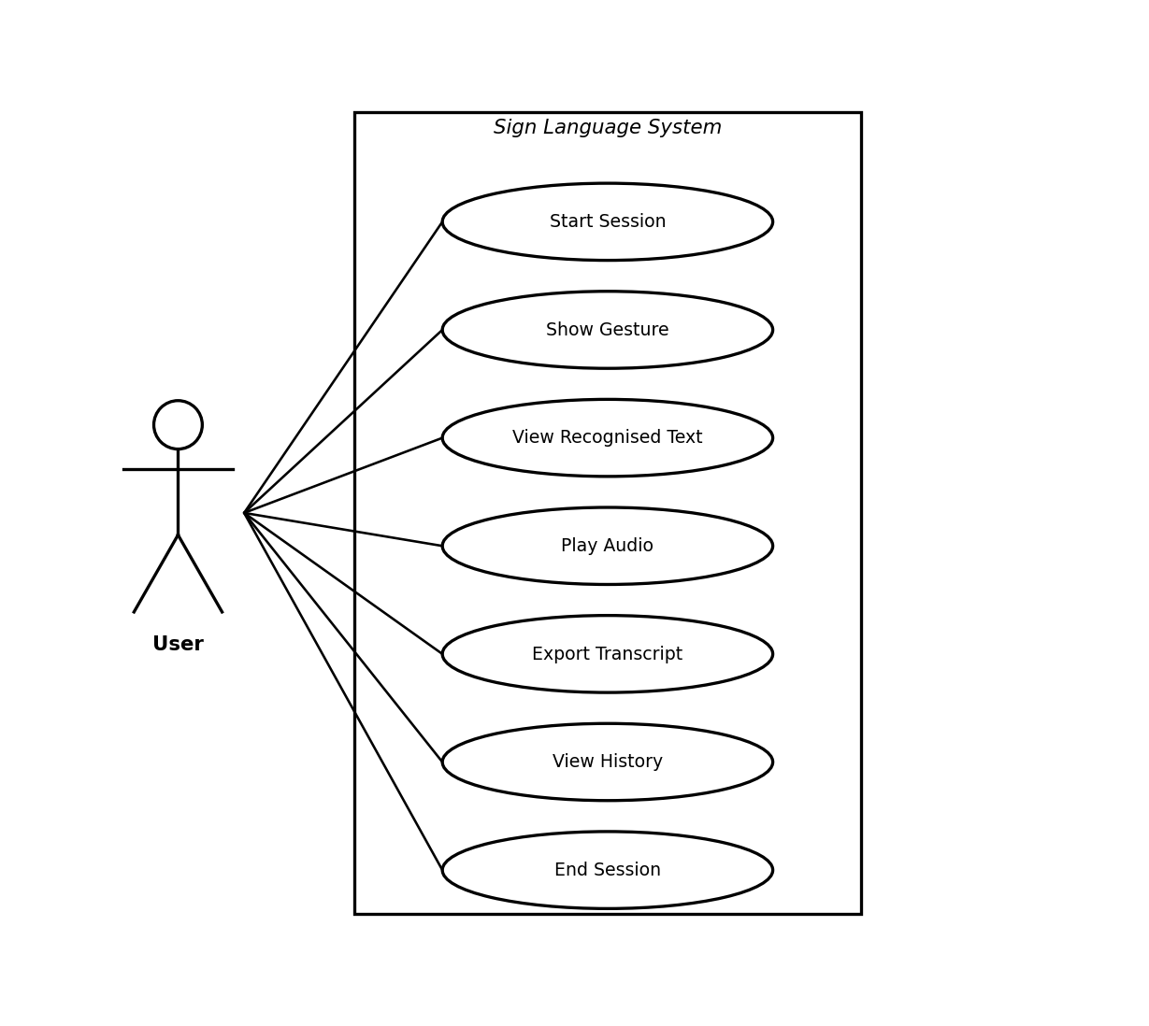
Figure No. 5.4 Use case diagram
5.4.2 Class Diagram
The class diagram presents the principal classes of the system, together with their attributes and operations.
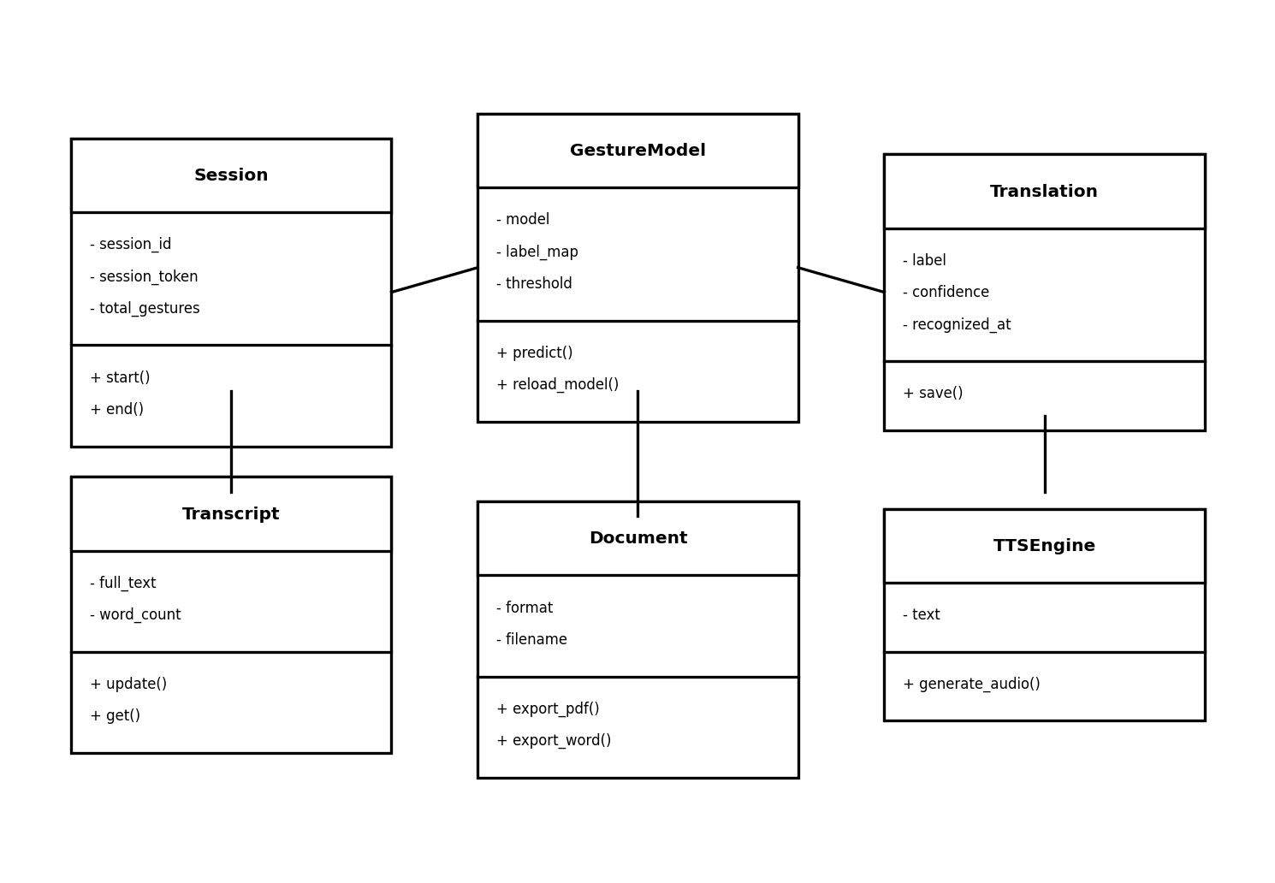
Figure No. 5.5 Class diagram
5.4.3 Activity Diagram
The activity diagram describes the step-by-step flow of the recognition process.
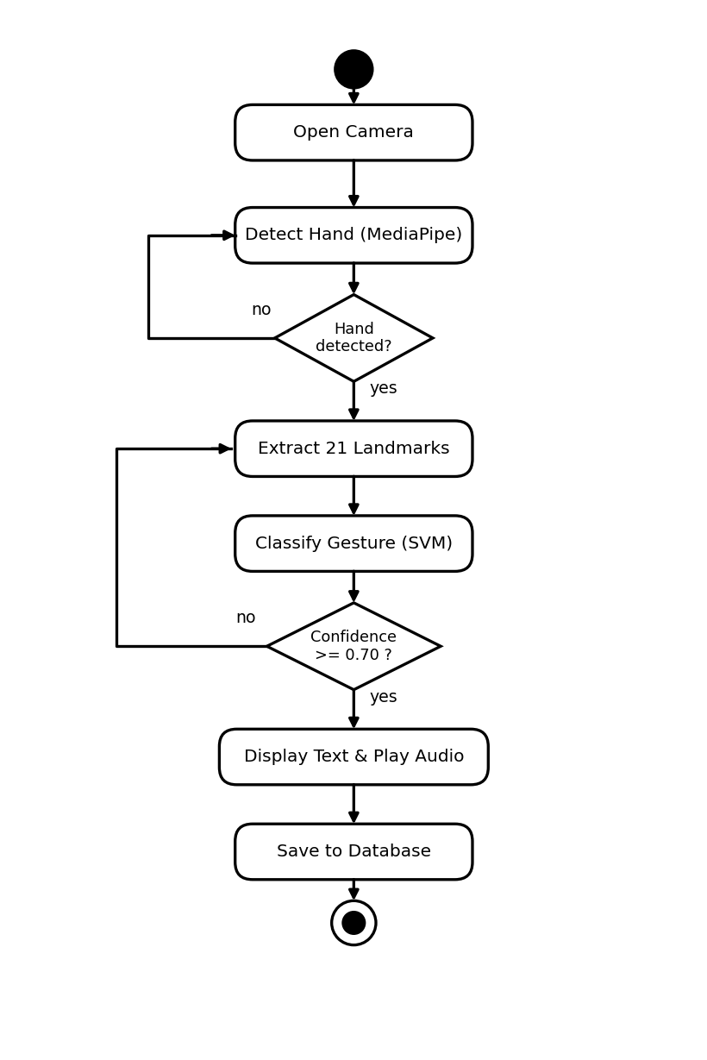
Figure No. 5.6 Activity diagram
5.4.4 Sequence Diagram
The sequence diagram shows the order of interactions between the components during one recognition cycle.
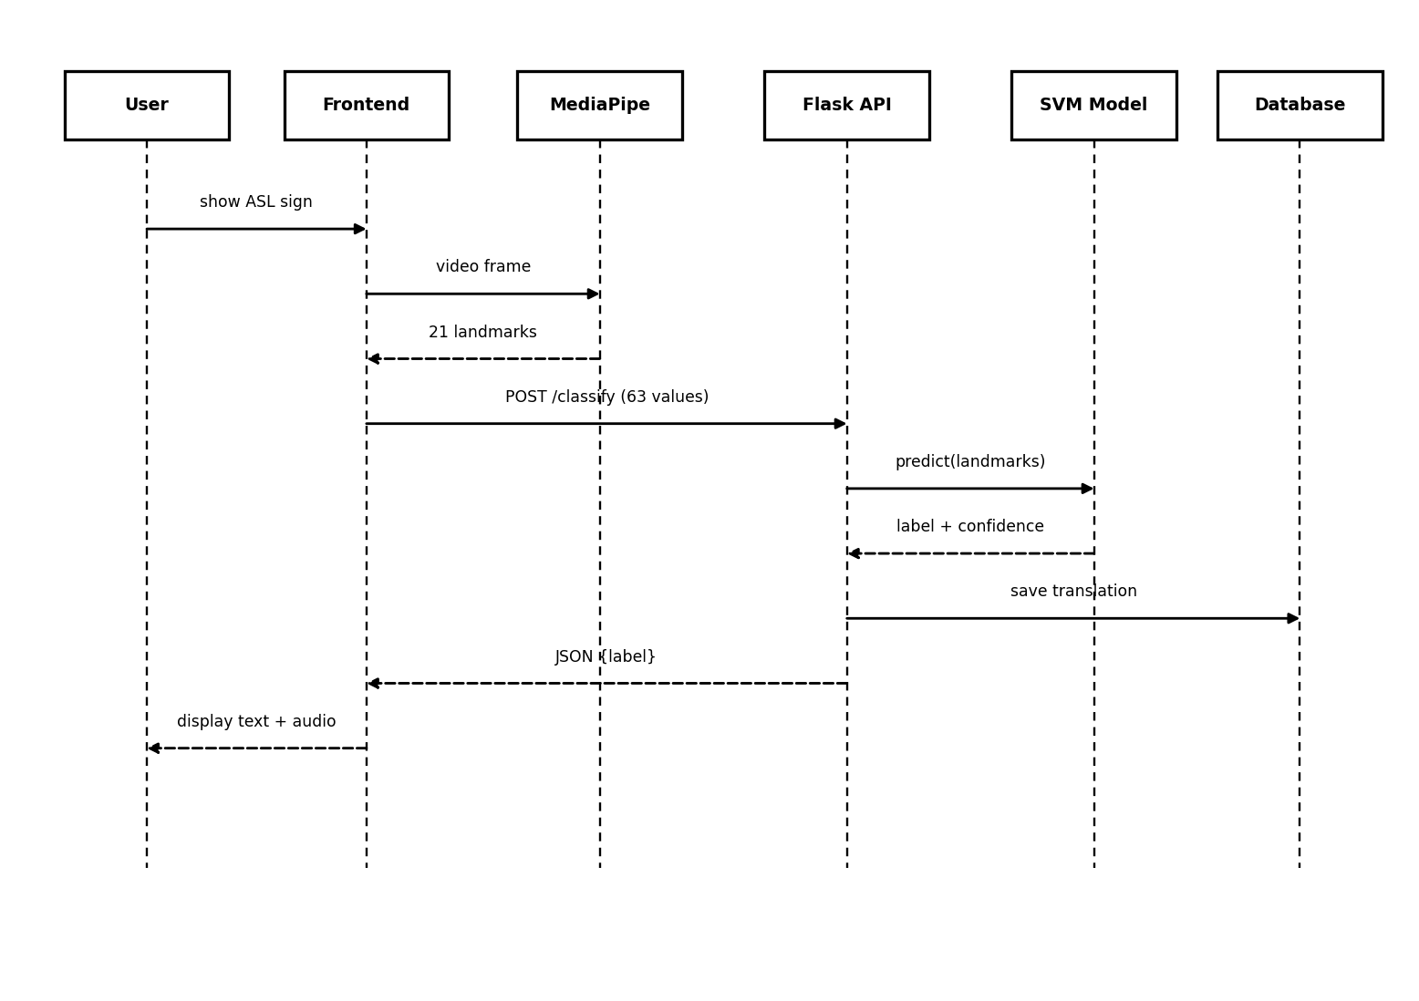
Figure No. 5.7 Sequence diagram
5.5 Database Design
The system uses an SQLite relational database, defined through the SQLAlchemy ORM, consisting of seven tables. The structure of each table is given below.
Table Name: Users
S.NO | FIELD NAME | DATA TYPE | SIZE | KEY | DESCRIPTION
1 | user_id | Integer | — | Primary Key | Unique user identifier
2 | username | Varchar | 50 | Not Null | Login name of the user
3 | email | Varchar | 100 | Not Null | Email address of the user
4 | created_at | DateTime | — | Not Null | Account creation time
5 | is_active | Boolean | — | Not Null | Whether the account is active
Table No 5.1 Users
Table Name: Gesture Labels
S.NO | FIELD NAME | DATA TYPE | SIZE | KEY | DESCRIPTION
1 | label_id | Integer | — | Primary Key | Unique label identifier
2 | class_index | Integer | — | Not Null | Model output class index (0–35)
3 | label_name | Varchar | 50 | Not Null | Gesture name (A–Z, 0–9)
4 | label_type | Varchar | 20 | Not Null | alphabet / number / control
Table No 5.2 Gesture Labels
Table Name: Sessions
S.NO | FIELD NAME | DATA TYPE | SIZE | KEY | DESCRIPTION
1 | session_id | Integer | — | Primary Key | Unique session identifier
2 | user_id | Integer | — | Foreign Key | Reference to users table
3 | session_token | Varchar | 100 | Not Null | Unique token for the session
4 | started_at | DateTime | — | Not Null | Session start time
5 | ended_at | DateTime | — | Null | Session end time
6 | total_gestures | Integer | — | Not Null | Gestures recognised
Table No 5.3 Sessions
Table Name: Translations
S.NO | FIELD NAME | DATA TYPE | SIZE | KEY | DESCRIPTION
1 | translation_id | Integer | — | Primary Key | Unique translation identifier
2 | session_id | Integer | — | Foreign Key | Reference to sessions table
3 | label_id | Integer | — | Foreign Key | Reference to gesture_labels
4 | confidence_score | Float | — | Not Null | Model confidence
5 | recognized_at | DateTime | — | Not Null | Time of recognition
Table No 5.4 Translations
Table Name: Transcripts
S.NO | FIELD NAME | DATA TYPE | SIZE | KEY | DESCRIPTION
1 | transcript_id | Integer | — | Primary Key | Unique transcript identifier
2 | session_id | Integer | — | Foreign Key | Reference to sessions table
3 | full_text | Text | — | Not Null | Complete recognised text
4 | word_count | Integer | — | Not Null | Number of words
5 | updated_at | DateTime | — | Not Null | Last update time
Table No 5.5 Transcripts
Table Name: Documents
S.NO | FIELD NAME | DATA TYPE | SIZE | KEY | DESCRIPTION
1 | document_id | Integer | — | Primary Key | Unique document identifier
2 | session_id | Integer | — | Foreign Key | Reference to sessions table
3 | format | Varchar | 10 | Not Null | Export format (PDF / DOCX)
4 | filename | Varchar | 200 | Not Null | Name of exported file
5 | downloaded_at | DateTime | — | Not Null | Time the file was generated
Table No 5.6 Documents
Table Name: System Logs
S.NO | FIELD NAME | DATA TYPE | SIZE | KEY | DESCRIPTION
1 | log_id | Integer | — | Primary Key | Unique log identifier
2 | session_id | Integer | — | Foreign Key | Reference to sessions table
3 | module_name | Varchar | 50 | Not Null | Module that generated the log
4 | log_level | Varchar | 10 | Not Null | INFO / WARN / ERROR
5 | message | Text | — | Not Null | Log message content
6 | logged_at | DateTime | — | Not Null | Time the log was recorded
Table No 5.7 System Logs
CHAPTER 6
PROJECT DESCRIPTION
6.1 Problem Definition
Problem Statement: communication between persons with hearing or speech impairments and the general public is difficult because sign language is understood by very few people. The available options — a human interpreter, written notes, or lip-reading — are not always accessible, are slow and costly, and leave no permanent record. There is a clear need for an automated system that can translate sign-language gestures into text and audio in real time.
Impact of these problems:
- Communication barrier in schools, hospitals, banks, and offices without a common medium of communication.
- Dependence on a human interpreter, which reduces independence and removes privacy from personal conversations.
- Delay and cost in arranging an interpreter or writing notes, discouraging spontaneous communication.
- No transcript that can be reviewed, saved, or shared afterwards.
Proposed Solution: a real-time Sign Language to Text and Audio Conversion System that captures gestures in the browser, classifies them with a trained model, displays the recognised text as subtitles, speaks it aloud, stores each session, and exports the transcript — all on a normal computer with a webcam.
6.2 Module Description
Webcam Capture and Hand Detection: accesses the webcam in the browser and uses MediaPipe to detect the hand and extract twenty-one landmark coordinates from each frame, sending only the numeric landmarks to the server.
Gesture Recognition: receives the landmarks at the Flask API and uses the trained Support Vector Machine model to classify the gesture into one of the thirty-six classes, with a confidence check so that only reliable predictions are accepted.
Transcript Builder: combines the recognised characters into words and sentences, using control gestures such as SPACE and DELETE, and maintains the live transcript of the session.
Text-to-Speech: converts the recognised text into spoken audio using gTTS, with pyttsx3 as an offline fallback.
Document Export: generates a formatted transcript of the session as a PDF (ReportLab) or Word (python-docx) file and records it in the database.
Session Management and History: starts and ends sessions, stores each translation with its confidence and time, and provides the history of a session.
Model Training: collects labelled hand-landmark samples, trains the Support Vector Machine model, and hot-reloads it, allowing the recognition accuracy to be improved over time.
CHAPTER 7
SOFTWARE TESTING
7.1 Introduction
Software testing is the process of evaluating the application to detect differences between the expected and the actual behaviour, and to confirm that the system meets its requirements. The Sign Language to Text and Audio Conversion System was tested at the unit, integration, and system levels, and its backend was validated using an automated pytest suite of twenty-one test cases, all of which passed.
7.2 Black Box Testing
Black box testing examines the functionality of the system without looking at its internal code. Each API endpoint was given valid and invalid inputs, and its output was compared with the expected result — for example, classifying valid landmarks, rejecting an incorrect landmark count, and returning an error for empty text.
7.3 White Box Testing
White box testing examines the internal logic and code paths of the system. The branches of the gesture-classification function, the confidence threshold check, and the database-saving logic were tested to ensure that every path behaves correctly.
7.4 System Testing
System testing evaluates the complete, integrated application end to end — from capturing landmarks and classifying gestures to building the transcript, generating audio, exporting documents, and storing data — to confirm that all modules work together correctly.
7.5 Unit Testing
Unit testing verifies each module or function in isolation. Functions such as session creation, gesture classification, transcript update, and document export were tested independently for valid and invalid input.
7.6 Integration Testing
Integration testing checks that the separate modules work correctly when combined, verifying that data passes correctly from the browser landmarks to the classification model, the database, the text-to-speech engine, and the export modules.
7.7 User Acceptance Testing
User acceptance testing determines whether the system is acceptable to its users. The application was tried by users who confirmed that the recognition, subtitles, audio output, and export features were easy to use and met their expectations.
7.8 Performance Testing
Performance testing measures the responsiveness of the system. Because hand detection runs in the browser and only small landmark arrays are sent to the server, the system classifies gestures and returns results with low latency, giving a smooth real-time experience.
7.9 Regression Testing
Regression testing re-runs the existing test cases after any change to confirm that new modifications have not broken previously working features. The pytest suite was re-executed after each change to the model and the API.
7.10 Security Testing
Security testing checks that the system handles data safely. Because the camera images stay in the browser and only numeric landmarks are transmitted, the privacy of the user is protected; invalid and malformed requests are rejected gracefully without crashing the server.
7.11 Compatibility Testing
Compatibility testing confirms that the application works across supported browsers and devices. The system was verified on modern browsers such as Google Chrome and Microsoft Edge on standard Windows machines with a webcam.
7.12 Adaptive Maintenance
Adaptive maintenance modifies the system to keep it working as its environment changes, such as updates to the browser, the MediaPipe library, or the Python packages used by the backend.
7.13 Perfective Maintenance
Perfective maintenance improves the system by adding enhancements and refining existing features, such as improving recognition accuracy and the user interface based on feedback.
7.14 Preventive Maintenance
Preventive maintenance makes changes that reduce the chance of future failures, such as cleaning up code, adding validation, and keeping dependencies up to date.
7.15 Maintenance Activities
Maintenance activities include monitoring the system, retraining the model with new gesture samples, fixing reported issues, and backing up the database so that the system remains reliable over time.
7.16 Functional Test
The functional test cases used to validate the backend, all of which passed, are summarised below.
Test Case ID | Module | Description | Expected Result | Status
TC01 | Health | Verify API health check | Status 'ok' returned | Pass
TC02 | Session | Start a new session | session_id and token returned | Pass
TC03 | Session | End an active session | Message 'ended' returned | Pass
TC04 | Recognition | Classify valid 63 landmarks | label + confidence returned | Pass
TC05 | Recognition | Reject wrong landmark count | accepted = false | Pass
TC06 | Recognition | Handle empty request body | accepted = false, no crash | Pass
TC07 | Transcript | Update transcript text | Message 'updated' returned | Pass
TC08 | Transcript | Retrieve transcript + word count | Correct word count | Pass
TC10 | TTS | Reject empty text | Status 400 error | Pass
TC14 | Export | Export transcript as Word | DOCX file generated | Pass
TC15 | Export | Export transcript as PDF | PDF file generated | Pass
TC16 | Dataset | List dataset images | image list + count | Pass
TC17 | CORS | Verify CORS headers | Correct headers present | Pass
TC20 | API | Response is valid JSON | JSON response returned | Pass
CHAPTER 8
CONCLUSION
The Sign Language to Text and Audio Conversion System successfully demonstrates a practical, real-time solution for translating American Sign Language gestures into text and speech. By performing hand-landmark detection in the browser with MediaPipe and classifying gestures on the server with a trained Support Vector Machine model, the system recognises the alphabets A–Z and the digits 0–9 accurately and instantly, while keeping the design lightweight and privacy-preserving.
The application builds a live transcript, speaks the recognised text aloud, stores each session, and exports the conversation as a PDF or Word document, all on a normal computer with a webcam and a standard browser. The backend was validated through an automated test suite of twenty-one cases, all of which passed. The project thus meets its objective of providing an affordable and easy-to-use assistive tool that helps reduce the communication barrier faced by the deaf and mute community.
CHAPTER 9
FURTHER ENHANCEMENT
In the future, the system can be enhanced by extending recognition from static letters and digits to dynamic, word-level signs by training on large word-level datasets such as MS-ASL, so that complete words and phrases can be recognised from the motion of the hands. Support for additional sign languages, such as Indian Sign Language (ISL), can also be added to widen the system's reach.
Further improvements include adding natural-language processing to form grammatically correct sentences, developing a mobile application for on-the-go access, migrating the service to the cloud for wider availability, and adding two-handed and facial-expression recognition to capture the full meaning of a sign. User accounts, multi-language audio output, and offline support can make the system more personal and dependable.
CHAPTER 10
APPENDICES
10.1 Sample Code
database.py (Database Models — SQLAlchemy ORM)
from flask_sqlalchemy import SQLAlchemy
from datetime import datetime

db = SQLAlchemy()

class User(db.Model):
__tablename__ = "users"
user_id = db.Column(db.Integer, primary_key=True, autoincrement=True)
username = db.Column(db.String(50), unique=True, nullable=False)
email = db.Column(db.String(100), unique=True, nullable=False)
created_at = db.Column(db.DateTime, default=datetime.utcnow)
is_active = db.Column(db.Boolean, default=True)
sessions = db.relationship("Session", backref="user", lazy=True)

class GestureLabel(db.Model):
__tablename__ = "gesture_labels"
label_id = db.Column(db.Integer, primary_key=True, autoincrement=True)
class_index = db.Column(db.Integer, unique=True, nullable=False)
label_name = db.Column(db.String(50), unique=True, nullable=False)
label_type = db.Column(db.String(20), default="alphabet")

class Session(db.Model):
__tablename__ = "sessions"
session_id = db.Column(db.Integer, primary_key=True, autoincrement=True)
user_id = db.Column(db.Integer, db.ForeignKey("users.user_id"), nullable=True)
session_token = db.Column(db.String(100), unique=True, nullable=False)
started_at = db.Column(db.DateTime, default=datetime.utcnow)
ended_at = db.Column(db.DateTime, nullable=True)
total_gestures = db.Column(db.Integer, default=0)
translations = db.relationship("Translation", backref="session", lazy=True)
transcript = db.relationship("Transcript", backref="session", uselist=False, lazy=True)

class Translation(db.Model):
__tablename__ = "translations"
translation_id = db.Column(db.Integer, primary_key=True, autoincrement=True)
session_id = db.Column(db.Integer, db.ForeignKey("sessions.session_id"), nullable=False)
label_id = db.Column(db.Integer, db.ForeignKey("gesture_labels.label_id"), nullable=False)
confidence_score = db.Column(db.Float, nullable=False)
recognized_at = db.Column(db.DateTime, default=datetime.utcnow)

class Transcript(db.Model):
__tablename__ = "transcripts"
transcript_id = db.Column(db.Integer, primary_key=True, autoincrement=True)
session_id = db.Column(db.Integer, db.ForeignKey("sessions.session_id"), unique=True, nullable=False)
full_text = db.Column(db.Text, default="")
word_count = db.Column(db.Integer, default=0)
updated_at = db.Column(db.DateTime, default=datetime.utcnow, onupdate=datetime.utcnow)

class Document(db.Model):
__tablename__ = "documents"
document_id = db.Column(db.Integer, primary_key=True, autoincrement=True)
session_id = db.Column(db.Integer, db.ForeignKey("sessions.session_id"), nullable=False)
format = db.Column(db.String(10), nullable=False)
filename = db.Column(db.String(200), nullable=False)
downloaded_at = db.Column(db.DateTime, default=datetime.utcnow)

class SystemLog(db.Model):
__tablename__ = "system_logs"
log_id = db.Column(db.Integer, primary_key=True, autoincrement=True)
session_id = db.Column(db.Integer, db.ForeignKey("sessions.session_id"), nullable=True)
module_name = db.Column(db.String(50), nullable=False)
log_level = db.Column(db.String(10), nullable=False)
gesture_model.py (Gesture Classification Model)
import os
import json
import numpy as np

CONFIDENCE_THRESHOLD = 0.70 # tuned for SVM Platt probabilities (was 0.85 for MLP softmax)

# Default label map A-Z + SPACE + DELETE
DEFAULT_LABEL_MAP = {i: chr(65+i) for i in range(26)}
DEFAULT_LABEL_MAP[26] = "SPACE"
DEFAULT_LABEL_MAP[27] = "DELETE"

SKLEARN_MODEL_PATH = "model/gesture_model.pkl"
TF_MODEL_PATH = "model/gesture_model.h5"
LABELMAP_PATH = "model/label_map.json"

class GestureModel:
def __init__(self):
self.model = None
self.model_type = None
self.demo_mode = False
self.label_map = self._load_label_map()
self._load()

def reload_model(self):
"""Force reload the label map and model files."""
print("[GestureModel] Reloading model...", flush=True)
self.model = None
self.model_type = None
self.demo_mode = False
self.label_map = self._load_label_map()
self._load()

def _load_label_map(self):
if os.path.exists(LABELMAP_PATH):
try:
with open(LABELMAP_PATH) as f:
raw = json.load(f)
lm = {int(k): v for k, v in raw.items()}
print(f"[GestureModel] Label map loaded: {lm}", flush=True)
return lm
except Exception as e:
print(f"[GestureModel] Label map load error: {e}", flush=True)
print("[GestureModel] No label_map.json — using default A-Z.", flush=True)
return DEFAULT_LABEL_MAP

def _load(self):
# Try sklearn model first — no TensorFlow dependency
if os.path.exists(SKLEARN_MODEL_PATH):
try:
import joblib
self.model = joblib.load(SKLEARN_MODEL_PATH)
self.model_type = "sklearn"
print(f"[GestureModel] Sklearn model loaded from '{SKLEARN_MODEL_PATH}'.", flush=True)
return
except Exception as e:
print(f"[GestureModel] Sklearn load error: {e}", flush=True)

# Try TF/Keras model
if os.path.exists(TF_MODEL_PATH):
try:
import tensorflow as tf
self.model = tf.keras.models.load_model(TF_MODEL_PATH)
self.model_type = "tensorflow"
print(f"[GestureModel] TF model loaded from '{TF_MODEL_PATH}'.", flush=True)
return
except Exception as e:
print(f"[GestureModel] TF load error: {e} — DEMO mode.", flush=True)

print("[GestureModel] No model found — DEMO mode.", flush=True)
self.demo_mode = True

def predict(self, landmarks):
if not landmarks or len(landmarks) != 63:
return {"label": None, "confidence": 0.0, "accepted": False}

if self.demo_mode:
arr = np.array(landmarks)
if arr.std() < 0.005:
return {"label": None, "confidence": 0.0, "accepted": False}
tts_engine.py (Text-to-Speech Engine)
def generate_audio(text: str, use_google: bool = True) -> str:
"""
Convert text to speech and save as MP3.

Args:
text : The text to speak.
use_google : True = gTTS (online), False = pyttsx3 (offline).

Returns:
Relative path to the generated MP3 file.
"""
if not text or not text.strip():
return None

filename = f"{uuid.uuid4().hex}.mp3"
filepath = os.path.join(AUDIO_DIR, filename)

if use_google:
try:
from gtts import gTTS
tts = gTTS(text=text.strip(), lang="en", slow=False)
tts.save(filepath)
print(f"[TTS] gTTS audio saved: {filepath}")
return filepath
except Exception as e:
print(f"[TTS] gTTS failed ({e}), falling back to pyttsx3.")

# Offline fallback — pyttsx3
try:
import pyttsx3
engine = pyttsx3.init()
engine.setProperty("rate", 160)
engine.setProperty("volume", 1.0)
engine.save_to_file(text.strip(), filepath)
engine.runAndWait()
engine.stop()
print(f"[TTS] pyttsx3 audio saved: {filepath}")
return filepath
except Exception as e:
print(f"[TTS] pyttsx3 also failed: {e}")
return None

10.2 Screen Shots
The screenshots of the main pages of the application are given below.
[SCREENSHOT: paste the Home Page here]
Home Page
[SCREENSHOT: paste the Live Recognition Page here]
Live Recognition Page
[SCREENSHOT: paste the Recognised Text and Subtitle View here]
Recognised Text and Subtitle View
[SCREENSHOT: paste the Audio Playback Controls here]
Audio Playback Controls
[SCREENSHOT: paste the Session History Page here]
Session History Page
[SCREENSHOT: paste the Exported Transcript (PDF / Word) here]
Exported Transcript (PDF / Word)
CHAPTER 11
REFERENCES
11.1 Web Reference
[1] https://ai.google.dev/edge/mediapipe
[2] https://scikit-learn.org/stable/
[3] https://flask.palletsprojects.com/
[4] https://react.dev/
[5] https://vitejs.dev/
[6] https://gtts.readthedocs.io/
[7] https://www.w3schools.com/
[8] https://github.com
11.2 Book Reference
[1] Géron, Aurélien. Hands-On Machine Learning with Scikit-Learn, Keras and TensorFlow (2nd Edition). O’Reilly Media, 2019.
[2] Raschka, Sebastian, and Mirjalili, Vahid. Python Machine Learning (3rd Edition). Packt Publishing, 2019.
[3] Sommerville, Ian. Software Engineering (10th Edition). Pearson Education, 2015.
[4] Grinberg, Miguel. Flask Web Development (2nd Edition). O’Reilly Media, 2018.
[5] Banks, Alex, and Porcello, Eve. Learning React (2nd Edition). O’Reilly Media, 2020.
DOCUMENT CHANGE LOG
This log records the corrections, placeholders, and layout adjustments made while reproducing the format of Project Doc Format.docx and filling it with the Sign Language to Text and Audio Conversion System project.
A. Sections Corrected / Reformatted
- Content: all the original “Online Voting System” / NESARAJ.T material was replaced with the Sign Language to Text and Audio Conversion System project (Surya A, Reg. No. 511924622038), as requested.
- Supervisor / HOD name standardised to “Dr. G. Manikandan, M.C.A., M.Phil., Ph.D.” (the original had inconsistent variants such as “Dr.MANIKANDAN G” and “Dr.G.MANIKANDAN.,M.Phil.,Ph.D”).
- Spelling fixes: “Vaniyabadi” → “Vaniyambadi”; “PROJET DESCRIPTION” → “PROJECT DESCRIPTION”; “ACKNOWLEDGMENT” → “ACKNOWLEDGEMENT”.
- Month/year unified to JUNE 2026 (the original mixed “August-2025” on the cover with “AUGUST 2024” on the certificate).
- Table of Contents “CHAPTER NO.” column renumbered correctly (the original mislabelled sub-sections 1.1, 1.2 … as chapters 2, 3, 4 …).
- Reference numbering fixed (“2. Book Reference” → “11.2 Book Reference”).
- Removed the stray “Top of Form / Bottom of Form” artifact and the inline note “(Tamil font style- AkrutiTml1)”.
B. Placeholders Added
- «Name of the Internal Guide / Supervisor» and «Designation» on the Certificate of Evaluation and the Bonafide Certificate.
- [SCREENSHOT: …] placeholders for the six application screens in Appendix 10.2.
- A blank line for the viva-voce examination date.
- The student photograph is shown as a placeholder (the original document’s personal photo was not reused).
C. Layout Adjustments
- All content is black & white except the colour logos on pages 1 and 3 (cover and bonafide certificate), as requested.
- The eight diagrams (Waterfall 3.1, Architecture 5.1, Data Flow 5.2, ER 5.3, Use Case 5.4, Class 5.5, Activity 5.6, Sequence 5.7) were drawn as proper UML / ER / DFD diagrams (ovals, diamonds, database cylinders, actors and sequence lifelines) in clean black & white, matching the academic style of the uploaded sample design document.
- All tables were made clean: white background, black borders and bold headings, with no colour shading; the database-design tables include a separate Size column.
- The Table of Contents, List of Figures and List of Tables are presented as proper bordered tables.
- The two-column signature blocks were rebuilt as aligned tables to remove the overlapping / duplicated text seen in the original.
- Typography set to Times New Roman 13 pt, 1.5 line spacing, A4; Roman page numbers for the front matter and Arabic page numbers for the body, placed in the top-right corner.
- The body chapters (2–11) and the database-design tables — which were only listed in the original’s contents — were added with project content and editable diagrams.

