SIGN LANGUAGE TO TEXT AND AUDIO CONVERSION SYSTEM

SYSTEM DIAGRAMS
(Architecture, DFD, ER and UML Diagrams)

SURYA A — Reg. No: 511924622038
Department of Master of Computer Applications
Priyadarshini Engineering College, Vaniyambadi

Figure No. 5.1 Architecture Diagram
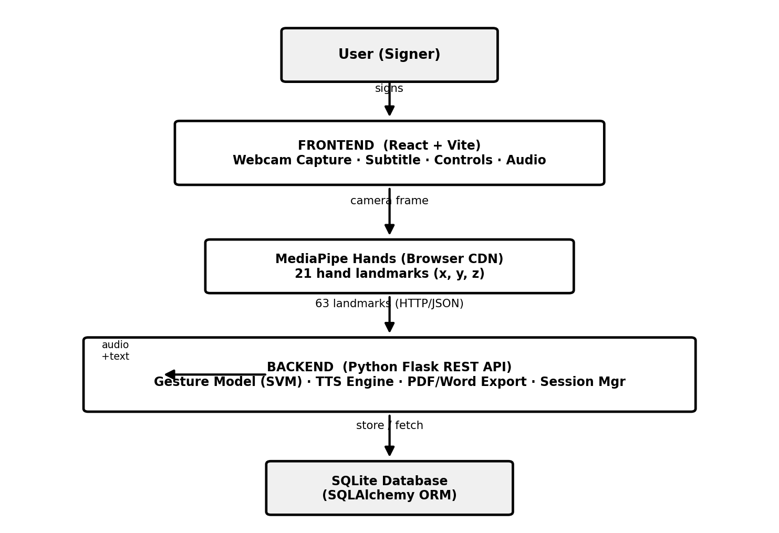
Figure No. 5.1 Architecture Diagram

Figure No. 5.2 Data Flow Diagram
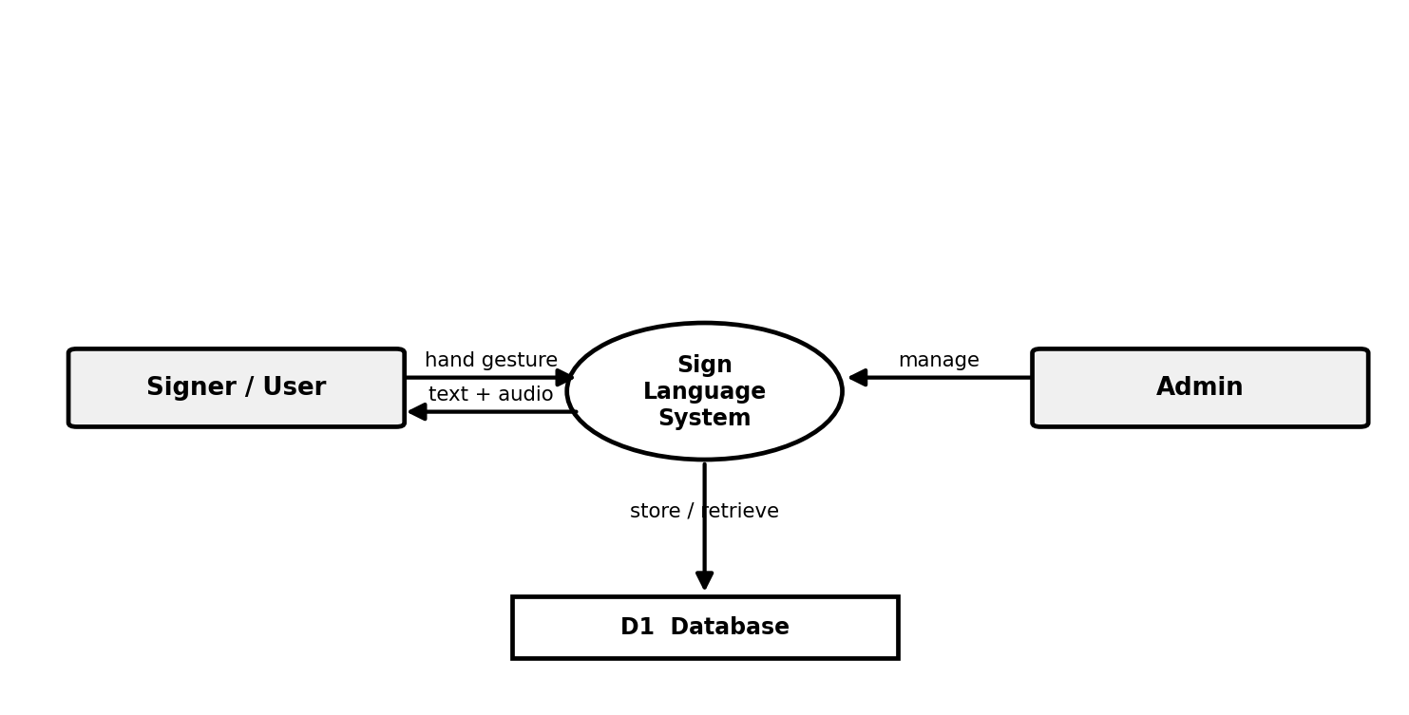
Figure No. 5.2 Data Flow Diagram

Figure No. 5.3 ER Diagram
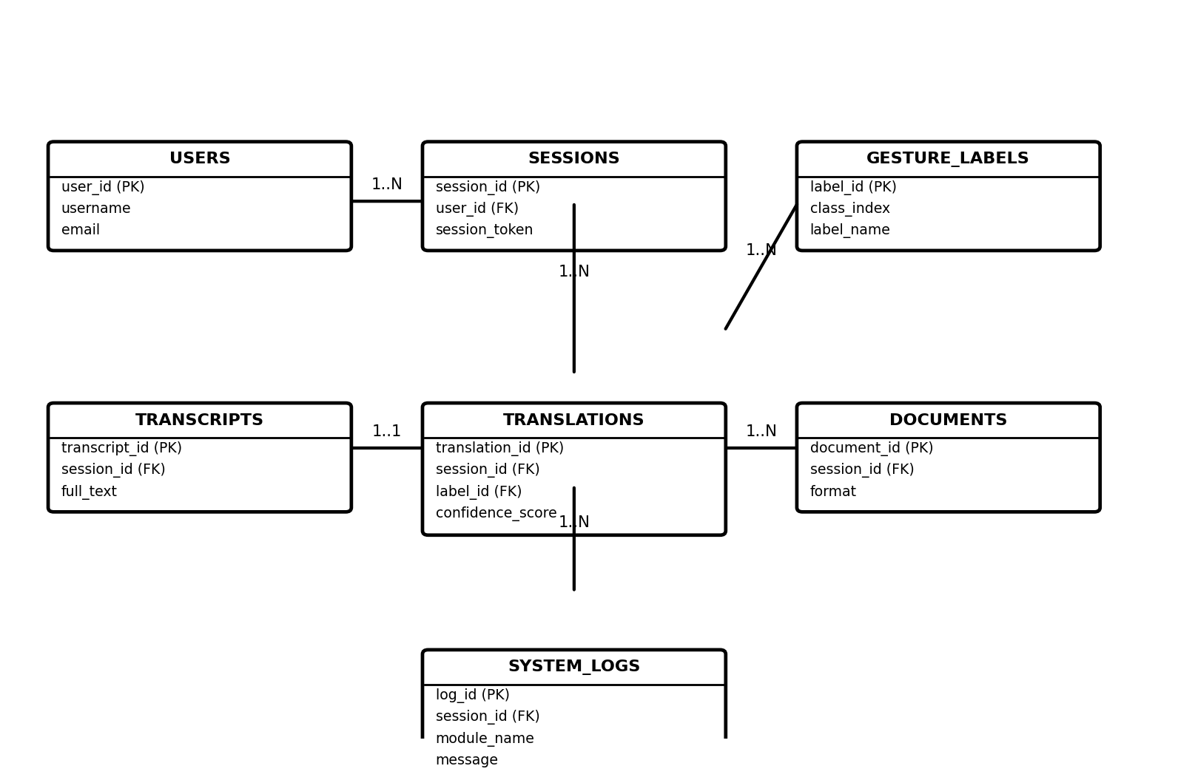
Figure No. 5.3 ER Diagram

Figure No. 5.4 Use Case Diagram
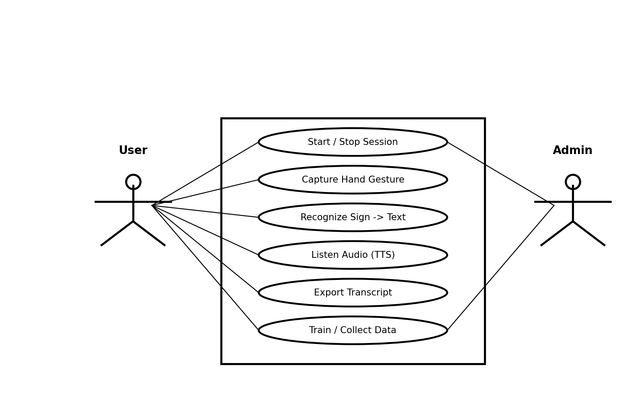
Figure No. 5.4 Use Case Diagram

Figure No. 5.5 Class Diagram
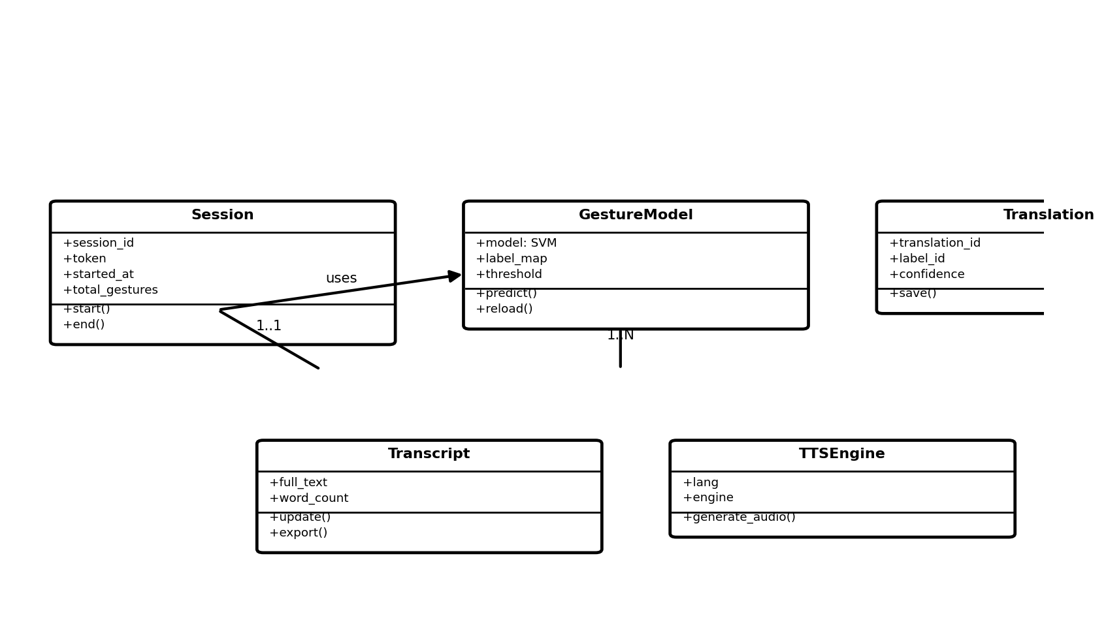
Figure No. 5.5 Class Diagram

Figure No. 5.6 Activity Diagram
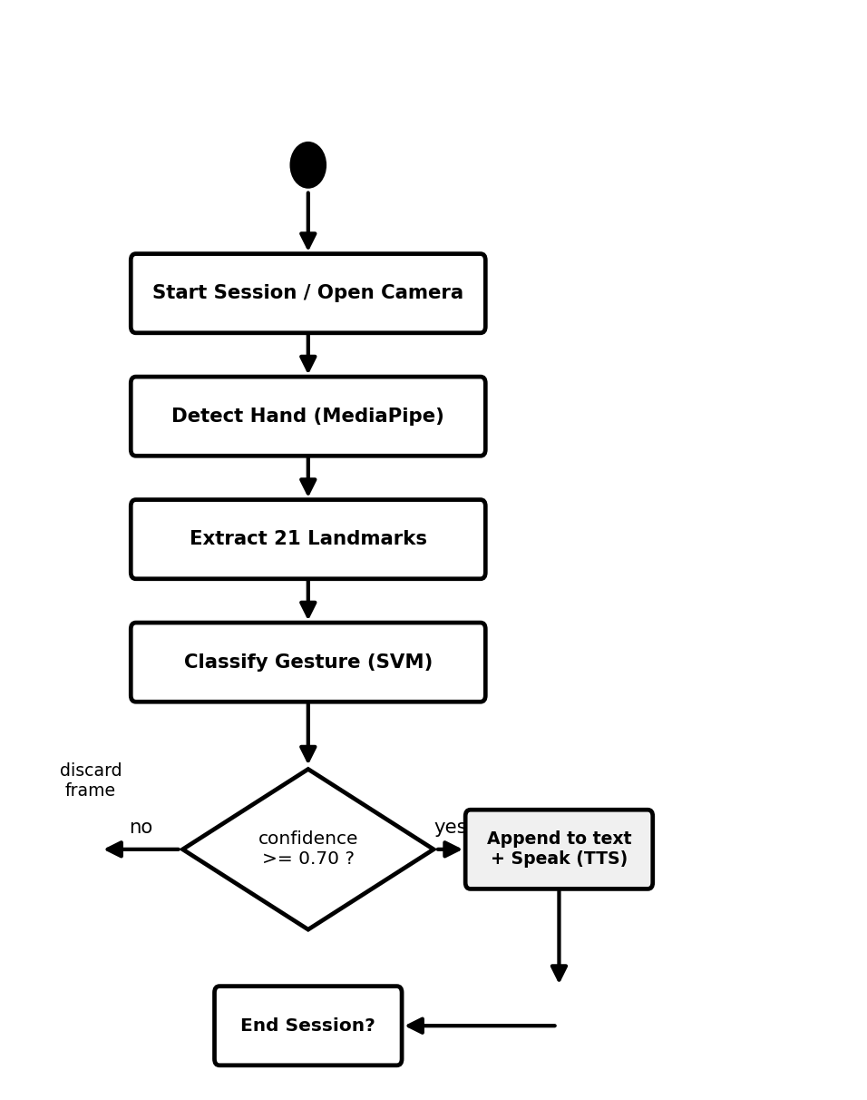
Figure No. 5.6 Activity Diagram

Figure No. 5.7 Sequence Diagram
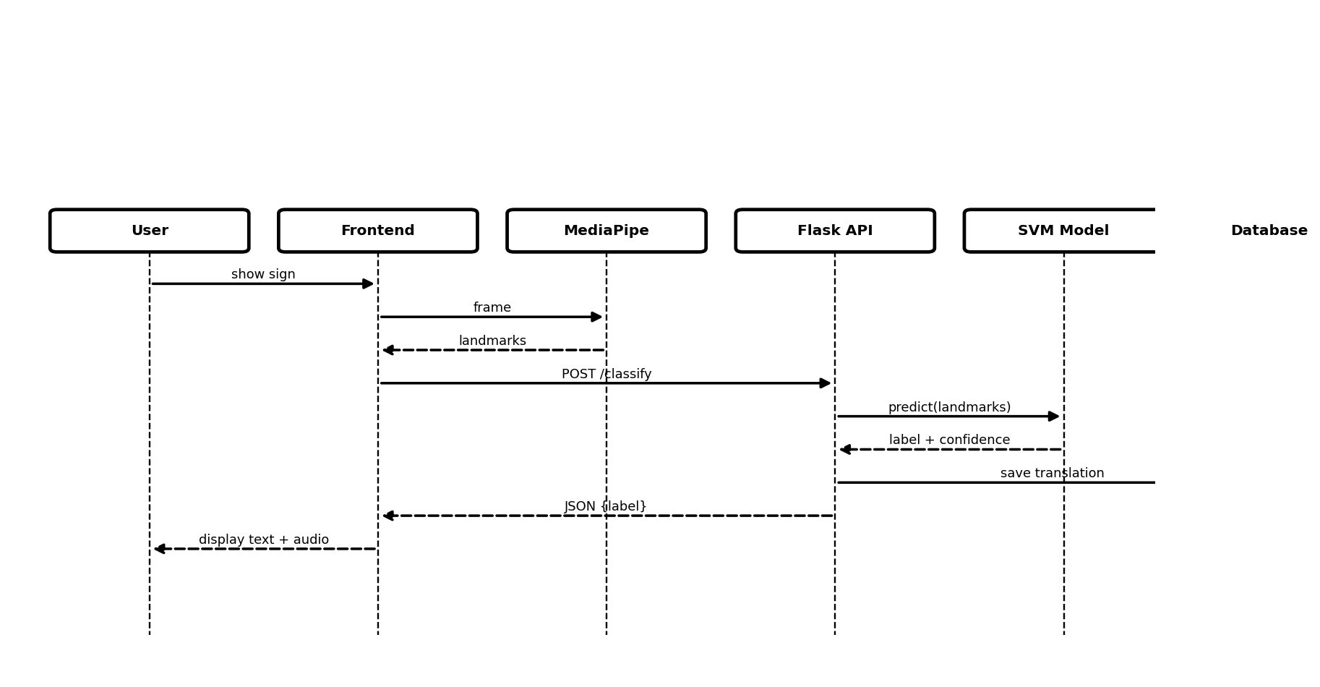
Figure No. 5.7 Sequence Diagram

