THE MAXWELL-BOLTZMANN DISTRIBUTION LAW

Two types of distribution functions have been discussed so far : the spatial distribution of molecules in a gravitational field, the Boltzmann distribution, and the speed distribution in a gas (the Maxwell distribution). These can be written in a combined form, the Maxwell Boltzmann distribution law.
The barometric formula governs the spatial distribution of the molecules in a gravity field according to the equation
The Boltzmann distribution law governs the spatial distribution of any system in which the particles have a potential energy that depends on the position.
For the special case of the gravity field, tp = This value of tp in Eq. (4.90) reduces
it to Eq. since = M/R.
The combined velocity and space distribution is written
dN* )3 / Z
----=-- = 4n
' (4.91)
where dN* is the number ofparticles per cubic metre at the position (x, y, z)that have speeds in the range e to e + de. Equation (4.91) is the Maxwell-Boltzmann distribution, which is similar to the Maxwell distribution, except that the exponential factor contains the total energy, kinetic plus potential, of the molecule instead of only the kinetic energy.
At any specified position in space, tp has a definite constant value, and so exp ( - tp/k T) is a constant. Then the right-hand side of Eq. (4. 91) is simply the Maxwell distribution multiplied by a constant. This means that at any position the distribution of speeds is Maxwellian regardless of the value of the potential energy at that point. For a gas in a gravity field this means that, although there are fewer molecules per cubic metre at 50 km height than at ground level, the fraction of molecules that have speeds in a given range is the same at both levels.

EXPERIMENTAL VERIFICATION OF THE MAXWELL DISTRIBUTION LAW
The amount of indirect evidence for the correctness of the Maxwell distribution law is overwhelming. The relationship of the distribution law to the rate of a chemical reaction has already been mentioned briefly (Section 4. 10). We shall see later that the functional form of the experimentally determined temperature dependence of the rate constant agrees with the dependence we expect from the Maxwell distribution. This agreement may be regarded as indirect evidence for the correctness of both the Maxwell distribution and our ideas concerning reaction rates.
Suppose for the sake of argument that speeds were not distributed and that all the molecules moved with the same velocity. Now consider the effect of a gravity field on such a gas. If at ground level all the molecules had the same vertical component of velocity W then all would have a kinetic energy !m W2 . The maximum height any molecule could reach is that at which all of the ground-level kinetic energy is converted into potential energy ; this height H is determined by the equality mgH = !m W2, or H = W2/2g. No molecule could reach a height greater than H, and if this situation prevailed, the atmosphere would have a sharp upper boundary. Furthermore, the density of the atmosphere would increase with the height above ground level, since the molecules at the higher levels are moving slowly and thus would spend a larger part of the time at these high levels. None of these predictions is confirmed by observation. The Maxwell distribution, however, says that some molecules have large kinetic energies and so can attain great heights ; but the pro portion of the molecules with these high energies is small. The Maxwell distribution predicts that the atmospheric density will decrease with increase in height, and that there will be no sharp upper boundary.
A number of direct experimental determinations of the velocity distribution have been made, all of which have verified the Maxwell law within the experimental error. A sketch of the apparatus used in one method is shown in Fig. 4. 14. The apparatus is entirely

s 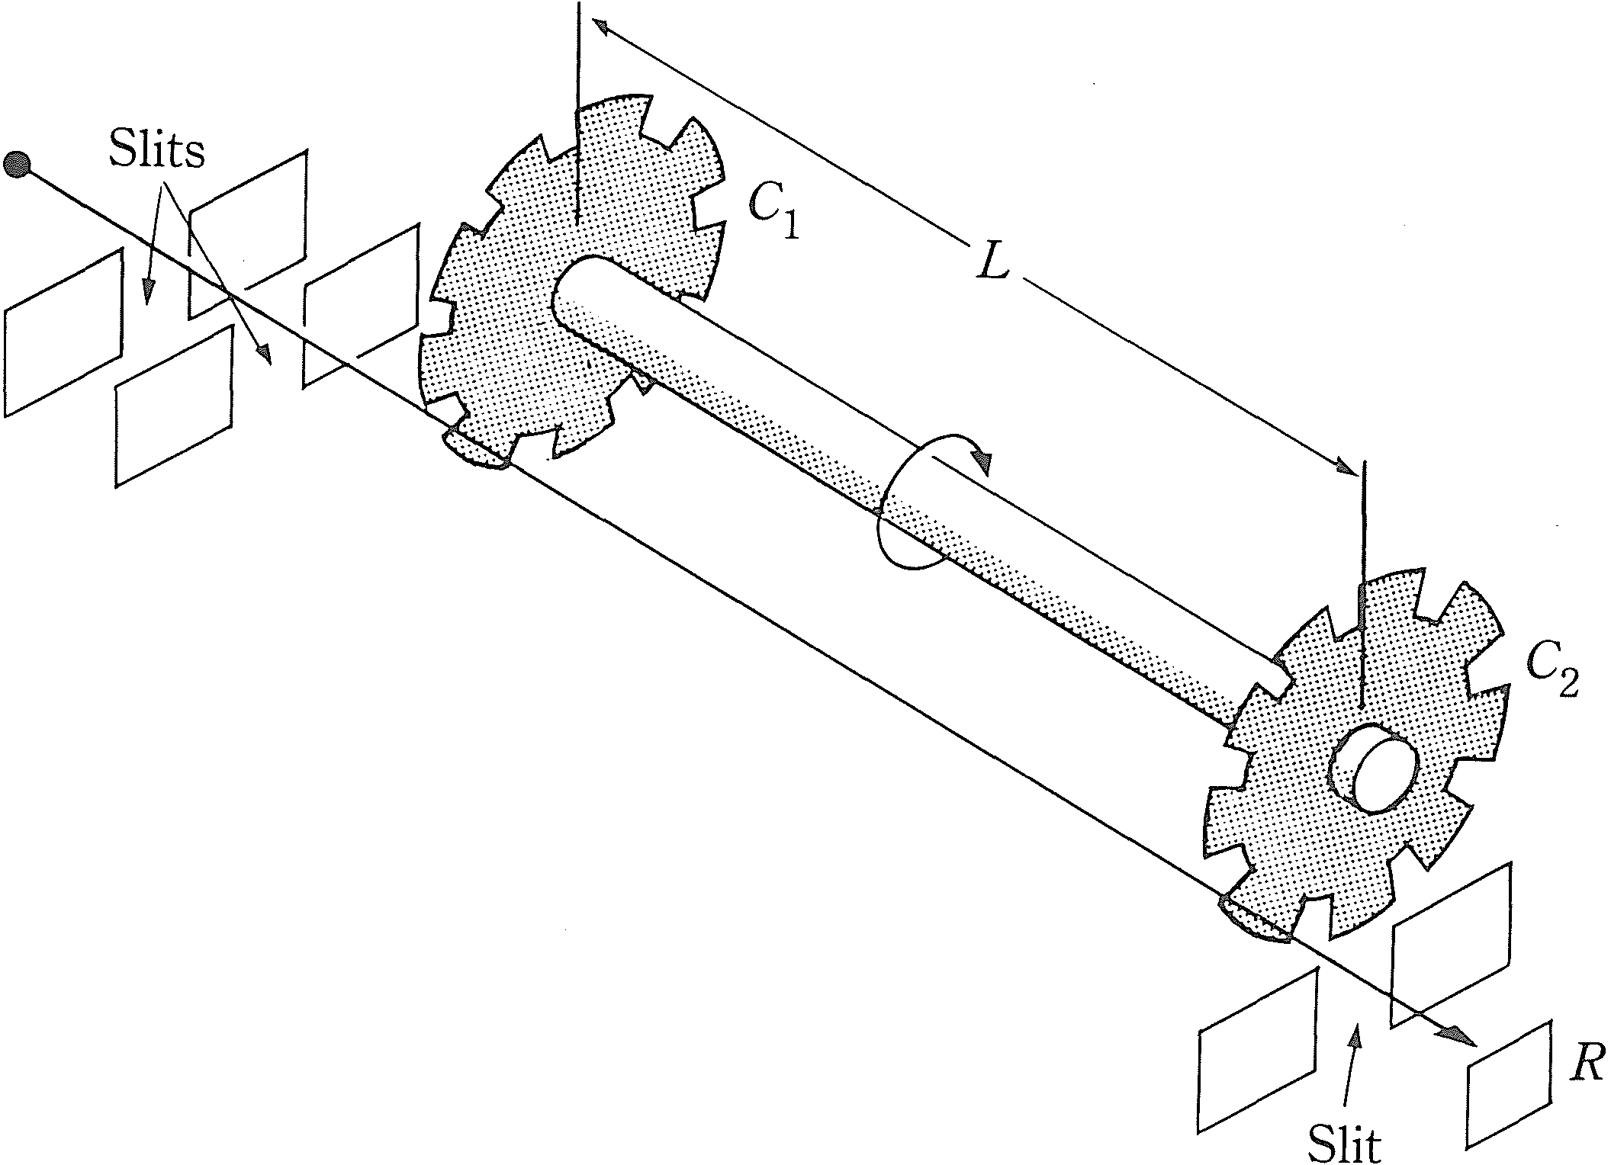

Figure 4.1 4 Experiment to ver ify the Maxwell di stribu ti on. (R ed rawn by permission from K. F. Herzfe ld and H. S mal lwood, A Treatise on Physical Chemistry, H. S. Taylor and S. Gl assto ne, ed s., vo l. II , 3d ed . New York : D. Van Nostra nd, 1 951 , p. 37.)
The molecules escape through a pinhole in the source S, are collimated by the slits, and then pass through one of the openings between the cogs in the cogwheel l ' The cogwheels e l and 2 are mounted on the same axle, which is rotated rapidly. Only those molecules that have a speed such that they travel the length L in the time required for the cogwheel to be displaced by the width of one opening can get to the detector at R. By changing the velocity of rotation ofthe cogwheels, molecules having different speeds can be admitted to R. The resemblance of this method to that of Fizeau for measuring the velocity of light should be noted. *

QUESTIONS
4.1 Why are probability laws required to describe gas molecules ?
4.2 What is the kinetic theory explanation of the ideal gas law dependence p oc V - I ?

4.3 Give a kinetic interpretation of why p for 1 mole of gaseous O 2 molecules is one-half that for 2 moles of gaseous 0 atoms at a given T and V.
4.4 Why does the Maxwell distribution go to zero at high speeds ? (Imagine what such molecules would do to the walls.) At zero speed ? (Imagine the fate of a molecule started at rest in the gas.)
4.5 If heavier gas molecules move more slowly than light gas molecules, why is the average kinetic energy independent of the mass ?
4.6 Would the average velocity components for gas molecules all vanish for a flowing gas ?

PROBLEMS
4.1 Compute the root-mean-square speed, the average speed, and the most probable speed of an oxygen molecule at 300 K and at 500 K. Compare with the values for hydrogen.
4.2 a) Compare the average speed of an oxygen molecule with that of a molecule of carbon tetrachloride at 20 °C.
b) Compare their average kinetic energies.
4.3 a) Compute the kinetic energy of a mole of a gas at 300 K and 500 K. b) Compute the average kinetic energy of a molecule at 300 K.
4.4 Kinetic theory was once criticized on the grounds that it should apply even to potatoes. Compute the average thermal speed at 25 °C of a potato weighing 100 g. Assuming that the earth's gravity field were turned off, how long would it take a potato to traverse 1 m? (After working the problem, compare with the result of Problem 2.2 1.)
4.5 An oxygen molecule having the average velocity at 300 K is released from the earth's surface to travel upward. If it could move without colliding with other molecules, how high would it go before corning to rest ? How high would it go if it had the average kinetic energy at 300 K?
4.6 Suppose that at some initial time all the molecules in a container have the same translational energy, 2.0 x 10- 2 1 J. As time passes, the motion becomes chaotic and the energies finally are distributed in a Maxwellian way.
a) Compute the final temperature of the system.
b) What fraction of the molecules finally have energies in the range between 1.98 x 10- 2 1 and
2.02 x 10- 2 1 J? [Hint : Since the range of energies in part (b) is small, the differential form of
the Maxwell distribution may be used.]
. ..
•. The quantity (c - <C»)2 = c 2 - 2c <c) + <C) 2 is the square of the deviation of the speed of
'-� . a molecule from the average speed. Compute the average value of this quantity using the Maxwell

* For a description of several methods of direct determination of the velocity distribution see K. F. Herzfeld and H. Smallwo od in A Treatise on Physical Chemistry, H. S. Taylor and S. Glasstone, eds., Vol. II, 3rd ed. New York : D. Van Nostrand, 19 51, p. 35ft".

