| **Name** | **Surya.A** |
| --- | --- |
| **Reg. No.** | **621421106052** |
| **Department** | **ECE** |
| **Year** | **III** |
| **College Name** | **Maha Barathi Engineering College** |
| **Group** | **IOT – Traffic Management** |

**PHASE-2**

**Innovation**

**In this phase you need to put your design into innovation to solve the problem.**

**Explain in detail the complete steps that will be taken by you to put your design that you thought of in previous phase into transformation.**

**Create a document around it and share the same for assessment**

**Traffic managent** 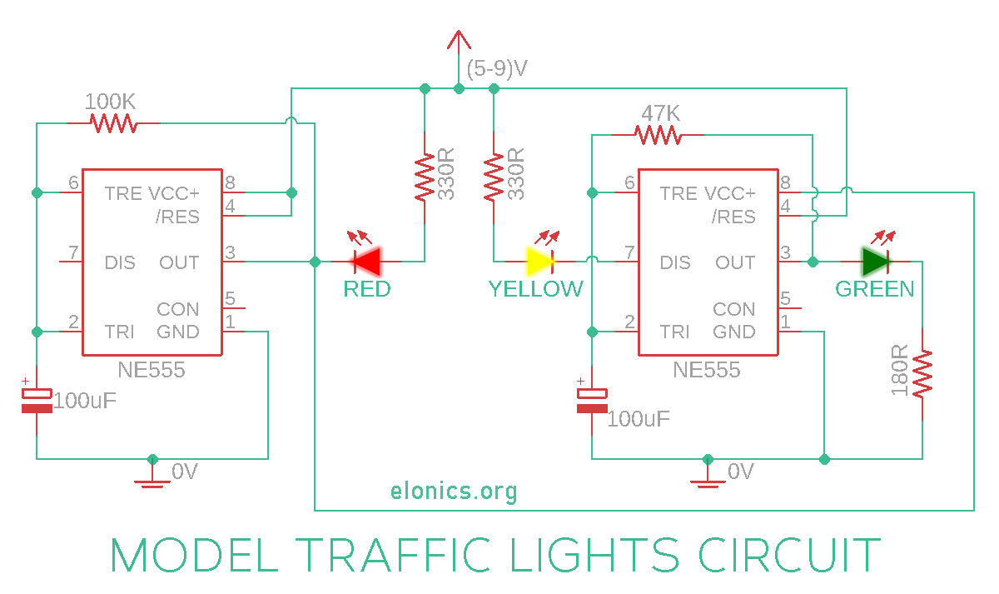

**WORKING**

**Circuit is very similar to the LED blinker circuit we have created in one of the previous videos. You may go through that video for better understanding:**[**Adjustable Flashing Blinking LED Circuit using 555 Timer IC**](https://elonics.org/adjustable-led-flasher-using-555-timer/)

**Here we have used two such astable circuits with the first astable circuit powering the other. So the second 555 timer IC will be powered only if the output of first 555 timer IC is ON.**

**The red LED is connected such that it turns ON only if the output of first 555 timer IC is at 0V. This is because the other terminal of red LED is connected to positive voltage. Yellow LED turns ON during discharge mode of second 555 IC, and the green LED turns ON whenever the output of second 555 timer IC is at positive voltage.**

**Immediately after we power ON this circuit, output of the first 555 timer IC will be in ON state because the voltage at PIN-3 (Trigger Pin) is less than 1/3rd of the supply voltage. The red LED cannot turn ON yet, but the second 555 IC is powered and so the green light turns ON.**

**The capacitor of 2nd 555 timer IC slowly charges and as soon as it charges to 2/3rd of the supply voltage (Threshold Voltage), the output of 2nd 555 IC turns OFF and the yellow LED glows because the discharge pin is activated.**

**Normally the yellow LED would turn ON for the same time as the green LED. But even before the capacitor of 2nd 555 timer IC reaches 1/3rd of supply voltage, the voltage across capacitor of 1st 555 timer IC reaches 2/3rds of the supply voltage and so the output of 1st 555 IC turns OFF, resulting in yellow LED turning OFF and the red LED turning ON.**