**Assignment-1**

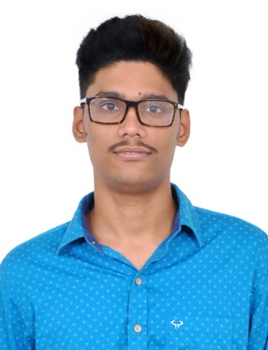

**Name : Surya Teja Avadhanula**

**Email ID :** [**suryatejasharma@gmail.com**](mailto:suryatejasharma@gmail.com)

I am Surya Teja an international student from India. I have done my undergraduate in Electronics and Communication Engineering (ECE) and currently pursuing master’s in Computer Sciences at SUNY New Paltz. Back in my undergrad, I have taken few courses related to Computer Sciences like C language, Computer Networks and Cryptography. Later I joined as software developer in Mindtree where I was part of a backend project working on Java, spring boot, MySQL and after that I switched onto a different project which dealt with HTML, CSS, jQuery, Ajax, ReactJS. I have pretty good knowledge over these technologies and willing to achieve more knowledge over frontend development.

As of now I have taken the course Advanced Web Programming since I can foresee that there is a lot to learn about the frontend technologies. The era keeps on changing and new programming languages keep adding up on the frontend development. As mentioned to above technologies I wish I could learn more and deep which would help progress a lot ahead in my future professionally.