**Topics: Descriptive Statistics and Probability**

1. Look at the data given below. Plot the data, find the outliers and find out $μ, σ, σ^{2}$

|  |  |
| --- | --- |
| **Name of company** | **Measure X** |
| Allied Signal | 24.23% |
| Bankers Trust | 25.53% |
| General Mills | 25.41% |
| ITT Industries | 24.14% |
| J.P.Morgan & Co. | 29.62% |
| Lehman Brothers | 28.25% |
| Marriott | 25.81% |
| MCI | 24.39% |
| Merrill Lynch | 40.26% |
| Microsoft | 32.95% |
| Morgan Stanley | 91.36% |
| Sun Microsystems | 25.99% |
| Travelers | 39.42% |
| US Airways | 26.71% |
| Warner-Lambert | 35.00% |

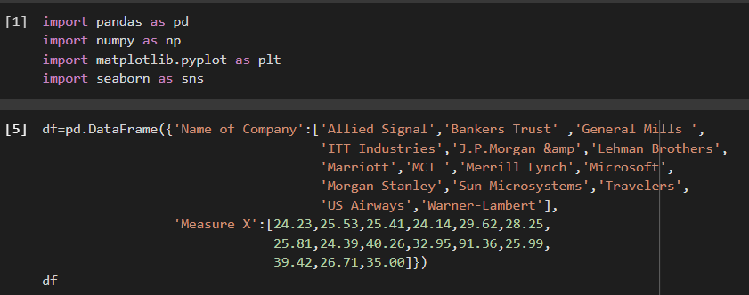

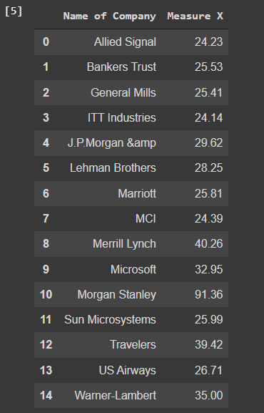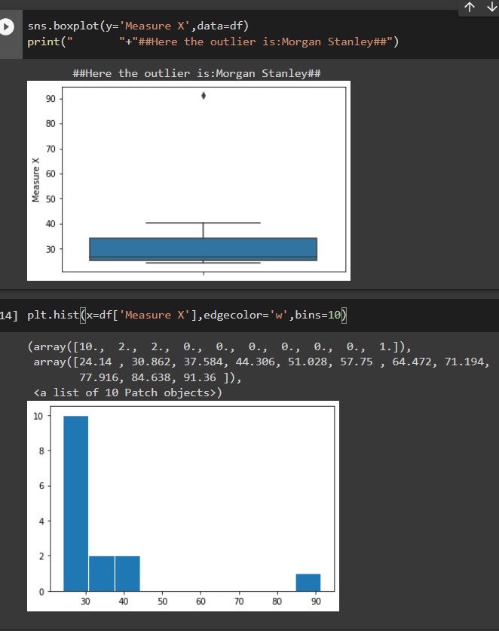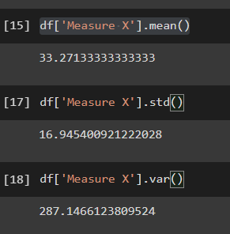



Answer the following three questions based on the box-plot above.

1. What is inter-quartile range of this dataset? (please approximate the numbers) In one line, explain what this value implies.

**ANSWER:**

**IQR= Q3-Q1=12-5=7**

1. What can we say about the skewness of this dataset?

**ANSWER:**

**It is positively skewed or Right skewed**

1. If it was found that the data point with the value 25 is actually 2.5, how would the new box-plot be affected?

**ANSWER:**

**It will not have any Outlier because it is not far from the range or not far from the boxplot**



Answer the following three questions based on the histogram above.

1. Where would the mode of this dataset lie?

**Answer:**

**Between the 5 and 8**

1. Comment on the skewness of the dataset.

**Answer:**

**Right skewed**

1. Suppose that the above histogram and the box-plot in question 2 are plotted for the same dataset. Explain how these graphs complement each other in providing information about any dataset

**Answer:**

The Data is **right skewed** irrespective of whether it is histogram boxplot. We can see outlier in both cases **datapoint at 25**

1. AT&T was running commercials in 1990 aimed at luring back customers who had switched to one of the other long-distance phone service providers. One such commercial shows a businessman trying to reach Phoenix and mistakenly getting Fiji, where a half-naked native on a beach responds incomprehensibly in Polynesian. When asked about this advertisement, AT&T admitted that the portrayed incident did not actually take place but added that this was an enactment of something that “could happen.” Suppose that one in 200 long-distance telephone calls is misdirected. What is the probability that at least one in five attempted telephone calls reaches the wrong number? (Assume independence of attempts.)

**Answer:**

Given that, one in 200 long-distance telephone calls is misdirected and To find that probability that at least one in five attempted telephone calls reaches the wrong number

* Probability of call misdirecting **(p)**=1/200
* Probability of call not Misdirecting **(q)**= 1-1/200=199/200
* No of calls**(n)**=5

**P(x)=** **ⁿCₓ*pˣ*qⁿ⁻ˣ**

at least one in five attempted telephone calls reaches the wrong number

=1-none of the call reaches to wrong number

=1-P (0)

=1- ⁿC0*(1/200)^0**\***(199/200)^5-0

=1-(199/200)^5

=0.02475

probability that at least one in five attempted telephone calls reaches the wrong number =**0.02475**

1. Returns on a certain business venture, to the nearest $1,000, are known to follow the following probability distribution

|  |  |
| --- | --- |
| x | P(x) |
| -2,000 | 0.1 |
| -1,000 | 0.1 |
| 0 | 0.2 |
| 1000 | 0.2 |
| 2000 | 0.3 |
| 3000 | 0.1 |

1. What is the most likely monetary outcome of the business venture?
2. Is the venture likely to be successful? Explain
3. What is the long-term average earning of business ventures of this kind? Explain
4. What is the good measure of the risk involved in a venture of this kind? Compute this measure

**Answer:**

most likely monetary outcome of the business venture is **$2000** as it has maximum probability = **0.3**

**E(X)           P(x)       E(X)P(X)**

-2,000   0.1            -200

-1,000     0.1            -100

0              0.2             0

1000         0.2           200

2000         0.3           600

3000         0.1         300

Expected value =   **∑E(X)P(X)** = **800**

long-term average earning of business ventures = **$ 800**

venture is likely to be successful as Expected value is +ve   = **$ 800**