**Topics: Normal distribution, Functions of Random Variables**

1. The time required for servicing transmissions is normally distributed with *μ* = 45 minutes and *σ* = 8 minutes. The service manager plans to have work begin on the transmission of a customer’s car 10 minutes after the car is dropped off and the customer is told that the car will be ready within 1 hour from drop-off. What is the probability that the service manager cannot meet his commitment?
2. 0.3875
3. **0.2676**
4. 0.5
5. 0.6987

**Answer:**

*μ* = 45

*σ* = 8

Since work begins after **10** min, so the time left to repair is **50** min.

Probability that the service manager cannot meet his commitment=**1-probability that the Service manager meet his commitment**

**P(X>50) =1-P(X<50)**

**Convert 50 to Z-Score**

**P(X<=50) =**P(Z<=(50-45)/8)=P(Z(0.625)) =**0 .73237**

**P(X>50)** =1- 0.73237=0.26763=**26.73%**

**Or**

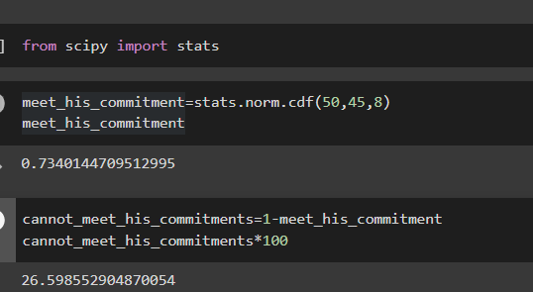

1. The current age (in years) of 400 clerical employees at an insurance claims processing center is normally distributed with mean *μ* = 38 and Standard deviation *σ* =6. For each statement below, please specify True/False. If false, briefly explain why.
2. More employees at the processing center are older than 44 than between 38 and 44.
3. A training program for employees under the age of 30 at the center would be expected to attract about 36 employees.

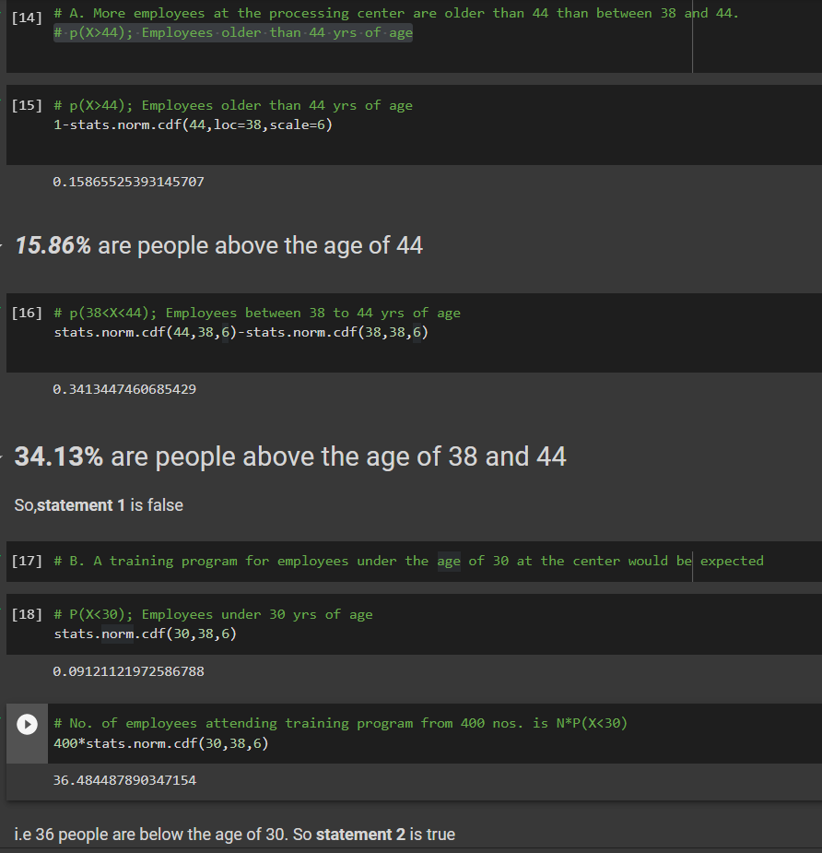

1. If *X1* ~ *N*(μ, σ2) and *X*2 ~ *N*(μ, σ2) are *iid* normal random variables, then what is the difference between 2 *X*1 and *X*1 + *X*2? Discuss both their distributions and parameters.

**Answer:**

2 X 1 = N(2μ, 4σ 2 )

X 1 + X 2 = N(µ+µ, σ^+σ^2 ) = N(2µ, 2σ^2 )

Sum of normally distributed random variables are normally distributed.

2X1 –( X 1 + X 2 ) = N(2μ, 4σ^2 ) - N(2μ, 2σ^2 ) = **N(6,σ^2 )**

1. Let X ~ N (100, 202). Find two values, *a* and *b*, symmetric about the mean, such that the probability of the random variable taking a value between them is 0.99.
2. 90.5, 105.9
3. 80.2, 119.8
4. 22, 78
5. **48.5, 151.5**
6. 90.1, 109.9

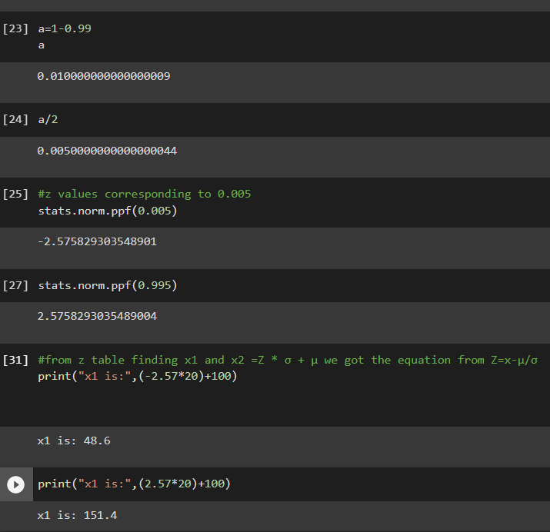

1. Consider a company that has two different divisions. The annual profits from the two divisions are independent and have distributions Profit1 ~ N(5, 32) and Profit2 ~ N(7, 42) respectively. Both the profits are in $ Million. Answer the following questions about the total profit of the company in Rupees. Assume that $1 = Rs. 45

**Answer:**

Division1 = Profit1 ~ N (5, 3^2) = N (Ẋ1=5, S1^2= 3^2)

Division2 = Profit2~ N (7, 4^2) = N (Ẋ2=7, S2^2 = 4^2)

µ = Company = (Profit1 + Profit2) = Mean Profit of Diivision1 + Division2= 5 + 7 = 12

Mean Profit of Company in rupees = 12 * 45 = **540 million**

1. Specify a Rupee range (centered on the mean) such that it contains 95% probability for the annual profit of the company.

**Answer:**

Variance of the Company Distribution =𝜎^2 = 3^2 + 4^2 = 9 + 16 = 25 = 52

Standard Deviation of the Company Distribution = 𝜎 = √52 = 5

Confidence Level = CL = 0.95

Confidence Interval = CI cc= 540 ± 1.96(225) = **(99,981) In Millions**

1. Specify the 5th percentile of profit (in Rupees) for the company

To calculate 5th percentile from Z table Zα/2= 0.05 = -1.645

5th percentile = µ - Zα/2= 0.05(𝜎)= 540 – 1.645(225) = **169.87 million**

1. Which of the two divisions has a larger probability of making a loss in a given year?

Probability of Company 1 Making Loss = P (X<0)

Zx1=0 = (0−225)/(135) **= 1.667**

Probability at x < 0 = P(Zx1=0) = 0.0485 = **4.85%**

Probability of Company 2 Making Loss = P (X<0)

Zx2=0 = (0−315)/ (180) = **−1.75**

Probability at x < 0 = P(Zx2=0) = 0.0401 = **4.01%**

**Therefore, Company 1 has High Probability of Making a loss in a given year**