Topics: Confidence Intervals

- For each of the following statements, indicate whether it is True/False. If false, explain why.

- The sample size of the survey should at least be a fixed percentage of the population size in order to produce representative results. -TRUE

- The sampling frame is a list of every item that appears in a survey sample, including those that did not respond to questions.- FALSE

- Larger surveys convey a more accurate impression of the population than smaller surveys.- TRUE

- PC Magazine asked all of its readers to participate in a survey of their satisfaction with different brands of electronics. In the 2004 survey, which was included in an issue of the magazine that year, more than 9000 readers rated the products on a scale from 1 to 10. The magazine reported that the average rating assigned by 225 readers to a Kodak compact digital camera was 7.5. For this product, identify the following:

- The population- All readers of PC Magazine
- The parameter of interest- Customer satisfaction on different brands of electronics
- The sampling frame-9000
- The sample size-225
- The sampling design-Population---Sampling Frame---Sample
- Any potential sources of bias or other problems with the survey or sample
When we say there's potential bias, we should also be able to argue if the results will probably be an overestimate or an underestimate.
Try to identify the source of bias in each scenario, and speculate on the direction of the bias (overestimate or underestimate).

- For each of the following statements, indicate whether it is True/False. If false, explain why.

- If the 95% confidence interval for the average purchase of customers at a department store is $50 to $110, then $100 is a plausible value for the population mean at this level of confidence. – TRUE
- 95% confidence interval for the average purchase of customers at a department store is $50 to $110, That means the population sample mean will falls between $50 to $110.100 also satisfies this
- If the 95% confidence interval for the number of moviegoers who purchase concessions is 30% to 45%, this means that fewer than half of all moviegoers purchase concessions. TRUE
- There is a 95% chance that only 30 to 45 % of moviegoers purchase concessions, which is less than 50%. this means that fewer than half of all moviegoers purchase concessions
- The 95% Confidence-Interval for μ only applies if the sample data are nearly normally distributed. TRUE
- IF the sample is not normally distributed, then that samples includes less information of population or Error in sample selection
- What are the chances that ?

- ¼
- ½
- ¾
- 1
Ans:D

- In January 2005, a company that monitors Internet traffic (WebSideStory) reported that its sampling revealed that the Mozilla Firefox browser launched in 2004 had grabbed a 4.6% share of the market.

- If the sample were based on 2,000 users, could Microsoft conclude that Mozilla has a less than 5% share of the market?
Answer:
Assume null hypothesis: H0: p>5%
Alternate hypothesis: Ha: p<5%
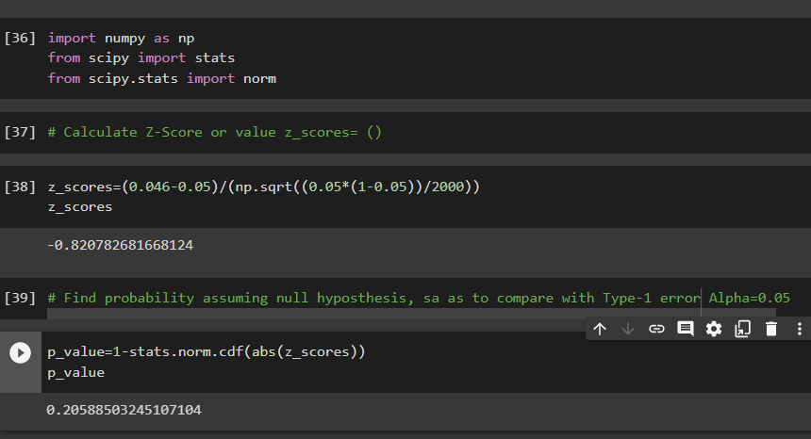
As (p_value = 0.2058) > (α = 0.05) ; Accept Null Hypothesis i.e. Mozilla market share > 5% Thus, Microsoft cannot conclude that Mozilla has a less than 5% share of the market

- WebSideStory claims that its sample includes all the daily Internet users. If that’s the case, then can Microsoft conclude that Mozilla has a less than 5% share of the market?
Answer:
We are given that Web Side Story claims that its sample includes all the daily
Internet users. This means that the 4.6% is the population percentage. Comparing it with
Microsoft&#39;s claim that Mozilla has a less than 5% share of the whole market is True. Hence,
we can conclude that Mozilla has a less than 5% share of the market.

- A book publisher monitors the size of shipments of its textbooks to university bookstores. For a sample of texts used at various schools, the 95% confidence interval for the size of the shipment was 250 ± 45 books. Which, if any, of the following interpretations of this interval are correct?

- All shipments are between 205 and 295 books. FALSE

- 95% of shipments are between 205 and 295 books. TRUE

- The procedure that produced this interval generates ranges that hold the population mean for 95% of samples.
TRUE
- If we get another sample, then we can be 95% sure that the mean of this second sample is between 205 and 295. TRUE

- We can be 95% confident that the range 160 to 340 holds the population mean. FALSE

- Which is shorter: a 95% z-interval or a 95% t-interval for μ if we know that σ =s?

- The z-interval is shorter
- The t-interval is shorter
- Both are equal
- We cannot say
Answer:
The z-interval is shorter

Questions 8 and 9 are based on the following: To prepare a report on the economy, analysts need to estimate the percentage of businesses that plan to hire additional employees in the next 60 days.

- How many randomly selected employers (minimum number) must we contact in order to guarantee a margin of error of no more than 4% (at 95% confidence)?

- 600
- 400
- 550
- 1000
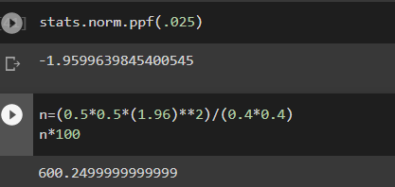

- Suppose we want the above margin of error to be based on a 98% confidence level. What sample size (minimum) must we now use?

- 1000
- 757
- 848
- 543

