**TABS/GROUPS**

Double tap on HOME → to hide/unhide the ribbon



Formula Bar



Right click on the Right arrow → to see all the sheet names



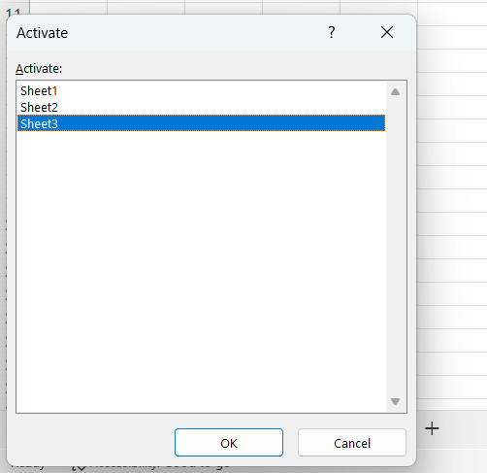

f2/double click → to enter /Edit the cell content

Group of worksheets → workbook

Group of cells → range

Click file → to explore excel templates

**Customize Ribbon - Create/Remove/Hide/Unhide tabs**

File → Options → Customize Ribbon

New tab → new grp → add items into grp → ok

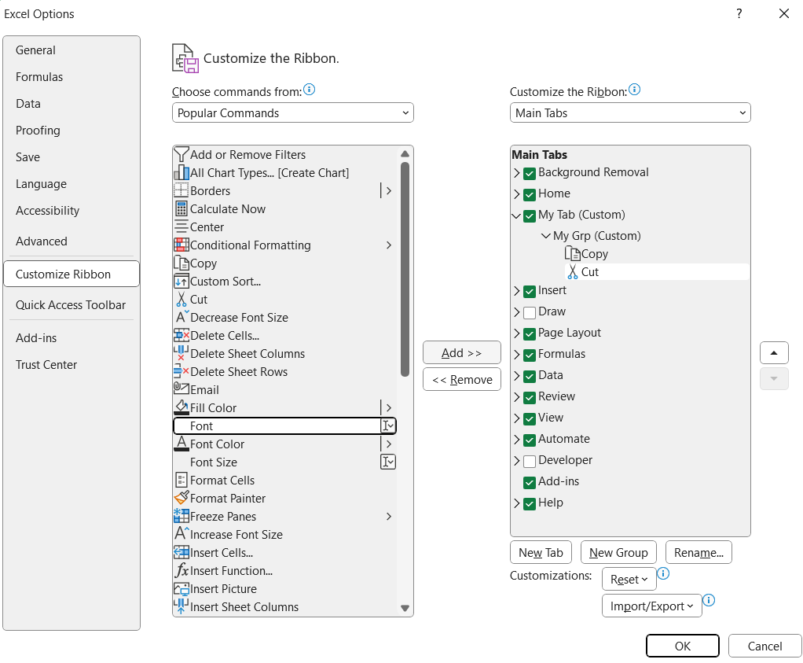

**EDITING DATA**

Ctrl + F → to find/ find and replace

**Copy & Paste column of cells to another cell**

Select cell to get content → write = and touch the cell u want here and drag down to get.

**Undo/Redo → Top left**

GoTo → Ctrl + G → to move to desired cell in the excel sheet

**GoTo in GUI -> top right (find & select)**

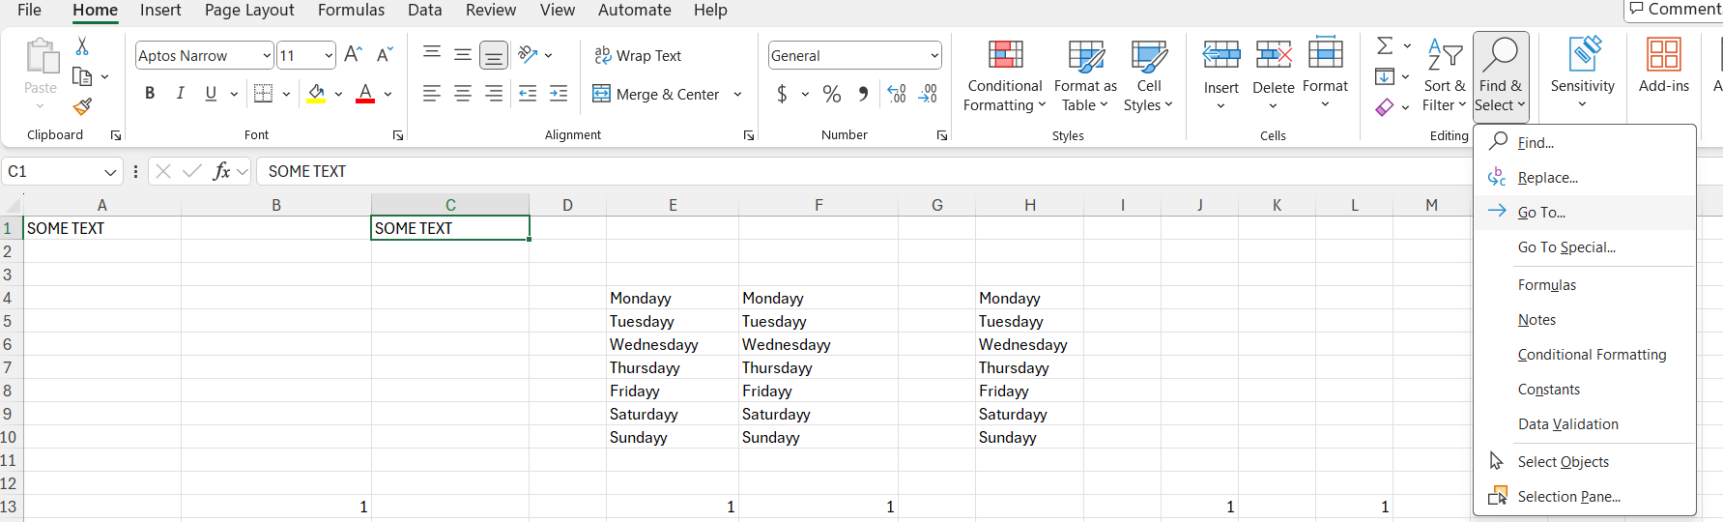

Click on goto select → goto special

Select formulas → to select all the cells with formulas alone

**FORMATTING DATA**

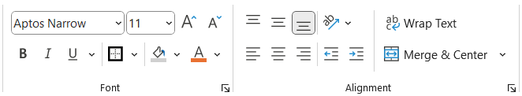

Font,alignment,font size,background color,indent,wrap text

Click on arrows → dialog box to assist you further

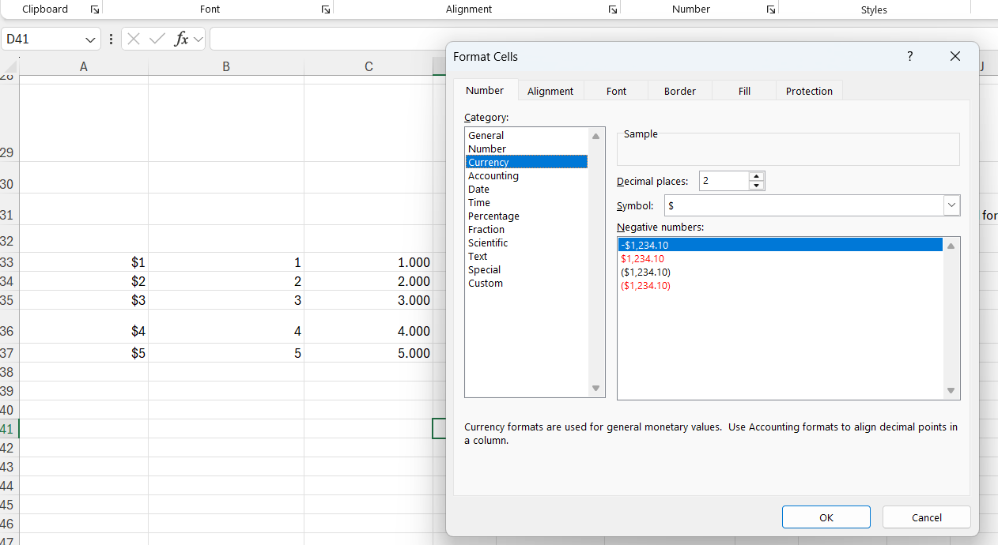

Ct