IN22 Indic Embedding Alignment Report
Focus: model alignment and LaBSE performance on Indic-Indic retrieval
Source artifacts: IN22 benchmark notebook: in22_indic_embedding_alignment_benchmark_colab(1).ipynb; saved metrics/plots folder: https://drive.google.com/drive/folders/1sPFO4hA3qKlBN2b9JVRRF7cEtNHZrMXo?usp=sharing

Dataset Description
This benchmark uses the IN22 evaluation suites, specifically IN22-Gen and IN22-Conv, for evaluating multilingual sentence embedding alignment across Indian languages. IN22 was selected because it provides multi-way aligned sentences across all 22 scheduled Indic languages plus English.
The dataset is used in two evaluation tracks:
Difference Between IN22-Gen and IN22-Conv
The benchmark uses both IN22-Gen and IN22-Conv because they test different types of language alignment.
Dataset suite | Description | Why it matters
IN22-Gen | Contains general-domain sentences from sources such as news, Wikipedia-style content, culture, and general information. | Useful for testing alignment on formal and general written text.
IN22-Conv | Contains conversational and daily-use sentences. | Useful for testing alignment on informal, natural, and spoken-style language.

1. Benchmark setup and main evaluation view
The benchmark evaluates sentence embedding alignment on IN22-Gen and IN22-Conv using all 22 scheduled Indic languages plus English. It has two tracks: (a) Indic-Indic only and (b) English-Indic bidirectional. The main goal is alignment, so the primary metrics are mean gold-pair cosine and cosine gap. Accuracy@1 is reported as supporting evidence for retrieval and separation.
Track | Directions evaluated | Purpose
Indic-Indic | 22 x 21 = 462 directed pairs | Measures alignment between scheduled Indic languages only. This is the main track for the mentor's current direction.
English-Indic bidirectional | 22 English->Indic + 22 Indic->English = 44 directed pairs | Checks how well Indic embeddings align with English as a reference language.
Interpretation rule: high mean gold-pair cosine alone is not enough. A model is useful for alignment only if the correct pairs are close and random/wrong pairs are clearly farther away. This is captured by cosine gap: mean_gold_cosine - mean_random_cosine.

2. Important result: mean cosine alone can be misleading
XLM-RoBERTa, MuRIL, and supervised SimCSE-RoBERTa show very high mean gold-pair cosine. However, their random-pair cosine is also very high, so the cosine gap becomes almost zero. This means many wrong candidates are also close in the embedding space. Therefore, these models look aligned by raw cosine, but they are not well separated for reliable nearest-neighbour alignment.
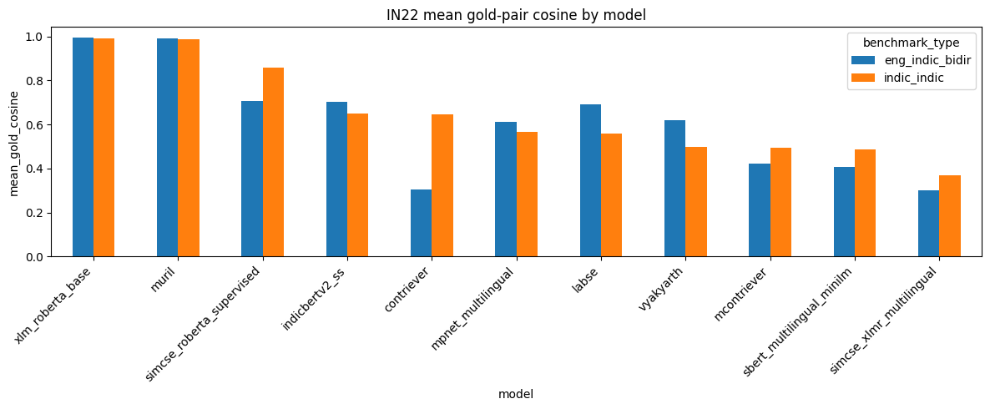
Figure 1. Mean gold-pair cosine by model. High values alone do not prove reliable alignment because wrong pairs may also have high cosine.
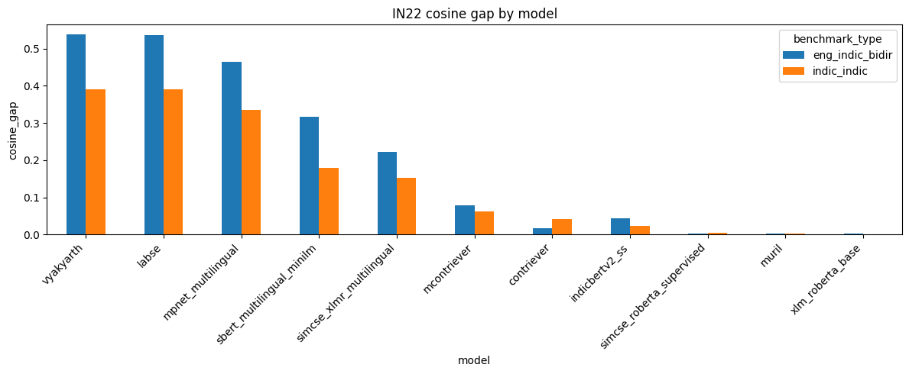
Figure 2. Cosine gap by model. This is the stronger alignment signal because it compares true pairs against random/wrong pairs.

3. Indic-Indic model comparison
For the Indic-Indic track, LaBSE is the strongest overall model. Vyakyarth has a marginally higher cosine gap, but LaBSE has much stronger Accuracy@1 and MRR. This means LaBSE is more reliable when the model must identify the correct translation among many Indic candidates.
Model | Mean gold cosine | Mean random cosine | Cosine gap | Accuracy@1 | Recall@10 | Interpretation
labse | 0.5602 | 0.1704 | 0.3898 | 0.6544 | 0.7338 | Best overall Indic-Indic performer
vyakyarth | 0.4971 | 0.1062 | 0.3910 | 0.4937 | 0.6277 | Highest gap, lower retrieval than LaBSE
mpnet_multilingual | 0.5682 | 0.2340 | 0.3342 | 0.4046 | 0.5506 | Strong general multilingual baseline
muril | 0.9868 | 0.9849 | 0.0018 | 0.2375 | 0.3787 | High cosine but weak separation
xlm_roberta_base | 0.9928 | 0.9913 | 0.0015 | 0.0877 | 0.1969 | Very high cosine, poor separation
Key point: for Indic-Indic alignment, LaBSE has a strong positive gap (0.3898) and the best Accuracy@1 (0.6544). In contrast, XLM-RoBERTa has a very high mean gold cosine (0.9928) but a near-zero gap (0.0015) and very low Accuracy@1 (0.0877). This confirms that high cosine by itself can hide poor uniformity/separation.

4. LaBSE performance in the Indic-Indic setting
LaBSE is the most useful model for the current Indic-Indic alignment task because it balances both requirements: gold translations are close, and random/wrong translations are farther away. It is also more consistent across IN22-Gen and IN22-Conv than most other models.
Dataset suite | Track | Mean gold cosine | Mean random cosine | Cosine gap | Accuracy@1 | Recall@10 | MRR
IN22-Gen | Indic-Indic | 0.5932 | 0.1806 | 0.4126 | 0.7433 | 0.7870 | 0.7595
IN22-Conv | Indic-Indic | 0.5271 | 0.1602 | 0.3669 | 0.5655 | 0.6806 | 0.6072
Overall | Indic-Indic | 0.5602 | 0.1704 | 0.3898 | 0.6544 | 0.7338 | 0.6833
IN22-Gen is easier for LaBSE than IN22-Conv: Accuracy@1 is 0.7433 on IN22-Gen and 0.5655 on IN22-Conv. This is expected because conversational text is usually more informal and semantically varied. Even in the harder conversational split, LaBSE keeps a large cosine gap (0.3669), which shows useful alignment.
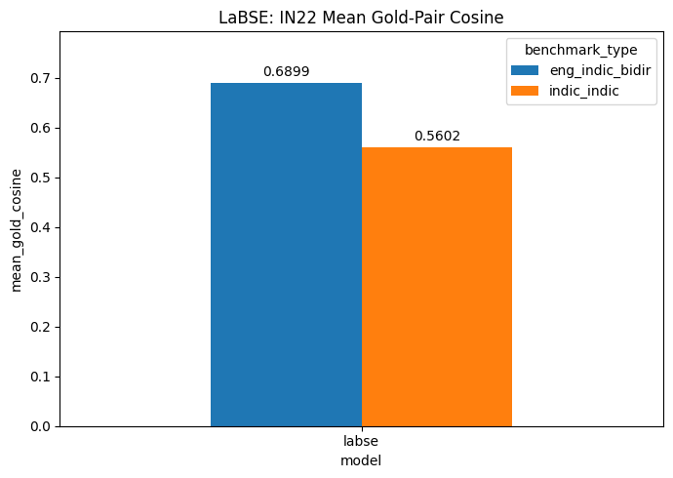

model | benchmark_type | mean_gold_cosine | mean_random_cosine | cosine_gap
labse | eng_indic_bidir | 0.689867 | 0.154158 | 0.535709
labse | indic_indic | 0.560159 | 0.170376 | 0.389783

5. LabSE pair-level behaviour on Indic-Indic
The heatmap below shows LaBSE on IN22-Gen Indic-Indic using cosine gap. Most language-pair directions have clear positive separation. Some directions involving lower-resource or script-specific languages, especially Meitei and Santali, are visibly weaker. This suggests that even the best model still needs pair-level analysis rather than only one average score.
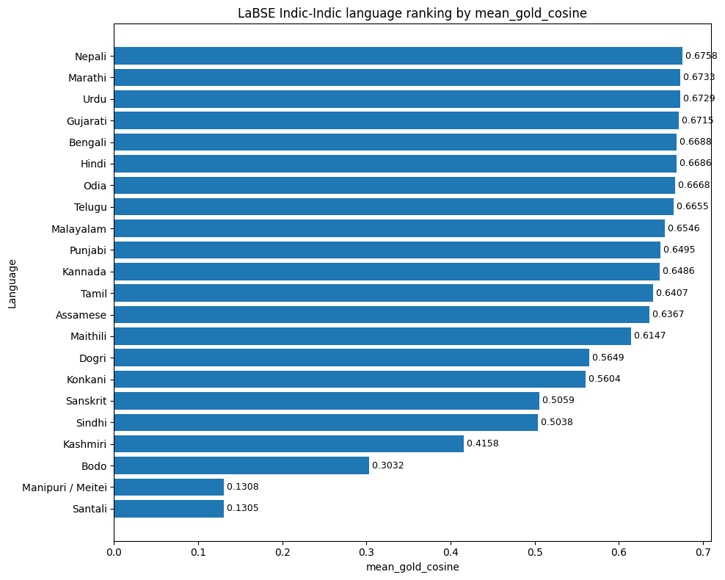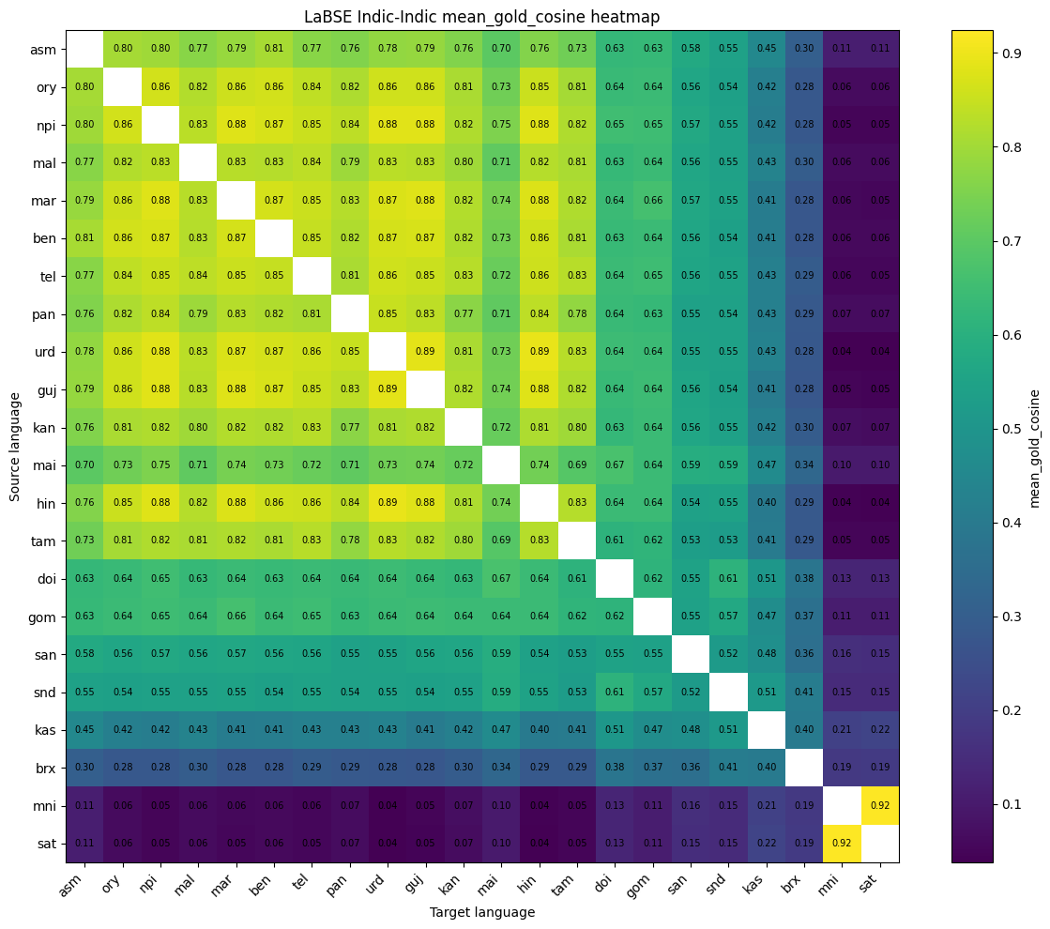

Figure 4. LaBSE IN22-Gen Indic-Indic cosine-gap heatmap. Brighter cells indicate stronger separation between true and random pairs.

6. Final conclusion and recommended use
The IN22 results show that LaBSE is the strongest overall choice for Indic alignment, especially for the Indic-Indic setting. Vyakyarth is a strong competitor for alignment because it has the highest cosine gap, but LaBSE is more reliable overall because it also has substantially higher retrieval performance. XLM-RoBERTa and MuRIL should not be selected based on mean cosine alone: their gold-pair cosine is extremely high, but their cosine gap is almost zero, showing weak separation. For final reporting, use LaBSE as the primary Indic-Indic alignment baseline, with Vyakyarth and multilingual MPNet as strong comparison models.
Supporting English-Indic result: LaBSE also performs strongly in the English-Indic bidirectional track, with mean gold cosine 0.6899, cosine gap 0.5357, Accuracy@1 0.8232, and Recall@10 0.8702. This supports the same conclusion, but the main focus should remain Indic-Indic alignment.

