Benchmark Comparison for Indic Embedding Evaluation
Nikunj threshold benchmark vs. Samanantar retrieval benchmark vs. Samanantar average-cosine benchmark

1. The Three Benchmark Setups
No. | Benchmark | Data used | Main metrics | What it answers
1 | Nikunj Samanantar Gold-Pair Threshold Benchmark | Samanantar; 500 random pairs for Hindi-English and Tamil-English | Mean gold-pair cosine; % pairs above 0.80 and 0.60 | Checks whether true translation pairs cross a fixed cosine threshold.
2 | Samanantar Translation Retrieval Benchmark | Samanantar; 2,000 pairs per Indic language; English->Indic and Indic->English directions | Accuracy@1, Recall@10, MRR, cosine gap | Checks whether the correct translation is ranked nearest among all candidates.
3 | Samanantar Average Gold-Pair Cosine Benchmark | Samanantar; 2,000 pairs per language pair | Mean cosine, median cosine, std, min/max, % above thresholds | Checks average closeness of only the gold translation pairs.
Key point: these benchmarks are related, but they are not interchangeable. A fixed cosine-threshold score, an average cosine score, and a retrieval Accuracy@1 score answer different questions.

2. Nikunj Samanantar Gold-Pair Threshold Benchmark
Method. Nikunj sampled 500 Samanantar translation pairs for Hindi-English and Tamil-English. For each model, the notebook encoded the source and target sentences, computed the cosine similarity for each gold translation pair, and summarized the score distribution. This is a gold-pair similarity evaluation, not a retrieval evaluation.
Model | Pair | Mean cosine | Pairs > 0.80 | Pairs > 0.60
LaBSE | hi<->en | 0.7991 | 68.2% | 95.4%
IndicBERT v2 | hi<->en | 0.7995 | 59.4% | 99.6%
IndicSBERT | hi<->en | 0.7517 | 44.8% | 87.0%
Vyakyarth | hi<->en | 0.7974 | 61.2% | 92.4%
LaBSE | ta<->en | 0.7708 | 69.4% | 89.8%
IndicBERT v2 | ta<->en | 0.7512 | 22.6% | 97.8%
IndicSBERT | ta<->en | 0.7016 | 32.6% | 79.2%
Vyakyarth | ta<->en | 0.7063 | 33.6% | 80.0%
Interpretation. LaBSE showing around 68-69% for pairs above 0.80 does not mean LaBSE failed retrieval. It only means roughly that fraction of gold pairs crossed a strict absolute threshold. A pair with cosine 0.75 fails the >0.80 test, even if it is still the closest candidate among thousands of alternatives.

3. Samanantar Translation Retrieval Benchmark
Method. The retrieval benchmark uses the same general parallel-text idea, but evaluates ranking. For a source sentence, the model compares it against all target-language candidates in the sampled set. If the correct translation is ranked first, it counts as an Accuracy@1 success. This setup therefore tests whether the embedding space is useful for translation retrieval, not just whether gold pairs have high absolute cosine scores.
Model | Avg Accuracy@1 | Avg Recall@10 | Avg MRR | Avg cosine gap
LaBSE | 0.9308 | 0.9517 | 0.9392 | 0.5918
Multilingual MPNet | 0.6555 | 0.8295 | 0.7180 | 0.5296
MuRIL | 0.4985 | 0.7224 | 0.5774 | 0.0037
SBERT Multilingual MiniLM | 0.3200 | 0.4820 | 0.3771 | 0.3132
mContriever | 0.2107 | 0.4049 | 0.2775 | 0.0949
IndicBERTv2-SS | 0.1122 | 0.1580 | 0.1305 | 0.0319
XLM-RoBERTa base | 0.0997 | 0.2448 | 0.1505 | 0.0040
Interpretation. LaBSE is clearly strongest under retrieval. This explains why a retrieval benchmark can report a value above 90% or even near-perfect in some language directions, while Nikunj's threshold benchmark reports fewer pairs above a strict 0.80 cosine threshold. They are measuring different properties.
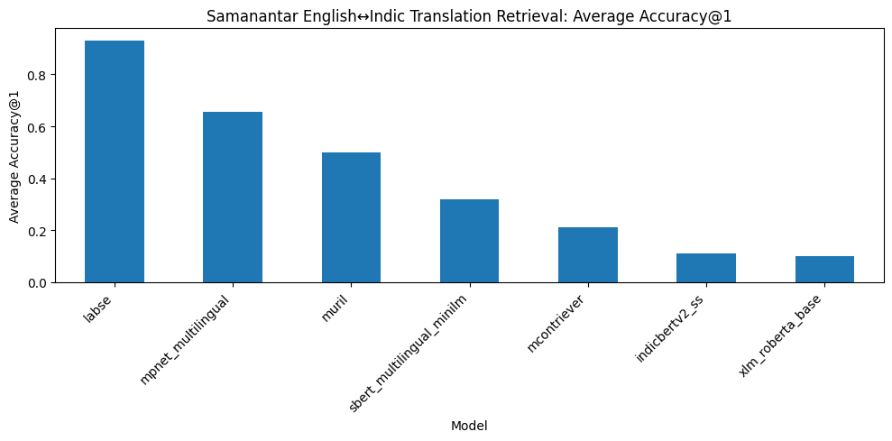
Figure 1. Samanantar retrieval benchmark: average Accuracy@1 by model.

4. Samanantar Average Gold-Pair Cosine Benchmark
Method. This benchmark was created as a closer comparison to Nikunj's method. It computes cosine similarity only for aligned gold translation pairs and then averages the score for each model-language pair. It does not test whether wrong target sentences also receive high cosine scores.
Model | Avg mean cosine | Avg % > 0.60 | Avg % > 0.80
XLM-RoBERTa base | 0.9941 | 1.0000 | 1.0000
MuRIL | 0.9916 | 1.0000 | 1.0000
LaBSE | 0.7872 | 0.9168 | 0.7425
Multilingual MPNet | 0.6641 | 0.6838 | 0.2685
IndicBERTv2-SS | 0.6287 | 0.5165 | 0.1327
mContriever | 0.4447 | 0.0431 | 0.0003
SBERT Multilingual MiniLM | 0.4107 | 0.2754 | 0.0860
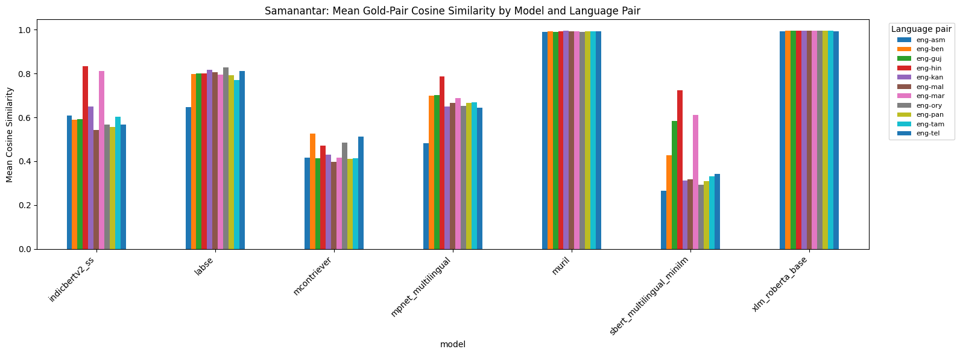
Figure 2. Samanantar average gold-pair cosine similarity by model and language pair.

5. Why the Results Differ
Evaluation type | Question asked | Example | Outcome
Threshold cosine | Is the gold pair cosine above a fixed value such as 0.80? | Correct pair cosine = 0.75 | Fails because 0.75 < 0.80
Average cosine | What is the average similarity of gold translation pairs? | Gold pairs are high on average | Looks strong, but says nothing about wrong candidates
Retrieval Accuracy@1 | Is the gold translation the nearest neighbour among all candidates? | Correct = 0.75; wrong candidates = 0.40, 0.33, 0.28 | Succeeds because the correct translation is still highest
Therefore, Nikunj's LaBSE result and the retrieval result are not contradictory. A strict threshold benchmark can report fewer than 80% of pairs above 0.80, while a retrieval benchmark can still report very high Accuracy@1 if the correct translations are ranked above all competing candidates.

6. Alignment and Uniformity
Alignment. Similar sentences should be close together. In this project, an English sentence and its Indic translation should have high cosine similarity. Nikunj's threshold benchmark and the average-cosine benchmark mainly measure this property.
Uniformity. Sentence embeddings should be spread out well in the vector space. Wrong or unrelated sentences should not all collapse into the same region. Retrieval metrics depend on this property because the correct translation must beat all wrong candidates, not just be close in absolute terms.
Observed behaviour | Meaning | Example/Implication
High average cosine + high Accuracy@1 | Good alignment and good separation | LaBSE is the clearest example.
High average cosine + low Accuracy@1 | Gold pairs are close, but wrong pairs may also be close; poor uniformity/separation | XLM-RoBERTa and MuRIL under mean pooling can show this behaviour.
Low average cosine + low Accuracy@1 | Weak alignment and weak retrieval usefulness | Some baseline/backbone models can fall here.
Moderate cosine + high Accuracy@1 | Absolute scores are not very high, but the correct candidate is still ranked above wrong candidates | This is why threshold metrics alone are insufficient.

7. Why XLM-RoBERTa Can Look Good in Average Cosine but Poor in Accuracy@1
XLM-RoBERTa is a multilingual backbone model, not a sentence-embedding model optimized for nearest-neighbour retrieval. With simple mean pooling, many embeddings can become highly similar to each other. This can produce very high gold-pair cosine scores while also giving similarly high scores to wrong candidates.
Example: Correct translation cosine = 0.99, but wrong sentence cosines = 0.98, 0.99, 0.98. The average gold-pair cosine looks excellent, but retrieval can fail because the correct translation is not clearly separated. This is a uniformity problem: the vector space is not spread out enough for reliable nearest-neighbour retrieval.

8. Final Reporting Recommendation
The strongest documentation should report both alignment-style and retrieval-style metrics. Average cosine or threshold cosine alone can be misleading because they only check gold-pair closeness. Retrieval Accuracy@1, Recall@10, MRR, and cosine gap show whether the embedding space can actually separate correct translations from wrong candidates.
Report component | Metric(s) | Reason
Primary retrieval metrics | Accuracy@1, Recall@10, MRR | Shows whether correct translations are ranked above candidates.
Alignment metrics | Mean gold-pair cosine, % > 0.80 | Shows whether true translation pairs are close in absolute terms.
Separation metric | Cosine gap | Shows whether true pairs are closer than random wrong pairs.
Qualitative check | Error examples | Shows where a model confuses semantically similar but incorrect candidates.

9. Result Folders and Notebooks
Samanantar Retrieval Accuracy Benchmark Results: Drive folder
Samanantar Average Gold-Pair Cosine Benchmark Results: Drive folder
Nikunj benchmark notebook: teammate_benchmark.ipynb
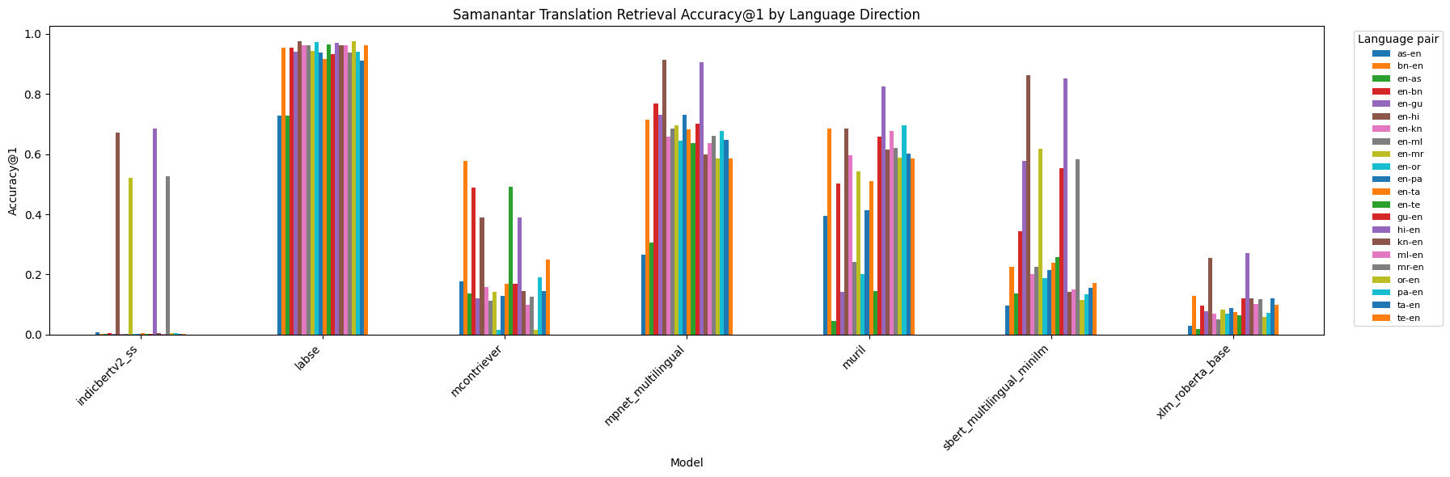
Figure 3. Samanantar retrieval Accuracy@1 by model and language direction.
Final conclusion. LaBSE remains the strongest model overall because it performs well in both gold-pair similarity and retrieval. XLM-RoBERTa demonstrates why average cosine alone is not enough: high gold-pair cosine can coexist with poor retrieval if embeddings are not uniformly spread and wrong candidates are also close.

