Indic Embedding Model Benchmark Report
Cross-lingual language alignment benchmark using FLORES-200
Output folder: Google Drive benchmark folder

1. Executive summary
Objective. The benchmark evaluates whether semantically equivalent sentences from different languages receive similar embeddings. The central test is translation retrieval: for a source sentence, the correct translation in a target language should be ranked as the nearest neighbour in embedding space.
Scope. The final run used FLORES dev + devtest, six languages, ten embedding/backbone models, and all directed cross-language pairs. This produced 300 model-language-pair rows: 10 models x 30 directed language pairs.
Headline result. LaBSE ranked first with 99.87% average Accuracy@1 across all language pairs. Multilingual MPNet ranked second, MuRIL ranked third, and SimCSE-XLMR/mContriever formed the middle tier. Raw backbone or non-cross-lingual sentence models performed much worse under simple mean pooling.

2. Overall results
Table 1 ranks models by average Accuracy@1 across all 30 directed language pairs. Accuracy@1 is the most direct answer to the alignment question because it measures whether the correct translation is the nearest neighbour.
Table 1. Overall model summary across all language pairs.
Rank | Model | Avg Accuracy@1 | Avg Recall@10 | Avg MRR | Avg cosine gap
1 | labse | 99.87% | 99.94% | 0.9990 | 0.5918
2 | mpnet_multilingual | 87.20% | 96.14% | 0.9052 | 0.6141
3 | muril | 77.61% | 91.88% | 0.8272 | 0.0033
4 | simcse_xlmr_multilingual | 53.46% | 80.30% | 0.6278 | 0.3328
5 | mcontriever | 45.03% | 70.68% | 0.5395 | 0.1469
6 | sbert_multilingual_minilm | 22.59% | 31.64% | 0.2581 | 0.2024
7 | xlm_roberta_base | 21.42% | 45.55% | 0.2962 | 0.0012
8 | contriever | 6.06% | 12.30% | 0.0843 | 0.0364
9 | indicbertv2_ss | 5.37% | 6.96% | 0.0612 | 0.0076
10 | simcse_roberta_supervised | 0.41% | 1.92% | 0.0114 | 0.0021

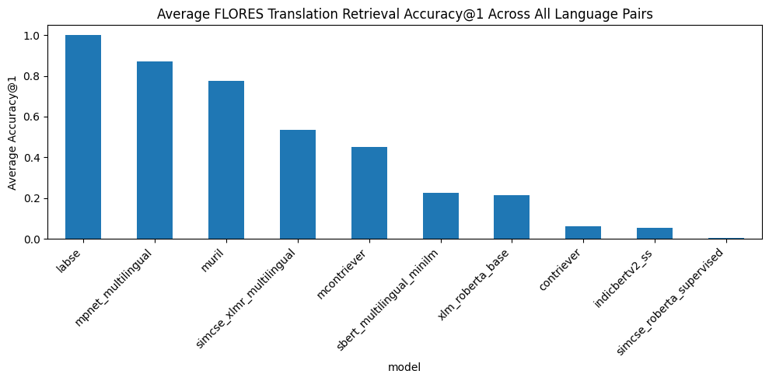
Figure 1. Average Accuracy@1 across all directed language pairs.

3. Interpretation of results
- LaBSE is the strongest alignment model. LaBSE achieved near-perfect Accuracy@1 and Recall@10. This indicates that its multilingual sentence space is highly aligned across the tested languages.
- Multilingual MPNet is the next strongest general baseline. It performed strongly across most language pairs but was consistently below LaBSE.
- MuRIL is a strong Indic-focused baseline but behaves differently from sentence-transformer models. MuRIL had high retrieval performance but a very small cosine gap. This suggests that nearest-neighbour ranking is useful for MuRIL, while raw cosine-gap magnitude should be interpreted carefully across model families.
- mContriever and SimCSE-XLMR are useful middle-tier baselines. These models performed better than XLM-R base and Contriever, but they did not match LaBSE or multilingual MPNet for sentence translation alignment.
- Backbone models need adaptation. XLM-R base and IndicBERTv2-SS were not competitive under simple mean pooling. This does not mean they are poor language models; it means they are not ready-made sentence embedding models for this retrieval setup without additional pooling, contrastive training, or fine-tuning.

4. Dataset and evaluation design
Table 2. Benchmark setup.
Item | Value
Dataset | FLORES-200
Splits used | dev + devtest
Examples per language | 2009
Languages | English, Hindi, Bengali, Telugu, Tamil, Malayalam
Language pairs | All directed cross-language pairs; same-language pairs excluded
Directed pairs per model | 6 languages x 5 targets = 30
Models evaluated | 10
Total metric rows | 300
Max sequence length | 128 tokens
Batch size | 32
Runtime | Google Colab GPU

Table 3. Languages used in the pilot benchmark.
Short code | FLORES code | Language
en | eng_Latn | English
hi | hin_Deva | Hindi
bn | ben_Beng | Bengali
te | tel_Telu | Telugu
ta | tam_Taml | Tamil
ml | mal_Mlym | Malayalam

5. Models evaluated
Table 4. Model collection and embedding method.
Model | HF checkpoint | Kind | Embedding method used
labse | sentence-transformers/LaBSE | sentence_transformer | Built-in SentenceTransformer encode/pooling
mpnet_multilingual | sentence-transformers/paraphrase-multilingual-mpnet-base-v2 | sentence_transformer | Built-in SentenceTransformer encode/pooling
muril | google/muril-base-cased | hf_mean_pool | Hugging Face AutoModel + attention-mask mean pooling
indicbertv2_ss | ai4bharat/IndicBERTv2-SS | hf_mean_pool | Hugging Face AutoModel + attention-mask mean pooling
xlm_roberta_base | FacebookAI/xlm-roberta-base | hf_mean_pool | Hugging Face AutoModel + attention-mask mean pooling
sbert_multilingual_minilm | sentence-transformers/paraphrase-multilingual-MiniLM-L12-v2 | sentence_transformer | Built-in SentenceTransformer encode/pooling
simcse_roberta_supervised | princeton-nlp/sup-simcse-roberta-base | hf_mean_pool | Hugging Face AutoModel + attention-mask mean pooling
simcse_xlmr_multilingual | ZurichNLP/unsup-simcse-xlm-roberta-base | hf_mean_pool | Hugging Face AutoModel + attention-mask mean pooling
contriever | facebook/contriever | hf_mean_pool | Hugging Face AutoModel + attention-mask mean pooling
mcontriever | facebook/mcontriever | hf_mean_pool | Hugging Face AutoModel + attention-mask mean pooling

6. Methodology
- Load aligned sentences: Each row index in FLORES corresponds to the same underlying sentence meaning across languages.
- Encode sentences: Each model converts the text into vectors. Sentence-transformer models use their packaged encoder; backbone models use mean pooling over token embeddings.
- Normalize vectors: Embeddings are normalized so dot product is used as cosine similarity.
- Compute similarity matrix: For each source-target language pair, every source sentence is compared against every target sentence.
- Rank the correct translation: The correct translation for row i should be target row i. The code records where target i appears in the sorted nearest-neighbour list.
- Save errors: For incorrect nearest-neighbour cases, the report stores source text, gold translation, predicted neighbour, gold cosine, predicted cosine, and margin.

Table 5. Evaluation metrics.
Metric | Meaning
Accuracy@1 | Fraction of cases where the correct translation is ranked first. Higher is better.
Recall@10 | Fraction of cases where the correct translation is within the top 10 candidates. Higher is better.
MRR | Mean reciprocal rank. Rewards correct translations being near the top. Higher is better.
Mean / median rank | Average and middle rank of the correct translation. Lower is better.
Cosine gap | Mean cosine of true translation pairs minus mean cosine of random mismatched pairs. Higher usually indicates cleaner separation.

7. Pair-level results and visual analysis
The full all-pair bar plot is included for completeness, but it is dense because there are 30 directed language pairs per model. The heatmaps in the appendix are easier to read pair-by-pair.
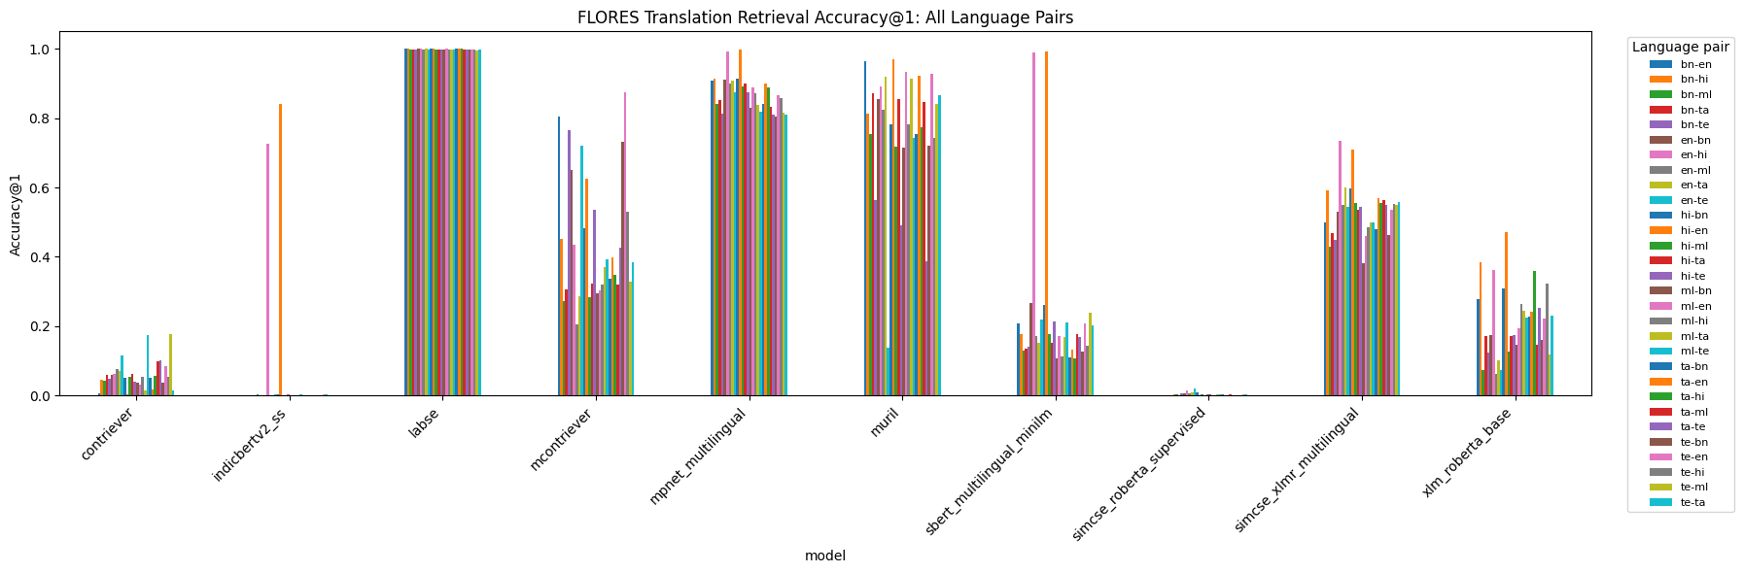
Figure 2. Accuracy@1 for every directed language pair and every model.

8. Strongest and weakest directions
Tables 6 and 7 show the best and worst single directed language pair for each model. This helps identify asymmetric behaviour such as hi-en performing differently from en-hi.
Table 6. Best directed pair per model.
Model | Best pair | Accuracy@1 | Recall@10 | MRR | Cosine gap
contriever | te-ml | 17.87% | 29.37% | 0.2202 | 0.1047
indicbertv2_ss | hi-en | 84.07% | 95.47% | 0.8803 | 0.0802
labse | en-hi | 100.00% | 100.00% | 1.0000 | 0.6408
mcontriever | te-en | 87.41% | 98.21% | 0.9175 | 0.2014
mpnet_multilingual | hi-en | 99.70% | 99.95% | 0.9982 | 0.7801
muril | hi-en | 97.06% | 99.50% | 0.9807 | 0.0036
sbert_multilingual_minilm | hi-en | 99.10% | 99.90% | 0.9942 | 0.7869
simcse_roberta_supervised | en-te | 2.09% | 4.83% | 0.0332 | 0.0040
simcse_xlmr_multilingual | en-hi | 73.37% | 92.73% | 0.8030 | 0.4126
xlm_roberta_base | hi-en | 47.14% | 75.36% | 0.5659 | 0.0015

Table 7. Weakest directed pair per model.
Model | Weakest pair | Accuracy@1 | Recall@10 | MRR | Cosine gap
contriever | hi-en | 0.45% | 1.89% | 0.0131 | 0.0166
indicbertv2_ss | bn-en | 0.00% | 1.19% | 0.0051 | 0.0027
labse | te-ml | 99.55% | 99.75% | 0.9966 | 0.5810
mcontriever | en-ml | 20.56% | 48.53% | 0.2973 | 0.0928
mpnet_multilingual | te-bn | 80.44% | 93.28% | 0.8511 | 0.5675
muril | en-te | 13.94% | 51.07% | 0.2510 | 0.0033
sbert_multilingual_minilm | ml-bn | 10.60% | 16.58% | 0.1293 | 0.1256
simcse_roberta_supervised | ml-en | 0.05% | 0.90% | 0.0052 | 0.0016
simcse_xlmr_multilingual | ml-bn | 38.18% | 66.95% | 0.4780 | 0.2860
xlm_roberta_base | en-ml | 6.17% | 18.72% | 0.1067 | 0.0013

9. Output artifacts generated
The working files are stored in the linked Drive folder, but the key artifacts are summarized below rather than dumped directly into this document. https://drive.google.com/drive/folders/1IDEnsAm8djLvwR6b_oKvgF0wh2Un2uV0
Table 8. Output artifacts.
Artifact | File pattern / name | Purpose
metrics CSV | flores_alignment_metrics_ALL_PAIRS_dev_devtest_nfull.csv | Full 300-row metrics table.
model summary CSV | model_summary_ALL_PAIRS_dev_devtest_nfull.csv | Average performance by model.
language-pair summary CSV | language_pair_summary_ALL_PAIRS_dev_devtest_nfull.csv | Detailed source-target results.
best/worst pair CSVs | best_language_pairs_... / worst_language_pairs_... | Directions where each model is strongest or weakest.
error CSVs | errors/*_dev_devtest_nfull_errors.csv | Wrong nearest-neighbour examples; 300 files generated.
plots | average_accuracy..., accuracy_by_model..., heatmaps | Figures included in this report.
notebook | indic_embedding_benchmark_colab.ipynb | Colab notebook used to run the benchmark.

10. Limitations
- This is a zero-shot benchmark. No model was fine-tuned on FLORES for this experiment.
- Raw backbone models were evaluated with a simple mean-pooling baseline, so their results should not be treated as their best possible performance.
- The experiment measures sentence-level translation alignment, not full document retrieval quality.
- Cosine-gap magnitudes are less directly comparable across model families than retrieval metrics such as Accuracy@1 and MRR.
- The current pilot uses six languages. More Indic languages can be added using the same harness.

11. Recommended next steps
- Use LaBSE as the primary cross-lingual alignment baseline.
- Keep multilingual MPNet and MuRIL as strong comparison baselines.
- Use mContriever for retrieval-oriented experiments, but evaluate it separately on retrieval benchmarks such as MIRACL.
- Add more Indic languages once the result tables and plots are stable.
- Run an optional small contrastive fine-tuning experiment on BPCC or Samanantar and compare before/after Accuracy@1 and MRR.
- Add qualitative error analysis for the weakest language pairs and models.

12. Conclusion
Conclusion. The benchmark confirms that ready-made multilingual sentence embedding models are much stronger for cross-lingual sentence alignment than raw multilingual backbones with simple mean pooling. LaBSE is the strongest model in this run, followed by multilingual MPNet and MuRIL. For production-style language alignment, LaBSE should be the default baseline, while backbone models should be fine-tuned or adapted before being used as sentence embeddings.

Appendix A. Accuracy@1 heatmaps by model
Each heatmap shows source language on the y-axis and target language on the x-axis. Values are Accuracy@1. Blank diagonal cells correspond to same-language pairs, which were skipped.
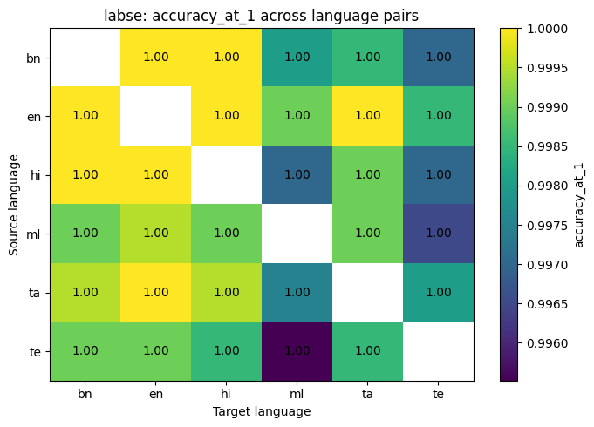
Appendix Figure. labse: Accuracy@1 heatmap across language pairs.
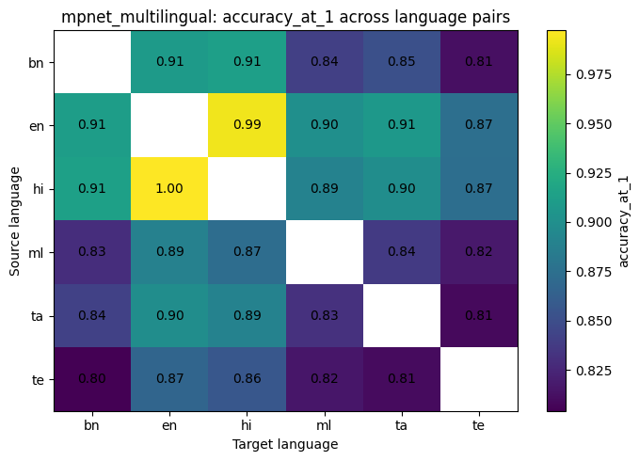
Appendix Figure. mpnet_multilingual: Accuracy@1 heatmap across language pairs.
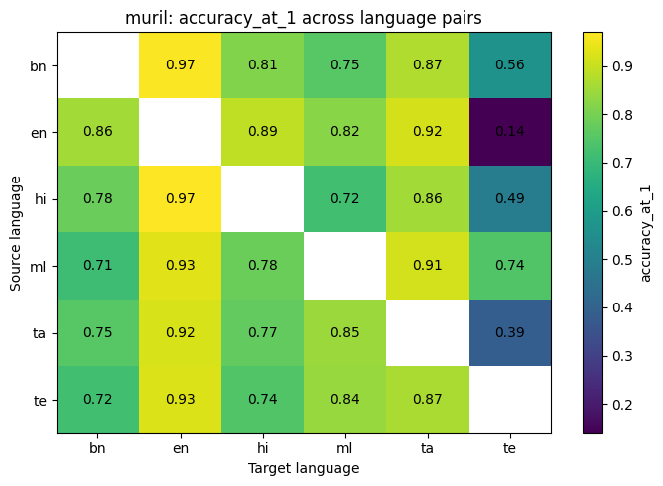
Appendix Figure. muril: Accuracy@1 heatmap across language pairs.
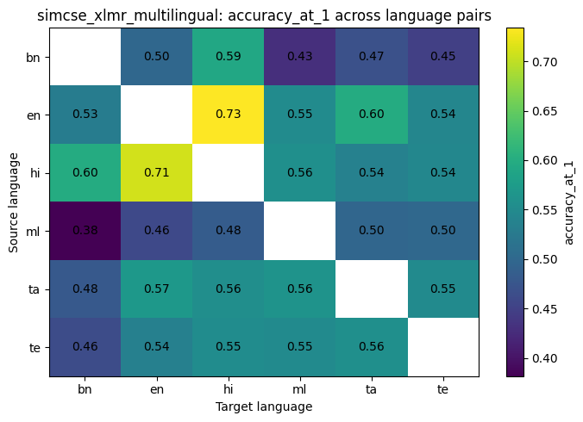
Appendix Figure. simcse_xlmr_multilingual: Accuracy@1 heatmap across language pairs.
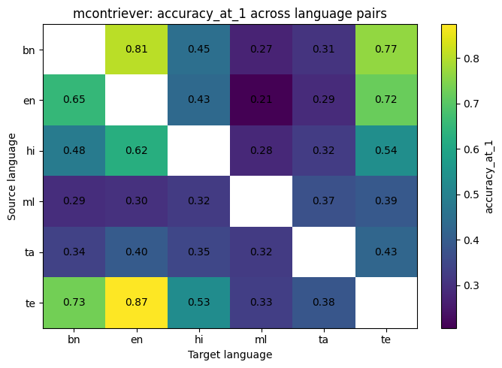
Appendix Figure. mcontriever: Accuracy@1 heatmap across language pairs.
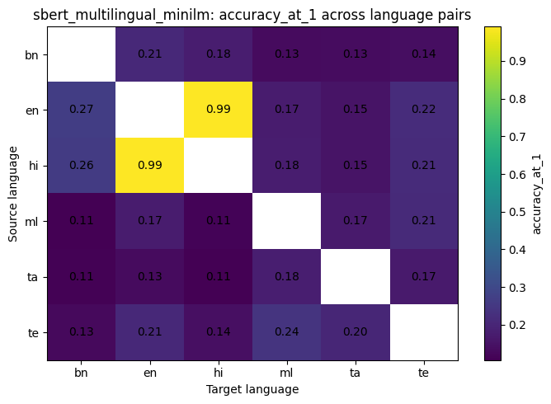
Appendix Figure. sbert_multilingual_minilm: Accuracy@1 heatmap across language pairs.
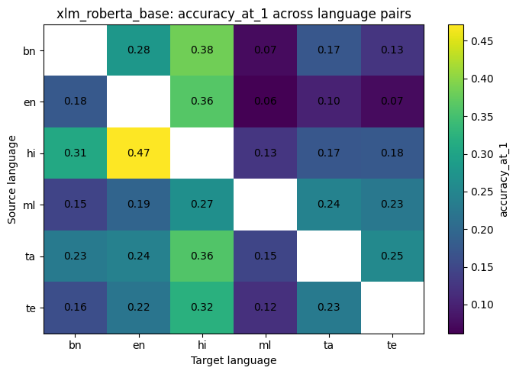
Appendix Figure. xlm_roberta_base: Accuracy@1 heatmap across language pairs.
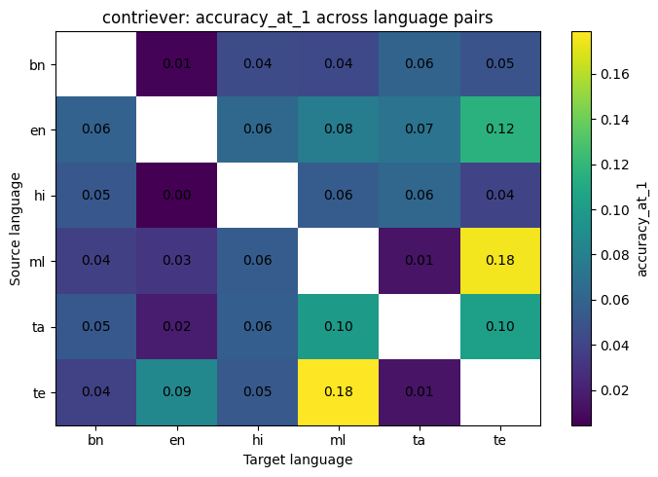
Appendix Figure. contriever: Accuracy@1 heatmap across language pairs.
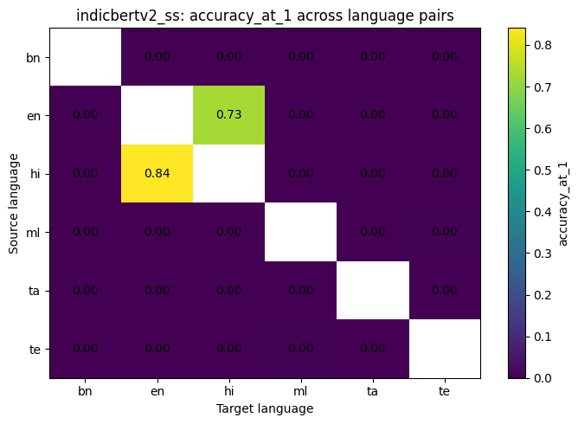
Appendix Figure. indicbertv2_ss: Accuracy@1 heatmap across language pairs.
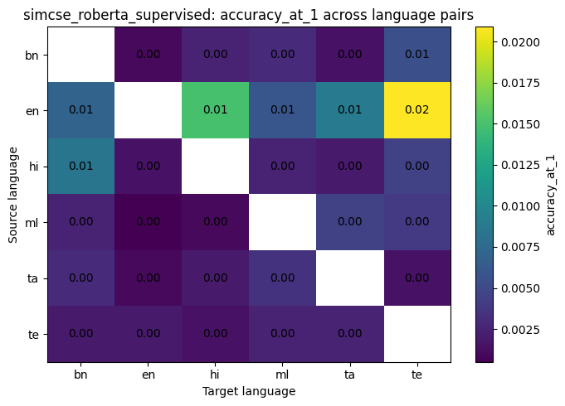
Appendix Figure. simcse_roberta_supervised: Accuracy@1 heatmap across language pairs.

Appendix B. Implementation notes
- Embeddings are cached per model-language-split-size combination to avoid repeated Colab computation.
- The cache filename includes model, language, split tag, number-of-examples tag, and max length.
- The all-pairs benchmark compares every language against every other language and skips same-language pairs.
- For each source row i, the correct target translation is also row i; the rank of target i is used for retrieval metrics.
- Error analysis stores only incorrect top-1 cases and sorts them by predicted_cosine - gold_cosine.

